Duplicate Question Retrieval on Quora Question Pairs: Sparse, Dense and Rank-Fusion Retrieval with Short-Text Vector Indexing
Students Name | Registration No. | Email-id

Abstract — When a user asks a question on a community question-answering site, the most useful response is often an existing thread that already asks the same thing in different words. This project treats duplicate-question detection on the Quora Question Pairs dataset as a ranked retrieval problem: 537,929 unique questions form the collection, human duplicate labels form 298,526 relevance judgements, and 400 held-out questions serve as queries. Four rankers are compared under one evaluation harness: TF-IDF, Okapi BM25, a Sentence-Transformer dense retriever, and a hybrid that merges BM25 and dense rankings with Reciprocal Rank Fusion (RRF). Because questions are short, standard stop-word removal and stemming reduced some queries to a single token and produced degenerate tied scores; we resolve this with a dual-space short-text indexing scheme that keeps light and heavy lexical representations in separate corpus-wide indexes and fuses them by rank. On the held-out set the dense retriever scores highest on all four metrics (nDCG@10 0.9431, MAP@10 0.9087), the RRF hybrid is second (nDCG@10 0.9251), and BM25 (0.7755) leads TF-IDF (0.7314) among the lexical methods.
Keywords: Information Retrieval · Duplicate Question Detection · Short-Text Vector Indexing · BM25 · Sentence Transformers · Reciprocal Rank Fusion · Quora Question Pairs

1. Introduction
Question-answering communities such as Quora accumulate many restatements of the same question. Each restatement fragments the answers that readers could otherwise find in one place, and asks writers to answer the same thing again. Detecting that an incoming question has already been asked is therefore a practical search problem: the new question is the query, the archive of earlier questions is the collection, and a document is relevant when a human would judge it to ask the same thing. This differs from classic ad-hoc retrieval in two ways. Queries and documents are both single short sentences rather than a few keywords against long articles, and relevance means equivalence of intent rather than topical overlap. Two questions can share almost every word and still differ (a budget of INR 15k versus INR 40000), or share very few words and still be duplicates.
Sparse lexical retrieval represents each text as a weighted vector over a vocabulary and scores documents through an inverted index. TF-IDF weighting [5] and the probabilistic BM25 function [1] remain strong baselines because they are fast, transparent and precise when a duplicate reuses the query's wording. Their weakness is vocabulary mismatch: a paraphrase that changes the words is invisible to an exact-match scorer. Short questions add a second difficulty. Normalisation steps designed for long documents, especially stop-word removal and stemming, can delete most of a five-word question and leave too little signal to rank on.
Dense retrieval encodes every question into a fixed-length embedding with a neural bi-encoder such as Sentence-BERT [2], so that paraphrases land close together, and answers a query by nearest-neighbour search over the embeddings [7]. This captures intent beyond surface wording, but it costs an encoding pass over the whole collection, is harder to inspect, and can under-weight rare exact tokens such as names and numbers that a lexical model matches directly.
Hybrid retrieval combines both views. Reciprocal Rank Fusion (RRF) [3] merges ranked lists using only each document's rank in each list, so the two systems' scores never need to be calibrated against one another.
This report presents Project 8, which makes four contributions: (i) it recasts the Quora Question Pairs classification data [4] as a retrieval benchmark with a corpus, qrels and held-out queries; (ii) it implements TF-IDF, BM25, dense and hybrid RRF rankers behind a common interface and evaluates them with Precision@10, Recall@10, MAP@10 and nDCG@10; (iii) it introduces a dual-space short-text vector indexing scheme for the lexical models, motivated by a failure that our own length-segmented evaluation exposed; and (iv) it delivers a Streamlit search interface with a performance comparison table and precision-recall graph. Section 2 describes the dataset, Section 3 the methodology, Section 4 the experiments and Section 5 the conclusions.

2. About Dataset
The Quora Question Pairs (QQP) dataset [4] was released by Quora in 2017. Each record holds two questions and a binary is_duplicate label assigned by human annotators. The file used here contains 404,290 question pairs, of which 149,263 are labelled as duplicates. QQP is distributed as a pair-classification task, so we converted it into a retrieval benchmark in three steps.
- Corpus. Every distinct question across both columns becomes one document, giving 537,929 unique questions identified by Quora's question IDs.
- Relevance judgements (qrels). Each duplicate pair is recorded in both directions (q1 → q2 and q2 → q1), yielding 298,526 (query, relevant document) rows over 149,650 distinct query IDs. Non-duplicate pairs add no judgements; those questions simply sit in the collection as competing documents.
- Held-out queries. 400 questions that have at least one labelled duplicate are held out as evaluation queries. Using a five-word threshold, 40 of them are short (five words or fewer) and 360 are long.

2.1 Dataset statistics and illustrative examples
Table 1 summarises the benchmark as built from the processed data files.
Table 1. Quora Question Pairs retrieval benchmark statistics.
Quantity | Value
Raw question pairs | 404,290
Pairs labelled duplicate (is_duplicate = 1) | 149,263
Unique questions in the retrieval corpus | 537,929
Qrel rows (query, relevant document) | 298,526
Query IDs with at least one relevant document | 149,650
Held-out evaluation queries | 400 (40 short, 360 long)
Dense index (documents × embedding dimension) | 100,000 × 384

Table 2 lists four real pairs from the raw file. Together they show why the task is hard for any single retrieval paradigm.
Table 2. Example question pairs from the Quora Question Pairs file.
Question 1 | Question 2 | Label
How do I speak English fluently? | How can I take my spoken English to a higher level when I speak good enough but not fluently? | Duplicate
Why is the Republician Party known as the GOP? | Why is the Republican party also called the GOP? | Duplicate
The loneliest number? | What is the loneliest number? | Duplicate
Which smartphone should I buy under INR 15k? | Which smartphone should I buy under INR 40000? | Not duplicate

The first pair is a paraphrase with little shared wording, which favours semantic matching. The second hinges on a misspelling (“Republician”), which defeats exact term matching but survives sub-word character evidence. The third is a three-word question, where aggressive normalisation leaves almost nothing to match. The fourth overlaps almost entirely in wording yet asks a different question; for a lexical ranker it is a hard negative.

3. Methodology
All four rankers implement the same interface: they are fitted once on the corpus and return a ranked list of (document, score) pairs for a query. Figure 1 shows the end-to-end pipeline, from dataset conversion to the evaluation harness and the user interface.

3.1 Preprocessing and Indexing
Lexical preprocessing lowercases the text, replaces punctuation with spaces and tokenises it with NLTK's word_tokenize. Two modes are defined. The heavy mode also removes NLTK's English stop-words and applies the Porter stemmer [6]. The light mode stops after tokenisation, so stop-words and surface word forms are kept. A text counts as short when it has at most five whitespace-separated words (short_text_word_threshold = 5). Each lexical representation is fitted once over the whole corpus, so every document is indexed identically within a given space. The dense retriever applies no lexical preprocessing. It encodes the raw question text into 384-dimensional L2-normalised embeddings, which are stored in a FAISS IndexFlatIP index so that exact inner-product search equals cosine similarity. For tractable encoding, the dense index covers a 100,000-question subsample that always includes the relevant documents of every evaluation query.
[ Quora Question Pairs: 404,290 labelled question pairs ]
│
▼
[ Corpus & qrels builder: 537,929 unique questions, 298,526 qrels ]
│
▼
[ Incoming question (the query) ]
│
┌───────────────────────────┼────────────────────────────┐
▼ ▼ ▼
[ TF-IDF ensemble ] [ BM25 ensemble ] [ Dense retriever ]
light: tokens+bigrams light: surface tokens all-MiniLM-L6-v2
heavy: stop-words+stem heavy: stop-words+stem 384-d, FAISS flat IP
char 3-5 (short only) 100,000-doc index
│ internal RRF │ internal RRF │
▼ │ │
[ TF-IDF ranking ] │ BM25 ranking │ Dense ranking
▼ │
[ Hybrid-RRF ranking (k = 60) ] ◄───────────┘
│
▼
[ Evaluation vs. qrels: P@10 · Recall@10 · MAP@10 · nDCG@10 · PR curve ]
│
▼
[ Streamlit UI: Search · Performance Comparison · Precision-Recall ]
Figure 1: Architecture of the duplicate-question retrieval pipeline, with internal lexical fusion and top-level hybrid fusion.

3.2 Ranking Models
Four ranking models are evaluated:
- TF-IDF vector space model: ranks documents by cosine similarity between TF-IDF vectors [5] in three corpus-wide spaces: light tokens with adjacent word bigrams, heavy stemmed unigrams, and character 3–5-grams within word boundaries (used for short queries only). The per-space rankings are merged with RRF.
- Okapi BM25: scores documents with BM25 [1], which saturates repeated term frequency and normalises for document length. It uses two Okapi indexes, one light and one heavy, whose rankings are fused with RRF.
- Sentence Transformer (dense retrieval): encodes queries and documents with the all-MiniLM-L6-v2 bi-encoder [2, 8] and retrieves nearest neighbours from the FAISS index [7].
- Hybrid Reciprocal Rank Fusion: fuses the BM25 ranking and the dense ranking with RRF. This combines two different paradigms, exact lexical matching and learned semantic similarity, so it is distinct from the lexical-only fusion used inside the TF-IDF and BM25 ensembles.

3.3 Reciprocal Rank Fusion Formulation
Given a set M of ranked lists, RRF assigns each document a score from its positions in those lists alone:
$$RRF\left(d\right) = \sum_{m∈M}{\frac{1}{k + {rank}_{m}\left(d\right)}}, k = 60$$
Here rank_{m}(d) is the 1-based position of document d in list m. A document missing from a list contributes nothing for that list. The constant k = 60 flattens the reciprocal curve, so a document ranked well by several systems beats one ranked first by a single system. Raw scores are never compared, which matters here because BM25 scores are unbounded while cosine similarities lie in a fixed range. One implementation of this formula is used at all three fusion points: inside TF-IDF, inside BM25 and in the top-level hybrid.

3.4 Short-Text Vector Indexing
QQP questions are short, and the standard heavy pipeline is tuned for longer text. On short questions, stop-word removal and stemming can leave a single token or none: “What is the google?” becomes [googl] and “How do I post here?” becomes [post]. Six of the 40 short evaluation queries collapsed in this way. A one-term query vector has cosine similarity 1.0 with every document that has also collapsed to that term, so many unrelated questions tied at the maximum score and the ranking among them was arbitrary. Short-text vector indexing therefore had to meet three requirements: keep enough of a short question to rank on, keep the stemming and stop-word normalisation that helps longer questions, and keep every index internally consistent.
Two simpler designs were tested and rejected using the evaluation in Section 4. Global light preprocessing removed the ties but also removed the normalisation that long questions benefit from, and segmenting queries by length showed long-query TF-IDF falling below its original level. Per-text mode selection, which chose light or heavy preprocessing for each text by its length inside one shared vocabulary, restored long queries but fragmented the vocabulary. A short query's surface form (for example geographic) could no longer match the stemmed form (geograph) of its longer duplicate, and the bigrams generated for queries had no counterparts among the documents.
The adopted design is dual-space indexing with rank fusion. Every document is indexed twice, in a light space (surface tokens plus word bigrams) and in a heavy space (stop-word-free stemmed unigrams). For TF-IDF, a third character n-gram space supplies sub-word evidence and is consulted only for short queries. At query time the query is processed in each space's own mode, each space returns its ranking, and the rankings are merged with the RRF formula of Section 3.3. Within any one space, query and documents are always tokenised the same way, so the mismatch of per-text selection cannot arise. Each question still receives both the faithful short-text view and the normalised long-text view, and rank fusion lets whichever view finds a duplicate place it near the top without having to compare scores across spaces.

4. Experimental Setup and Performance Analysis

4.1 Setup and Metrics
Each of the 400 held-out queries is issued to every ranker. A query's relevant set is its qrels entry, and a document whose text is identical to the query is excluded from results so that a question cannot retrieve itself. The lexical models search the full 537,929-question corpus, and the dense model searches its 100,000-question index. We report four metrics at a cutoff of 10, averaged over queries: Precision@10, the fraction of the top ten that is relevant; Recall@10, the fraction of a query's relevant documents found in the top ten; MAP@10, the mean over queries of average precision computed on the top ten; and nDCG@10 [9] with binary gains, which rewards placing duplicates near rank 1. Precision-recall curves average P@k and R@k for k = 1 to 50.

4.2 Overall Results
Table 3. Held-out retrieval performance on Quora Question Pairs (400 queries, cutoff 10). Best value per column in bold.
Ranking Model | Precision@10 | Recall@10 | MAP@10 | nDCG@10
TF-IDF | 0.1310 | 0.8341 | 0.6631 | 0.7314
BM25 | 0.1368 | 0.8582 | 0.7129 | 0.7755
Dense | 0.1738 | 0.9659 | 0.9087 | 0.9431
Hybrid-RRF | 0.1708 | 0.9535 | 0.8843 | 0.9251

The dense retriever is best on every metric, with Precision@10 0.1738, Recall@10 0.9659, MAP@10 0.9087 and nDCG@10 0.9431. Hybrid RRF is second on every metric (0.1708 / 0.9535 / 0.8843 / 0.9251), well ahead of both lexical models. Among the lexical models, BM25 beats TF-IDF on all four metrics (nDCG@10 0.7755 versus 0.7314), which matches the expectation that term-frequency saturation and length normalisation suit short, uneven questions better than raw TF-IDF weighting.
Precision@10 is low for every method, at 0.1738 even for the best. This is a property of the benchmark, not a retrieval failure. With 298,526 qrel rows spread over 149,650 query IDs, most queries have very few labelled duplicates, so even a perfect ranker cannot fill ten slots with relevant documents. The rank-sensitive metrics are more informative. Dense retrieval's MAP@10 of 0.9087 against BM25's 0.7129 shows that it does not merely find duplicates within the top ten but places them at or near rank 1.
Dense retrieval wins because duplicate detection is a paraphrase problem, and a bi-encoder trained on sentence pairs maps re-worded questions to nearby vectors where lexical models see little overlap. The hybrid does not surpass it because RRF weights its inputs equally. When one input (BM25, nDCG@10 0.7755) is markedly weaker than the other (dense, 0.9431), lexical false positives at high BM25 ranks receive as much credit as correct dense results and push some of them down. The hybrid remains far stronger than BM25 alone and keeps an interpretable exact-match signal. Two caveats apply to the dense margin and are discussed in Section 5: the dense index is smaller than the lexical one, and the pre-trained encoder's training data may overlap this benchmark.

4.3 Segmented Analysis: Short versus Long Queries
Because the short-text work targets a specific query regime, the lexical models were also evaluated separately on short (≤ 5 words) and long queries (Table 4). The aggregate figures in Table 3 for TF-IDF and BM25 are exactly the query-weighted means of these rows.
Table 4. Lexical model performance segmented by query length (cutoff 10).
Model | Query group | Queries | Precision@10 | Recall@10 | MAP@10 | nDCG@10
TF-IDF | Short | 40 | 0.1450 | 0.8389 | 0.7225 | 0.7908
TF-IDF | Long | 360 | 0.1294 | 0.8335 | 0.6565 | 0.7247
BM25 | Short | 40 | 0.1375 | 0.8198 | 0.6550 | 0.7314
BM25 | Long | 360 | 0.1367 | 0.8625 | 0.7193 | 0.7804

With dual-space indexing, short queries are no longer TF-IDF's weak segment: short-query nDCG@10 is 0.7908 against 0.7247 for long queries, and MAP@10 is 0.7225 against 0.6565. BM25 shows the opposite pattern (short nDCG@10 0.7314, long 0.7804; short Recall@10 0.8198, long 0.8625). The likely reason is architectural. TF-IDF's short-query path adds the character n-gram space, while BM25 has only its light and heavy word spaces, so BM25 gets no sub-word evidence for very short questions. The short segment contains only 40 queries, so these per-segment differences carry more sampling noise than the aggregate figures.

4.4 Development-Stage Comparison of Short-Text Indexing
Table 5 traces TF-IDF through the indexing designs of Section 3.4. The original figures are inflated by the 1.0-score ties described there, so they are a reference point rather than a target.
Table 5. TF-IDF across short-text indexing designs (cutoff 10).
Indexing design | Scope | Precision@10 | Recall@10 | MAP@10 | nDCG@10
Original heavy pipeline | All 400 | 0.1283 | 0.8198 | 0.6642 | 0.7274
Global light mode | All 400 | 0.1158 | 0.7301 | 0.5517 | 0.6184
Global light mode | Short 40 | 0.1225 | 0.7087 | 0.5044 | 0.5887
Per-text mode, shared vocabulary | All 400 | 0.1200 | 0.7574 | 0.6206 | 0.6784
Per-text mode, shared vocabulary | Long 360 | 0.1256 | 0.7949 | 0.6564 | 0.7148
Per-text mode, shared vocabulary | Short 40 | 0.0700 | 0.4205 | 0.2981 | 0.3508
Dual-space RRF (final) | All 400 | 0.1310 | 0.8341 | 0.6631 | 0.7314
Dual-space RRF (final) | Short 40 | 0.1450 | 0.8389 | 0.7225 | 0.7908
Dual-space RRF (final) | Long 360 | 0.1294 | 0.8335 | 0.6565 | 0.7247

The per-text design shows why segmentation was necessary. Its long-query figures recovered, but short-query nDCG@10 fell to 0.3508, a regression the aggregate (0.6784) only partly revealed. The final dual-space design is the only one that is strong on both segments, and it exceeds the original aggregate on Precision@10, Recall@10 and nDCG@10 while removing the tie artefact. The same pattern holds for BM25 (aggregate nDCG@10 0.7613 originally, 0.7526 with global light mode, 0.7137 with per-text selection and 0.7755 with dual-space fusion) and carries through to the hybrid, which inherits the BM25 ranking (0.9228, 0.9081, 0.8937 and 0.9251).

4.5 Precision-Recall Curve
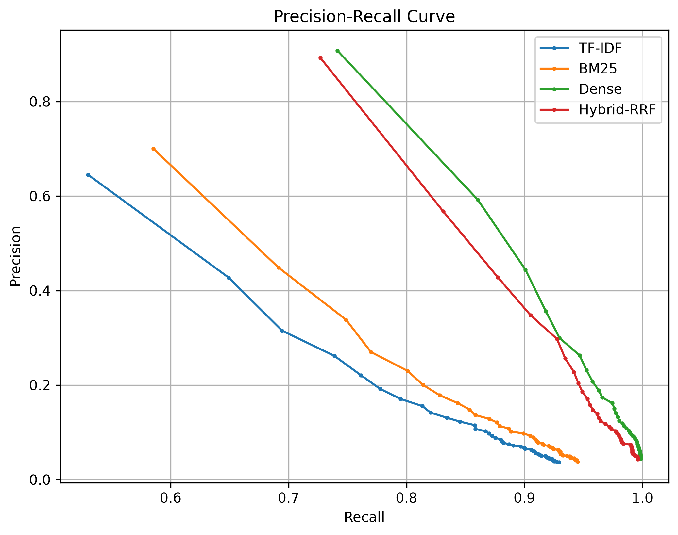
Figure 2: Precision-recall curves for the four rankers, with P@k and R@k averaged over the 400 held-out queries for cutoffs k = 1 to 50.
Figure 2 confirms the ordering of Table 3 across the whole operating range, not just at k = 10. The dense curve lies above all others at every cutoff, the hybrid curve lies just below it, and both start at much higher precision for small k and approach full recall by k = 50. BM25 dominates TF-IDF throughout, and both lexical curves end at visibly lower recall even at k = 50, so some labelled duplicates remain out of reach of exact-match retrieval however deep the ranking goes.

5. Conclusion
This project built and evaluated a duplicate-question retrieval system on Quora Question Pairs, framing duplicate detection as ranked retrieval over 537,929 questions with 400 held-out queries. Learned semantic similarity is the decisive signal for this task: the dense retriever leads on every metric (nDCG@10 0.9431, MAP@10 0.9087). The BM25 and dense RRF hybrid comes within reach of it (nDCG@10 0.9251) while keeping an exact-match signal, and it is the more defensible deployment choice when names, numbers or rare terms matter. Among lexical models, BM25 consistently outperforms TF-IDF. The project's main engineering result is the dual-space short-text vector indexing scheme. It removed degenerate tied rankings on short questions and lifted short-query TF-IDF to nDCG@10 0.7908 without sacrificing long queries. Length-segmented evaluation was what exposed both rejected designs, so segmentation should be standard practice whenever a fix targets a sub-population of queries.
Limitations.
- Unequal index sizes. The dense model searches a 100,000-question subsample that always contains the evaluation queries' relevant documents, whereas the lexical models search all 537,929 questions. The dense model faces fewer distractors, which favours it in the comparison.
- Possible training overlap. The model card for all-MiniLM-L6-v2 lists Quora duplicate-question pairs among its fine-tuning data, so some evaluation pairs may have been seen during pre-training.
- Cold-start latency. The interface fits all lexical spaces over the full corpus and loads the dense model and index at start-up, so the first launch is slow. Latency was not measured in this study.
- Long-tail paraphrases and the cutoff. Recall@10 is below 1.0 for every method, so some labelled duplicates rank outside the top ten. For queries with many duplicates, the cutoff caps recall outright: on one query with 33 labelled duplicates, the best ranker placed 9 of them in its top ten.
- Evaluation scope. The short segment has 40 queries, the five-word threshold was fixed rather than tuned, segmentation covered only the lexical models, and QQP labels are incomplete. Unlabelled true duplicates count as non-relevant, so all scores are conservative.
Future work. Natural next steps are to index the full corpus densely with an approximate nearest-neighbour index to remove the size asymmetry; to replace equal-weight RRF with weighted fusion or a tuned k so that a weaker component cannot dilute a stronger one; to re-rank fused candidates with a cross-encoder; to evaluate a dense encoder known to exclude QQP from training, or fine-tune one on a training split disjoint from the evaluation queries; to tune the short-text threshold and add a character space to BM25; and to report per-query latency and significance tests alongside effectiveness.

References
1. Robertson, S., Zaragoza, H.: The Probabilistic Relevance Framework: BM25 and Beyond. Foundations and Trends in Information Retrieval 3(4), 333–389 (2009)
2. Reimers, N., Gurevych, I.: Sentence-BERT: Sentence Embeddings using Siamese BERT-Networks. In: Proceedings of the 2019 Conference on Empirical Methods in Natural Language Processing and the 9th International Joint Conference on Natural Language Processing (EMNLP-IJCNLP), pp. 3982–3992. Association for Computational Linguistics (2019)
3. Cormack, G.V., Clarke, C.L.A., Buettcher, S.: Reciprocal Rank Fusion Outperforms Condorcet and Individual Rank Learning Methods. In: Proceedings of the 32nd International ACM SIGIR Conference on Research and Development in Information Retrieval, pp. 758–759. ACM (2009)
4. Iyer, S., Dandekar, N., Csernai, K.: First Quora Dataset Release: Question Pairs. Quora (2017). https://quoradata.quora.com/First-Quora-Dataset-Release-Question-Pairs
5. Salton, G., Buckley, C.: Term-Weighting Approaches in Automatic Text Retrieval. Information Processing & Management 24(5), 513–523 (1988)
6. Porter, M.F.: An Algorithm for Suffix Stripping. Program 14(3), 130–137 (1980)
7. Johnson, J., Douze, M., Jégou, H.: Billion-Scale Similarity Search with GPUs. IEEE Transactions on Big Data 7(3), 535–547 (2021)
8. Wang, W., Wei, F., Dong, L., Bao, H., Yang, N., Zhou, M.: MiniLM: Deep Self-Attention Distillation for Task-Agnostic Compression of Pre-Trained Transformers. In: Advances in Neural Information Processing Systems 33 (NeurIPS 2020), pp. 5776–5788 (2020)
9. Järvelin, K., Kekäläinen, J.: Cumulated Gain-Based Evaluation of IR Techniques. ACM Transactions on Information Systems 20(4), 422–446 (2002)

