Duplicate Question Retrieval on Quora Question Pairs: Sparse, Dense and Rank-Fusion Retrieval with Short-Text Vector Indexing
Students Name | Registration No. | Email-id

Abstract — Duplicate-question detection is cast as ranked retrieval on Quora Question Pairs: 537,929 unique questions form the collection, 298,526 duplicate-label judgements form the qrels, and 400 randomly sampled questions are the evaluation queries. We compare TF-IDF, BM25, a Sentence-Transformer dense retriever and a hybrid that fuses BM25 and dense rankings with Reciprocal Rank Fusion (RRF). Standard preprocessing collapsed some short questions to one token and produced tied cosine scores of 1.0; a dual-space indexing scheme that fuses light, heavy and character-level rankings removes the ties. Dense retrieval scores highest on all four metrics (nDCG@10 0.9431, MAP@10 0.9087), the hybrid is second (0.9251) and BM25 (0.7755) leads TF-IDF (0.7314). Design choices were made on these same queries, so the figures are development-set figures and probably optimistic.
Keywords: Information Retrieval · Duplicate Question Detection · Short-Text Vector Indexing · BM25 · Sentence Transformers · Reciprocal Rank Fusion · Quora Question Pairs

1. Introduction
Question-answering sites accumulate restatements of the same question, which splits answers across threads. Detecting a repeat is a retrieval problem: the new question is the query, earlier questions are the collection, and a document is relevant if annotators labelled it a duplicate. It differs from ad-hoc search because queries and documents are single short sentences and relevance means the same intent, not the same topic: “Which smartphone should I buy under INR 15k?” and “…under INR 40000?” share almost every word yet are not duplicates.
Sparse lexical retrieval scores documents by weighted term overlap with the query; TF-IDF [5] and BM25 [1] are the standard models. It cannot see a paraphrase that shares few words, and normalisation can erase most of a very short question. Dense retrieval embeds each question as a vector with a bi-encoder such as Sentence-BERT [2] and ranks by vector similarity, which tolerates re-wording but needs an encoding pass and can miss rare exact tokens. Hybrid retrieval merges the two rankings; Reciprocal Rank Fusion (RRF) [3] does so from ranks alone, so no score calibration is needed.
This report (i) converts QQP [4] into a retrieval benchmark, (ii) compares TF-IDF, BM25, dense and hybrid rankers on four metrics, (iii) describes a dual-space short-text indexing scheme that length-segmented evaluation showed to be necessary, and (iv) provides a Streamlit search interface.

2. About Dataset
QQP [4] consists of question pairs with a human-assigned binary is_duplicate label; the file used has 404,290 pairs, 149,263 of them duplicates. It has no collection or relevance judgements, so we derived them (Table 1):
- Corpus: every distinct question, 537,929 in all.
- Qrels: each duplicate pair is recorded in both directions, giving 298,526 (query, relevant document) rows over 149,650 query IDs. Non-duplicate pairs add no judgements; those questions stay in the collection as distractors, and an unlabelled true duplicate counts as non-relevant.
- Evaluation queries: 400 questions drawn at random (seed 42) from those with a qrel; 40 have at most five words, 360 more. They remain in the collection: only a document whose text equals the query is removed from its own results.

2.1 Dataset visualisation and examples
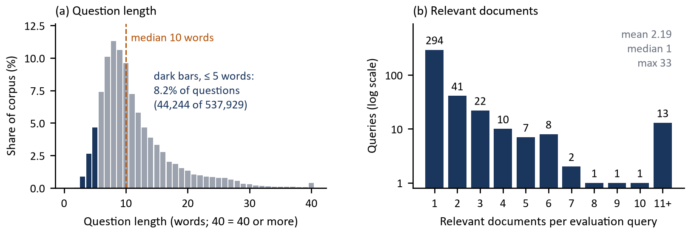
Figure 1: (a) Question length in the corpus, questions of at most five words in dark. (b) Relevant documents per evaluation query (log scale).
Questions are short (Figure 1a): the median is 10 words and 8.2% have at most five, the regime where normalisation can erase most of the text (Section 3.4). Most evaluation queries have one relevant document (294 of 400; mean 2.19, maximum 33; Figure 1b), which caps Precision@10 (Section 4). In Table 2, pair 1 is a paraphrase with little word overlap, pair 2 a three-word question, and pair 3, a non-duplicate, shares almost every word with its partner.
Table 1. Dataset statistics. | Table 2. Example pairs from the QQP file.
  Quantity | Value
  Raw question pairs | 404,290
  Labelled duplicates | 149,263
  Corpus (unique questions) | 537,929
  Qrel rows | 298,526
  Query IDs with a qrel | 149,650
  Evaluation queries | 400
  short / long (≤5 / >5 words) | 40 / 360
  Dense index | 100,000 × 384
  # | Question 1 | Question 2 | Dup.
  1 | How do I speak English fluently? | How can I take my spoken English to a higher level when I speak good enough but not fluently? | Yes
  2 | The loneliest number? | What is the loneliest number? | Yes
  3 | Which smartphone should I buy under INR 15k? | Which smartphone should I buy under INR 40000? | No

3. Methodology
All four rankers share one interface and are unsupervised: nothing is trained on the qrels, which are used only for scoring. Figure 2 shows the pipeline; the Search tab queries the retrievers live, while the comparison and PR tabs read the evaluation outputs.

3.1 Preprocessing and Indexing
Preprocessing lowercases, replaces punctuation with spaces and tokenises with NLTK word_tokenize. Heavy mode then removes English stop-words and applies the Porter stemmer [6]; light mode stops after tokenisation. A text is short if it has at most five whitespace-separated words. TF-IDF and BM25 are built once over all 537,929 questions: TF-IDF stores sparse document-term matrices (scikit-learn) and scores a query against every row, while BM25 uses rank_bm25, which scans every document's term counts for each query term. Neither uses an inverted index at query time. The dense retriever encodes the raw question into a 384-dimensional unit vector held in a FAISS IndexFlatIP. To keep encoding tractable the dense index holds 100,000 questions: the 400 queries and their relevant documents (1,276 questions in the run log) plus a seeded random fill.
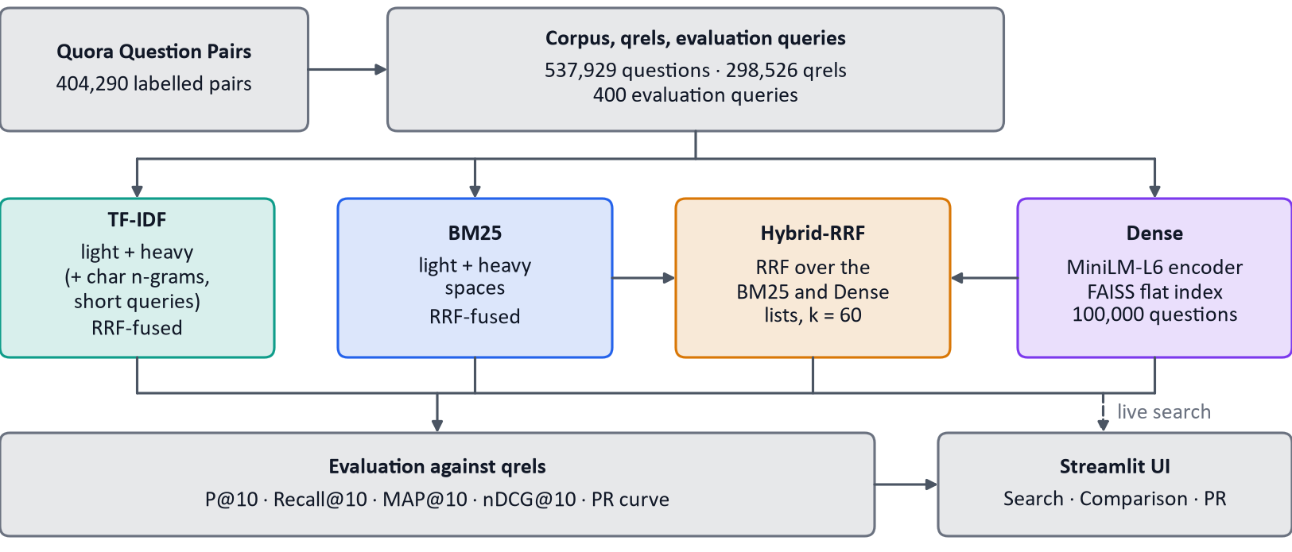
Figure 2: Pipeline. TF-IDF and BM25 each fuse their internal spaces with RRF; Hybrid-RRF fuses the BM25 and Dense lists (TF-IDF is not part of it).

3.2 Ranking Models
Table 3 records the design choices; the four models are defined below.
Table 3. Design rationale. “spec” marks choices the assignment specified; “ours” marks our engineering choices; “spec / ours” means the family or step is specified and the specific checkpoint or mode is ours.
Component | Chosen | Not used / not evaluated | Why
TF-IDF (spec) | scikit-learn TfidfVectorizer, custom analysers, cosine | From-scratch inverted index (written, unused in results) | Specified model. Sparse matrices give exact cosine over all questions; one preprocessing function feeds every space.
BM25 (spec) | rank_bm25 BM25Okapi, library defaults (untuned) | Tuned parameters, other variants: not tried | Specified model. A maintained library avoids re-implementing the scoring.
Dense encoder (spec / ours) | all-MiniLM-L6-v2, 384-d | Other encoders: not compared | A Sentence Transformer is specified; this checkpoint is small, free, runs on CPU and needs no training split.
Vector index (ours) | FAISS IndexFlatIP on unit vectors | Approximate indexes: not built | Exact search equals cosine with no approximation error; 100,000 × 384 float32 is about 150 MB.
Fusion (spec) | RRF on ranks, k = 60 | Weighted fusion, learned re-ranker, other k: not evaluated | Ranks need no calibration between unbounded BM25 and bounded cosine; a learned re-ranker needs labels, and the qrels are the evaluation labels.
Preprocessing (spec / ours) | NLTK tokeniser, stop-words, Porter; light and heavy modes | Other stemmers, lemmatisers: not tried | Steps are specified. Heavy mode alone collapsed short questions, hence light mode (Section 3.4).
Interface (ours) | Streamlit, three tabs | Other front ends: not tried | A Python app giving the three required outputs: search, comparison table, PR graph.
Metrics (spec) | P@10, Recall, MAP, nDCG@10 at cutoff 10 | - | Most queries have one relevant document, so P@10 is capped and the other three carry the comparison.

TF-IDF [5] represents a text as a vector over terms with the weight below, where tf is the raw count, N the number of questions and df_{t} the number containing term t (scikit-learn's smoothed form). Vectors are L2-normalised, so similarity is the cosine. Rare terms weigh more, which helps when a duplicate shares a distinctive word.
$$w_{t,d} = {tf}_{t,d} · \left(\ln\left(\frac{1 + N}{1 + {df}_{t}}\right) + 1\right)$$ | $$\cos\left(q, d\right) = \frac{q · d}{\left\|q\right\|\left\|d\right\|}$$
BM25 [1] scores a document as below, with idf(t) = ln((N − n_{t} + 0.5)/(n_{t} + 0.5)), f_{t,d} the term count, |d| the document length and avgdl the mean length. k₁ saturates repeated terms and b scales by length. We use rank_bm25's BM25Okapi with its defaults k₁ = 1.5, b = 0.75 (untuned); the library replaces a negative idf by 0.25 times the mean idf. BM25 scores are unbounded, so they cannot be added to cosine scores.
$$BM25\left(q, d\right) = \sum_{t ∈ q}{idf\left(t\right) · \frac{f_{t,d} (k_{1} + 1)}{f_{t,d} + k_{1}\left(1 − b + b \frac{|d|}{avgdl}\right)}}$$
Dense retrieval maps each question to a unit vector f(x) with all-MiniLM-L6-v2 [2, 8] and ranks by cosine, sim(q, d) = f(q)·f(d), using exact FAISS search [7]; comparing meaning rather than words, it can match a re-worded duplicate. Hybrid-RRF applies RRF (Section 3.3) to two lists of 100 documents: the BM25 ensemble's output and the dense list. TF-IDF is not included. The BM25 list is itself an RRF fusion of its light and heavy spaces, so the hybrid is RRF over an RRF-fused list, and its dense side searches the same 100,000-question index.

3.3 Reciprocal Rank Fusion Formulation
RRF scores a document by summing, over the ranked lists M that contain it, a reciprocal of its rank plus a constant, where rank_{m}(d) is the 1-based position of d in list m; a list that omits d contributes nothing:
$$RRF\left(d\right) = \sum_{m ∈ M}{\frac{1}{k + {rank}_{m}\left(d\right)}}, k = 60$$
Table 4. RRF worked example (illustrative ranks, k = 60). | Only positions are used, so lists from different scorers need no calibration. The constant k = 60 (the assignment's value, also used in [3]) limits how much one first place can outweigh agreement between lists. Table 4 scores illustrative ranks with the project's own function: document E, found at rank 5 by both lists, outranks D, found at rank 2 by only one. The same function performs the fusion inside TF-IDF, inside BM25 and in the hybrid.
  Doc | BM25 | Dense | RRF | Fused
  A | 1 | 3 | 0.0323 | 2
  B | 2 | 1 | 0.0325 | 1
  C | 3 | - | 0.0159 | 5
  D | - | 2 | 0.0161 | 4
  E | 5 | 5 | 0.0308 | 3

3.4 Short-Text Vector Indexing
Short-text vector indexing means building representations that still carry enough signal when a question has only a few words. Heavy preprocessing can reduce a short question to one token or none: “What is the google?” becomes [googl] (Figure 3, top lane), and six of the 40 short evaluation queries collapsed to zero or one token. Many documents were reduced to the same one-dimensional vector, so non-identical questions tied at cosine 1.0 and their order was arbitrary.
Two designs were tried and rejected on the evidence of length-segmented evaluation (Figure 4). Global light mode (no stop-word removal or stemming for any text) removed the ties but pushed long-query TF-IDF below its original level, although long queries were never affected. Per-text mode selection (light for short texts, heavy for long, inside one shared vocabulary) restored long queries but fragmented the vocabulary: a short query kept “geographic” while its longer duplicate was stemmed to “geograph”, and bigrams existed only on the query side.
The adopted design is dual-space indexing with rank fusion. Every question is indexed in independent corpus-wide spaces: light (surface tokens plus word bigrams), heavy (stemmed unigrams without stop-words) and, for TF-IDF only, character 3–5-grams within word boundaries, consulted only for queries of at most five words. A query is processed in each space exactly as that space's documents were; each space returns up to 100 documents and the lists are fused with the RRF formula above (Figure 3). BM25 uses its light and heavy spaces for every query. Within a space, query and documents share one tokenisation, which removes the mismatch; across spaces, fusing ranks avoids comparing incompatible scores. The five-word threshold was chosen by inspecting the data, not tuned.
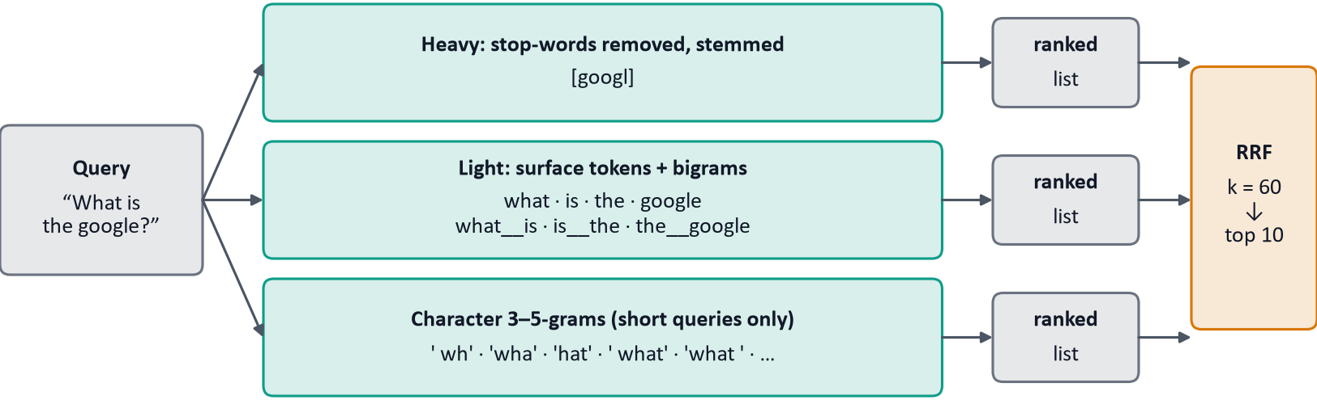
Figure 3: Dual-space indexing for the TF-IDF query “What is the google?”; BM25 uses the first two lanes.

4. Experimental Setup and Performance Analysis
Setup and metrics. The 400 evaluation queries are run through all four rankers at cutoff 10 (top 50 for the PR curves). The rankers are unsupervised, so no training data leaks; the queries stay in the collection and only the document with identical text is removed. However, the short-text design (Section 3.4) was chosen by inspecting results on these same queries, with no separate development split, so all figures are development-set figures and probably optimistic. In Table 5, R is the query's relevant set, T₁₀ its top ten and rel_{i} ∈ {0, 1} the relevance at rank i. AP is divided by |R| rather than min(10, |R|), which is lower than the usual convention for the 13 queries with more than ten relevant documents.
Table 5. Metric definitions as implemented (cutoff 10). | The qrels cap Precision@10. With 2.19 relevant documents per query on average the bound is 2.19/10 ≈ 0.22; because queries with more than ten relevant documents cannot fill the cutoff, the exact ceiling for a perfect ranker is the mean of min(|R|, 10)/10 = 0.184. Dense retrieval's 0.1738 is 94% of that.
  Metric | Definition
  P@10 | |R ∩ T₁₀| / 10
  Recall@10 | |R ∩ T₁₀| / |R|
  AP@10 (MAP@10: mean over queries) | (1 / |R|) · Σ_{i=1..10} P@i · rel_{i}
  nDCG@10 [9] | DCG@10 / IDCG@10; DCG@10 = Σ_{i=1..10} rel_{i} / log₂(i + 1); IDCG@10 is DCG@10 of the ideal ranking (min(10, |R|) relevant first)
Overall results. Table 6 and Figure 5a give the results; Figure 5b gives the precision-recall curves.
Table 6. Retrieval performance on the 400 evaluation queries (cutoff 10). Best per column in bold.
Ranking Model | P@10 | Recall@10 | MAP@10 | nDCG@10
TF-IDF | 0.1310 | 0.8341 | 0.6631 | 0.7314
BM25 | 0.1368 | 0.8582 | 0.7129 | 0.7755
Dense | 0.1738 | 0.9659 | 0.9087 | 0.9431
Hybrid-RRF | 0.1708 | 0.9535 | 0.8843 | 0.9251

Dense retrieval leads on every metric (nDCG@10 0.9431, MAP@10 0.9087, Recall@10 0.9659); Hybrid-RRF is second on every metric (nDCG@10 0.9251) and BM25 beats TF-IDF on all four (nDCG@10 0.7755 against 0.7314). At k = 1 precision is 0.9075 (Dense), 0.8925 (Hybrid-RRF), 0.7000 (BM25) and 0.6450 (TF-IDF), so Dense puts a duplicate first for about nine in ten queries. In Figure 5b the order Dense, Hybrid-RRF, BM25, TF-IDF holds for precision and recall at every k from 1 to 50, and the k = 10 markers reproduce the P@10 and Recall@10 columns of Table 6. At k = 50 recall is 0.999 (Dense), 0.996 (Hybrid-RRF), 0.945 (BM25) and 0.929 (TF-IDF), so the lexical models still miss some labelled duplicates within the top 50.
A plausible reason for Dense's lead is that duplicates are paraphrases and the encoder embeds meaning; no ablation isolated this. Dense also searches an index about 5.4 times smaller than the lexical models (100,000 against 537,929 questions), which favours it and the hybrid's dense side by an unmeasured amount. Hybrid-RRF sits below Dense, consistent with equal-weight RRF letting the weaker BM25 list dilute the dense list; this was not tested.
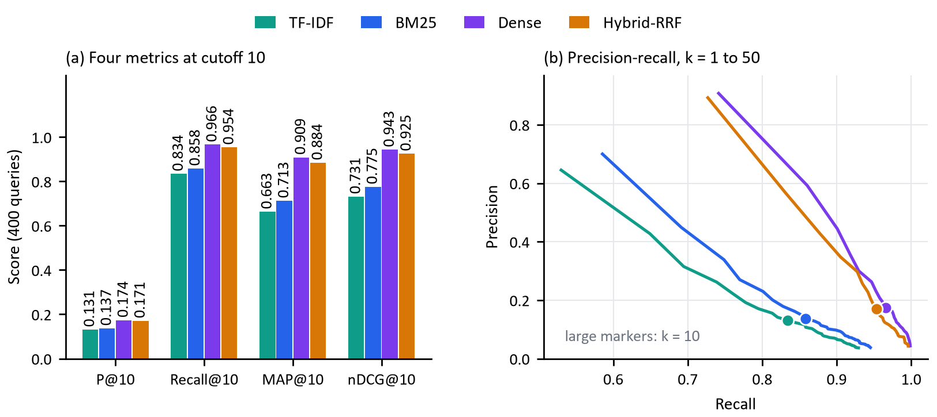
Figure 5: (a) The four metrics for each method. (b) Precision-recall curves for k = 1 to 50, averaged over the 400 queries; large markers show k = 10.
Segmented analysis. Table 7 splits the lexical models by query length; the TF-IDF and BM25 rows of Table 6 are the query-weighted means of these rows. TF-IDF is stronger on short queries (nDCG@10 0.7908) than on long ones (0.7247) while BM25 shows the opposite (0.7314 short, 0.7804 long). The reason for this difference was not tested, and with 40 short queries it is noisy. Figure 4 follows TF-IDF nDCG@10 through the designs of Section 3.4; the original figure is inflated by the 1.0 ties, and missing bars were not recorded. The per-text design's aggregate (0.6784) hid a short-query collapse to 0.3508. The final design beats the per-text design on both segments, and its aggregate 0.7314 matches the original 0.7274 without relying on ties.
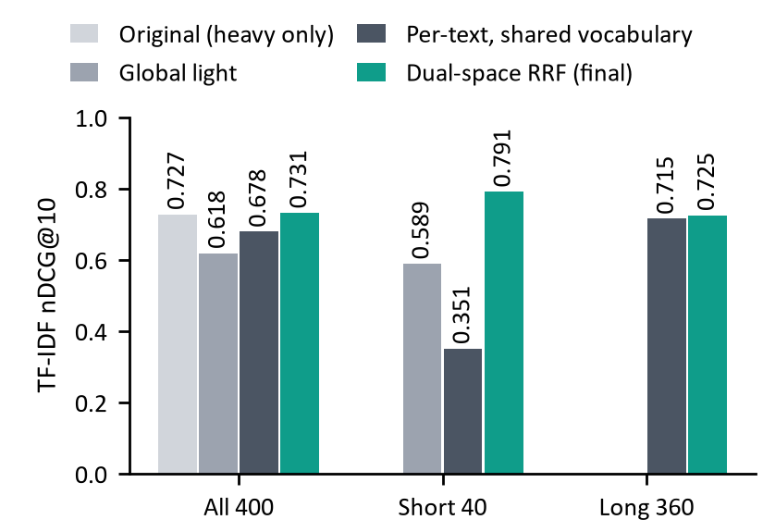  Figure 4: TF-IDF nDCG@10 by indexing design and query group. | Table 7. Lexical models by query length (cutoff 10).
  Model | Group | n | P@10 | R@10 | MAP | nDCG
  TF-IDF | Short | 40 | 0.1450 | 0.8389 | 0.7225 | 0.7908
  TF-IDF | Long | 360 | 0.1294 | 0.8335 | 0.6565 | 0.7247
  BM25 | Short | 40 | 0.1375 | 0.8198 | 0.6550 | 0.7314
  BM25 | Long | 360 | 0.1367 | 0.8625 | 0.7193 | 0.7804
Run time. Table 8 reports measured fit and per-query times.
Table 8. Approximate times from one CPU run (2026-09-27); Dense used cached embeddings.
Method | Fit time (s) | Mean time per query (s)
TF-IDF | 126 | 0.57
BM25 | 297 | 1.99
Dense | 0.8 | 0.035
Hybrid-RRF | - | 2.09

5. Conclusion
On the 400 evaluation queries, semantic similarity was the strongest single signal: Dense led on every metric, Hybrid-RRF came within 0.0180 nDCG@10 of it (0.9251 against 0.9431) while keeping an exact-match component, and BM25 beat TF-IDF. Dual-space indexing removed the 1.0 ties and gave TF-IDF a short-query nDCG@10 of 0.7908 (0.3508 under the per-text design) with long-query nDCG@10 at 0.7247. Evaluating by query length caught two regressions that aggregate metrics had hidden.
Limitations.
- Development-set figures. Design choices were made by inspecting these 400 queries with no separate development split, so the figures are probably optimistic. The rankers are unsupervised, so there is no training leakage.
- Unequal pools. Dense, and the dense side of the hybrid, search 100,000 questions; TF-IDF and BM25 search 537,929. This favours Dense and Hybrid-RRF by an unmeasured amount.
- Untuned and unswept. BM25 uses library defaults, k = 60 and the five-word threshold were not swept, segmentation covered only the lexical models, and the short group has 40 queries. Whether the pre-trained encoder saw QQP in training was not checked.
- Labels and cutoff. Unlabelled true duplicates count as non-relevant, and 13 queries have more than ten relevant documents, so Recall@10 cannot reach 1 for them.
- Speed. In one CPU run of the evaluation script (Table 8; approximate, from log timestamps, including top-50 ranking and scoring) BM25 took about 2.0 s per query and loading to fully fitted took 7.3 minutes, which is slow for interactive use.
Future work: a separate development split and equal-sized pools; weighted fusion and a k sweep; a cross-encoder re-ranker; tuned BM25 parameters and a character space for BM25; and significance tests.

References
1. Robertson, S., Zaragoza, H.: The Probabilistic Relevance Framework: BM25 and Beyond. Foundations and Trends in Information Retrieval 3(4), 333–389 (2009)
2. Reimers, N., Gurevych, I.: Sentence-BERT: Sentence Embeddings using Siamese BERT-Networks. In: Proceedings of EMNLP-IJCNLP, pp. 3982–3992. ACL (2019)
3. Cormack, G.V., Clarke, C.L.A., Buettcher, S.: Reciprocal Rank Fusion Outperforms Condorcet and Individual Rank Learning Methods. In: Proceedings of SIGIR, pp. 758–759. ACM (2009)
4. Iyer, S., Dandekar, N., Csernai, K.: First Quora Dataset Release: Question Pairs. Quora (2017)
5. Salton, G., Buckley, C.: Term-Weighting Approaches in Automatic Text Retrieval. Information Processing & Management 24(5), 513–523 (1988)
6. Porter, M.F.: An Algorithm for Suffix Stripping. Program 14(3), 130–137 (1980)
7. Johnson, J., Douze, M., Jégou, H.: Billion-Scale Similarity Search with GPUs. IEEE Transactions on Big Data 7(3), 535–547 (2021)
8. Wang, W., Wei, F., Dong, L., Bao, H., Yang, N., Zhou, M.: MiniLM: Deep Self-Attention Distillation for Task-Agnostic Compression of Pre-Trained Transformers. In: Advances in Neural Information Processing Systems 33, pp. 5776–5788 (2020)
9. Järvelin, K., Kekäläinen, J.: Cumulated Gain-Based Evaluation of IR Techniques. ACM Transactions on Information Systems 20(4), 422–446 (2002)

