Duplicate Question Retrieval on Quora Question Pairs: Sparse, Dense and Rank-Fusion Retrieval with Short-Text Vector Indexing
Students Name | Registration No. | Email-id
Siddhant Vashitha | 23FE10CSE00597 | SIDDHANT.23FE10CSE00597@muj.manipal.edu
Shams Ahmad Khan | 23FE10CSE00647 | SHAMS.23FE10CSE00647@muj.manipal.edu
Shreyansh Trivedi | 23FE10CSE00557 | SHREYANSH.23FE10CSE00557@muj.manipal.edu
Rishit Lathia | 23FE10CSE00680 | RISHIT.23FE10CSE00680@muj.manipal.edu

Abstract — This report treats duplicate-question detection as a search task on Quora Question Pairs. The collection has 537,929 unique questions, the answer key (qrels) has 298,526 duplicate judgements, and 400 randomly chosen questions are the test queries. We compare four methods: TF-IDF, BM25, a dense retriever built on a Sentence Transformer, and a hybrid that merges the BM25 and dense rankings with Reciprocal Rank Fusion (RRF). Standard text cleaning shrank some short questions to a single word, which gave many tied cosine scores of 1.0. A dual-space indexing scheme, which merges light, heavy and character-level rankings, removes these ties. Dense retrieval scores highest on all four metrics (nDCG@10 0.9431, MAP@10 0.9087), the hybrid is second (0.9251), and BM25 (0.7755) beats TF-IDF (0.7314). We made design choices by looking at these same queries, so the figures are development-set figures and are probably optimistic.
Keywords: Information Retrieval · Duplicate Question Detection · Short-Text Vector Indexing · BM25 · Sentence Transformers · Reciprocal Rank Fusion · Quora Question Pairs

1. Introduction
Question-answering sites collect many versions of the same question, which splits the answers across several threads. Finding a repeat is a search problem: the new question is the query, the earlier questions are the collection, and a document is relevant if annotators labelled it a duplicate. This differs from ordinary web search because queries and documents are both single short sentences, and relevance means the same intent, not just the same topic. For example, “Which smartphone should I buy under INR 15k?” and “…under INR 40000?” share almost every word but are not duplicates.
Sparse lexical retrieval scores each document by how many weighted words it shares with the query; TF-IDF [5] and BM25 [1] are the standard methods. It cannot see a paraphrase that shares few words, and text cleaning can remove most of a very short question. Dense retrieval turns each question into a vector using a bi-encoder such as Sentence-BERT [2] and ranks by vector similarity. It handles re-worded questions well, but needs an encoding step and can miss rare exact words. Hybrid retrieval merges the two rankings. Reciprocal Rank Fusion (RRF) [3] does this using ranks alone, so the scores need no adjusting.
This report turns QQP [4] into a search benchmark, compares four rankers on four metrics, describes a dual-space indexing scheme for short text that evaluation by query length showed to be necessary, and provides a Streamlit search interface.

2. About Dataset
QQP [4] is a set of question pairs, each with a yes/no label is_duplicate assigned by people. The file we used has 404,290 pairs, of which 149,263 are duplicates. It has no ready-made collection or relevance judgements, so we built them (counts in Table 1):
- Corpus: every distinct question, 537,929 in all.
- Qrels: each duplicate pair is stored in both directions, giving 298,526 (query, relevant document) rows over 149,650 query IDs. Non-duplicate pairs add no rows; those questions stay in the collection as distractors. A true duplicate that nobody labelled counts as not relevant.
- Evaluation queries: 400 questions picked at random (seed 42) from those that have a qrel; 40 have at most five words and 360 have more. They stay in the collection; only a document whose text is identical to the query is removed from its own results.
Table 1. Dataset statistics.
Quantity | Value | Quantity | Value
Raw question pairs | 404,290 | Query IDs with a qrel | 149,650
Labelled duplicates | 149,263 | Evaluation queries | 400
Corpus (unique questions) | 537,929 | Short / long (≤5 / >5 words) | 40 / 360
Qrel rows | 298,526 | Dense index (questions × dims) | 100,000 × 384

2.1 Dataset visualisation and examples
Questions are short (Figure 1a): the median is 10 words, and 8.2% have at most five. This is where text cleaning can erase most of the question (Section 3.4). Most evaluation queries have just one relevant document (294 of 400; mean 2.19, maximum 33; Figure 1b), which limits Precision@10 (Section 4). In Table 2, pair 1 is a paraphrase with little word overlap, pair 2 is a three-word question, and pair 3, which is not a duplicate, shares almost every word.
Table 2. Example pairs from the QQP file.
# | Question 1 | Question 2 | Dup.
1 | How do I speak English fluently? | How can I take my spoken English to a higher level when I speak good enough but not fluently? | Yes
2 | The loneliest number? | What is the loneliest number? | Yes
3 | Which smartphone should I buy under INR 15k? | Which smartphone should I buy under INR 40000? | No

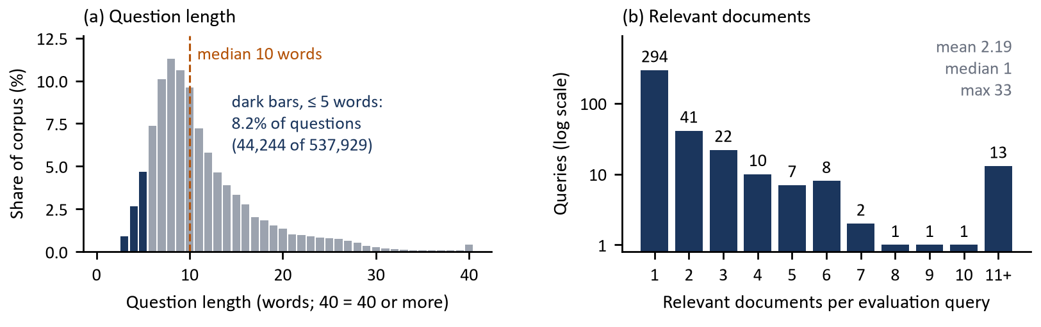
Figure 1: (a) Question length in the corpus, questions of at most five words in dark. (b) Relevant documents per evaluation query (log scale).

3. Methodology
All four rankers use the same interface and none is trained: the qrels are used only for scoring. Figure 2 shows the pipeline. The Search tab runs the retrievers live, while the comparison and precision-recall tabs read the saved evaluation results.
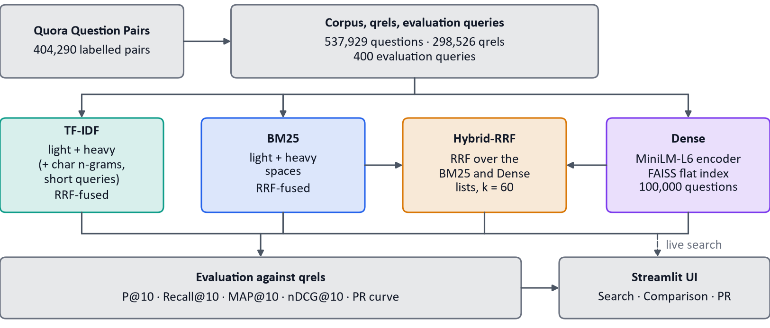
Figure 2: Pipeline. TF-IDF and BM25 each merge their internal spaces with RRF; Hybrid-RRF merges the BM25 and Dense lists (TF-IDF is not part of it).

3.1 Preprocessing and Indexing
Preprocessing makes the text lowercase, replaces punctuation with spaces, and splits it into words with NLTK word_tokenize. Heavy mode then removes common English stop-words and shortens words with the Porter stemmer [6]; light mode stops after splitting. A text counts as short if it has at most five words separated by spaces. TF-IDF and BM25 are built once over all 537,929 questions. TF-IDF keeps sparse document-term matrices (scikit-learn) and scores a query against every row. BM25 uses rank_bm25, which goes through every document's word counts for each query word. Neither uses an inverted index at query time. The dense retriever encodes the raw question into a 384-number unit vector stored in a FAISS IndexFlatIP. To keep encoding manageable, the dense index holds only 100,000 questions: the 400 queries and their relevant documents (1,276 questions in the run log) plus a random fill chosen with a fixed seed.

3.2 Ranking Models
Table 3 lists the design choices; the four models are described below.
Table 3. Design rationale. Spec = specified by the assignment; Ours = our own choice. None of the listed alternatives was evaluated.
Component | Origin | Chosen | Alternatives | Why
TF-IDF | Spec | scikit-learn TfidfVectorizer, cosine | Own inverted index (written, unused) | Specified. Sparse matrices give exact cosine over every question.
BM25 | Spec | rank_bm25 BM25Okapi, defaults | Tuned parameters, other variants | Specified. A maintained library saves us rewriting the scoring.
Dense encoder | Spec + ours | all-MiniLM-L6-v2, 384-d | Other encoders | Encoder type was specified; this model is small, free and runs on a CPU.
Vector index | Ours | FAISS IndexFlatIP on unit vectors | Approximate indexes | Exact cosine, no approximation error; 100,000 × 384 numbers take about 150 MB.
Fusion | Spec | RRF on ranks, k = 60 | Weighted fusion, learned re-ranker, other k | Ranks need no score adjusting between BM25 and cosine; a learned re-ranker needs labels, and our only labels are the ones used for testing.
Preprocessing | Spec + ours | NLTK, Porter; light and heavy modes | Other stemmers, lemmatisers | Steps were specified; heavy mode alone shrank short questions too much (Section 3.4).
Interface | Ours | Streamlit, three tabs | Other front ends | A Python app that gives search, a comparison table and a PR graph.
Metrics | Spec | P@10, Recall, MAP, nDCG at 10 | - | Specified; P@10 has a low maximum (Section 4), so the other three metrics carry the comparison.

TF-IDF [5] turns a text into a vector over words, using the weight below. Here tf is the word count, N is the number of questions, and df_{t} is the number of questions that contain word t (scikit-learn's smoothed form). Each vector is scaled to length 1 (L2-normalised), so similarity is the cosine. Rare words get more weight, which helps when a duplicate shares an unusual word.
$$w_{t,d} = {tf}_{t,d} · \left(\ln\left(\frac{1 + N}{1 + {df}_{t}}\right) + 1\right)$$ | $$\cos\left(q, d\right) = \frac{q · d}{\left\|q\right\|\left\|d\right\|}$$
BM25 [1] scores a document with the formula below. Here idf(t) = ln((N − n_{t} + 0.5)/(n_{t} + 0.5)), f_{t,d} is the word count, |d| is the document length and avgdl is the average length. k₁ limits the gain from repeated words, and b controls how much length is penalised. We use rank_bm25's BM25Okapi with its default values k₁ = 1.5 and b = 0.75 (not tuned); the library replaces a negative idf with 0.25 times the mean idf. BM25 scores have no upper limit, so they cannot be added to cosine scores.
$$BM25\left(q, d\right) = \sum_{t ∈ q}{idf\left(t\right) · \frac{f_{t,d} (k_{1} + 1)}{f_{t,d} + k_{1}\left(1 - b + b \frac{|d|}{avgdl}\right)}}$$
Dense retrieval turns each question into a unit vector f(x) with all-MiniLM-L6-v2 [2, 8] and ranks by cosine, sim(q, d) = f(q)·f(d), using exact FAISS search [7]. Because it compares meaning instead of words, it can match a re-worded duplicate. Hybrid-RRF applies RRF (Section 3.3) to two lists of 100 documents: the output of the BM25 ensemble and the dense list. TF-IDF is not included. The BM25 list is itself an RRF merge of its light and heavy spaces, so the hybrid is RRF over an RRF-merged list, and its dense side searches the same 100,000-question index.

3.3 Reciprocal Rank Fusion Formulation
RRF gives each document a score by adding up, over every ranked list M that contains it, one divided by (k plus its rank). Here rank_{m}(d) is the position of d in list m, counting from 1; a list that does not contain d adds nothing:
$$RRF\left(d\right) = \sum_{m ∈ M}{\frac{1}{k + {rank}_{m}\left(d\right)}}, k = 60$$
Only positions are used, so lists from different scorers need no adjusting. The constant k = 60 (the value given in the assignment, also used in [3]) stops one first place from outweighing agreement between lists. Table 4 scores example ranks with the project's own function: document E, at rank 5 in both lists, beats D, at rank 2 in only one. The same function does the merging inside TF-IDF, inside BM25 and in the hybrid.
Table 4. RRF worked example (example ranks, k = 60).
Doc | BM25 rank | Dense rank | RRF score | Fused rank
A | 1 | 3 | 0.0323 | 2
B | 2 | 1 | 0.0325 | 1
C | 3 | - | 0.0159 | 5
D | - | 2 | 0.0161 | 4
E | 5 | 5 | 0.0308 | 3

3.4 Short-Text Vector Indexing
Short-text vector indexing means building representations that still carry enough information when a question has only a few words. Heavy preprocessing can shrink a short question to one word or none: “What is the google?” becomes [googl] (Figure 3, top lane), and six of the 40 short evaluation queries shrank to zero or one word. Many documents were reduced to the same one-dimensional vector, so different questions tied at cosine 1.0 and their order was arbitrary.
We tried two designs and rejected both, based on evaluation split by query length (Table 7 and Figure 4, Section 4). Global light mode (no stop-word removal or stemming for any text) removed the ties but lowered TF-IDF on long queries below its original level, even though long queries had not been affected by the problem. Per-text mode selection (light for short texts, heavy for long ones, inside one shared vocabulary) fixed long queries but broke the vocabulary: a short query kept “geographic” while its longer duplicate was stemmed to “geograph”, and bigrams (word pairs) existed only on the query side.
The design we adopted is dual-space indexing with rank fusion. Every question is indexed in separate spaces over the whole collection: light (plain words plus word pairs), heavy (stemmed single words, stop-words removed) and, for TF-IDF only, groups of 3 to 5 characters within words, used only for queries of at most five words. A query is processed in each space in exactly the same way as that space's documents. Each space returns up to 100 documents, and the lists are merged with the RRF formula above (Figure 3). BM25 uses its light and heavy spaces for every query. Inside one space, query and documents are split into words in the same way, which removes the mismatch. The five-word threshold was chosen by looking at the data, not tuned.
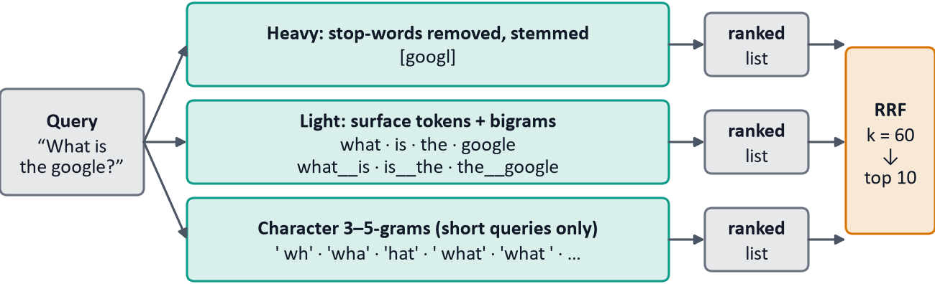
Figure 3: Dual-space indexing for the TF-IDF query “What is the google?”; BM25 uses the first two lanes.

4. Experimental Setup and Performance Analysis
Setup and metrics. The 400 evaluation queries are run through all four rankers, looking at the top 10 results (top 50 for the PR curves). Nothing is trained on the qrels. The queries stay in the collection, and only a document with identical text is removed. The short-text design (Section 3.4) was chosen by looking at these same queries, with no separate development split, so all figures are development-set figures and are probably optimistic. In Table 5, R is the set of relevant documents for the query, T₁₀ is its top ten, and rel_{i} ∈ {0, 1} says whether the document at rank i is relevant. AP is divided by |R| instead of min(10, |R|), which gives a lower value than the usual convention for the 13 queries with more than ten relevant documents.
Table 5. Metric definitions as implemented (cutoff 10).
Metric | Definition
P@10 | |R ∩ T₁₀| / 10
Recall@10 | |R ∩ T₁₀| / |R|
AP@10 (MAP@10 = mean over queries) | (1 / |R|) · Σ_{i=1..10} P@i · rel_{i}
nDCG@10 [9] | DCG@10 / IDCG@10, with DCG@10 = Σ_{i=1..10} rel_{i} / log₂(i + 1); IDCG@10 is the DCG@10 of the ideal ranking (min(10, |R|) relevant first)

Precision ceiling. The qrels limit Precision@10. A perfect ranker scores min(|R|, 10)/10 on each query, and the mean of this over the 400 queries is 0.184. The looser bound 2.19/10 ≈ 0.22 ignores that 13 queries have more than ten relevant documents. Dense retrieval's 0.1738 is 94% of the exact ceiling.
Table 6. Retrieval performance on the 400 evaluation queries (cutoff 10). Best per column in bold.
Ranking Model | P@10 | Recall@10 | MAP@10 | nDCG@10
TF-IDF | 0.1310 | 0.8341 | 0.6631 | 0.7314
BM25 | 0.1368 | 0.8582 | 0.7129 | 0.7755
Dense | 0.1738 | 0.9659 | 0.9087 | 0.9431
Hybrid-RRF | 0.1708 | 0.9535 | 0.8843 | 0.9251

Overall results (Table 6, Figure 5a; precision-recall curves in Figure 5b). Dense retrieval is best on every metric (nDCG@10 0.9431, MAP@10 0.9087, Recall@10 0.9659). Hybrid-RRF is second on every metric (nDCG@10 0.9251), and BM25 beats TF-IDF on all four (nDCG@10 0.7755 against 0.7314). At k = 1 precision is 0.9075 (Dense), 0.8925 (Hybrid-RRF), 0.7000 (BM25) and 0.6450 (TF-IDF), so Dense puts a duplicate first for about nine of ten queries. In Figure 5b the order Dense, Hybrid-RRF, BM25, TF-IDF holds for both precision and recall at every k from 1 to 50, and the k = 10 markers match the P@10 and Recall@10 columns of Table 6. At k = 50 recall is 0.999 (Dense) but only 0.945 (BM25) and 0.929 (TF-IDF).
A likely reason for Dense's lead is that duplicates are paraphrases and the encoder captures meaning; no ablation tested this. Dense also searches an index 5.4 times smaller (100,000 against 537,929 questions), which favours it and the hybrid by an unmeasured amount. Hybrid-RRF is below Dense, perhaps because equal-weight RRF lets the weaker BM25 list pull down the dense list; this was not tested.
Segmented analysis. Table 7 splits the lexical models by query length; the TF-IDF and BM25 rows of Table 6 are the query-weighted averages of these rows. TF-IDF does better on short queries (nDCG@10 0.7908) than on long ones (0.7247), while BM25 does the opposite (0.7314 short, 0.7804 long). We did not test why, and with only 40 short queries the difference may be noise. Figure 4 follows TF-IDF nDCG@10 through the designs of Section 3.4; the original figure is inflated by the 1.0 ties. The per-text design's overall score (0.6784) hid a collapse to 0.3508 on short queries. The final design beats the per-text design on both groups; its overall score of 0.7314 is within 0.004 of the original 0.7274, but without the 1.0 ties behind it.
Table 7. Lexical models by query length (cutoff 10).
Model | Group | n | P@10 | Recall@10 | MAP@10 | nDCG@10
TF-IDF | Short | 40 | 0.1450 | 0.8389 | 0.7225 | 0.7908
TF-IDF | Long | 360 | 0.1294 | 0.8335 | 0.6565 | 0.7247
BM25 | Short | 40 | 0.1375 | 0.8198 | 0.6550 | 0.7314
BM25 | Long | 360 | 0.1367 | 0.8625 | 0.7193 | 0.7804

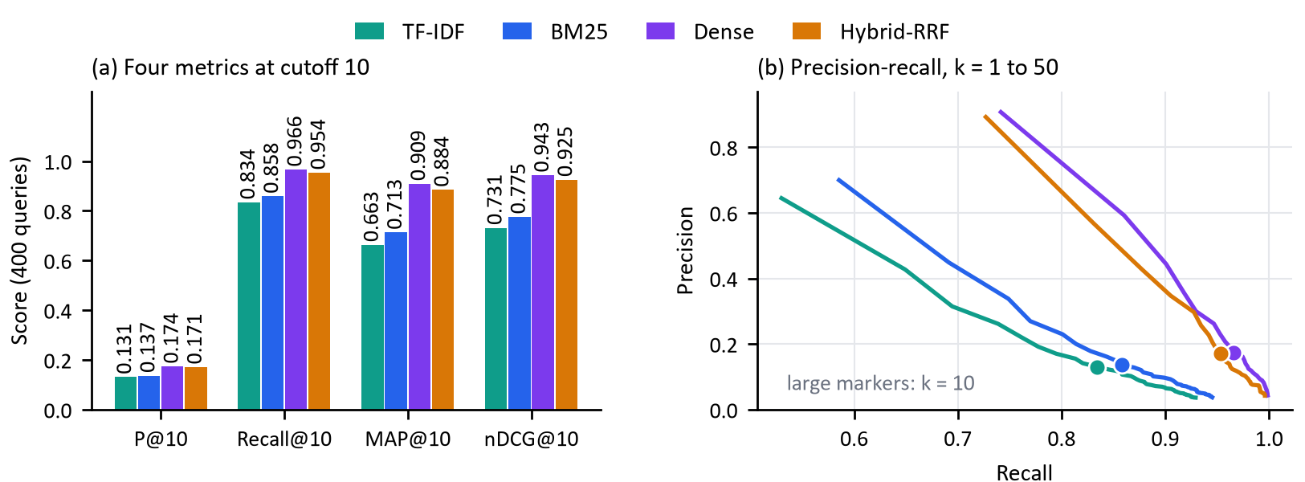
Figure 5: (a) The four metrics for each method. (b) Precision-recall curves for k = 1 to 50, averaged over the 400 queries; large markers show k = 10.
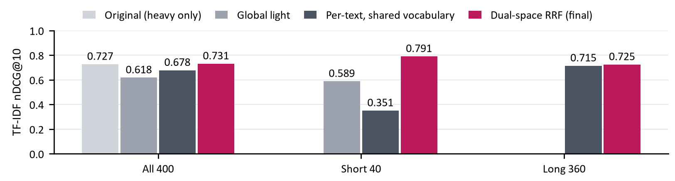
Figure 4: TF-IDF nDCG@10 by indexing design and query group; missing bars were not recorded.

5. Conclusion
On the 400 evaluation queries, similarity of meaning was the strongest single signal: Dense led on every metric, Hybrid-RRF came within 0.0180 nDCG@10 of it (0.9251 against 0.9431) while keeping an exact-match component, and BM25 beat TF-IDF. Dual-space indexing removed the 1.0 ties and gave TF-IDF a short-query nDCG@10 of 0.7908 (0.3508 under the per-text design).
Limitations.
- Development-set figures. We made design choices by looking at these 400 queries, with no separate development split, so the figures are probably optimistic. The rankers are unsupervised: nothing is trained on the qrels.
- Unequal pools. Dense, and the dense side of the hybrid, search 100,000 questions; TF-IDF and BM25 search 537,929. This favours Dense and Hybrid-RRF by an unmeasured amount.
- Untuned and unswept. BM25 uses library defaults. We did not test other values of k (60) or of the five-word threshold. The analysis by query length covered only the lexical models, and the short group has just 40 queries.
- Encoder training data. The model card of all-MiniLM-L6-v2 lists Quora Question Triplets (103,663) among its fine-tuning data, so Dense may have seen related pairs; we did not measure the overlap with our queries.
- Labels and cutoff. True duplicates that nobody labelled count as not relevant, and 13 queries have more than ten relevant documents, so Recall@10 cannot reach 1 for them.
- Speed. Approximate figures from the log of one CPU run (2026-09-27; Dense used saved embeddings; per-query times include ranking the top 50): fitting took 126 s for TF-IDF, 297 s for BM25 and 0.8 s for Dense, and the mean time per query was 0.57 s (TF-IDF), 1.99 s (BM25), 0.035 s (Dense) and 2.09 s (Hybrid-RRF); start-up took 7.3 minutes, which is slow for interactive use.
Future work: a separate development split, equal-sized pools, tests of other values of k, a re-ranker and tuned BM25.

References
1. Robertson, S., Zaragoza, H.: The Probabilistic Relevance Framework: BM25 and Beyond. Found. Trends Inf. Retr. 3(4), 333–389 (2009)
2. Reimers, N., Gurevych, I.: Sentence-BERT: Sentence Embeddings using Siamese BERT-Networks. In: Proceedings of EMNLP-IJCNLP, pp. 3982–3992. ACL (2019)
3. Cormack, G.V., Clarke, C.L.A., Buettcher, S.: Reciprocal Rank Fusion Outperforms Condorcet and Individual Rank Learning Methods. In: Proceedings of SIGIR, pp. 758–759. ACM (2009)
4. Iyer, S., Dandekar, N., Csernai, K.: First Quora Dataset Release: Question Pairs. Quora (2017)
5. Salton, G., Buckley, C.: Term-Weighting Approaches in Automatic Text Retrieval. Information Processing & Management 24(5), 513–523 (1988)
6. Porter, M.F.: An Algorithm for Suffix Stripping. Program 14(3), 130–137 (1980)
7. Johnson, J., Douze, M., Jégou, H.: Billion-Scale Similarity Search with GPUs. IEEE Transactions on Big Data 7(3), 535–547 (2021)
8. Wang, W., Wei, F., Dong, L., Bao, H., Yang, N., Zhou, M.: MiniLM: Deep Self-Attention Distillation for Task-Agnostic Compression of Pre-Trained Transformers. In: NeurIPS 33, pp. 5776–5788 (2020)
9. Järvelin, K., Kekäläinen, J.: Cumulated Gain-Based Evaluation of IR Techniques. ACM TOIS 20(4), 422–446 (2002)

