Algorithm Performance Measurement and Benchmarking Tool
Lab Assignment 2: Final Report
Field | Detail
School | School of Engineering & Technology
Department | SOET
Program / Semester | BCA (AI&DS), Semester V, Session 2026-27
Course | ENCA351 Design and Analysis of Algorithms Lab
Faculty | Dr. Aarti
Student name | Shreyansh Vaibhaw
Roll number | 2401201094
GitHub repository | algorithm-performance-tool-shreyansh
Reference run | 2026-09-28 11:22:50, CPython 3.12.10, Windows-11-10.0.26200-SP0

1. Introduction

1.1 Importance of algorithm analysis
An algorithm that feels instant on a test file can stall on production data. Algorithm analysis exists to predict that before it happens. It describes how running time and memory grow with the input size n, in classes such as O(log n), O(n) and O(n squared), and it does so without reference to a particular machine or language. That independence is the point: the class tells us that an O(n squared) routine will take about a hundred times longer when its input grows tenfold, on any computer, forever.
The same independence is also the limitation. Big-O notation hides constant factors and machine effects on purpose, so it cannot say how many milliseconds a call will take on a given laptop, whether a function that is O(n) in theory has been implemented that way, or whether an assumption baked into the analysis, such as constant-time arithmetic, actually holds for the data at hand.

1.2 Need for performance measurement
Measurement fills that gap. Running the code at several input sizes and recording time, memory and the number of basic operations shows the constants theory hides, confirms or contradicts the predicted growth, and exposes hidden costs. In this project one such cost turned out to matter: Python integers have arbitrary precision, so the n multiplications inside a factorial do not take constant time once the running product has hundreds of digits.
Measuring well is harder than it looks. A timer has finite resolution, one run of a microsecond function is mostly noise, garbage collection can fire in the middle of a measurement, and a memory profiler changes the program it profiles. Part of the work in this assignment was getting those details right and documenting them, so that the numbers in this report mean what they appear to mean.

1.3 Objectives and scope
- Build a Python tool that executes a chosen algorithm or code snippet at a chosen input size and reports execution time, memory usage and operation counts.
- Compare linear search with binary search on datasets of 100 to 50,000 records (Task 2).
- Compare four program structures: single loop, nested loop, recursive factorial and iterative factorial (Task 3).
- Automate the experiments across the assignment's input sizes and record every measurement (Task 4).
- Chart the results, fit the observed growth trend and set it against the theoretical complexity (Tasks 5 and 6).
- Discuss which implementations perform better, how input size affects them, and the time-space trade-offs involved (Task 7).
The tool is written in Python 3 with Streamlit for the web interface, pandas for tables, matplotlib for charts, tracemalloc and memory_profiler for memory, and Jupyter for the notebook. All code, results, charts and this report are in the GitHub repository named on the cover page.

2. Tool design and measurement method

2.1 Architecture
The project is split into small modules with one job each. The Streamlit app and the notebook are thin layers over the same functions, so an experiment run from the command line, from the notebook and from the web page produces the same kind of record.
File | Responsibility
search_analysis.py | Linear and binary search that count key comparisons; dataset generation with a fixed seed; worst-case key selection.
code_benchmark.py | The four code snippets. Each returns its value and the number of basic operations implied by its structure.
benchmark_engine.py | Timing, memory measurement, the Measurement record, the automated suite across input sizes, CSV output.
complexity_analysis.py | Theoretical table, power-law fit of time against n (the observed growth exponent), theory-versus-observed table.
visualization.py | matplotlib charts with one fixed colour per algorithm, and plain-language trend summaries.
app.py | Streamlit web app with one page per task.
run_benchmarks.py | One command that runs the suite and writes results/, graphs/ and the complexity table.
project_notebook.ipynb | The whole study as an executed Jupyter notebook.

2.2 Measuring execution time
- Timer. time.perf_counter() is read immediately before and after the call. It is the highest-resolution monotonic clock Python offers.
- Repetition. Fast functions are called repeatedly until at least five samples covering 50 ms of total time exist; the median is reported. A 3 s budget stops the loop early, so a function that takes minutes runs once. Binary search was timed 1,000 times per size, the largest nested loop once.
- Garbage collection is paused while timing, as Python's own timeit module does, so a collection cycle cannot land inside a sample.
- Argument construction happens before the clock starts. Generating a 50,000-element dataset is not part of a search's time.

2.3 Measuring memory
Memory is measured with tracemalloc, which hooks every allocation the Python interpreter makes and reports the peak amount of heap memory in use. The engine records the peak extra memory allocated during one call, relative to the level just before it, so the numbers are the algorithm's own footprint plus its returned result.
Two decisions follow from how tracemalloc works.
- Timing and tracing are separate runs. Tracing every allocation slowed the loop snippets by 24x to 60x on the test machine. A time measured while tracing describes the profiler, not the algorithm, so the engine times first without tracing and then traces a second, untimed run.
- Traces that would take hours are skipped. The engine multiplies the untraced time by the measured overhead factor to predict the traced time. When that exceeds a 30 s budget it records "not measured" and the reason. This happened for the nested loop at 10,000 and 50,000 iterations: tracing the 2.5 billion allocations of the largest case would have taken about three hours. Its O(1) memory is confirmed at 100 and 1,000 iterations, where the trace is affordable.
tracemalloc sees Python heap objects, not the interpreter's call frames, which live in a separate stack area. For the recursive factorial this matters: the O(n) stack shows up indirectly, through the one integer argument each open frame keeps alive, so the true cost of recursion is larger than the traced number. The tool also offers memory_profiler as a second backend. It samples the whole process's resident set size through psutil at page granularity, which is what a task manager would show, and it reports zero growth for most of these small algorithms.

2.4 Counting operations
- Linear search: one comparison per element examined.
- Binary search: one comparison per probe of the middle element. A probe needs an equality test and an ordering test in Python, but algorithmically it is one three-way comparison, the usual textbook convention.
- Loops: one operation per iteration of the innermost loop (n for the single loop, n squared for the nested loop).
- Factorials: n recursive calls, or n - 1 multiplications. These counts follow exactly from the structure of the snippet, so they are derived from n rather than counted with an extra variable that would slow the timed code.

2.5 Experimental setup
Item | Setting
Machine | Intel64 Family 6 Model 142 Stepping 12, GenuineIntel, 8 logical CPUs
Operating system | Windows-11-10.0.26200-SP0
Python | CPython 3.12.10
Search datasets | Distinct integers, sorted, seed 42; sizes 100, 1,000, 10,000 and 50,000
Search key | -1, which is never present: the worst case for both algorithms
Factorial inputs | n = 100, 500 and 1,000 (the recursion limit is raised for n = 1,000)
Loop inputs | n = 100, 1,000, 10,000 and 50,000 iterations
Command | python run_benchmarks.py, one process, no other load

3. Experimental results
All numbers below come from the reference run saved in results/benchmark_results.csv. Times are medians of the repeated runs described in section 2.2; memory is the tracemalloc peak from a separate run.

3.1 Search algorithms
Table 1 shows both searches on the same sorted datasets with an absent key. Linear search's time grew 970x while the dataset grew 500x; binary search's grew 1.4x.
n | Linear: time | Linear: comparisons | Linear: memory | Binary: time | Binary: comparisons | Binary: memory
100 | 10.5 us | 100 | 288 bytes | 3.6 us | 6 | 288 bytes
1,000 | 196.7 us | 1,000 | 376 bytes | 3.4 us | 9 | 316 bytes
10,000 | 1.66 ms | 10,000 | 376 bytes | 4.9 us | 13 | 316 bytes
50,000 | 10.18 ms | 50,000 | 376 bytes | 5.0 us | 15 | 316 bytes
Table 1. Search results for an absent key (worst case).
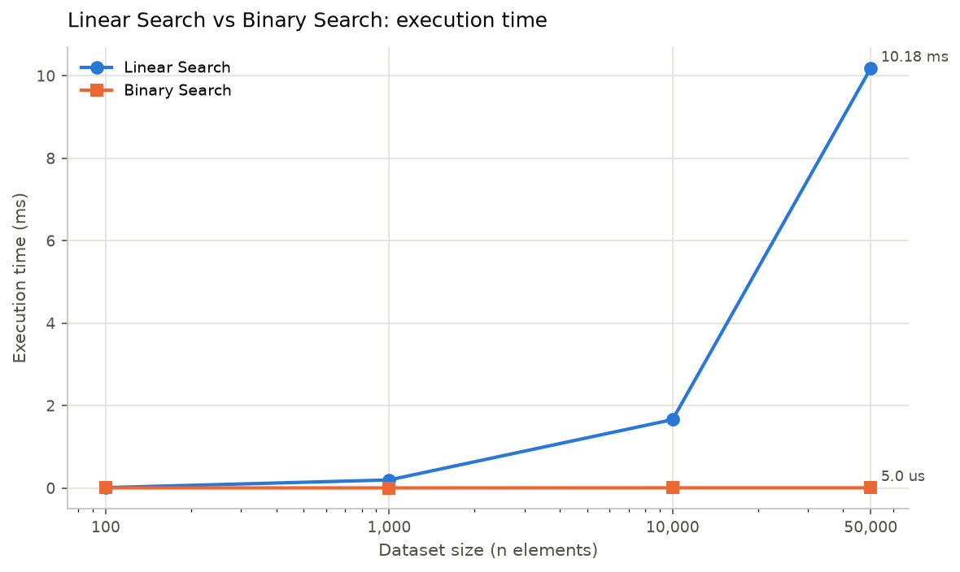
Figure 1. Dataset size against execution time, linear axes. Binary search is flat at a few microseconds.
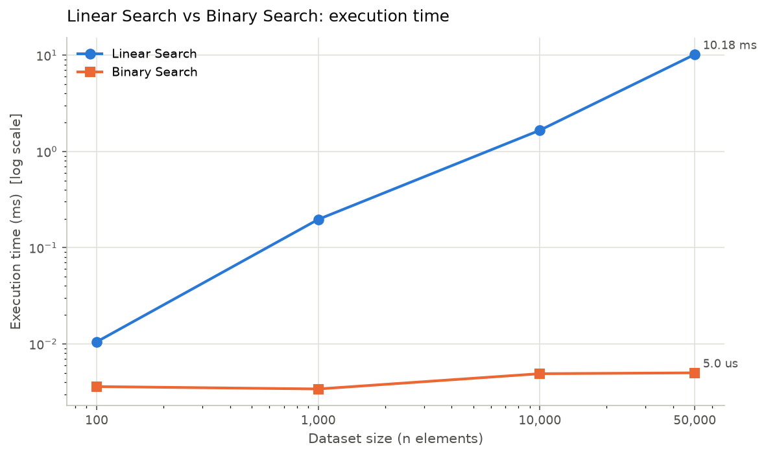
Figure 2. The same data with a logarithmic time axis, which makes both trends visible.
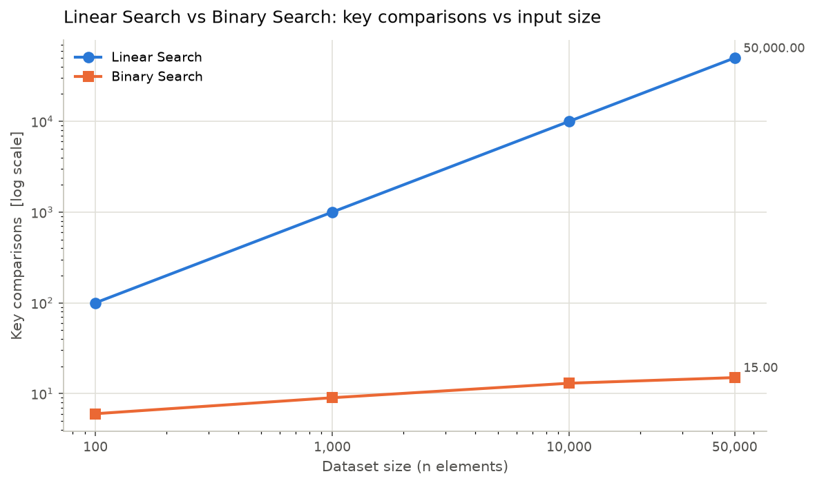
Figure 3. Key comparisons against dataset size. Linear search needs n; binary search needs floor(log2 n) + 1.
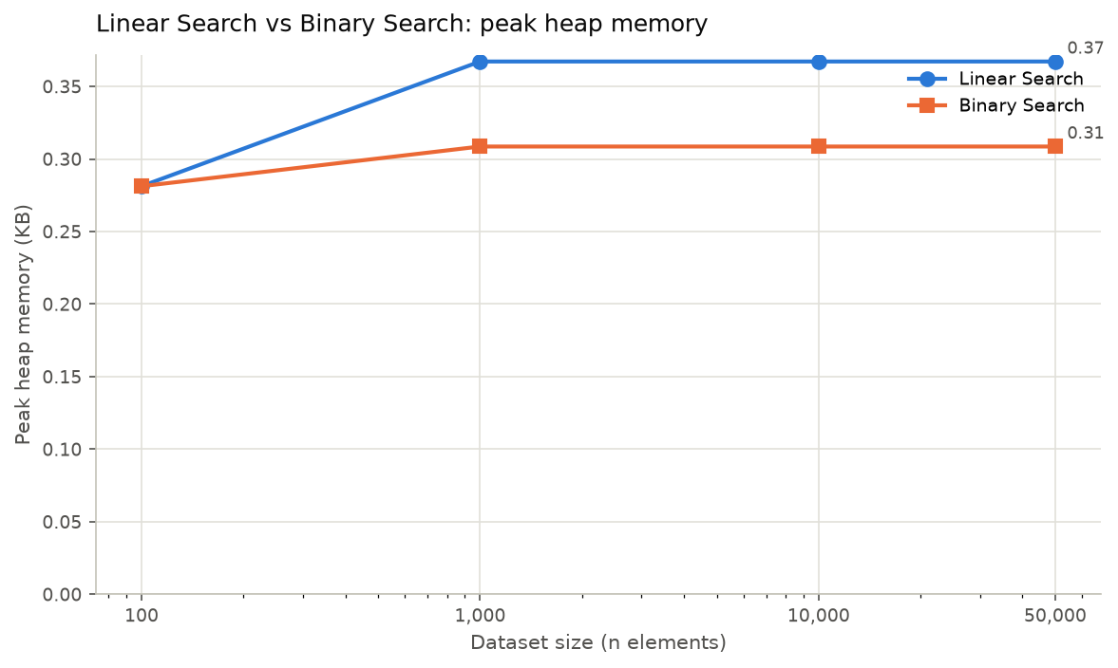
Figure 4. Peak heap memory. Both searches use a few hundred bytes regardless of n.

3.2 Factorial programs
Table 2 compares the two factorial implementations. At n = 1,000 the recursive version took 1.24x as long as the loop and peaked at 23.77 KB of heap against 2.39 KB.
n | Recursive: time | Recursive: memory | Iterative: time | Iterative: memory | Time ratio (rec / iter)
100 | 21.0 us | 324 bytes | 14.3 us | 324 bytes | 1.47x
500 | 228.2 us | 8.14 KB | 160.9 us | 1.15 KB | 1.42x
1,000 | 692.0 us | 23.77 KB | 558.5 us | 2.39 KB | 1.24x
Table 2. Recursive against iterative factorial.
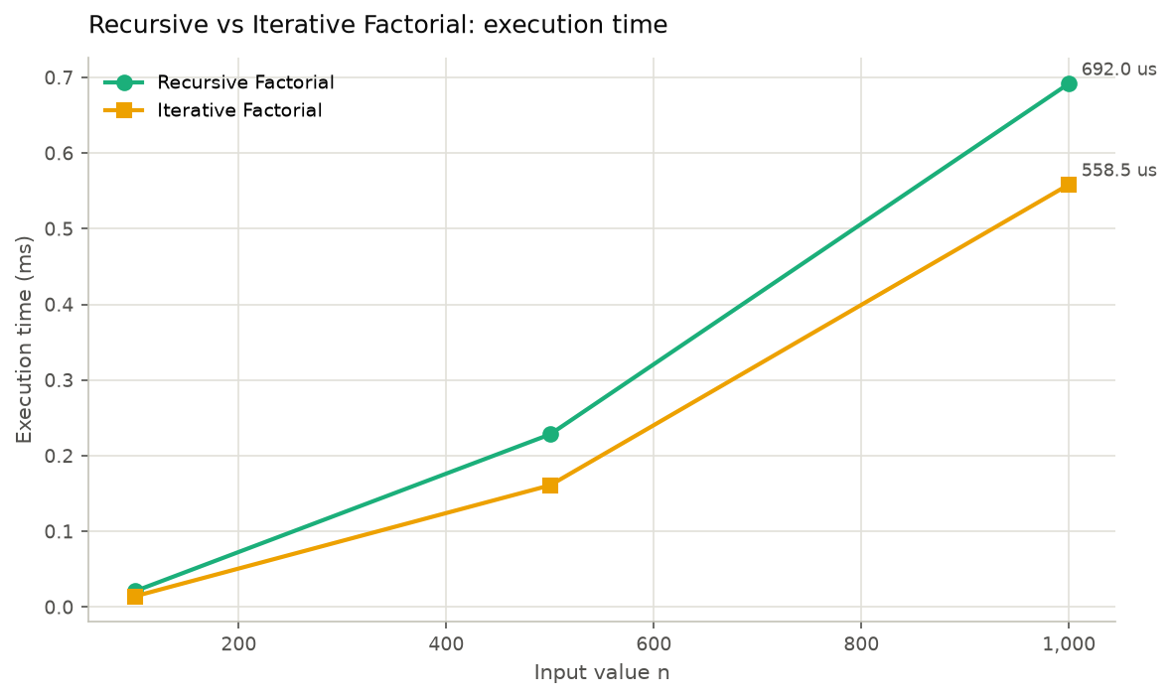
Figure 5. Input n against execution time for the two factorial versions.
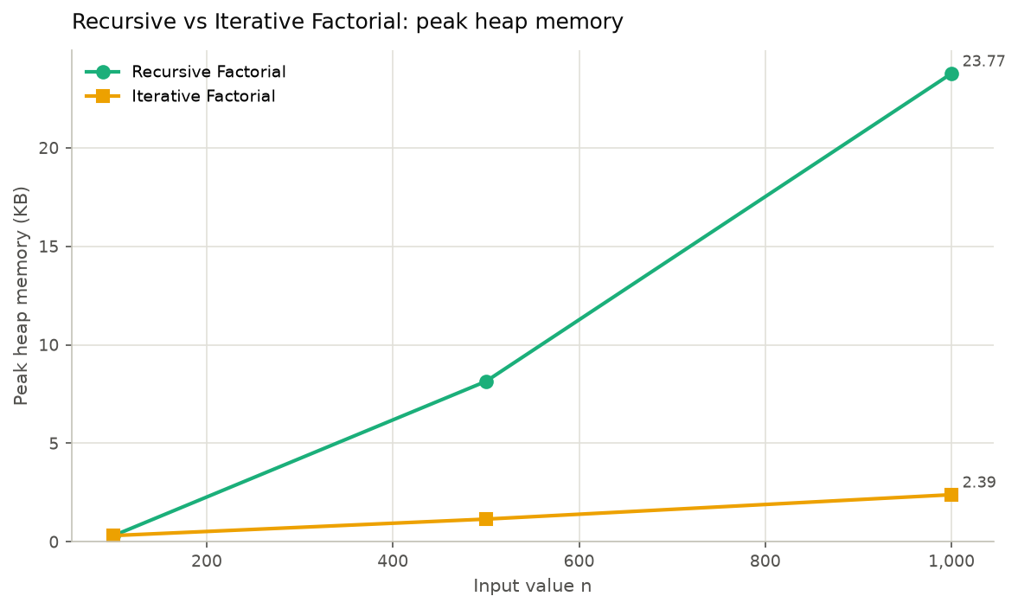
Figure 6. Peak heap memory. The recursive version grows linearly with n; the loop's growth is the size of n! itself.

3.3 Loop-based programs
Table 3 compares the single and nested loops. At n = 50,000 the nested loop performed 2,500,000,000 inner iterations and took 328.99 s, against 4.44 ms for the single loop: a ratio of 74,068x.
n | Single: time | Single: memory | Nested: time | Nested: memory | Nested: inner iterations
100 | 7.0 us | 256 bytes | 691.1 us | 256 bytes | 10,000
1,000 | 78.4 us | 288 bytes | 80.21 ms | 320 bytes | 1,000,000
10,000 | 866.2 us | 288 bytes | 8.85 s | not traced | 100,000,000
50,000 | 4.44 ms | 292 bytes | 328.99 s | not traced | 2,500,000,000
Table 3. Single against nested loop traversal. Memory for the nested loop at 10,000 and 50,000 was not traced (section 2.3).
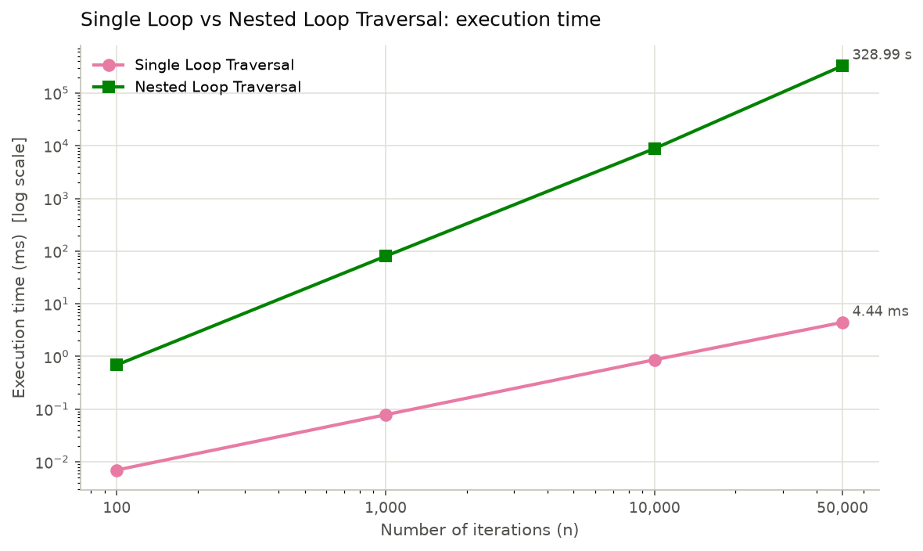
Figure 7. Iterations against execution time, logarithmic time axis. The nested loop's line is twice as steep.
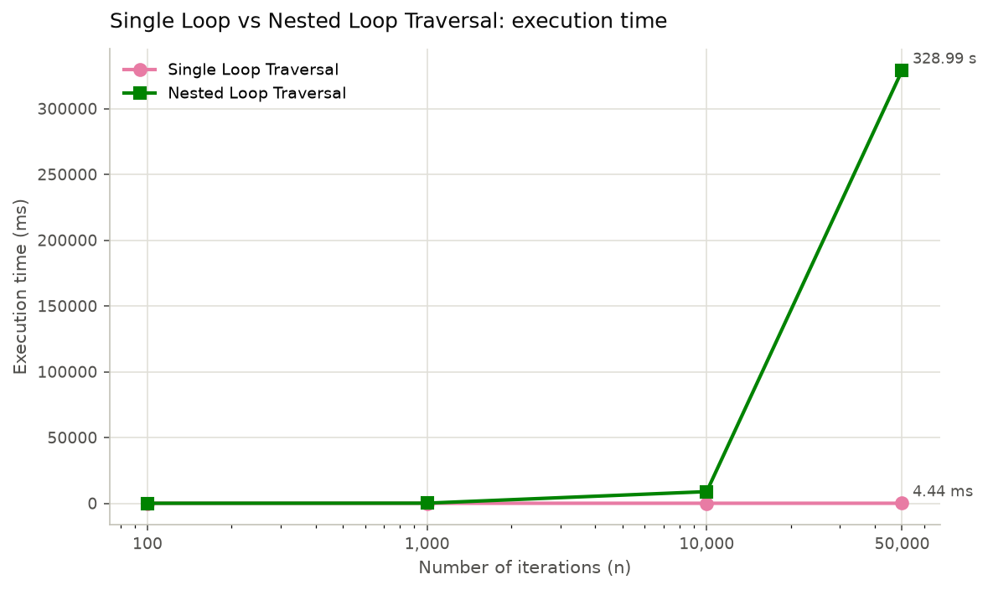
Figure 8. The same data on linear axes; the single loop is invisible next to the nested loop.
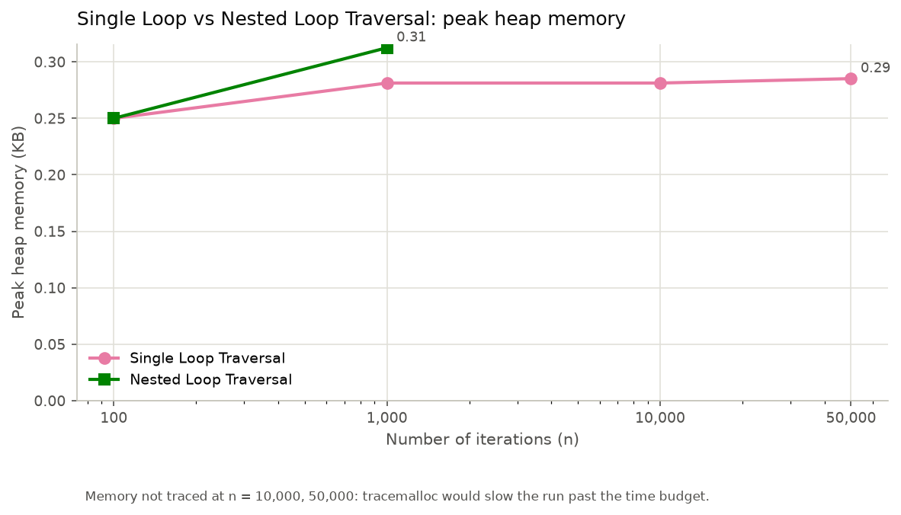
Figure 9. Peak heap memory for the loops at the sizes where tracing was affordable.

3.4 All algorithms together
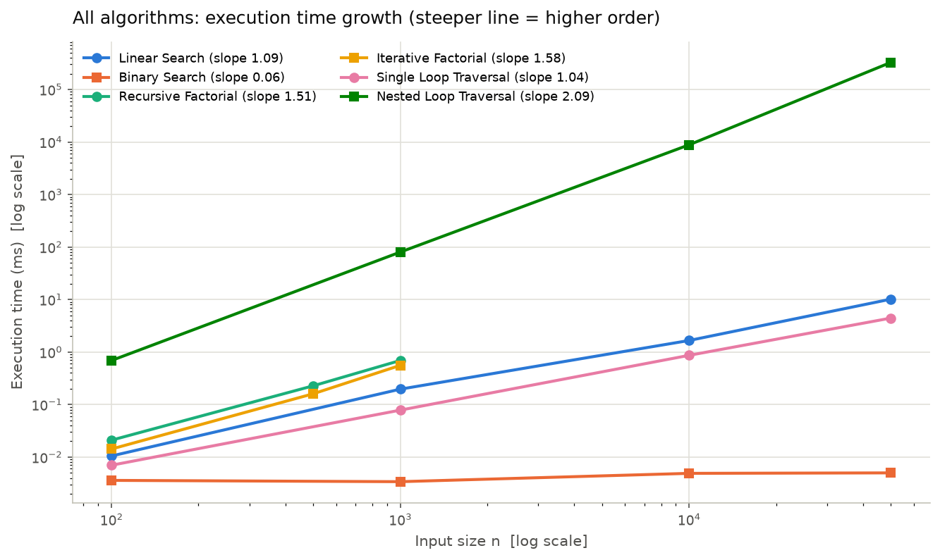
Figure 10. Every algorithm on log-log axes. A power law is a straight line whose slope is the growth exponent.

3.5 Screenshots of the tool
The Streamlit application, started with streamlit run app.py. Each page corresponds to one task of the assignment.
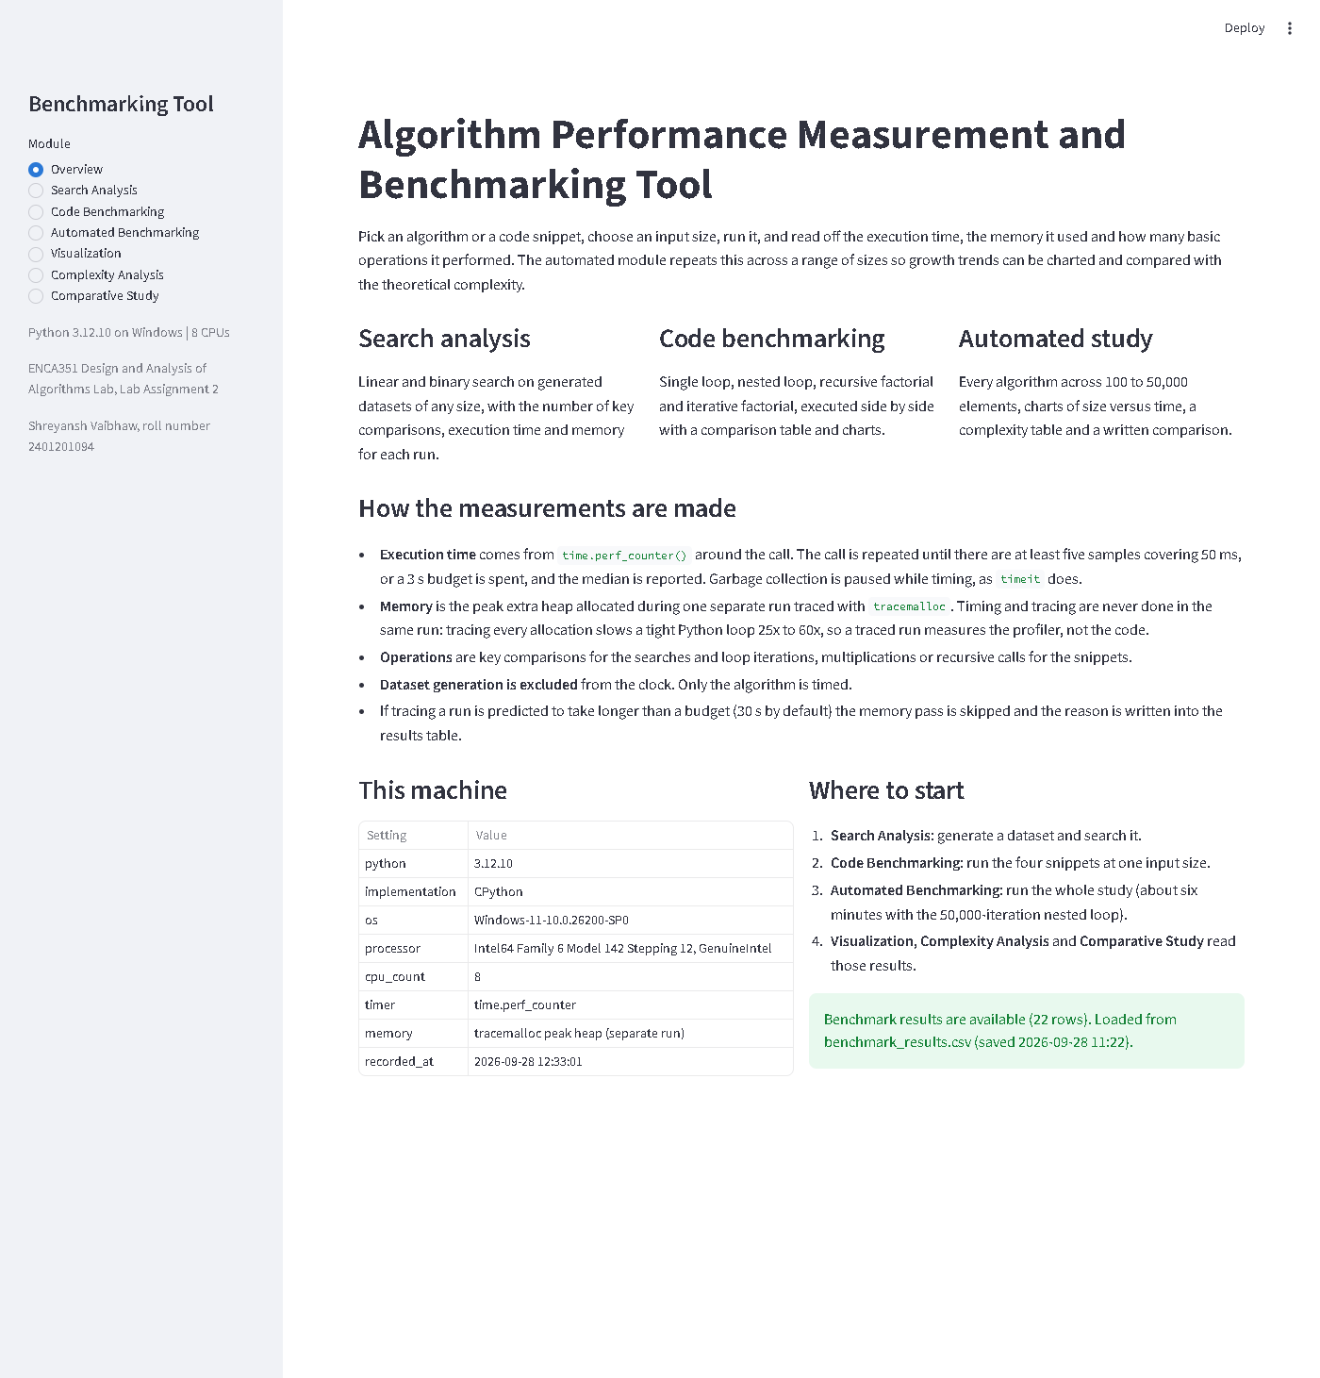
Figure 11. Overview page: what the tool measures and how.
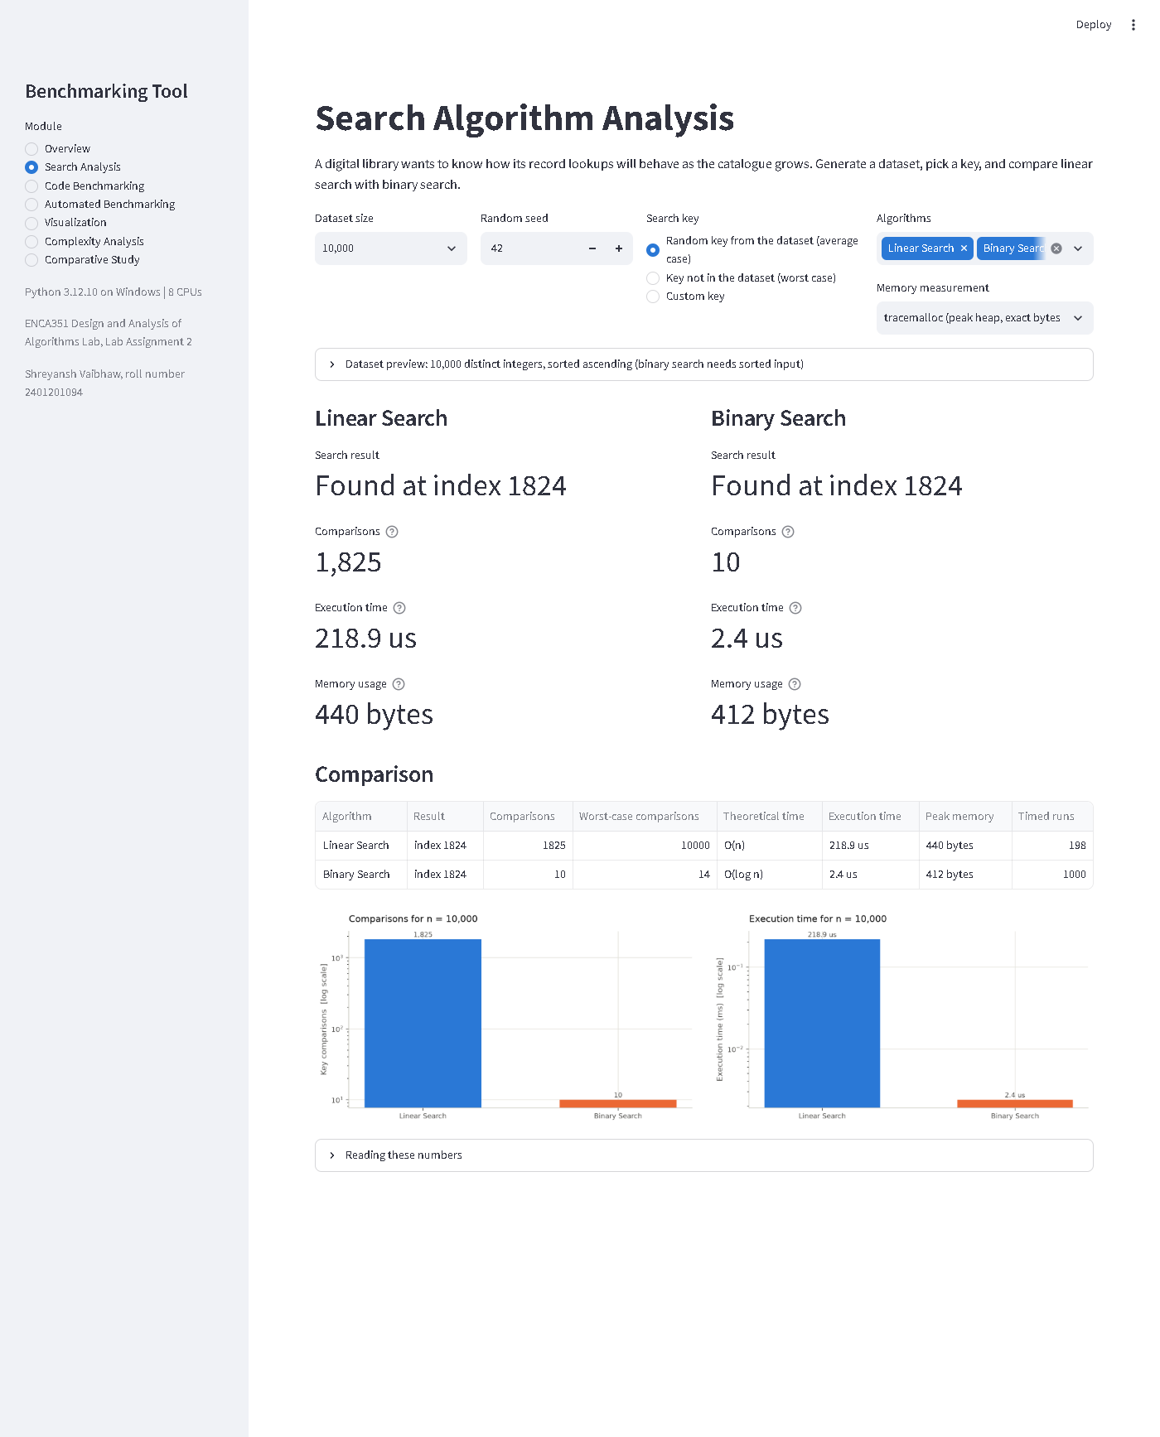
Figure 12. Search analysis page: dataset generation, key choice, and both searches with comparisons, time and memory.
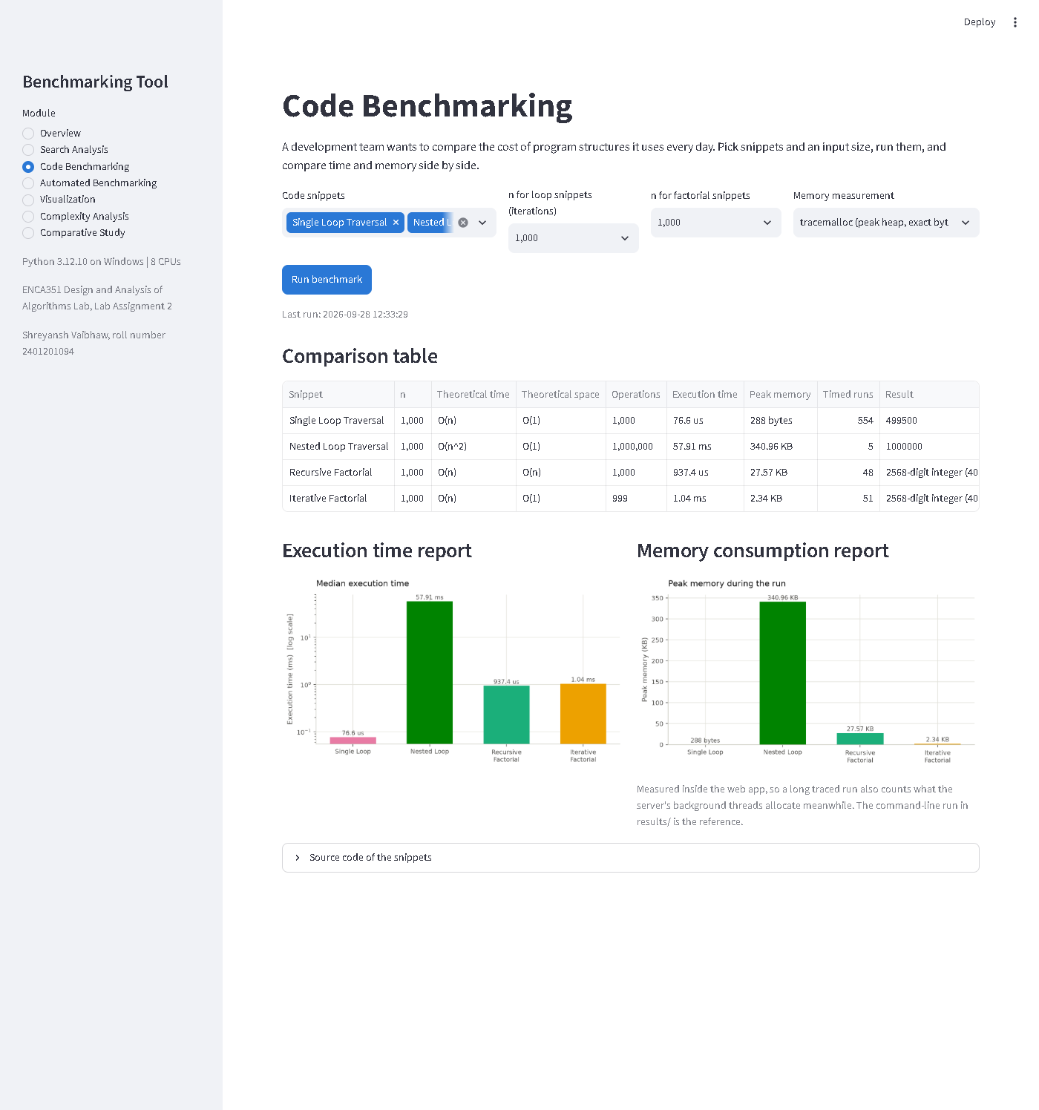
Figure 13. Code benchmarking page: the four snippets with the comparison table and the time and memory reports.
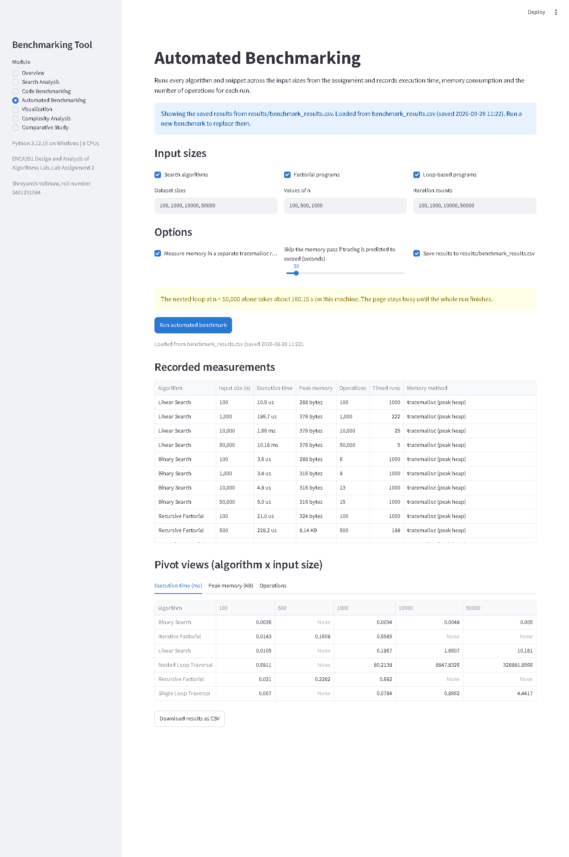
Figure 14. Automated benchmarking page: input sizes, options and the recorded measurements.
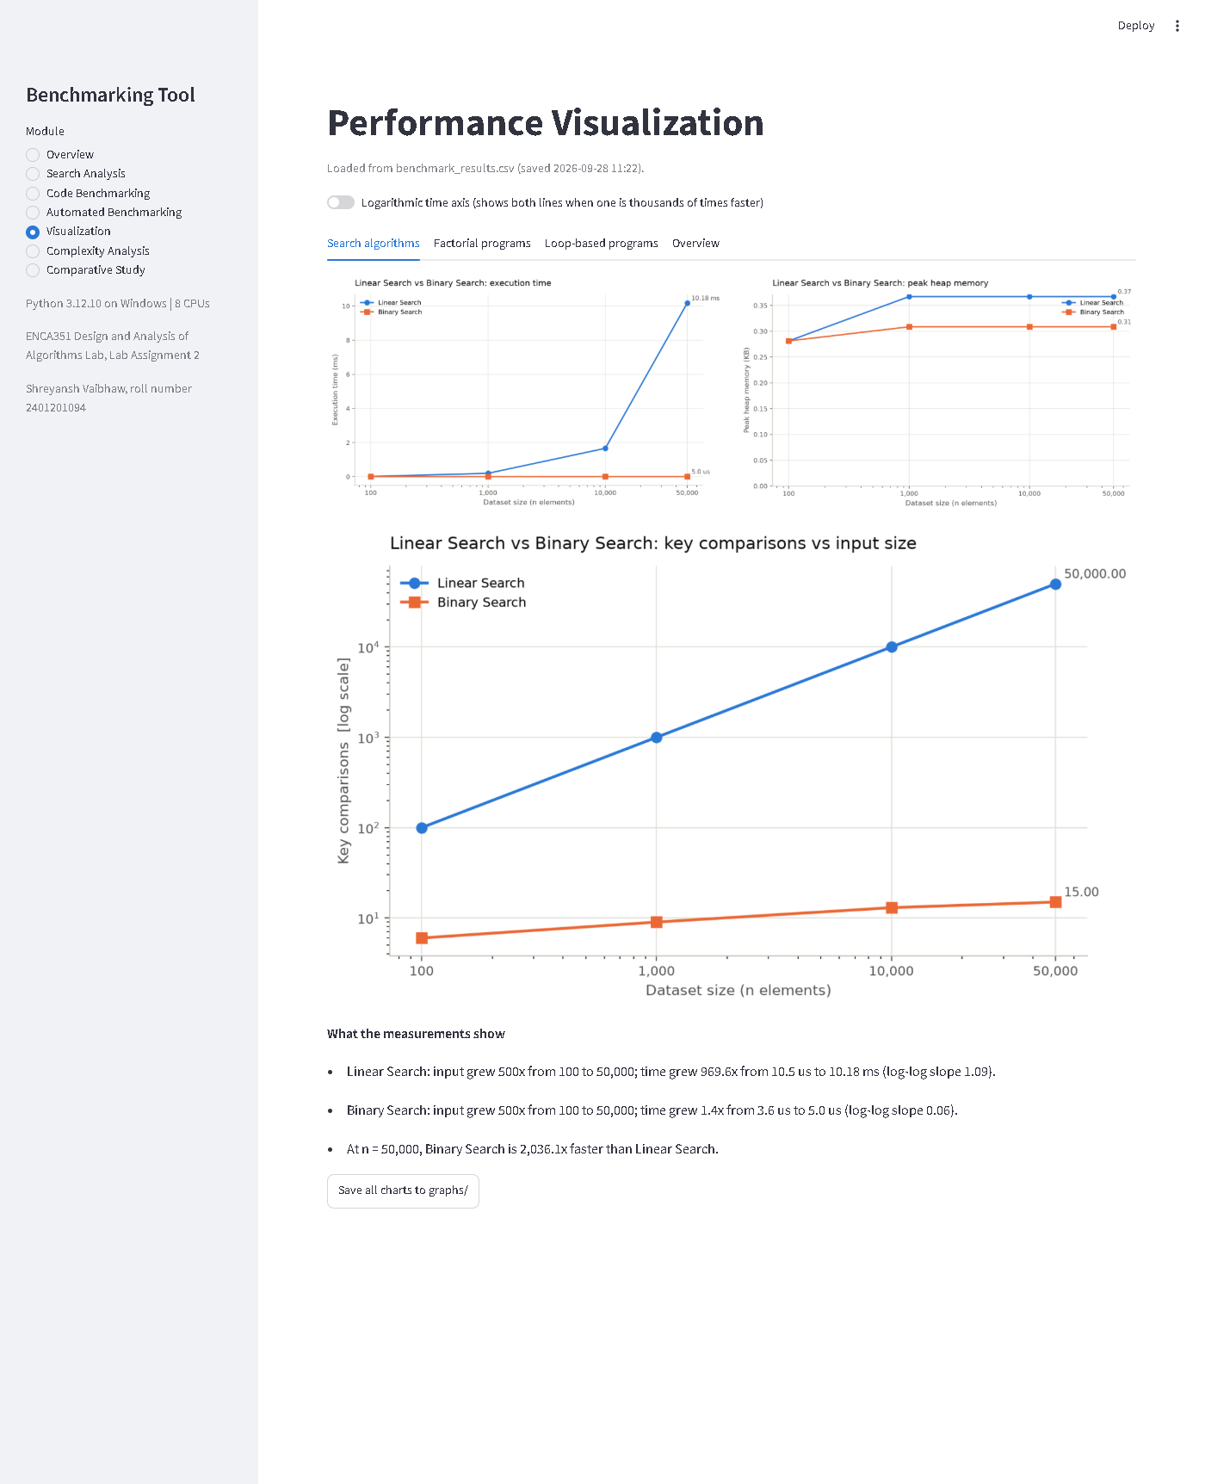
Figure 15. Visualization page: charts and trend summaries per comparison.
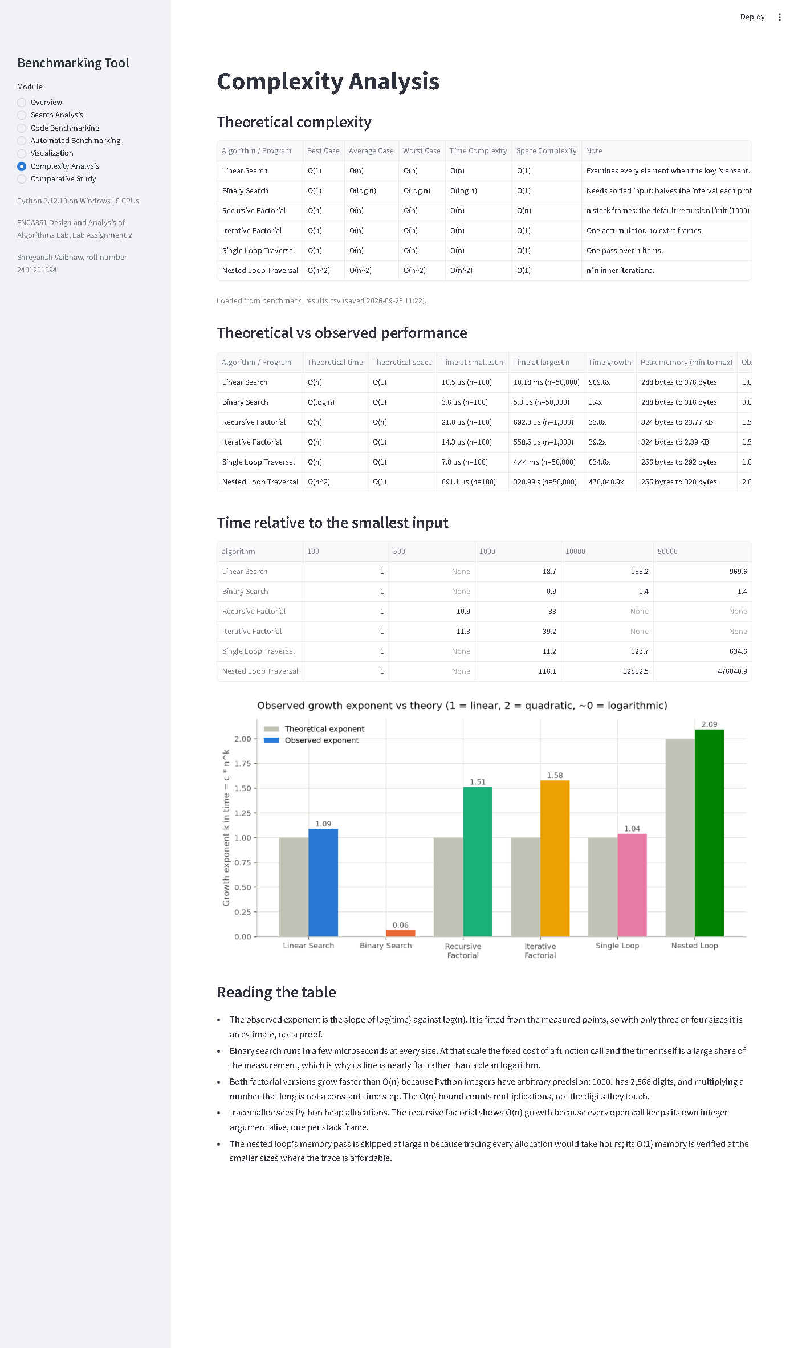
Figure 16. Complexity analysis page: theoretical against observed performance.
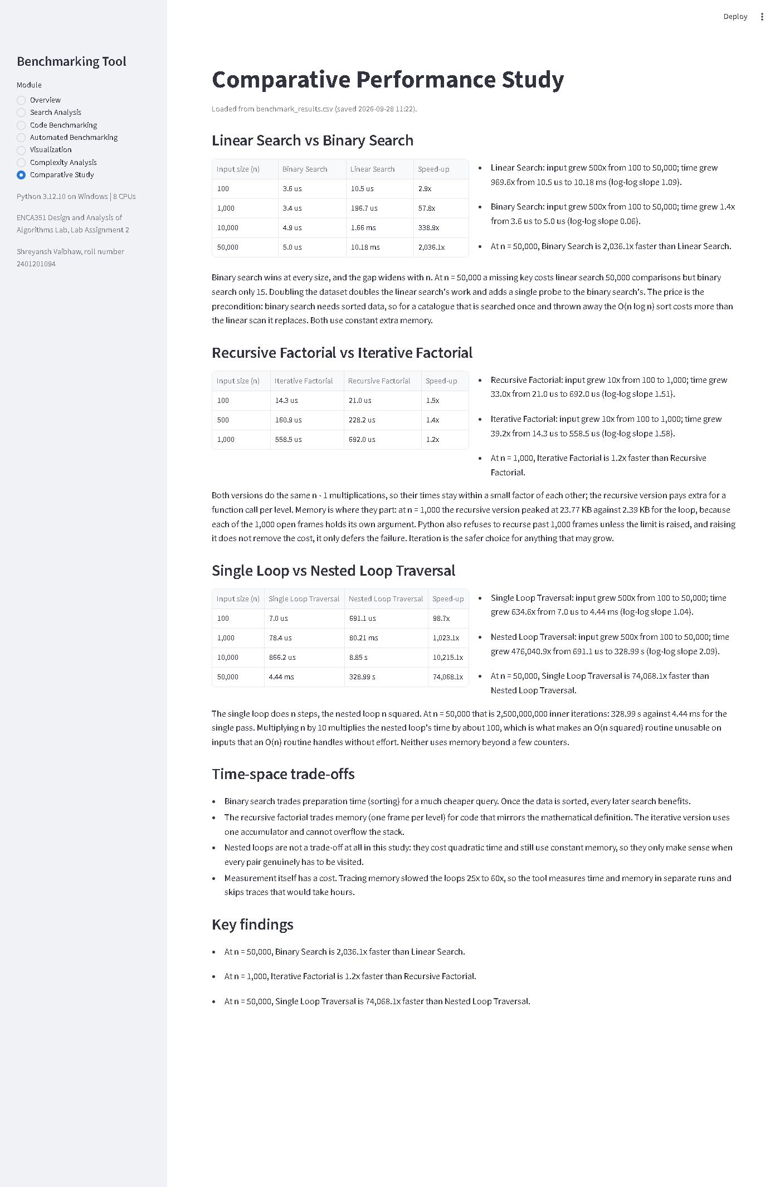
Figure 17. Comparative study page: speed-up tables and discussion.

4. Analysis

4.1 Comparison of search algorithms
Binary search was faster at every size, and the ratio grew with n: 2.9x at 100 elements and 2,036x at 50,000. The comparison counts explain it. Linear search examined every element, 50,000 comparisons for an absent key at 50,000, while binary search needed 15 probes, 2 more than at 10,000. Doubling the catalogue doubles the linear search's work and adds a single probe to the binary search's.
The observed exponents were 1.09 for linear search and 0.06 for binary search. Linear search matches its O(n) bound closely. Binary search's line is almost flat rather than a clean logarithm because a five-microsecond call is dominated by fixed costs: entering the function, setting up the loop, and the timer itself. The logarithm is visible in the comparison counts (6, 9, 13, 15) rather than in the clock.
Both searches used constant memory, about 300 to 380 bytes, which is the loop variables and the result object. What binary search asks in return is sorted input. Sorting costs O(n log n) once. For a catalogue that is searched a handful of times, a linear scan can be the cheaper total; for a library catalogue queried thousands of times a day, the sort is paid once and every lookup benefits.

4.2 Comparison of recursive and iterative implementations
Both factorial versions perform the same n - 1 multiplications, so their times stayed within a small factor: at n = 1,000 the recursive version took 1.24x as long as the loop, the extra being one function call per level. Memory is where they part. At n = 1,000 the recursive version peaked at 23.77 KB, the loop at 2.39 KB, and the recursive figure grows linearly with n (Figure 6). Every open recursive call keeps its own integer argument alive on the heap, one object per frame. The interpreter frames themselves are not visible to tracemalloc, so the true stack cost is higher still.
Python enforces that cost with a hard limit: it refuses to recurse past 1,000 frames by default, so n = 1,000 could not run until the tool raised sys.setrecursionlimit. Raising the limit does not remove the cost, it only moves the point of failure. The loop keeps one accumulator, cannot overflow the stack, and was faster at every size. For anything whose input may grow, iteration is the safer choice.
One result surprised me. Both factorials grew faster than their O(n) bound predicts, with exponents of 1.51 and 1.58. The reason is arithmetic, not control flow: 1000! has 2,568 digits, and multiplying a number that long by a small integer takes time proportional to its length. The O(n) analysis assumes constant-time multiplication, which holds for machine integers and fails for Python's arbitrary-precision ones. Measured across the three sizes the cost looks like n to the power 1.5, which is what n multiplications of numbers that grow with n produce.

4.3 Complexity analysis
Table 4 sets the theoretical complexity against what was measured. The observed exponent is the slope of a straight-line fit to log(time) against log(n) across the measured sizes; slope 1 is linear growth, slope 2 quadratic, and a slope near 0 constant or logarithmic.
Algorithm | Theory: time | Theory: space | Time at smallest n | Time at largest n | Growth | Exponent | Observed trend | Verdict
Linear Search | O(n) | O(1) | 10.5 us | 10.18 ms | 970x | 1.09 | linear | matches theory
Binary Search | O(log n) | O(1) | 3.6 us | 5.0 us | 1x | 0.06 | constant / logarithmic | matches theory
Recursive Factorial | O(n) | O(n) | 21.0 us | 692.0 us | 33x | 1.51 | between linear and quadratic (n log n-like) | grows faster than the bound predicts
Iterative Factorial | O(n) | O(1) | 14.3 us | 558.5 us | 39x | 1.58 | between linear and quadratic (n log n-like) | grows faster than the bound predicts
Single Loop Traversal | O(n) | O(1) | 7.0 us | 4.44 ms | 635x | 1.04 | linear | matches theory
Nested Loop Traversal | O(n^2) | O(1) | 691.1 us | 328.99 s | 476,041x | 2.09 | quadratic | matches theory
Table 4. Theoretical against observed performance.
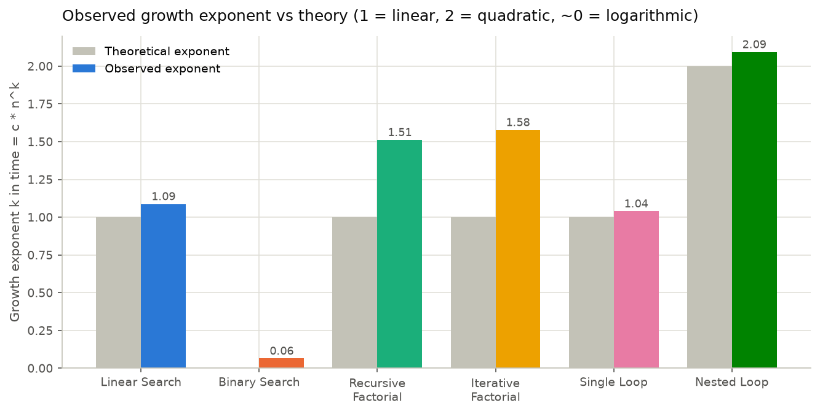
Figure 18. Observed growth exponent next to the exponent theory predicts.
Linear search (1.09), the single loop (1.04) and the nested loop (2.09) land close to their predicted exponents of 1, 1 and 2. Binary search (0.06) is in the constant-or-logarithmic band, as expected. The two factorials sit between linear and quadratic for the reason given in section 4.2. Space complexity was confirmed directly: constant memory for the searches and loops, linear growth for the recursive factorial.

4.4 Performance observations
- Impact of input size. A 500x increase in input multiplied the linear search's time by 970x, the single loop's by 635x, the nested loop's by 476,041x, and the binary search's by 1.4x. Order of growth, not the constant factor, decides what happens at scale.
- Complexity against actual time. Big-O predicted the ranking correctly in every comparison, but constants still matter within a class. Linear search and the single loop are both O(n), yet at n = 50,000 the search took 10.18 ms and the loop 4.44 ms: enumerating and comparing each element costs more than adding it.
- Time-space trade-offs. Binary search trades preparation time (sorting) for cheap queries. The recursive factorial trades memory, one frame per level, for code that mirrors the mathematical definition. Nested loops are not a trade-off at all: they cost quadratic time and still only use a few counters, so they are only justified when every pair genuinely has to be visited.
- Measurement has a cost. Tracing memory slowed the loops 24x to 60x, which is why the engine measures time and memory in separate runs and skips traces that would take hours. At the microsecond scale the timer and the call overhead are a large share of what is measured, which is why binary search's curve is flatter than a logarithm.

5. Conclusion

5.1 Key findings
- Binary search beat linear search by 2,036x at 50,000 elements, and the gap doubles whenever the dataset doubles.
- The nested loop needed 328.99 s at 50,000 iterations against 4.44 ms for the single loop. An O(n squared) routine is already impractical at a size an O(n) routine handles in milliseconds.
- The recursive and iterative factorials ran within 1.24x of each other, but the recursive version's memory grew linearly with n and needed the recursion limit raised to reach n = 1,000.
- Both factorials grew faster than O(n) because Python's arbitrary-precision multiplication is not a constant-time step. Big-O is only as good as its assumptions.
- Careful measurement matters: separating timing from tracing, repeating fast calls, excluding input generation and pausing garbage collection all changed the numbers noticeably during development.

5.2 Most efficient implementations observed
- Search: binary search, provided the data is sorted and searched more than a few times.
- Factorial: the iterative version, faster at every size, constant frames, no recursion limit.
- Traversal: the single loop; the nested loop should only be used when every pair must be visited.

5.3 Future enhancements
- Add sorting and hashing algorithms, and a hash-table lookup to compare with binary search.
- Report confidence intervals from the repeated runs instead of a single median.
- Measure the interpreter's frame stack directly, for example by sampling stack depth, so recursion cost is not inferred from heap objects.
- Let users paste their own snippet, run it in a sandboxed subprocess and benchmark it alongside the built-in ones.
- Compare interpreters (CPython versions, PyPy) to show how much of a constant factor is the runtime rather than the algorithm.

References
- Horowitz, E., Sahni, S. and Rajasekaran, S. Fundamentals of Computer Algorithms. Universities Press.
- Kleinberg, J. and Tardos, E. Algorithm Design. Pearson.
- Python Software Foundation. The Python Standard Library: time, tracemalloc, timeit, sys. https://docs.python.org/3/library/
- Streamlit Inc. Streamlit documentation. https://docs.streamlit.io
- Pedregosa, F. et al. memory_profiler. https://github.com/pythonprofilers/memory_profiler
- Project Jupyter. Jupyter Notebook documentation. https://jupyter-notebook.readthedocs.io
- Hunter, J. D. Matplotlib: A 2D graphics environment. Computing in Science & Engineering, 9(3), 2007.

Appendix A. Complete measurement table
Every row recorded by the reference run (results/benchmark_results.csv). Time is the median; min and max are the fastest and slowest of the timed runs.
Algorithm | n | Median time | Min | Max | Runs | Peak memory | Operations
Linear Search | 100 | 10.5 us | 10.0 us | 81.1 us | 1000 | 288 bytes | 100
Linear Search | 1,000 | 196.7 us | 134.2 us | 1.23 ms | 222 | 376 bytes | 1,000
Linear Search | 10,000 | 1.66 ms | 1.57 ms | 4.72 ms | 25 | 376 bytes | 10,000
Linear Search | 50,000 | 10.18 ms | 8.76 ms | 10.99 ms | 5 | 376 bytes | 50,000
Binary Search | 100 | 3.6 us | 2.3 us | 42.1 us | 1000 | 288 bytes | 6
Binary Search | 1,000 | 3.4 us | 3.3 us | 18.9 us | 1000 | 316 bytes | 9
Binary Search | 10,000 | 4.9 us | 4.6 us | 64.8 us | 1000 | 316 bytes | 13
Binary Search | 50,000 | 5.0 us | 4.9 us | 138.9 us | 1000 | 316 bytes | 15
Recursive Factorial | 100 | 21.0 us | 20.4 us | 176.2 us | 1000 | 324 bytes | 100
Recursive Factorial | 500 | 228.2 us | 217.7 us | 806.8 us | 199 | 8.14 KB | 500
Recursive Factorial | 1,000 | 692.0 us | 666.2 us | 1.16 ms | 67 | 23.77 KB | 1,000
Iterative Factorial | 100 | 14.3 us | 13.5 us | 77.5 us | 1000 | 324 bytes | 99
Iterative Factorial | 500 | 160.9 us | 130.2 us | 299.4 us | 296 | 1.15 KB | 499
Iterative Factorial | 1,000 | 558.5 us | 471.7 us | 971.7 us | 87 | 2.39 KB | 999
Single Loop Traversal | 100 | 7.0 us | 6.5 us | 103.7 us | 1000 | 256 bytes | 100
Single Loop Traversal | 1,000 | 78.4 us | 76.1 us | 246.2 us | 583 | 288 bytes | 1,000
Single Loop Traversal | 10,000 | 866.2 us | 813.8 us | 1.70 ms | 52 | 288 bytes | 10,000
Single Loop Traversal | 50,000 | 4.44 ms | 4.21 ms | 5.31 ms | 12 | 292 bytes | 50,000
Nested Loop Traversal | 100 | 691.1 us | 630.0 us | 1.08 ms | 69 | 256 bytes | 10,000
Nested Loop Traversal | 1,000 | 80.21 ms | 77.51 ms | 90.30 ms | 5 | 320 bytes | 1,000,000
Nested Loop Traversal | 10,000 | 8.85 s | 8.85 s | 8.85 s | 1 | not traced | 100,000,000
Nested Loop Traversal | 50,000 | 328.99 s | 328.99 s | 328.99 s | 1 | not traced | 2,500,000,000

