School of Engineering & Technology

Department: SOET | Session: 2026-27
Program: BCA (AI&DS) | Semester: V
Course Code: ENCA351 | Course Name: Design and Analysis of Algorithms Lab
Faculty: Dr. Aarti | Assignment: Capstone Assignment 1

Smart City Traffic Management and Route Optimization System
Capstone Assignment: Final Project Report
A graph-algorithm based system for route planning, traffic analysis, connectivity checks and infrastructure planning in a city road network
Submitted by | Shreyansh Vaibhaw
Roll number | 2401201094
Program | BCA (AI&DS), Semester V
Submitted to | Dr. Aarti
GitHub repository | https://github.com/ShreyanshVaibhaw/smart-city-traffic-system-shreyansh-vaibhaw
Date | September 2026

Table of contents
Abstract 3
1. Introduction 3
1.1 Smart city concepts 3
1.2 Importance of traffic optimization 3
1.3 Problem statement and objectives 3
1.4 Tools and technologies 4
2. System design 4
2.1 The road network as a graph 4
2.2 Modules 4
2.3 The web application 5
2.4 Algorithms and where they are used 6
2.5 Implementation notes 6
3. Experimental results 7
3.1 Sample road network 7
3.2 Route planning with Dijkstra's algorithm 8
3.3 Traffic analysis with the Bellman-Ford algorithm 10
3.4 Network connectivity with BFS and DFS 13
3.5 Infrastructure planning with Prim's and Kruskal's algorithms 16
3.6 Measurements on networks of different sizes 18
4. Analysis 21
4.1 Comparison of graph algorithms 21
4.2 Traffic optimization observations 22
4.3 Infrastructure planning insights 22
4.4 Suitability of each algorithm for traffic management 22
5. Conclusion 23
5.1 Key findings 23
5.2 Benefits of graph algorithms in transportation systems 23
5.3 Future improvements 23
References 23
Appendix A: Repository contents 24
Appendix B: Running the project 24

Abstract
Traffic congestion is one of the most visible problems of fast-growing cities. This project models a city's road network as a weighted graph and uses classic graph algorithms to answer the questions that commuters and city administrators ask every day: what is the fastest route between two places, how does that route change when a road is congested or closed, which parts of the city can be reached from a given point, and which roads must be built to connect every intersection at the lowest cost. Dijkstra's algorithm, the Bellman-Ford algorithm, breadth first search, depth first search, Prim's algorithm and Kruskal's algorithm were implemented by hand in Python and wrapped in an interactive Streamlit application. A Jupyter notebook runs all algorithms on random cities with 10, 25, 50 and 100 intersections and compares execution time, memory and results. Dijkstra was two to three times faster than Bellman-Ford at every size, Prim was faster than Kruskal at every size, and BFS and DFS were indistinguishable, while every algorithm finished in well under a millisecond on the largest city.

1. Introduction

1.1 Smart city concepts
A smart city uses data and software to run its services better: water, power, waste, public safety and, most visibly, transport. Sensors on roads and in vehicles report where traffic is, control rooms watch the whole network at once, and navigation apps guide millions of individual trips. Behind all of these services sits the same abstraction: the road network is a graph. Intersections are vertices, roads are edges, and the time or distance needed to drive along a road is the weight of its edge. Once the city is represented this way, decades of well-understood graph algorithms become available to answer practical questions quickly and reliably.
This project builds exactly that representation and puts the most important algorithms behind an interactive interface, so that a commuter can ask for a route, an administrator can simulate congestion, and a planner can see which roads matter most.

1.2 Importance of traffic optimization
Congestion costs a city in several ways at once. Commuters lose time, vehicles burn fuel while idling, emissions rise, and emergency vehicles arrive later. Roads and junctions are expensive to build, so the existing network has to be used as well as possible. Traffic optimization tackles this from four directions, and each one maps onto a graph problem:
- Route planning. Find the least-cost route between two points (single-source shortest path).
- Dynamic rerouting. Recompute routes when road costs change because of congestion, accidents or closures, and quantify the extra cost (shortest path on an edited graph).
- Reachability. Know which intersections can still be reached from a point, and how far a disruption spreads (graph traversal).
- Infrastructure planning. Connect every intersection with the smallest total construction cost (minimum spanning tree).

1.3 Problem statement and objectives
The assignment asks for a Smart City Traffic Management System that models a city as a graph and uses graph algorithms to help commuters and administrators make efficient routing decisions. The objectives of this project are:
1. Represent the city as a weighted graph and display both the adjacency list and the adjacency matrix.
2. Compute the shortest route between a source and a destination with Dijkstra's algorithm and show every intermediate distance update.
3. Simulate congestion by changing road costs, recompute routes with the Bellman-Ford algorithm and compare the original and updated routes.
4. Explore the network from a starting intersection with breadth first search and depth first search and report the traversal order and the reachable intersections.
5. Generate the minimum spanning tree with Prim's and Kruskal's algorithms and report the selected roads and the total infrastructure cost.
6. Compare the algorithms experimentally on networks of 10, 25, 50 and 100 intersections.
7. Provide an interactive web application, a Jupyter notebook and this report.

1.4 Tools and technologies
Table 1: Tools and technologies used
Tool | Purpose in this project
Python 3.12 | Implementation language for every algorithm and the application
Streamlit | Interactive web application with one page per module
NetworkX | Drawing the road network (the algorithms themselves are written by hand)
Matplotlib | Maps, route highlights and the charts of the experiments
pandas and NumPy | Adjacency matrix, result tables and the experiment data
Jupyter | Project notebook with the walk-through and the comparative analysis
Git and GitHub | Version control and submission of the private repository

2. System design

2.1 The road network as a graph
The city is stored in a class called RoadNetwork. Every intersection is a vertex, every road is an undirected edge (traffic flows both ways) and the travel cost of the road is the edge weight. Costs must be positive numbers; they can be kilometres or minutes, the algorithms do not care. Internally the graph is a dictionary of dictionaries, which is the classic adjacency list: roads["Central Square"] is itself a dictionary that maps each neighbouring intersection to the cost of the road between them.
The adjacency list needs space proportional to the number of intersections plus roads, and listing the neighbours of an intersection takes time proportional to its degree, which is exactly what the traversal and shortest path algorithms need. The adjacency matrix is produced on demand as a pandas DataFrame: it needs space proportional to the square of the number of intersections, but it answers "is there a road between A and B?" in constant time, and it is the representation most people find easiest to read. The application displays both, as the assignment requires.

2.2 Modules
Table 2: Modules of the system
Module | File | Algorithms | Purpose
Road Network Modeling | road_network.py | Adjacency list and matrix | Create or load a city, add intersections and roads, assign costs, save and load CSV files
Route Planning | route_planner.py | Dijkstra | Shortest route, total travel cost, every intermediate distance update
Traffic Analysis | traffic_analysis.py | Bellman-Ford | Congestion and closure simulation, route recomputation, before and after comparison
Network Connectivity | connectivity_module.py | BFS, DFS | Traversal order, reachable and unreachable intersections, regions of the city
Infrastructure Planning | mst_planner.py | Prim, Kruskal | Minimum spanning tree, selected roads, total infrastructure cost
Comparative Analysis | experiments.py | All of the above | Execution time and memory on cities of 10, 25, 50 and 100 intersections
Visualisation | visualizer.py | - | Map drawing and table formatting shared by the app, the notebook and this report
Web application | app.py | - | Streamlit interface that ties the modules together

2.3 The web application
The application is a single Streamlit script with a sidebar that selects one of six pages. The current city lives in the Streamlit session state, so a city built on the first page is available on every other page. The sample city is loaded automatically, which means every module shows a result the moment it is opened; the user can then change the source and destination, edit road costs or load a different city. Every result is recomputed live when an input changes, so there are no stale outputs. Figure 1 shows the Road Network page.
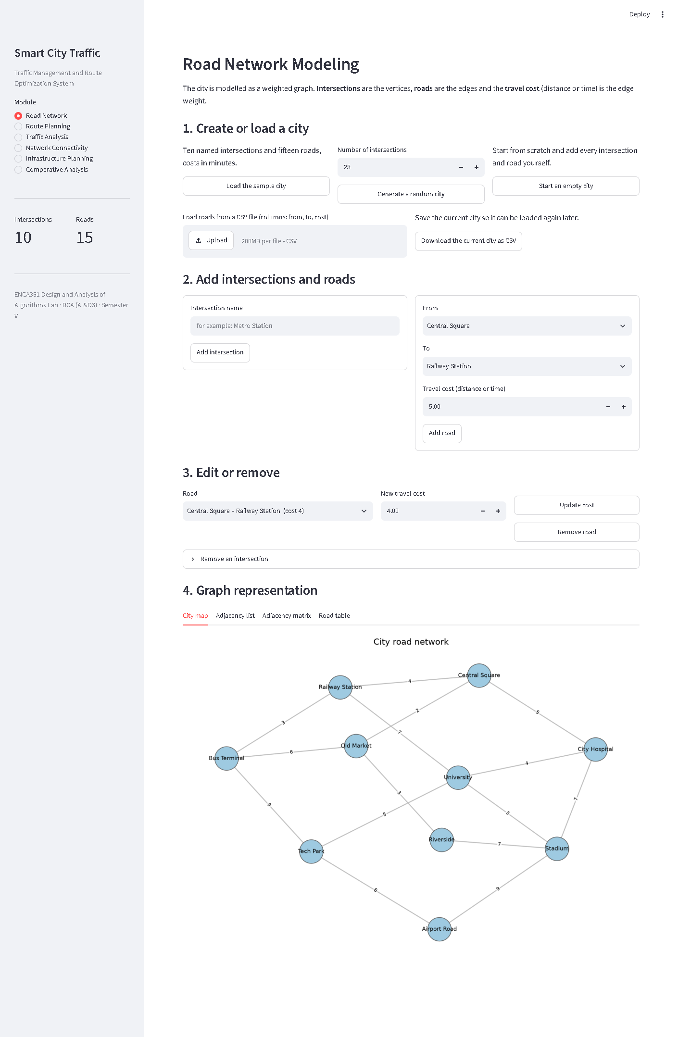
Figure 1: Road Network Modeling page of the application

2.4 Algorithms and where they are used
Table 3: Algorithms used in the system (V = intersections, E = roads)
Algorithm | Used in | Time complexity | Real-world application
Dijkstra | Route Planning | O((V + E) log V) | Navigation systems, ride sharing, emergency routing
Bellman-Ford | Traffic Analysis | O(V × E), early stop | Dynamic traffic management, accident rerouting, closures
Breadth First Search | Network Connectivity | O(V + E) | Traffic monitoring, spread of a disruption
Depth First Search | Network Connectivity | O(V + E) | Network exploration, accessibility analysis
Prim | Infrastructure Planning | O(E log V) | Road expansion, utility distribution
Kruskal | Infrastructure Planning | O(E log E) | Smart city infrastructure development

2.5 Implementation notes
- Dijkstra. A binary heap (Python's heapq) holds (distance, intersection) pairs. Every time a shorter distance is found the update is recorded, and after every visited intersection a snapshot of the whole distance table is stored, so the application can show the working step by step.
- Bellman-Ford. Every road is relaxed in both directions in each pass. The loop stops as soon as a pass changes nothing, and one extra check would detect a negative cycle (it never fires here, because every road cost is positive). Congestion is applied to a copy of the city, so the original and the congested routes can be compared side by side.
- BFS and DFS. BFS uses a deque as its queue and records the queue after every step. DFS is the recursive version and records the current route from the start, which is the recursion stack.
- Prim and Kruskal. Prim keeps the candidate roads in a heap and adds the cheapest road that reaches a new intersection. Kruskal sorts all roads and uses a union-find structure with path halving to reject roads that would create a cycle. Both report every decision they make.
- Measurements. The experiments call every algorithm with the step recording switched off, so the timings measure the algorithm alone and not the bookkeeping used for display.

3. Experimental results

3.1 Sample road network
The sample city used throughout the application and the notebook has 10 intersections and 15 roads. The costs are travel times in minutes. The roads are listed in Table 4 and drawn in Figure 2.
Table 4: Roads of the sample city
From | To | Cost (min)
Central Square | Railway Station | 4
Central Square | Old Market | 2
Central Square | City Hospital | 5
Railway Station | Bus Terminal | 3
Railway Station | University | 7
Old Market | Bus Terminal | 6
Old Market | Riverside | 3
City Hospital | University | 4
City Hospital | Stadium | 7
Bus Terminal | Tech Park | 9
University | Tech Park | 5
University | Stadium | 3
Riverside | Stadium | 7
Stadium | Airport Road | 9
Tech Park | Airport Road | 6

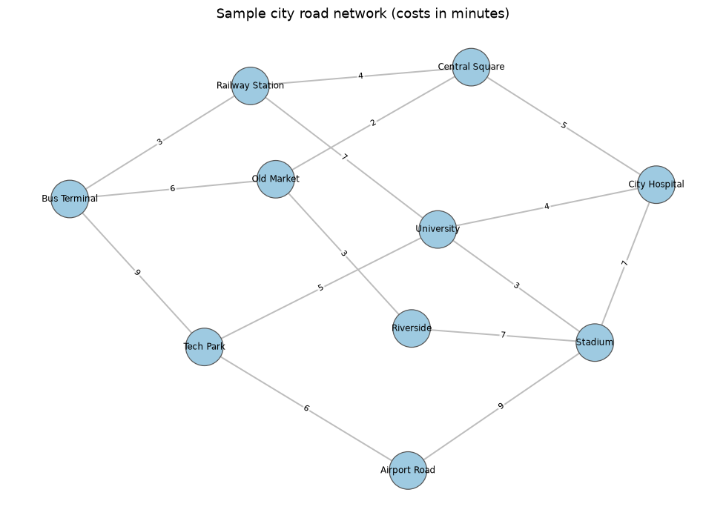
Figure 2: Sample city road network with travel costs in minutes
Table 5: Adjacency list of the sample city
Intersection | Neighbours (cost)
Central Square | City Hospital (5), Old Market (2), Railway Station (4)
Railway Station | Bus Terminal (3), Central Square (4), University (7)
Old Market | Bus Terminal (6), Central Square (2), Riverside (3)
City Hospital | Central Square (5), Stadium (7), University (4)
Bus Terminal | Old Market (6), Railway Station (3), Tech Park (9)
University | City Hospital (4), Railway Station (7), Stadium (3), Tech Park (5)
Riverside | Old Market (3), Stadium (7)
Stadium | Airport Road (9), City Hospital (7), Riverside (7), University (3)
Tech Park | Airport Road (6), Bus Terminal (9), University (5)
Airport Road | Stadium (9), Tech Park (6)

Table 6: Adjacency matrix of the sample city (0 = no direct road)
 | Central Sq. | Railway St. | Old Market | Hospital | Bus Term. | University | Riverside | Stadium | Tech Park | Airport Rd.
Central Sq. | 0 | 4 | 2 | 5 | 0 | 0 | 0 | 0 | 0 | 0
Railway St. | 4 | 0 | 0 | 0 | 3 | 7 | 0 | 0 | 0 | 0
Old Market | 2 | 0 | 0 | 0 | 6 | 0 | 3 | 0 | 0 | 0
Hospital | 5 | 0 | 0 | 0 | 0 | 4 | 0 | 7 | 0 | 0
Bus Term. | 0 | 3 | 6 | 0 | 0 | 0 | 0 | 0 | 9 | 0
University | 0 | 7 | 0 | 4 | 0 | 0 | 0 | 3 | 5 | 0
Riverside | 0 | 0 | 3 | 0 | 0 | 0 | 0 | 7 | 0 | 0
Stadium | 0 | 0 | 0 | 7 | 0 | 3 | 7 | 0 | 0 | 9
Tech Park | 0 | 0 | 0 | 0 | 9 | 5 | 0 | 0 | 0 | 6
Airport Rd. | 0 | 0 | 0 | 0 | 0 | 0 | 0 | 9 | 6 | 0

3.2 Route planning with Dijkstra's algorithm
A commuter travels from Central Square to Airport Road. Dijkstra's algorithm finds the route Central Square → City Hospital → University → Tech Park → Airport Road with a total travel cost of 20 minutes, which is confirmed by adding the four road costs (5 + 4 + 5 + 6). The algorithm made 13 distance updates while settling all 10 intersections. Table 7 lists every update in the order it happened and Table 8 gives the final shortest cost from Central Square to every intersection.
Table 7: Intermediate distance updates made by Dijkstra's algorithm
Step | Visiting | Road to | Road cost | Old distance | New distance
1 | Central Square | Railway Station | 4 | ∞ | 4
2 | Central Square | Old Market | 2 | ∞ | 2
3 | Central Square | City Hospital | 5 | ∞ | 5
4 | Old Market | Bus Terminal | 6 | ∞ | 8
5 | Old Market | Riverside | 3 | ∞ | 5
6 | Railway Station | Bus Terminal | 3 | 8 | 7
7 | Railway Station | University | 7 | ∞ | 11
8 | City Hospital | University | 4 | 11 | 9
9 | City Hospital | Stadium | 7 | ∞ | 12
10 | Bus Terminal | Tech Park | 9 | ∞ | 16
11 | University | Tech Park | 5 | 16 | 14
12 | Stadium | Airport Road | 9 | ∞ | 21
13 | Tech Park | Airport Road | 6 | 21 | 20

Table 8: Shortest cost to every intersection
Intersection | Shortest cost from Central Square | Reached via
Central Square | 0 | -
Railway Station | 4 | Central Square
Old Market | 2 | Central Square
City Hospital | 5 | Central Square
Bus Terminal | 7 | Railway Station
University | 9 | City Hospital
Riverside | 5 | Old Market
Stadium | 12 | City Hospital
Tech Park | 14 | University
Airport Road | 20 | Tech Park

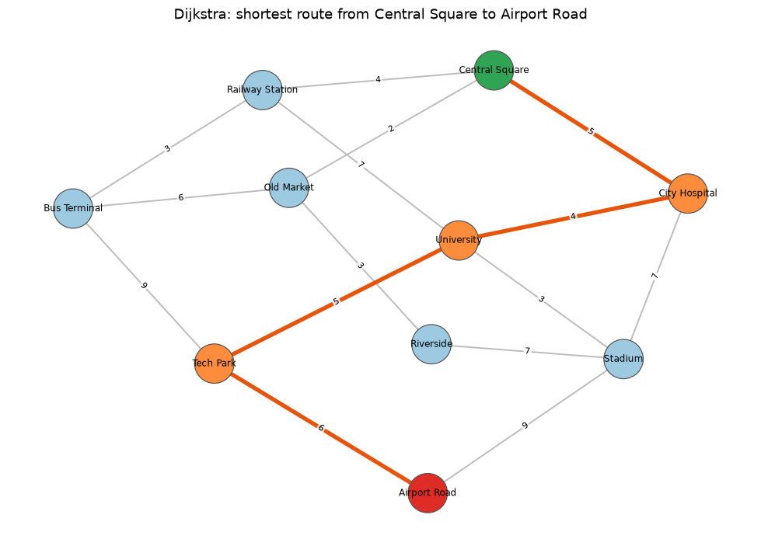
Figure 3: Shortest route from Central Square to Airport Road (orange)
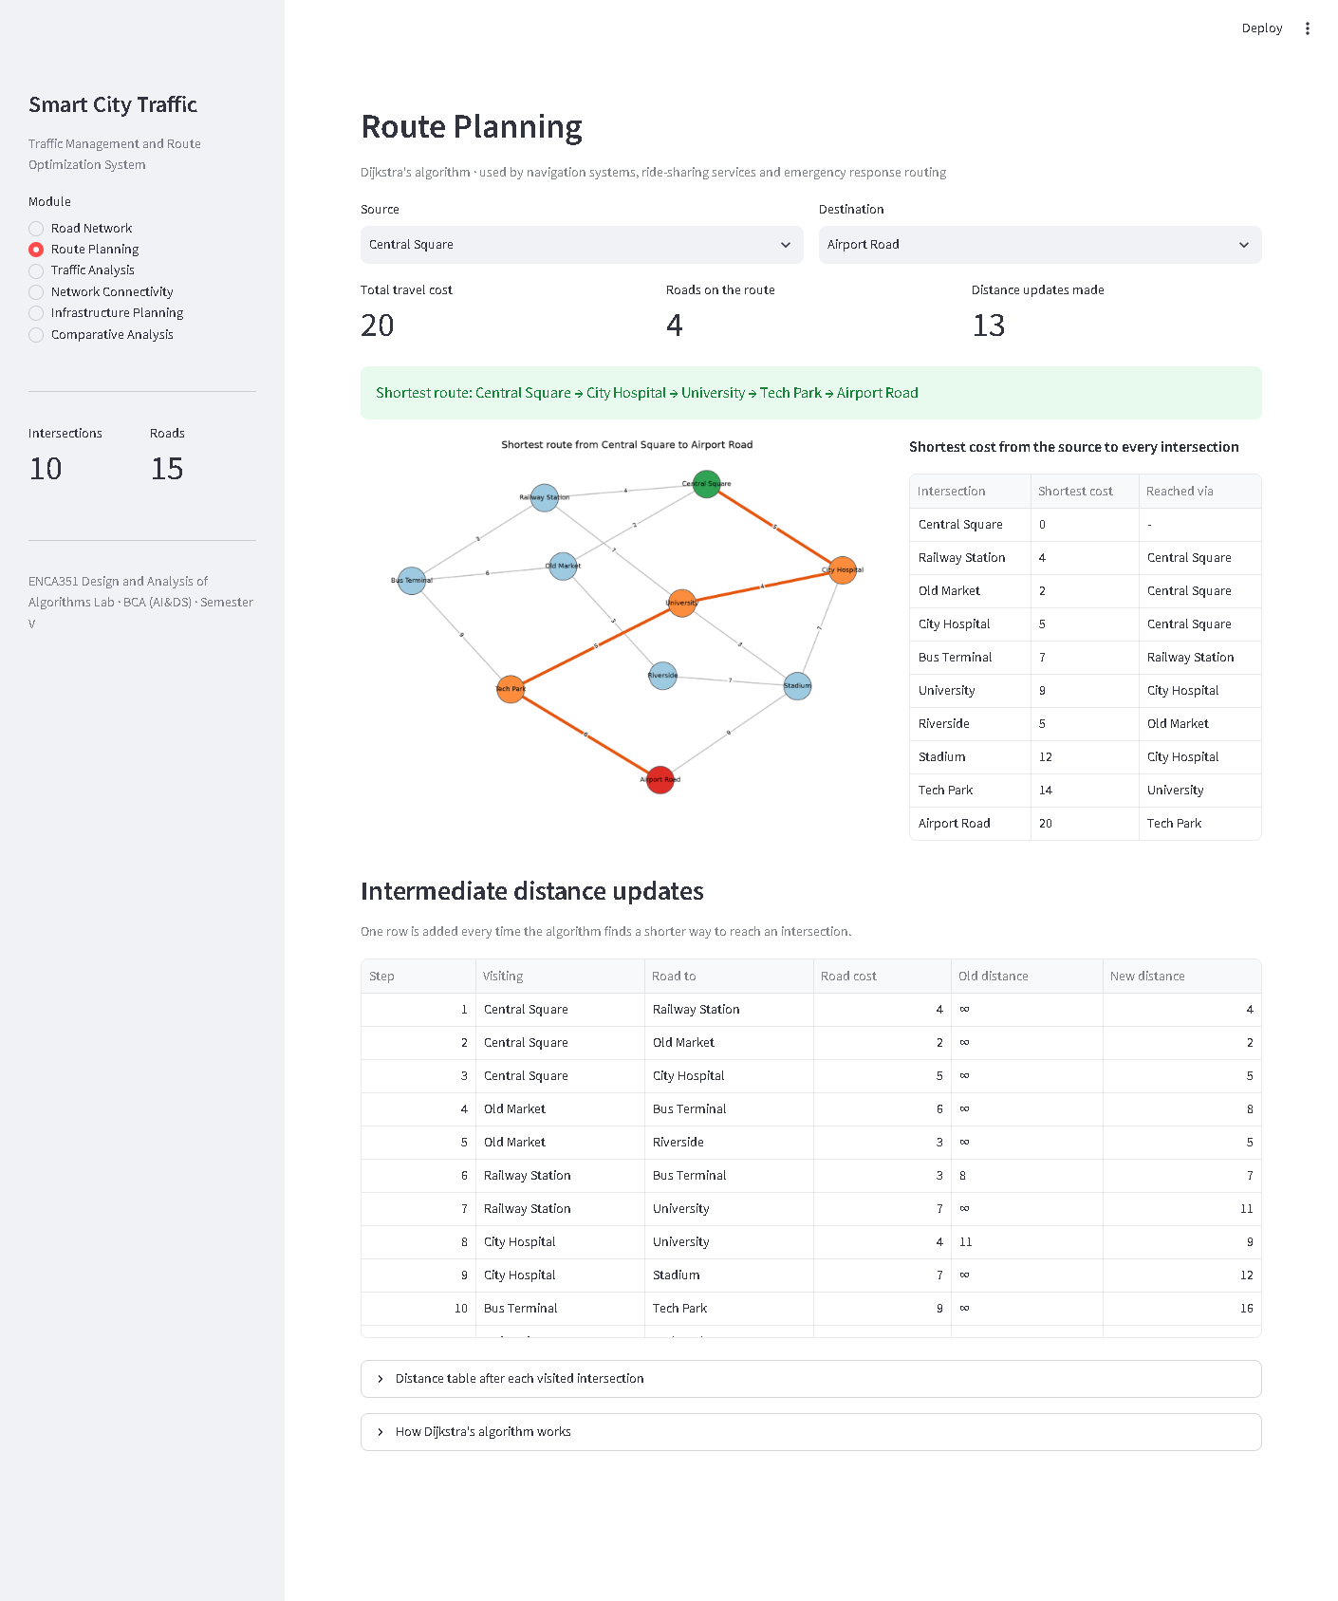
Figure 4: Route Planning page with the intermediate distance updates

3.3 Traffic analysis with the Bellman-Ford algorithm
On the unchanged city the Bellman-Ford algorithm produces the same route and cost as Dijkstra (Central Square → City Hospital → University → Tech Park → Airport Road, 20 minutes). It ran 2 passes out of a possible 9: the second pass changed nothing, so the algorithm stopped there. Table 9 shows the distance table after each pass.
Table 9: Bellman-Ford distance table after each pass (original city)
Pass | Central Sq. | Railway St. | Old Market | Hospital | Bus Term. | University | Riverside | Stadium | Tech Park | Airport Rd.
1 | 0 | 4 | 2 | 5 | 7 | 9 | 5 | 12 | 14 | 20
2 | 0 | 4 | 2 | 5 | 7 | 9 | 5 | 12 | 14 | 20

Scenario 1: peak-hour congestion. Every road on the current shortest route becomes three times slower, which is what happens when everybody uses the same main route at the same time.
Table 10: Roads slowed down in the peak-hour scenario
Road | Original cost | Congested cost
Central Square – City Hospital | 5 | 15
City Hospital – University | 4 | 12
University – Tech Park | 5 | 15
Tech Park – Airport Road | 6 | 18

Table 11: Route comparison for the peak-hour scenario
 | Route | Travel cost (min)
Original | Central Square → City Hospital → University → Tech Park → Airport Road | 20
After congestion | Central Square → Old Market → Riverside → Stadium → Airport Road | 21
Difference | route changed | +1 (5% more)

The commuter is diverted to a completely different route through Old Market, Riverside and Stadium, and loses only 1 minute, because the city offers a good alternative. Bellman-Ford ran 2 passes on the congested city.
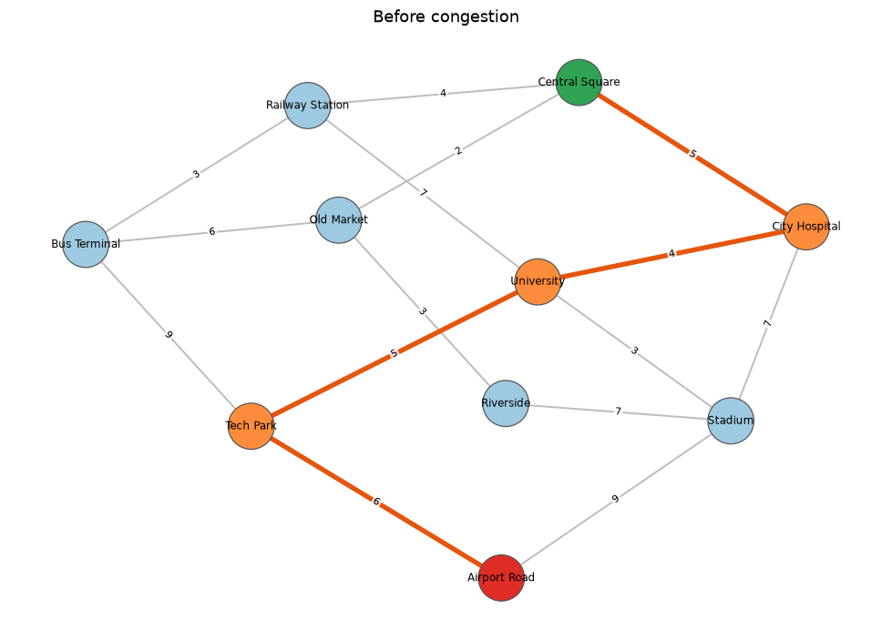
Figure 5: Route before congestion
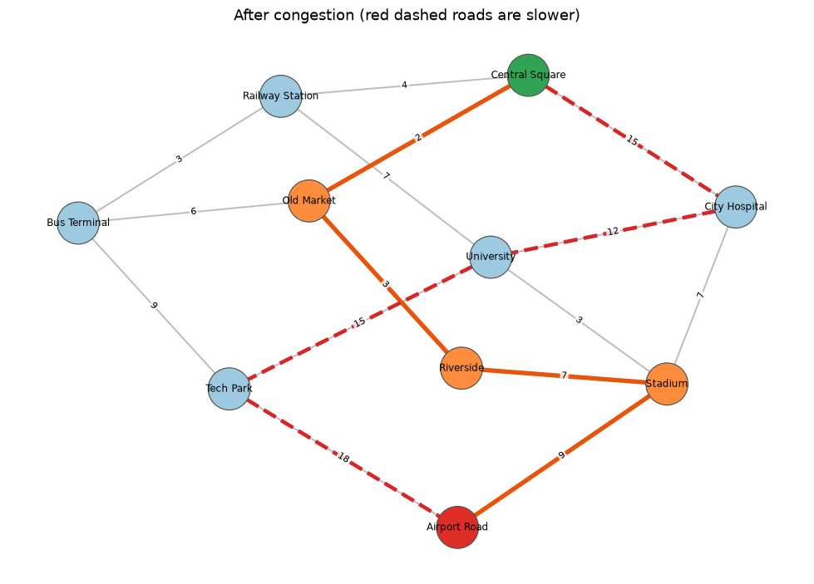
Figure 6: Route after peak-hour congestion; the red dashed roads became slower
Scenario 2: road closure. An accident closes the road between University and Tech Park. The best route becomes Central Square → City Hospital → Stadium → Airport Road at 21 minutes, again only 1 minute more than before. Closing a road removes it from the graph, so Bellman-Ford is simply run on a city with one road fewer.
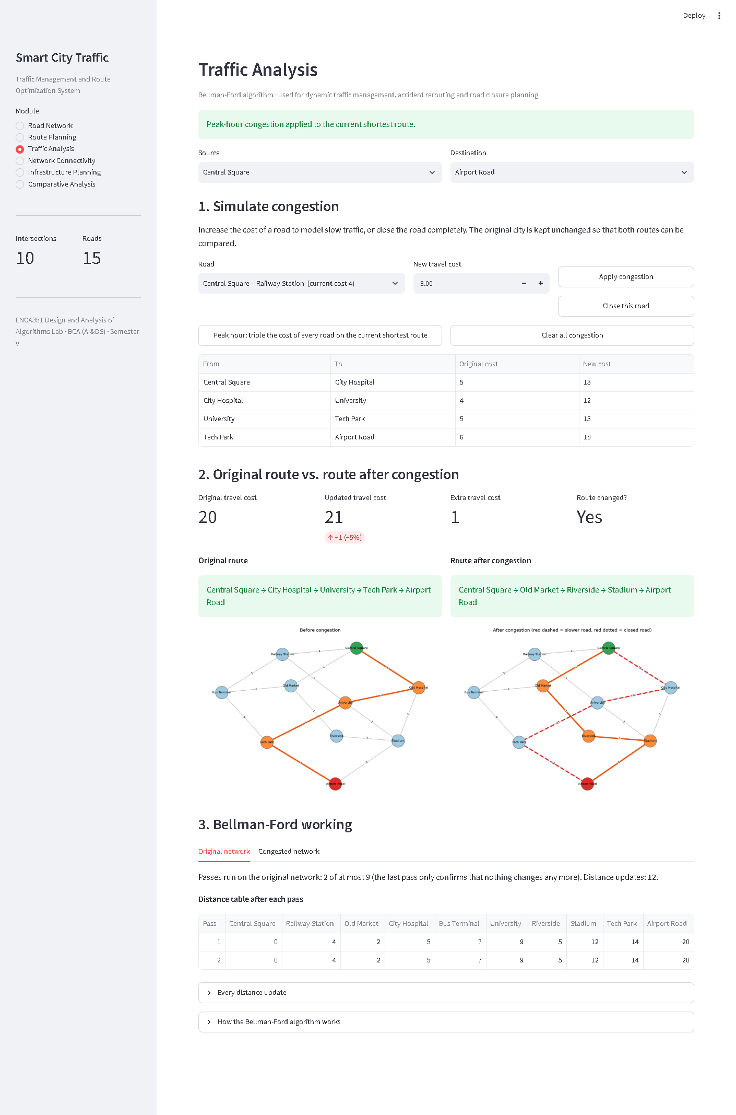
Figure 7: Traffic Analysis page comparing the original and congested routes

3.4 Network connectivity with BFS and DFS
Both traversals start at Central Square. BFS visits the intersections level by level: Central Square → Railway Station → Old Market → City Hospital → Bus Terminal → University → Riverside → Stadium → Tech Park → Airport Road. DFS follows one road as far as it goes before backtracking: Central Square → Railway Station → Bus Terminal → Old Market → Riverside → Stadium → City Hospital → University → Tech Park → Airport Road. Both reach all 10 intersections, so the sample city is connected. Tables 12 and 13 show the queue and the recursion route at every step.
Table 12: Breadth first search step by step
Step | Visiting | Level | Newly discovered | Queue after this step
1 | Central Square | 0 | Railway Station, Old Market, City Hospital | Railway Station, Old Market, City Hospital
2 | Railway Station | 1 | Bus Terminal, University | Old Market, City Hospital, Bus Terminal, University
3 | Old Market | 1 | Riverside | City Hospital, Bus Terminal, University, Riverside
4 | City Hospital | 1 | Stadium | Bus Terminal, University, Riverside, Stadium
5 | Bus Terminal | 2 | Tech Park | University, Riverside, Stadium, Tech Park
6 | University | 2 | - | Riverside, Stadium, Tech Park
7 | Riverside | 2 | - | Stadium, Tech Park
8 | Stadium | 2 | Airport Road | Tech Park, Airport Road
9 | Tech Park | 3 | - | Airport Road
10 | Airport Road | 3 | - | (empty)

Table 13: Depth first search step by step
Step | Visiting | Depth | Route from the start
1 | Central Square | 0 | Central Square
2 | Railway Station | 1 | Central Square -> Railway Station
3 | Bus Terminal | 2 | Central Square -> Railway Station -> Bus Terminal
4 | Old Market | 3 | Central Square -> Railway Station -> Bus Terminal -> Old Market
5 | Riverside | 4 | Central Square -> Railway Station -> Bus Terminal -> Old Market -> Riverside
6 | Stadium | 5 | Central Square -> Railway Station -> Bus Terminal -> Old Market -> Riverside -> Stadium
7 | City Hospital | 6 | Central Square -> Railway Station -> Bus Terminal -> Old Market -> Riverside -> Stadium -> City Hospital
8 | University | 7 | Central Square -> Railway Station -> Bus Terminal -> Old Market -> Riverside -> Stadium -> City Hospital -> University
9 | Tech Park | 8 | Central Square -> Railway Station -> Bus Terminal -> Old Market -> Riverside -> Stadium -> City Hospital -> University -> Tech Park
10 | Airport Road | 9 | Central Square -> Railway Station -> Bus Terminal -> Old Market -> Riverside -> Stadium -> City Hospital -> University -> Tech Park -> Airport Road

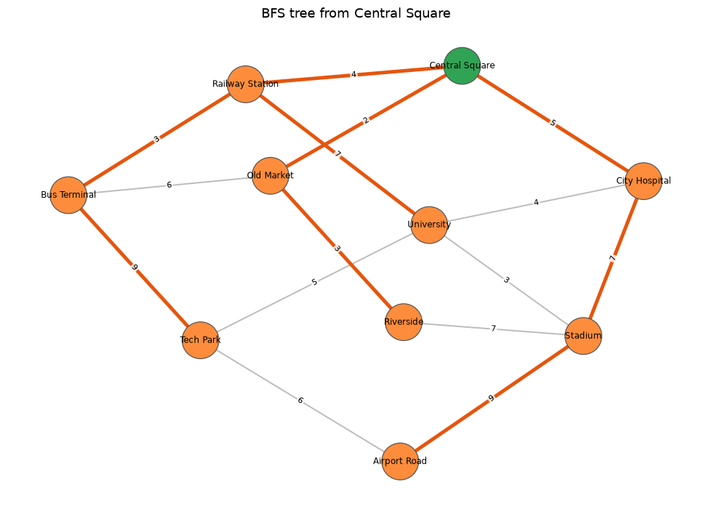
Figure 8: BFS tree from Central Square (orange roads show how each intersection was first reached)
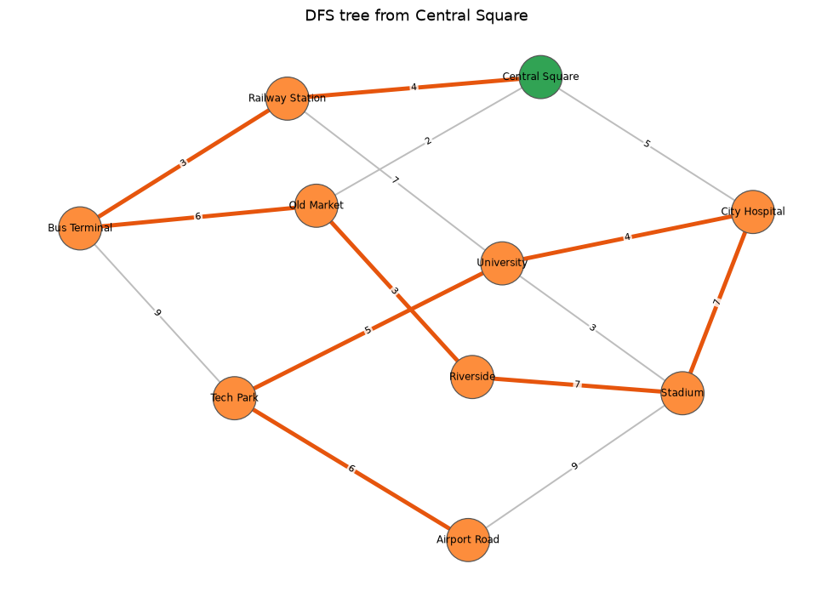
Figure 9: DFS tree from Central Square
Connectivity also reveals how a city breaks apart. When both roads into Airport Road are closed, BFS from Central Square reaches only 9 intersections and the city splits into 2 regions: one with 9 intersections and one containing only Airport Road. The application reports such unreachable intersections and lists the regions.
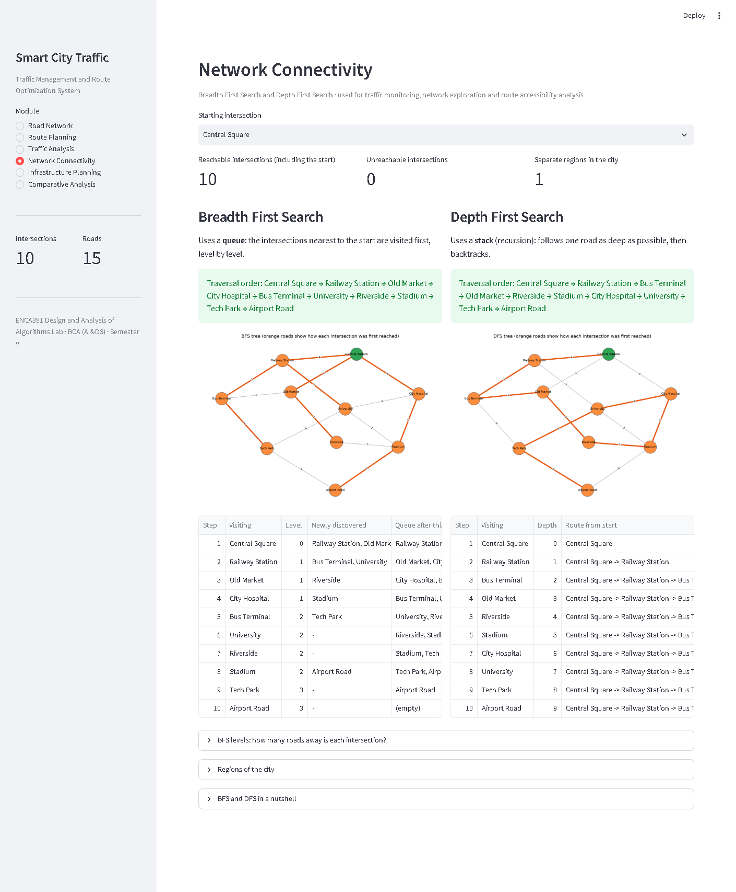
Figure 10: Network Connectivity page

3.5 Infrastructure planning with Prim's and Kruskal's algorithms
Building all 15 roads of the sample city would cost 80 units. Both Prim's and Kruskal's algorithms select 9 roads with a total cost of 35, a saving of 45, and in this city they choose exactly the same roads (yes). Table 14 lists the selected roads and Tables 15 and 16 show every decision of the two algorithms.
Table 14: Roads selected for the minimum spanning tree
From | To | Cost
Central Square | Old Market | 2
Railway Station | Bus Terminal | 3
Old Market | Riverside | 3
University | Stadium | 3
Central Square | Railway Station | 4
City Hospital | University | 4
Central Square | City Hospital | 5
University | Tech Park | 5
Tech Park | Airport Road | 6

Table 15: Prim's algorithm step by step (starting at Central Square)
Step | Road | Cost | Decision
1 | Central Square - Old Market | 2 | Added to the tree
2 | Old Market - Riverside | 3 | Added to the tree
3 | Central Square - Railway Station | 4 | Added to the tree
4 | Railway Station - Bus Terminal | 3 | Added to the tree
5 | Central Square - City Hospital | 5 | Added to the tree
6 | City Hospital - University | 4 | Added to the tree
7 | University - Stadium | 3 | Added to the tree
8 | University - Tech Park | 5 | Added to the tree
9 | Old Market - Bus Terminal | 6 | Skipped (both ends already connected)
10 | Tech Park - Airport Road | 6 | Added to the tree

Table 16: Kruskal's algorithm step by step (roads in order of cost)
Step | Road | Cost | Decision
1 | Central Square - Old Market | 2 | Added to the tree
2 | Railway Station - Bus Terminal | 3 | Added to the tree
3 | Old Market - Riverside | 3 | Added to the tree
4 | University - Stadium | 3 | Added to the tree
5 | Central Square - Railway Station | 4 | Added to the tree
6 | City Hospital - University | 4 | Added to the tree
7 | Central Square - City Hospital | 5 | Added to the tree
8 | University - Tech Park | 5 | Added to the tree
9 | Old Market - Bus Terminal | 6 | Rejected (would create a cycle)
10 | Tech Park - Airport Road | 6 | Added to the tree

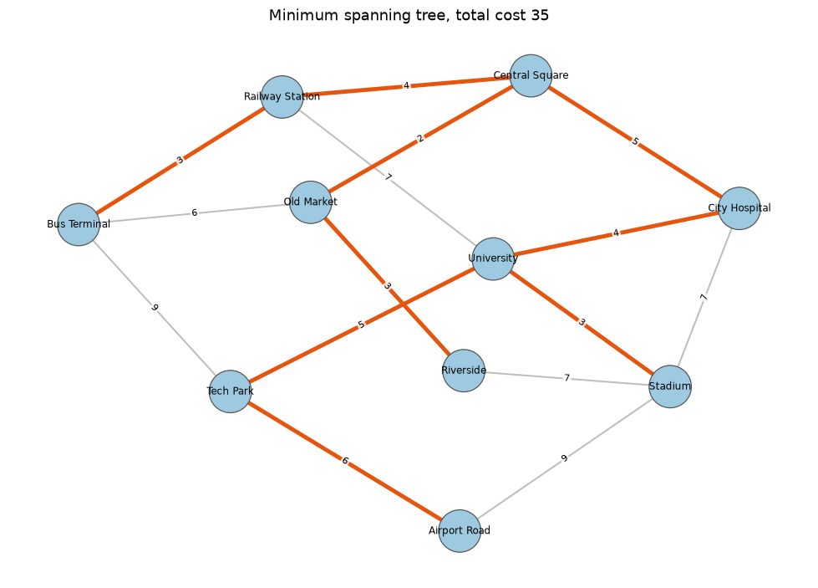
Figure 11: Minimum spanning tree of the sample city (orange roads)
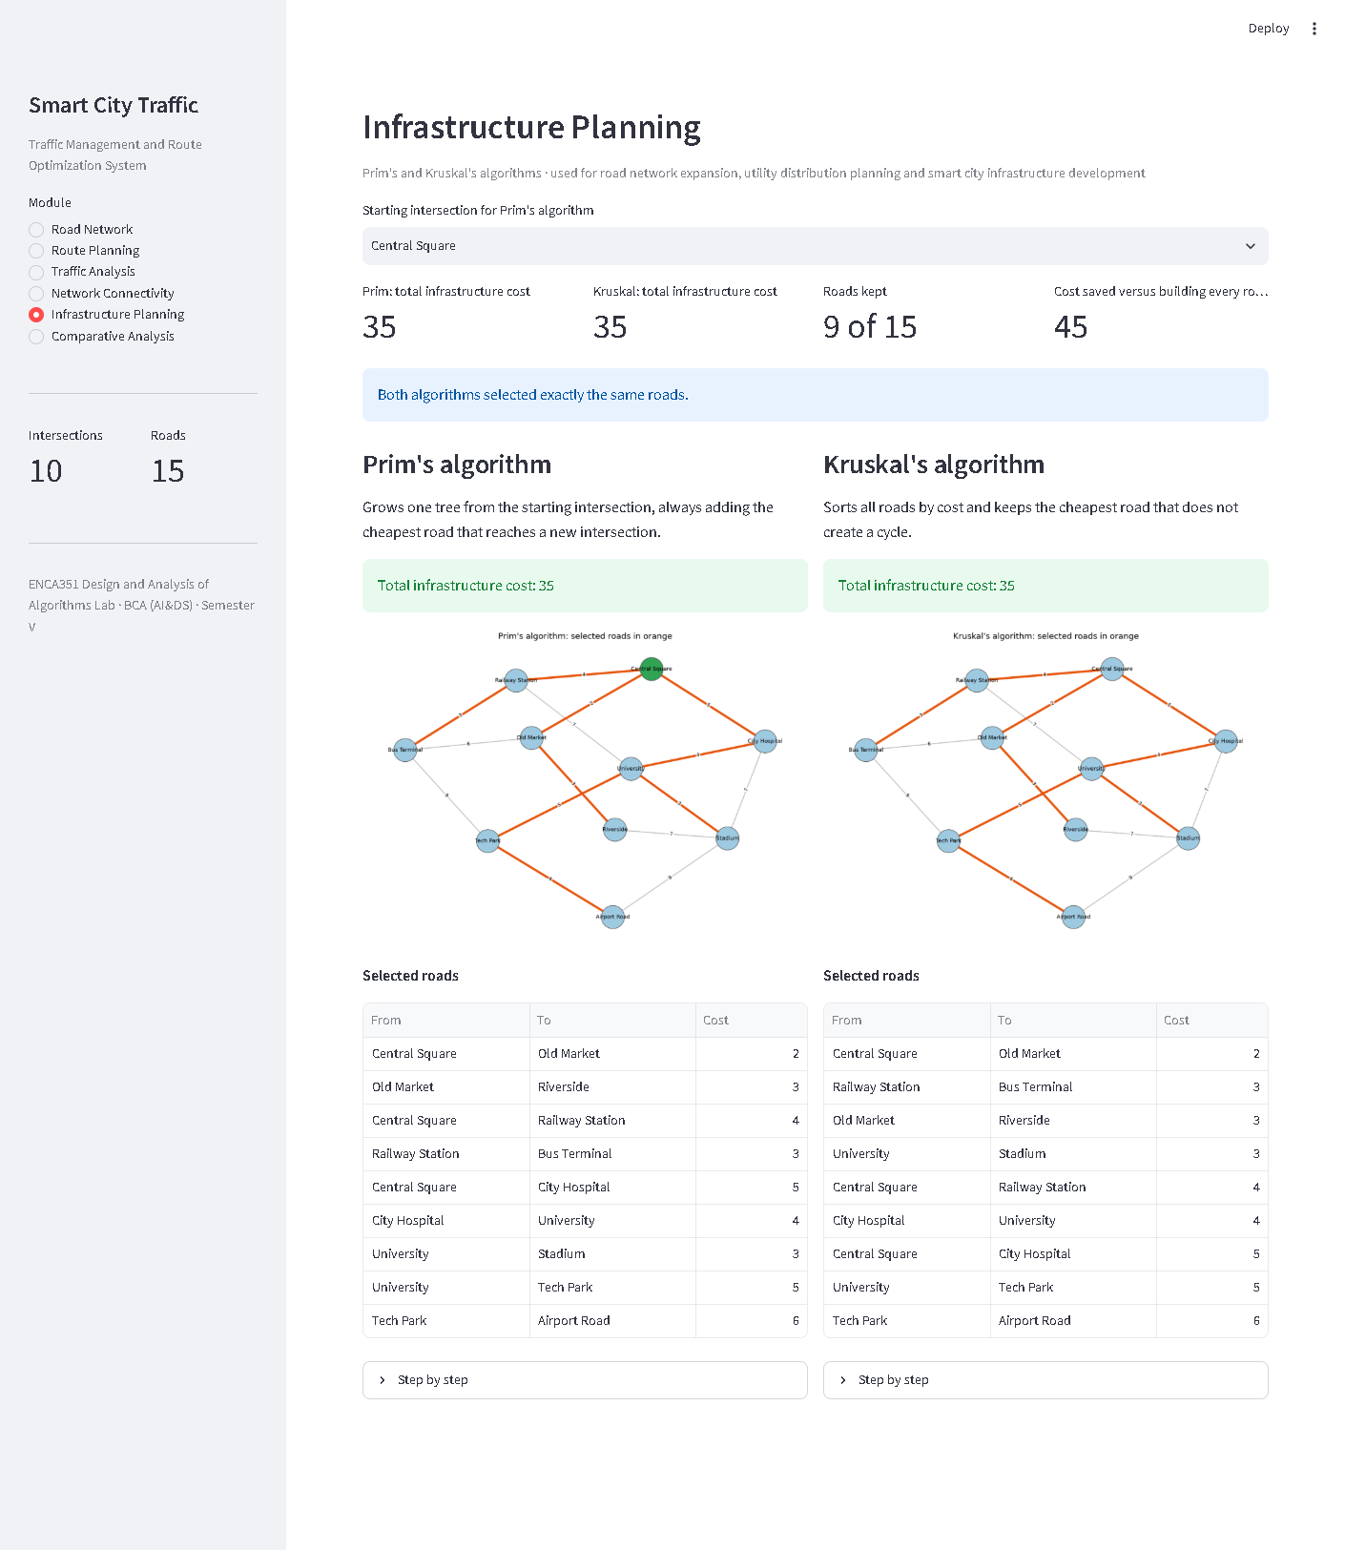
Figure 12: Infrastructure Planning page

3.6 Measurements on networks of different sizes
Random but connected cities with 10, 25, 50 and 100 intersections were generated with about two roads per intersection and costs between 1 and 20. Every algorithm was run on every city. The execution time is the median of 30 runs with the step recording switched off; the peak memory is measured with Python's tracemalloc module. The route is always from the first to the last intersection of the city. Table 17 contains every measurement; Figures 15 and 16 plot them.
Table 17: All measurements of the comparative analysis
Intersections | Roads | Algorithm | Time (ms) | Peak memory (KB) | Result
10 | 20 | Dijkstra | 0.0120 | 1.5 | route cost 27 using 2 roads
10 | 20 | Bellman-Ford | 0.0272 | 3.4 | route cost 27 using 2 roads
10 | 20 | BFS | 0.0068 | 2.2 | 10 intersections reached
10 | 20 | DFS | 0.0083 | 2.7 | 10 intersections reached
10 | 20 | Prim | 0.0147 | 1.4 | 9 roads, total cost 43
10 | 20 | Kruskal | 0.0236 | 3.8 | 9 roads, total cost 43
25 | 50 | Dijkstra | 0.0321 | 4.5 | route cost 18 using 5 roads
25 | 50 | Bellman-Ford | 0.0943 | 4.5 | route cost 18 using 5 roads
25 | 50 | BFS | 0.0173 | 5.1 | 25 intersections reached
25 | 50 | DFS | 0.0186 | 5.9 | 25 intersections reached
25 | 50 | Prim | 0.0403 | 3.4 | 24 roads, total cost 143
25 | 50 | Kruskal | 0.0625 | 4.6 | 24 roads, total cost 143
50 | 100 | Dijkstra | 0.0720 | 6.2 | route cost 19 using 7 roads
50 | 100 | Bellman-Ford | 0.1918 | 13.9 | route cost 19 using 7 roads
50 | 100 | BFS | 0.0335 | 7 | 50 intersections reached
50 | 100 | DFS | 0.0368 | 9.7 | 50 intersections reached
50 | 100 | Prim | 0.0812 | 3.7 | 49 roads, total cost 262
50 | 100 | Kruskal | 0.1258 | 13.4 | 49 roads, total cost 262
100 | 200 | Dijkstra | 0.1595 | 18 | route cost 31 using 3 roads
100 | 200 | Bellman-Ford | 0.4460 | 17.3 | route cost 31 using 3 roads
100 | 200 | BFS | 0.0702 | 17.8 | 100 intersections reached
100 | 200 | DFS | 0.0744 | 21.7 | 100 intersections reached
100 | 200 | Prim | 0.1648 | 12.7 | 99 roads, total cost 663
100 | 200 | Kruskal | 0.2651 | 15.5 | 99 roads, total cost 663

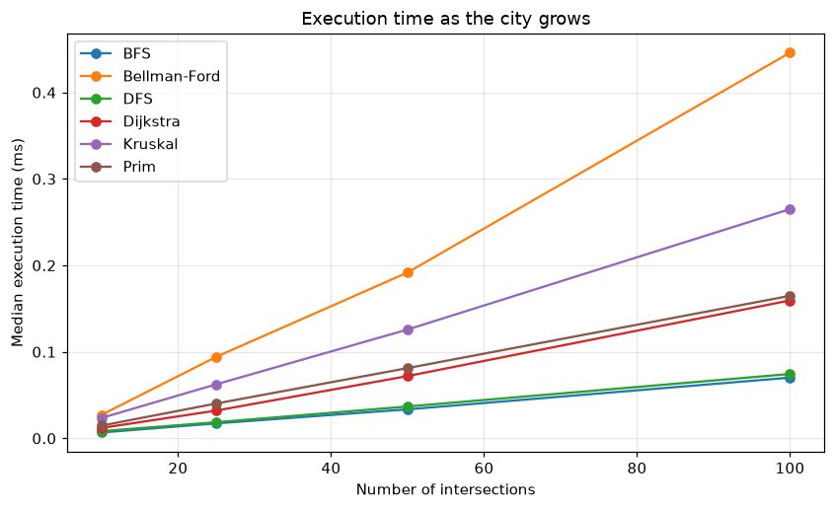
Figure 13: Execution time as the city grows
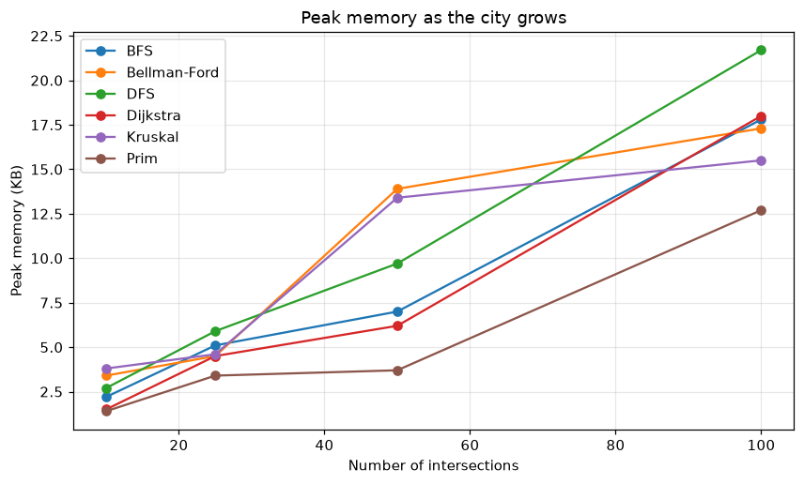
Figure 14: Peak memory as the city grows
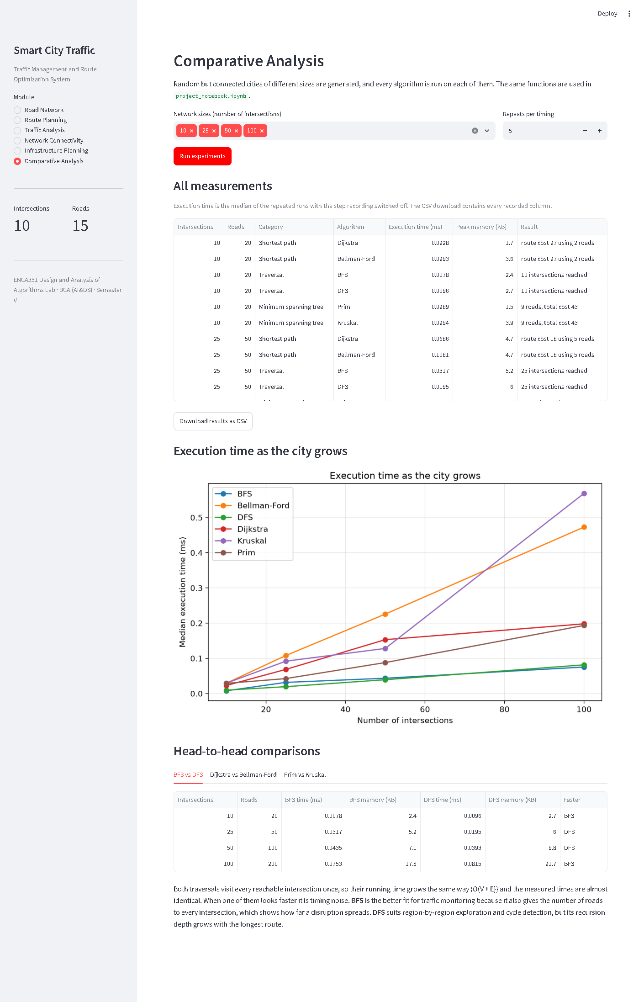
Figure 15: Comparative Analysis page of the application

4. Analysis

4.1 Comparison of graph algorithms
The three head-to-head comparisons below come from the measurements in Table 17. All timings are fractions of a millisecond, so the ratios between algorithms matter more than the absolute values, which would change on a different computer.
Table 18: BFS versus DFS
Intersections | Roads | BFS time (ms) | DFS time (ms) | BFS memory (KB) | DFS memory (KB) | Faster
10 | 20 | 0.0068 | 0.0083 | 2.2 | 2.7 | BFS
25 | 50 | 0.0173 | 0.0186 | 5.1 | 5.9 | BFS
50 | 100 | 0.0335 | 0.0368 | 7 | 9.7 | BFS
100 | 200 | 0.0702 | 0.0744 | 17.8 | 21.7 | BFS

BFS versus DFS. Both traversals visit every reachable intersection exactly once and look at every road twice, so both run in O(V + E) time, and the measurements agree: the two are within a few microseconds of each other at every size, and the memory used grows the same way. For traffic management BFS is the more useful of the two because it also produces the number of roads from the start to every intersection, which tells a control room how far a disruption spreads. DFS is a natural fit for exploring the network region by region and for detecting cycles, but the recursive version goes one call deeper for every intersection on the current route, which becomes a limitation on very long chains of roads.
Table 19: Dijkstra versus Bellman-Ford
Intersections | Roads | Dijkstra time (ms) | Bellman-Ford time (ms) | Bellman-Ford / Dijkstra | Bellman-Ford passes | Dijkstra memory (KB) | Bellman-Ford memory (KB)
10 | 20 | 0.0120 | 0.0272 | 2.3× | 2 | 1.5 | 3.4
25 | 50 | 0.0321 | 0.0943 | 2.9× | 4 | 4.5 | 4.5
50 | 100 | 0.0720 | 0.1918 | 2.7× | 4 | 6.2 | 13.9
100 | 200 | 0.1595 | 0.4460 | 2.8× | 5 | 18 | 17.3

Dijkstra versus Bellman-Ford. Both algorithms found the same route and the same cost on every city, as they must. Dijkstra was the faster one at every size, between 2.3 and 2.9 times faster than Bellman-Ford. The reason is the amount of work per road: Dijkstra relaxes each road once, when the intersection it leaves is settled, so its cost is O((V + E) log V). Bellman-Ford relaxes every road in every pass, so its cost is O(V × E) in the worst case. The early stop kept the number of passes small, between 2 and 5 instead of V − 1, which is why the gap did not grow even wider on these random cities. For live navigation Dijkstra is clearly the right choice. Bellman-Ford still earns its place in the traffic analysis module: it is simple to rerun after a planner edits road costs and its pass-by-pass table is easy to explain and to check by hand. It would also tolerate negative costs and detect negative cycles, which Dijkstra cannot do; in this project every road cost is positive, so that ability is a safety net rather than a daily need.
Table 20: Prim versus Kruskal
Intersections | Roads | Prim time (ms) | Kruskal time (ms) | Kruskal / Prim | Prim memory (KB) | Kruskal memory (KB)
10 | 20 | 0.0147 | 0.0236 | 1.6× | 1.4 | 3.8
25 | 50 | 0.0403 | 0.0625 | 1.6× | 3.4 | 4.6
50 | 100 | 0.0812 | 0.1258 | 1.5× | 3.7 | 13.4
100 | 200 | 0.1648 | 0.2651 | 1.6× | 12.7 | 15.5

Prim versus Kruskal. Both algorithms reached the same minimum total cost on every city, as they must. Prim was faster at every size, by a factor of 1.5 to 1.6, and usually used less memory. Prim only pushes the roads that leave the growing tree onto its heap, while Kruskal must first sort every road and then run a union-find check on each one. Kruskal's advantage is clarity rather than speed: its sorted list of roads with an accept or reject decision for each one (Table 16) is the easier result to explain to city planners, and it works directly on a plain list of roads without needing an adjacency structure.

4.2 Traffic optimization observations
- A route that is optimal at one moment is not optimal for long. Tripling the cost of the roads on the best route pushed the commuter onto a completely different route through the other side of the city, and closing a single road did the same. A traffic system therefore has to recompute routes whenever costs change, which is exactly what the Bellman-Ford module does on a copy of the city.
- Alternative routes limit the damage. In both scenarios the extra travel cost was only one minute because the sample city has parallel routes. A city with a single main road would see far larger increases, which argues for keeping alternatives even if they are not used in normal traffic.
- Showing the working builds trust. The intermediate distance updates and the pass-by-pass tables make it possible to check a route by hand, which matters when an administrator has to justify a diversion.
- Rerouting must be cheap. Even Bellman-Ford took well under a millisecond on 100 intersections, so a city could recompute routes for every reported change in real time; for larger networks Dijkstra's better scaling would matter.

4.3 Infrastructure planning insights
- The minimum spanning tree of the sample city keeps 9 of 15 roads and costs 35 instead of 80, a saving of 56 percent, while still connecting every intersection.
- The spanning tree has no redundancy: every road in it is a bridge, so a single closure splits the city. The connectivity module showed how quickly a city breaks into regions when roads are removed. A real plan would start from the tree and then add the cheapest roads that create alternative routes for the busiest connections.
- Prim and Kruskal always agree on the total cost, so either can be used; the choice depends on whether a planner prefers to grow the network from a chosen point (Prim) or to review roads in order of cost (Kruskal).

4.4 Suitability of each algorithm for traffic management
Table 21: Suitability of each algorithm
Algorithm | Best suited for | Why
Dijkstra | Live route planning for commuters and emergency vehicles | Fastest and scales best; needs positive costs, which travel times always are
Bellman-Ford | Recomputing routes after administrators edit road costs | Simple to rerun on an edited graph; its pass-by-pass working is easy to explain and check
BFS | Monitoring how far a disruption spreads | Gives the number of roads from the start to every intersection
DFS | Exploring a region or checking whether a route exists | Same cost as BFS; naturally follows one road to its end
Prim | Growing a new network from an existing hub | Fastest MST algorithm in the experiments; expands from a chosen intersection
Kruskal | Reviewing candidate roads in order of construction cost | Produces a sorted accept or reject list that is easy to explain

5. Conclusion

5.1 Key findings
- A city road network fits naturally into a weighted graph. The adjacency list keeps every operation simple and the adjacency matrix gives a readable overview.
- Dijkstra's algorithm found the fastest route in the sample city (20 minutes from Central Square to Airport Road) and its intermediate distance updates make the result easy to verify.
- The Bellman-Ford module recomputed routes after congestion and closures and quantified the extra travel cost; in both scenarios a good alternative route limited the loss to one minute.
- BFS and DFS showed which intersections are reachable, in what order, and how the city splits into regions when roads close.
- Prim's and Kruskal's algorithms connected every intersection for 35 instead of 80, and always agreed with each other.
- In the experiments Dijkstra was two to three times faster than Bellman-Ford, Prim was faster than Kruskal, and BFS and DFS were indistinguishable. Every algorithm finished in under half a millisecond on a city of 100 intersections.

5.2 Benefits of graph algorithms in transportation systems
Graph algorithms turn a map into something a computer can reason about. They give exact answers, not estimates: the route Dijkstra returns is provably the cheapest one for the given costs, and the spanning tree Kruskal builds is provably the cheapest way to connect the city. They are fast enough to run continuously as conditions change, they show their working so that decisions can be checked, and the same code serves commuters, control rooms and planners. Because the algorithms only see vertices, edges and weights, the same system works for a metro network, a delivery fleet or a set of utility lines.

5.3 Future improvements
- One-way roads, which need a directed graph and small changes to the traversal and MST modules.
- Live costs from traffic sensors or a map service, so that congestion is measured instead of simulated.
- A* search with a geographic heuristic to speed up route planning on city-scale networks.
- Traffic signal timing at intersections, modelled as a waiting cost on the vertices.
- Resilience planning: start from the minimum spanning tree and add the cheapest roads that give every busy connection a second route.

References
[1] T. H. Cormen, C. E. Leiserson, R. L. Rivest and C. Stein, Introduction to Algorithms, 4th edition, MIT Press, 2022. Chapters on elementary graph algorithms, minimum spanning trees and single-source shortest paths.
[2] J. Kleinberg and É. Tardos, Algorithm Design, Pearson, 2006. Chapters 3 and 4.
[3] Python Software Foundation, Python 3 documentation, https://docs.python.org/3/
[4] Streamlit Inc., Streamlit documentation, https://docs.streamlit.io/
[5] NetworkX developers, NetworkX documentation, https://networkx.org/documentation/stable/
[6] Matplotlib developers, Matplotlib documentation, https://matplotlib.org/stable/

Appendix A: Repository contents
Table 22: Files in the GitHub repository
File or folder | Contents
README.md | Overview, setup and usage instructions, results summary
app.py | Streamlit web application
road_network.py | RoadNetwork graph class, adjacency list and matrix, CSV load and save
route_planner.py | Dijkstra's algorithm
traffic_analysis.py | Bellman-Ford algorithm and congestion simulation
connectivity_module.py | Breadth first search, depth first search, connected regions
mst_planner.py | Prim's and Kruskal's algorithms
experiments.py | Comparative analysis helpers
visualizer.py | Map drawing and table formatting
project_notebook.ipynb | Walk-through of every module and the comparative analysis, saved with outputs
results/ | experiment_results.csv and the figures produced by the notebook
screenshots/ | Screenshots of the running application
report/ | This report
requirements.txt | streamlit, networkx, matplotlib, pandas, numpy, jupyter

Appendix B: Running the project
1. Create and activate a virtual environment: python -m venv .venv, then .venv\Scripts\activate.
2. Install the packages: pip install -r requirements.txt.
3. Start the application: streamlit run app.py, then open http://localhost:8501.
4. Open the notebook: jupyter notebook project_notebook.ipynb.

