SPAWN POINT
Game Design Document (GDD)

Tagline: Fix broken games before the studio collapses
Team: Shreyansh Dixit
Date of Last Update: May 2026

Index
1. Title Page
2. Game Overview
3. Gameplay
4. Mechanics
5. Story and Narrative
6. Game World
7. Characters
8. Levels
9. Interface

2. Game Overview

2.1 Game Concept
Spawn Point is a roguelike game design simulation where the player controls a newly hired game designer navigating a struggling indie studio. The player physically moves within a pixel-art office environment to collect broken game briefs and solve them using design decisions under time and resource constraints.

2.2 Target Audience
Segment | Age | Platform | Interests
Game Design Students | 18–28 | PC/Mobile | Systems, GDLC
Strategy Players | 16–35 | Mobile | Decision making
Indie Game Fans | 18–35 | PC | Pixel art, simulation

2.3 Genre(s)
Roguelike, Simulation, Strategy, Light Exploration

2.4 Game Flow Summary
Main Menu → Cutscene → Office Map → Reception → Game Brief → Desk → Solve via Cards → Simulation → Results → Upgrade → Next Run
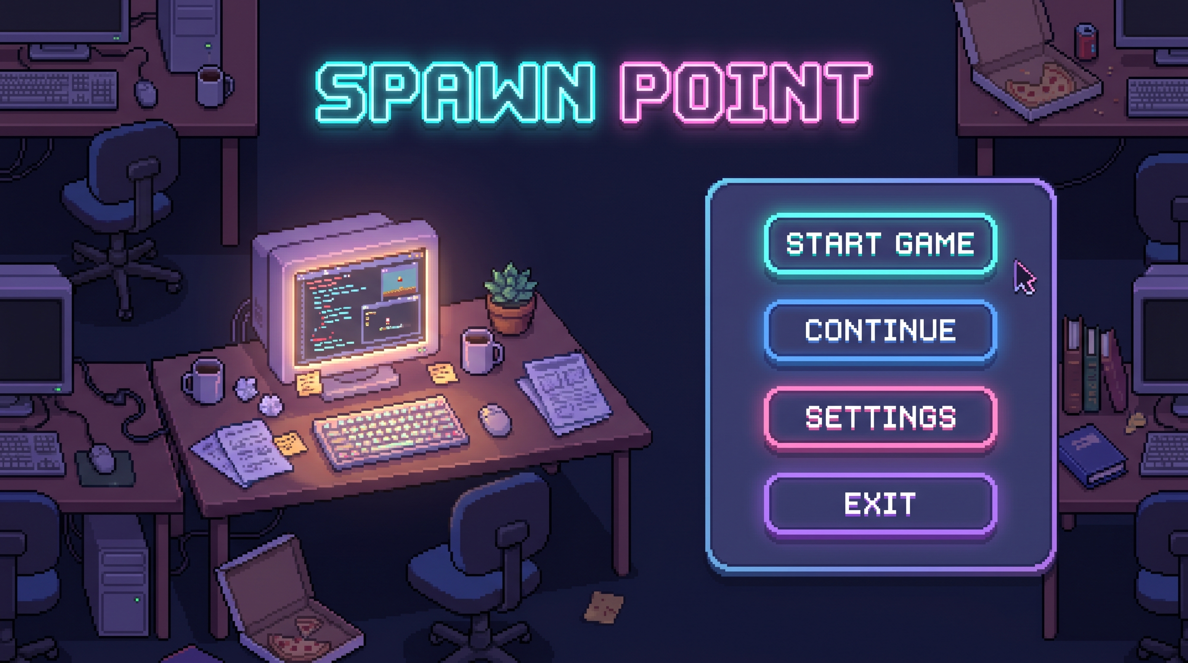
Figure 1 Main Menu screen showing entry interface and visual tone

2.5 Look and Feel
Pixel-art top-down style with neon-lit indoor office aesthetics. The environment feels cozy yet chaotic, with animated NPCs working in the background. Interaction zones such as reception and desk are clearly highlighted.

3. Gameplay

3.1 Objectives
- Fix broken game systems
- Improve retention, engagement, and revenue
- Meet deadlines
- Manage resources effectively
- Progress in career

3.2 Game Progression
Players begin as a Junior Designer and progress through roles by completing tasks. Rewards can be used to unlock skills, tools, and upgrades.

3.3 Play Flow
Walk to Reception → Interact → View Brief → Accept Task → Walk to Desk → Apply Cards → Monitor Stats → Complete → Results
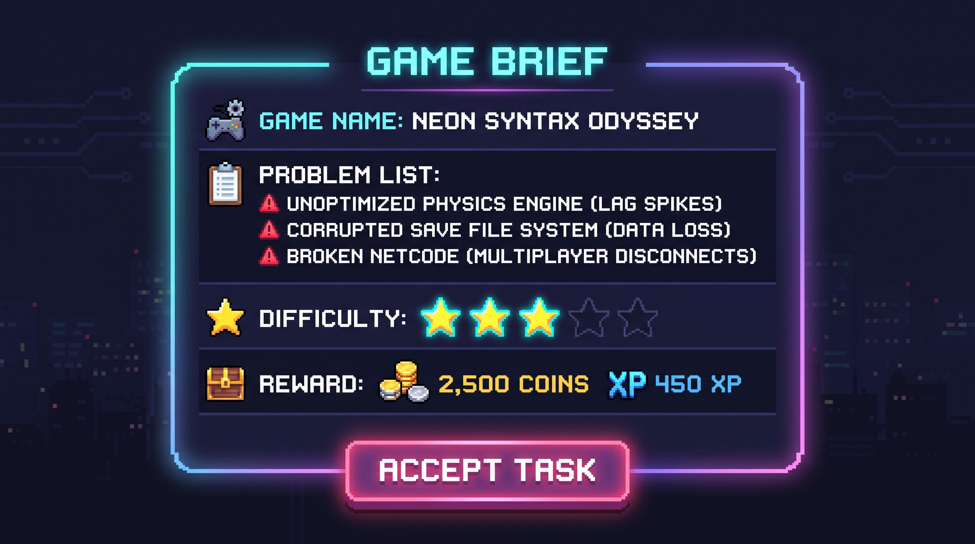
Figure 2 Game Brief panel showing problem overview and task details

3.4 Mission / Challenge Structure
Each mission presents a game concept with multiple issues such as low retention or weak monetization, along with limited time and energy constraints.

3.5 Puzzle Structure
System-based decision puzzles where players balance trade-offs to optimize outcomes.

4. Mechanics

4.1 Rules
- Player must move physically within office
- Resources are limited
- Every decision has trade-offs
- Deadlines must be met
- Energy decreases over time

4.2 Model of Game Universe
Movement → Interaction → Decision → Stat Change → Simulation → Feedback

4.3 Physics
Basic 2D top-down movement with collision.

4.4 Economy
Players earn currency through successful tasks. Currency is used for skill upgrades, courses, and consumables. Energy management plays a key role during runs.

4.5 Character Movement
Top-down movement using WASD or joystick.

4.6 Objects
Reception desk, work desk, vending machine, NPCs, and game brief cards.
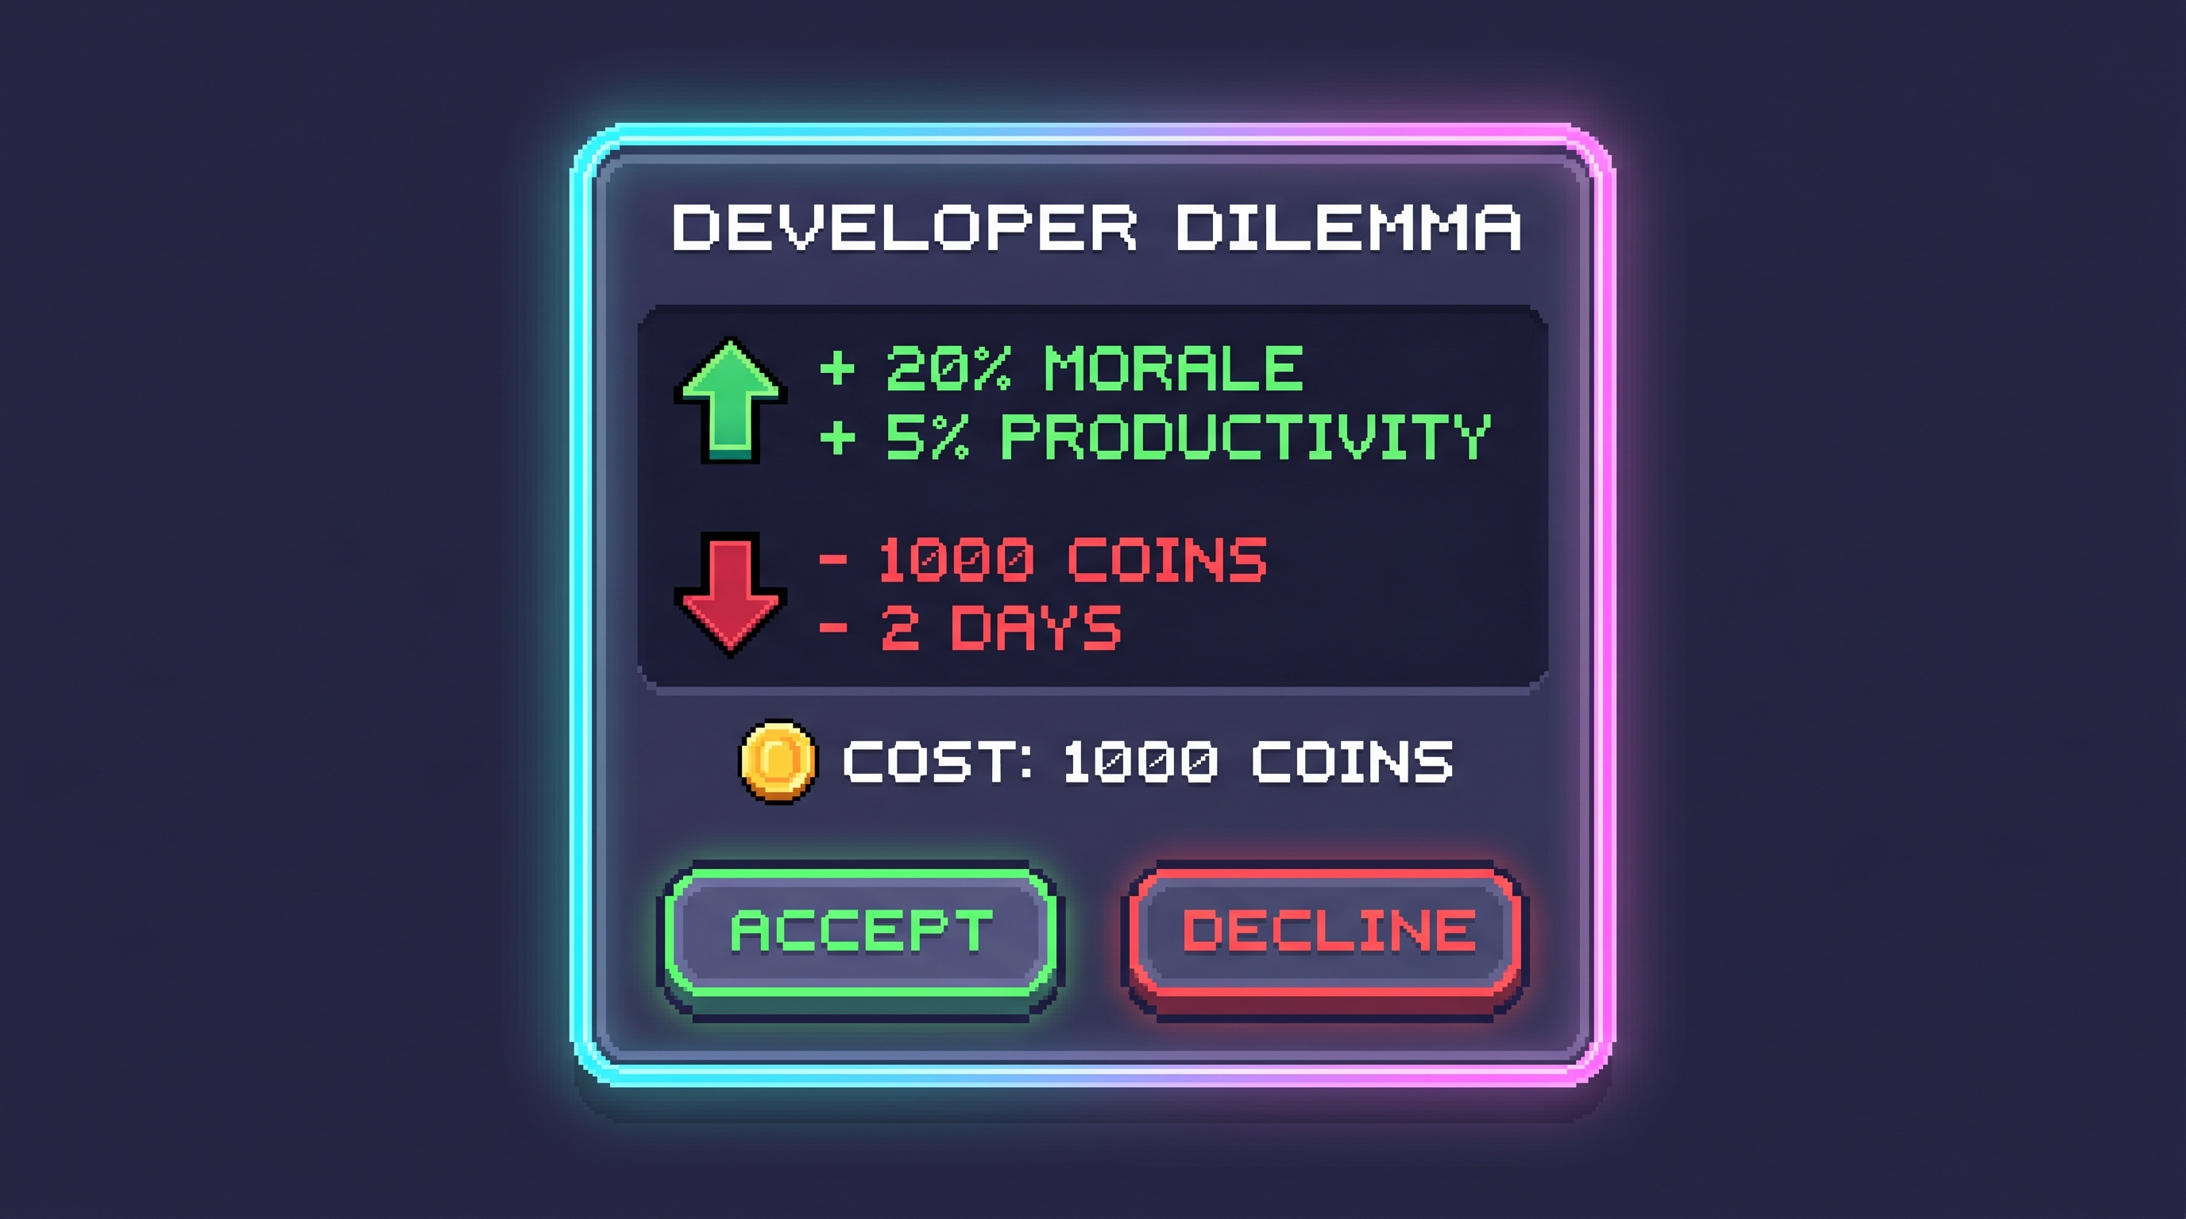
Figure 3 Example decision card with trade-offs and cost

4.7 Actions
Move, interact, select cards, apply decisions.

4.8 Combat
Not applicable.

4.9 Screen Flow
Main Menu → Cutscene → Office Map → Reception Panel → Desk Panel → Result Screen → Upgrade Screen → Repeat
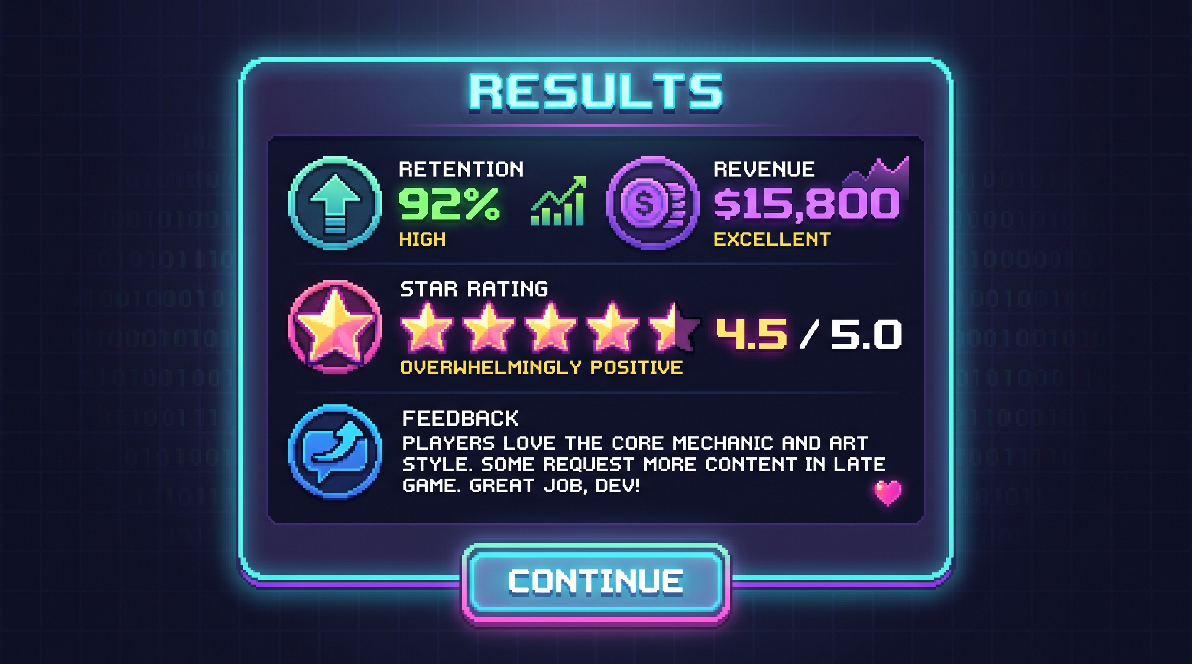
Figure 4 Result screen displaying performance metrics and player feedback

4.10 Game Options
Sound toggle, music toggle, basic settings.

4.11 Replaying and Saving
Roguelike runs with persistent meta progression.

4.12 Cheats and Easter Eggs
To be added.

5. Story and Narrative

5.1 Backstory
Vivan, a struggling individual, secures a job as a game designer in a failing indie studio.

5.2 Plot Elements
Studio crisis, increasing responsibility, career growth.

5.3 Story Progression
Tasks become more complex and impactful over time.

5.4 Cutscenes
Pixel-art intro cutscene depicting Vivan’s journey and entry into the studio.

6. Game World
Pixel-art office environment with reception, desks, vending machine, and NPC areas.
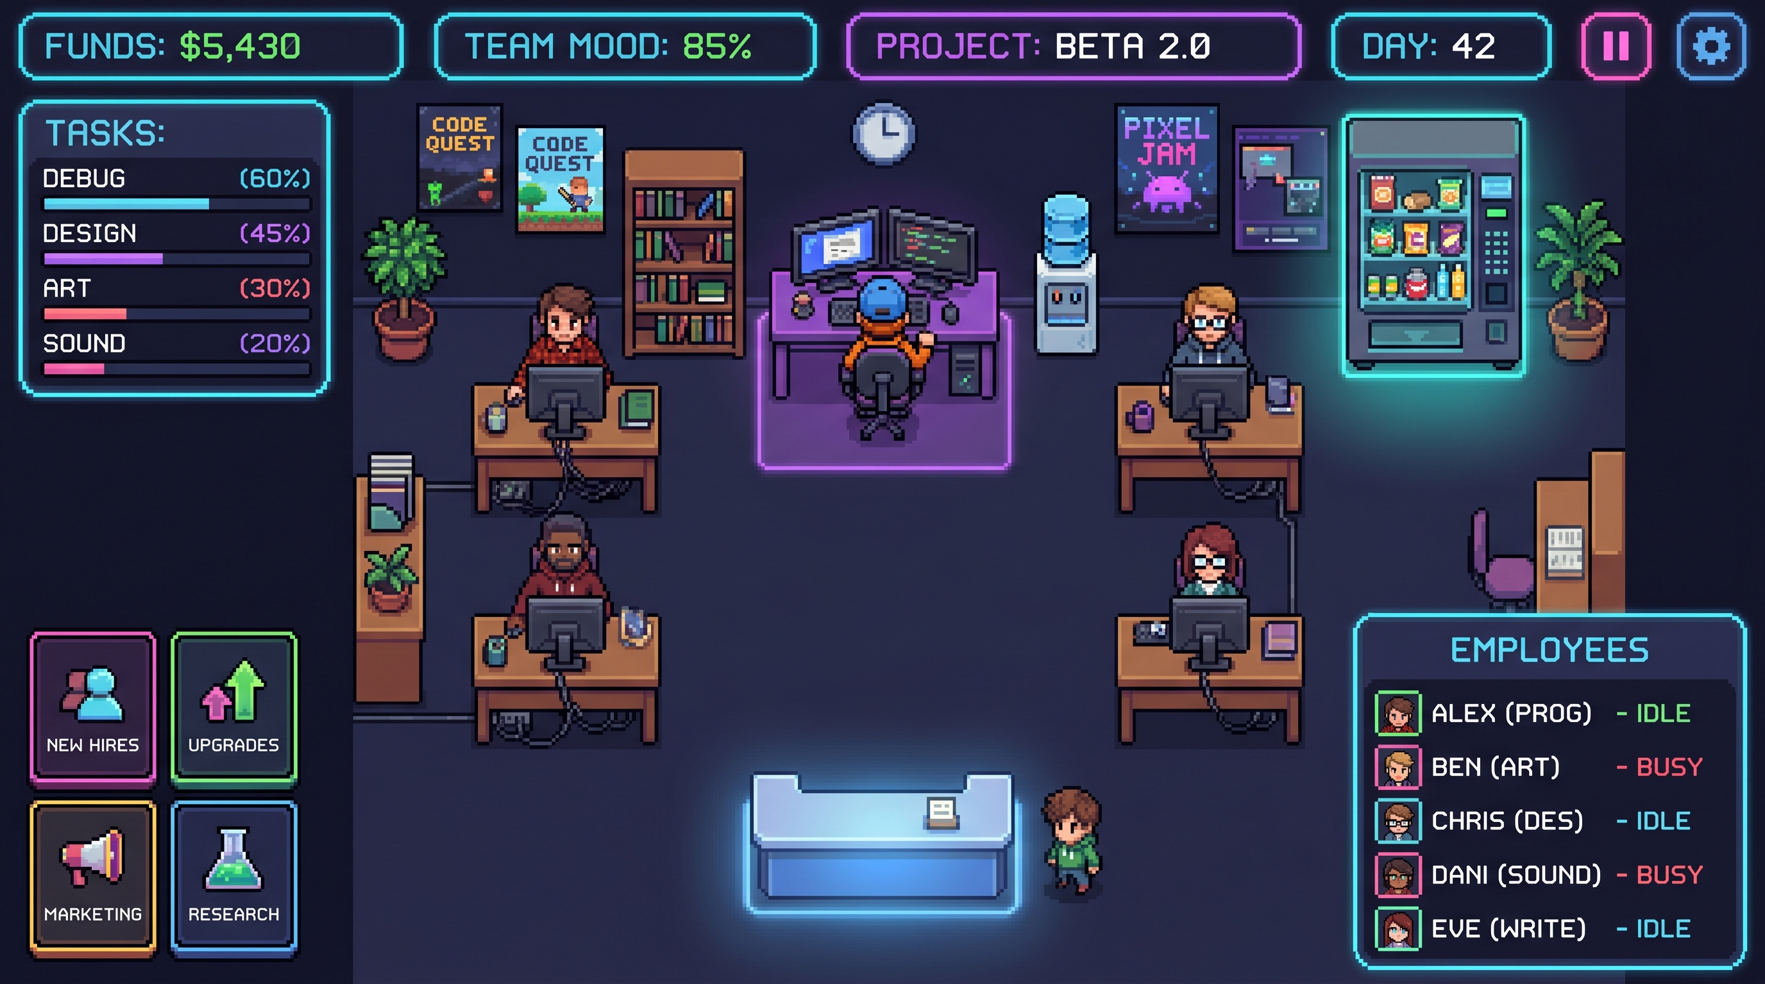
Figure 5 Office gameplay environment with NPCs, reception, and interactive zones

7. Characters

Main Character
Vivan – A determined beginner aiming to grow into a lead designer.

NPCs
Name | Role
Riya | Receptionist
Arjun | Senior Developer
Meera | UI Designer
Kabir | QA Tester
Neha | Producer

8. Levels
Training level introduces movement and card system. Later levels increase complexity.

9. Interface
Pixel-art UI with HUD showing resources. Menus include main, work panel, result screen, and upgrades. Audio includes ambient office sounds and retro UI effects.
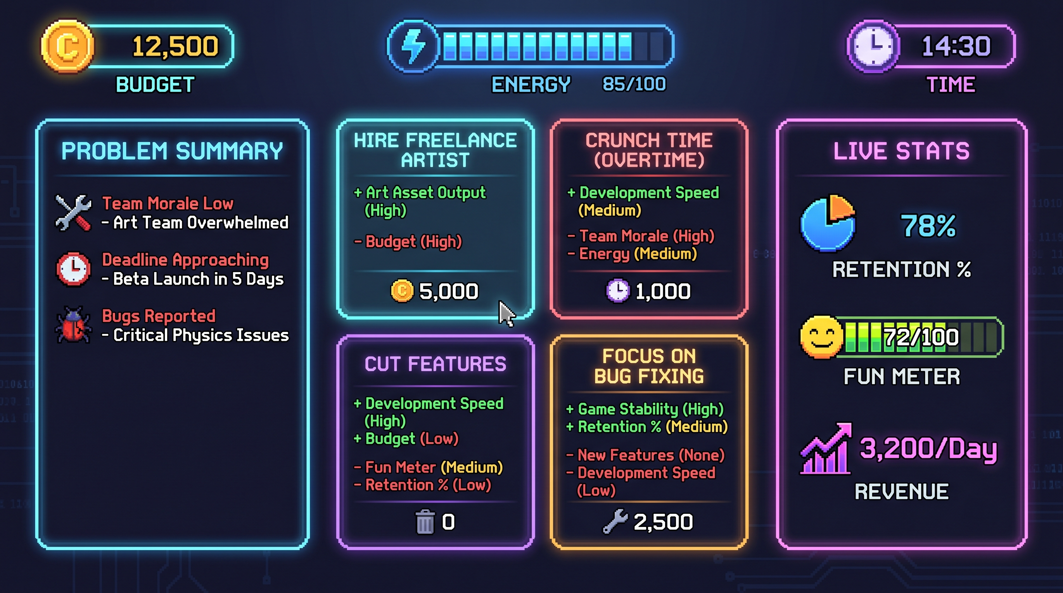
Figure 6 Core gameplay UI showing decision cards, problem summary, and live stats

