Quality Manual

1. Scope
This manual applies to all manufacturing sites and to every supplier of safety critical parts.

2. Responsibilities
- Plant head
- Quality manager
- Approves the audit plan
- Reviews corrective actions

3. Audit schedule
Audit schedule 2026
Site | Quarter | Auditor | Status
Pune | Q2 | R. Kulkarni | Planned
Chakan | Q3 | A. Rao | Open
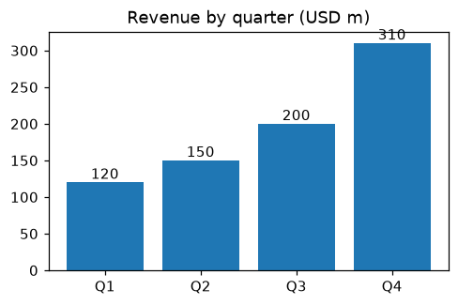
Figure 1. Non-conformances by quarter.

