Quarterly Review
Revenue grew in every quarter of the year.
Quarter | Revenue
Q1 | 120
Q4 | 310
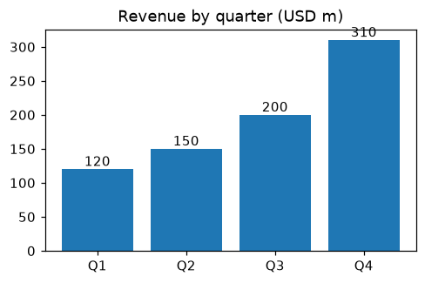
Figure 1. Revenue by quarter (USD m).

Photo 1. The Chakan plant.

