ASSIGNMENT-1

AIM : Implement NOT , AND , OR gates using NAND gate using NAND2TETRIS Simulator SCHEMATIC DIAGRAM , BOOLEAN EXPRESSION and TRUTH TABLE :

[A] NOT gate using NAND –
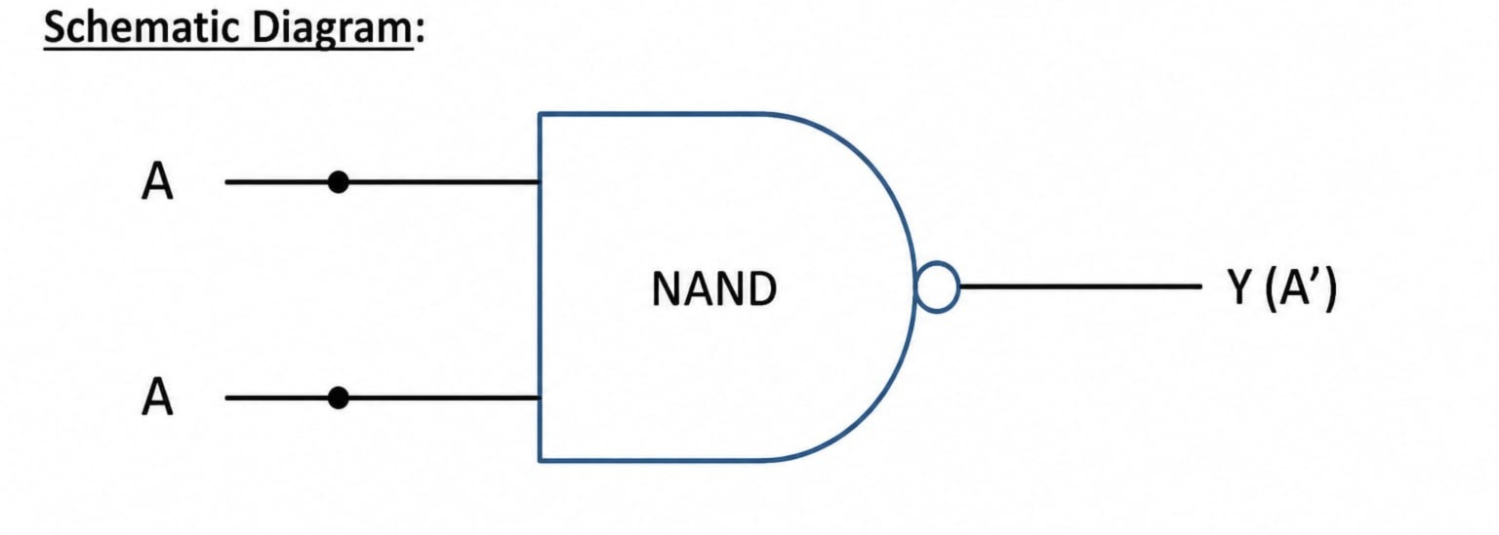

Boolean Expression –
Y = (A.A)’=A’
Truth Table –
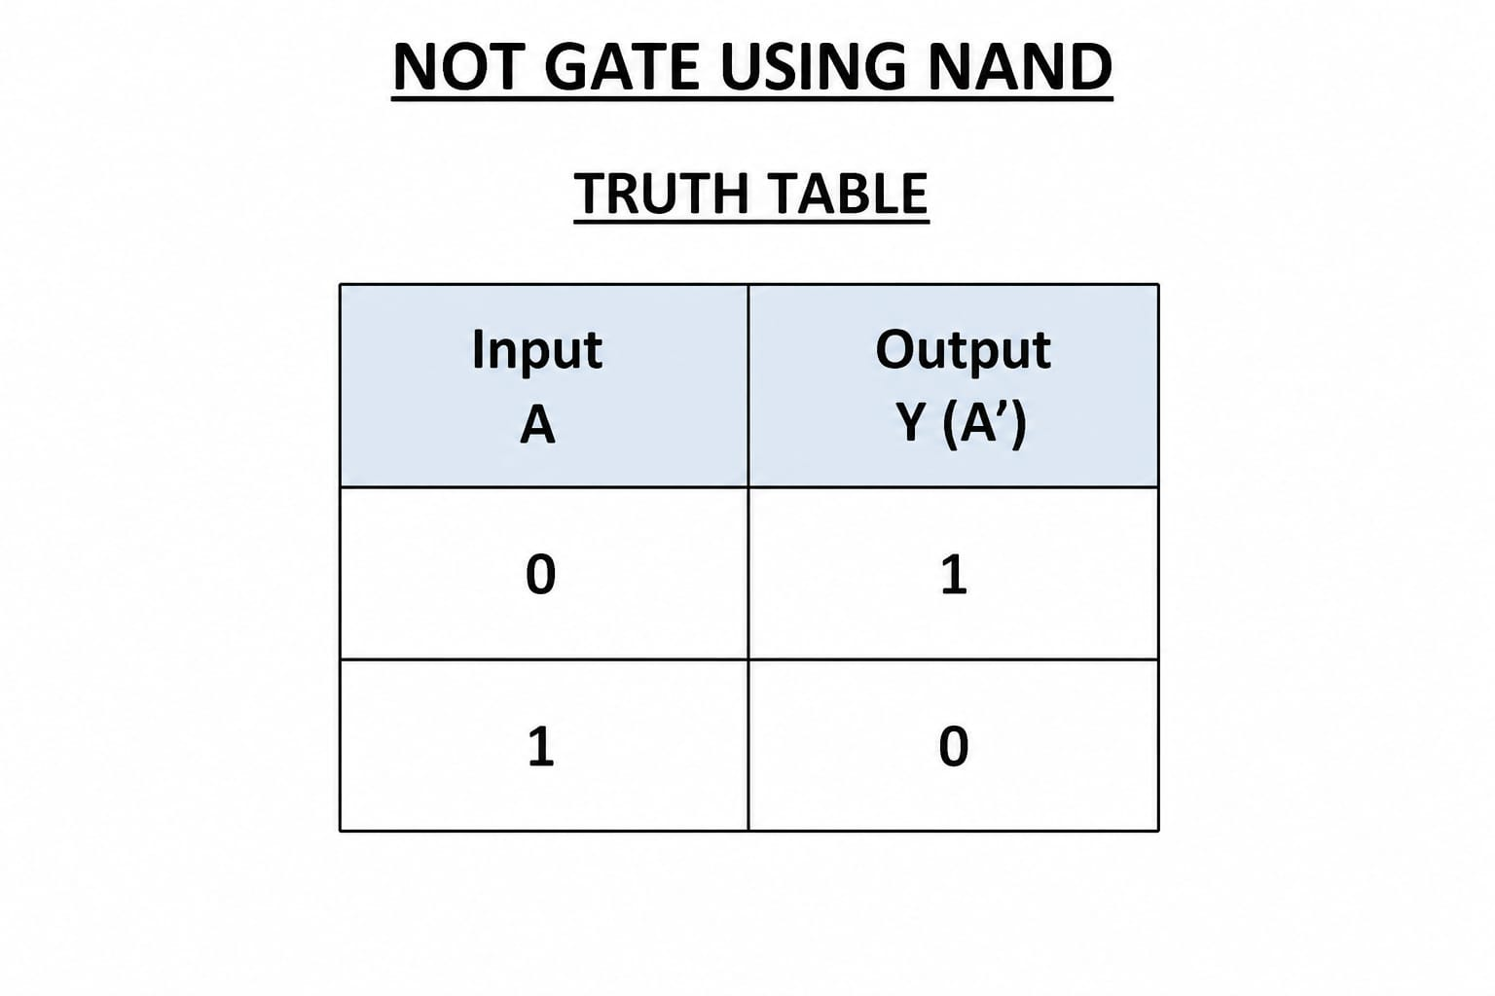

Code :
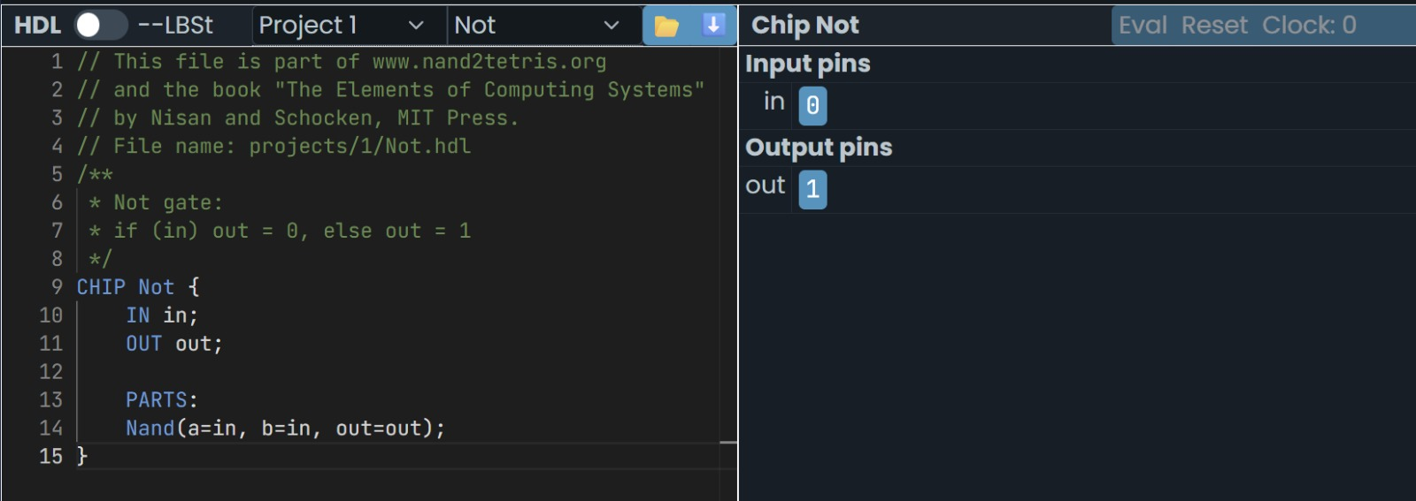

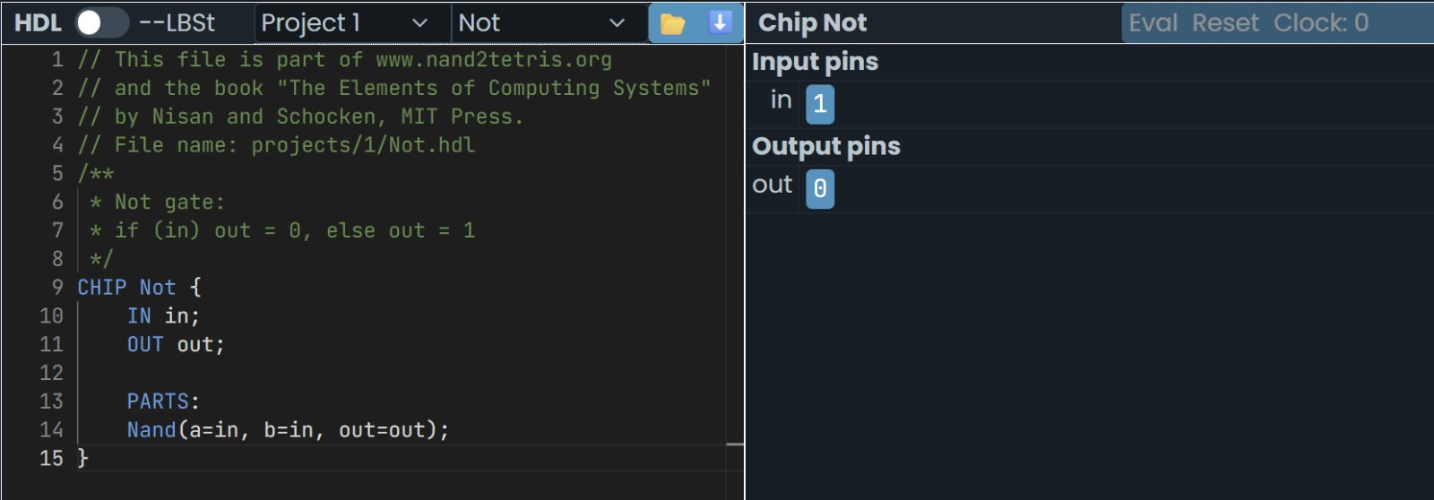

[B] AND gate using NAND:
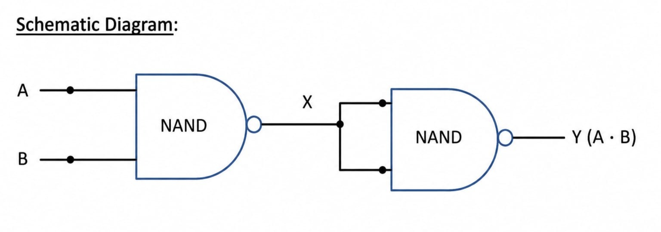
Boolean Expression :
X=(A.B)’
Y=(X.X)’=A.B
Truth Table :
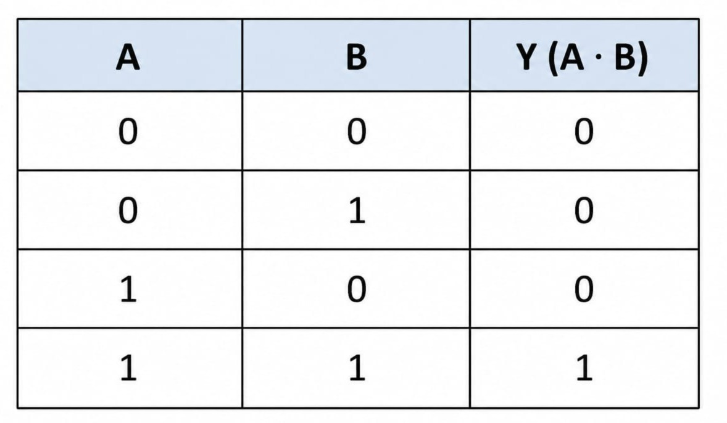
Code :
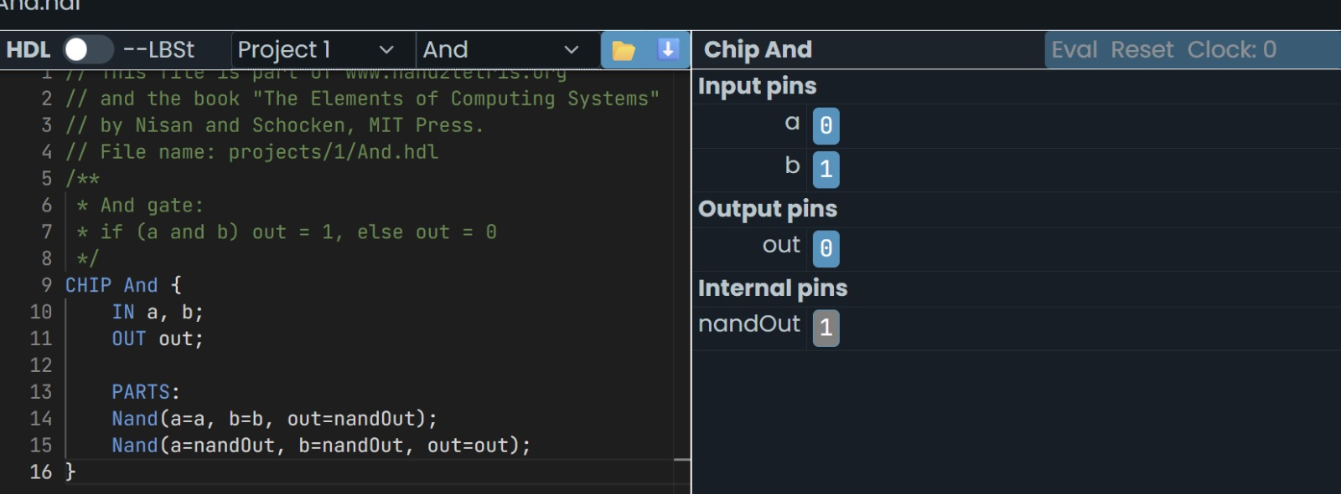

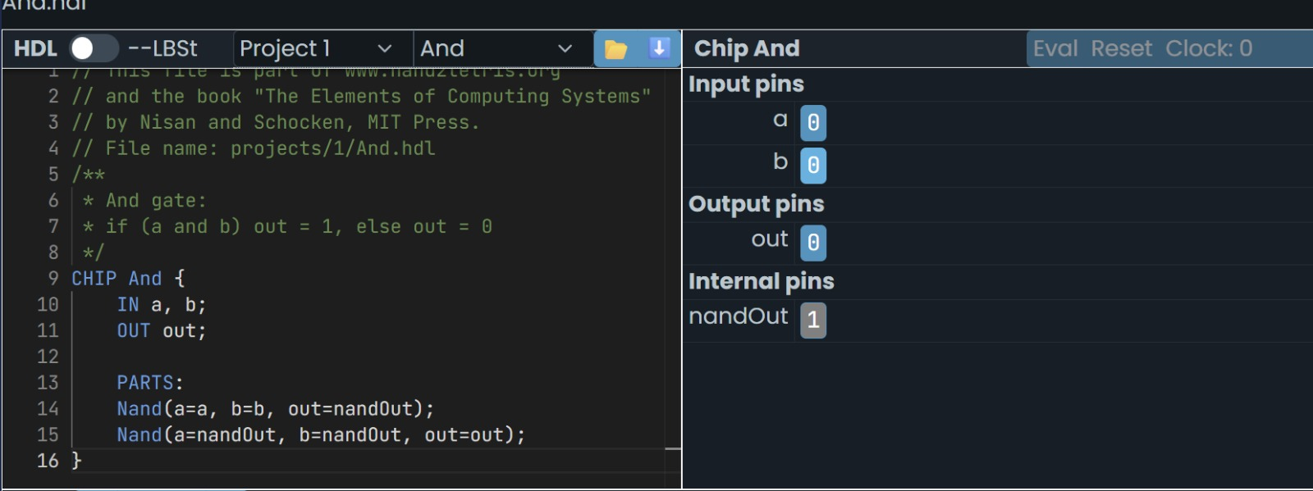

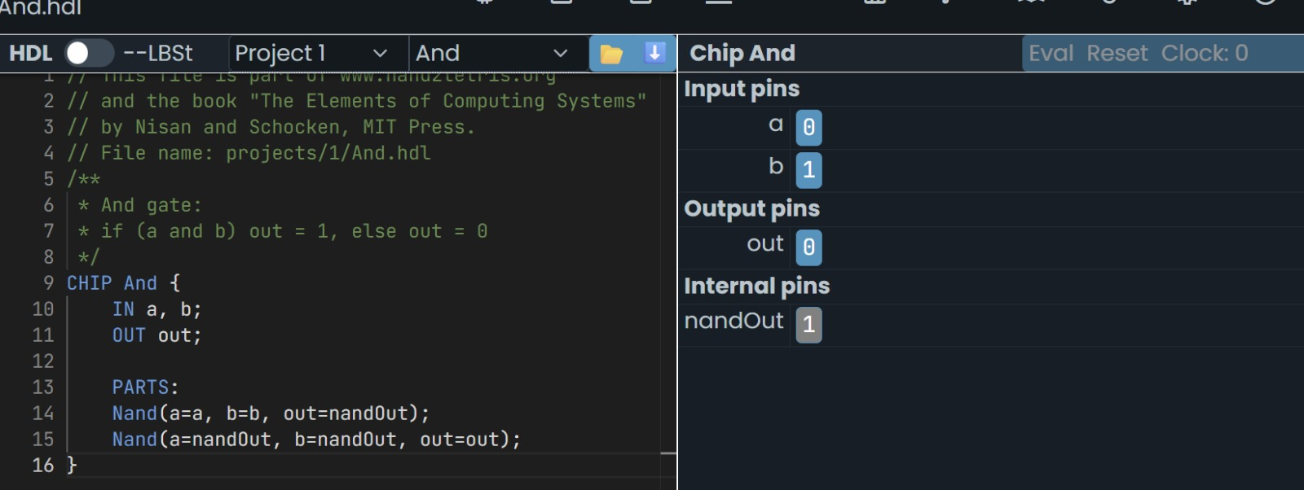

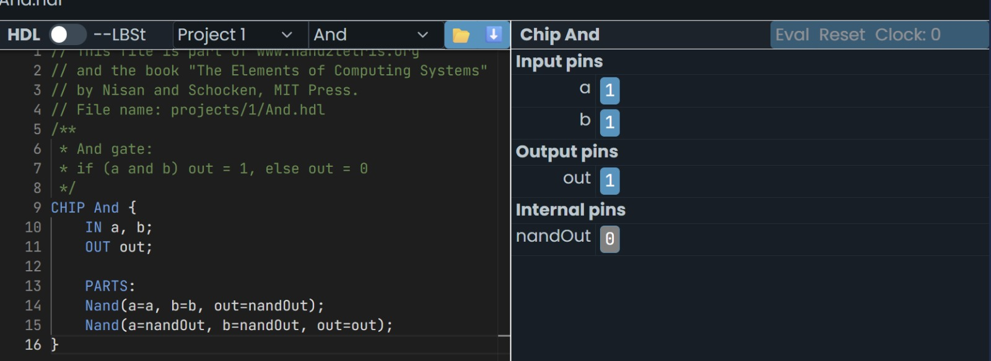

[c] OR gate using NAND :
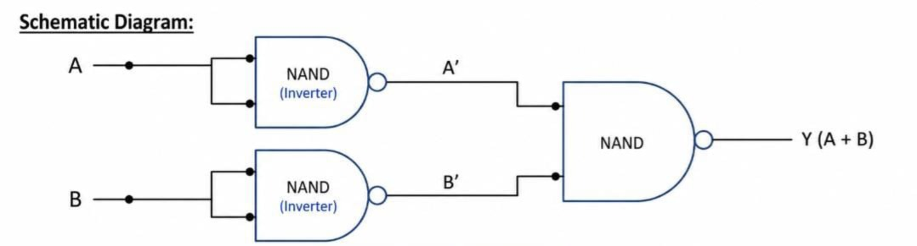
Boolean Expression –
Y= (A’.B’)’=A+B
Truth Table –
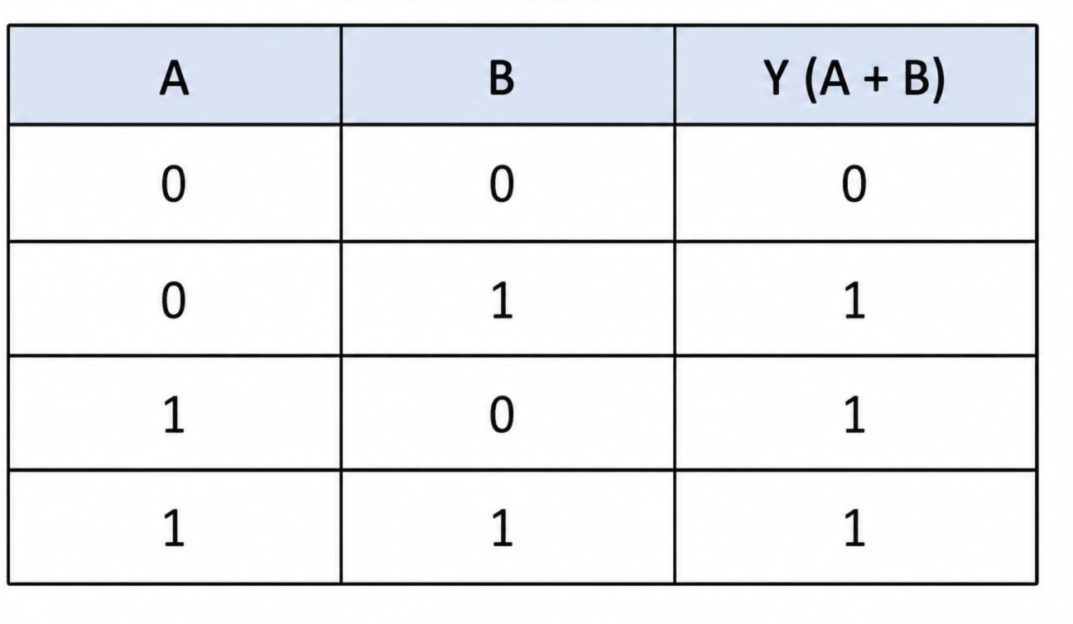

Code-
