**Assignment No. 4**

Name : Srushti Nandgaonkar

Roll No. 66

**Aim : Problem Statement**

Set up a GitLab CI/CD Pipeline.

* Create a blank project :

Create a blank project. Create a gitlab-ci.yml file at the root of your repository. This file is where you define the CI/CD jobs and choose the template as bash.

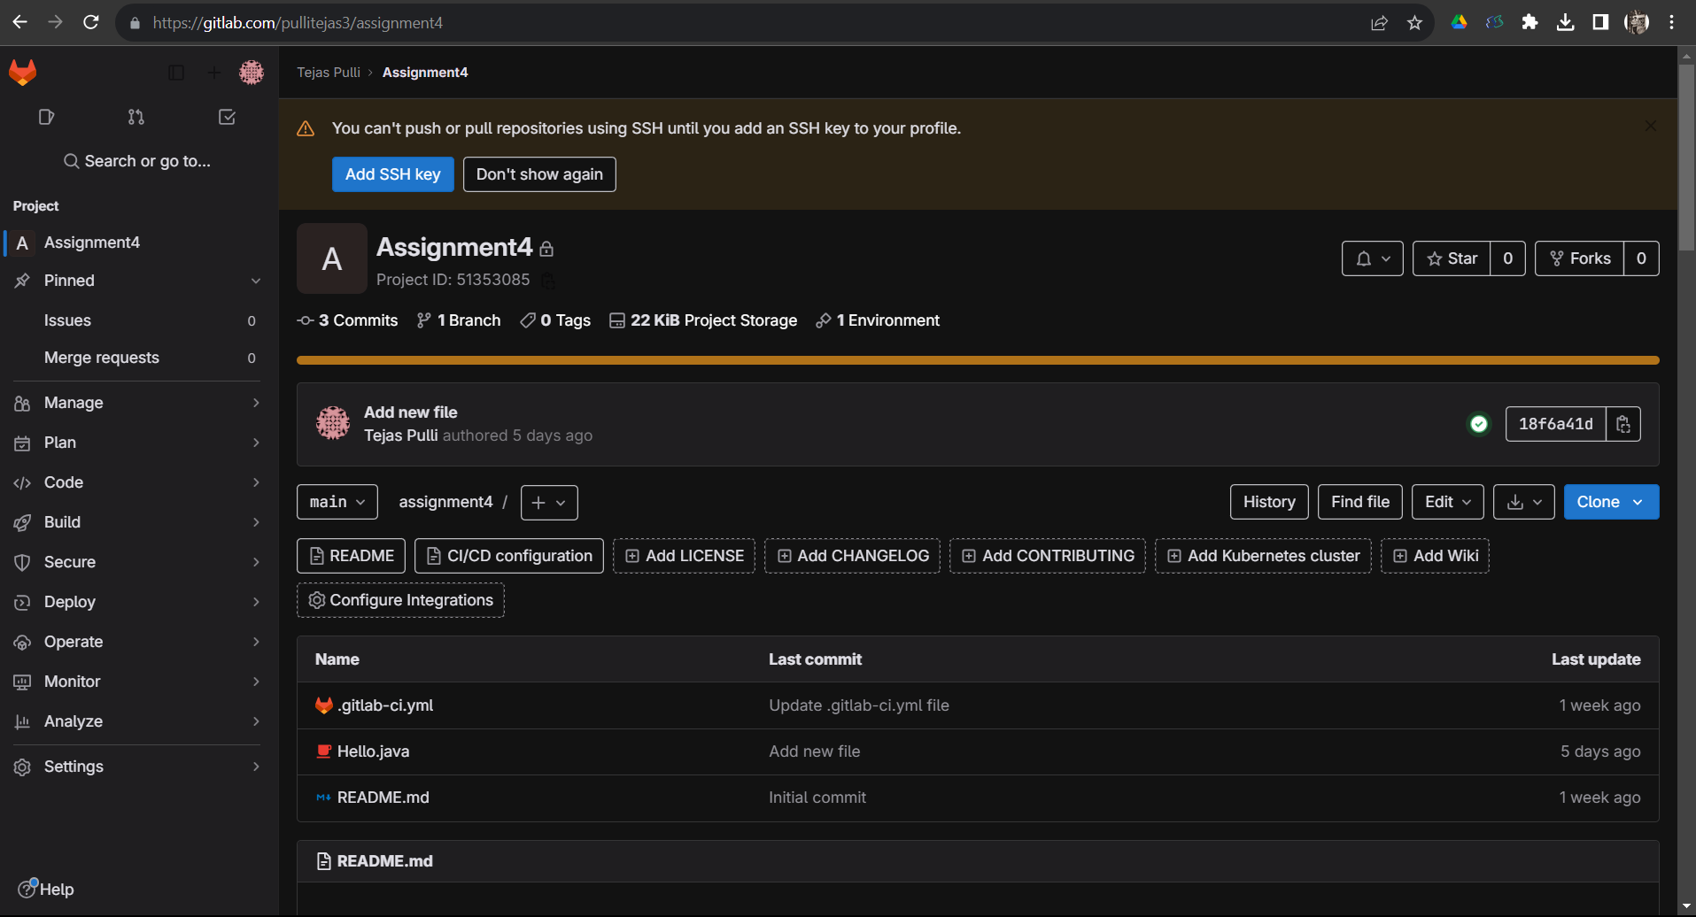

* Register and Start Runner:

Now, you have to install the runner. Then register for the runner, Once the registration is successful start the runner.

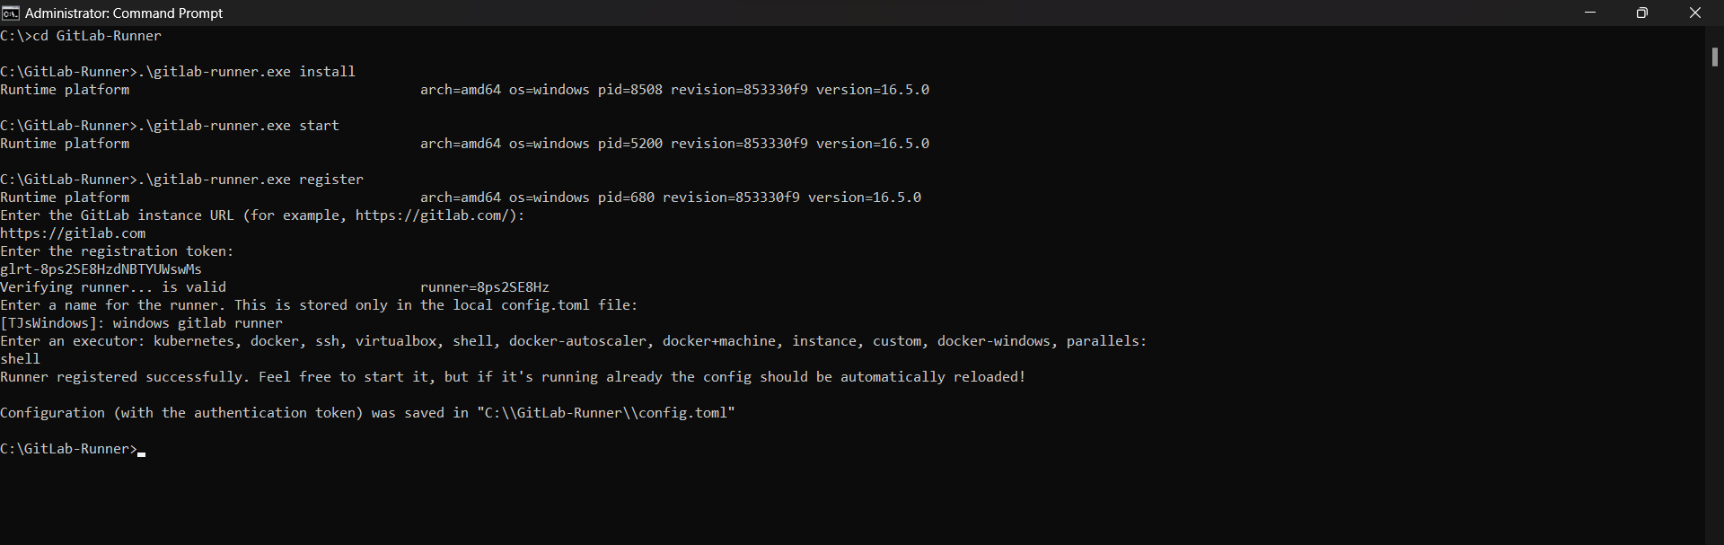

* Change in config.toml:

Once the runner is started, In config.toml we have to change pwsh to powershell and save the changes and also delete old runners.

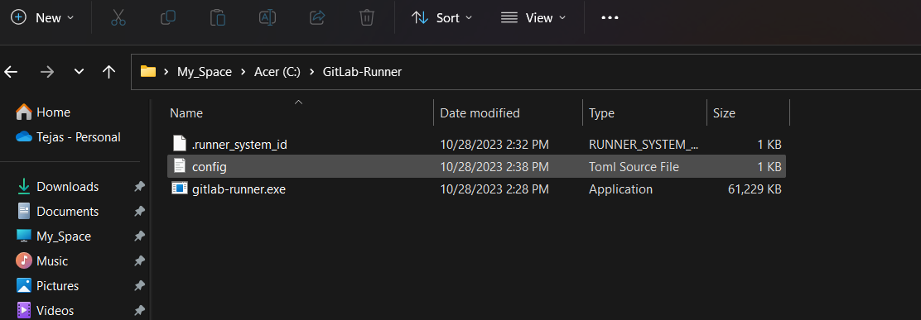

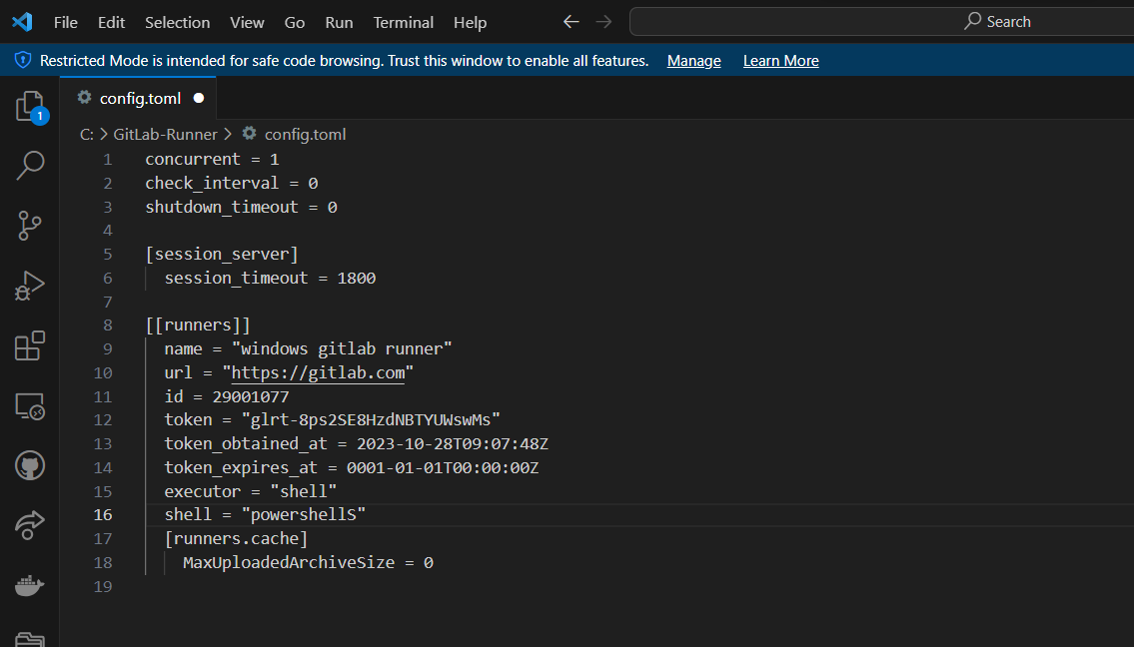

* Add New File and run pipeline:

Add a new file Hello.java in a project. Now to run a pipeline Go to settings→Runner→disable the shared runners.

Edit the project runner, click on checkbox run untagged jobs. It will start executing the pipeline in build, test, and deploy phase one by one.

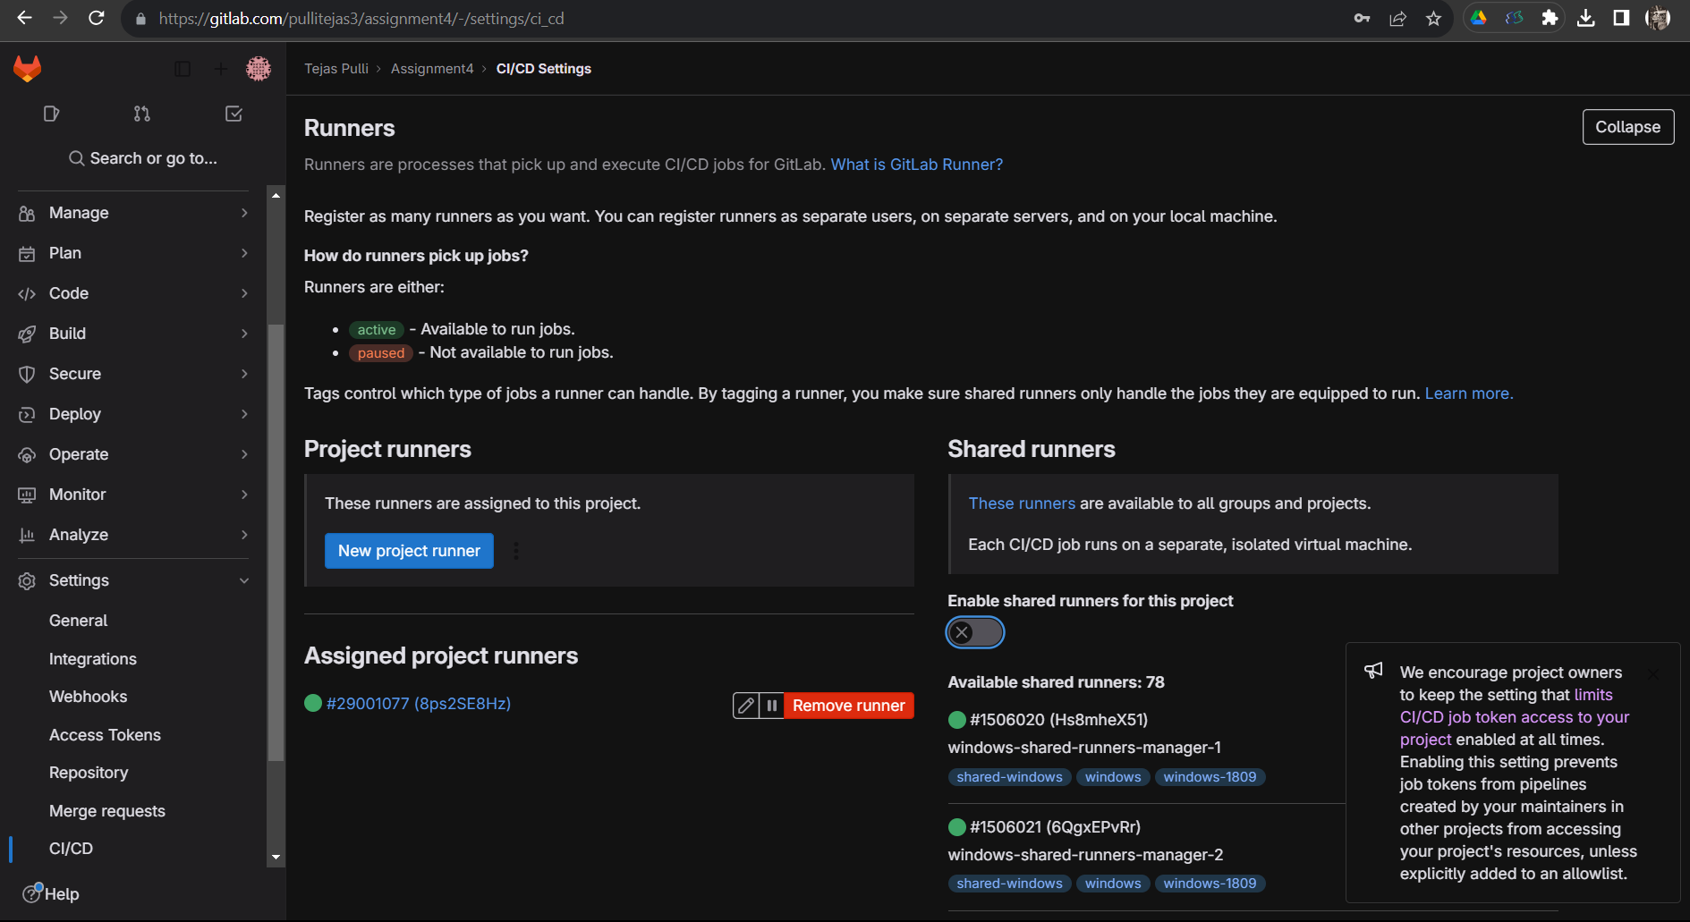

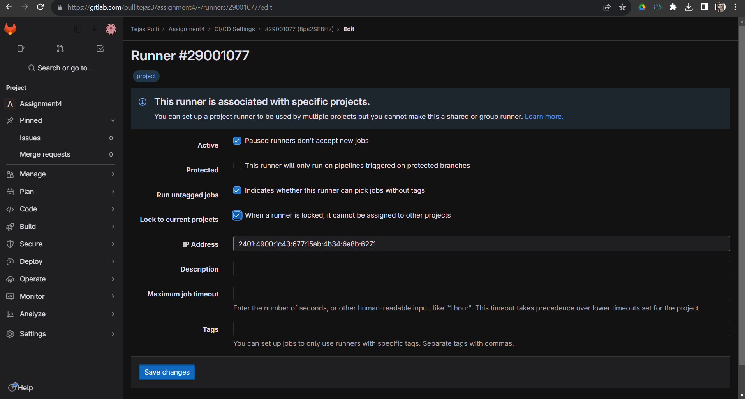

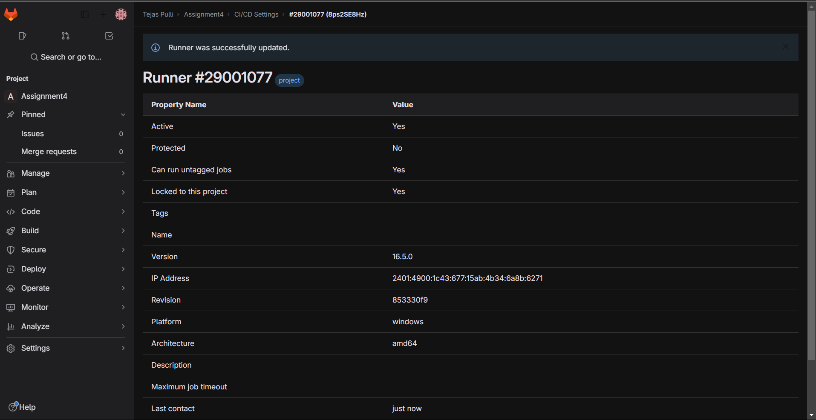

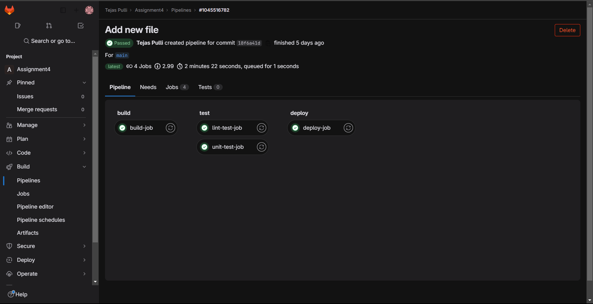

* To check jobs:

Goto CI/CD→ pipelines → click on run pipelines

