**Assignment No. 8**

Name : Srushti Nandgaonkar

Roll No. 66

**Aim : Problem Statement**

Set up a Jenkins job that picks up an application from a GitHub repository, builds it, and runs it and dockerizes the application.

* **Create Jenkins Job:**

Create a Jenkins job using New Item in Jenkins dashboard. Name the project and choose pipeline type

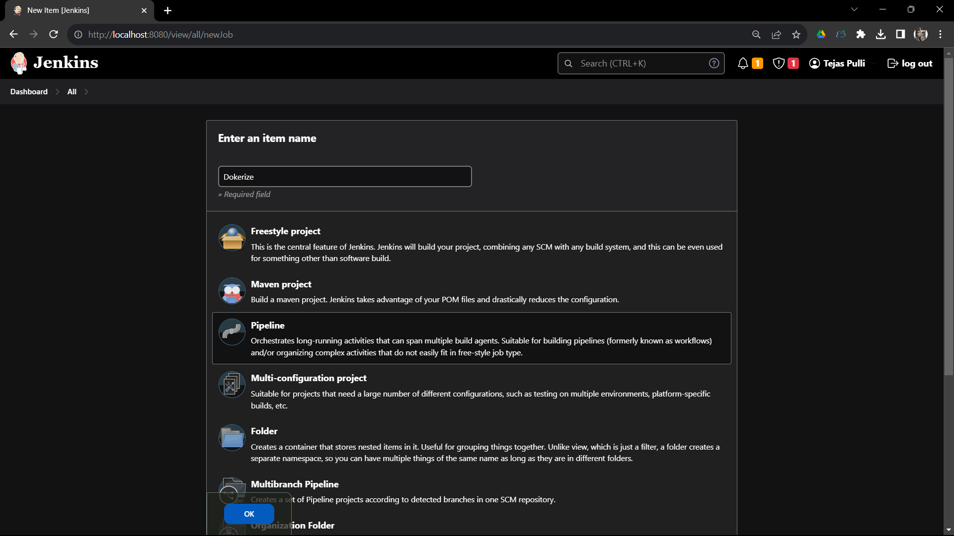

* **Create GitHub Repository:**

Create Github repository which contains the main files alongwith Jenkins Script and Docker file.

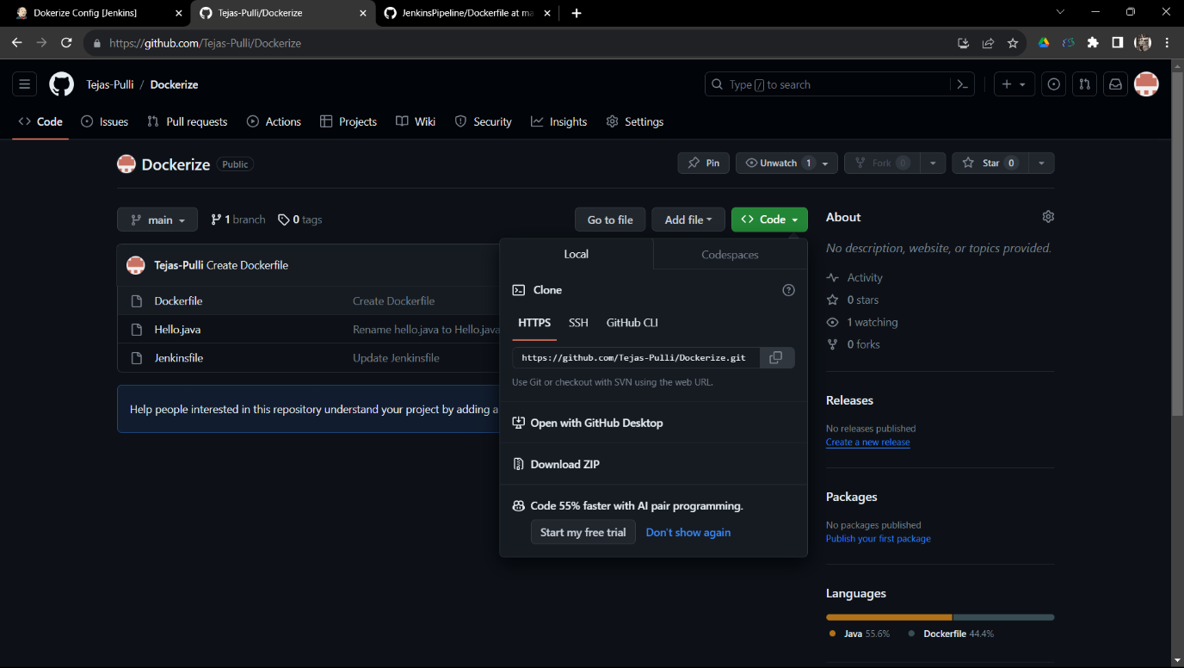

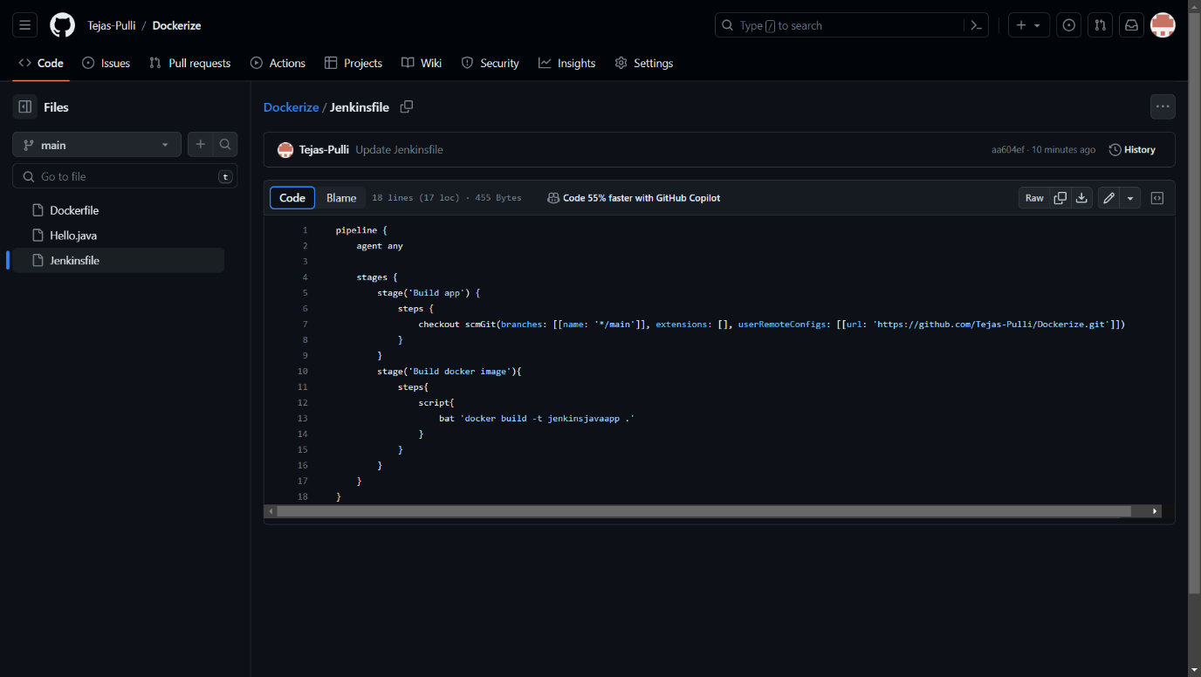

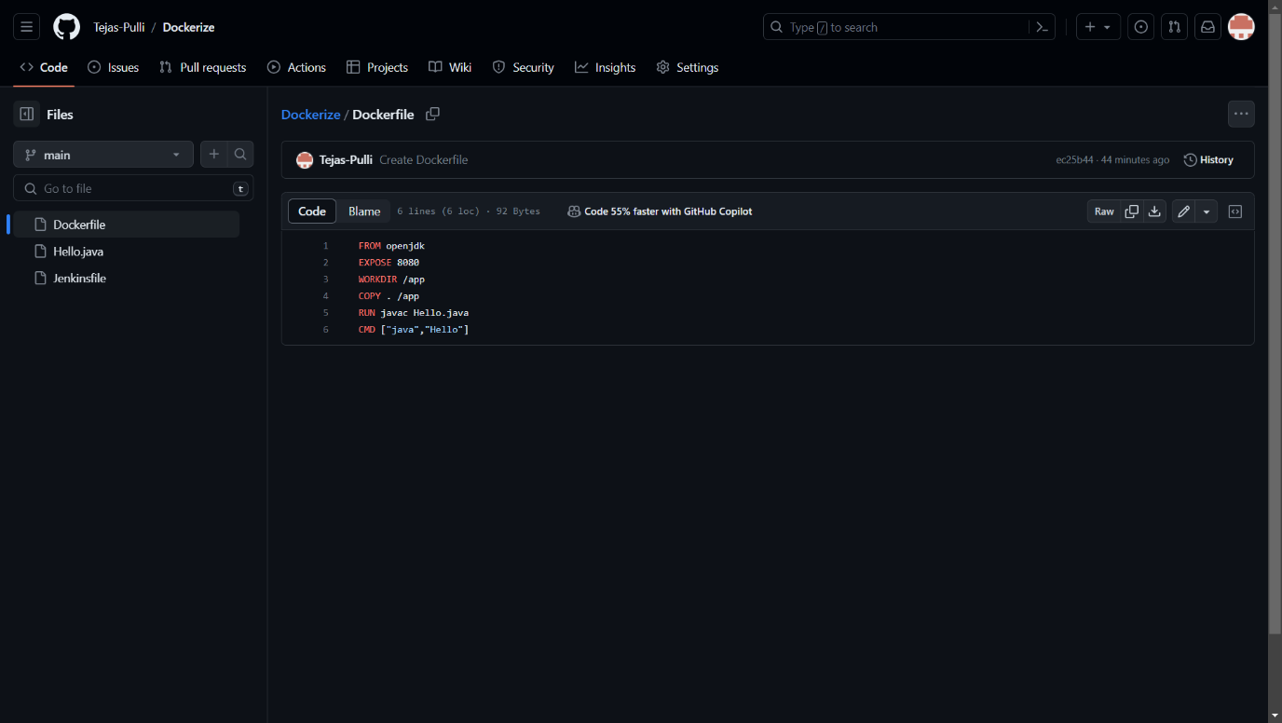

* **Configure the Project :**

Choose GitHub hook trigger for GITScm polling from the Build Triggers

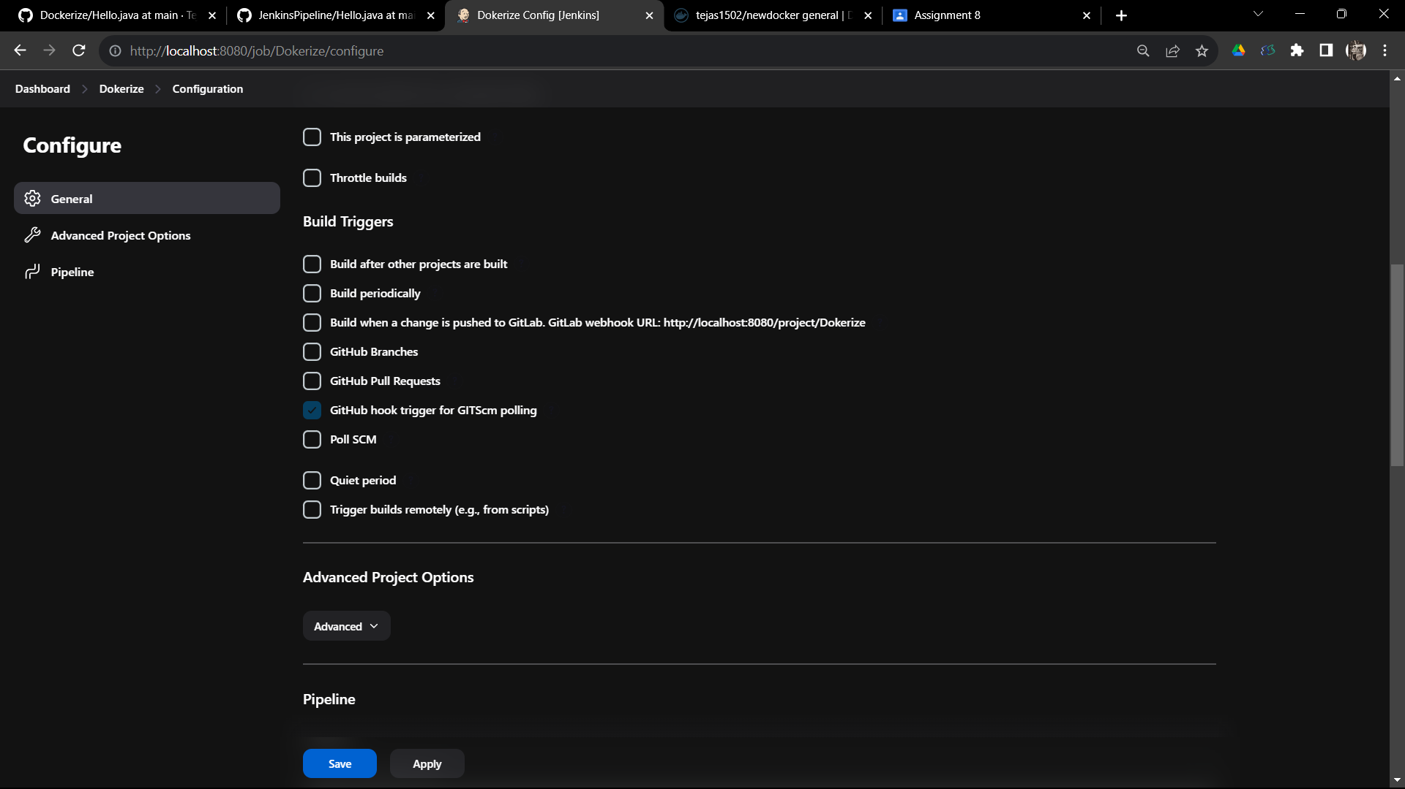

Add the git repository link in the pipeline section and Save the configuration

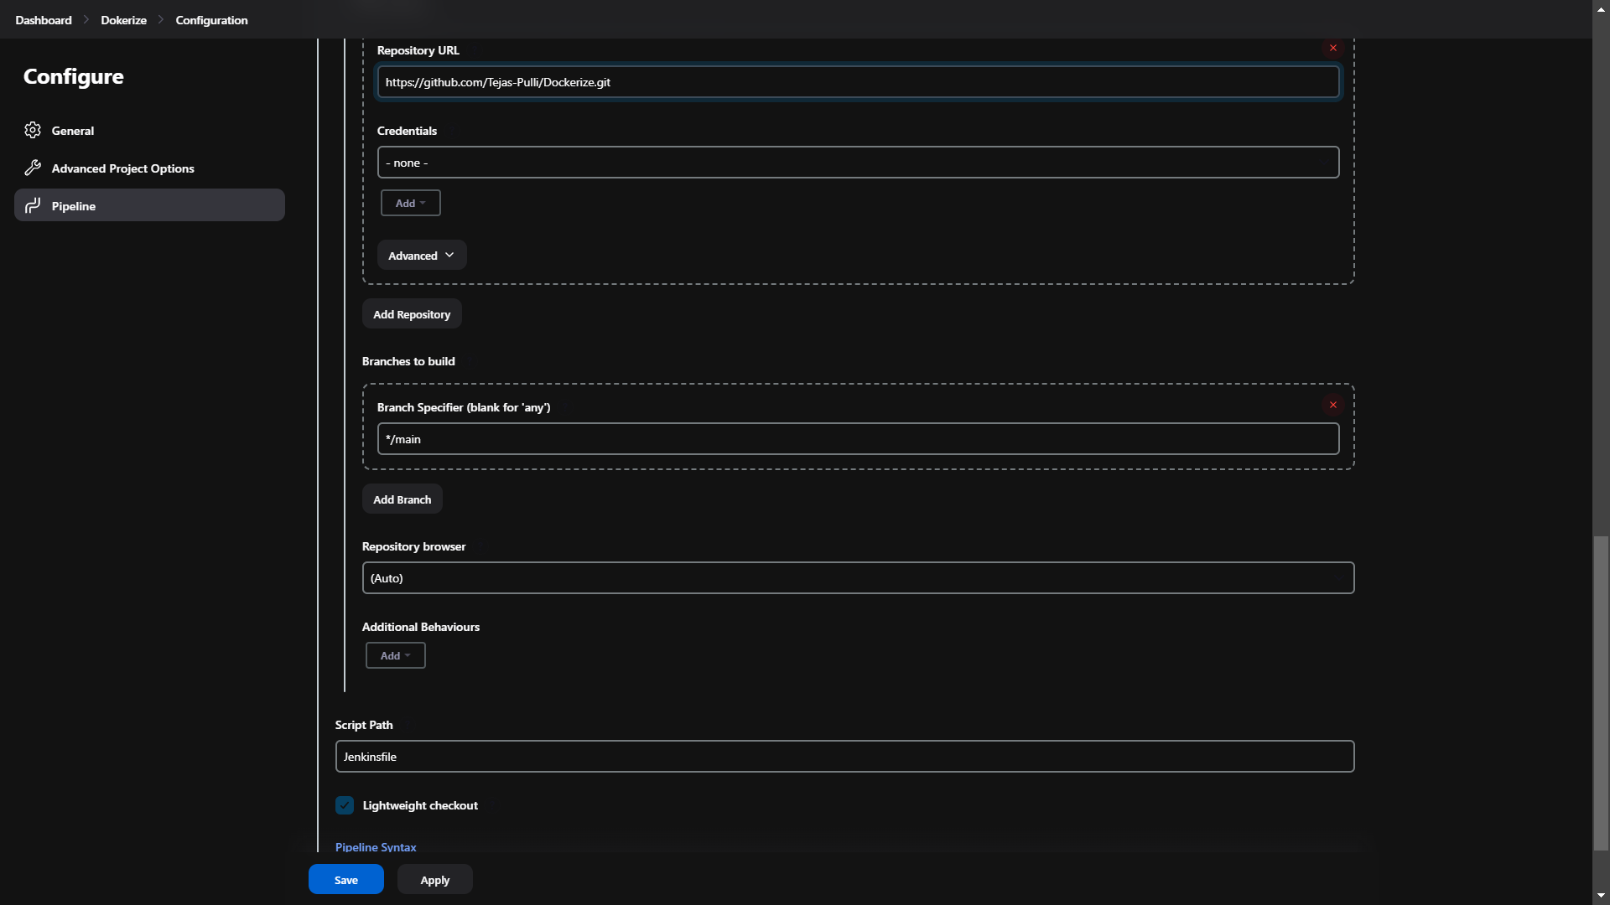

* **Build Application:**

Using Build Now build the application

