TASK 1 : Directory Navigation & Exploration

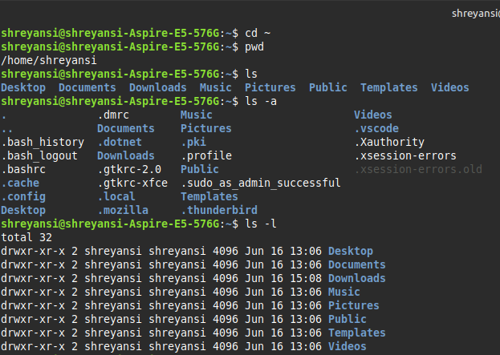

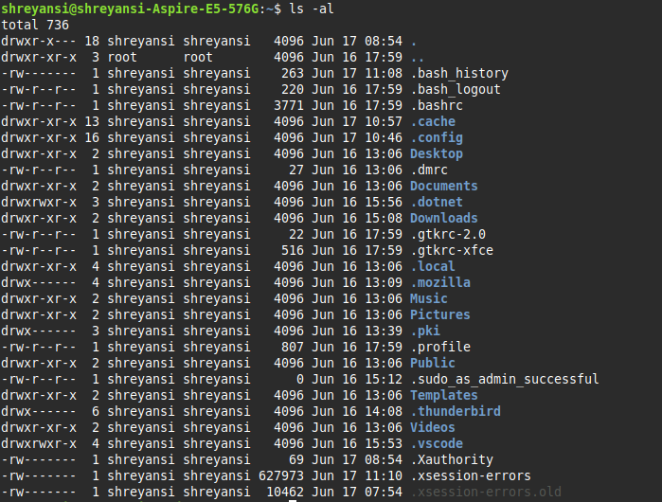
The ls command lists files and directories in the current directory. ls -a shows all files, including hidden ones (those starting with a .). ls -l displays files in a long listing format with details like permissions, owner, size, and date. ls -al combines both options to show detailed info about all files, including hidden ones.

TASK 2 : Creating & Managing Directories

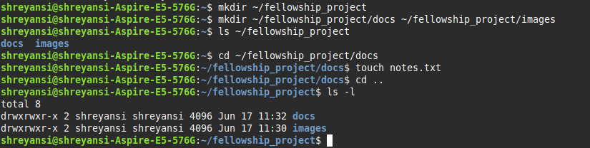
The touch command is used to create an empty file if it doesn’t already exist. If the file does exist, touch updates its last modified timestamp without changing its content.

TASK 3 : File Permission Basics

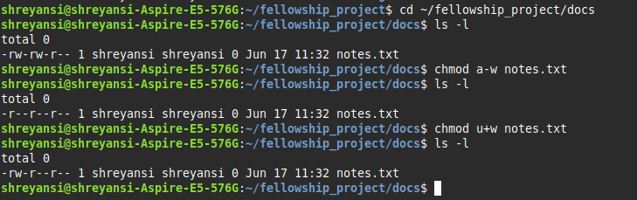
The a-w option in the chmod command removes write permission from all users — that includes the file owner, the group, and others. In contrast, u+w adds write permission back only for the owner (user) of the file. These symbolic options make it easy to adjust file permissions without affecting unrelated settings.

TASK 4 : Numeric Permission with chmod
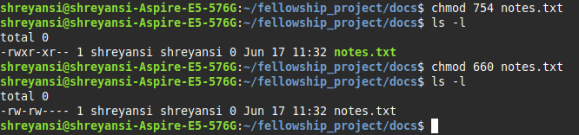
Numeric values like 754 or 660 in the chmod command represent permission settings for the owner, group, and others, using a 3-digit format. Each digit is a sum of permission bits: 4 for read (r), 2 for write (w), and 1 for execute (x). For example, 7 (4+2+1) means read, write, and execute, 5 (4+1) means read and execute, and 0 means no permissions.

TASK 5 : Ownership & Group Commands

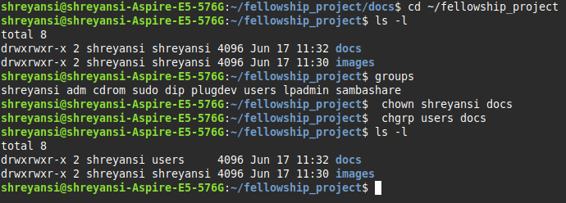
The chown command changes the owner of a file or directory, assigning it to a different user. In contrast, chgrp changes only the group associated with the file or directory, without affecting the owner. Both commands are used to manage access and permissions in multi-user environments.

TASK 6 : Practical Application
[ Applying File System Commands to a Real-World Scenario ]

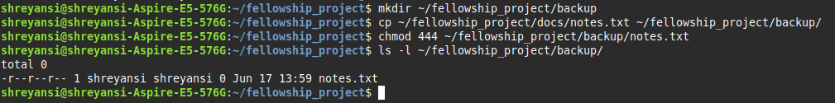
In a real project, we might use these commands when creating a secure backup of important documentation, such as project notes or finalized reports. By copying the file to a separate backup directory and making it read-only, we ensure that no one — not even the original author — can accidentally modify or delete the backup version. This is especially helpful in collaborative environments where multiple users access the same system. It also provides a quick way to restore or reference a clean version of the file if the working copy is lost or corrupted. Using these file permissions helps enforce basic data integrity and safety.

TASK 7 : Advance File Explorations
[ Explore advanced ls options / additional commands ]

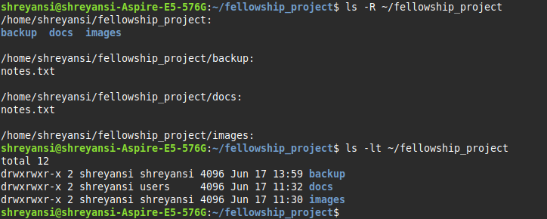
The -R option means recursive listing, which shows all files and directories, including contents of subdirectories.
And, the -t option sorts files and directories by modification time, with the most recently modified items shown first.

Now, using commands : mv, rm & find

- mv : The mv command is useful for organizing, renaming, or moving files between folders.
- find : We use it to search for files & directories, here all .txt files.
- rm : It is used for removing files & directories ( rm -r for directory ).
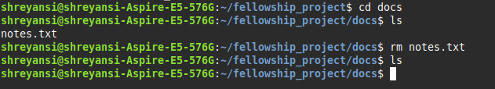

TASK 8 : Symbolic Links & Recursive Permissions
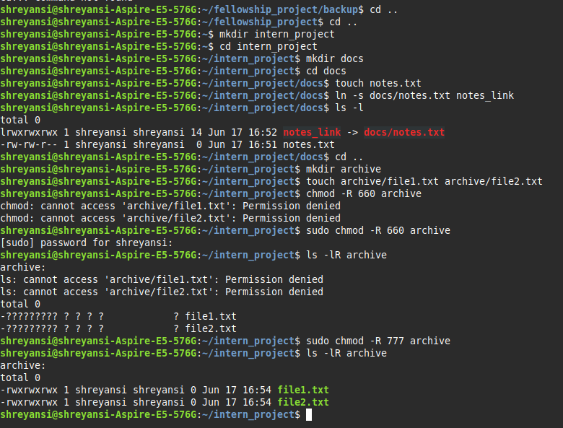
A symbolic link (or symlink) is like a shortcut or pointer to the original file. It stores the path to the target file and can span across different directories or file systems. A hard link is another name for the same file, sharing the same inode, and only works within the same file system. If the original file is deleted, a symbolic link becomes broken, while a hard link still keeps the data accessible. Use symbolic links when you want flexibility, such as linking config files or creating shortcuts across directories.
Additionally, in Linux, to enter a folder or list files, the directory needs execute (x) permission. Without x, even ls cannot read the content and we get Permission denied.

TASK 9 : (BONUS) Advanced Archiving & Linux Package Management

Part 1 :
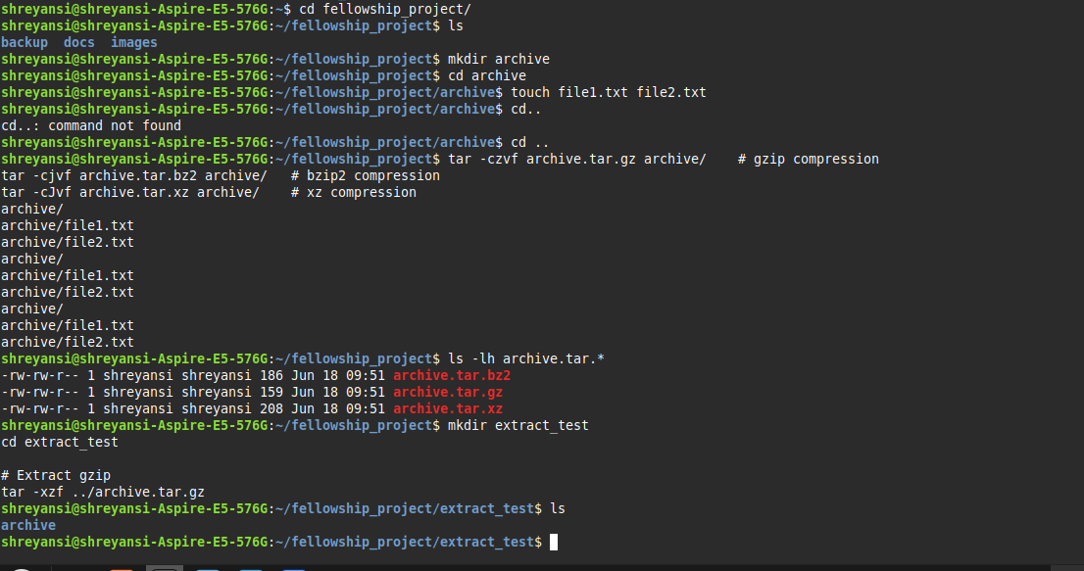
In this case, gzip produced the smallest file (159 bytes), followed by bzip2 (186 bytes), and xz gave the largest file (208 bytes). This result is unusual because normally xz compresses better, but here the files were empty or very small. With such small input, compression overhead can actually make the files slightly larger.

And, Password Protection Zip :
