**Babu Banarasi Das University**

**Case Study on**

**Predictive Analysis of Student Data During COVID-19 Using SPSS**

**SUBMITTED TO: SUBMITTED BY: Mr. Ayushman Bhadoriya Shreya Pandey**

* **Agenda**

To analyze and predict student academic performance during the COVID-19 pandemic using IBM SPSS Modeler

* **Outcomes**

Learned how to use SPSS Modeler for predictive analysis and how to visualize relationships between variables.

* **Required Tool**

IBM SPSS Modeler and Microsoft Excel.

* **Working**

The dataset was imported into SPSS Modeler, variables were defined, descriptive statistics were calculated, and a predictive model was built to estimate final grades.

**Steps (Main Practical Work)**

Step 1: Import Dataset

The dataset containing attendance, assignment, and exam scores was imported using the Excel node. 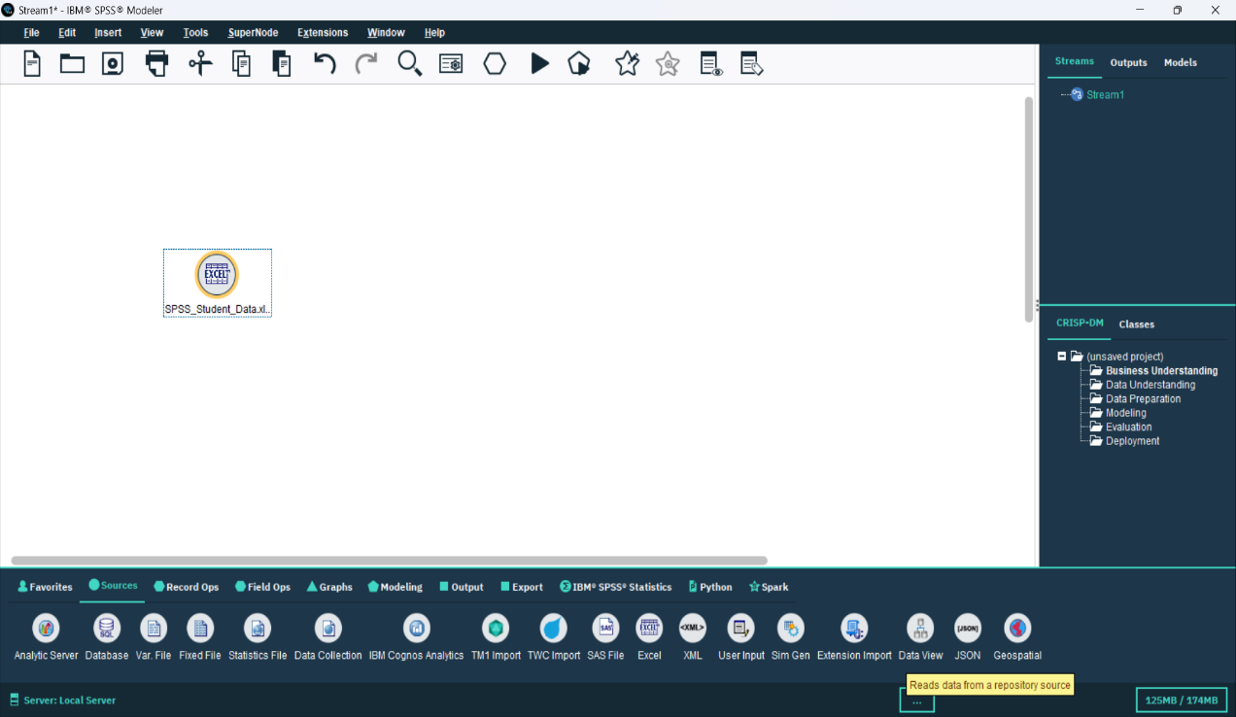

**Step 2: Define Variables**

The Type node was used to define Final Grade as the target and other fields as input variables.

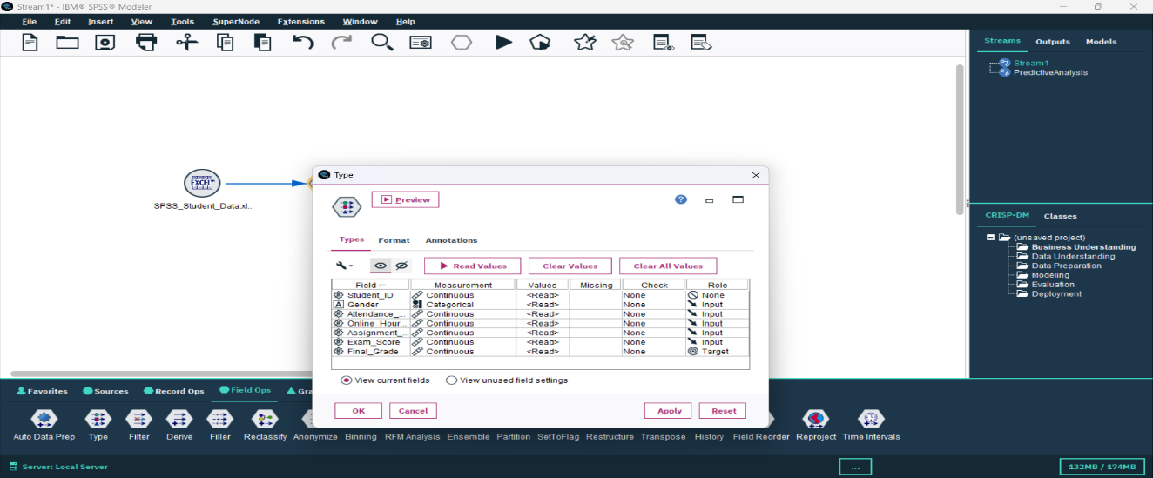

**Step 3: Descriptive Statistics**

The Statistics node provided mean, minimum, maximum, and standard deviation of key

variables.

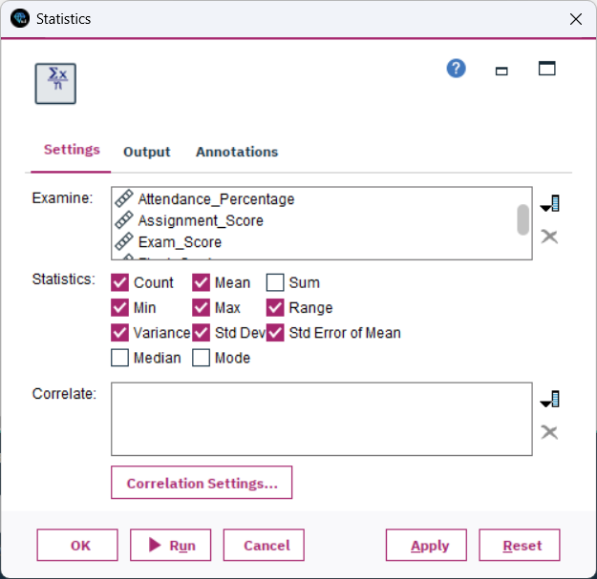 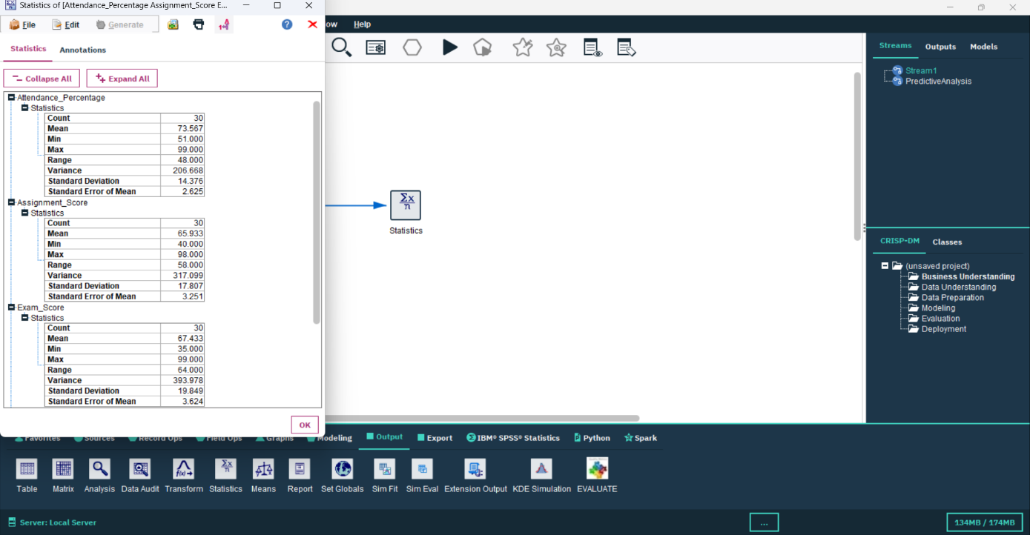

**Step 4: Predictive Model**

The **Regression Node** in SPSS Modeler builds a **predictive model** that shows how independent variables (like attendance, assignment score, exam marks) affect the **target variable** (Final Grade). 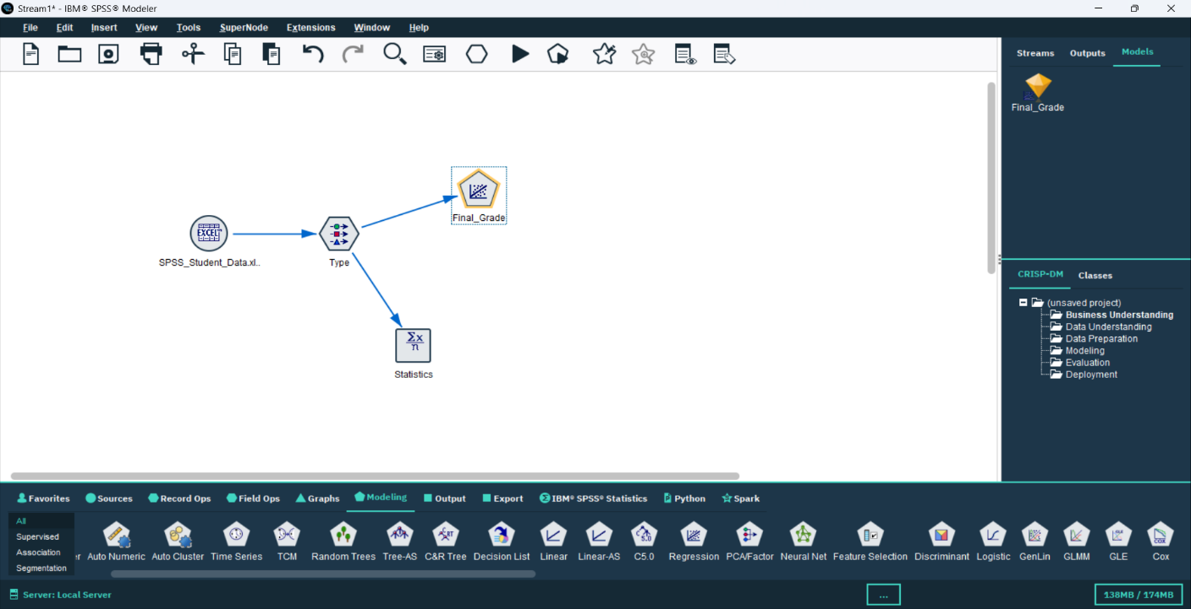

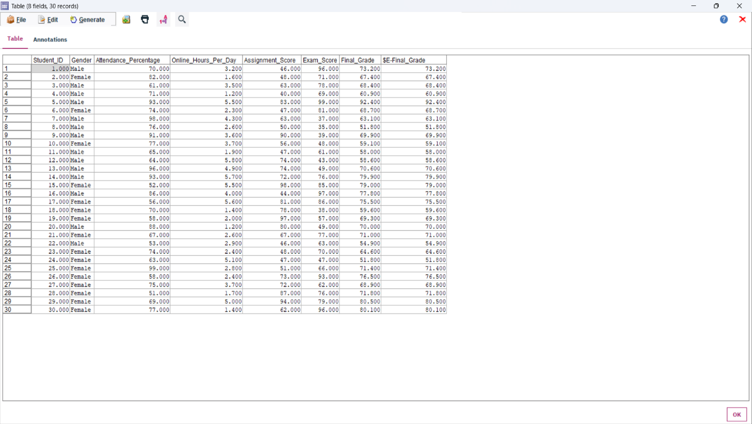

**Step 5: Visualization**

The scatter plot showed a strong positive relationship between actual and predicted grades

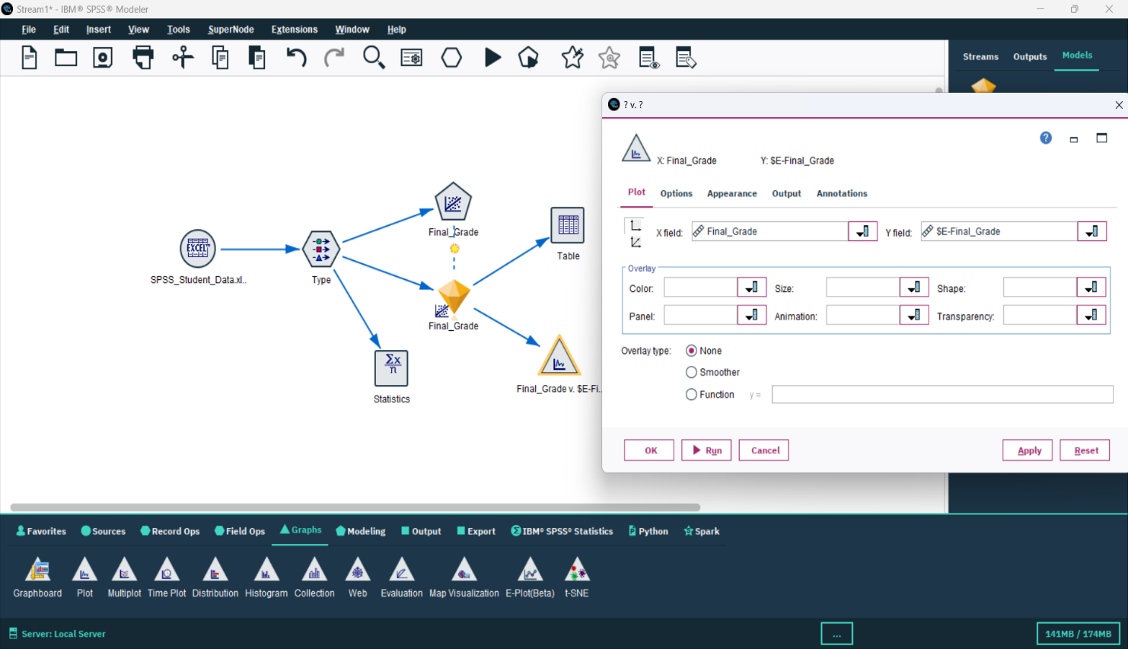

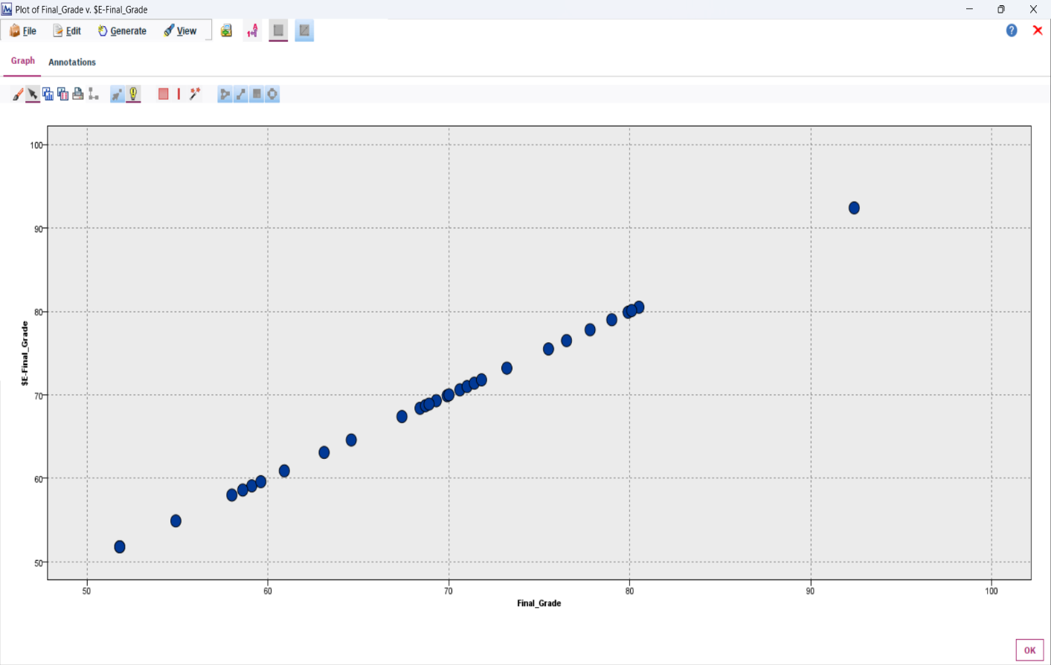

* **Conclusion**

The predictive model built in SPSS Modeler effectively estimated student performance. Higher attendance and exam scores were the most influential factors for better grades.