My TryHackMe profile: https://tryhackme.com/p/ShreyasNambiar

Room 1: What is Networking?

The main purpose of this room was to learn the basic idea of networking.
Before learning advanced networking concepts, it is important to understand how computers, phones, servers and other devices communicate with each other.

What I Did – Step-by-Step:
Step 1 – Opened the TryHackMe Room
I first opened the What is Networking? room on TryHackMe.
I read the introduction and instructions provided in the room before starting the tasks.
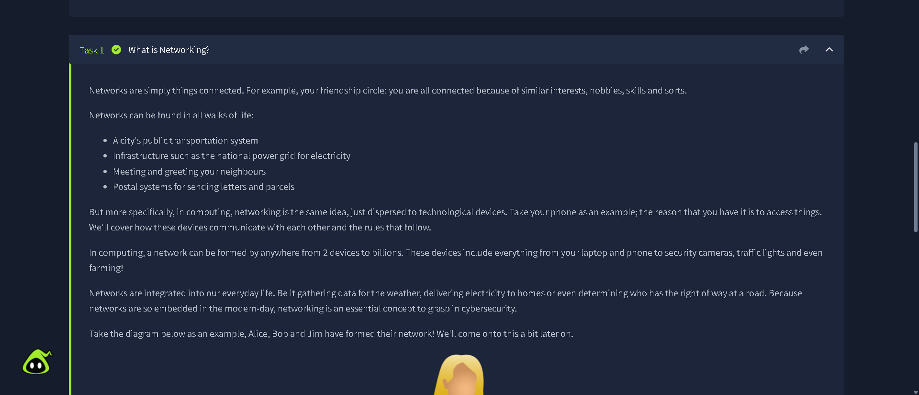

Step 2 – Learned What a Network Is:
I learned that a network is a group of connected devices that can communicate and exchange information with each other.
I went through the questions in this section and submitted my answers in TryHackMe.

Step 3 – Learned About IP Addresses:
Next, I learned about IP addresses.
An IP address is used to identify a device on a network.
An IP address helps network devices know where data needs to be sent.

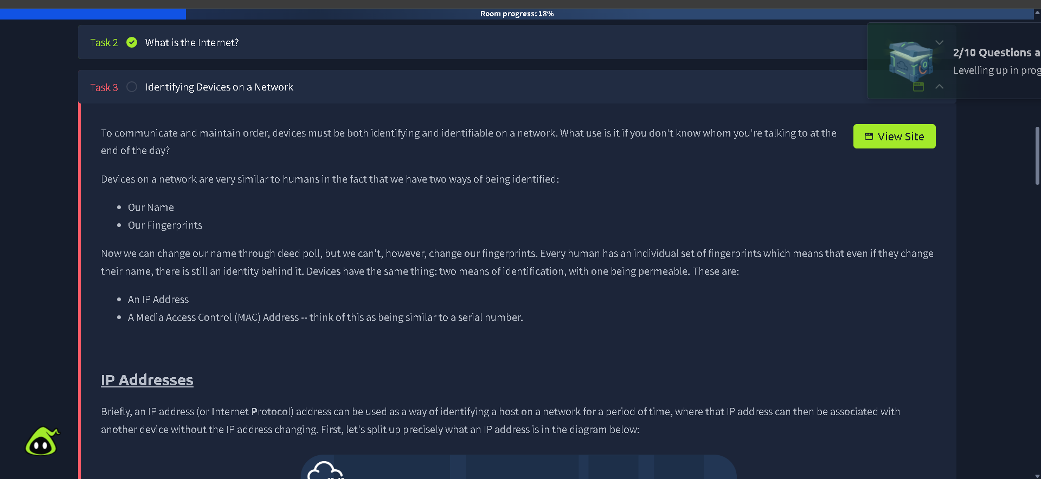

Step 4 – Learned About MAC Addresses:
I then learned about MAC addresses.
A MAC address is a unique identifier associated with a network interface.
While an IP address is used for communication on a network, a MAC address identifies the network interface at the hardware/network-access level.
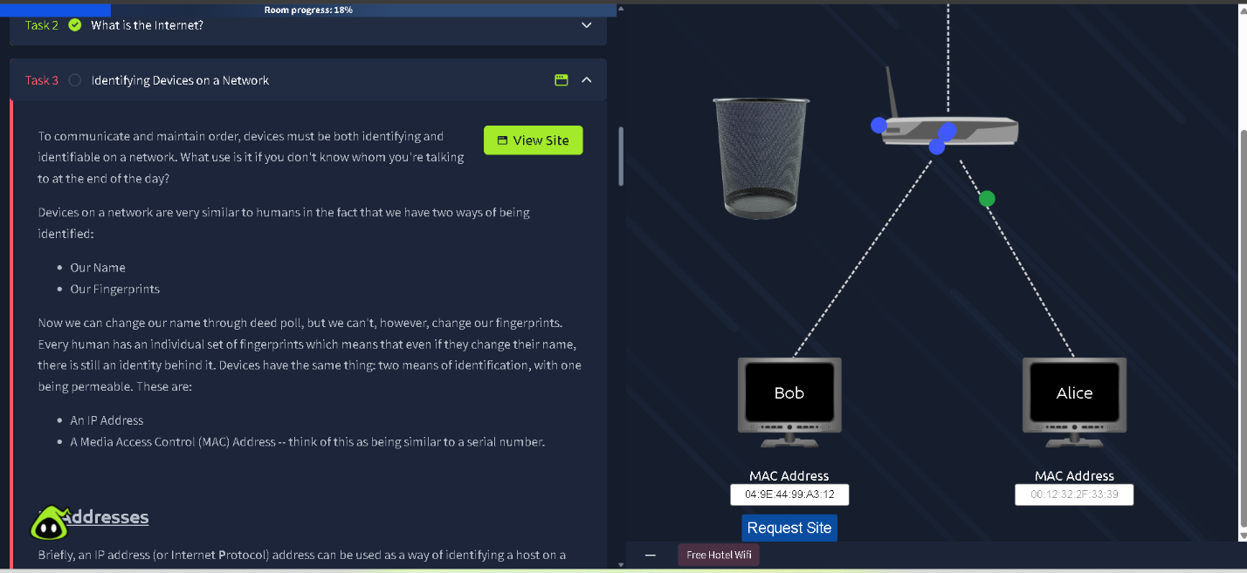

Step 5 – Learned About Packets and Communication:
The room also explained that information sent across a network is divided into smaller pieces called packets.
These packets travel through the network and are used to transfer information between devices.
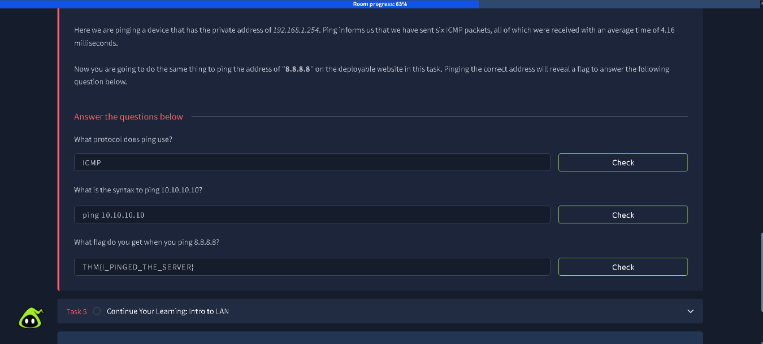

\
Step 6 – Completed the Room:
After completing all the required tasks and questions, TryHackMe showed that the room was completed.
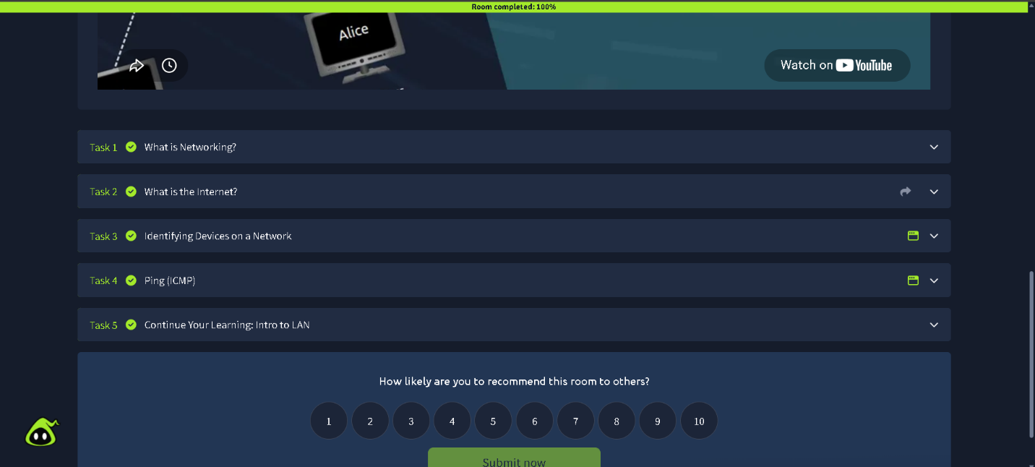

What I Learned – What is Networking?
After completing this room, I understood the basic idea of computer networking.
The main things I learned were:
1. Networks
2. IP Addresses
3. MAC Addresses
4. Packets/Pings
5. Network Communication

Room 2: Intro to Networking?

What I Did – Step-by-Step:
Step 1 – Opened the Room:
I opened the Intro to Networking room on TryHackMe and read the instructions.
I started the room and went through each section in order.
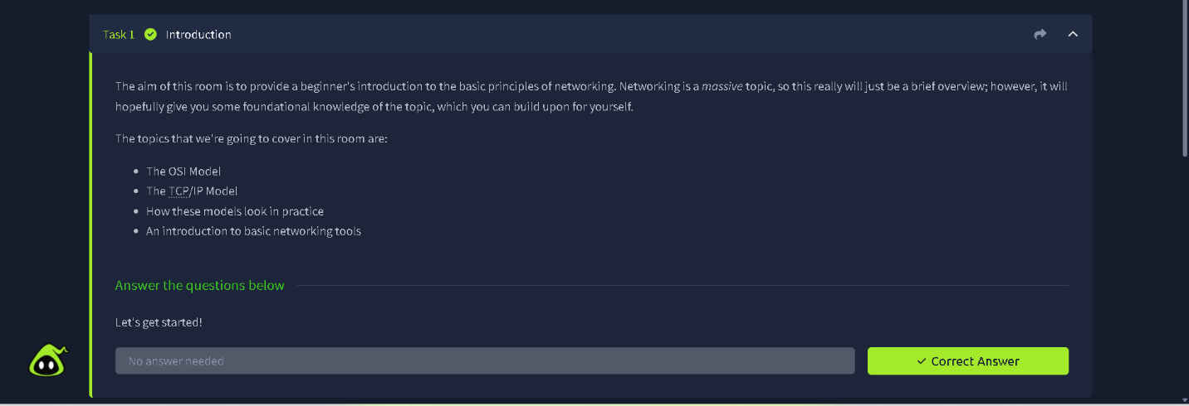

Step 2 – Learned About the OSI Model:
The first major concept I learned was the OSI model.
The OSI model is a way of understanding how network communication works by dividing it into seven layers.
The seven layers are:
- Physical
- Data Link
- Network
- Transport
- Session
- Presentation
- Application

Step 3 – Learned About TCP and UDP:
Next, I learned about TCP and UDP.
TCP focuses on reliable communication. It makes sure that data is delivered correctly and in the correct order.
UDP is faster and has less overhead, but it does not provide the same reliability as TCP.

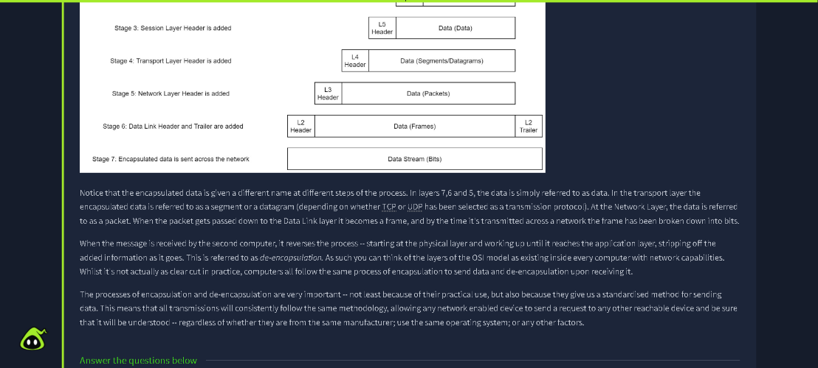

Step 4 – Learned About DNS:
I learned about DNS (Domain Name System).
DNS converts domain names that are easy for humans to remember into IP addresses that computers use.
For example:
google.com can be translated by DNS into an IP address.
This allows users to access websites using names instead of remembering numerical IP addresses.

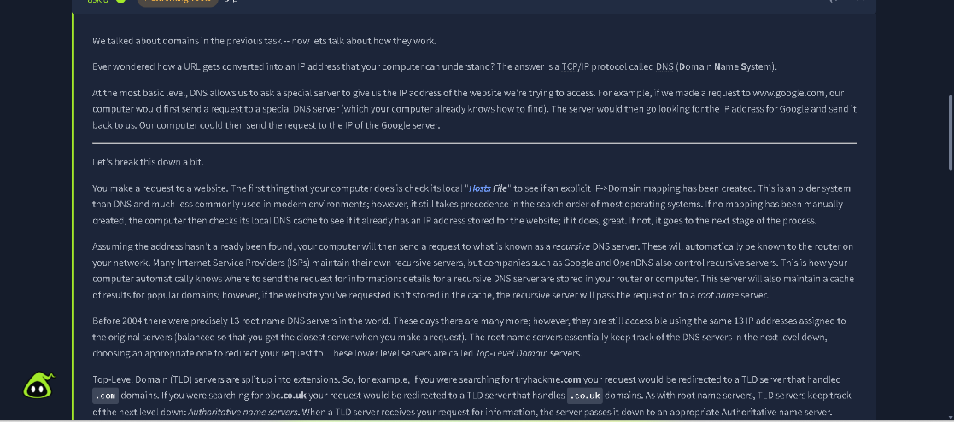

Step 7 – Completed the Room:
After completing the required tasks and answering the questions, I reached the end of the room.
TryHackMe displayed the completion status for the room.

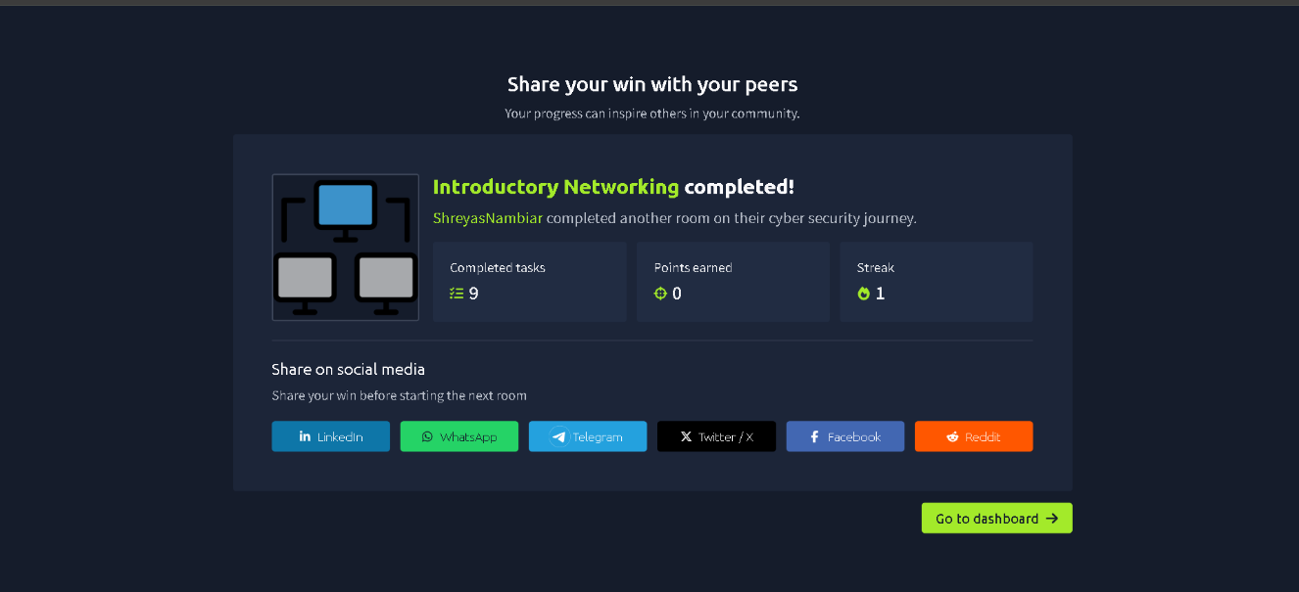

What I Learned – Intro to Networking:
This room helped me understand networking in more detail.
The main things I learned were:
1. OSI Model
2. TCP and UDP.
3. Ports
4. DNS
5. Networking Commands
The room also helped me understand how basic networking commands can be used to obtain information about network connections and devices.

