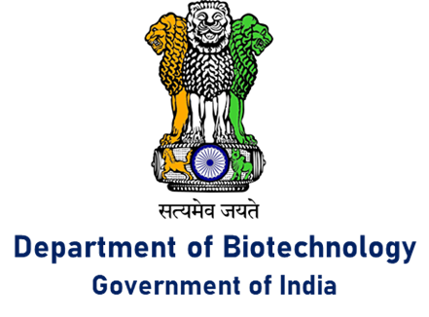

**World Environment Day (WED)**

**Department of Biotechnology Initiatives**

World Environment Day (WED) is celebrated every year on the 5th of June as a reminder to humanity that we have only one earth, and it is our duty to preserve our environment. The theme of WED 2020, hosted by Colombia in partnership with Germany, is “Time for Nature” – an acknowledgement of the importance of biodiversity and the grave anthropogenic threats being faced by it. India hosted WEB 2018 with the theme “Beat Plastic Pollution” and China hosted WEB 2019 with the theme “Beat Air Pollution”. Department of Biotechnology (DBT) is committed to meet these challenges through innovation, targeted Research, Development &Demonstration (RD&D) initiatives.

DBT has supported major projects to convert biomass into waste or value and India being a member of Mission Innovation has taken many initiatives to accelerate innovations in clean energy.

Major focus has been to promote innovation, R&D for development of sustainable biofuels, carbon capture and utilization and converting solar energy into clean fuels using biotechnological approaches and advance tools.

DBT has supported projects on conservation of endangered flora including several medicinal plants, and fauna like Royal Bengal Tiger, Indian Elephant, Nilgiri Tahr etc., using modern molecular techniques. An effective bio restoration technology for mangrove forests developed with DBT support has been taken up for field scale demonstration for restoration of degraded mangrove forests in Sunderbans, West Bengal. A detailed study on biodiversity and preservation of coral reefs of Palk Bay area is underway. Multiple projects on bioremediation of pesticides such as Lindane, Chlorpyriphos, Trichloropyridinol etc., have been supported. Treatment of textile industry effluent for dye decolourization and detoxification is being attempted through various strategies including phytoremediation and improved microbial wastewater treatment techniques. Constructed wetland technologies are being developed for reducing the pollution burden on our rivers.

 DBT is also actively exploring R&D opportunities toward achieving the following objectives:

* finding eco-friendly biodegradable alternatives to plastic packaging
* biosensors for low-cost monitoring of air and water pollution
* establishment of analytical protocols, mapping and remediation strategies for emerging pollutants such as certain plasticizers, preservatives, antibiotics, pesticides, micro-plastics etc.