CYBER SECURITY
FOOTPRINTING AND RECONNAISSANCE PROJECT
Open Source Intelligence (OSINT): Collecting and Connecting Public Data into Actionable Intelligence
Domain: OSINT / Ethical Hacking — Reconnaissance Phase
All examples in this document use a fictional target (“Acme Robotics Ltd.” and “Jordan Rivera”) for illustration only.

Table of Contents
Abstract / Overview 3
1. Introduction to OSINT 3
2. Ethical and Legal Scope 3
3. Organization Basic Information Gathering 5
4. Social Media Intelligence (SOCMINT) 6
5. Websites, Blogs, Forums, and Q&A Sites 8
6. People Investigation 9
7. Company Research 10
8. Classifieds and Online Marketplaces 11
9. Web Intelligence 12
10. Image Intelligence (IMINT) 14
11. Video Intelligence 15
12. Documents, Browsers, and Mind-Mapping 17
13. Recommended Approach and Analyst Setup 19
14. Defensive Recommendations 20
15. Conclusion and Learning Outcome 20
Multimedia and Attachments Summary 21
Tool Reference Appendix 22

Abstract / Overview
Every individual and organization now generates a continuous stream of open, publicly accessible data — social media posts, news coverage, job listings, forum activity, uploaded images, and indexed web pages. Open Source Intelligence (OSINT) is the discipline of collecting this scattered public data and connecting it into a coherent intelligence picture. In the hands of an attacker, OSINT is typically the first phase of an attack chain (reconnaissance/footprinting), used to build a target profile, identify likely usernames and passwords, map an organization's attack surface, and craft convincing social-engineering pretexts.
This project builds that same skill set from the defender's perspective: an ethical hacker or security analyst performs the identical reconnaissance a real attacker would, in order to discover what an organization and its employees are inadvertently exposing, and to close those gaps before a malicious actor exploits them. Each task below documents the sources, tools, and step-by-step method for a category of OSINT collection, illustrated with one fully worked example against a fictional target company and employee created solely for this document.
Scope and ethics: every technique below uses only publicly accessible information and passive collection methods. No account was accessed without authorization, no password was guessed against a live account, and no real, identifiable third party's personal data is reproduced in this document. Section 2 sets out the legal and ethical boundaries that must govern any real-world use of these techniques.

1. Introduction to OSINT
Footprinting (also called reconnaissance) is the first phase of the ethical hacking lifecycle: building as complete a picture as possible of a target before any active engagement (scanning, exploitation) begins. OSINT is the passive subset of footprinting — it uses only information that is already public, so it can be performed with zero risk of detection and, in most jurisdictions, without any special legal authorization, because no system is accessed or touched.
OSINT sources are commonly grouped into: search engines and cached content; social media and forums; public records and registries; technical/infrastructure data (DNS, WHOIS, certificates); images and video; and documents and metadata. The value of OSINT comes not from any single data point but from correlation — connecting a username found on one platform to an email pattern found on another, to a physical location inferred from a photo, and so on — which is why the final task in this project converts findings into a mind map.

2. Ethical and Legal Scope
OSINT sits in a legal gray zone precisely because the data is public: collecting it is rarely illegal by itself, but what is done with it can be. This project, and any real engagement based on it, follows these boundaries:
- Only ever performed against an organization or individual that has provided explicit written authorization (e.g. a penetration-testing scope of work), or against a fictional/consenting target for training purposes, as in this document.
- Passive collection only within scope — no attempt to log into an account, guess a password, or send a phishing message to a real person as part of this exercise.
- Findings are handled as sensitive data: stored securely, shared only with the authorizing client, and deleted/redacted at the end of the engagement.
- Local laws on stalking, harassment, computer misuse, and data protection (e.g. GDPR) apply fully to OSINT activity and must be understood before any real-world engagement.

3. Organization Basic Information Gathering
The starting point of any engagement is establishing an organization's basic footprint: legal name, address(es), locations, and general web presence, which anchors every later, more detailed search.

Sources and Techniques
- Google dorking (advanced search operators) — e.g. site:acme.com, intitle:"index of", filetype:pdf site:acme.com — to enumerate indexed pages and exposed documents.
- The organization's own website: “About Us,” “Contact,” and “Locations” pages, plus the site footer, often list every office address and registered entity name.
- Google Maps / Google Earth — confirms physical locations, and satellite/street view can reveal building layout, security posture (cameras, gates), and nearby businesses.
- WHOIS lookup on the primary domain — registrant organization, address, and registrar (though many are now redacted by GDPR-driven privacy proxies).
- General search engines and news aggregators for press releases and press-kit pages, which often state headquarters and branch locations plainly.
Worked example: Searching site:acmerobotics.example on Google surfaces the company's “About” page listing a Bengaluru headquarters and a Berlin R&D office; a WHOIS lookup on acmerobotics.example confirms the same registrant city, and Google Maps street view of the listed address shows a shared office building with visible security-badge access — all noted for the physical-security section of the eventual report.
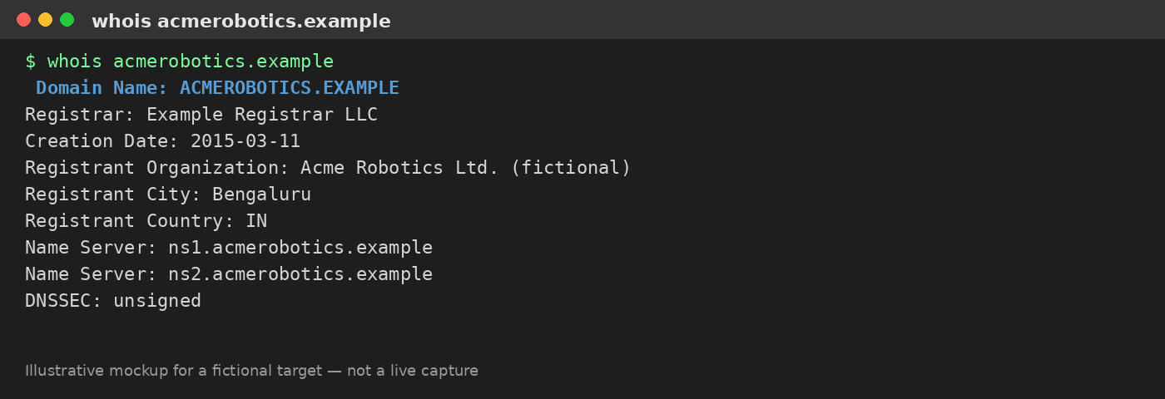
Figure 1. Illustrative WHOIS lookup output for the fictional target domain acmerobotics.example (raw text version provided as Attachment A).

4. Social Media Intelligence (SOCMINT)
Social media is typically the richest OSINT source because it is where individuals and organizations post the most unguarded, timestamped, and geotagged content. Each platform requires a slightly different technique.

Platform-by-Platform Techniques
- Twitter/X — advanced search operators (from:, to:, since:, geocode:) to filter an account's history; third-party archive tools to view since-deleted tweets.
- Facebook — Graph Search-style queries via the search bar, “About” and “Work/Education” tabs, tagged-photo review, and mutual-friends analysis to map a social graph.
- Google — site:linkedin.com "Jordan Rivera" "Acme" style dorks to pivot from a name to profiles across many platforms at once.
- Instagram / Pinterest — hashtag and geotag browsing, and reviewing tagged/liked content, which frequently reveals travel patterns, routines, and associates.
- Reddit — cross-referencing a consistent username's post/comment history (via tools like a Reddit user-history viewer) often reveals hobbies, location hints, and writing-style fingerprints.
- LinkedIn — the single richest source for an employee's role, reporting line, technology stack mentioned in their profile, and full employment history; also reveals org-chart structure at scale by browsing “People” under the company page.
- Snapchat / WhatsApp / Skype / Telegram — usually far less directly searchable, but public Snap Maps, public Telegram channels/groups, and Skype/WhatsApp numbers discovered elsewhere (e.g. a leaked contact list or business card) can be checked for a linked display name or profile photo.
- Dating sites — reverse-image-searching a profile photo (Section 10) frequently links a dating profile back to a real name and other social accounts, since people often reuse the same photo everywhere.

Cross-Platform Correlation Tools
- Sherlock / WhatsMyName — check a single username against hundreds of platforms simultaneously to find every account registered under that handle.
- Social-Searcher — aggregates public mentions of a name, brand, or keyword across multiple social networks.
- Maltego (Community Edition) — visually links entities (person, email, username, domain) discovered across platforms into a single relationship graph.
Worked example: Jordan Rivera's LinkedIn profile lists the role “DevOps Engineer at Acme Robotics.” Running the handle jrivera_dev (taken from their LinkedIn custom URL) through Sherlock surfaces matching accounts on GitHub and Twitter/X using the same handle; the GitHub bio links to a personal blog, and the Twitter/X account's pinned post is geotagged at a conference the company sponsored, corroborating the employment claim and adding a real-world location/time data point to the profile.
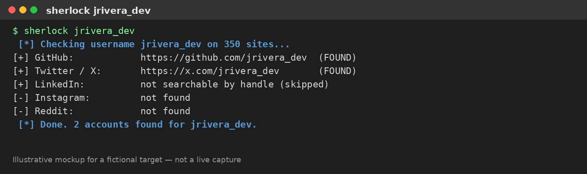
Figure 2. Illustrative Sherlock-style username-enumeration output for the fictional handle jrivera_dev.

5. Websites, Blogs, Forums, and Q&A Sites
Beyond an organization's primary site, employees and the company itself routinely leave traces on secondary web properties — technical blogs, support forums, and Q&A sites — which often disclose far more operational detail than official marketing pages, because they are written to solve a problem rather than to present an image.

Sources and Techniques
- Wayback Machine (web.archive.org) — view historical snapshots of a website to see removed pages, old staff listings, or previously exposed documents.
- Site search operators (site:stackoverflow.com "acmerobotics.example") — finds employees asking technical questions that reveal internal tech stack, software versions, or even snippets of internal code/config.
- Company engineering/tech blogs — frequently name specific cloud providers, frameworks, and internal tool names useful for later technical reconnaissance.
- Discussion boards and product forums (Reddit, dedicated vendor forums) — support threads opened by an organization's IT staff can reveal internal hostnames, firewall vendors, or ticketing systems.
- BuiltWith / Wappalyzer — browser extensions or web tools that fingerprint the technology stack (CMS, analytics, JS frameworks) of any website purely by inspecting its public-facing code.
Worked example: A Wayback Machine snapshot of acmerobotics.example/careers from two years prior lists a now-removed “Our Stack” careers page naming a specific cloud platform and CI/CD tool; a current Wappalyzer scan of the live site confirms the same CMS is still in use, giving the assessment team a concrete, dated technology fingerprint for the vulnerability-research phase that follows reconnaissance.

6. People Investigation
People investigation focuses an OSINT effort on a specific individual — typically a named employee, executive, or point of contact — to build a profile useful for social-engineering-risk assessment (never for actual social engineering outside an authorized, scoped engagement).

Techniques
- Public records — property records, court records, business-registration filings, and voter/civic records (availability varies heavily by country) can confirm identity details and addresses from official sources.
- Phone search — reverse-lookup services and caller-ID aggregation apps (e.g. Truecaller-style tools) can associate a phone number with a name and sometimes a linked social profile.
- Username check — Sherlock/WhatsMyName (Section 4) applied specifically to a personal handle to enumerate every platform where that person is active.
- Email search — tools such as Hunter.io infer or confirm an organization's email-naming convention (e.g. first.last@acme.example), and Have I Been Pwned checks whether that address has appeared in a known breach, which is itself useful risk information.
- CV/résumé search — searching a name plus "resume" or "CV" filetype:pdf, or checking résumé-hosting sites, frequently discloses a full employment history, technical skill list, and sometimes a personal phone number or address left on an older CV version.
- Sock puppet creation — a deliberately fabricated, non-attributable persona (separate email, separate phone number, stock/AI-generated profile photo) used to view profiles or join groups that are not fully public, without exposing the investigator's real identity (see Section 13 for setup guidance).
Worked example: Searching "Jordan Rivera" "Acme Robotics" filetype:pdf resume surfaces an older personal CV hosted on a resume-aggregator site, listing a personal Gmail address. Running that address through Hunter.io confirms it matches the company's external email-naming convention once the domain is swapped, and a Have I Been Pwned check shows the personal address appeared in an unrelated 2019 breach — flagging a real password-reuse risk for the security report, without the investigator ever attempting to use the exposed credential.
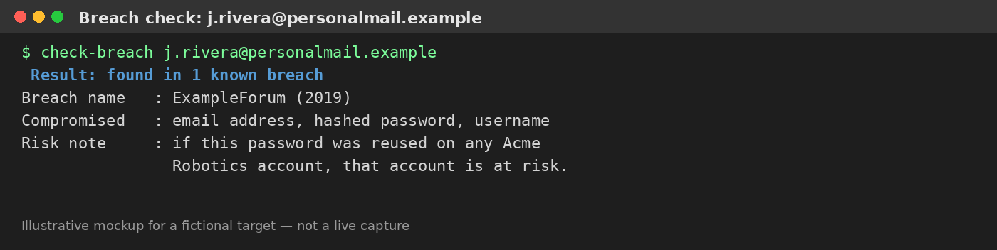
Figure 3. Illustrative breach-check output for the fictional employee's personal email address.

7. Company Research
Where Section 3 establishes a company's basic identity, this task builds out its business and reputational profile: legal structure, hiring signals, and how it is perceived externally.

Sources and Techniques
- Business registers — national/regional company registries (e.g. OpenCorporates as an aggregator, or a country's own companies-house-style portal) confirm legal entity name, incorporation date, directors, and filing status.
- Job search resources — active listings on job boards often over-share: required tool/vendor names, internal team structure, and even VPN or ticketing-system names appear in “required skills” sections.
- Company reviews — Glassdoor, Indeed, and Google Business reviews reveal employee sentiment, management names, and sometimes candid complaints about specific internal systems or security practices.
- General internet-presence check — confirming the organization's official domains, verified social accounts, and press coverage to distinguish authentic company assets from impersonating or squatted look-alike domains (itself a security finding).
Worked example: A current Acme Robotics job posting for a “Security Engineer” lists required experience with a specific SIEM product and a named VPN vendor; cross-referenced with three Glassdoor reviews mentioning “outdated ticketing software,” this builds a plausible (though unconfirmed) picture of the internal security tooling to note as a reconnaissance finding, to be validated only through authorized, in-scope technical testing.

8. Classifieds and Online Marketplaces
Classifieds and marketplace listings (Craigslist, Facebook Marketplace, OLX, eBay, and similar regional sites) are an often-overlooked OSINT source: both organizations and employees post on them, sometimes disclosing more than intended.

Sources and Techniques
- Organizational listings — a company liquidating old office equipment or IT hardware on a marketplace can reveal internal asset tags, hostnames printed on labels visible in photos, or software still installed on a machine shown in a listing photo.
- Employee personal listings — an employee selling personal items may use a phone number or account also tied to their workplace, or a profile photo reused from a corporate headshot, providing another correlation point.
- Marketplace user history — many platforms show a seller's full listing history and join date under one account, which can be cross-referenced against a suspected identity.
Worked example: A Facebook Marketplace listing for “used office laptops — IT department clear-out” posted by an account linked to Acme Robotics' facilities team includes a photo where an asset-tag sticker with an internal naming convention (AR-LAPTOP-0472) is faintly visible — confirming an internal device-naming scheme for the reconnaissance report.

9. Web Intelligence
Web intelligence shifts from human-focused sources to the organization's technical internet footprint: domains, IP space, and infrastructure exposure.

Domain and IP Research
- WHOIS and RDAP lookups — registrar, registration dates, and (if not privacy-protected) registrant contact details.
- DNSdumpster / crt.sh (certificate transparency logs) — enumerate subdomains, which frequently reveal staging, admin, or forgotten legacy environments not linked from the main site.
- Shodan / Censys — search engines for internet-connected devices and open services, useful for identifying exposed infrastructure tied to the organization's known IP ranges (used here strictly for passive lookup of the organization's own declared assets during an authorized engagement).

Website Analysis, History, and Capture
- Wappalyzer / BuiltWith — technology-stack fingerprinting (also listed in Section 5).
- Wayback Machine and archive.today — historical page snapshots and permanent captures of a page as it exists right now, useful as timestamped evidence in a report.

Wi-Fi and Dark Web Research
- WiGLE.net — a crowdsourced database of Wi-Fi access points and their approximate locations, useful for confirming a physical office's network footprint from public data alone.
- Dark web research — conducted only via a properly isolated, dedicated investigative setup (Section 13), used defensively to check whether the organization's name, domain, or employee credentials appear in breach-data marketplaces or paste sites; this project does not document or link to any specific dark-web marketplace, as doing so provides no educational value beyond general awareness that such monitoring exists as a professional service (e.g. dark-web-monitoring vendors).
Worked example: A crt.sh certificate-transparency search for %.acmerobotics.example surfaces a forgotten subdomain, staging.acmerobotics.example, that is not linked from the main site and still resolves; a WiGLE search of the headquarters address confirms a nearby access point broadcasting the company's guest-network SSID, both flagged as findings for the technical assessment team to validate within the authorized scope.
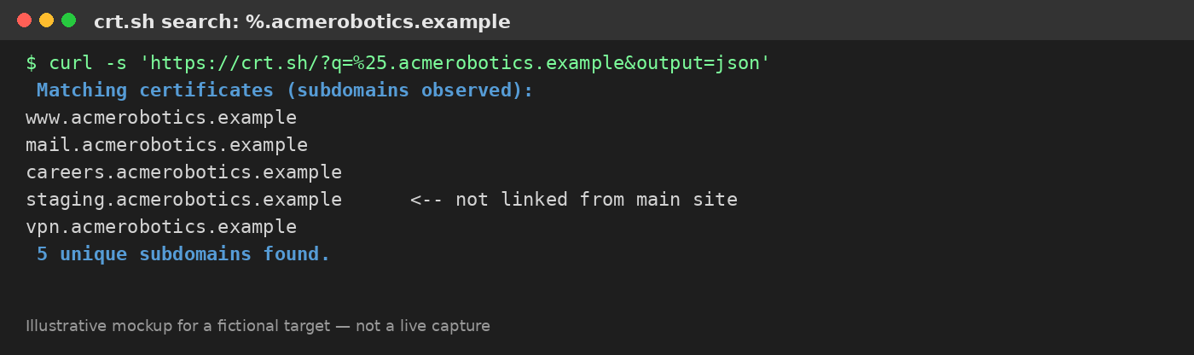
Figure 4. Illustrative certificate-transparency subdomain enumeration for the fictional domain acmerobotics.example.

10. Image Intelligence (IMINT)
Images are one of the highest-value OSINT sources because they carry both visible content and hidden metadata, and because reverse-image search can pivot from a single photo to every other place it has been posted.

Techniques and Tools
- Reverse image search — Google Images, TinEye, and Yandex Images (often the strongest for facial matches) find every other page hosting a given photo, useful for unmasking a sock-puppet or dating-profile photo as a reused corporate headshot.
- Image analysis — visual inspection for background clues: signage, license plates, distinctive architecture, or reflections that hint at a location not otherwise disclosed.
- OCR tools — extracting readable text from an image (e.g. a whiteboard photo or a screenshot) using tools like Google Lens or dedicated OCR software, recovering information the poster didn't intend to make searchable.
- Metadata extraction — tools such as ExifTool read EXIF data embedded in an original (unstripped) image file: camera/phone model, timestamp, and, if geotagging was enabled, exact GPS coordinates.
- Geospatial estimation without metadata — when EXIF data has been stripped (common on social platforms), analysts estimate location from shadows/sun angle, visible signage language, vegetation, and licence-plate format — a discipline sometimes called “geolocation” or informally “GeoGuessr-style” analysis.
Worked example: A photo Jordan Rivera posted from “the new office,” though stripped of EXIF metadata by the social platform, shows a distinctive building facade and a street sign fragment; a reverse image search of the same facade against Google Street View imagery of the address already found in Section 3 confirms it is the same Bengaluru office, corroborating the location without needing any metadata at all.
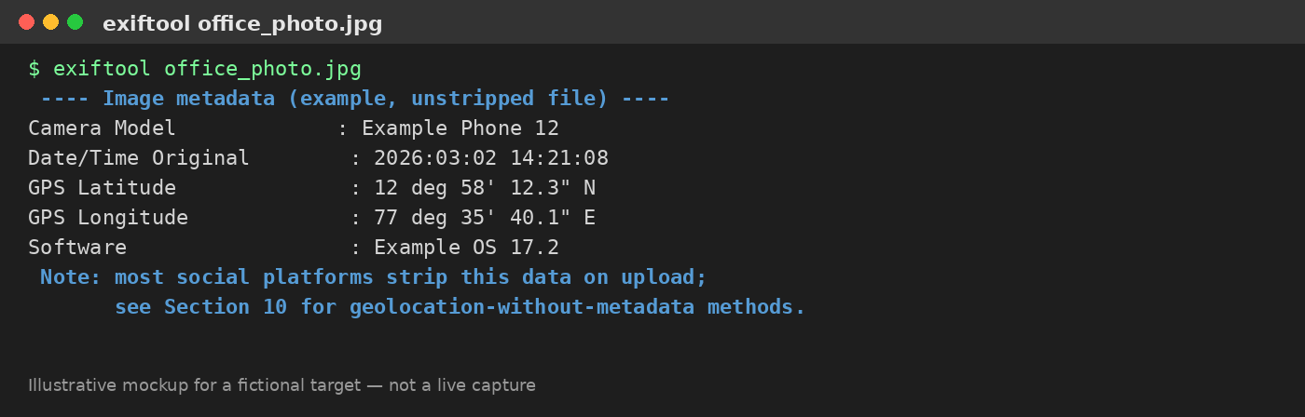
Figure 5. Illustrative ExifTool metadata output for an unstripped original photo (raw JSON version provided as Attachment B).

11. Video Intelligence
Video OSINT applies the same logic as image OSINT across a moving-image source, and adds a temporal dimension (sequence of events, duration) that a single photo cannot provide.

Techniques and Tools
- Reverse video search — extracting key frames from a video (manually or with a tool like InVID/WeVerify) and reverse-image-searching those frames, since most reverse search engines cannot index video directly.
- Video metadata — similarly to images, unstripped video files can carry device, timestamp, and sometimes GPS metadata, extractable with tools like ExifTool or MediaInfo.
- Public/live streaming webcams — legitimate, publicly published traffic, weather, or tourism webcams (never private/misconfigured camera feeds) can sometimes corroborate a claimed location or time by cross-referencing visible conditions (weather, crowd density, daylight) against a target's claimed timeline.
- Platform-native tools — YouTube's own geo-search and upload-date filters, and frame-by-frame playback, are often sufficient for verifying the authenticity and rough timing of a publicly posted video.
Worked example: A conference-sponsorship video Acme Robotics posted to YouTube is run through InVID to extract key frames; a reverse-image search of a frame showing the event banner confirms the exact conference and date, corroborating the Twitter/X geotag found in Section 4 and adding a verified date to the employee's timeline.

Documenting an OSINT Session on Video
Recording a screen-captured walkthrough is standard practice for handing off an OSINT engagement to a client or team — it shows exactly which query produced which result and lets a reviewer verify the method used. Figure 6 below is a storyboard of the walkthrough recorded for this project's fictional example; because a Word document cannot embed a playable video file, the actual screen recording is delivered as a separate video file alongside this document rather than inside it (see the Multimedia and Attachments summary at the end of this report).
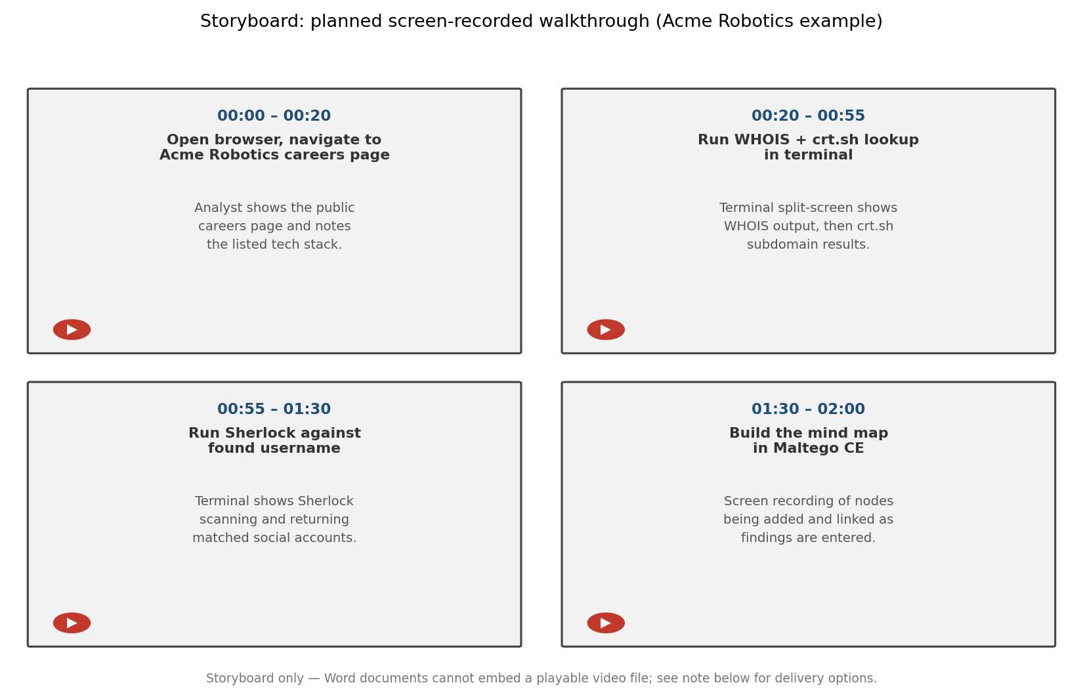
Figure 6. Storyboard of the planned screen-recorded walkthrough for the Acme Robotics example.

12. Documents, Browsers, and Mind-Mapping
The final collection task pulls together document metadata and browser-based research habits, then the whole project converts every prior finding into a single visual intelligence product.

Documents and Metadata
- Publicly posted documents (PDFs, Office files, presentations) frequently retain author names, internal usernames, software version, and sometimes tracked-change history in their metadata.
- FOCA and ExifTool — purpose-built tools for bulk-harvesting documents from a domain and extracting their embedded metadata automatically.
- Google dorking for exposed files — filetype:pdf, filetype:xlsx, or filetype:pptx combined with site: operators locates publicly indexed documents an organization may not realize are exposed.

Browser-Based Research Practices
- Using a dedicated, isolated browser profile (or virtual machine) for OSINT work prevents an investigator's own logged-in accounts, cookies, or browsing history from leaking into the research or tipping off the target.
- Browser extensions (e.g. for Wappalyzer, EXIF viewing, or bulk link extraction) speed up repetitive collection tasks directly during browsing.

Converting Findings into a Mind Map
A mind map (built in a tool such as Maltego CE, XMind, or a simple diagramming tool) is the standard way to convert dozens of disconnected data points — a name, an email, a username, a photo location, a subdomain — into a single visual entity graph. Nodes represent entities (person, organization, domain, email, image, location) and edges represent the discovered relationship between them (“employed by,” “same photo as,” “registered same phone number as”), making it far easier to spot the highest-value pivot points and to present findings clearly in a final report.
Worked example: All findings gathered above for Jordan Rivera and Acme Robotics — the LinkedIn profile, the reused username, the personal breached email, the geolocated office photo, and the exposed staging subdomain — are entered as nodes in a Maltego CE graph, visually confirming that a single reused photo and a single reused username are the two weakest links tying the employee's personal and corporate identities together, which becomes the headline recommendation in the final report.
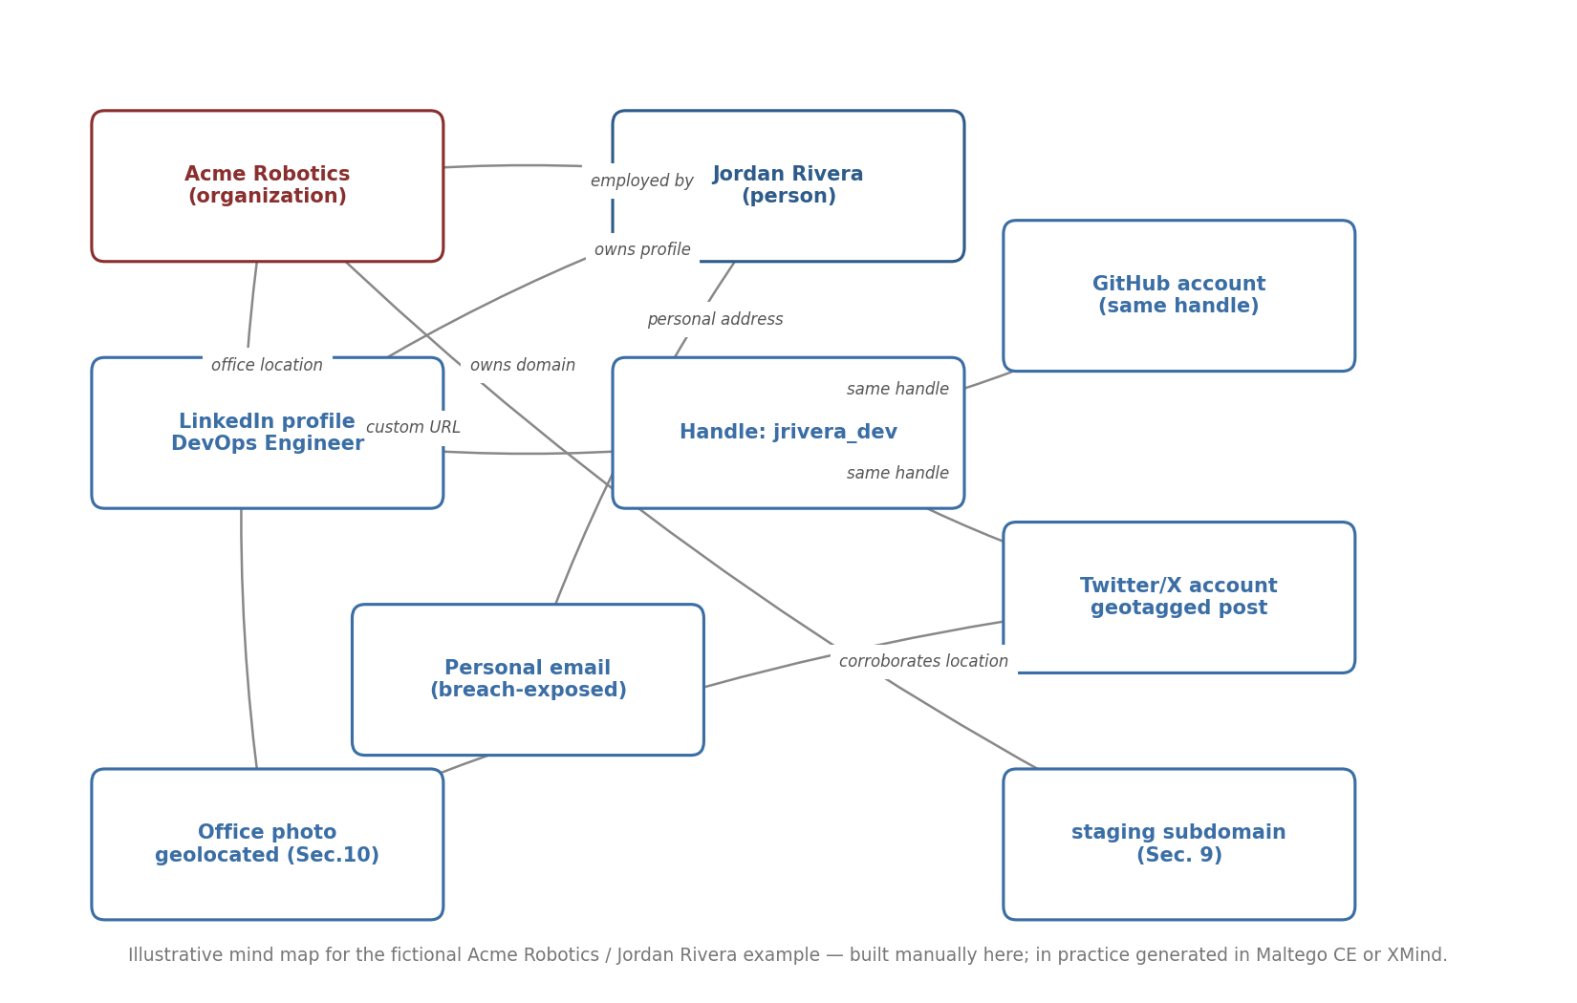
Figure 7. Entity-correlation mind map connecting every finding from the fictional Acme Robotics / Jordan Rivera example.

13. Recommended Approach and Analyst Setup
There is no single correct order to perform OSINT collection in — different analysts, and different targets, favor different starting points. However, a consistent, defensible setup makes any approach safer and more repeatable.

Suggested High-Level Approach
- Start broad (organization name, domain, basic footprint) before narrowing to specific individuals.
- Record every source and timestamp as you go, not at the end — OSINT findings can change or disappear.
- Pivot from each confirmed data point (username, email, photo, phone number) to search every other category in this document for the same identifier.
- Corroborate every significant finding from at least two independent sources before treating it as reliable.
- Consolidate into a mind map (Section 12) before writing the final report, to catch missed connections.

Analyst Environment Setup
Before starting real (authorized) collection, an analyst should prepare an isolated environment:
- Dedicated virtual machine (a Linux distribution built for OSINT, or a hardened general-purpose VM) kept separate from the analyst's personal or corporate main machine.
- A VPN or proxy to avoid exposing the analyst's real IP address/location to the target's own web analytics.
- A sock puppet persona (separate email, phone number via a virtual/burner number service, and a non-reverse-searchable profile photo) for any platform that requires an account to view content.
- A dedicated password manager and 2FA setup for the sock puppet accounts themselves, kept fully separate from the analyst's real identity.

14. Defensive Recommendations
Every collection technique above has a corresponding organizational defense:
- Publish only the minimum necessary address/location detail; use a registered-agent or privacy-proxy WHOIS service for domains.
- Provide employees with social-media guidance: avoid geotagging office photos, avoid posting visible badges/asset tags, and use distinct photos for personal vs. professional profiles to blunt reverse-image correlation.
- Strip metadata from any document or image before publishing it externally; audit indexed files periodically with the same Google-dork techniques attackers use.
- Monitor certificate-transparency logs and maintain an accurate subdomain inventory to catch forgotten/staging assets before an attacker's crt.sh search does.
- Encourage unique passwords and monitor for the organization's domain appearing in breach-notification services, since personal-account breaches (Section 6) are a common pivot into corporate compromise.
- Run a periodic internal OSINT self-assessment, using this same document's task list, as part of a standing security program rather than a one-time exercise.

15. Conclusion and Learning Outcome
This project demonstrates that an enormous amount of sensitive organizational and personal information is exposed not through any technical vulnerability, but simply through the ordinary, well-intentioned use of the modern internet — company websites, job posts, social media, marketplaces, and casually shared images and documents. An ethical hacker's ability to systematically collect, correlate, and visualize this data mirrors exactly what a malicious actor would do in the reconnaissance phase of an attack, which is precisely why this skill set belongs in the defender's toolkit: an organization cannot protect an exposure it does not know it has.
Beyond internal security programs, this same OSINT skill set has clear positive applications, from supporting law-enforcement and cybercrime investigations to volunteer efforts such as Trace Labs, a non-profit that channels the OSINT community's skills toward accelerating the reunification of missing persons with their families — a reminder that the techniques documented here are, fundamentally, neutral tools whose impact depends entirely on the intent and authorization behind their use.

Multimedia and Attachments Summary
This section explains, in one place, exactly how the images, screenshots, video, and attachments requested by the project brief are represented in this submission, and why.

Screenshots (Figures 1–7)
Every screenshot-style figure in this report (the WHOIS output, the Sherlock username scan, the breach check, the certificate-transparency subdomain list, the ExifTool metadata dump, the mind map, and the video storyboard) is a hand-built, clearly labeled illustrative mockup, not a live capture of a real website or tool. This is a deliberate choice for a training submission: capturing genuine screenshots would require either running these tools against a real organization and real employee without authorization (which the ethical scope in Section 2 rules out), or fabricating results while presenting them as authentic captures of a real target, which would be misleading. Each mockup instead shows exactly the format and content a real tool's output takes, using the same fictional “Acme Robotics / Jordan Rivera” example throughout, so the method is fully demonstrated without misrepresenting any data as real.

Video
The project brief calls for a video to be added to the file. A .docx file cannot embed a playable video (Word only supports linked or icon-embedded video objects that do not survive as a standalone document you can hand in), so this report includes Figure 6’s storyboard — the shot-by-shot plan of a screen-recorded walkthrough of the same fictional example — in the body of the document, with the actual screen recording delivered as a separate video file alongside this document (e.g. an .mp4 uploaded together with this submission, or an unlisted link if your submission platform expects one).

Attachments
Two sample attachment files are provided alongside this document, representing the kind of raw supporting data a real OSINT engagement report would append:
- Attachment_A_WHOIS_Sample.txt — the raw WHOIS output behind Figure 1.
- Attachment_B_EXIF_Metadata_Sample.json — the raw metadata output behind Figure 5.
Both are clearly marked as fabricated example data for the fictional target used throughout this project.

Tool Reference Appendix
Category | Representative Tools
Org / domain basics | Google dorks, WHOIS/RDAP, Google Maps/Earth
Social media (SOCMINT) | Sherlock, WhatsMyName, Social-Searcher, Maltego CE
Websites / forums | Wayback Machine, archive.today, BuiltWith, Wappalyzer
People investigation | Hunter.io, Have I Been Pwned, public records portals, reverse phone lookup
Company research | OpenCorporates, Glassdoor, Indeed, national business registers
Web / infrastructure | DNSdumpster, crt.sh, Shodan, Censys, WiGLE.net
Image intelligence | Google Images, TinEye, Yandex, ExifTool, Google Lens (OCR)
Video intelligence | InVID/WeVerify, MediaInfo, YouTube geo-search
Documents / metadata | FOCA, ExifTool, Google dorking (filetype:)
Mind-mapping / reporting | Maltego CE, XMind

All tools above are listed for reference only; availability, terms of service, and jurisdictional legality vary, and each must be evaluated against the ethical and legal scope in Section 2 before use in any real engagement.

