**NATIONAL INSTITUTE OF TECHNOLOGY, KARNATAKA**





**COMPUTER SCIENCE AND ENGINEERING DEPARTMENT**

Database Management

Project Report On

Connect +

Submitted by,

Sayan Paul (11CO86)

ShravanKumar (11CO87)

Shreyas G (11CO88)

Sham Gopal (11CO89)

Batch: D

Submitted To: Mr.Ravindranath C

**I**ntroduction

***Connect+*** is a social networking service platform to build social networks or social relations among people who, for example, share interests, activities, backgrounds, or real-life connections. A social network service consists of a representation of each user, his/her social links, and a variety of additional services. Most social network services are web-based and provide means for users to interact over the Internet, such as e-mail. Social network service usually means an individual-centered.

***Connect+*** allow users to share ideas, pictures, posts, activities, events, and interests with people in their network.

This project has Nine relations namely

* **User**
* **Login**
* **Message**
* **Page**
* **Page_Likes**
* **Post**
* **Post_Likes**
* **PR_PIC**
* **Friend_LIST.**

Also it contains Six entities such as

* **User**
* **Login**
* **Page**
* **Post**
* **Message**
* **Pr_Pic.**

**Information Gathering**

Each User is allowed to create a profile, upload profile pictures, and post/share pictures on page or others walls. They can communicate by sending message to each other.

Also they can like pages, like posts.

We have used following tools for the implementation of project and reports:

* Lucid Chart to draw ER diagrams.
* WordPad for making
* XAMPP server to run server
* MySQL to maintain database
* Web Brower to run application
* SEQUEL for querying.
* Dream Viewer for *HTML, CSS* management.

Languages used for the implementation of the project:

* ***PHP***
* ***HTML***
* ***CSS***
* ***JAVASCRIPT***

**Entity Relation Diagram For Connect+**

**Entities Used:**

1. **User:**

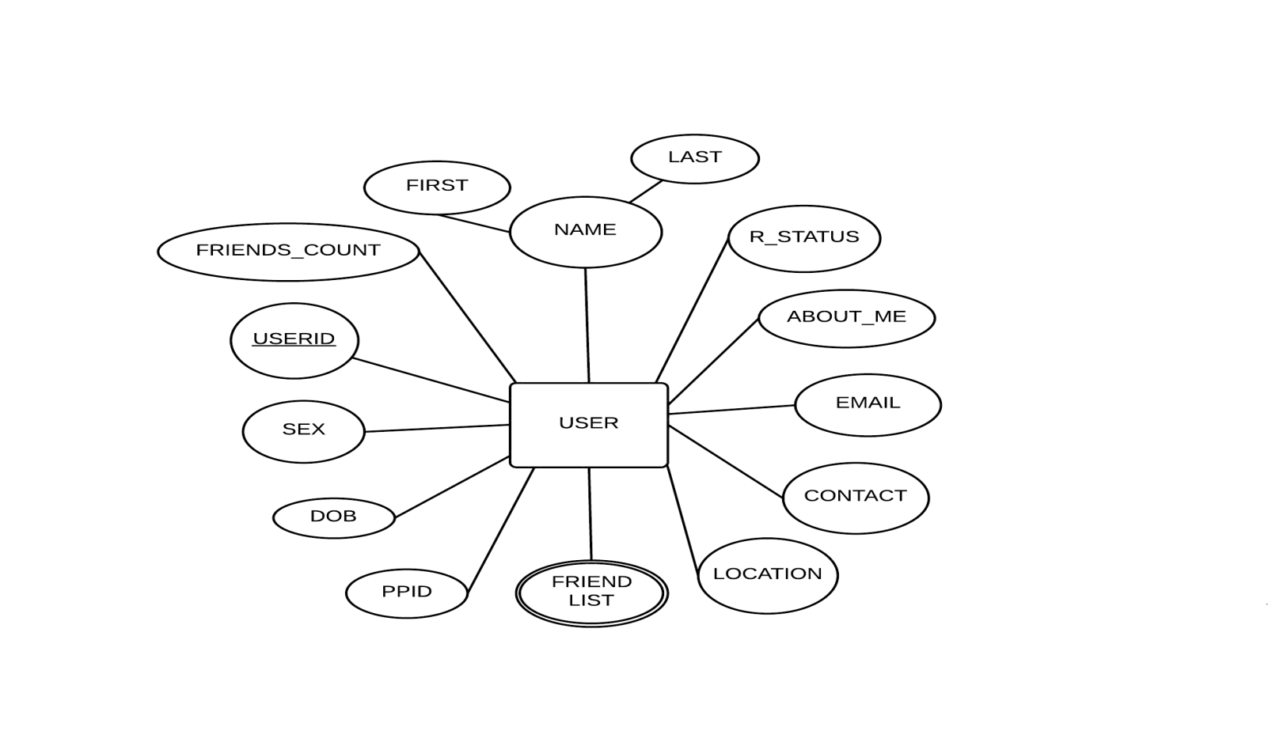

The entity called ***User*** is used to store the profile information of all users.

**Attributes:**

* USERID is primary key for User Entity. Unique Id is given to each user upon joining Connect+.
* NAME is Composite attribute which contains user’s First name and Last Name.
* CONTACT t is an attribute that contains contact information which is used to inform the user in case of updates or requests.
* LOCATION contains user’s current location. This information is used to provide suggestions.
* FRIEND LIST is a multivalued attribute which contains set of UserID s of friends connected to user.
* PIC URL: it contains the URL of User’s profile picture.
* DOB: It Contains Date of Birth of the User.

1. **LOGIN:**

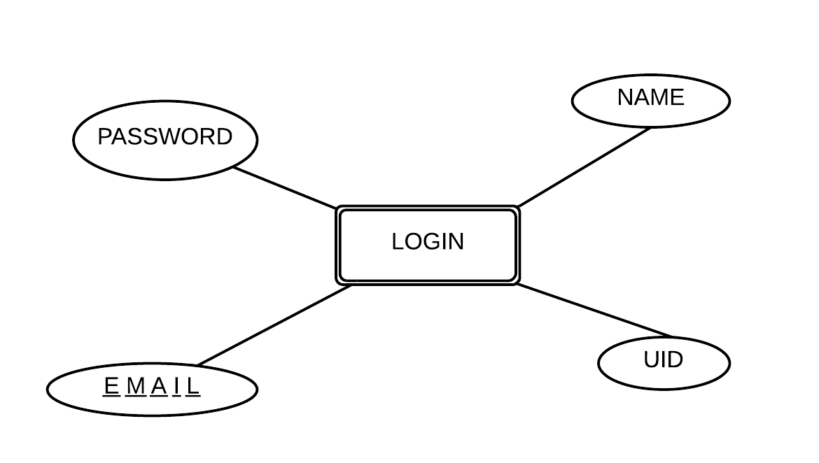

***Login*** is a weak entity used to authenticate the user. It the encrypted Password and email associated with the user.

Attributes:

* Name: It contains the name of the user.
* UID: It contains User ID of the user.
* EMAIL: It contains associated email account for the user.
* PASSWORD: It contains the password.

1. **PAGE :**

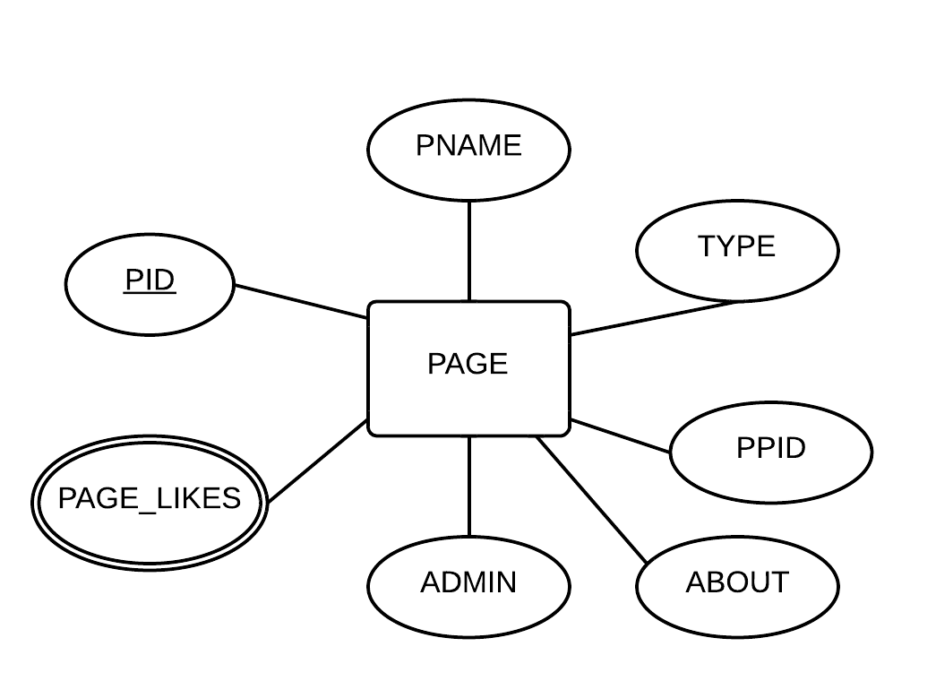

***Page*** contains information related to all pages in the Connect+ database.

Attributes:

* PID: It is the primary key of the PAGE entity and unique ID assigned to each page.
* PNAME: It contains name of the page.
* TYPE: It specifies what type of page it is such as Entertainment, food, clothes etc.
* PIC_URL: It contains the URL of the page’s display picture.
* ADMIN: It contains user ID of the admin.
* PAGE_LIKES: It is a multivalued attribute which contains set of ID’s of all people who have liked the page.
* ABOUT: It contains information/description of the page.

1. **POST :**

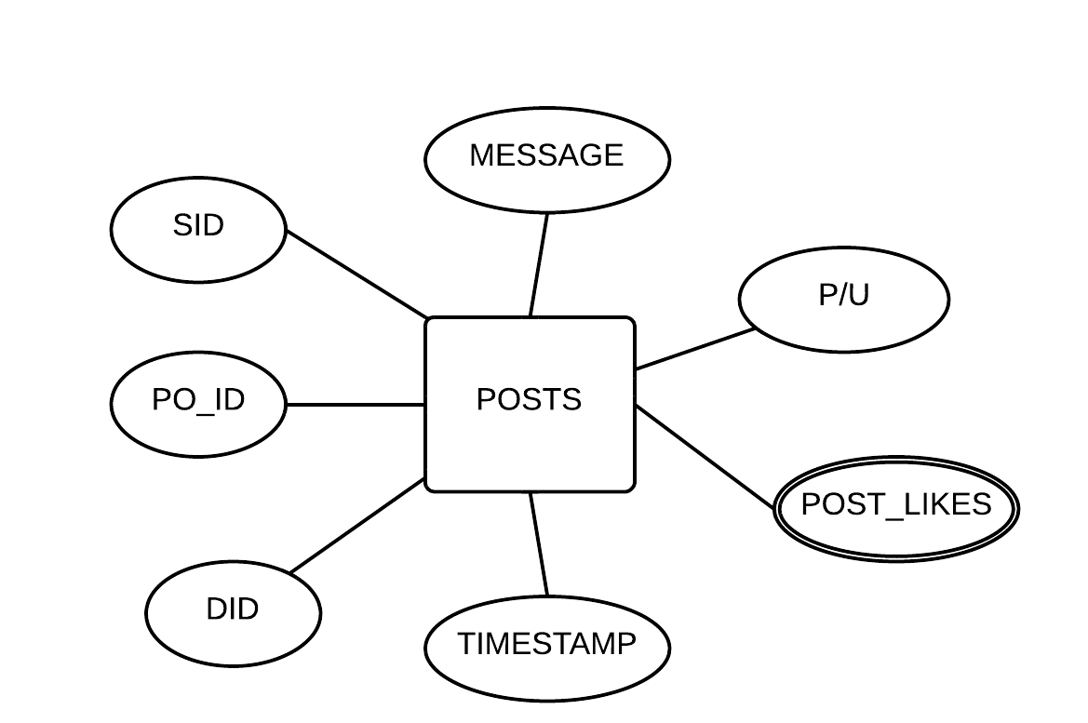

Users are allowed to create ***post***s and post messages which can be viewed by other users/himself.

Attributes:

* PO_ID: It is the primary key of the POST entity and a unique ID assigned to each post.
* MESSAGE: It contains the actual message/information posted by the user.
* POST_LIKES: Is a multivalued attribute containing IDs of all people who liked the post.
* TIMESTAMP: It contains time when message is posted.
* SID: Contains Source ID, which posted the message.
* DID: Contains the Destination ID, where the message should be posted. On the

Users’ wall/Page walls indicated by P/U attribute.

* P/U : It is a key which indicates whether message should be posted in User wall/Page wall.

1. **MESSAGE:**

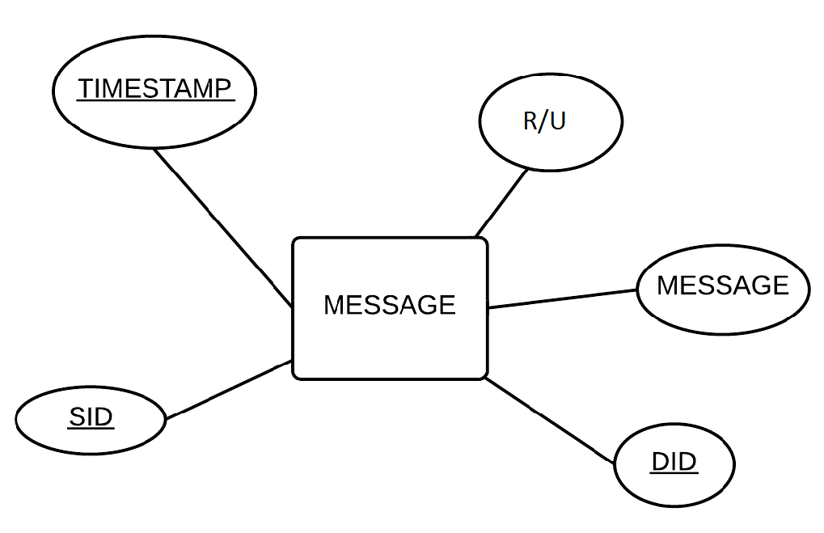

***Message*** is an entity which contains information about message that is to be conveyed or already conveyed. Users are allowed to send message to each other.

Attributes:

* TIMESTAMP: It contains time at which message is sent/received.
* MESSAGE: It contains the actual private information communicated by two users.
* DID: It has the Destination ID of the receiver.
* SID: It has Source Id of the sender.
* R/W: It is an attribute which indicates whether the message is read or not.

1. **PR_PIC :**

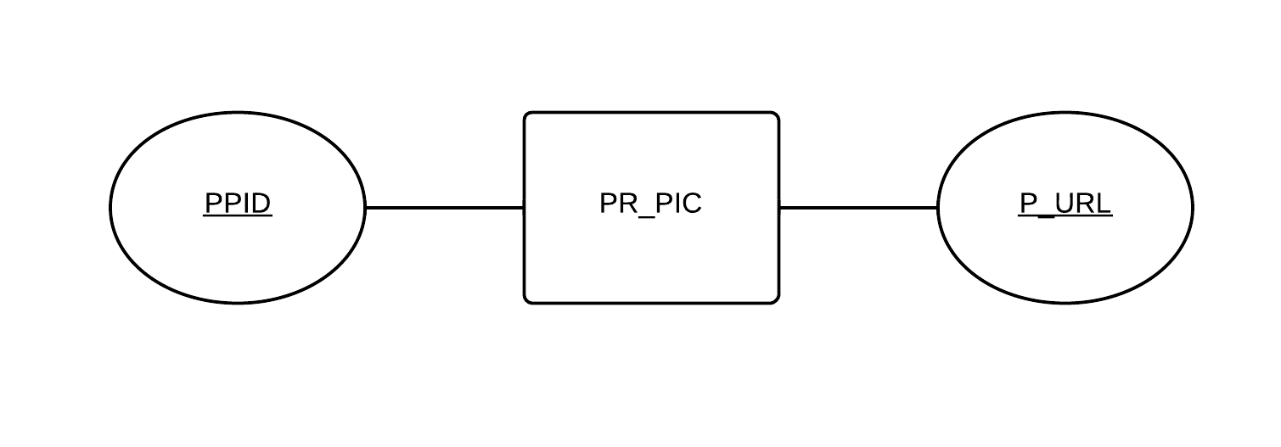

It contains information Picture and it allows user to upload/share a picture.

Attributes:

* PPID: It contains ID of the picture which could be posted on a page or made profile picture.
* P_URL: It contains URL of the image.

**Entity Relationship Diagram**

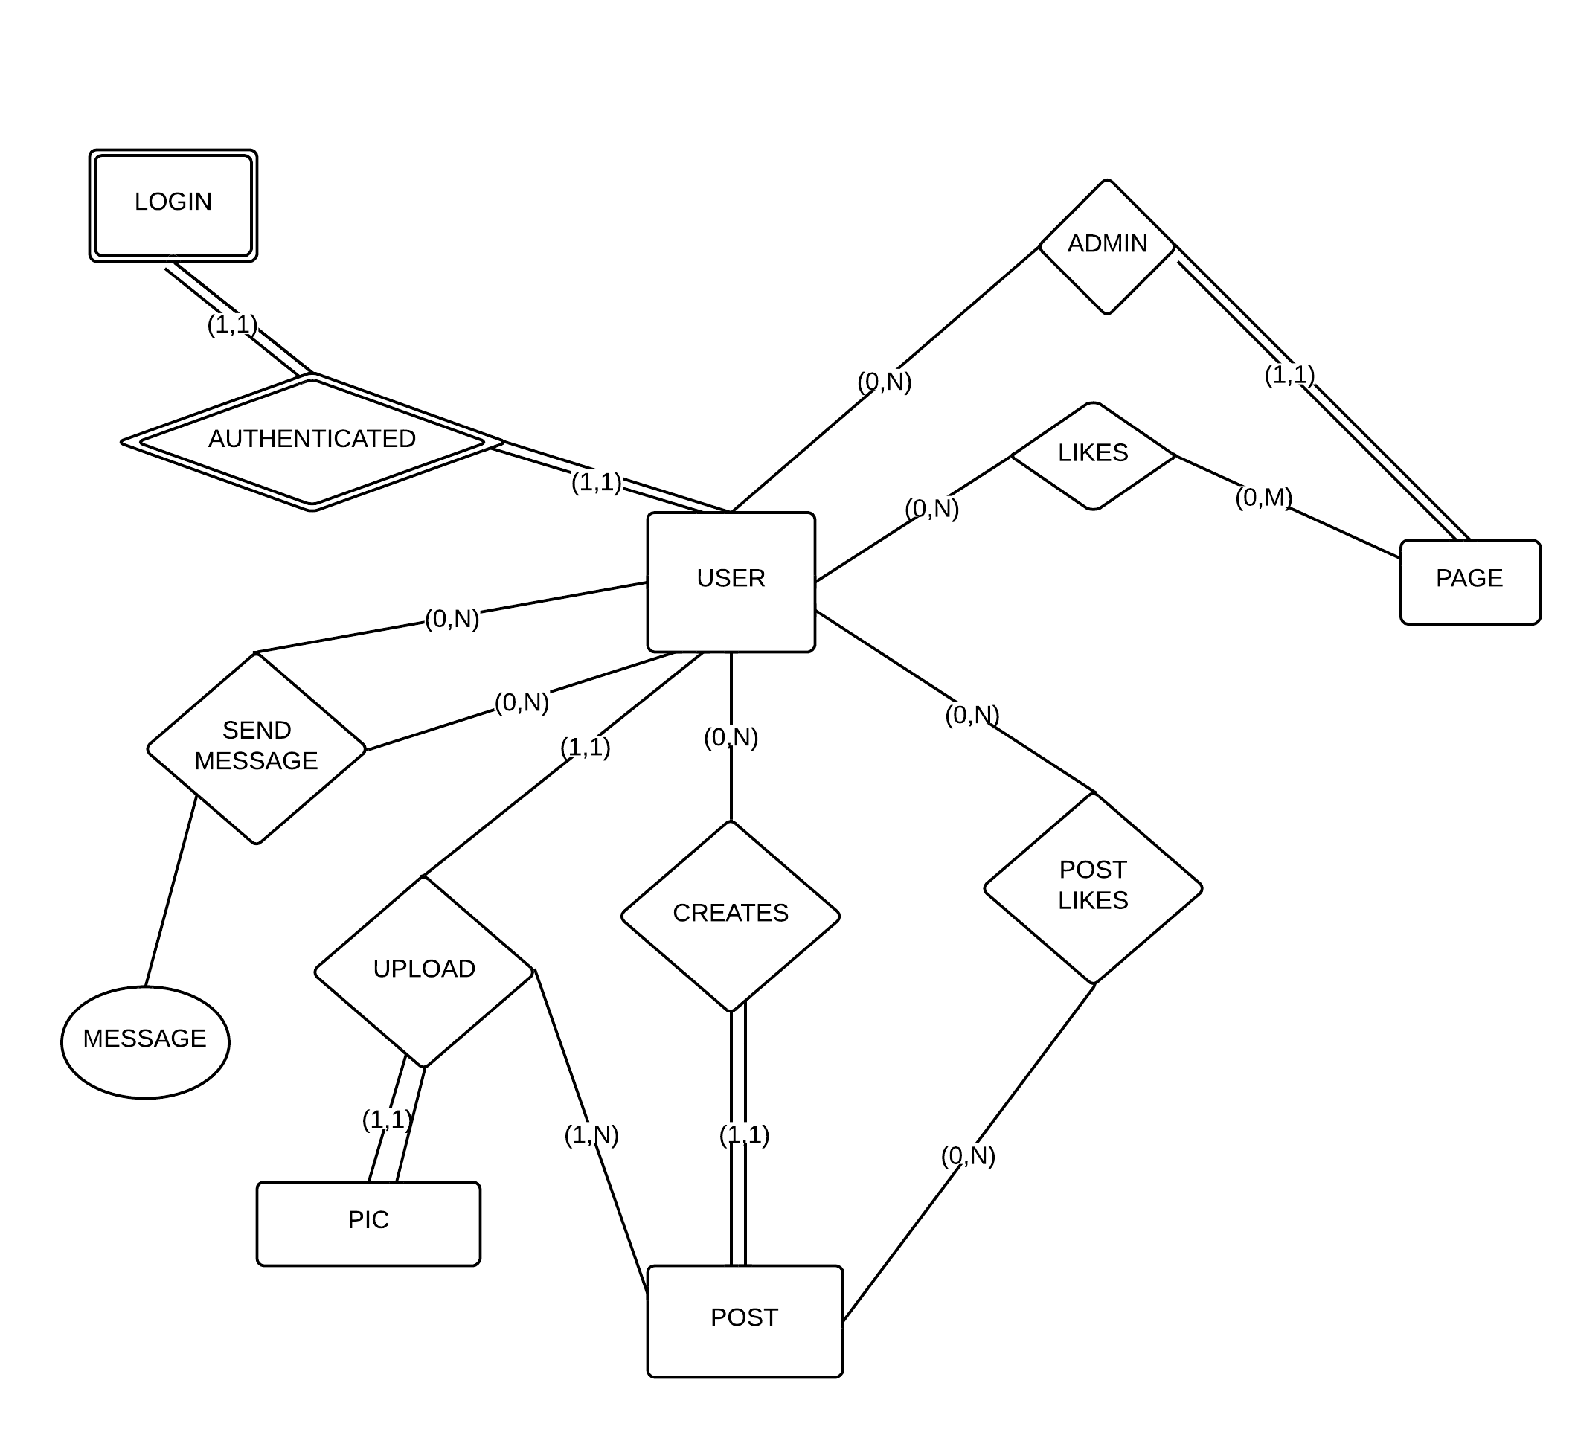

**Schema**

**Relations:**

User:

|  |  |  |  |  |  |  |  |  |  |  |  |
| --- | --- | --- | --- | --- | --- | --- | --- | --- | --- | --- | --- |
| ID | First name | Last name | Contact | DOB | SEX | LOCATION | PPID | About Me | emailID | R_Status | FRCNT |

LOGIN:

|  |  |  |  |
| --- | --- | --- | --- |
| NAME | PASSWORD | EMAIL_ID | ID |

MESSAGE:

|  |  |  |  |  |
| --- | --- | --- | --- | --- |
| SID | DID | MESSAGE | TIMESTAMP | R/U |

PAGE:

|  |  |  |  |  |  |
| --- | --- | --- | --- | --- | --- |
| PID | ADMIN_ID | NAME | TYPE | PPID | ABOUT |

PAGE_LIKES:

|  |  |
| --- | --- |
| PID | LK_ID |

POST:

|  |  |  |  |  |  |
| --- | --- | --- | --- | --- | --- |
| SID | DID | PID | MESSAGE | TIMESTAMP | P/U |

PR_PIC:

|  |  |
| --- | --- |
| PPID | IMG_URL |

FRIEND_LIST:

|  |  |
| --- | --- |
| UID | FR_ID |

POST_LIKES:

|  |  |
| --- | --- |
| PID | LK_ID |

**Normalization (3rd Normal form)**

User:

|  |  |  |  |  |  |  |  |  |  |  |  |
| --- | --- | --- | --- | --- | --- | --- | --- | --- | --- | --- | --- |
| ID | First name | Last name | Contact | DOB | SEX | LOCATION | PPID | About Me | emailID | R_Status | FRCNT |

LOGIN:

|  |  |  |  |
| --- | --- | --- | --- |
| NAME | PASSWORD | EMAIL_ID | ID |

MESSAGE:

|  |  |  |  |  |
| --- | --- | --- | --- | --- |
| SID | DID | MESSAGE | TIMESTAMP | R/U |

PAGE:

|  |  |  |  |  |  |
| --- | --- | --- | --- | --- | --- |
| PID | ADMIN_ID | NAME | TYPE | PPID | ABOUT |

PAGE_LIKES:

|  |  |
| --- | --- |
| PID | LK_ID |

POST:

|  |  |  |  |  |  |
| --- | --- | --- | --- | --- | --- |
| SID | DID | PID | MESSAGE | TIMESTAMP | P/U |

PR_PIC:

|  |  |
| --- | --- |
| PPID | IMG_URL |

FRIEND_LIST:

|  |  |
| --- | --- |
| UID | FR_ID |

POST_LIKES:

|  |  |
| --- | --- |
| PID | LK_ID |