COMPUTER SCIENCE AND ENGINEERING

NATIONAL INSTITUTE OF TECHNOLOGY KARNATAKA
SURATHKAL

UNIX PROGRAMMING
MINI PROJECT

ONLINE SHOPPING DATABASE

SUBMITTED TO: B R CHANDAVARKAR
SUBMITTED BY: SHREYAS G 11CO88

INTRODUCTION
This project is based on building an online shopping database on electronics items and give a user a detailed list of items required.
The project in coded in shell script. A shell program runs in interpretive mode. It is not compiled into a separate executable file as C program. Each statement is loaded into memory when it is to be executed.

A shell script is a script written for the shell, or command line interpreter, of an operating system. The shell is often considered a simple domain-specific programming language. Typical operations performed by shell scripts include file manipulation, program execution, and printing text.
Many shell script interpreters double as command line interface, such as the various Unix shells, Windows PowerShell or the MS-DOS COMMAND.COM. Others, such as AppleScript or the graphical Windows Script Host (WScript.exe), add scripting capability to computing environments without requiring a command line interface. Other examples of programming languages primarily intended for shell scripting include DCL and JCL.

ADVANTAGES AND DISADVANTAGES
Often, writing a shell script is much quicker than writing the equivalent code in other programming languages. The many advantages include easy program or file selection, quick start, and interactive debugging. A shell script can be used to provide a sequencing and decision-making linkage around existing programs, and for moderately-sized scripts the absence of a compilation step is an advantage. Interpretive running makes it easy to write debugging code into a script and re-run it to detect and fix bugs. Non-expert users can use scripting to tailor the behavior of programs, and shell scripting provides some limited scope for multiprocessing.
On the other hand, shell scripting is prone to costly errors. Inadvertent typing errors such as rm -rf * / (instead of the intended rm –rf */) are folklore in the Unix community; a single extra space converts the command from one that deletes everything in the sub-directories to one which deletes everything—and also tries to delete everything in the root directory. Similar problems can transform cp and mv into dangerous weapons, and misuse of the > redirect can delete the contents of a file. This is made more problematic by the fact that many UNIX commands differ in name by only one letter: cp, cd, dd, df, etc.
Another significant disadvantage is the slow execution speed and the need to launch a new process for almost every shell command executed. When a script's job can be accomplished by setting up a pipeline in which efficient filter commands perform most of the work, the slowdown is mitigated, but a complex script is typically several orders of magnitude slower than a conventional compiled program that performs an equivalent task.
There are also compatibility problems between different platforms. Larry Wall, creator of Perl, famously wrote that "It is easier to port a shell than a shell script."
Similarly, more complex scripts can run into the limitations of the shell scripting language itself; the limits make it difficult to write quality code and extensions by various shells to ameliorate problems with the original shell language can make problems worse. Many disadvantages of using some script languages are caused by design flaws within the language syntax or implementation, and are not necessarily imposed by the use of a text-based command line; there are a number of shells which use other shell programming languages or even full-fledged languages like Scsh

DESCRIPTION

A database of different list of items is created in a text file for each components.
The user is first asked to enter login-id and password and checks the validity of the password.
A new page displaying various options is shown (pic included) once user selects a particular choice the corresponding subpage is loaded and a keyword is accepted as input and all items regarding particular keyword is displayed.
For example if user enters keyword “dell” as the items which are products of dell which is available in database in displayed like dell monitors,keyboards,mouse,laptops etc.
If the keyword does not match any string in database a suitable message is displayed corresponding to input.
Once specific list of similar items is displayed on output along with its details user can go through all the items in list in detail.He is asked to enter the index number of list to be purchased, that specific line is extracted to amount which is displayed at the end using a delimiter is added to sum variable initialized to zero at begining.
A loop is created for the user to purchase multiple items of desired choice once the user is done with the purchasing he can exit the loop.
The detailed bill of all the purchases which was added to cart before is displayed along with total outstanding output. User is two options for payment either through credit/debit card or net banking, once the corresponding choice is accepted the details of the customer like the shipping address, mobile number , card number and pin if its card or redirected to online process gateway to make the final payment .
When all the transactions is done a message is displayed on the successful payment and thanksgiving for online purchase is displayed.

CODE
#!/bin/usr/sh
#online electronic shopping website
tput bold
cat ss1
printf " \n\n\n\n "
printf " %45s ****** Welcome To Online Electronic Shopping ****** \n"
printf "Enter User-name : "
read us
stty -echo
printf "Enter Password :"
read pas
stty echo
def="shreyas"
while [ $pas != $def ]
do
echo "invalid password"
stty -echo
printf "enter password"
read pas
done
stty echo
printf "\n"
choice="y"
sum=0
tput clear
cat /dev/null>bill.txt
while [ $choice = "y" ]
do
printf " %50s Please Enter Your Choice:-"
echo "\n1: Laptops & Computer Peripherals \n2: Camera's \n3: Gaming\n4: Display All Items\n5: Exit\n"
read ch
case $ch in
1)echo "You are present in Computer Section"
echo "*Laptop \n*Keyboard\n*Mouse\n*USB Pen-Drives\n*ExternalHard- Disk\n*Monitor\n*Speakers”
echo "Enter Keyword "
read key
d=` grep -i -e $key example.txt>key;echo $?`
if [ $d -eq 0 ]
then
grep -i -e $key example.txt>dis.txt
cat -n dis.txt|more
echo "Enter index you want to purchase "
read ind
d=`head -n $ind dis.txt| tail -1 | cut -d '|' -f 2 | tr -cd \[\:digit:]
head -n $ind dis.txt|tail -1|cut -d '|' -f '1'>>bill.txt
sum=`expr $sum + $d`
else
echo "Sorry out of stock / not available "
fi;;
2) echo "You are Present in Camera Section "
grep '|' camera.txt>dis.txt
cat -n dis.txt
echo "Enter index you want to purchase "
read ind
d=`head -n $ind dis.txt| tail -1 | cut -d '|' -f 2 | tr -cd \[\:digit:]`
head -n $ind dis.txt|tail -1|cut -d '|' -f '1'>>bill.txt
sum=`expr $sum + $d`;;
3)echo "You are Present in Gaming Section "
grep '|' games.txt>dis.txt
cat -n dis.txt
echo "Enter index you want to purchase "
read ind
d=`head -n $ind dis.txt| tail -1 | cut -d '|' -f 2 | tr -cd \[\:digit:]`
head -n $ind dis.txt|tail -1|cut -d '|' -f '1'>>bill.txt
sum=`expr $sum + $d`;;
4)echo " %50s Here is the list of all items available"
cat example.txt >dis.txt
cat camera.txt >>dis.txt
cat games.txt >>dis.txt
cat dis.txt|more;;
5)exit 1 ;;
*)echo "Please Enter correct choice "
esac
echo "Do you want to purchase more(y/n)"
read choice
done
clear
If [ $sum -ne 0 ]
then
echo "Your detailed bill "
cat -n bill.txt
printf "\n \n \n "
printf " %20s The total outstanding amount is Rs $sum \n"
echo "Select any one of the following payment method"
printf " 1:Credit\Debit card 2:NetBanking "
read ch
clear
printf " %50s Hello $us \n"
printf "Please Enter Your Shipping Address : "
read add
printf "Enter your Contact Number "
read num
case $ch in
1) printf "Enter Card Number"
read card
stty –echo
printf "Enter PIN "
read pin
stty echo;;
2) printf "Select type of card"
printf "\n*SBI\n*CITI\n*ING VYSA\n"
read choice
clear
printf "%20s Welcome to Net Banking \n $choice\n\n "
printf "Enter User-Name "
read uname
stty –echo
printf "Enter password "
read pwd
stty echo
while [ -z $pwd ]
do
printf "Please enter password\n"
read pwd
done
printf "\nPress 1 to proceed to Payment else press 0 to cancel\n"
read pin;;
*) printf "Please select a suitable choice ";;
esac
if [ $pin -eq 0 ]
then
echo "Request Cancelled"
else
echo "\nTHANK YOU FOR YOUR KIND CO-OPERATION"
echo " Your amount has been debitted to us "
echo " Your shipment will arrive within 15 days "
echo"----------------------------------------------------------------------------"
fi
else
echo "\nTHANK YOU FOR YOUR KIND CO-OPERATION"
echo "---------------------------------------------------------------------------------"
fi
//END OF PROGRAM

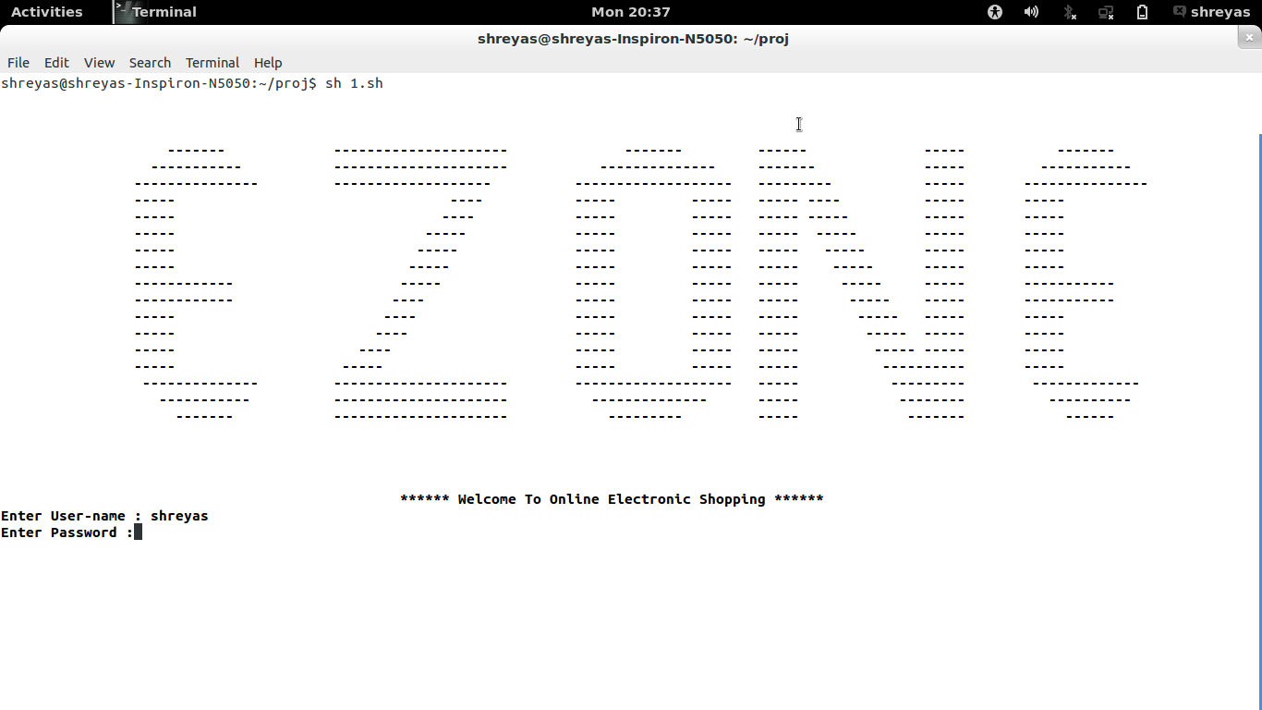
LIST OF CHOICES
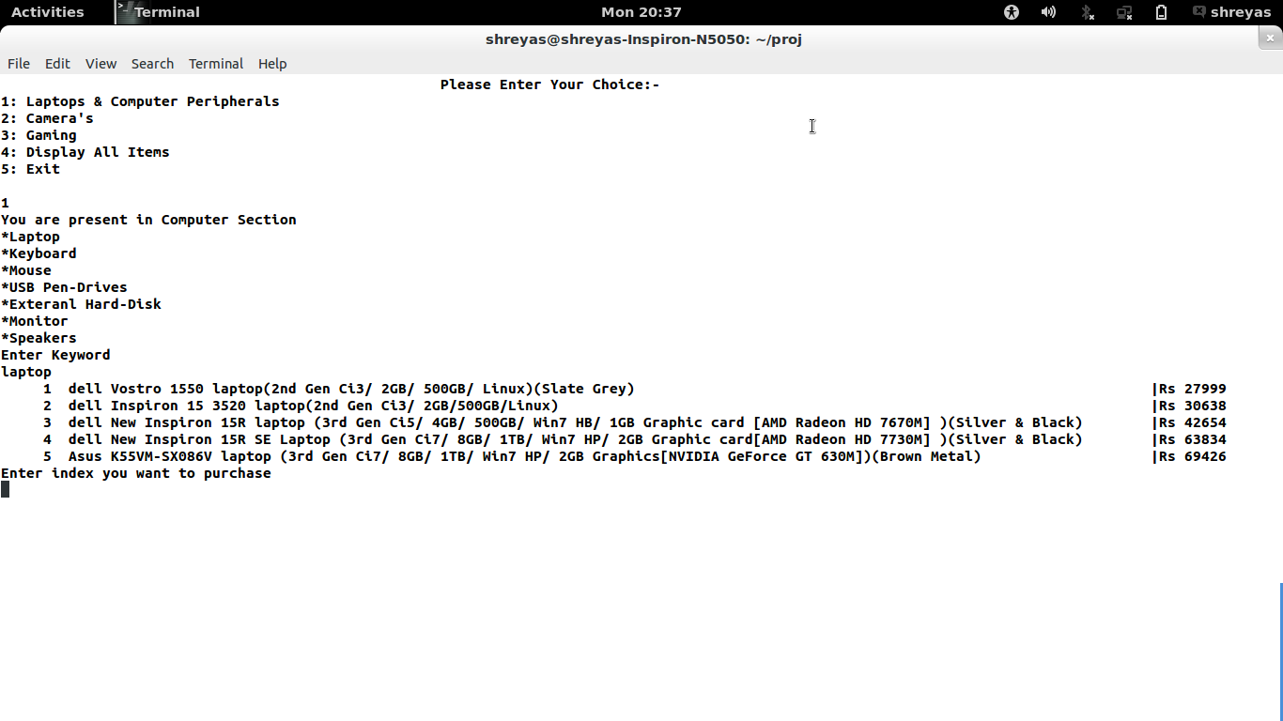
MY DATABASE
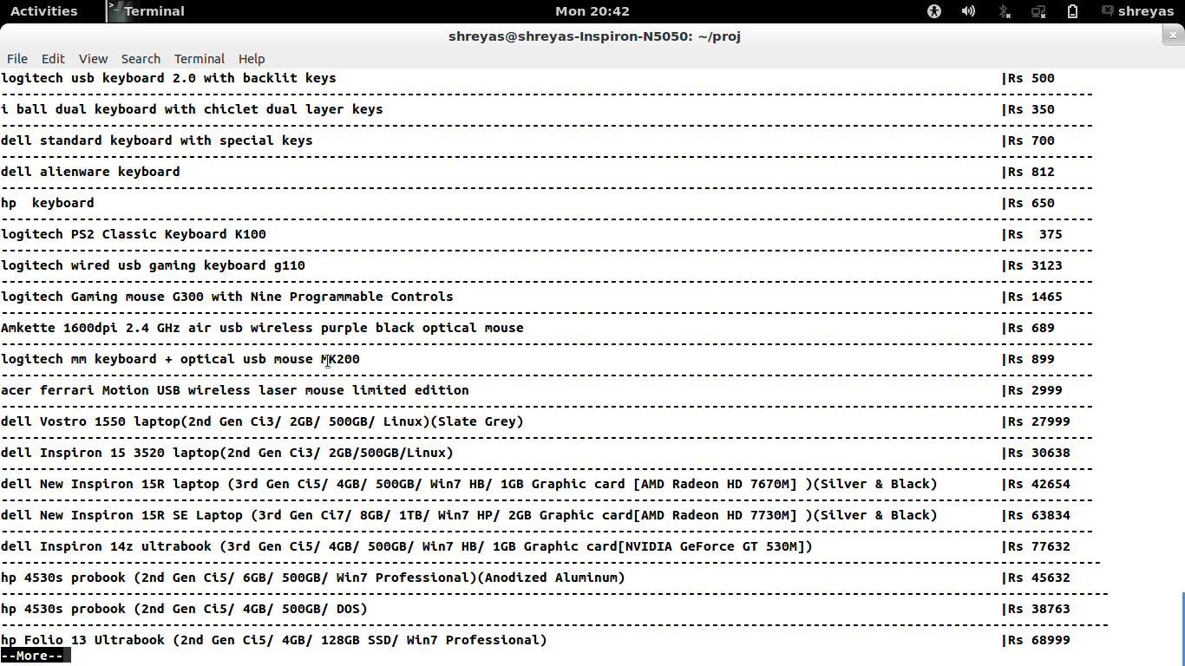

DETAILED BILL
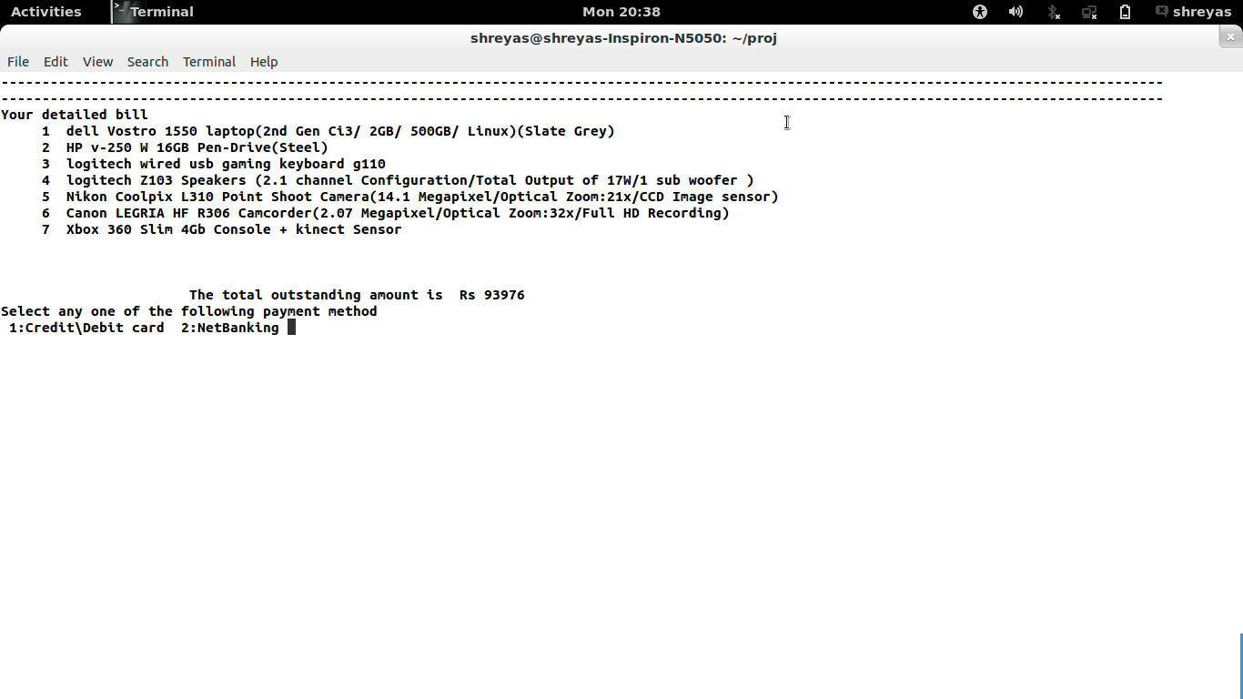

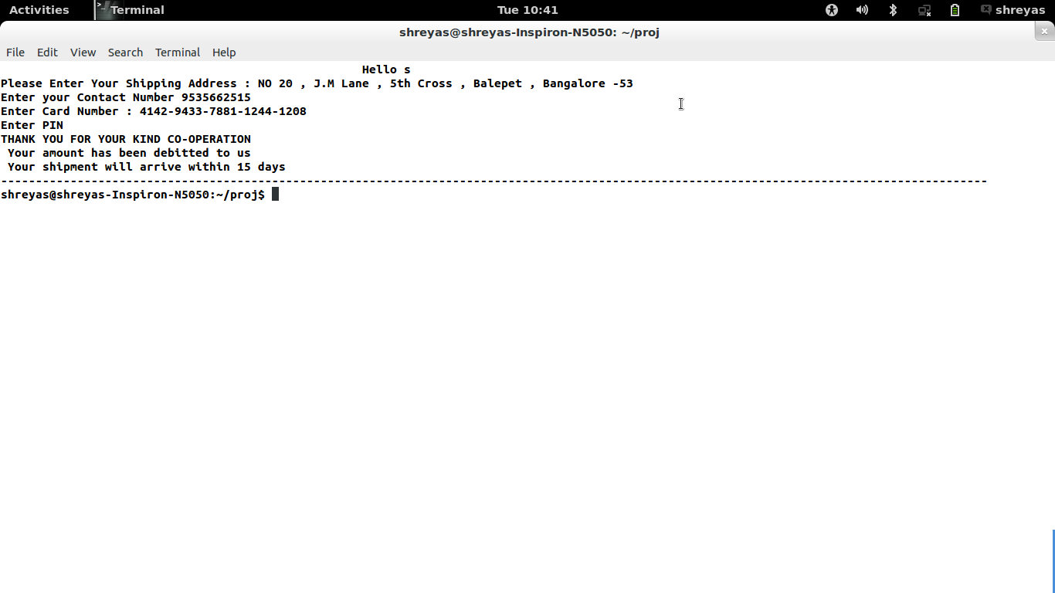
CUSTOMER DETAILS

