VIRTUAL LAN

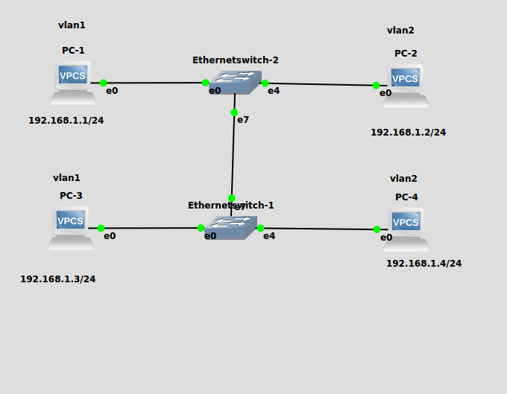

ping to PC 1 which is in same lan i.e vlan1



pinging to PC2 which is in different vlan i.e in vlan2



LAB EXERSISES

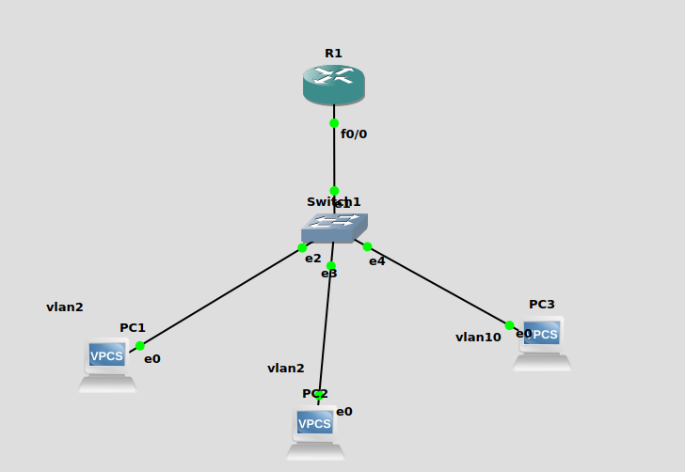
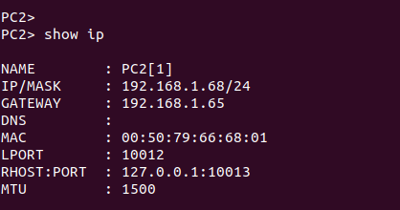
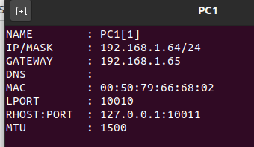



PC1 and PC2 from same vlan i.e vlan2
PC3 in Vlan 10

pingging inside same network


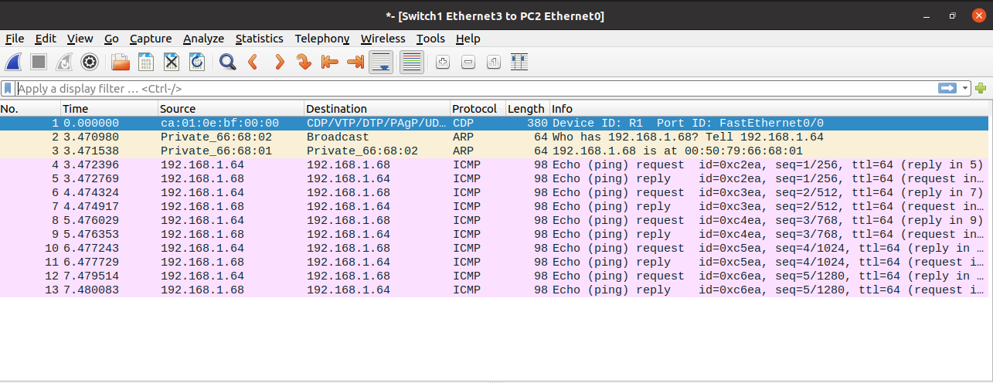

pinging to different vlan



