WEEK 7:

Q1.

<!DOCTYPE html>

<html>

<head>

<style> #test{

top:100px; margin:10px; padding:10px; width:300px; position:relative; border:5px solid black

}

</style>

</head>

<body>

<div id="test">

<p>click button to get offset top for the test div</p>

<p><button onclick="myFunction()">try it</button></p>

<p>offset top is:<span id="demo"></span></p>

</div>

<script>function myFunction(){

var testDiv=document.getElementById("test"); document.getElementById("demo").innerHTML=testDiv.offsetTop;

}</script>

</body>

</html>

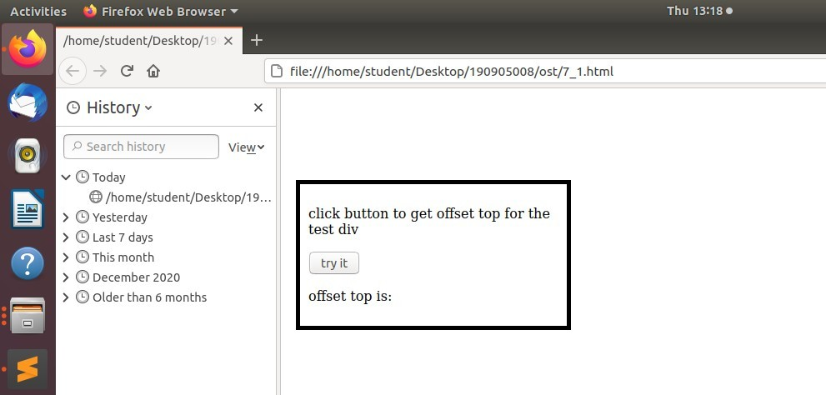

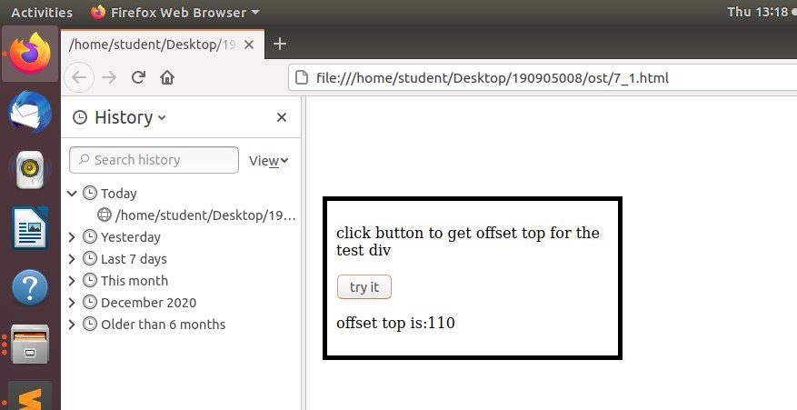

Q2.

<!DOCTYPE html>

<html>

<head>

<title>Greeting using JavaScript</title>

</head>

<body>

<label id="lblGreetings"></label>

</body>

<script>

var myDate = new Date(); var hrs = myDate.getHours(); var greet;

if (hrs < 12)

greet = 'Good Morning';

else if (hrs >= 12 && hrs <= 17) greet = 'Good Afternoon';

else if (hrs >= 17 && hrs <= 24) greet = 'night';

document.getElementById('lblGreetings').innerHTML =

'<b>' + greet + '</b> Mr.Kamath'+' time is '+myDate.getHours()

+':'+myDate.getMinutes()+':'+myDate.getSeconds();

</script>

</html>

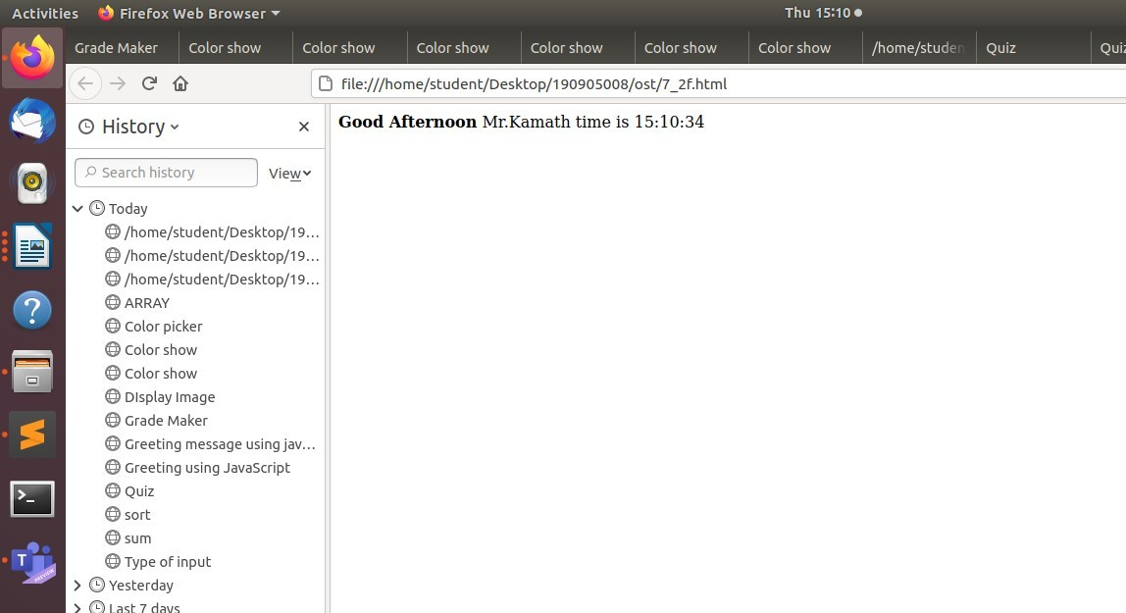

Q3.

<!DOCTYPE html>

<html>

<head>

<title>rain</title>

</head>

<body onload="rain()">

<script type="text/javascript"> var n = 1;

function rain() { this.rain_len = 5; this.rain_ang = Math.PI/3;

var ctx = myCanvas.getContext('2d'); var x = Math.random() * 100;

var y = Math.random() * 50; ctx.strokeStyle = "#0000FF"; ctx.beginPath(); ctx.moveTo(x,y);

ctx.lineTo(x-Math.cos(this.rain_ang)*this.rain_len,y- Math.sin(this.rain_ang)*this.rain_len);

ctx.stroke(); n = n + 1;

if (n == 100) {

ctx.clearRect(0, 0, 200, 100);

n = 1;

}

var t = setTimeout(rain, 10);

}

</script>

<canvas id="myCanvas" width="200" height="100"></canvas>

</body>

</html>

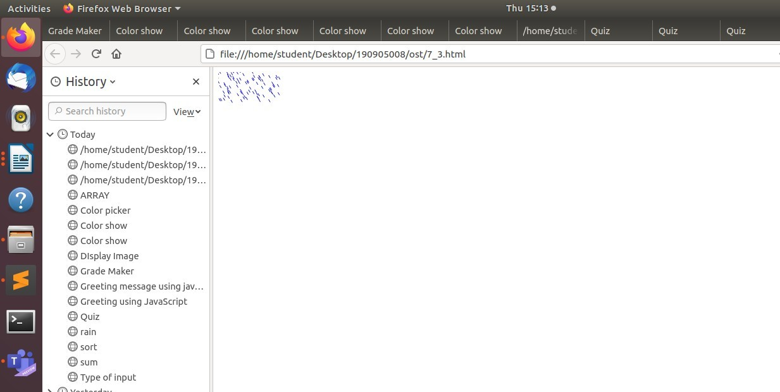

Q4.

<!DOCTYPE HTML>

<html>

<head>

<title>

Bouncing Ball!!

</title>

<style>

h3 {

color: RED;

}

canvas {

background-color: #F08080; width: 600px;

height: 400px; position: absolute; top: 20%;

left: 20%;

}

</style>

</head>

<body>

<center>

<h3>Bouncing ball!!</h3>

<canvas>

</canvas>

<script>

var canvas = document.querySelector("canvas");

canvas.width = window.innerWidth; canvas.height = window.innerHeight;

var l = canvas.getContext('2d');

var x = Math.floor(Math.random() * innerWidth); var y = Math.floor(Math.random() * innerHeight); var vx = Math.floor(Math.random() * 2);

var vy = Math.floor(Math.random() * 4); var radius = 20;

move();

function move() { requestAnimationFrame(move);

l.clearRect(0, 0, innerWidth, innerHeight); l.beginPath();

l.strokeStyle = "black";

l.arc(x, y, radius, 0, Math.PI * 2, false); l.stroke();

l.fillStyle="blue"; l.fill();

if (radius + x > innerWidth) vx = 0 - vx;

if (x - radius < 0) vx = 0 - vx;

if (y + radius > innerHeight)

vy = 0 - vy;

if (y - radius < 0) vy = 0 - vy;

x = x + vx; y = y + vy;

}

</script>

</center>

</body>

</html>

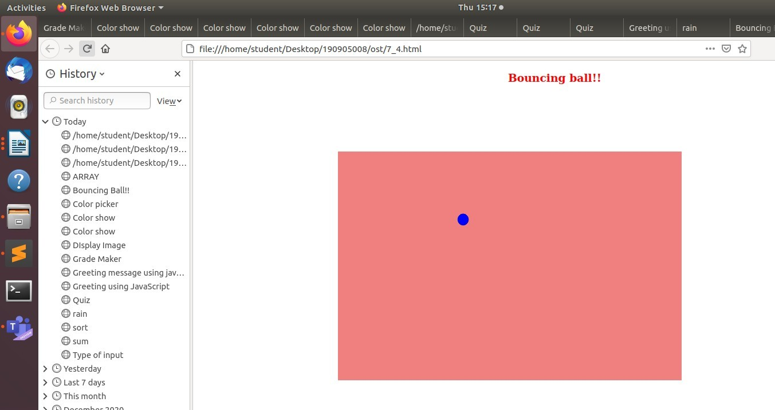

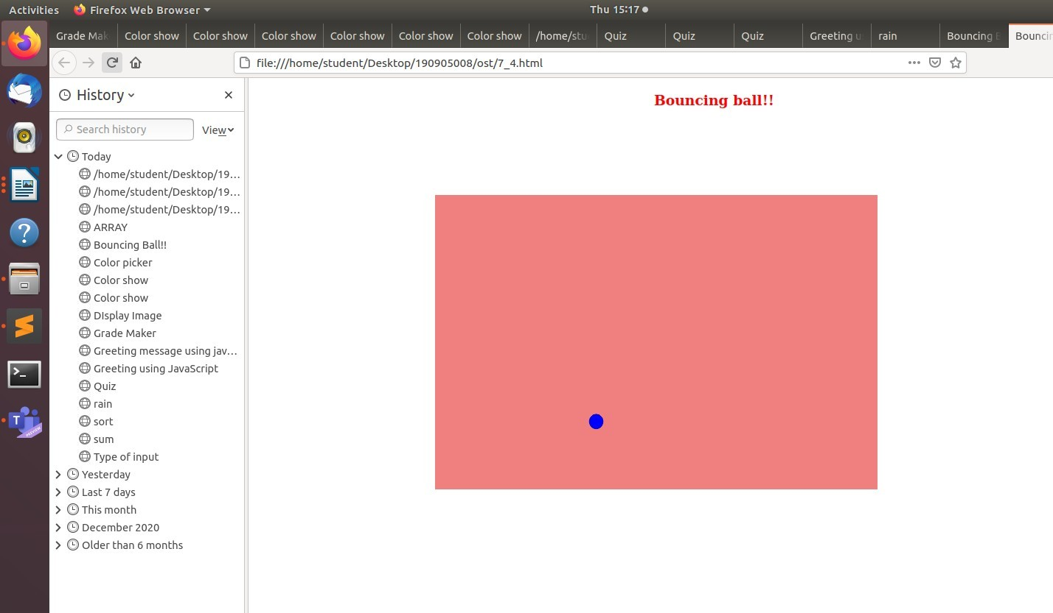

Q5.

<!DOCTYPE HTML>

<html>

<head>

<title> Color picker

</title>

</head>

<body>

<p>

Choose color</p>

<div>

<input type="color" id="head" name="head" value="#e66465">

<label for="head">Head</label>

</div>

<div>

<input type="color" id="body" name="body" value="#6b73c">

<label for="body">Body</label>

</div>

<div>

<input type="color" id="end" name="end" value="yellow">

<label for="end">End</label>

</div>

</body>

</html>

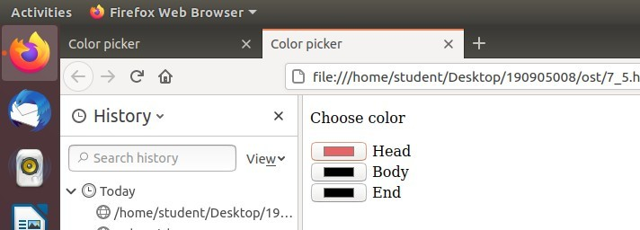



0 file:///home/sCudenL/Desktop/190905008/osL/7 5.h Xml 

> Choose color

Head Body



End

a/19...



Hue: 360 -

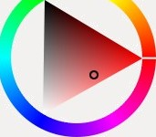

SaLura£ion: 57 — + Value: 90 - +

Color name: #E66465

Red: 230 — -I-

Green: 100 — -I-

Blue: 10a — -F

Cancel Select