WEEK 8:

Q1.

<!DOCTYPE HTML>

<html>

<head>

<title>

DIsplay Image

</title>

</head>

<body>

<canvas id="myCanvas" width="200" height="300" style="">

<script type="text/javascript">

var c=document.getElementById("myCanvas"); var ctx=c.getContext("2d"); ctx.fillStyle="black"; ctx.fillRect(20,20,125,200);

var d=document.getElementById("myCanvas"); var dtx=d.getContext("2d"); dtx.fillStyle="green"; ctx.rotate(40*Math.PI/180);

dtx.fillRect(100,-20,125,200);

</script>

</canvas>

</body>

</html>

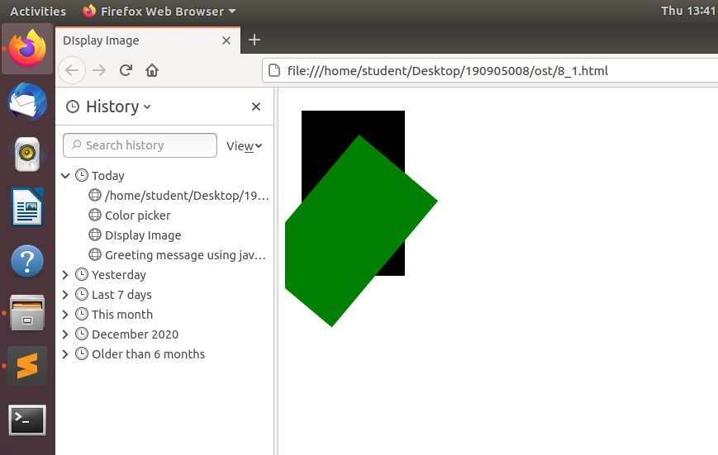

Q2.

<!DOCTYPE HTML>

<html>

<head>

<title> sum</title></head>

<body>

<div id="sum"></div>

<script>

var sum=0;

var num=prompt("enter number of elements:"); var arr=Array();

var n;

var product=1;

for(var i=0;i<num;i=i+1){ n=prompt("enter the number");

sum+=parseInt(n); product*=n;

}

document.getElementById("sum").innerHTML="sum is: "+sum+" product is: "+product;

alert("sum is: "+sum+" product is: "+product);

</script>

</body>

</html>

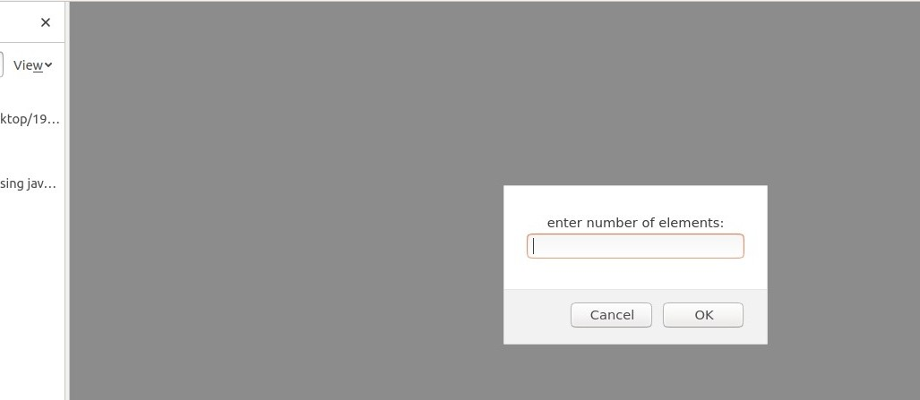

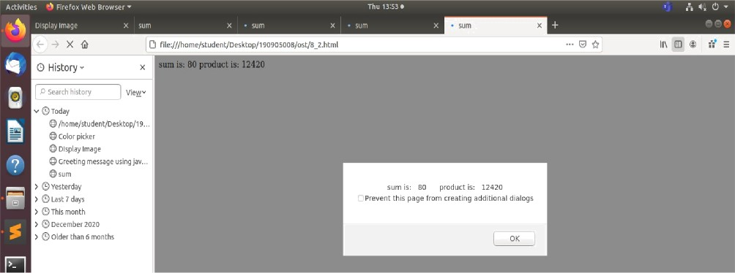

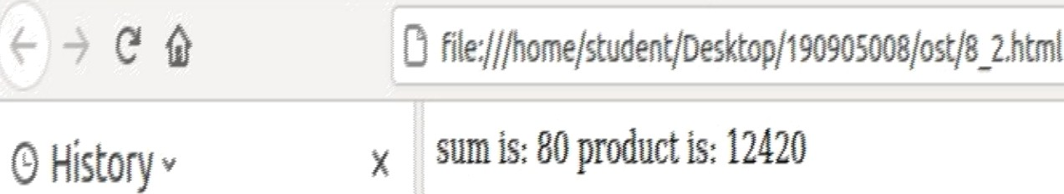

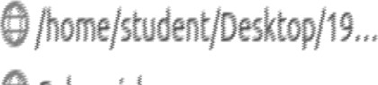•0›&

Q3.

<!DOCTYPE HTML>

<html>

<head>

<title> sort</title></head>

<body>

<script type="text/javascript">

var a=parseInt(prompt("enter number1 ")); var b=parseInt(prompt("enter number2 ")); var c=parseInt(prompt("enter number3 "));

if(a>b){

if(a>c){max=a;} else{max=c;}

}

else if(b>a){ if(b>c){max=b;} else{max=c;}

}

alert("max is "+max); if(a>b&&c>b) {

min=b;

}

else if(b>a&&c>a)

{min=a;} else{min=c;} alert("min is "+min);

</script>

</body>

</html>

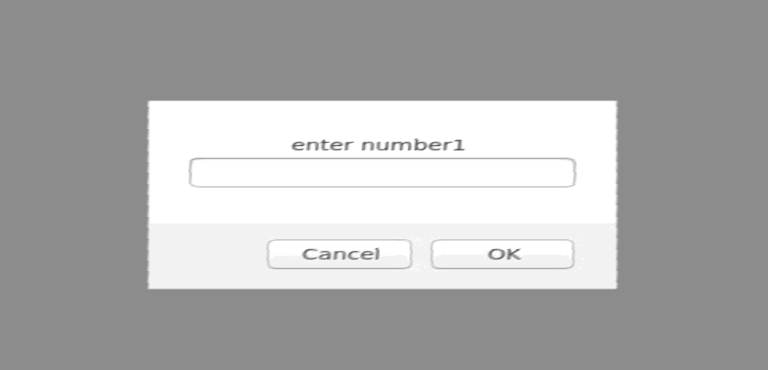

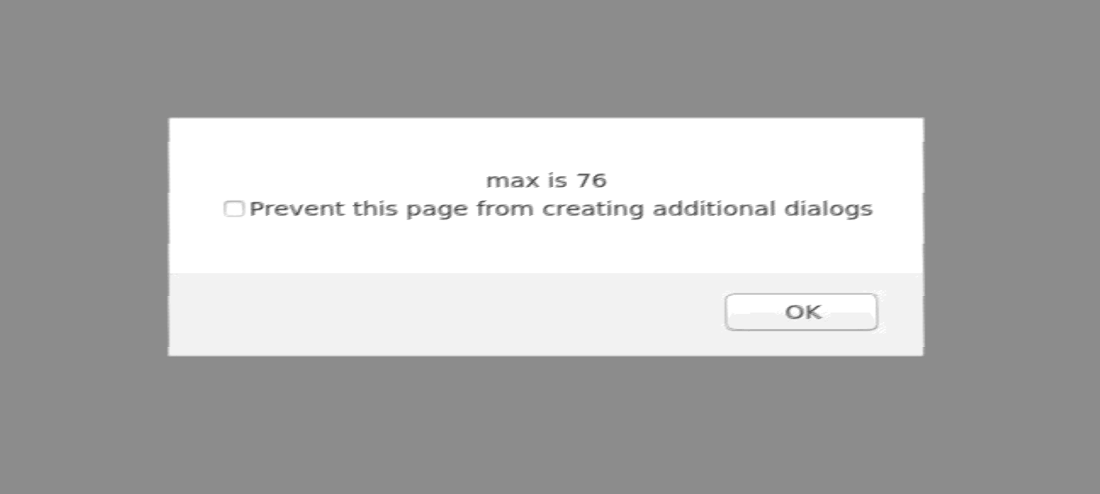

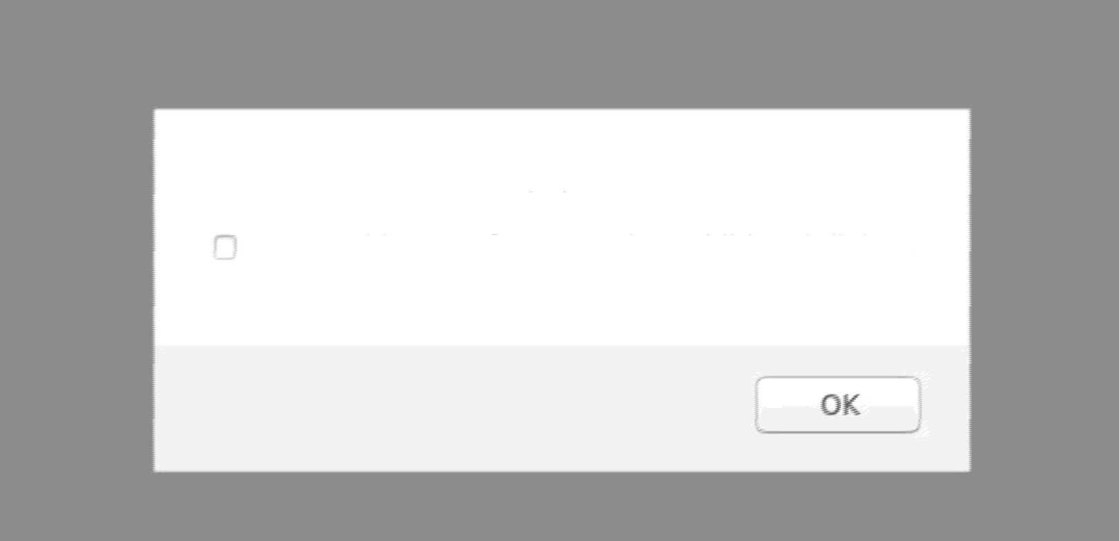

min is 43

Prevent this page from creating add”itional dialogs

Q4.

<!DOCTYPE html>

<html>

<head>

<title>Type of input</title>

</head>

<body>

<script type="text/javascript"> function checkInput() {

var input = document.getElementById("inp").value; var output = document.getElementById("out")

if (input.match(/(true)|(false)/g)) output.setAttribute("value" ,"boolean");

else if (input.match(/[A-z]/g)) output.setAttribute("value" ,"string"); else output.setAttribute("value" ,"integer");

}

</script>

<input type="text" name="in" id="inp" placeholder="Enter something..."><br>

<input type="text" name="out" id="out"><br>

<button onclick="checkInput()">Check</button>

</body>

</html>

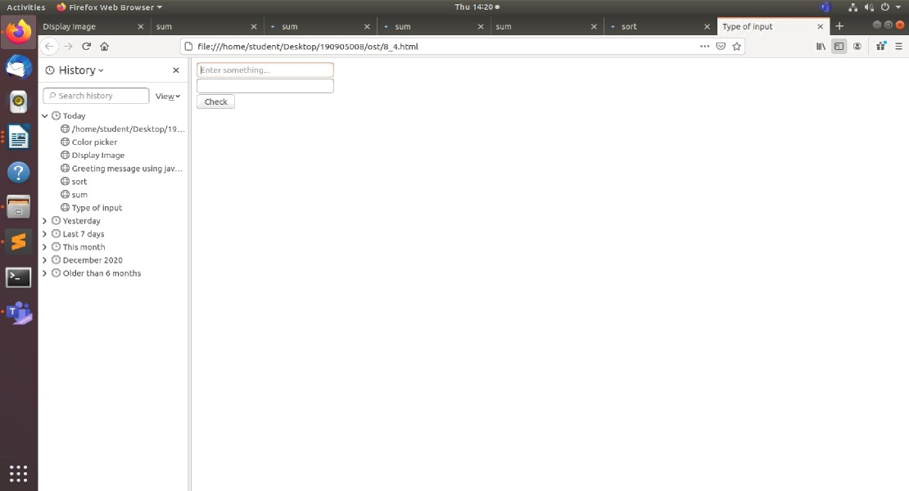



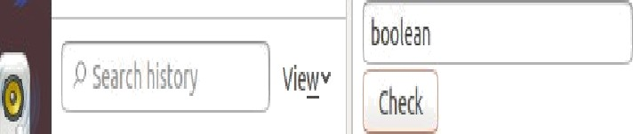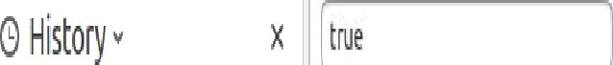

V }@jjj

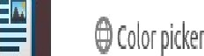



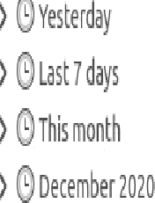

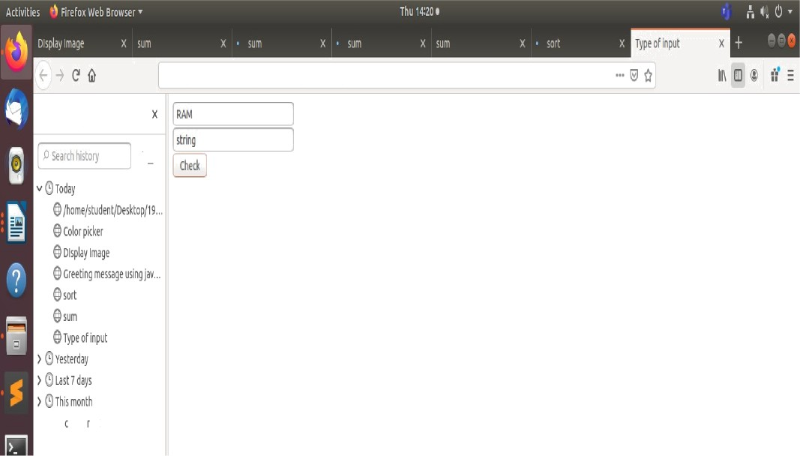

file:///forie/st deJt/DesLtoy/1J0905008/ost/8 *.html

› OD mb £0Z0

) Oift#dfl I0EC#S

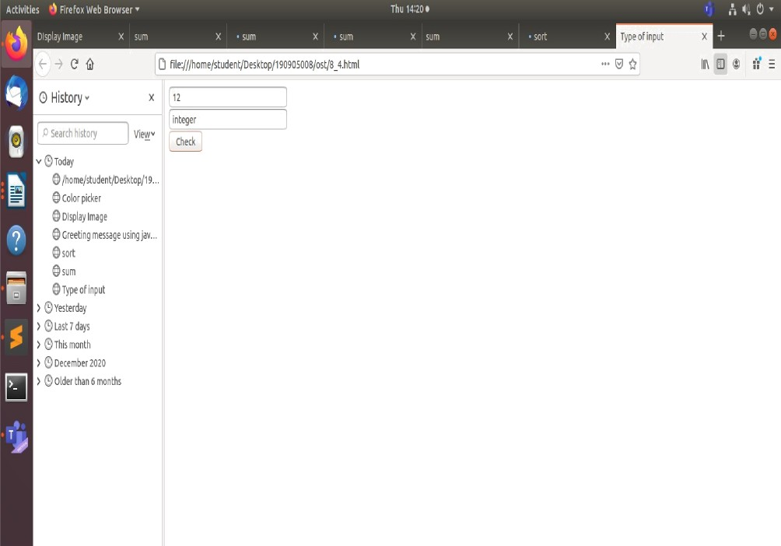

Q5.

<!DOCTYPE html>

<html>

<head>

<title></title>

</head>

<body>

<canvas id="myCanvas" width="300" height="150">

<script type="text/javascript">

var c = document.getElementById("myCanvas"); var ctx = c.getContext("2d");

ctx.beginPath();

ctx.arc(100, 75, 50, 0, 2 * Math.PI); ctx.stroke();

ctx.fillStyle = "yellow"; ctx.fill();

var d = document.getElementById("myCanvas"); var dtx = d.getContext("2d");

dtx.beginPath();

dtx.arc(75, 65, 5, 0, 2 * Math.PI); dtx.stroke();

dtx.fillStyle = "black"; dtx.fill();

var e = document.getElementById("myCanvas"); var etx = e.getContext("2d");

etx.beginPath();

etx.arc(125, 65, 5, 0, 2 * Math.PI); etx.stroke();

etx.fillStyle = "black"; etx.fill();

var f = document.getElementById("myCanvas");

var ftx = f.getContext("2d"); ftx.beginPath();

ftx.arc(100, 75, 40, 0, 1 * Math.PI); ftx.stroke();

</script>

</body>

</html>

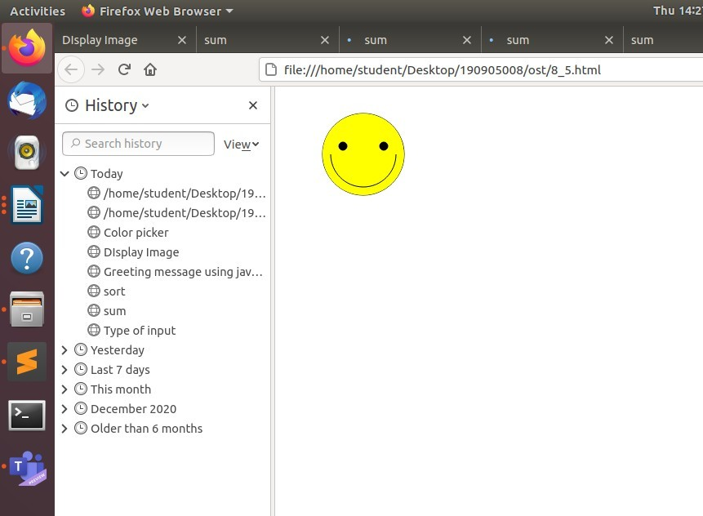

Q6.

<!DOCTYPE html>

<html>

<head>

<title> ARRAY </title>

</head>

<body>

<script type="text/javascript"> var array = [];

function add(value) { array.push(value);

document.getElementById("array_out").setAttribute("value", array);

}

function del(value) {

for (var i = array.length - 1; i >= 0; i--) { if (array[i] == value) {

array.splice(i, 1);

}

}

document.getElementById("array_out").setAttribute("value", array);

}

</script>

<input type="text" name="output" id="array_out"><br>

<input type="text" name="input" id="word_in" placeholder="Enter word to delete/insert"><br>

<button onclick="add(getElementById('word_in').value)">Insert</button>

<button onclick="del(getElementById('word_in').value)">Delete</button>

</body>

</html>

 @ fi(e:///home/studenl:/Desktop/190905008/ost/8_6.html





*w* @ Today

X

Vi — insert Oelete

@ /home/student /Desktop/J9... @/home/student/Desktop/39... @ ARRAY

@ Display Image

@ Greeting message using jav...

sum

 file://home/tuden/Oesktop/dBD9O8OO8/osQ8 6html

*@* HisLory - 

> Ootderchansmonths

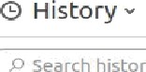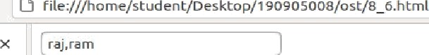ARRAY

today



@ ARRAY

› @ yesterday

› @ Last 7 days

› @ Otder Lhan d months

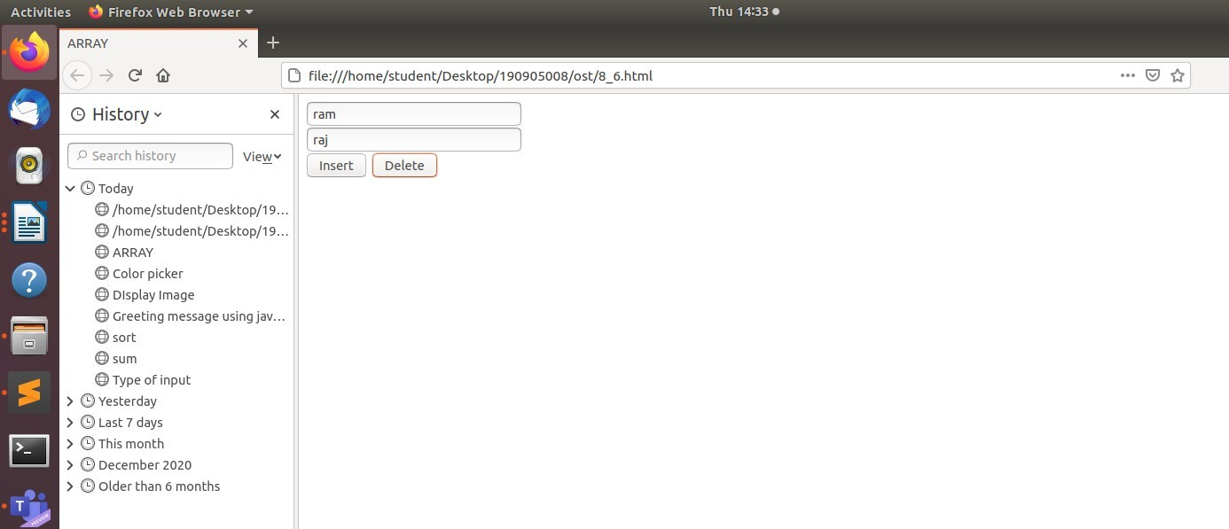

Q7.

<!DOCTYPE html>

<html>

<head>

<title>Grade Maker</title>

</head>

<body>

<script type="text/javascript"> function calc() {

var sum=0;

for (var i = 1; i <= 4; i++) {

sum += parseInt(document.getElementById('m'+i).value);

}

var avg = sum/4; var grade = "";

if (avg < 60) grade = 'Fail!!';

else if (avg < 70 && avg > 60) grade = 'D'; else if (avg < 80 && avg > 70) grade = 'C'; else if (avg < 90 && avg > 80) grade = 'B'; else grade = 'A';

alert(grade);

}

</script>

Enter marks of subject 1: <input type="text" name="m1" id="m1"><br> Enter marks of subject 2: <input type="text" name="m2" id="m2"><br> Enter marks of subject 3: <input type="text" name="m3" id="m3"><br> Enter marks of subject 4: <input type="text" name="m4" id="m4"><br>

<button onclick="calc()">Calculate the grade</button>

</body>

</html>

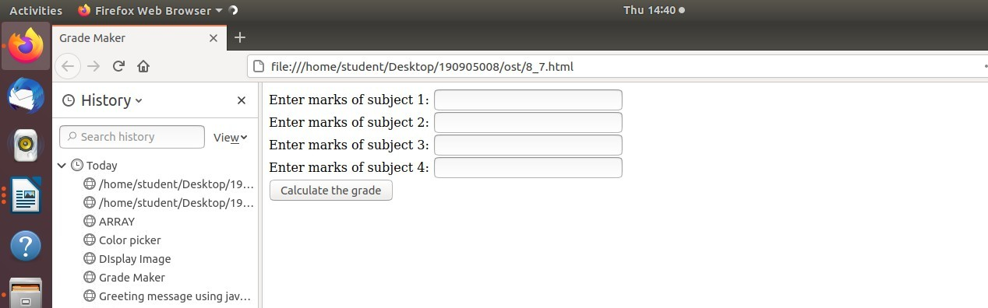

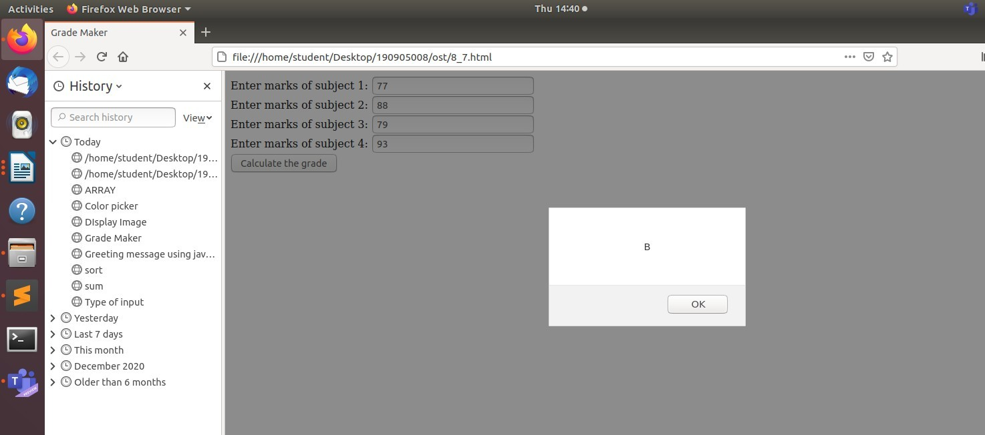

Q8.

<!DOCTYPE html>

<html>

<head>

<title>Color show</title>

</head>

<script type="text/javascript"> function red(){

var canvas = document.getElementById("canvas"); var ctx = canvas.getContext("2d");

ctx.fillStyle = "red"; ctx.fillRect(0, 0, 50, 50);

}

function green(){

var canvas = document.getElementById("canvas"); var ctx = canvas.getContext("2d");

ctx.fillStyle = "green"; ctx.fillRect(0, 0, 50, 50);

}

function blue(){

var canvas = document.getElementById("canvas"); var ctx = canvas.getContext("2d");

ctx.fillStyle = "blue"; ctx.fillRect(0, 0, 50, 50);

}

</script>

<body>

<canvas width=70 height=70 id="canvas"></canvas>

<form>

<input type="radio" onclick="red();"> Red<br>

<input type="radio" onclick="green();"> Green<br>

<input type="radio" onclick="blue();"> Blue

</form>

</body>

</html>

CJ rite:///hom e/studentyoesw op/isososooa/ost/z_u.html

HtStO#• *

T /home/student/oesktop/s9... Btue





O H istory -

fi file://he me/stud en t/Deskto p/490905D0B/o s t/B B. h finn I



O Rea

4B /home/ rudenr oeskrop/d9... Blue

@ Grade Maker

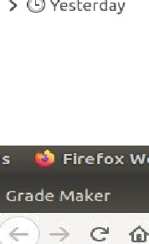C9 rite:/yñome/tudent/oesktop/,ooPosoos/osQB Bhtmt 

@ H isLory -

O Red

M/home tudeni/Desktop/J9... g Blue

› @ yesterday

> @ Last 7 days





O Red

fl/home tudent/oesktop/9... Blue

> @ Ye se rd ay

› @ case 7 days

Q9.

<!DOCTYPE html>

<html>

<head>

<title></title>

</head>

<body>

<p>

Name[take only capital letters]:

<input type="text" name="onlyalphabet" onkeypress="return (event.charCode > 64 && event.charCode < 91)">

<p>

</p>

<p>

Password[show stars]:

<input type="password" name="pwd" maxlength="10">

Phone number[10 digits only]:

<input type="text" id="phone" name="phone" maxlength="10"

pattern="[1-9]{1}[0-9]{9}">

</p>

</body>

</html>

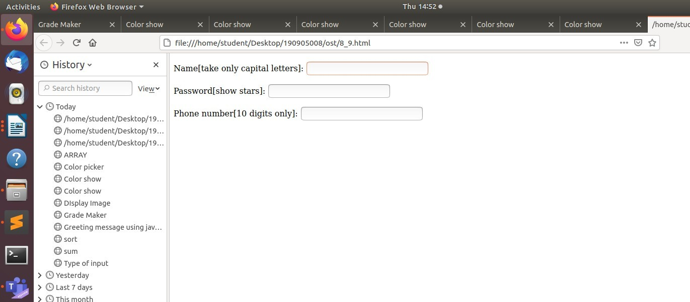

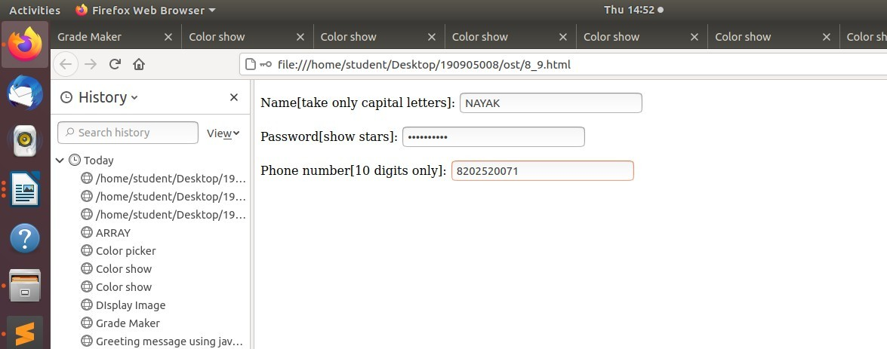

Q10.

<!DOCTYPE html>

<html>

<head>

<title>Quiz</title>

</head>

<body>

<h1>GENERAL KNOWLEDGE-QUIZ</h1>

<script type="text/javascript"> function calculate_score() {

var score = 0;

if (document.getElementById("q22").checked) score += 1; if (document.getElementById("q22").checked) score += 1; if (document.getElementById("q33").checked) score += 1; document.getElementById('Score').innerHTML = " "+score;

}

</script>

Who is the President of INDIA? <br>

<input type="radio" name="q1" id="q11">Narendra Modi<br>

<input type="radio" name="q1" id="q12">Ramnath Kovind<br>

<input type="radio" name="q1" id="q13">Devegowda<br>

<br>

Which is the national bird of India?<br>

<input type="radio" name="q2" id="q21">crow<br>

<input type="radio" name="q2" id="q22">peacock<br>

<input type="radio" name="q2" id="q23">parrot<br>

<br>

In which year Covid lockdown took place in India?<br>

<input type="radio" name="q3" id="q31">2021<br>

<input type="radio" name="q3" id="q32">2019<br>

<input type="radio" name="q3" id="q33">2020<br>

<br>

<button onclick="calculate_score()">Submit</button>

<br><hr>

<b>Score:</b><span id="Score"></span>

</body>

</html>

