BRACT’s

Vishwakarma Institute of Technology, Pune

Practical Implementation Sheet

Department: CSE-AI Semester: 5 Academic Year: 2026-27

Division: E Batch: 3 Practical No: 10

Roll no: 68 PRN No: 12412100 Name of Student: Shreyas Shinde

Subject Name: Deep Learning

Problem Statement:

Design and implement a deep learning application for audio classification that incorporates speech-to-text and text-to-speech functionality using an appropriate deep learning architecture and evaluate its performance using suitable metrics.

Algorithm:

- Import the required libraries for audio processing, deep learning, speech recognition, and speech synthesis.
- Load the RAVDESS speech emotion dataset containing audio recordings of different emotions.
- Select four emotion classes: neutral, happy, sad, and angry.
- Extract MFCC (Mel-Frequency Cepstral Coefficients) features from the audio recordings.
- Encode the emotion labels and divide the dataset into training and testing sets.
- Build a 1D CNN model for audio emotion classification.
- Compile the model using the Adam optimizer and categorical cross-entropy loss.
- Train the CNN model and monitor its training and validation performance.
- Predict emotion labels for the test recordings.
- Evaluate the model using accuracy, precision, recall, F1-score, and a confusion matrix.
- Implement speech-to-text functionality to convert spoken audio into text.
- Implement text-to-speech functionality to generate spoken output from the recognized text.
- Display the predicted emotion and confidence score for a new audio recording

Code:
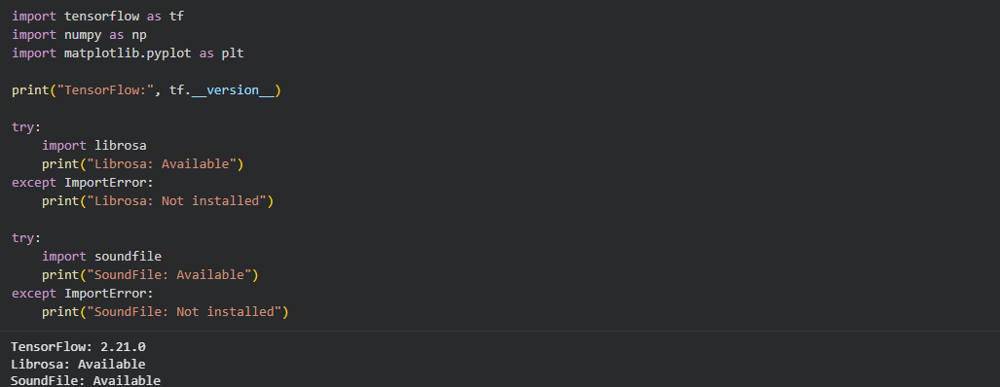
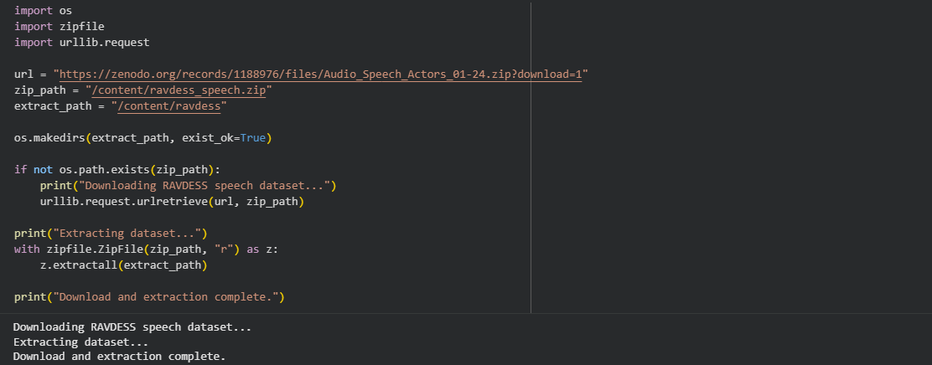
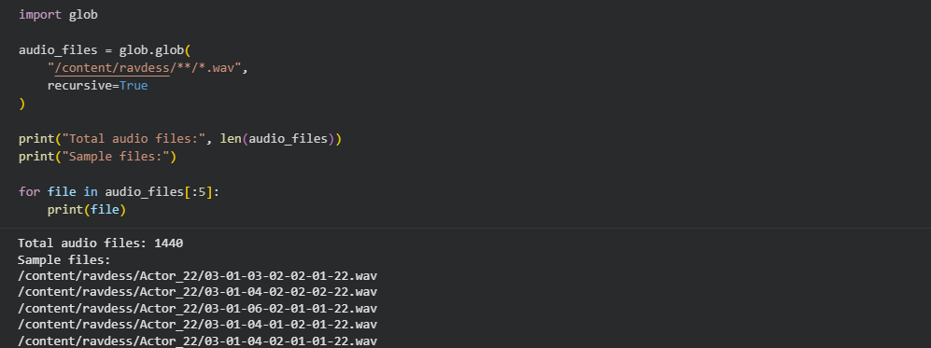
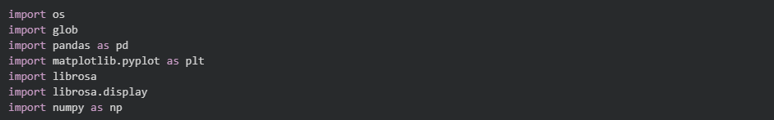
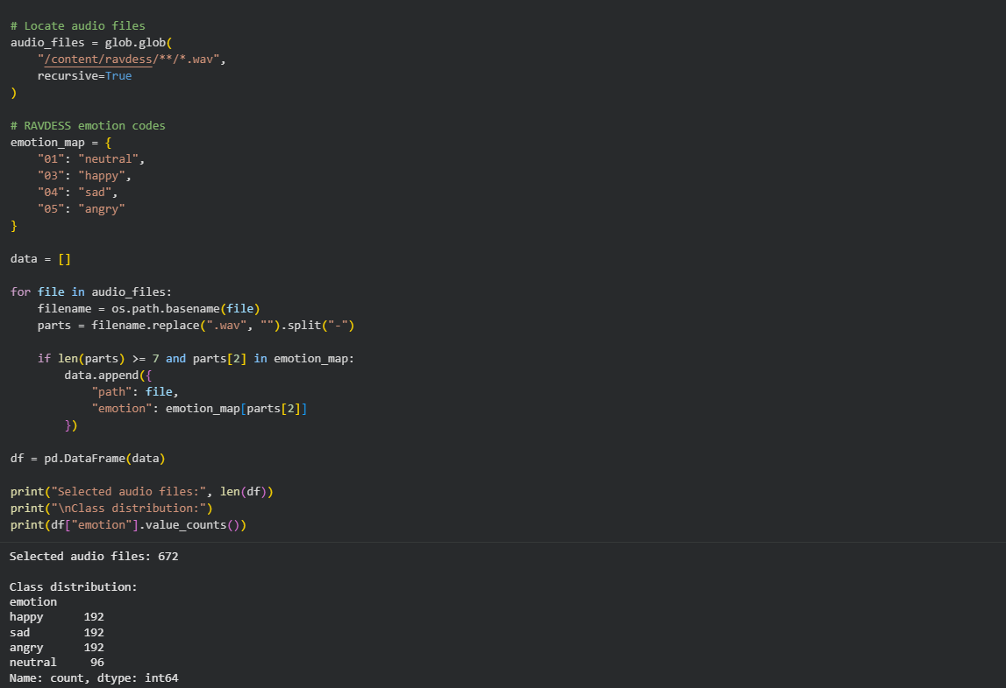
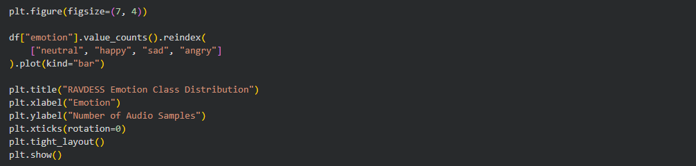
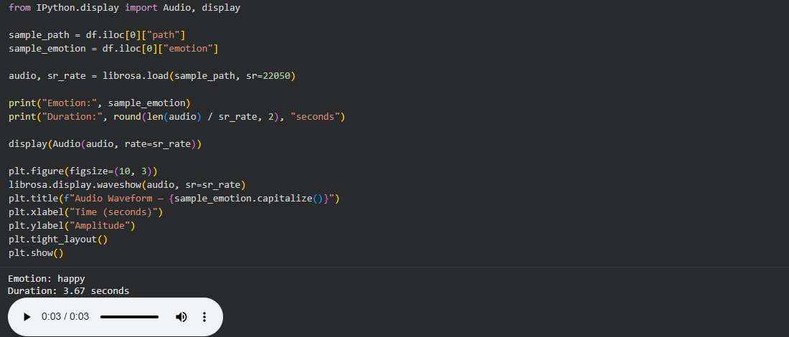
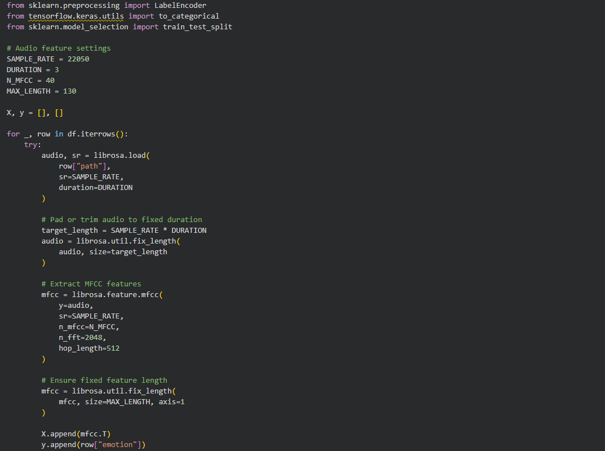
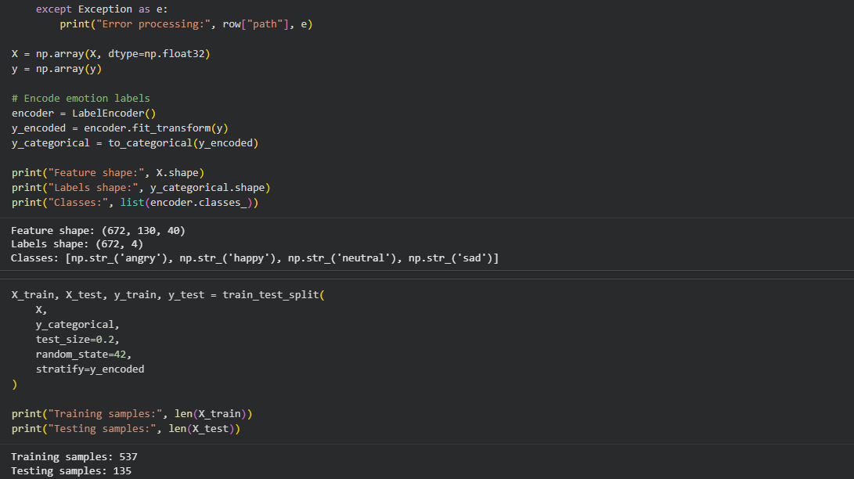
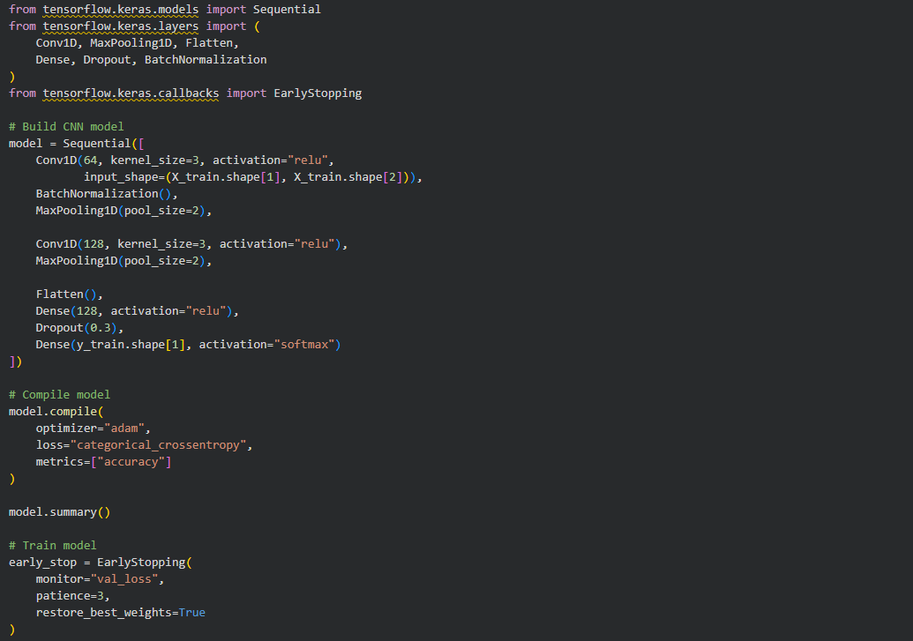
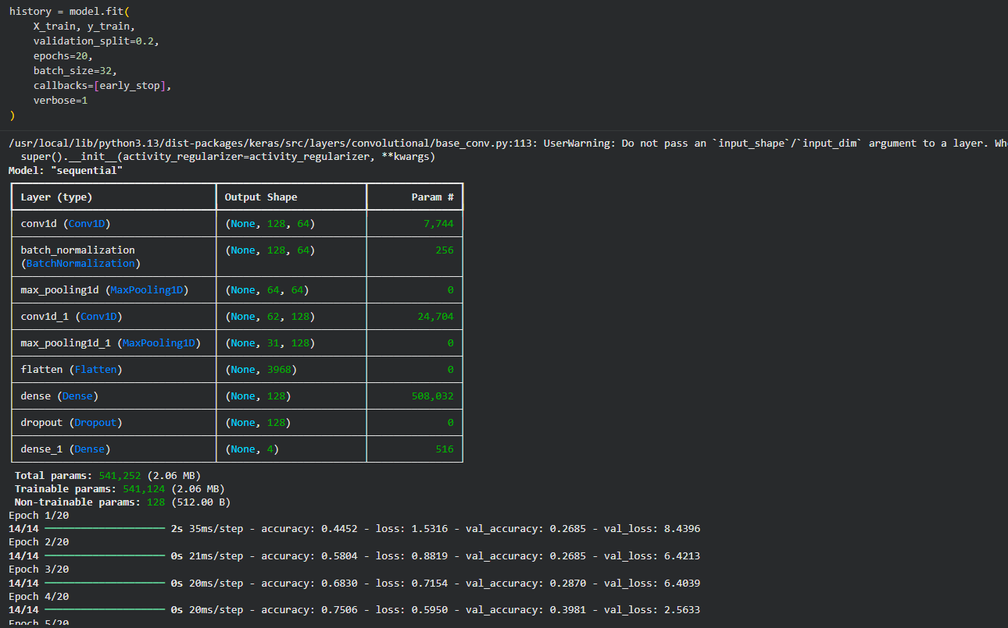
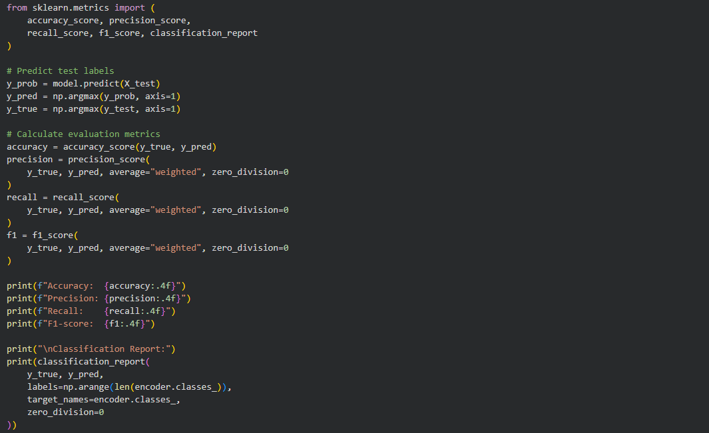
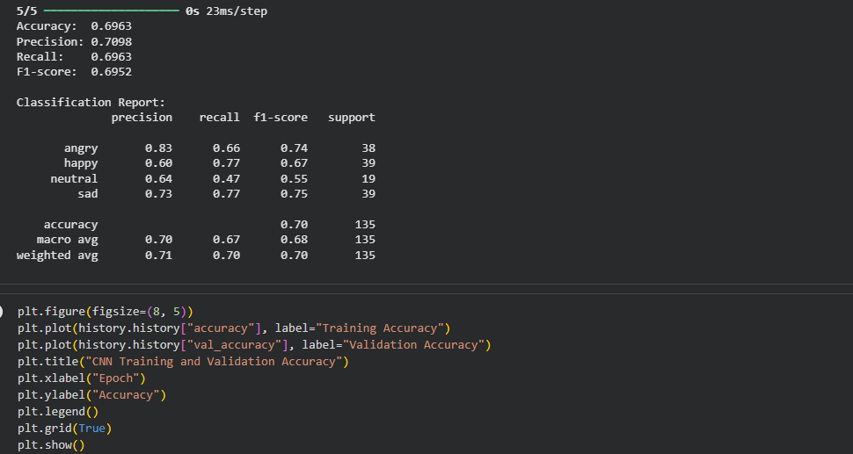
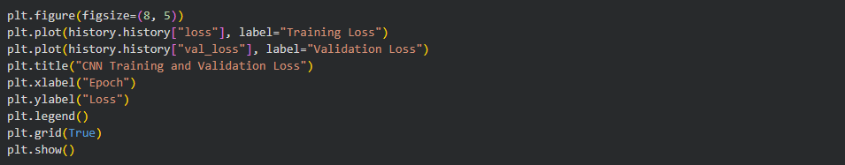

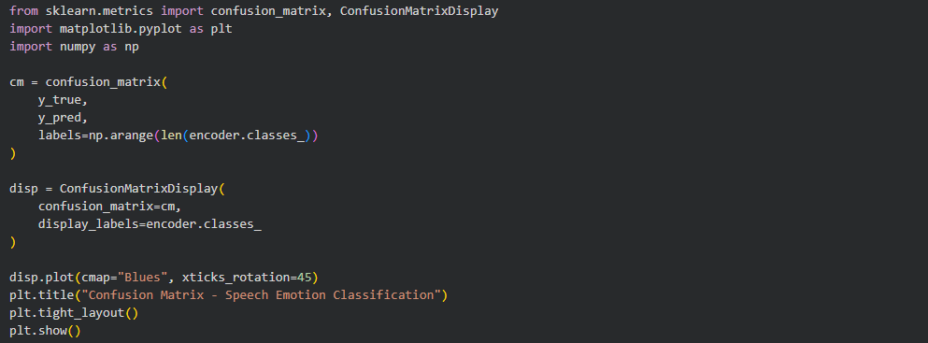
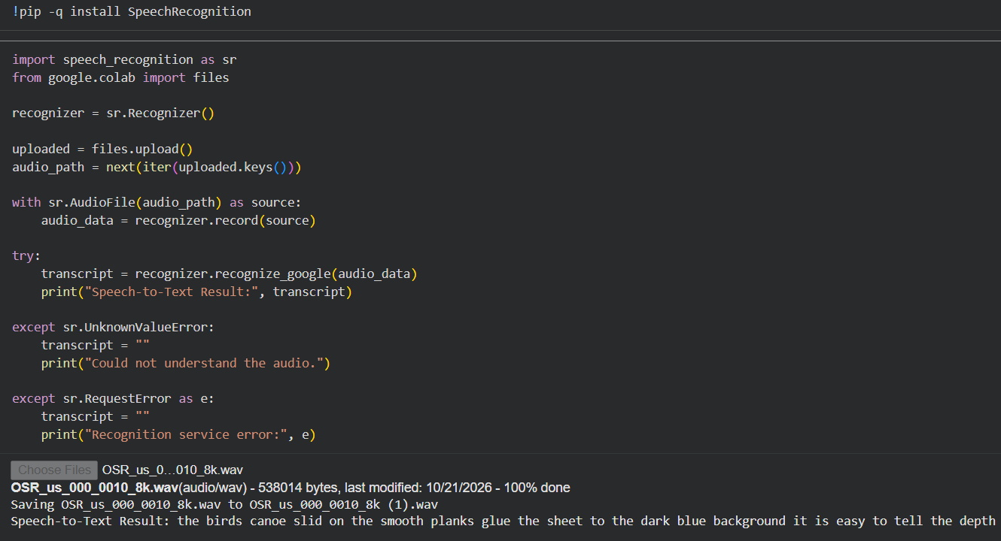
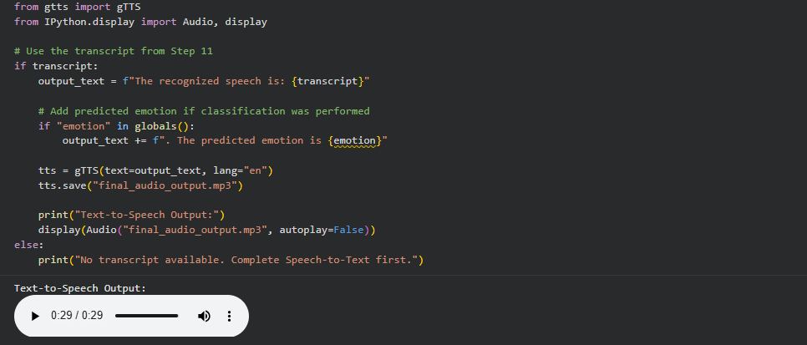
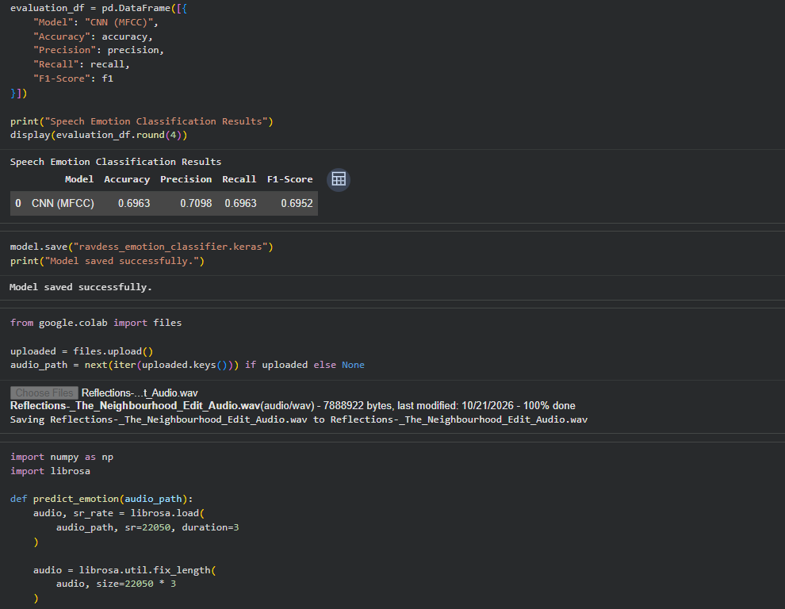
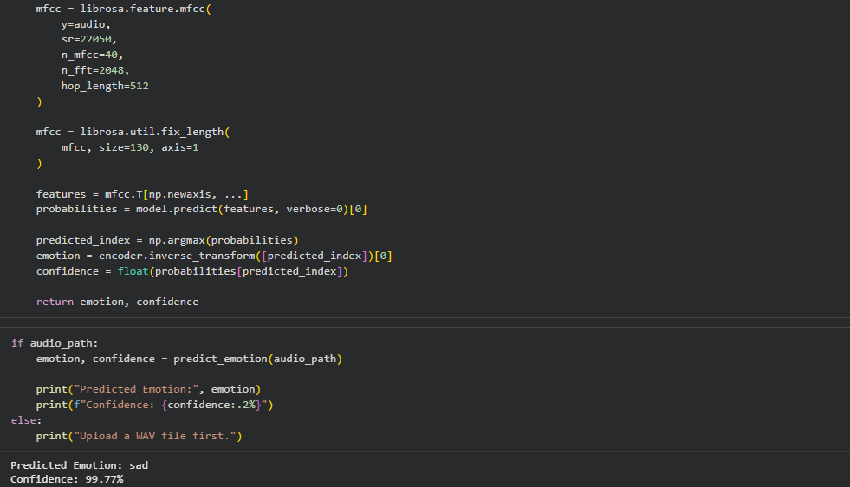

Output :

Figure 1: RAVDESS Emotion Class Distribution
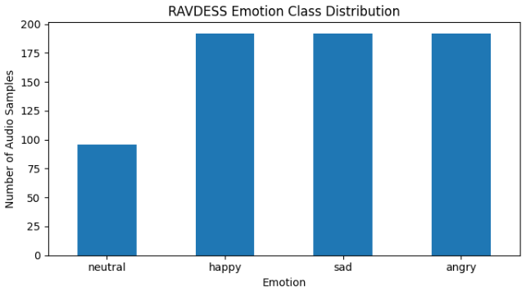

Figure 2: Sample Audio Waveform
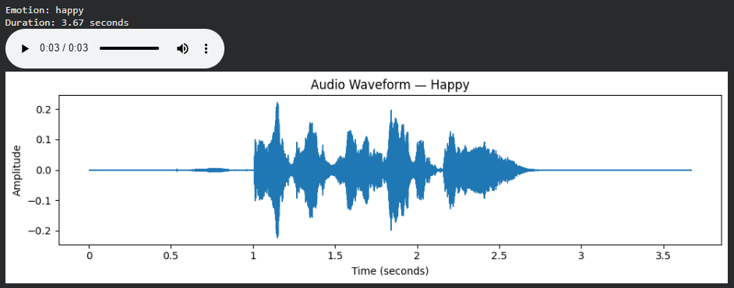

Figure 3: CNN Training and Validation Accuracy

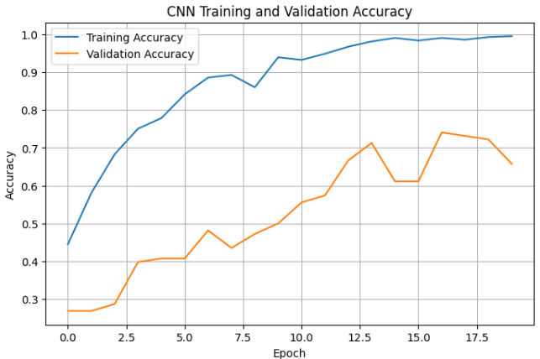
Figure 4: CNN Training and Validation Loss

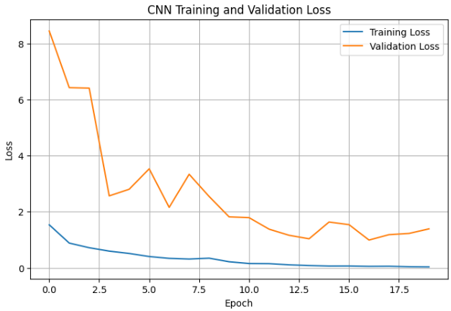

Figure 5: Confusion Matrix for Speech Emotion Classification

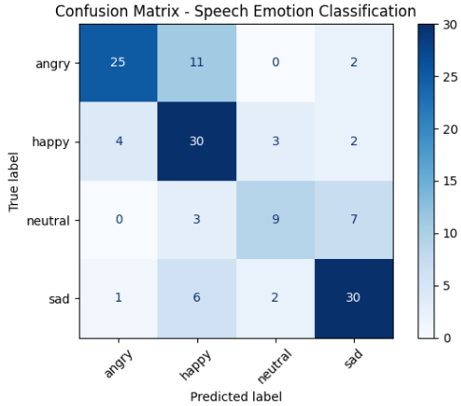

Table 1: Audio Classification Performance

Evaluation Metric | Obtained Value
Accuracy | 69.63%
Precision (Weighted) | 70.98%
Recall (Weighted) | 69.63%
F1-Score (Weighted) | 69.52%

Table 2: Class-wise Performance

Emotion | Precision | Recall | F1-Score | Support
Angry | 0.83 | 0.66 | 0.74 | 38
Happy | 0.60 | 0.77 | 0.67 | 39
Neutral | 0.64 | 0.47 | 0.55 | 19
Sad | 0.73 | 0.77 | 0.75 | 39
Macro Average | 0.70 | 0.67 | 0.68 | 135
Weighted Average | 0.71 | 0.70 | 0.70 | 135

Conclusion :

A deep learning-based audio classification application was developed using a 1D CNN and MFCC features extracted from the RAVDESS speech emotion dataset. The model classifies audio recordings into neutral, happy, sad, and angry emotions. Its performance was evaluated using accuracy, precision, recall, F1-score, and a confusion matrix. Speech-to-text functionality was incorporated to transcribe spoken input, while text-to-speech generated spoken output. The application demonstrates the integration of audio feature extraction, deep learning-based emotion classification, speech recognition, and speech synthesis in a single workflow.

