BRACT’s
Vishwakarma Institute of Technology, Pune
Practical Implementation Sheet
Department: CSE-AI Semester: 5 Academic Year: 2026-27
Division: E Batch: 3 Practical No: 4
Roll no: 68 PRN No: 12412100 Name of Student: Shreyas Shinde
Subject Name : Deep Learning

Problem Statement : Develop an LSTM-based model for time-series forecasting using stock price, weather, or sales datasets.

Algorithm :
- Import Required Libraries
Import NumPy, Pandas, Matplotlib, yFinance, Scikit-learn, and TensorFlow/Keras libraries.
- Collect the Dataset
Download historical Apple (AAPL) stock-price data from Yahoo Finance for the period 2015–2025.
- Select the Target Variable
Select the daily Closing Price as the variable to be predicted.
- Preprocess the Data
Convert the closing-price values into a NumPy array and normalize them to the range 0–1 using Min-Max Scaling.
- Split the Dataset
Divide the dataset into 80% training data and 20% testing data.
- Create Time-Series Sequences
Use the previous 60 trading days as input to predict the closing price of the next trading day.
- Reshape the Data
Reshape the input into the three-dimensional format required by an LSTM:
(samples, time steps, features).
- Build the LSTM Model
Construct a Sequential neural network containing:
  - LSTM layer with 64 units
  - Dropout layer with 20%
  - LSTM layer with 64 units
  - Dropout layer with 20%
  - Dense output layer with one neuron
- Compile the Model
Use the Adam optimizer and Mean Squared Error (MSE) as the loss function.
- Train the Model
Train the model using the training sequences for 20 epochs with a batch size of 32.
- Generate Predictions
Use the trained LSTM model to predict stock prices for the testing dataset.
- Inverse Transform the Predictions
Convert the normalized predictions back to the original stock-price scale.
- Evaluate the Model
Calculate Mean Absolute Error (MAE), Mean Squared Error (MSE), and Root Mean Squared Error (RMSE).
- Visualize Results
Plot the actual stock prices against the predicted stock prices to evaluate how closely the model follows the actual trend.
- Predict the Next Day's Price
Use the latest 60 trading days to generate a prediction for the next closing price.
Code :

# ============================================================
# LSTM BASED TIME-SERIES FORECASTING
# Stock Price Prediction using Apple (AAPL) Dataset
# ============================================================

# ------------------------------------------------------------
# 1. INSTALL AND IMPORT REQUIRED LIBRARIES
# ------------------------------------------------------------

# Install yfinance for downloading stock market data
!pip install yfinance -q

import numpy as np
import pandas as pd
import matplotlib.pyplot as plt
import yfinance as yf

from sklearn.preprocessing import MinMaxScaler
from sklearn.metrics import mean_squared_error, mean_absolute_error

from tensorflow.keras.models import Sequential
from tensorflow.keras.layers import LSTM, Dense, Dropout

# ------------------------------------------------------------
# 2. DOWNLOAD THE DATASET
# ------------------------------------------------------------

# Download Apple's historical stock data from Yahoo Finance
df = yf.download(
"AAPL",
start="2015-01-01",
end="2025-01-01",
auto_adjust=False
)

# Display the first five rows
print("First five rows of the dataset:")
print(df.head())

# Display dataset information
print("\nDataset Shape:", df.shape)

print("\nMissing Values:")
print(df.isnull().sum())

# ------------------------------------------------------------
# 3. EXTRACT CLOSING PRICE
# ------------------------------------------------------------

# Select the Closing Price because it is the target
# variable that the LSTM model will forecast.
close_price = df["Close"]

# Convert to a one-dimensional series if required
close_price = close_price.squeeze()

print("\nClosing Price Data:")
print(close_price.head())

# ------------------------------------------------------------
# 4. VISUALIZE HISTORICAL STOCK PRICE
# ------------------------------------------------------------

plt.figure(figsize=(14, 6))

plt.plot(close_price)

plt.title("Apple (AAPL) Historical Closing Price")
plt.xlabel("Date")
plt.ylabel("Closing Price (USD)")

plt.grid(True)
plt.show()

# ------------------------------------------------------------
# 5. CONVERT DATA INTO NUMPY ARRAY
# ------------------------------------------------------------

# Convert closing prices into a NumPy array
data = close_price.values.reshape(-1, 1)

print("Original Data Shape:", data.shape)

# ------------------------------------------------------------
# 6. NORMALIZE THE DATA
# ------------------------------------------------------------

# Min-Max Scaling converts the values to the range 0 to 1.
# This helps the LSTM model learn more efficiently.

scaler = MinMaxScaler(feature_range=(0, 1))

scaled_data = scaler.fit_transform(data)

print("\nOriginal Price Range:")
print(data.min(), "to", data.max())

print("\nScaled Price Range:")
print(scaled_data.min(), "to", scaled_data.max())

# ------------------------------------------------------------
# 7. SPLIT DATA INTO TRAINING AND TESTING DATA
# ------------------------------------------------------------

# Use 80% of the data for training
train_size = int(len(scaled_data) * 0.8)

train_data = scaled_data[:train_size]
test_data = scaled_data[train_size:]

print("\nTraining Samples:", len(train_data))
print("Testing Samples:", len(test_data))

# ------------------------------------------------------------
# 8. CREATE TIME-SERIES SEQUENCES
# ------------------------------------------------------------

# The model uses the previous 60 trading days
# to predict the next trading day's closing price.

time_step = 60

def create_sequences(data, time_step):
X = []
y = []

for i in range(time_step, len(data)):
# Previous 60 days are used as input
X.append(data[i-time_step:i, 0])

# Current day is used as target
y.append(data[i, 0])

return np.array(X), np.array(y)

# Create training sequences
X_train, y_train = create_sequences(
train_data,
time_step
)

# Create testing sequences
X_test, y_test = create_sequences(
test_data,
time_step
)

print("\nTraining Input Shape:", X_train.shape)
print("Training Target Shape:", y_train.shape)

print("Testing Input Shape:", X_test.shape)
print("Testing Target Shape:", y_test.shape)

# ------------------------------------------------------------
# 9. RESHAPE DATA FOR LSTM
# ------------------------------------------------------------

# LSTM expects input in the following format:
#
# (Number of Samples, Time Steps, Number of Features)
#
# Here:
# Time Steps = 60
# Features = 1 (Closing Price)

X_train = X_train.reshape(
X_train.shape[0],
X_train.shape[1],
1
)

X_test = X_test.reshape(
X_test.shape[0],
X_test.shape[1],
1
)

print("\nFinal Training Input Shape:", X_train.shape)
print("Final Testing Input Shape:", X_test.shape)

# ------------------------------------------------------------
# 10. BUILD THE LSTM MODEL
# ------------------------------------------------------------

model = Sequential()

# First LSTM layer
model.add(
LSTM(
units=64,
return_sequences=True,
input_shape=(time_step, 1)
)
)

# Dropout helps reduce overfitting
model.add(Dropout(0.2))

# Second LSTM layer
model.add(
LSTM(
units=64,
return_sequences=False
)
)

# Another dropout layer
model.add(Dropout(0.2))

# Output layer
# One neuron because we are predicting one value
model.add(Dense(1))

# Display model architecture
print("\nLSTM Model Architecture:")
model.summary()

# ------------------------------------------------------------
# 11. COMPILE THE MODEL
# ------------------------------------------------------------

# Adam optimizer is used for efficient gradient-based learning.
# Mean Squared Error is used as the loss function.

model.compile(
optimizer="adam",
loss="mean_squared_error"
)

# ------------------------------------------------------------
# 12. TRAIN THE MODEL
# ------------------------------------------------------------

print("\nTraining the LSTM model...")

history = model.fit(
X_train,
y_train,
epochs=20,
batch_size=32,
validation_split=0.1,
verbose=1
)

# ------------------------------------------------------------
# 13. PLOT TRAINING AND VALIDATION LOSS
# ------------------------------------------------------------

plt.figure(figsize=(10, 5))

plt.plot(
history.history["loss"],
label="Training Loss"
)

plt.plot(
history.history["val_loss"],
label="Validation Loss"
)

plt.title("LSTM Training and Validation Loss")
plt.xlabel("Epoch")
plt.ylabel("Loss")

plt.legend()
plt.grid(True)

plt.show()

# ------------------------------------------------------------
# 14. GENERATE PREDICTIONS
# ------------------------------------------------------------

# Use the trained model to predict the test data.

predictions = model.predict(X_test)

print("\nPrediction Shape:", predictions.shape)

# ------------------------------------------------------------
# 15. CONVERT PREDICTIONS BACK TO ORIGINAL SCALE
# ------------------------------------------------------------

# The predictions are currently between 0 and 1.
# Inverse transformation converts them back to USD.

predicted_prices = scaler.inverse_transform(
predictions
)

actual_prices = scaler.inverse_transform(
y_test.reshape(-1, 1)
)

# Display some predictions
print("\nFirst 5 Predicted Prices:")
print(predicted_prices[:5])

print("\nFirst 5 Actual Prices:")
print(actual_prices[:5])

# ------------------------------------------------------------
# 16. EVALUATE MODEL PERFORMANCE
# ------------------------------------------------------------

# Mean Squared Error
mse = mean_squared_error(
actual_prices,
predicted_prices
)

# Root Mean Squared Error
rmse = np.sqrt(mse)

# Mean Absolute Error
mae = mean_absolute_error(
actual_prices,
predicted_prices
)

print("\n====================================")
print(" MODEL PERFORMANCE")
print("====================================")

print("Mean Squared Error (MSE):", mse)
print("Root Mean Squared Error (RMSE):", rmse)
print("Mean Absolute Error (MAE):", mae)

# ------------------------------------------------------------
# 17. PLOT ACTUAL VS PREDICTED PRICES
# ------------------------------------------------------------

plt.figure(figsize=(14, 6))

plt.plot(
actual_prices,
label="Actual Price"
)

plt.plot(
predicted_prices,
label="Predicted Price"
)

plt.title("Actual vs Predicted AAPL Stock Price")
plt.xlabel("Time")
plt.ylabel("Stock Price (USD)")

plt.legend()
plt.grid(True)

plt.show()

# ------------------------------------------------------------
# 18. PREDICT NEXT DAY'S CLOSING PRICE
# ------------------------------------------------------------

# Select the latest 60 trading days
last_60_days = scaled_data[-time_step:]

# Reshape the data into the format expected by the LSTM
last_60_days = last_60_days.reshape(
1,
time_step,
1
)

# Predict the next day's normalized closing price
next_day_prediction = model.predict(
last_60_days
)

# Convert prediction back to actual price
next_day_price = scaler.inverse_transform(
next_day_prediction
)

print("\n====================================")
print(" NEXT DAY FORECAST")
print("====================================")

print(
"Predicted Next Closing Price: $",
round(float(next_day_price[0][0]), 2)
)

Output :
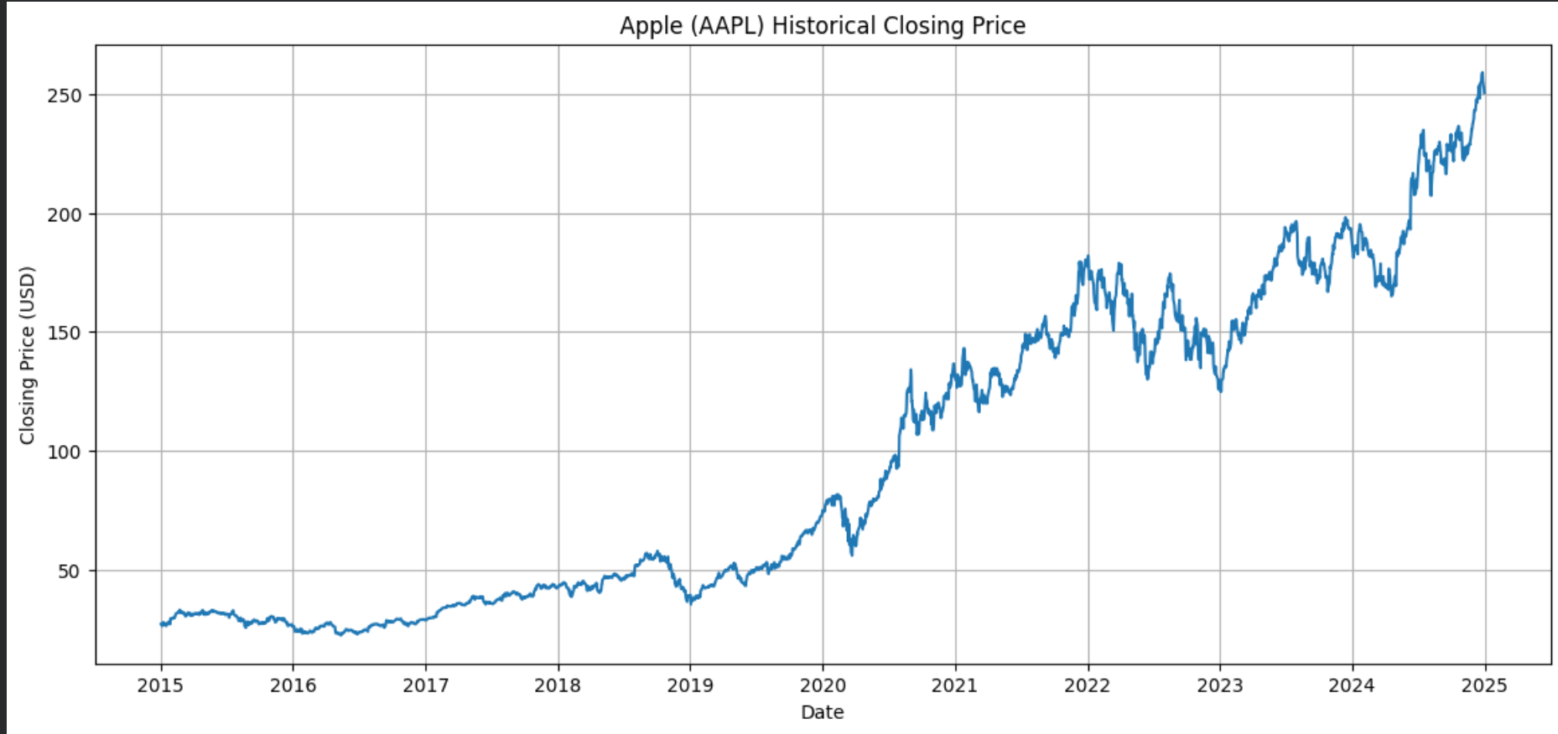
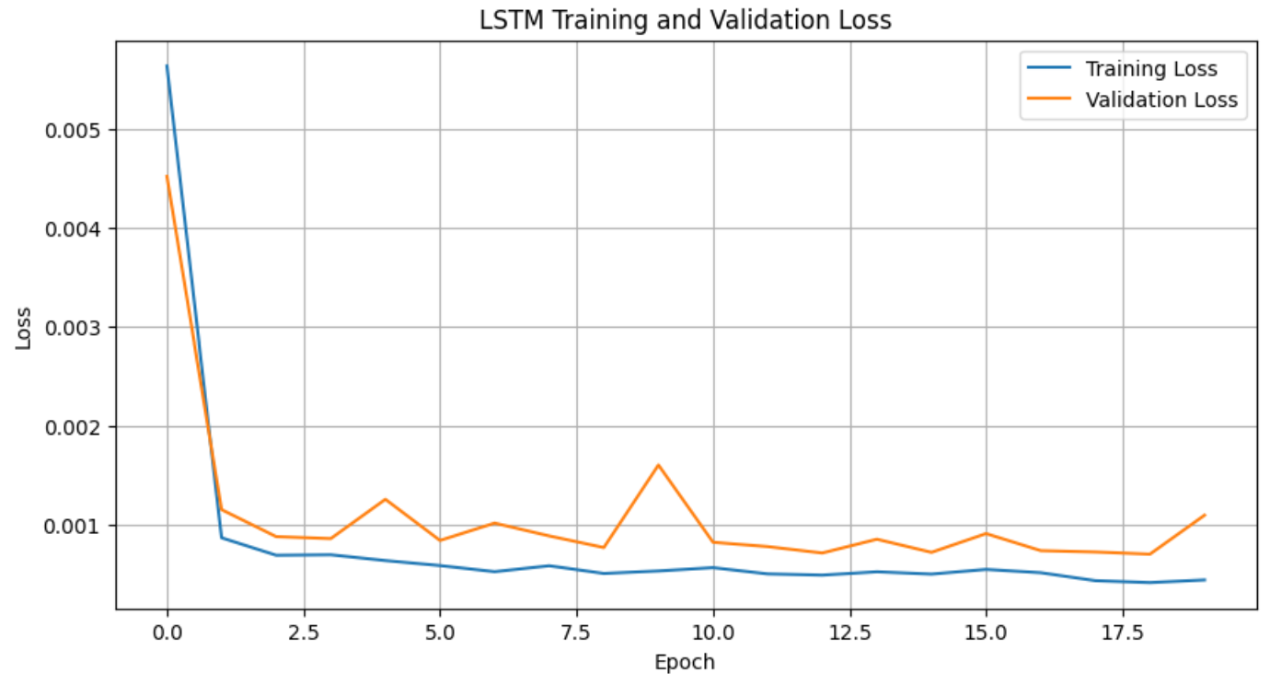
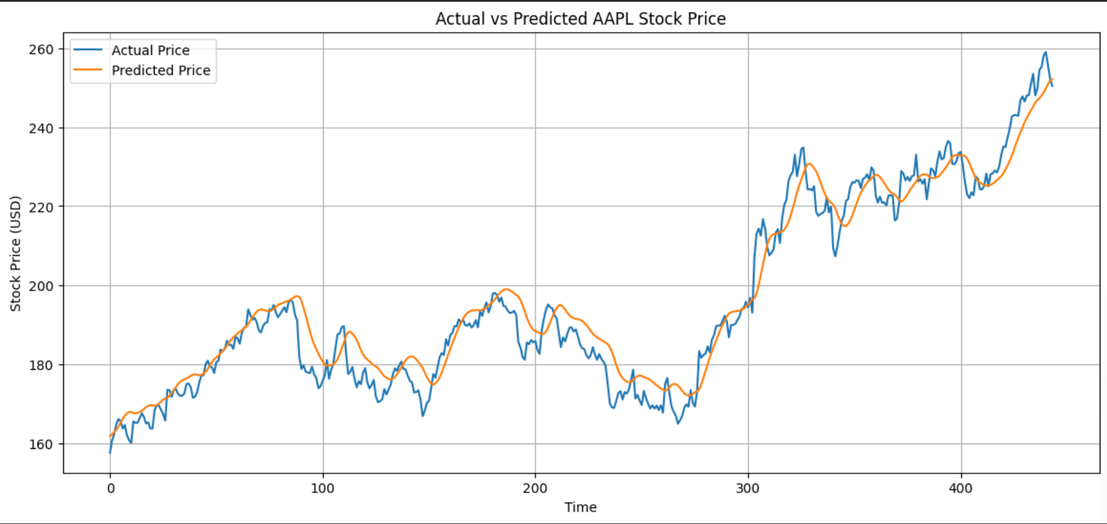
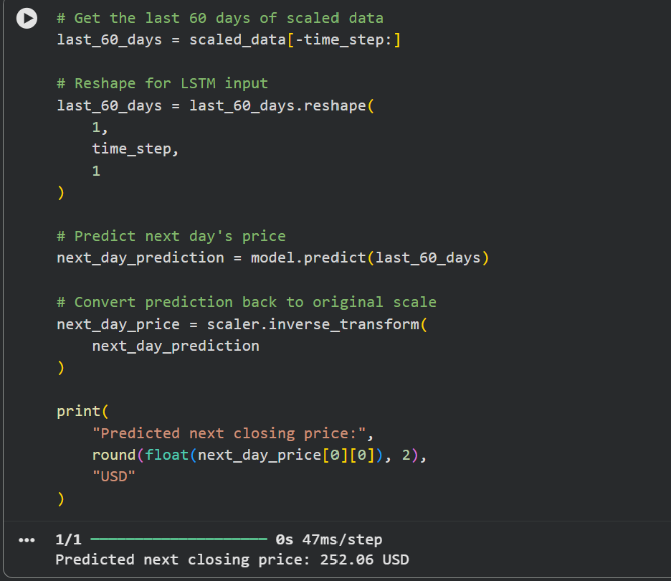
Conclusion:-
The LSTM-based time-series forecasting model was successfully developed to predict the closing price of Apple (AAPL) stock using historical stock-price data. The historical data was normalized using Min-Max Scaling and converted into sequences of 60 previous trading days, which were provided as input to the LSTM network.
The model was trained using two LSTM layers with dropout regularization and the Adam optimizer. Its performance was evaluated using Mean Squared Error (MSE), Root Mean Squared Error (RMSE), and Mean Absolute Error (MAE). The comparison between actual and predicted prices demonstrates that the LSTM model can learn temporal patterns in historical stock-price data.
Thus, the experiment demonstrates the application of Long Short-Term Memory networks for time-series forecasting. However, stock prices are influenced by many external factors and contain substantial randomness, so predictions based solely on historical closing prices have inherent limitations.

