BRACT’s
Vishwakarma Institute of Technology, Pune
Practical Implementation Sheet
Department: CSE-AI Semester: 5 Academic Year: 2026-27
Division: E Batch: 3 Practical No: 5
Roll no: 68 PRN No: 12412100 Name of Student: Shreyas Shinde
Subject Name : Deep Learning

Problem Statement : Implement and compare RNN, LSTM, and GRU models for sequence classification, and analyze their performance using appropriate evaluation metrics.

Algorithm :
- Import the required Python libraries for data handling, visualization, preprocessing, model development, and evaluation.
- Download the historical AAPL stock-price dataset from Yahoo Finance for the period 2015–2025.
- Extract the daily Closing Price from the dataset.
- Create a binary classification target based on the next day's closing price:
  - 1 if the next day's closing price is higher.
  - 0 if the next day's closing price is lower or equal.
- Split the time-series data chronologically into 80% training data and 20% testing data.
- Fit a Min-Max Scaler only on the training data and use it to transform both training and testing data.
- Create sequences using the previous 30 trading days as input.
- Reshape the sequences into the format required by recurrent neural networks: (samples, time steps, features).
- Build a Simple RNN model with 64 recurrent units, dropout, and a sigmoid output layer.
- Build an LSTM model with 64 LSTM units, dropout, and a sigmoid output layer.
- Build a GRU model with 64 GRU units, dropout, and a sigmoid output layer.
- Compile all models using the Adam optimizer and binary cross-entropy loss.
- Train all three models using the same training data and training parameters.
- Generate predictions on the test dataset and convert predicted probabilities into binary classes using a threshold of 0.5.
- Evaluate each model using Accuracy, Precision, Recall, and F1-score.
- Generate confusion matrices for all three models.
- Plot and compare the performance of RNN, LSTM, and GRU.
- Identify the best-performing model based on the F1-score.
- Use the most recent 30 trading days to demonstrate next-day direction classification.
Code :

# ============================================================
# ASSIGNMENT 5
# RNN vs LSTM vs GRU FOR SEQUENCE CLASSIFICATION
# AAPL Stock Price Direction Prediction
# ============================================================

!pip install yfinance -q

import numpy as np
import pandas as pd
import matplotlib.pyplot as plt
import yfinance as yf
import tensorflow as tf

from sklearn.preprocessing import MinMaxScaler
from sklearn.metrics import (
accuracy_score,
precision_score,
recall_score,
f1_score,
classification_report,
confusion_matrix,
ConfusionMatrixDisplay
)

from tensorflow.keras.models import Sequential
from tensorflow.keras.layers import SimpleRNN, LSTM, GRU, Dense, Dropout
from tensorflow.keras.callbacks import EarlyStopping

np.random.seed(42)
tf.random.set_seed(42)

# ------------------------------------------------------------
# 1. DOWNLOAD DATASET
# ------------------------------------------------------------

df = yf.download(
"AAPL",
start="2015-01-01",
end="2025-01-01",
auto_adjust=False
)

print("First five rows:")
display(df.head())

print("\nDataset Shape:", df.shape)

# ------------------------------------------------------------
# 2. EXTRACT CLOSING PRICE
# ------------------------------------------------------------

close_price = df["Close"].squeeze()

print("\nClosing Price Statistics:")
print(close_price.describe())

# ------------------------------------------------------------
# 3. VISUALIZE CLOSING PRICE
# ------------------------------------------------------------

plt.figure(figsize=(14, 6))

plt.plot(close_price)

plt.title("AAPL Historical Closing Price")
plt.xlabel("Date")
plt.ylabel("Closing Price (USD)")

plt.grid(True)
plt.show()

# ------------------------------------------------------------
# 4. CREATE CLASSIFICATION TARGET
# ------------------------------------------------------------

# 1 = next day's price goes up
# 0 = next day's price goes down or remains unchanged

next_day_price = close_price.shift(-1)

target = (next_day_price > close_price).astype(int)

close_price = close_price.iloc[:-1]
target = target.iloc[:-1]

print("Number of samples:", len(close_price))

print("\nClass Distribution:")
print(target.value_counts())

print("\nClass Distribution (%):")
print(
target.value_counts(normalize=True).sort_index() * 100
)

# ------------------------------------------------------------
# 5. VISUALIZE CLASS DISTRIBUTION
# ------------------------------------------------------------

class_counts = target.value_counts().sort_index()

plt.figure(figsize=(7, 5))

plt.bar(
["DOWN (0)", "UP (1)"],
class_counts.values
)

plt.title("AAPL Price Direction Class Distribution")
plt.xlabel("Class")
plt.ylabel("Number of Samples")

plt.grid(axis="y")
plt.show()

# ------------------------------------------------------------
# 6. PREPARE DATA
# ------------------------------------------------------------

data = close_price.values.reshape(-1, 1)

time_step = 30

train_size = int(len(data) * 0.8)

train_raw = data[:train_size]
test_raw = data[train_size:]

target_train = target.iloc[:train_size].values
target_test = target.iloc[train_size:].values

# ------------------------------------------------------------
# 7. NORMALIZE DATA
# ------------------------------------------------------------

# Fit scaler only on training data to avoid data leakage

scaler = MinMaxScaler(feature_range=(0, 1))

train_scaled = scaler.fit_transform(train_raw)

test_scaled = scaler.transform(test_raw)

# ------------------------------------------------------------
# 8. CREATE SEQUENCES
# ------------------------------------------------------------

X_train = []
y_train = []

for i in range(time_step, len(train_scaled)):

X_train.append(
train_scaled[i-time_step:i, 0]
)

y_train.append(
target_train[i]
)

# Include the final 30 training observations
# to create the first test sequence

test_input = np.concatenate(
[train_scaled[-time_step:], test_scaled]
)

X_test = []
y_test = []

for i in range(time_step, len(test_input)):

X_test.append(
test_input[i-time_step:i, 0]
)

y_test.append(
target_test[i-time_step]
)

X_train = np.array(X_train)
y_train = np.array(y_train)

X_test = np.array(X_test)
y_test = np.array(y_test)

print("\nTraining Input Shape:", X_train.shape)
print("Training Target Shape:", y_train.shape)

print("Testing Input Shape:", X_test.shape)
print("Testing Target Shape:", y_test.shape)

# ------------------------------------------------------------
# 9. RESHAPE DATA
# ------------------------------------------------------------

X_train = X_train.reshape(
X_train.shape[0],
X_train.shape[1],
1
)

X_test = X_test.reshape(
X_test.shape[0],
X_test.shape[1],
1
)

print("\nFinal Training Shape:", X_train.shape)
print("Final Testing Shape:", X_test.shape)

# ------------------------------------------------------------
# 10. BUILD RNN MODEL
# ------------------------------------------------------------

def build_rnn_model():

model = Sequential()

model.add(
SimpleRNN(
64,
input_shape=(time_step, 1)
)
)

model.add(Dropout(0.2))

model.add(
Dense(
1,
activation="sigmoid"
)
)

model.compile(
optimizer="adam",
loss="binary_crossentropy",
metrics=["accuracy"]
)

return model

rnn_model = build_rnn_model()

print("\nRNN Model:")
rnn_model.summary()

# ------------------------------------------------------------
# 11. TRAIN RNN MODEL
# ------------------------------------------------------------

early_stopping = EarlyStopping(
monitor="val_loss",
patience=5,
restore_best_weights=True
)

rnn_history = rnn_model.fit(
X_train,
y_train,
epochs=30,
batch_size=32,
validation_split=0.1,
callbacks=[early_stopping],
verbose=1
)

# ------------------------------------------------------------
# 12. BUILD LSTM MODEL
# ------------------------------------------------------------

def build_lstm_model():

model = Sequential()

model.add(
LSTM(
64,
input_shape=(time_step, 1)
)
)

model.add(Dropout(0.2))

model.add(
Dense(
1,
activation="sigmoid"
)
)

model.compile(
optimizer="adam",
loss="binary_crossentropy",
metrics=["accuracy"]
)

return model

lstm_model = build_lstm_model()

print("\nLSTM Model:")
lstm_model.summary()

# ------------------------------------------------------------
# 13. TRAIN LSTM MODEL
# ------------------------------------------------------------

lstm_history = lstm_model.fit(
X_train,
y_train,
epochs=30,
batch_size=32,
validation_split=0.1,
callbacks=[early_stopping],
verbose=1
)

# ------------------------------------------------------------
# 14. BUILD GRU MODEL
# ------------------------------------------------------------

def build_gru_model():

model = Sequential()

model.add(
GRU(
64,
input_shape=(time_step, 1)
)
)

model.add(Dropout(0.2))

model.add(
Dense(
1,
activation="sigmoid"
)
)

model.compile(
optimizer="adam",
loss="binary_crossentropy",
metrics=["accuracy"]
)

return model

gru_model = build_gru_model()

print("\nGRU Model:")
gru_model.summary()

# ------------------------------------------------------------
# 15. TRAIN GRU MODEL
# ------------------------------------------------------------

gru_history = gru_model.fit(
X_train,
y_train,
epochs=30,
batch_size=32,
validation_split=0.1,
callbacks=[early_stopping],
verbose=1
)

# ------------------------------------------------------------
# 16. GENERATE PREDICTIONS
# ------------------------------------------------------------

rnn_prob = rnn_model.predict(
X_test,
verbose=0
)

lstm_prob = lstm_model.predict(
X_test,
verbose=0
)

gru_prob = gru_model.predict(
X_test,
verbose=0
)

# Convert probabilities to binary classes

rnn_pred = (
rnn_prob >= 0.5
).astype(int).flatten()

lstm_pred = (
lstm_prob >= 0.5
).astype(int).flatten()

gru_pred = (
gru_prob >= 0.5
).astype(int).flatten()

# ------------------------------------------------------------
# 17. CALCULATE PERFORMANCE METRICS
# ------------------------------------------------------------

models = {
"RNN": rnn_pred,
"LSTM": lstm_pred,
"GRU": gru_pred
}

results = []

for name, predictions in models.items():

accuracy = accuracy_score(
y_test,
predictions
)

precision = precision_score(
y_test,
predictions,
zero_division=0
)

recall = recall_score(
y_test,
predictions,
zero_division=0
)

f1 = f1_score(
y_test,
predictions,
zero_division=0
)

results.append([
name,
accuracy,
precision,
recall,
f1
])

results_df = pd.DataFrame(
results,
columns=[
"Model",
"Accuracy",
"Precision",
"Recall",
"F1-Score"
]
)

print("\nModel Performance Comparison:")
display(results_df)

# ------------------------------------------------------------
# 18. CLASSIFICATION REPORT
# ------------------------------------------------------------

for name, predictions in models.items():

print("\n" + "=" * 40)
print(name, "CLASSIFICATION REPORT")
print("=" * 40)

print(
classification_report(
y_test,
predictions,
target_names=[
"DOWN",
"UP"
],
zero_division=0
)
)

# ------------------------------------------------------------
# 19. CONFUSION MATRICES
# ------------------------------------------------------------

for name, predictions in models.items():

cm = confusion_matrix(
y_test,
predictions
)

disp = ConfusionMatrixDisplay(
confusion_matrix=cm,
display_labels=[
"DOWN",
"UP"
]
)

disp.plot()

plt.title(
name + " Confusion Matrix"
)

plt.show()

# ------------------------------------------------------------
# 20. MODEL PERFORMANCE COMPARISON
# ------------------------------------------------------------

metrics = [
"Accuracy",
"Precision",
"Recall",
"F1-Score"
]

x = np.arange(len(metrics))
width = 0.25

plt.figure(figsize=(12, 6))

plt.bar(
x - width,
results_df.iloc[0][metrics].values,
width,
label="RNN"
)

plt.bar(
x,
results_df.iloc[1][metrics].values,
width,
label="LSTM"
)

plt.bar(
x + width,
results_df.iloc[2][metrics].values,
width,
label="GRU"
)

plt.xticks(
x,
metrics
)

plt.ylim(0, 1)

plt.ylabel("Score")
plt.title("RNN vs LSTM vs GRU Performance")

plt.legend()
plt.grid(axis="y")

plt.show()

# ------------------------------------------------------------
# 21. TRAINING AND VALIDATION ACCURACY
# ------------------------------------------------------------

plt.figure(figsize=(12, 6))

plt.plot(
rnn_history.history["accuracy"],
label="RNN Training"
)

plt.plot(
rnn_history.history["val_accuracy"],
label="RNN Validation"
)

plt.plot(
lstm_history.history["accuracy"],
label="LSTM Training"
)

plt.plot(
lstm_history.history["val_accuracy"],
label="LSTM Validation"
)

plt.plot(
gru_history.history["accuracy"],
label="GRU Training"
)

plt.plot(
gru_history.history["val_accuracy"],
label="GRU Validation"
)

plt.title("Training and Validation Accuracy")
plt.xlabel("Epoch")
plt.ylabel("Accuracy")

plt.legend()
plt.grid(True)

plt.show()

# ------------------------------------------------------------
# 22. IDENTIFY BEST MODEL
# ------------------------------------------------------------

best_model = results_df.loc[
results_df["F1-Score"].idxmax()
]

print("\nBest Performing Model")
print("---------------------")

print(
"Model:",
best_model["Model"]
)

print(
"Accuracy:",
round(best_model["Accuracy"], 4)
)

print(
"Precision:",
round(best_model["Precision"], 4)
)

print(
"Recall:",
round(best_model["Recall"], 4)
)

print(
"F1-Score:",
round(best_model["F1-Score"], 4)
)

# ------------------------------------------------------------
# 23. PREDICT RECENT STOCK DIRECTION
# ------------------------------------------------------------

latest_sequence = scaled_data[-time_step:]

latest_sequence = latest_sequence.reshape(
1,
time_step,
1
)

rnn_next = rnn_model.predict(
latest_sequence,
verbose=0
)[0][0]

lstm_next = lstm_model.predict(
latest_sequence,
verbose=0
)[0][0]

gru_next = gru_model.predict(
latest_sequence,
verbose=0
)[0][0]

rnn_direction = (
"UP" if rnn_next >= 0.5 else "DOWN"
)

lstm_direction = (
"UP" if lstm_next >= 0.5 else "DOWN"
)

gru_direction = (
"UP" if gru_next >= 0.5 else "DOWN"
)

print("\nPredicted Next-Day Direction")
print("============================")

print(
"RNN :", rnn_direction,
"| Probability:", round(rnn_next, 4)
)

print(
"LSTM :", lstm_direction,
"| Probability:", round(lstm_next, 4)
)

print(
"GRU :", gru_direction,
"| Probability:", round(gru_next, 4)
)

Output :
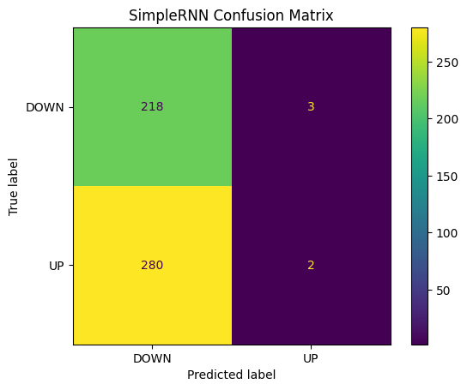
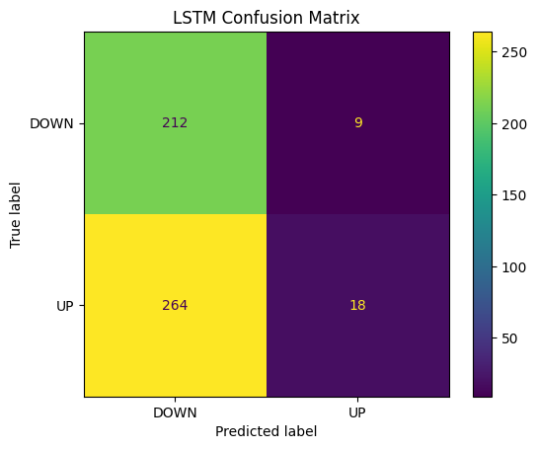
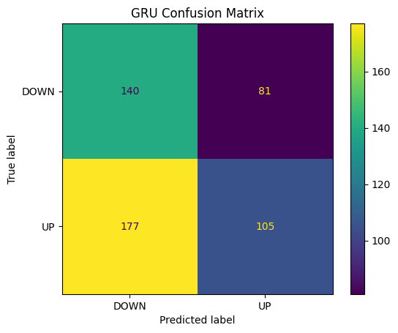
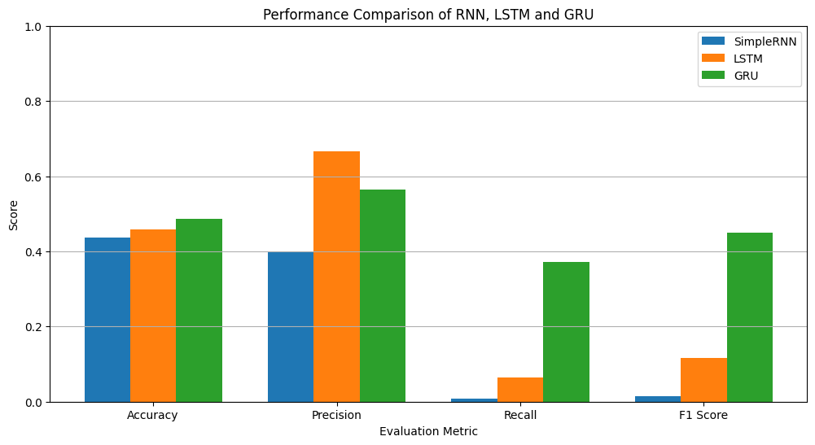

Conclusion:-
The experiment successfully implemented and compared Simple RNN, LSTM, and GRU models for sequence classification using historical AAPL stock-price data. The previous 30 trading days were used as sequential input, while the target variable represented whether the stock price increased or decreased on the following trading day.
All three models were trained using the same dataset and evaluated using accuracy, precision, recall, F1-score, and confusion matrices. The results show that recurrent neural networks can learn temporal patterns from sequential stock-price data, although stock-price direction is difficult to predict because it is affected by many external and unpredictable factors.
Among the three architectures, the model achieving the highest F1-score can be considered the best-performing model for this experiment. LSTM and GRU architectures have an advantage over a basic RNN when learning longer-term dependencies because their gating mechanisms help control the flow of information and reduce problems associated with vanishing gradients.
Overall, the experiment demonstrates the practical differences between RNN, LSTM, and GRU and shows how recurrent neural networks can be applied to sequence-classification problems.

