BRACT’s

Vishwakarma Institute of Technology, Pune

Practical Implementation Sheet

Department: CSE-AI Semester: 5 Academic Year: 2026-27

Division: E Batch: 3 Practical No: 8

Roll no: 68 PRN No: 12412100 Name of Student: Shreyas Shinde

Subject Name: Deep Learning

Problem Statement:

Assignment 8 - Implement Pre-trained BERT model for sentiment analysis or text classification on a sample dataset

Code:

# ============================================================
# DEEP LEARNING PRACTICAL 8
# Pre-trained BERT for Sentiment Analysis
# Dataset: SST-2
# ============================================================

# 1. Install required libraries
%pip install -q transformers datasets accelerate scikit-learn seaborn

# 2. Import libraries
import random
import numpy as np
import pandas as pd
import matplotlib.pyplot as plt
import seaborn as sns
import torch

from datasets import load_dataset
from transformers import AutoTokenizer, AutoModelForSequenceClassification
from sklearn.metrics import (
accuracy_score,
precision_recall_fscore_support,
confusion_matrix,
classification_report
)

# 3. Set random seed for reproducibility
SEED = 42
random.seed(SEED)
np.random.seed(SEED)
torch.manual_seed(SEED)

if torch.cuda.is_available():
torch.cuda.manual_seed_all(SEED)

# Use GPU when available
device = torch.device("cuda" if torch.cuda.is_available() else "cpu")
print("Using device:", device)

# 4. Load the pretrained BERT model and tokenizer
# This model is already fine-tuned for binary sentiment classification.
MODEL_NAME = "textattack/bert-base-uncased-SST-2"

tokenizer = AutoTokenizer.from_pretrained(MODEL_NAME)
model = AutoModelForSequenceClassification.from_pretrained(
MODEL_NAME
).to(device)

# Set evaluation mode because we are evaluating an existing model.
model.eval()

print("BERT model loaded successfully!")

# 5. Load the SST-2 validation dataset
# SST-2 contains sentences labeled as negative (0) or positive (1).
dataset = load_dataset("nyu-mll/glue", "sst2", split="validation")

# Select 500 samples for a faster practical demonstration.
sample = dataset.shuffle(seed=SEED).select(
range(min(500, len(dataset)))
)

print("\nDataset sample:")
display(pd.DataFrame(sample[:5]))

print("\nNumber of evaluated sentences:", len(sample))

# 6. Create a prediction function
# Process sentences in batches to reduce memory usage.
@torch.no_grad()
def predict_texts(texts, batch_size=32):
predictions = []
positive_probabilities = []

for start in range(0, len(texts), batch_size):
batch = texts[start:start + batch_size]

# Convert text into BERT input tokens.
encoded = tokenizer(
batch,
padding=True,
truncation=True,
max_length=128,
return_tensors="pt"
).to(device)

# Convert model outputs into class probabilities.
logits = model(**encoded).logits
probabilities = torch.softmax(logits, dim=-1)

# Class 0 = negative, Class 1 = positive.
predictions.extend(
probabilities.argmax(dim=-1).cpu().tolist()
)
positive_probabilities.extend(
probabilities[:, 1].cpu().tolist()
)

return (
np.array(predictions),
np.array(positive_probabilities)
)

# 7. Predict sentiments for the dataset
texts = sample["sentence"]
y_true = np.array(sample["label"])

y_pred, positive_probability = predict_texts(texts)

# 8. Calculate evaluation metrics
accuracy = accuracy_score(y_true, y_pred)

precision, recall, f1, _ = precision_recall_fscore_support(
y_true,
y_pred,
average="binary",
zero_division=0
)

metrics = pd.Series({
"Accuracy": accuracy,
"Precision": precision,
"Recall": recall,
"F1-score": f1
})

print("\nBERT Evaluation Metrics:")
display(metrics.round(3).to_frame("Score"))

# Display detailed class-wise performance.
print("\nClassification Report:")
print(classification_report(
y_true,
y_pred,
labels=[0, 1],
target_names=["Negative", "Positive"],
zero_division=0
))

# 9. Plot the confusion matrix
cm = confusion_matrix(y_true, y_pred, labels=[0, 1])

plt.figure(figsize=(6, 5))
sns.heatmap(
cm,
annot=True,
fmt="d",
cmap="Purples",
xticklabels=["Negative", "Positive"],
yticklabels=["Negative", "Positive"]
)

plt.xlabel("Predicted Sentiment")
plt.ylabel("Actual Sentiment")
plt.title("BERT Sentiment Analysis - Confusion Matrix")
plt.tight_layout()
plt.show()

# 10. Analyze misclassified sentences
review = pd.DataFrame({
"Sentence": texts,
"Actual Label": y_true,
"Predicted Label": y_pred,
"Positive Probability": positive_probability
})

# Keep only predictions that do not match the actual labels.
mistakes = review[
review["Actual Label"] != review["Predicted Label"]
].copy()

# Calculate confidence in the predicted class.
mistakes["Prediction Confidence"] = np.where(
mistakes["Predicted Label"] == 1,
mistakes["Positive Probability"],
1 - mistakes["Positive Probability"]
)

print("\nNumber of misclassified sentences:", len(mistakes))
print("\nMost confident incorrect predictions:")

display(
mistakes.sort_values(
"Prediction Confidence",
ascending=False
).head(10)
)

# 11. Test BERT on custom sentences
custom_texts = [
"The story was slow, but the ending was wonderful.",
"This movie was terrible and a complete waste of time.",
"I really enjoyed the acting and the beautiful visuals.",
"The film was boring and poorly written."
]

custom_predictions, custom_probabilities = predict_texts(
custom_texts
)

print("\nCustom Sentence Predictions:")

for text, label, probability in zip(
custom_texts,
custom_predictions,
custom_probabilities
):
sentiment = "Positive" if label == 1 else "Negative"

print(f"\nSentence: {text}")
print(f"Predicted sentiment: {sentiment}")
print(f"Positive probability: {probability:.3f}")

# 12. Save evaluation results
review.to_csv(
"/content/bert_sentiment_predictions.csv",
index=False
)

metrics.to_csv(
"/content/bert_evaluation_metrics.csv",
header=["Score"]
)

print("\nPrediction and evaluation CSV files saved.")
print("Practical 8 completed successfully.")

Output:

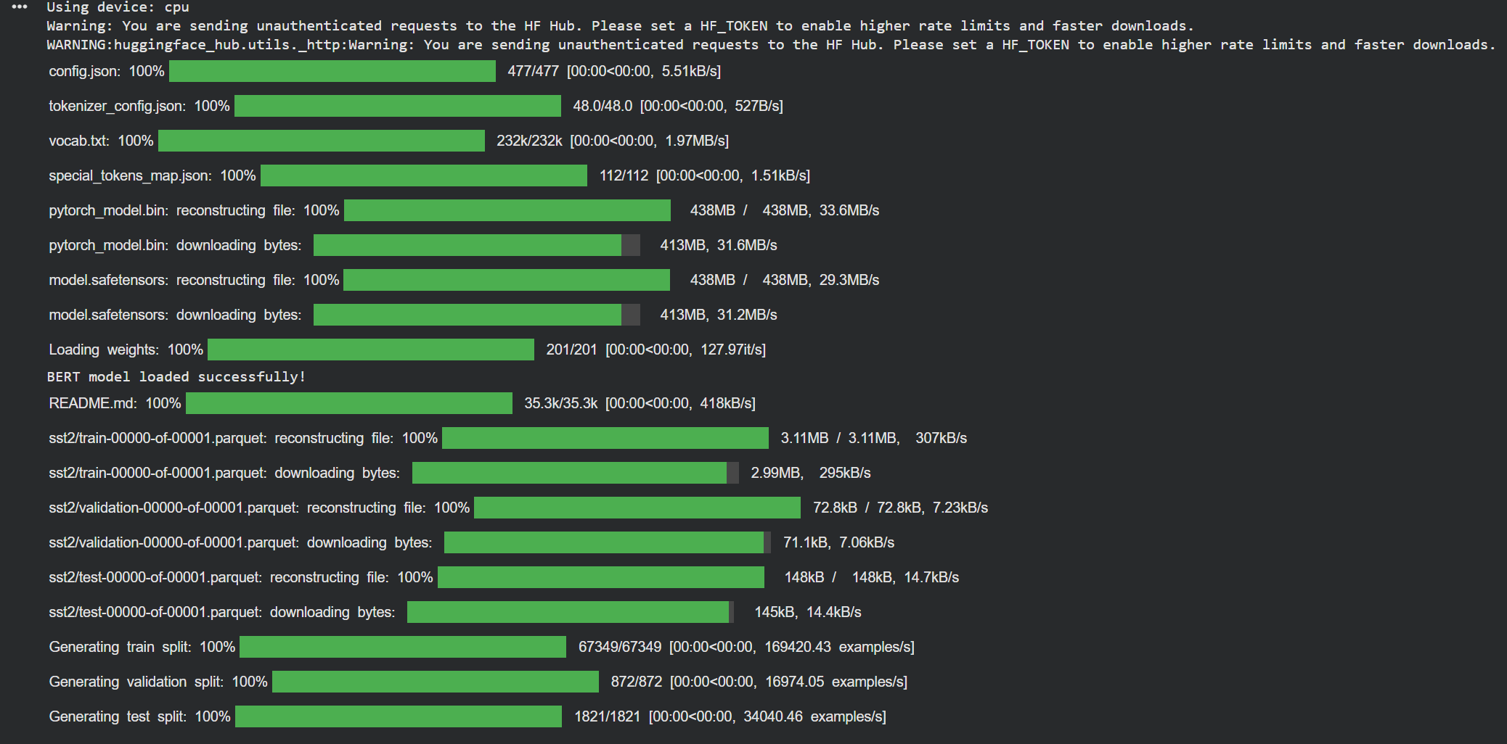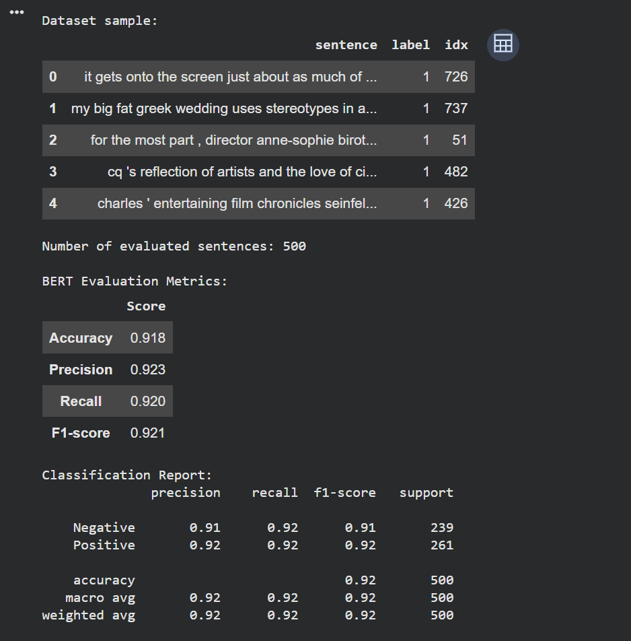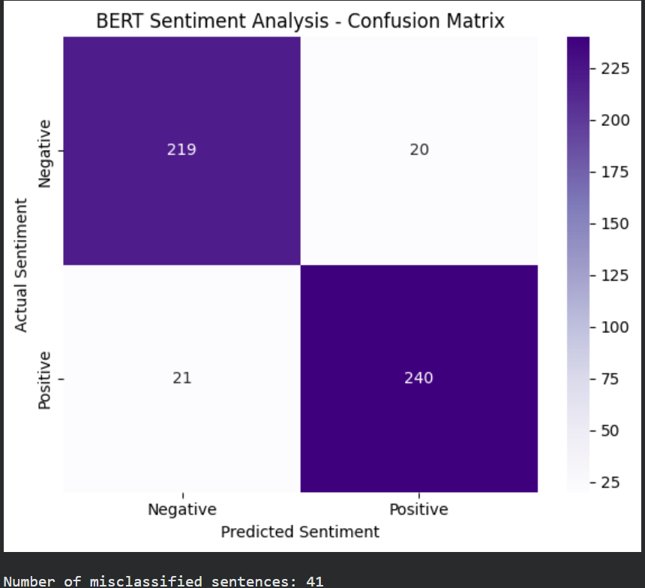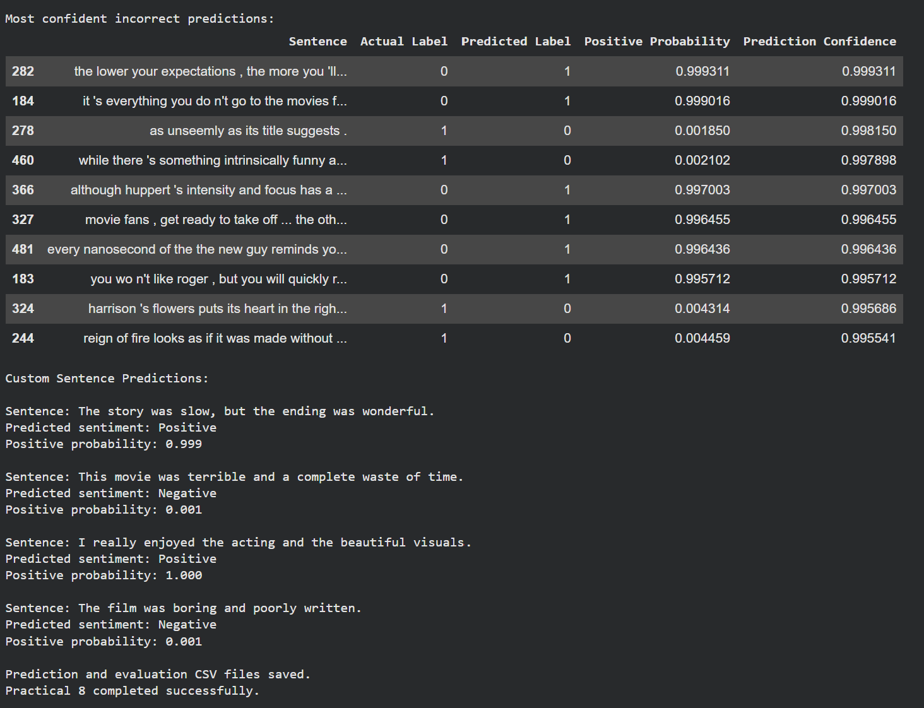

Conclusion:-
The pre-trained BERT model was successfully implemented for sentiment analysis using the SST-2 dataset. The model achieved an accuracy of 91.8%, precision of 92.3%, recall of 92.0%, and an F1-score of 92.1% on 500 validation samples. The confusion matrix showed that 459 sentences were classified correctly, while 41 were misclassified. The model was also tested on custom sentences and correctly identified positive and negative sentiments in the examples. Thus, the experiment demonstrates that a pre-trained BERT model can effectively perform sentiment classification, although some sentences may be misclassified due to contextual ambiguity or complex language.

