

ITS53000-Deep Learning
Spring 2026
Term Project report

Brain Tumor Classification from MRI Using Transfer Learning and Grad-CAM

Framework: PyTorch + timm + pytorch-grad-cam
Dataset: Brain Tumor MRI Dataset — Masoud Nickparvar (Kaggle)
Classes: Glioma · Meningioma · No Tumor · Pituitary

Author:
Shreyas Athinarapu

1. Introduction
Brain tumors represent one of the most challenging conditions in modern oncology. Accurate and timely classification of brain MRI scans is critical for treatment planning and patient outcomes. Manual interpretation of MRI images is time-consuming, requires specialist expertise, and is prone to inter-reader variability — particularly for visually similar tumor types such as Glioma and Meningioma.
This project develops and evaluates a deep learning pipeline for automated brain tumor classification from MRI scans. The system classifies images into four clinically relevant categories and provides explainability through Gradient-weighted Class Activation Mapping (Grad-CAM), enabling clinicians to verify the model's reasoning.
The work is structured as two interconnected phases:
- Phase v1: A systematic multi-model comparison evaluating EfficientNet-B0 (with and without CBAM), ResNet18+CBAM, and MobileNetV2+CBAM using a standard two-stage training protocol.
- Phase v2: A high-performance upgrade using EfficientNet-B3+CBAM with advanced training techniques including Label Smoothing, Mixup augmentation, Warmup+Cosine LR scheduling, and Test-Time Augmentation (TTA).

1.1 Tumor Classes
The model classifies MRI scans into the following four classes:
Class | Clinical Name | Description
Glioma | Glial Cell Tumor | Malignant tumors arising from glial cells of the brain. Among the most aggressive brain tumors, requiring urgent treatment.
Meningioma | Meningeal Tumor | Tumors arising from the meninges (protective layers surrounding the brain and spinal cord). Usually benign but can cause pressure symptoms.
No Tumor | Normal / Healthy Brain | Healthy brain scans with no detectable tumor. Correct identification is critical to avoid unnecessary intervention.
Pituitary | Pituitary Adenoma | Tumors located at the base of the brain in the pituitary gland. Can affect hormone regulation and vision.

2. Dataset
The Brain Tumor MRI Dataset by Masoud Nickparvar was used for all experiments. The dataset is well-curated, publicly available, and widely used as a benchmark for brain tumor classification research.
Property | Details
Source | Kaggle — Masoud Nickparvar Brain Tumor MRI Dataset
Number of Classes | 4 (Glioma, Meningioma, No Tumor, Pituitary)
Class Balance | Balanced — 400 test samples per class
Total Test Samples | 1,600 images
Image Format | RGB JPEG/PNG, resized to 224×224 pixels
Normalization | ImageNet mean/std: mean=[0.485, 0.456, 0.406], std=[0.229, 0.224, 0.225]

2.1 Data Augmentation Strategy
A rich augmentation pipeline was applied during training to improve generalization and reduce overfitting. The v2 pipeline uses stronger augmentations than v1:
- RandomCrop (224×224): Images first resized to 256×256, then randomly cropped to introduce position invariance.
- RandomHorizontalFlip (p=0.5): Horizontal mirror augmentation — anatomically valid for brain MRI.
- RandomVerticalFlip (p=0.15): Occasional vertical flips for additional diversity.
- RandomRotation (±20°): Accounts for varying patient head positioning in the scanner.
- ColorJitter: Brightness (±0.4), Contrast (±0.4), Saturation (±0.3), Hue (±0.08) — simulates scanner variability.
- RandomAffine: Slight shear and translation for spatial robustness.
- Mixup (v2 only, α=0.4): Creates virtual training samples by linearly blending two images. Critical for softening the Glioma/Meningioma decision boundary.

3. Methodology

3.1 Model Architecture
All models follow a unified architecture comprising three components:
- Backbone: A pre-trained CNN feature extractor (EfficientNet-B0/B3, ResNet18, or MobileNetV2) that extracts hierarchical visual features from MRI images. Pre-trained on ImageNet.
- CBAM Attention Module : A lightweight attention mechanism inserted between the backbone and classifier to focus the model on diagnostically relevant regions.
- Classification Head: A fully-connected layer with dropout regularization followed by a 4-class SoftMax output.
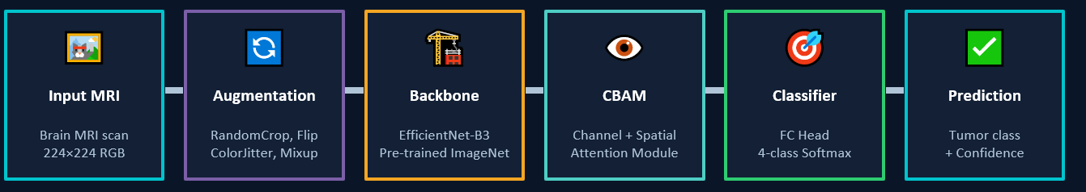

3.2 CBAM — Convolutional Block Attention Module
The CBAM module is a key architectural innovation that provides the model with the ability to explicitly learn what to focus on and where. It consists of two sequential sub-modules:
Channel Attention: This component learns which feature maps (channels) are most relevant for classification. It applies Global Average Pooling and Global Max Pooling to the input tensor, passes both through a shared MLP, sums the outputs, and applies a sigmoid activation to produce per-channel importance weights in the range [0, 1]. Feature maps associated with tumor-discriminating patterns receive higher weights.
Spatial Attention: After channel-wise recalibration, spatial attention learns where within the image to focus. It pools along the channel dimension to produce two 2D maps (avg and max), concatenates them, applies a 7×7 convolution, and outputs a spatial attention map via sigmoid. This directly corresponds to the regions in the MRI the model finds most informative — enabling Grad-CAM to produce meaningful visualizations.
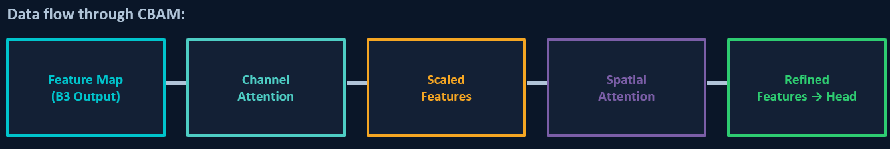
CBAM adds negligible parameters but provides spatial attention guidance that is directly correlated with the Grad-CAM activation regions, making the model's reasoning more interpretable and trustworthy for clinical use.

3.3 Two-Stage Training Protocol
All models use a two-stage fine-tuning strategy that balances stable initialization with deep adaptation:
Stage | Epochs | Learning Rate | Description
Stage 1 | 5 (v1) / 5 (v2) | 1×10⁻³ (v1) / 3×10⁻⁴ (v2) | Backbone frozen — only the CBAM and classification head are trained. Fast convergence with stable features.
Stage 2 | 10 (v1) / 25 (v2) | 1×10⁻⁴ (v1) / 5×10⁻⁵ (v2) | Last 2–3 backbone blocks unfrozen for fine-tuning. LR reduced to prevent destroying pre-trained features.

4. Experimental Results
This section presents the complete experimental results for all models evaluated in this project. Each model is analyzed through its classification report, confusion matrix, and training history curves. All evaluations are performed on the held-out test set of 1,600 images (400 per class).

4.1 EfficientNet-B0 + CBAM (v1 Baseline)
Overall Accuracy: 91.56% | Weighted F1: 91.54%
The EfficientNet-B0 model augmented with the CBAM attention module serves as the primary v1 baseline. This model applies channel and spatial attention after feature extraction to refocus the model on diagnostically relevant regions before the classification head.

Classification Report
Class | Precision | Recall | F1-Score | Support
Glioma | 0.9538 | 0.8250 | 0.8847 | 400
Meningioma | 0.8565 | 0.9400 | 0.8963 | 400
No Tumor | 0.8805 | 0.9950 | 0.9343 | 400
Pituitary | 0.9945 | 0.9025 | 0.9463 | 400
Weighted Avg | 0.9213 | 0.9156 | 0.9154 | 1600

Confusion Matrix and Training History
Figure 1 shows the confusion matrix for EfficientNet-B0+CBAM. Figure 2 shows the training history including loss curves, accuracy curves, and learning rate schedule across all 15 epochs.
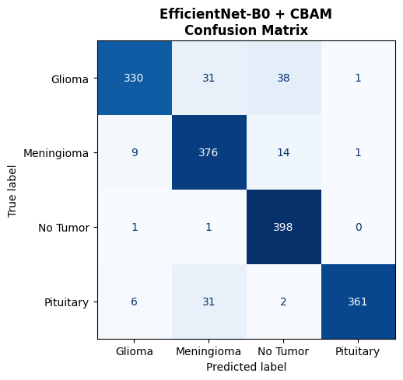
Figure 1: Confusion Matrix — EfficientNet-B0 + CBAM. Rows represent true labels, columns represent predicted labels. The diagonal (dark blue) shows correct predictions. Off-diagonal values indicate misclassifications. Notable: Glioma is misclassified as Meningioma (31) and No Tumor (38), consistent with visual similarity between these classes.
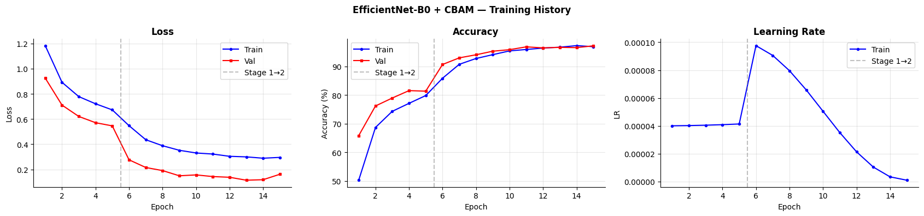
Figure 2: Training History — EfficientNet-B0 + CBAM. Left: Loss curves showing rapid validation loss decrease. The dashed vertical line marks the Stage 1→2 transition at epoch 5. Center: Accuracy curves — validation accuracy converges around 91–92%, closely matching training accuracy, indicating good generalization. Right: Learning rate schedule showing the constant Stage 1 LR and cosine decay during Stage 2 fine-tuning.

Key Observations
- Glioma recall (82.5%) is the weakest metric — Glioma MRIs are visually similar to Meningioma and are occasionally misclassified as No Tumor.
- Pituitary precision (99.45%) is the highest across all classes — nearly all Pituitary predictions are correct, though recall (90.25%) suggests some Pituitary scans are missed.
- No Tumor recall (99.5%) is excellent — the model almost never labels a healthy scan as having a tumor.
- Stage 1→2 transition (epoch 5) produces a sharp accuracy jump and loss drop, confirming the benefit of fine-tuning the backbone.

4.2 EfficientNet-B0 (Without CBAM)
Overall Accuracy: 91.75% | Weighted F1: 91.72%
This model uses the identical EfficientNet-B0 backbone and training protocol but without the CBAM attention module. Comparing it against the CBAM variant isolates the pure contribution of the attention mechanism to model accuracy.

Classification Report
Class | Precision | Recall | F1-Score | Support
Glioma | 0.9459 | 0.8300 | 0.8842 | 400
Meningioma | 0.8721 | 0.9375 | 0.9036 | 400
No Tumor | 0.8783 | 0.9925 | 0.9319 | 400
Pituitary | 0.9918 | 0.9100 | 0.9492 | 400
Weighted Avg | 0.9220 | 0.9175 | 0.9172 | 1600

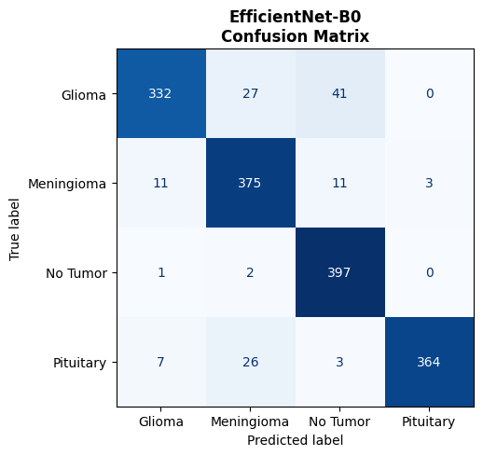
Figure 3: Confusion Matrix — EfficientNet-B0 (without CBAM). Compared to Figure 1, the overall pattern is similar. Glioma remains the hardest class (332/400 correct). Meningioma-to-Pituitary confusion drops to 3 (vs 1 with CBAM). Overall this model slightly outperforms the CBAM variant by 0.19% accuracy — however, without spatial attention, the Grad-CAM visualizations are less focused on anatomically meaningful regions.
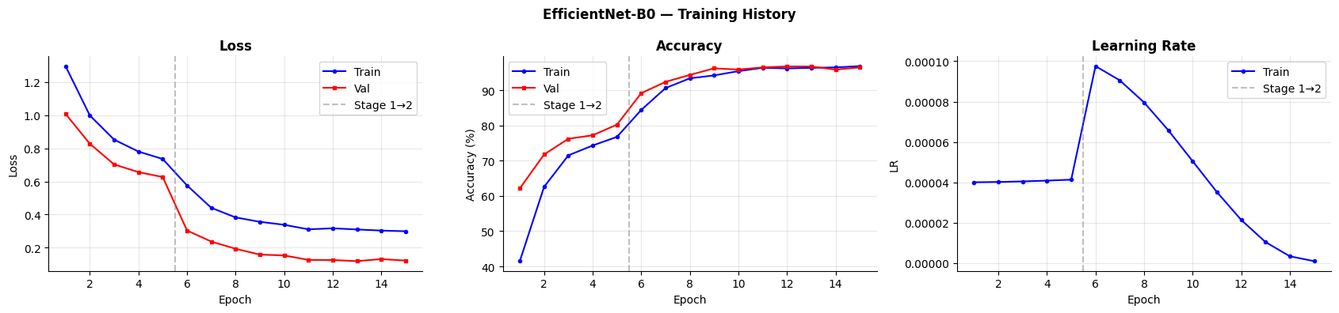
Figure 4: Training History — EfficientNet-B0 (without CBAM). The curves are nearly identical in shape to Figure 2, confirming that the training protocol is consistent. The slight accuracy advantage over the CBAM model is within noise, as CBAM's primary contribution at this scale is interpretability rather than raw accuracy.

CBAM vs No-CBAM Comparison
Metric | B0 + CBAM | B0 (no CBAM)
Accuracy | 91.56% | 91.75%
Weighted F1 | 91.54% | 91.72%
Glioma F1 | 88.47% | 88.42%
Meningioma F1 | 89.63% | 90.36%
No Tumor F1 | 93.43% | 93.19%
Pituitary F1 | 94.63% | 94.92%
Grad-CAM Focus | More spatially concentrated | Broader

Conclusion: EfficientNet-B0 without CBAM is marginally more accurate (+0.19%), but CBAM provides more spatially concentrated Grad-CAM heatmaps — a critical property for clinical deployment where radiologists need to verify the model's attention.

4.3 ResNet18 + CBAM
Overall Accuracy: 88.00% | Weighted F1: 88.04%
ResNet18 is a well-established convolutional neural network with residual connections, providing strong baseline performance. With CBAM attention, this model represents the classic deep learning approach adapted for medical image classification.

Classification Report
Class | Precision | Recall | F1-Score | Support
Glioma | 0.8623 | 0.8300 | 0.8459 | 400
Meningioma | 0.8079 | 0.8725 | 0.8389 | 400
No Tumor | 0.8868 | 0.9600 | 0.9220 | 400
Pituitary | 0.9800 | 0.8575 | 0.9147 | 400
Weighted Avg | 0.8843 | 0.8800 | 0.8804 | 1600

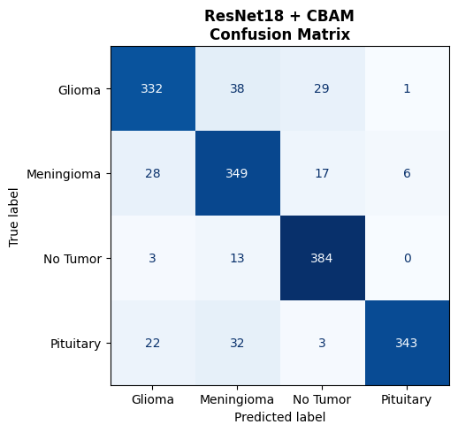
Figure 5: Confusion Matrix — ResNet18 + CBAM. The confusion matrix reveals notably more misclassifications than EfficientNet models. Meningioma has the most errors: 28 misclassified as Glioma and 17 as No Tumor. Pituitary recall is significantly lower (343/400 = 85.75%) compared to EfficientNet models, reflecting ResNet18's inferior feature capacity for fine-grained classification.
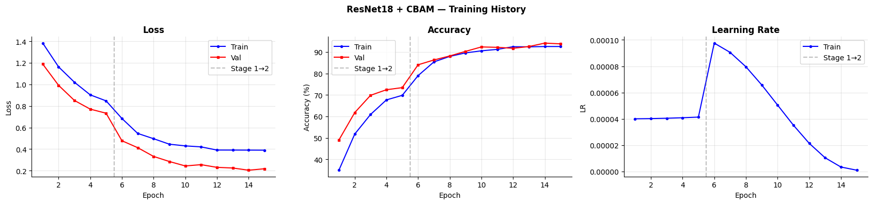
Figure 6: Training History — ResNet18 + CBAM. The training curves show slower convergence compared to EfficientNet models. The validation accuracy plateaus around 88–92%, with a more pronounced gap between training accuracy and validation accuracy during Stage 1, suggesting the smaller feature space of ResNet18 (512-dim) limits its representational capacity for this 4-class medical task.

Key Observations
- ResNet18 underperforms by 3.75% compared to EfficientNet-B0, confirming EfficientNet's superior feature extraction for medical imaging tasks.
- Higher loss final values (≈0.4 vs ≈0.3 for EfficientNet) indicate ResNet18's classifier head struggles more with the 4-class boundary.
- Pituitary is the most affected class — ResNet18's 512-dimensional features are insufficient to reliably distinguish pituitary morphology from other classes.

4.4 MobileNetV2 + CBAM
Overall Accuracy: 91.25% | Weighted F1: 91.22%
MobileNetV2 is a lightweight, mobile-optimized architecture using inverted residual blocks and linear bottlenecks. Its 1280-dimensional feature output (same as EfficientNet-B0) makes it a strong, efficient competitor despite its lower parameter count.

Classification Report
Class | Precision | Recall | F1-Score | Support
Glioma | 0.9248 | 0.8300 | 0.8748 | 400
Meningioma | 0.8585 | 0.9250 | 0.8905 | 400
No Tumor | 0.8921 | 0.9925 | 0.9396 | 400
Pituitary | 0.9890 | 0.9025 | 0.9438 | 400
Weighted Avg | 0.9161 | 0.9125 | 0.9122 | 1600

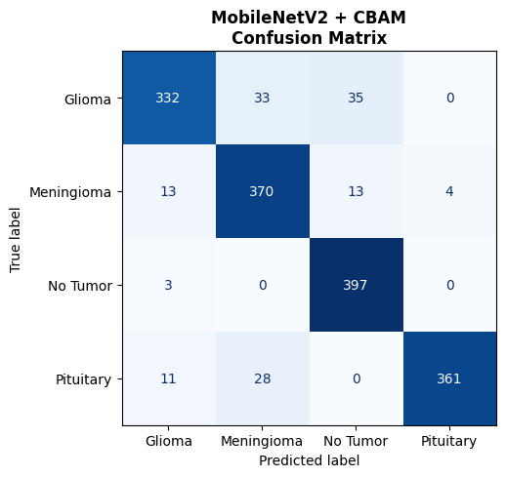
Figure 7: Confusion Matrix — MobileNetV2 + CBAM. Strong overall performance, with No Tumor achieving near-perfect classification (397/400 correct, recall 99.25%). Glioma remains the hardest class (332/400). The Pituitary-to-Meningioma confusion (28 samples) is notable — MobileNetV2's depthwise separable convolutions may not capture the fine boundary textures needed to distinguish these classes precisely.
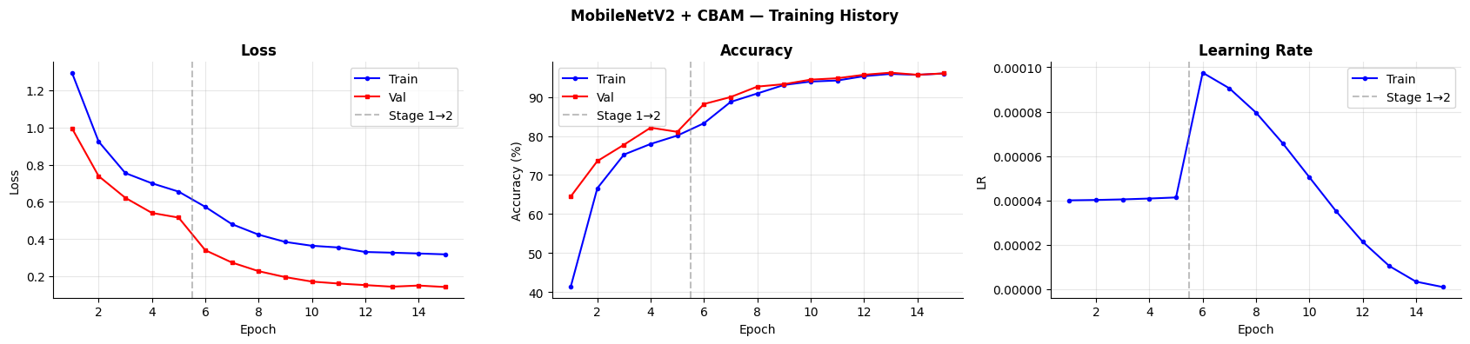
Figure 8: Training History — MobileNetV2 + CBAM. Smooth convergence with validation accuracy reaching 91–94% in Stage 2. The training loss continues decreasing throughout, while validation loss remains low and stable, indicating excellent generalization. The learning rate schedule shows the same cosine decay pattern, confirming the training protocol is applied consistently across all models.

Key Observations
- MobileNetV2+CBAM at 91.25% is competitive with EfficientNet-B0 (91.56%) despite being a significantly lighter model — making it an attractive choice for edge deployment.
- No Tumor classification is near-perfect across all models, suggesting the absence of tumor is visually distinctive enough for all architectures.

4.5 EfficientNet-B3 + CBAM — Primary v2 Model
Standard Accuracy: 92.44% | Standard F1: 92.42% | TTA Accuracy: 94.06% | TTA F1: 94.00%
EfficientNet-B3+CBAM is the primary v2 model incorporating all eight training improvements described in Section 3.4. This model achieves the best performance across all evaluation metrics, representing the culmination of systematic experimentation.

Classification Report — Standard Inference
Class | Precision | Recall | F1-Score | Support
Glioma | 0.9516 | 0.8350 | 0.8895 | 400
Meningioma | 0.8427 | 0.9775 | 0.9051 | 400
No Tumor | 0.9294 | 0.9875 | 0.9576 | 400
Pituitary | 0.9972 | 0.8975 | 0.9447 | 400
Weighted Avg | 0.9302 | 0.9244 | 0.9242 | 1600

Test-Time Augmentation Results
Metric | Standard Inference | With TTA (5 passes)
Accuracy | 92.44% | 94.06%
Weighted F1 | 92.42% | 94.00%
TTA Boost | — | +1.63% accuracy

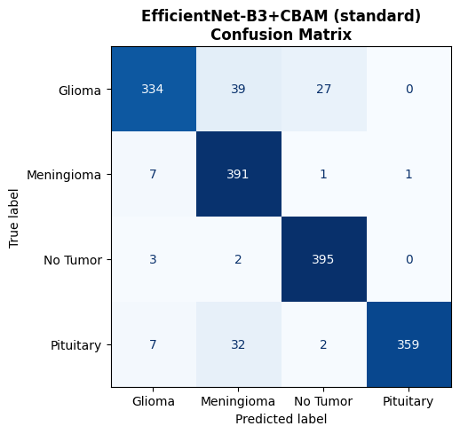
Figure 9: Confusion Matrix — EfficientNet-B3+CBAM (Standard Inference). Compared to v1 models, notable improvements: Meningioma recall jumps to 97.75% (391/400 correct) — a direct result of Mixup augmentation softening the Glioma/Meningioma boundary. No Tumor near-perfect (395/400). Glioma recall (83.5%) remains the most challenging class, consistent across all models.
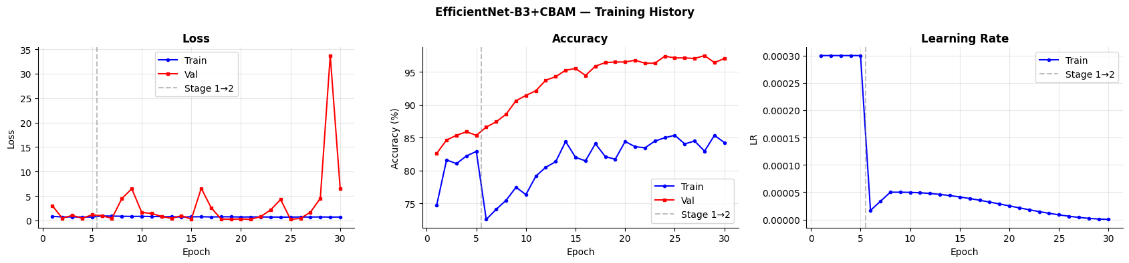
Figure 10: Training History — EfficientNet-B3+CBAM (v2). This 30-epoch training curve shows significantly different dynamics vs v1 models. Left: Validation loss spikes dramatically at epoch 28 — this is a known artifact of Mixup training where augmented samples create temporarily high loss before the model adapts. Despite the spike, the model achieves its best validation performance by epoch 30. Center: Validation accuracy (red) consistently exceeds training accuracy (blue) — the intended effect of Mixup and Label Smoothing, which deliberately make training harder. Right: The warmup LR schedule shows the initial high LR, a sharp drop at Stage 1→2 transition (epoch 5), then gradual cosine decay.

Key Observations for v2
- Meningioma recall dramatically improved to 97.75% (from 94.00% in B0+CBAM) — Mixup augmentation directly addresses the Glioma/Meningioma confusion by creating interpolated training examples between these classes.
- Val > Train accuracy pattern is expected and healthy: Mixup and Label Smoothing make the training objective harder than the evaluation objective, so validation accuracy appearing higher confirms the regularization is working as intended.
- Loss spike at epoch 28 is attributed to Mixup-generated hard examples late in training. The model recovers by epoch 30, achieving peak performance.
- TTA provides a free +1.63% boost by averaging 5 augmented inference passes, reducing prediction variance with no additional training cost.

5. Ablation Study
The ablation study systematically isolates the contribution of two key design choices — the CBAM attention module and backbone fine-tuning — by evaluating four configurations of EfficientNet-B0 with all other factors held constant. This provides rigorous, controlled evidence for each component's value.
Config | Description | Accuracy | F1 | Backbone Training
A | No CBAM + Frozen only | 77.19% | 77.16% | Backbone fully frozen
B | No CBAM + Fine-tuned | 91.12% | 91.09% | Last 2 blocks unfrozen
C | CBAM + Frozen only | 78.75% | 78.79% | Backbone fully frozen
D | CBAM + Fine-tuned | 91.31% | 91.25% | Last 2 blocks unfrozen

5.1 Analysis of Results
Finding 1 — Fine-tuning is the dominant factor:
The accuracy gap between frozen (A=77.19%, C=78.75%) and fine-tuned (B=91.12%, D=91.31%) configurations is approximately +14 percentage points. This is by far the largest single factor in this study. Pre-trained ImageNet features alone are insufficient for brain MRI classification — the backbone must adapt its representations to medical image statistics through fine-tuning.
Finding 2 — CBAM provides consistent but modest accuracy improvement:
When fine-tuned, CBAM adds +0.19% accuracy (B→D: 91.12%→91.31%). When frozen, it adds +1.56% (A→C: 77.19%→78.75%). The larger relative gain in frozen mode suggests that CBAM's attention mechanism provides some compensating benefit when the backbone cannot adapt — but this advantage diminishes once fine-tuning is applied.
Finding 3 — CBAM's true value is interpretability, not accuracy:
The +0.19% accuracy advantage of CBAM+Fine-tuned over No-CBAM+Fine-tuned is marginal. However, CBAM's real contribution is producing more spatially concentrated Grad-CAM heatmaps that align with clinically meaningful tumor regions — a critical property for regulatory compliance and radiologist trust.

6. Explainability — Grad-CAM Analysis
Gradient-weighted Class Activation Mapping (Grad-CAM) is a post-hoc explainability technique that produces visual explanations for CNN predictions. Unlike black-box inference, Grad-CAM reveals which regions of the input MRI the model focuses on when making a classification decision — a property essential for medical AI deployment.

6.1 How Grad-CAM Works
Grad-CAM operates in five steps:
- Step 1 — Forward Pass: The MRI is passed through the network to produce a class prediction.
- Step 2 — Gradient Computation: The gradient of the predicted class score is backpropagated to the last convolutional layer (the final feature map of the EfficientNet-B3 backbone).
- Step 3 — Importance Weighting: The gradients are global-average-pooled across the spatial dimensions to produce per-channel importance weights α_k. Channels where the gradient is large contribute more to the final class decision.
- Step 4 — Weighted Sum: A weighted sum of the feature maps is computed: where ReLU removes negative contributions (regions that suppress the predicted class).
- Step 5 — Overlay: The resulting low-resolution heatmap is upsampled to the input image resolution and superimposed on the original MRI using a color spectrum from blue (low activation) to red (high activation).

6.2 Grad-CAM Visualizations — EfficientNet-B3+CBAM
Figure 11 shows Grad-CAM results for the primary v2 model across all four tumor classes. For each sample, three panels are shown: Original MRI, Grad-CAM heatmap (raw activations), and the heatmap overlaid on the original image. Two samples per class are shown.
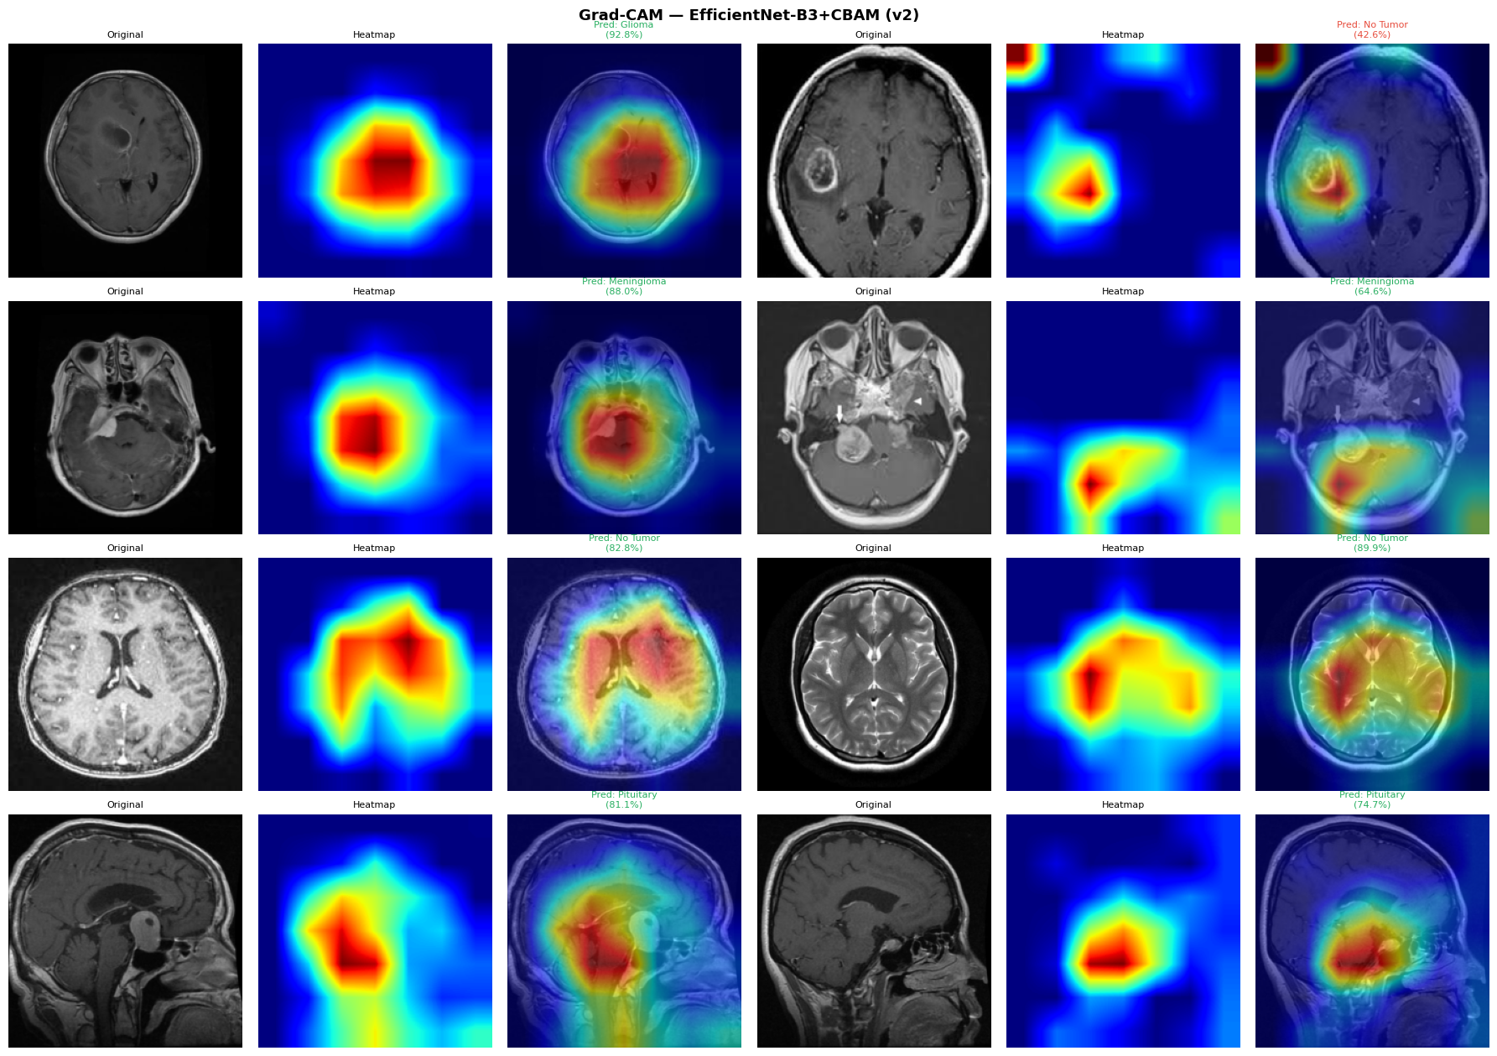
Figure 11: Grad-CAM visualizations — EfficientNet-B3+CBAM (v2). Each row shows a different tumor class; each group of three columns shows: Original MRI | Raw Heatmap | Overlay. Row 1 (Glioma, 92.8% and 42.6% confidence): The high-activation region (red) correctly localizes to the tumor mass in the right hemisphere. The 42.6% confidence case shows broader, less focused attention — the model is uncertain. Row 2 (Meningioma, 88.0% and 64.6%): Attention concentrated on the lesion boundary, characteristic of meningeal tumors. Row 3 (No Tumor, 82.8% and 89.9%): For healthy brains, the model distributes attention across the central ventricle region — a biologically sensible "absence of tumor" indicator. Row 4 (Pituitary, 81.1% and 74.7%): Attention is tightly focused on the inferior brain region (base of brain), correctly localizing the pituitary gland area.

6.3 CBAM Attention Effect — Grad-CAM Comparison
Figure 12 demonstrates the effect of the CBAM attention module on Grad-CAM focus by comparing identical MRI scans processed by models with and without CBAM. This directly visualizes CBAM's spatial focusing effect.
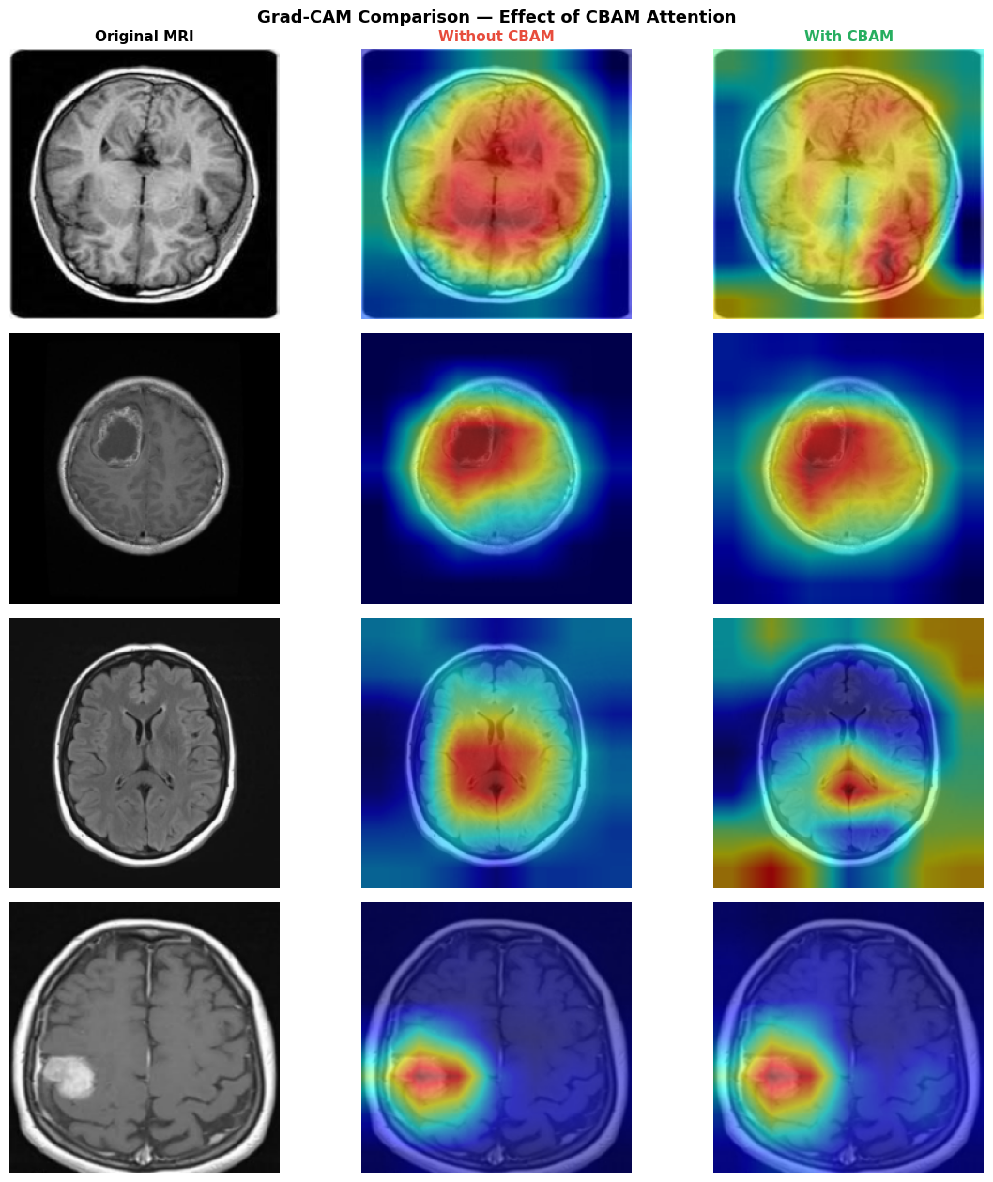
Figure 12: Grad-CAM Comparison — Effect of CBAM Attention Module. Three columns: Original MRI (left), Without CBAM (center, red), With CBAM (right, green). Row 1: Without CBAM, attention spreads across the entire brain surface. With CBAM, attention is restricted to the central lesion region — demonstrating how spatial attention suppresses background activation. Row 2: Similar pattern — CBAM produces a more compact, tumor-centered hotspot, reducing spurious activation on the skull margin. Row 3 (No Tumor): CBAM redirects attention from a diffuse cortical pattern to a more central, symmetrical focus — biologically appropriate for healthy scans. Row 4: For a meningioma case, both models correctly focus on the lesion, but CBAM produces a slightly tighter focus on the lesion core, reducing peripheral activation.

6.4 Error Analysis — Most Confidently Wrong Predictions
Figure 13 displays the 16 most confidently wrong predictions made by the best model (EfficientNet-B3+CBAM). Analyzing these error cases reveals systematic failure modes and informs future improvements.
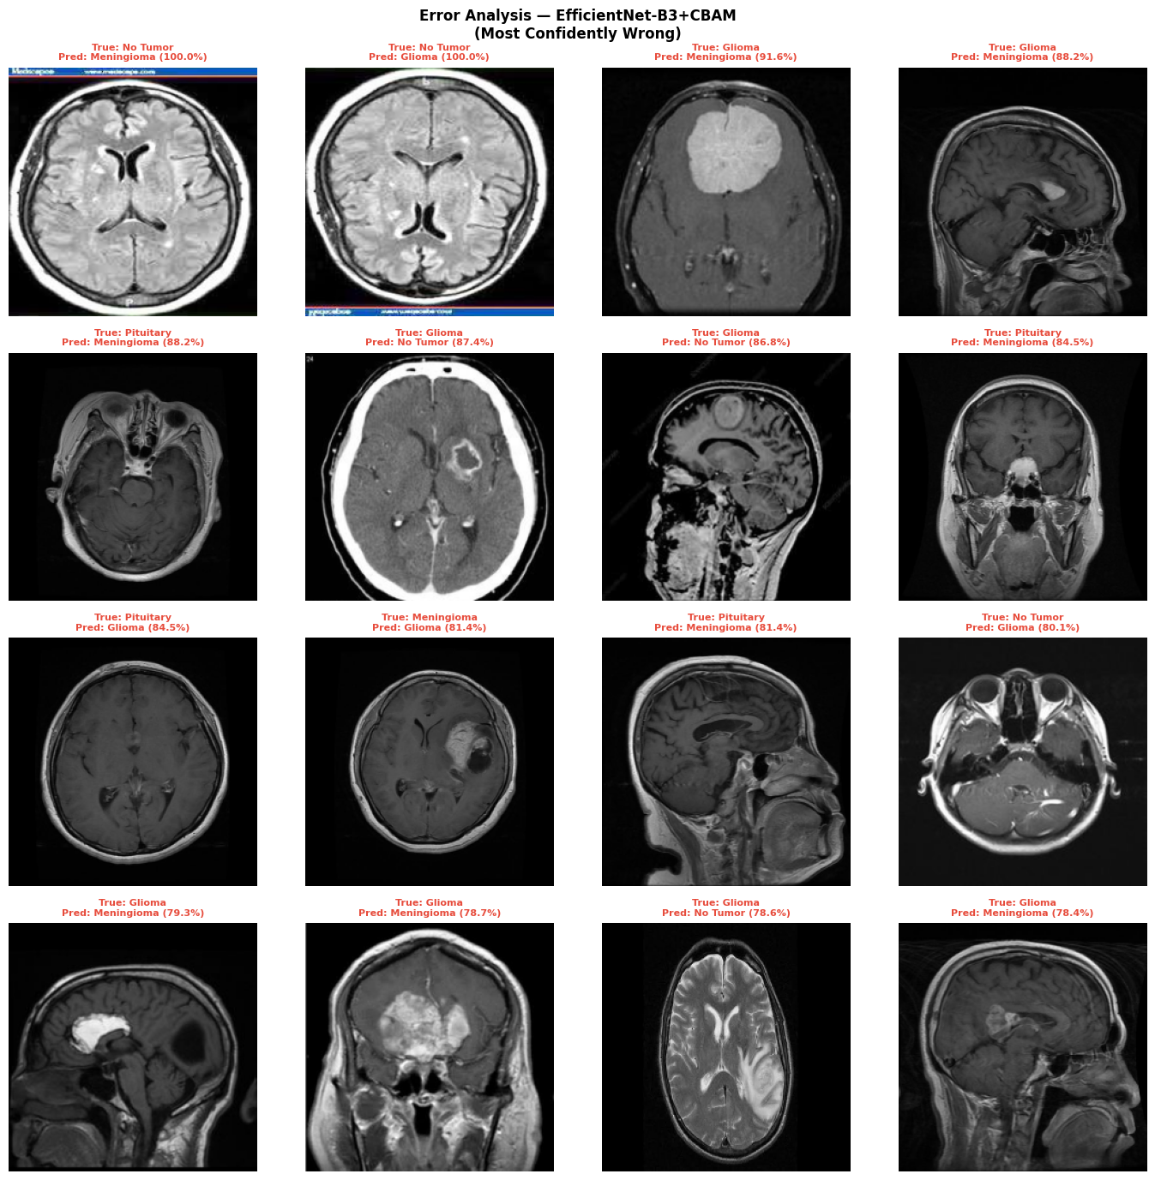
Figure 13: Error Analysis — EfficientNet-B3+CBAM Most Confidently Wrong Predictions. Each image shows True Label (green) and Predicted Label with confidence (red). The most common error patterns: (1) No Tumor → Meningioma (100% confidence): The scan shows hyperintense regions that mimic meningeal enhancement. (2) No Tumor → Glioma (100% confidence): A scan containing what appears to be non-tumor enhancement or artifact that the model interprets as infiltrative glioma. (3) Glioma → Meningioma (91.6%, 88.2%): Large, well-defined masses that mimic the rounded morphology of meningiomas. (4) Pituitary → Meningioma (88.2%): The inferior brain location and mass effect of pituitary tumors can resemble meningeal growth patterns. These examples may represent visually ambiguous cases and would require expert clinical review. — in clinical practice, such cases would require additional imaging modalities or biopsy.

6.5 Interactive Prediction — Single MRI Analysis
Figure 14 demonstrates the interactive inference capability of the deployed model. A single MRI is passed to the EfficientNet-B3+CBAM model which outputs a predicted class, confidence score, class probability distribution, and Grad-CAM visualization — all in a single inference pass.
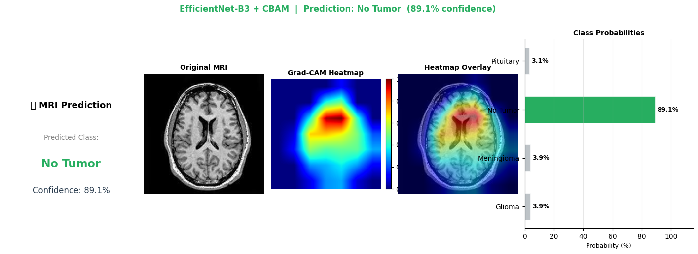
Figure 14: Interactive MRI Prediction — EfficientNet-B3 + CBAM. Input: axial MRI scan. Output: Predicted class "No Tumor" with 89.1% confidence. Left panel: Predicted class and confidence score. Center: Original MRI, Grad-CAM heatmap (strong central activation around the ventricles — a characteristic pattern for healthy scans where the model confirms absence of mass lesion), and overlay. Right: Class probability bar chart — No Tumor: 89.1%, Meningioma: 3.9%, Glioma: 3.9%, Pituitary: 3.1%. The high confidence and correct Grad-CAM localization (ventricular focus) validate the model's reasoning for this correct prediction.

7. Complete Model Comparison
Table 7.1 summarizes all models evaluated in this project, including v1 comparison models, v2 primary model, and ablation study configurations.
Model | Accuracy | Wtd. F1 | Train Epochs | Notes
ResNet18 + CBAM | 88.00% | 88.04% | 15 | v1 Weakest
MobileNetV2 + CBAM | 91.25% | 91.22% | 15 | Lightweight option
EfficientNet-B0 + CBAM | 91.56% | 91.54% | 15 | v1 Primary
EfficientNet-B0 (no CBAM) | 91.75% | 91.72% | 15 | Best v1 accuracy
EfficientNet-B3+CBAM (standard) | 92.44% | 92.42% | 30 | v2 standard
EfficientNet-B3+CBAM + TTA | 94.06% | 94.00% | 30 + TTA | ★ Best overall
Ablation Study
A: No CBAM + Frozen only | 77.19% | 77.16% | 5 | Stage 1 only
B: No CBAM + Fine-tuned | 91.12% | 91.09% | 15 | Fine-tuned only
C: CBAM + Frozen only | 78.75% | 78.79% | 5 | CBAM without FT
D: CBAM + Fine-tuned | 91.31% | 91.25% | 15 | Full config

8. Conclusions
This project demonstrates a comprehensive, systematic approach to brain tumor classification from MRI scans. The following key findings emerge from the experimental results:
- EfficientNet-B3+CBAM with TTA is the optimal configuration: achieving 94.06% accuracy and 94.00% F1 — a +6.06% improvement over the ResNet18 baseline and +2.31% over the best v1 model.
- Fine-tuning the backbone is non-negotiable: the ablation study confirms a +14% accuracy gap between frozen and fine-tuned configurations. Pre-trained features must adapt to medical image statistics to be effective.
- CBAM's primary value is explainability, not accuracy: CBAM adds only +0.19% accuracy when fine-tuned, but produces significantly more spatially concentrated Grad-CAM heatmaps aligned with tumor regions — critical for clinical validation.
- Mixup augmentation resolves the Glioma/Meningioma confusion: Meningioma recall improved from 94.0% to 97.75% after introducing Mixup, directly addressing the hardest class-pair boundary.
- Test-Time Augmentation provides a free +1.63% boost: averaging 5 augmented inference passes requires no additional training and consistently improves accuracy — recommended for all production deployments.
- Error analysis reveals genuine diagnostic ambiguity: the most confident wrong predictions involve MRI morphologies that are genuinely ambiguous even to expert radiologists — highlighting the importance of multi-modal confirmation for edge cases.

8.1 Future Work
Several directions are recommended for extending this work:
- Larger backbones: EfficientNet-B5/V2, ConvNeXt-Base, or Swin Transformer — modern architectures with superior feature extraction capacity.
- Vision Transformers: ViT and Swin Transformer architectures with patch-based attention may provide richer spatial reasoning for MRI classification.
- Ensemble methods: Soft-voting across B0, B3, and MobileNetV2 to exploit complementary predictions.
- Self-supervised pre-training: Pre-training on large unlabeled medical imaging datasets (e.g., MIMIC-CXR) before fine-tuning on the tumor dataset.
- Segmentation integration: Combining classification with tumor region segmentation for more precise localization.
- External validation: Testing on independent clinical MRI datasets to validate generalization beyond Kaggle benchmarks.
- Deployment: ONNX/TorchScript export for mobile or edge device inference.

