# Week 3 - Spring Core and Maven - Hands-On

## Exercise 1: Configuring a Basic Spring Application

Scenario:  
Your company is developing a web application for managing a library. You need to use the Spring Framework to handle the backend operations.

* Steps:

1. 1. Set Up a Spring Project:  
   - Create a Maven project named LibraryManagement.  
   - Add Spring Core dependencies in the pom.xml file.
2. 2. Configure the Application Context:  
   - Create an XML configuration file named applicationContext.xml in the src/main/resources directory.  
   - Define beans for BookService and BookRepository in the XML file.
3. 3. Define Service and Repository Classes:  
   - Create a package com.library.service and add a class BookService.  
   - Create a package com.library.repository and add a class BookRepository.

4. Run the Application:  
- Create a main class to load the Spring context and test the configuration.

SCREENSHOTS  
  
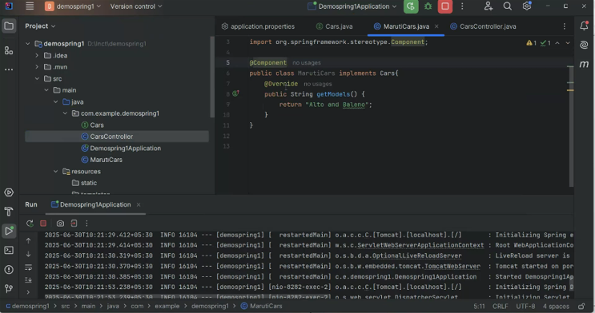

## Exercise 2: Implementing Dependency Injection

Scenario:  
In the library management application, you need to manage the dependencies between the BookService and BookRepository classes using Spring's IoC and DI.

* Steps:

1. 1. Modify the XML Configuration:  
   - Update applicationContext.xml to wire BookRepository into BookService.
2. 2. Update the BookService Class:  
   - Ensure that BookService class has a setter method for BookRepository.
3. 3. Test the Configuration:  
   - Run the LibraryManagementApplication main class to verify the dependency injection.  
     
     
   SCREENSHOTS  
     
     
   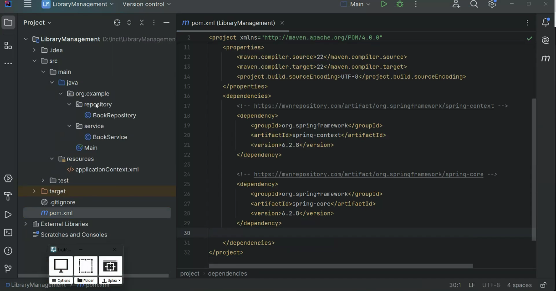

## Exercise 4: Creating and Configuring a Maven Project

Scenario:  
You need to set up a new Maven project for the library management application and add Spring dependencies.

* Steps:

1. 1. Create a New Maven Project:  
   - Create a new Maven project named LibraryManagement.
2. 2. Add Spring Dependencies in pom.xml:  
   - Include dependencies for Spring Context, Spring AOP, and Spring WebMVC.
3. 3. Configure Maven Plugins:  
   - Configure the Maven Compiler Plugin for Java version 1.8 in the pom.xml file.  
     
   SCREENSHOTS  
   