**Styling the Cohort Tracker React Application**

**Objectives**

Understanding the need for styling react component

Working with CSS Module and inline styles

My Academy team at Cognizant want to create a dashboard containing the details of ongoing and completed cohorts. A react application is created which displays the detail of the cohorts using react component. You are assigned the task of styling these react components.

**Setup & Preparation:**

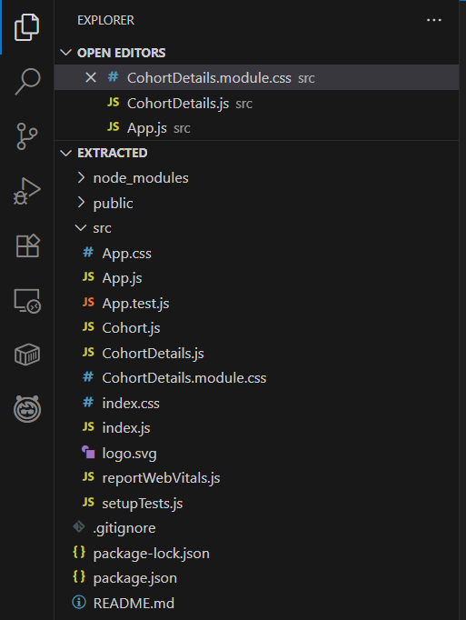The required setup was done by command line interface and the following project structure was obtained after extraction.

**Styling with CSS Modules:**

Create a new file:  
 *src/CohortDetails.module.css*

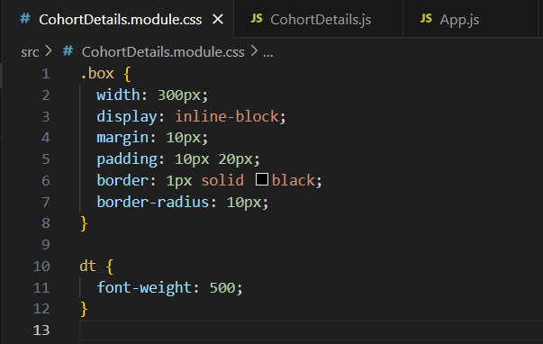

**Update CohortDetails.js**

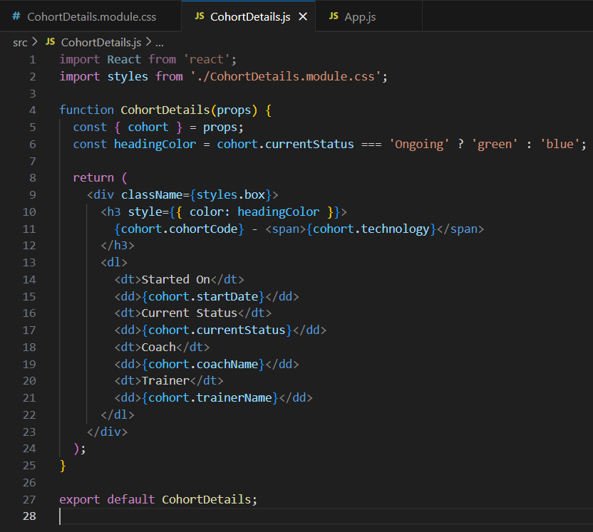

**Render Data**

Ensure App.js Renders All Cohorts:

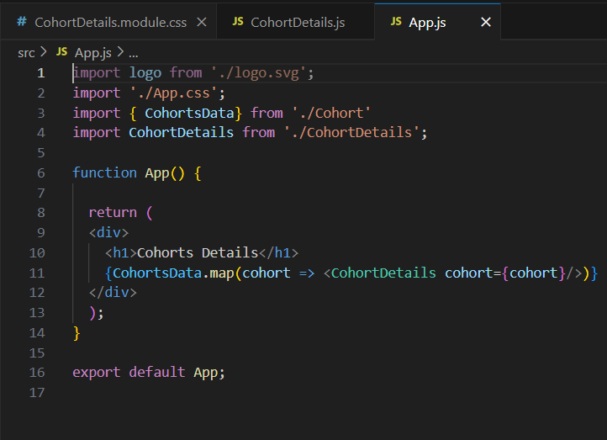

**OUTPUT**

On performing the steps and running the app we obtain React Cohort Tracker which displays well-formatted and visually distinct cohort details, improving readability and professional appearance.

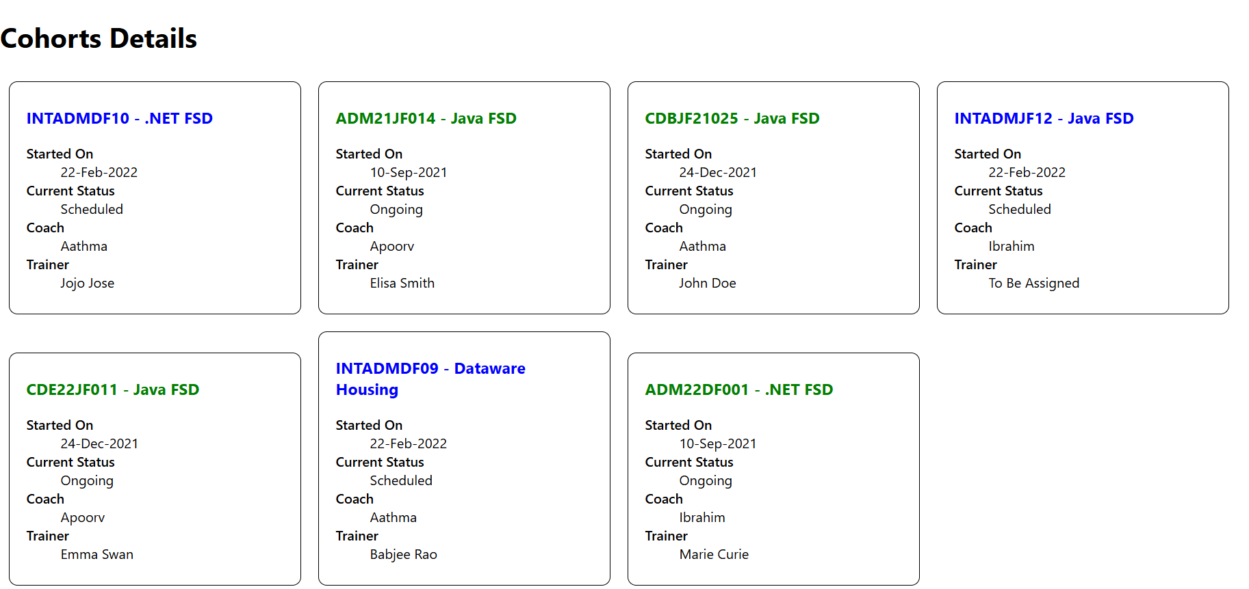

React Blog Application

**Objectives**

Explain the need and Benefits of component life cycle

Identify various life cycle hook methods

List the sequence of steps in rendering a component

**Application Setup**

**Create a React App:**

npx create-react-app blogapp

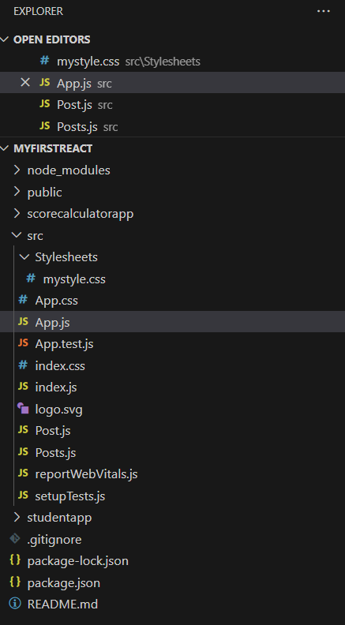

**File Structure & Components**

**Update App.js**

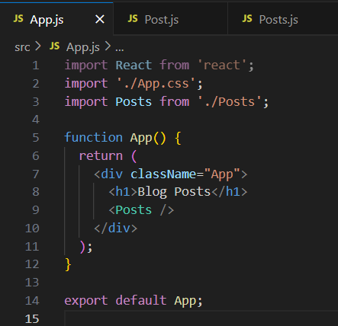

**Create Post.js in src**

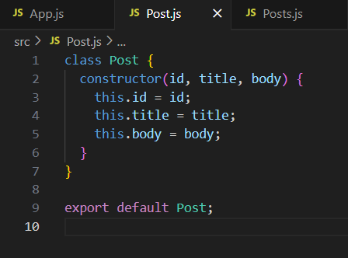

**Create Posts.js**

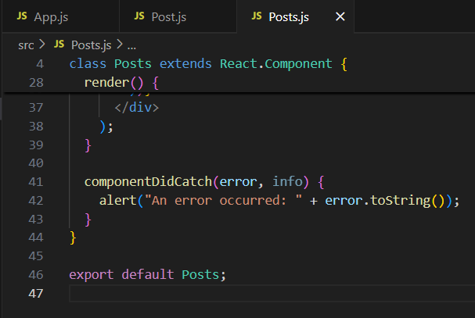

**OUTPUT**

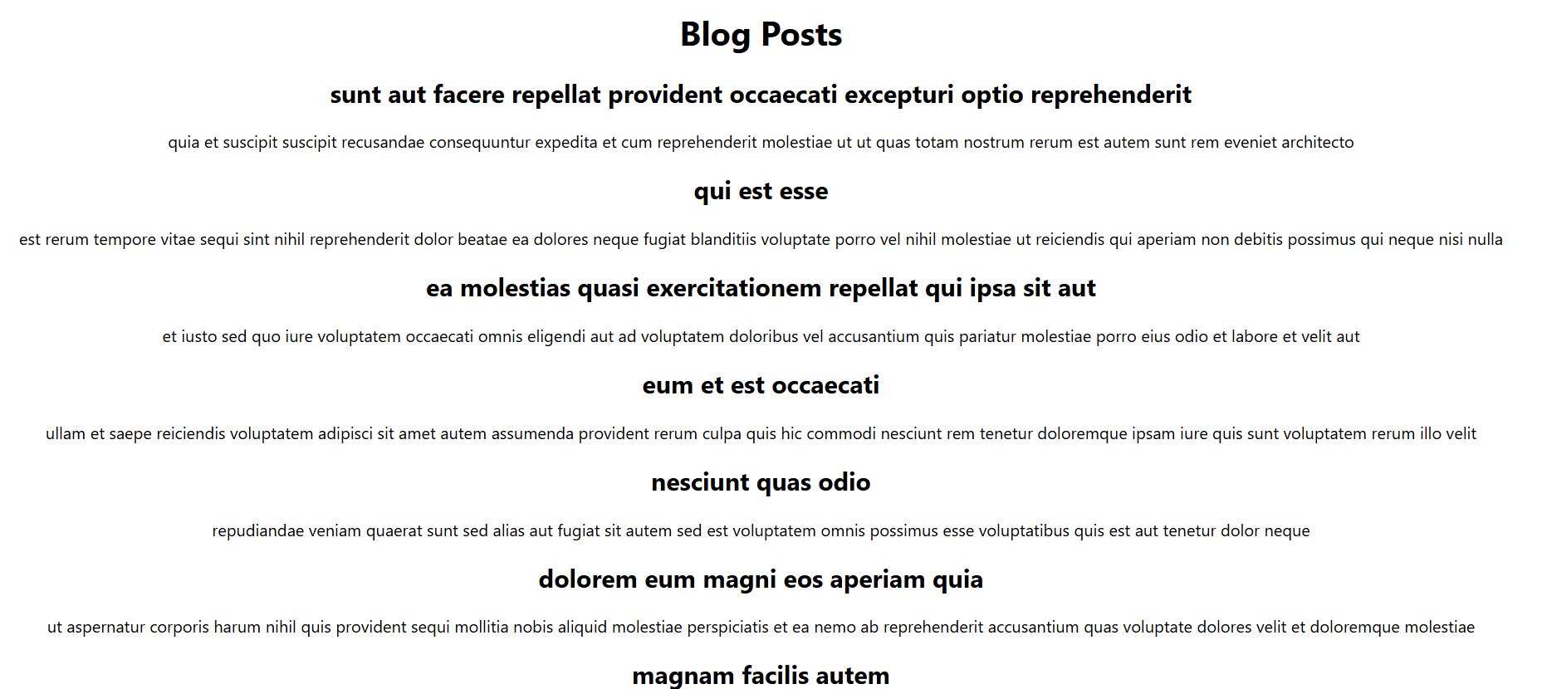

**Summary: Student Management Portal**

**Objectives**

Explain React components

Identify the differences between components and JavaScript functions

Identify the types of components

Explain class component

Explain function component

Define component constructor

Define render() function

**Create a New React Project**

npx create-react-app scorecalculatorapp

On creating we obtain the following structure

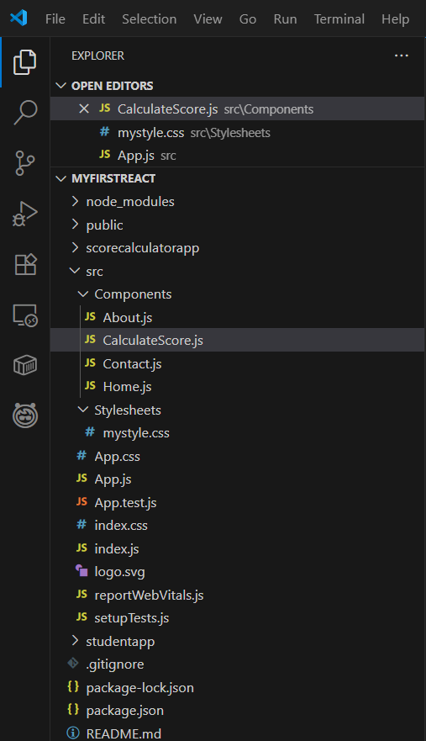

**Create CalculateScore.js**

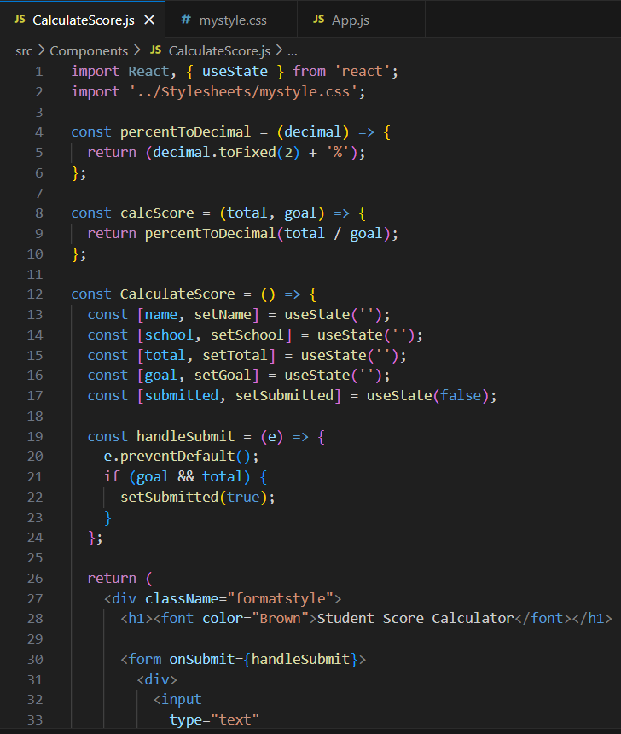

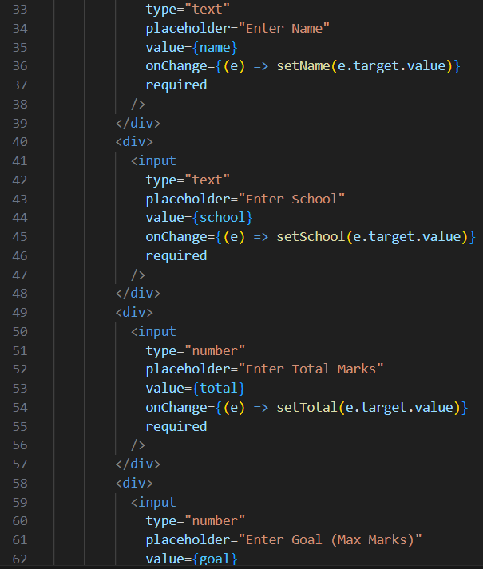

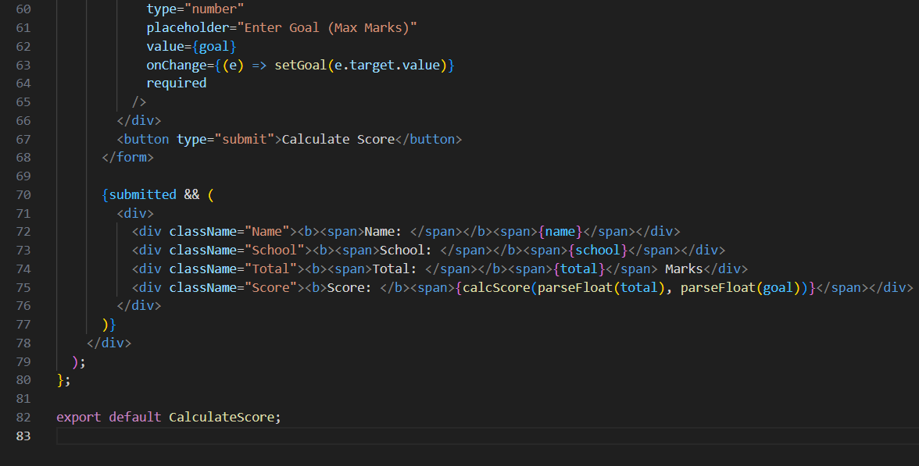

**Create CSS File for Styling**

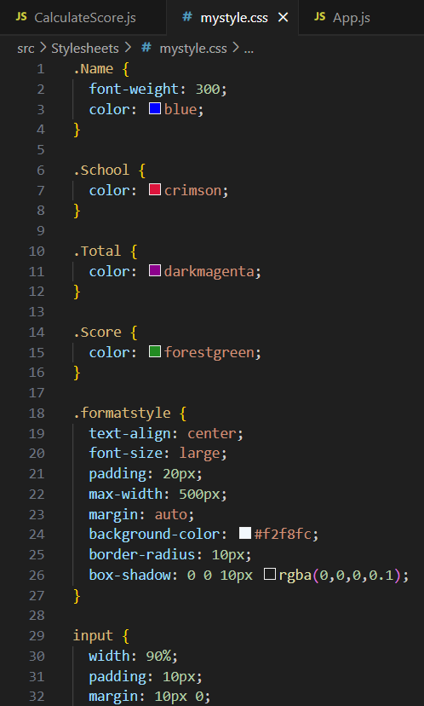

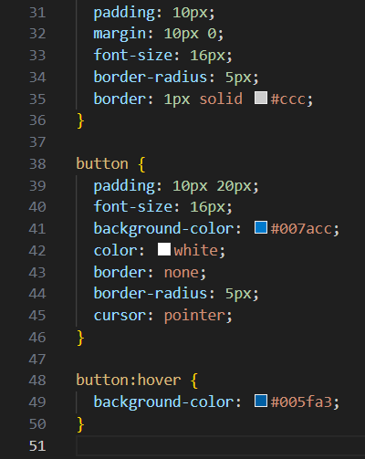

**Update App.js**

In src/App.js, import and render the CalculateScore component:

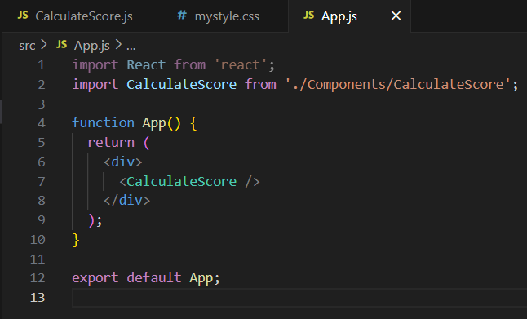

**OUTPUT:**

On performing the above steps we get the desired output.

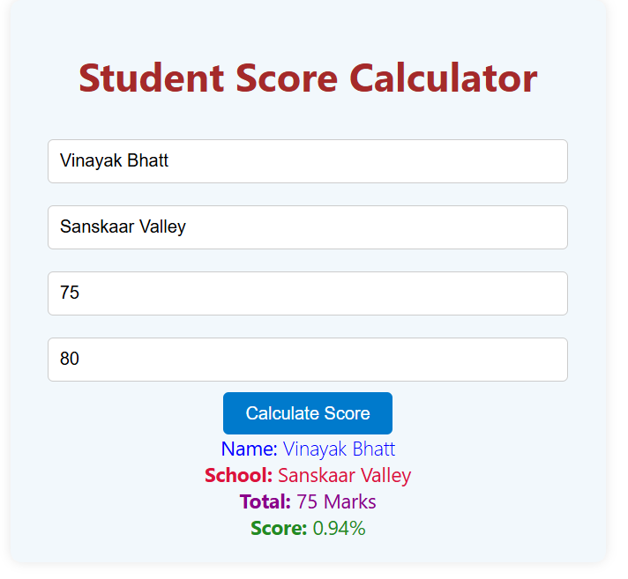

Student Management Portal

## **Objectives:-**

Explain React components

Identify the differences between components and JavaScript functions

Identify the types of components

Explain class component

Explain function component

Define component constructor

Define render() function

**Steps:-**

**Create a New React Project**

Open the terminal in Visual Studio Code and run:

npx create-react-app StudentApp

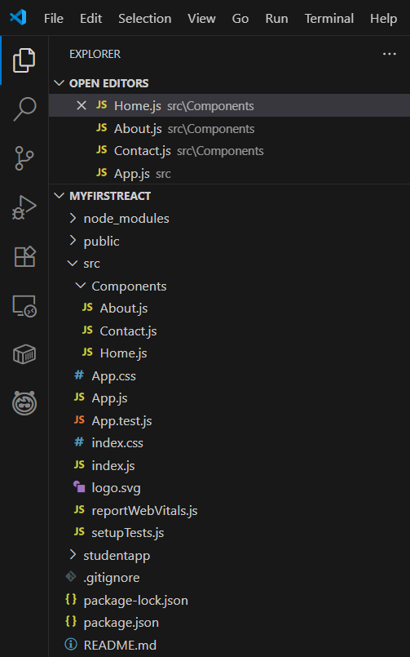

**Create Components Folder**

Inside src/, create a folder named: Components

Inside this folder, add a file named:

**Home.js**

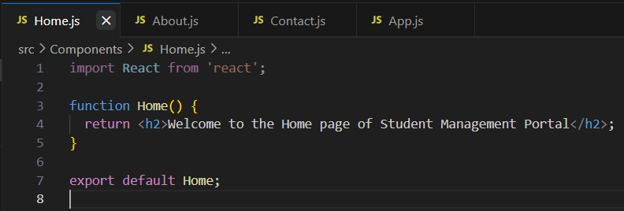

**Create About and Contact Components**

In the same Components folder:

**Create About.js**

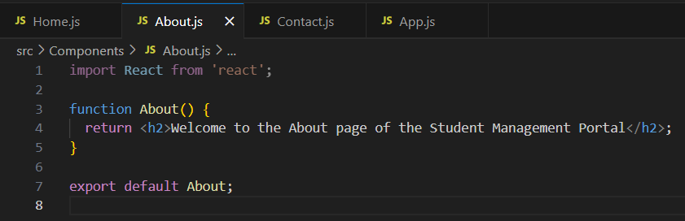

**Create Contact.js:**

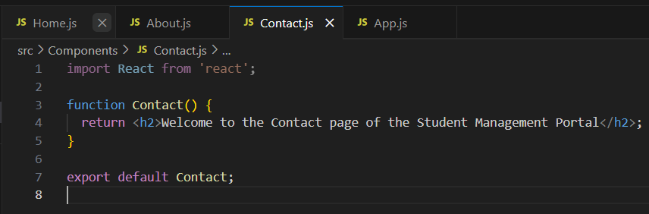

**Update App.js**

Edit src/App.js to import and render all three components:

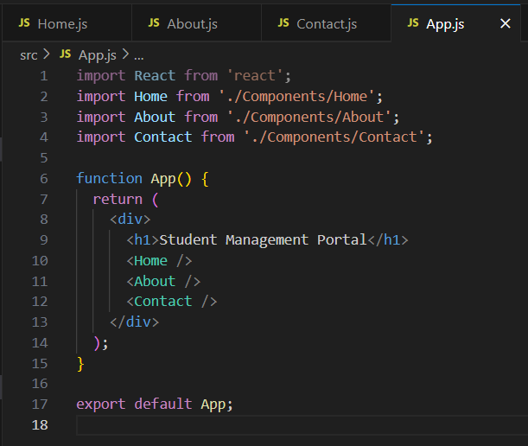

**OUTPUT:**

On performing these steps we get the desired output.

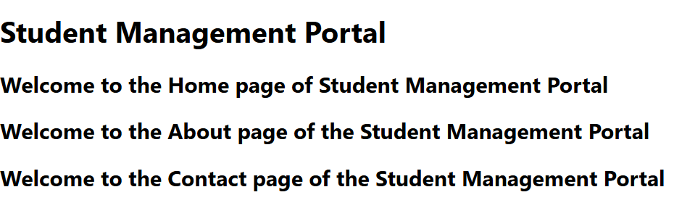

Creating Your First React App

**Objective:**

Build a basic React application named **myfirstreact** that displays a heading message:  
**"Welcome to the first session of React"**

**Steps:**

**Install Node.js and npm**

**Install create-react-app CLI Tool**

**Create a New React Application**

**Navigate to the Project Directory**

Open the Project in Visual Studio Code

We obtain the following structure after creating and editing of the program.

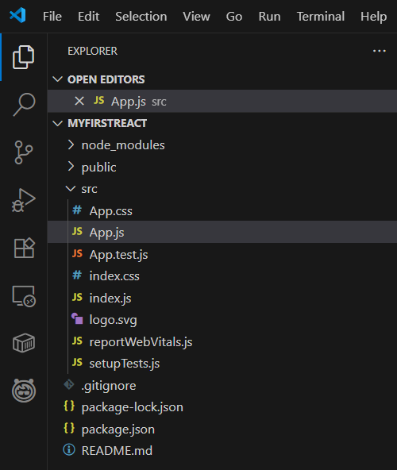

**Edit the App.js File**

Navigate to: src/App.js and edit accordingly

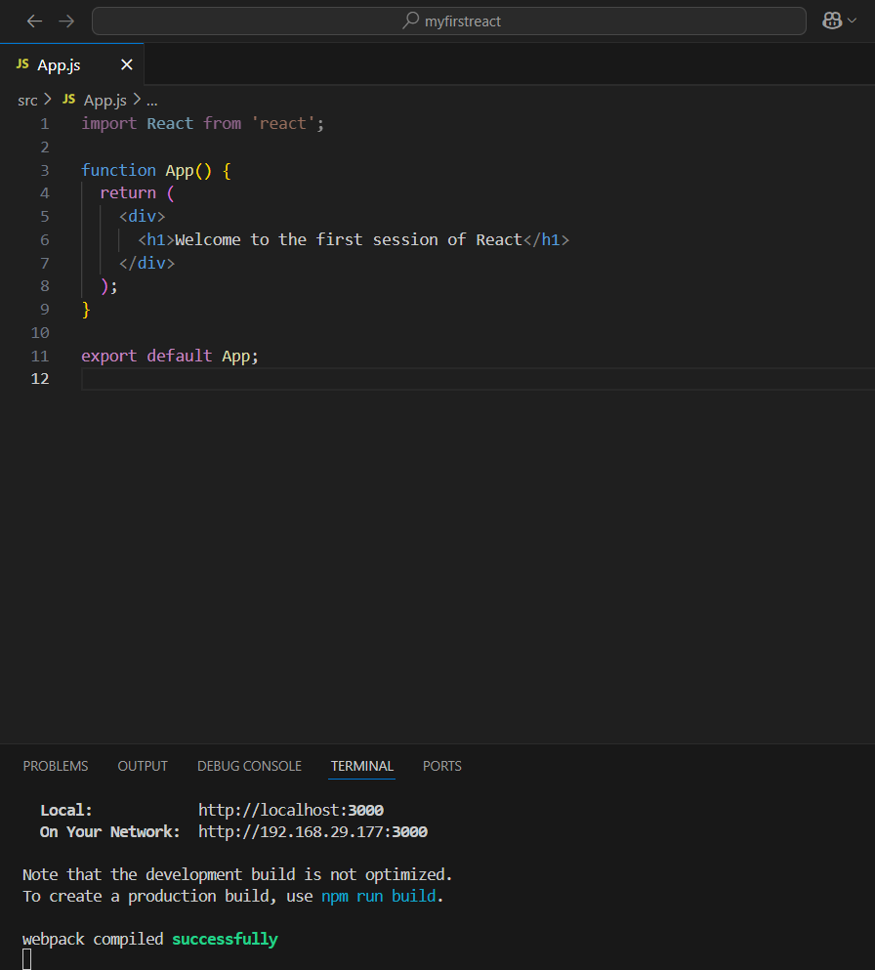

**OUTPUT:**

On running the application we get:

