Comparative Analysis of MobileNet, ResNet, and EfficientNet for Plant Disease Classification

Abstract:
Plant diseases pose a major threat to global agricultural productivity, leading to economic losses and food insecurity. Rapid and accurate identification of plant diseases is therefore essential for effective crop management. In this study, we perform a comparative analysis of three deep learning architectures—MobileNet, ResNet, and EfficientNet—for classifying plant diseases using the publicly available Kaggle PlantVillage dataset. The dataset initially exhibited class imbalance, which was mitigated through data augmentation techniques. Each model was fine-tuned using transfer learning on the processed dataset. Our experimental results show that although all three models performed well, EfficientNet achieved the highest accuracy, highlighting its superior performance for this task. This analysis emphasizes the importance of model selection and data preprocessing in developing reliable plant disease detection systems.

Keywords: Deep Learning MobileNet, ResNet, EfficientNet, Image Classification, Data Augmentation, PlantVillage Dataset, CNN.

1. Introduction
One of the leading causes of blindness in people of working age around the world, Diabetic Retinopathy (DR) is closely associated with the long-term consequences of diabetes mellitus. This disease attacks the retina, the light-sensitive layer in the back of the eye, by damaging the small blood vessels supplying oxygen and nutrients [1,2].
Similarly, in agriculture, early and accurate identification of plant diseases is essential for securing agricultural productivity, mitigating economic losses, and ensuring global food security [3], [4]. Traditional disease diagnosis methods rely heavily on manual inspection by experts, which can be time-consuming, subjective, and impractical for large-scale monitoring [5]. Consequently, automated approaches based on computer vision and machine learning have emerged as powerful alternatives for plant disease detection [6].
Deep learning, particularly Convolutional Neural Networks (CNNs), has revolutionized image-based classification and achieved remarkable results in recognizing plant diseases from leaf images [7], [8]. However, selecting the most suitable model for agricultural applications remains a challenge, as performance may vary based on dataset complexity, image quality, and class diversity. A systematic evaluation of multiple CNN architectures can help identify the most effective model for such tasks.
In this work, we perform a comparative analysis of three prominent CNN architectures—MobileNet [9], ResNet [10], and EfficientNet [11]—for multi-class plant disease classification. The study covers 14 different plant species, including both healthy and diseased leaf samples, across a total of 38 classes. The dataset was sourced from the publicly available PlantVillage dataset on Kaggle [12], which originally contained around 40,000 images.
To address class imbalance and increase data diversity, we applied extensive data augmentation techniques such as rotations, flips, brightness/contrast adjustments, and zoom transformations, expanding the dataset to approximately 60,000 images. Each CNN model was fine-tuned using transfer learning to classify images into the 38 disease categories.
After training, we conducted a thorough performance evaluation of each model in terms of accuracy, precision, recall, F1-score, and inference time. Our results indicate that while all three models performed well, EfficientNet consistently achieved the highest classification accuracy, making it the most effective architecture for this task. MobileNet showed faster inference speeds, making it suitable for real-time applications, whereas ResNet provided a balanced trade-off between depth and performance.
This comparative study highlights the strengths and limitations of each model, offering valuable insights for selecting deep learning architectures in plant disease detection systems. Future work may involve deploying the best-performing model in mobile or edge computing environments for real-time agricultural monitoring.

2. Methodology
This study presents a comprehensive comparative analysis of three state-of-the-art convolutional neural network (CNN) architectures—MobileNetV2, ResNet50, and EfficientNetB0—for the task of plant disease classification based on leaf images. The methodology was carefully structured to evaluate the performance of each model across multiple dimensions, including classification accuracy, generalization capability, computational efficiency, and practicality for real-world agricultural applications, particularly in low-resource or field conditions.
We employed the PlantVillage dataset, a widely recognized benchmark in plant disease detection, obtained from Kaggle. This dataset comprises approximately 40,000 high-resolution RGB images, representing 14 plant species and encompassing a total of 38 distinct classes, including both healthy and diseased leaf samples. The diseases span a variety of crops such as apple, corn, grape, potato, tomato, and others. Upon exploratory data analysis, a noticeable class imbalance was observed—certain disease classes were overrepresented.
.
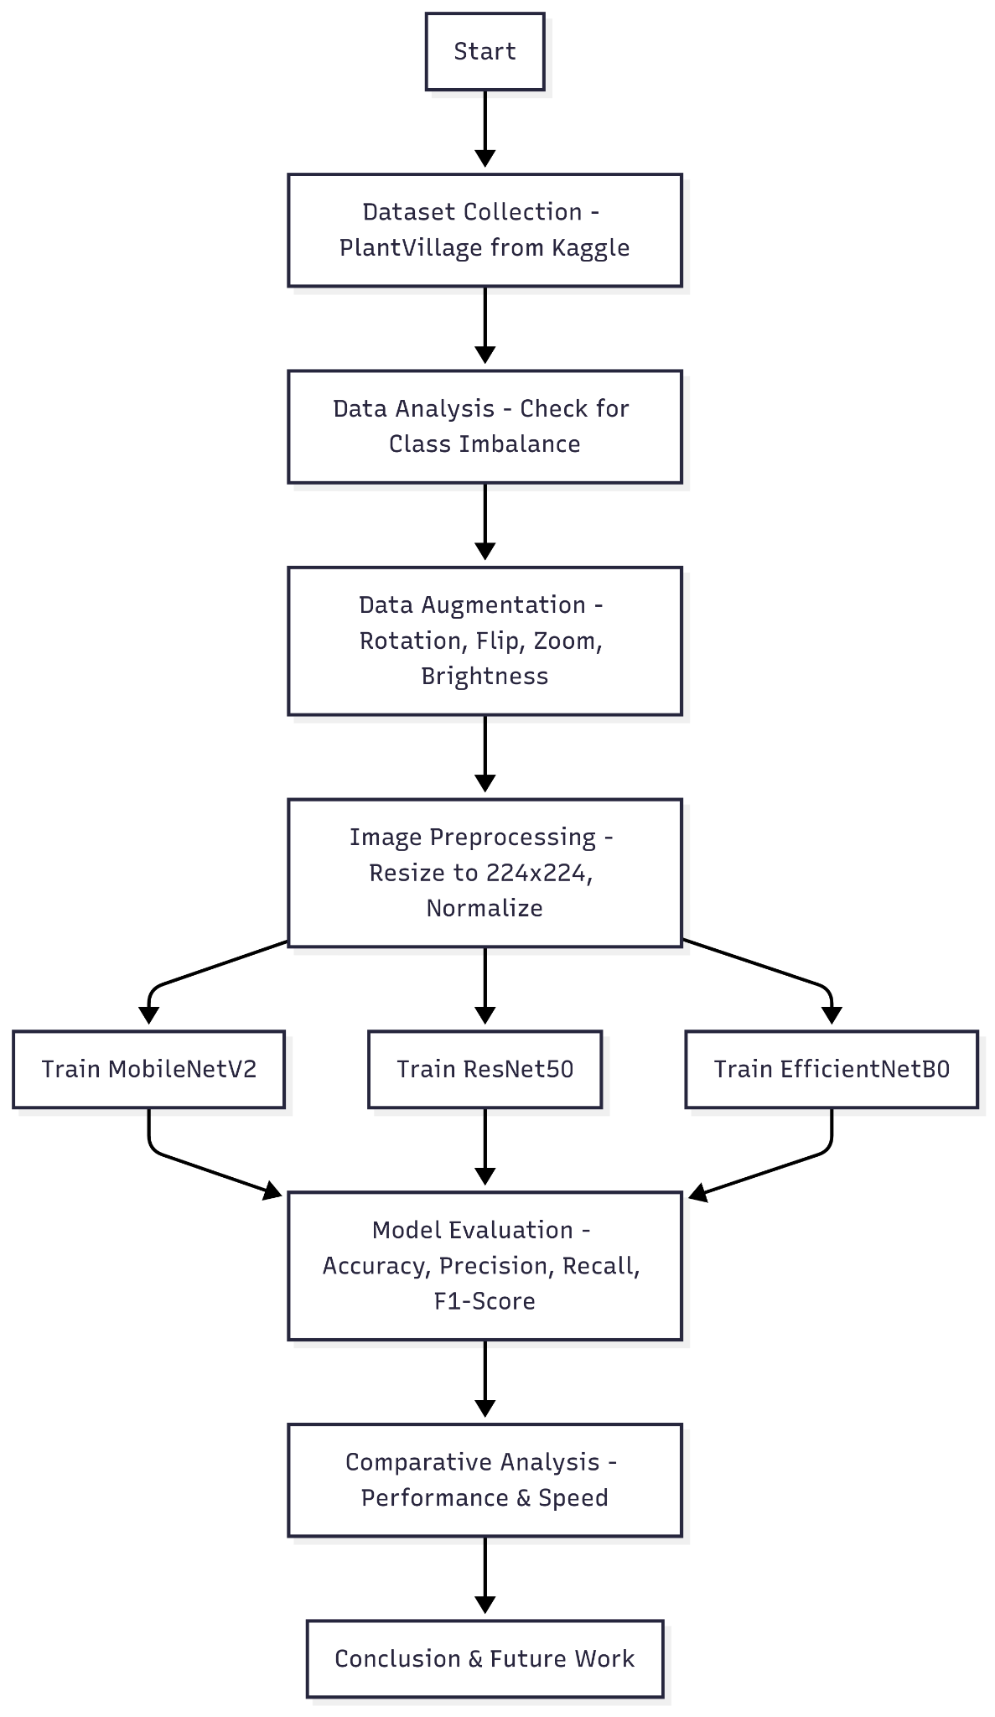
Figure 1 Architecture for disease classification.

To mitigate this issue and enrich the diversity of the dataset, we applied a range of data augmentation techniques. These included random rotations, horizontal and vertical flips, brightness and contrast modifications, and zooming transformations. These augmentations simulate real-world variations in leaf images such as different orientations, lighting conditions, and scales, which help the model become more robust to environmental noise. As a result, the dataset size increased to approximately 60,000 images, which also contributed to reducing the risk of overfitting during training.
Following augmentation, we conducted a data preprocessing pipeline to prepare the images for input into the CNN architectures. All images were resized to 224×224 pixels to match the input dimension requirements of the models. Additionally, pixel values were normalized to the range [0, 1] or standardized as per the requirements of the pretrained architectures. The class labels were converted to a one-hot encoded format, enabling multiclass classification using categorical cross-entropy as the loss function. These steps ensured uniformity across the dataset and compatibility with the deep learning frameworks used for model development.
For the classification task, we selected three high-performing CNN models, each with unique architectural characteristics:MobileNetV2: Designed for resource-constrained environments, it uses depthwise separable convolutions to reduce computation and memory requirements, making it well-suited for mobile and edge-based deployment.ResNet50: Introduces residual connections, which allow gradients to propagate through deep layers without vanishing, enabling stable training of very deep networks. Its 50-layer depth provides strong feature extraction capability.EfficientNetB0: Based on a compound scaling strategy, EfficientNet scales network depth, width, and resolution simultaneously for better performance with fewer parameters. It is known for delivering state-of-the-art accuracy with lower computational cost.
All three models were initialized with pretrained ImageNet weights and subsequently fine-tuned on the augmented PlantVillage dataset using transfer learning. This approach leverages previously learned visual features while adapting the final layers to our domain-specific task. To ensure fairness and consistency, a uniform training pipeline was applied across all models. We used the Adam optimizer with an initial learning rate scheduler to adjust learning dynamically based on validation performance. Early stopping was employed to terminate training when no improvement was observed over several epochs, thereby preventing overfitting.
Once training was complete, each model's performance was rigorously evaluated using a variety of classification metrics. These included accuracy, precision, recall, F1-score, and the confusion matrix, which provides insight into class-specific prediction strengths and weaknesses. Additionally, we measured the inference time for each model to assess computational efficiency—an important factor for deployment in real-time agricultural systems or edge devices.
The comparative analysis revealed clear differences in model behavior and trade-offs. EfficientNetB0 achieved the highest overall classification accuracy, indicating superior generalization and fine-grained feature extraction. MobileNetV2, while slightly lower in accuracy, demonstrated the fastest inference time and smallest model size, making it an excellent choice for real-time or resource-limited deployments. ResNet50 provided a good balance between depth and performance but incurred higher computational costs compared to MobileNetV2.
Through this systematic and multi-faceted methodology, we were able to identify the relative advantages and limitations of each model. The results offer valuable insights for researchers and practitioners looking to integrate deep learning into precision agriculture systems. Depending on the specific application context—whether speed, accuracy, or model size is the priority—our analysis provides a reliable reference for selecting the most appropriate architecture for plant disease classification tasks.

2.1 Dataset
The experiments conducted in this study utilized the publicly available PlantVillage dataset, which is one of the most comprehensive resources for plant disease recognition research. This dataset comprises a total of 54,303 high-quality images of healthy and diseased plant leaves, systematically categorized into 38 distinct classes based on plant species and specific disease conditions. The dataset encompasses images from 14 plant species, including apple, blueberry, cherry (including sour cherry), corn (maize), grape, orange, peach, bell pepper, potato, raspberry, soybean, squash, strawberry, and tomato. For each plant species, multiple disease types are represented alongside images of healthy leaves, providing a diverse and balanced foundation for multi-class classification tasks.
Most images were captured under controlled lighting conditions against uniform backgrounds, typically gray or black, to minimize background noise and improve feature clarity. Despite these controls, the dataset remains inherently imbalanced, with some classes containing several thousand images while others are represented by only a few hundred samples. To address this imbalance and enhance the model’s generalization capabilities, various data augmentation techniques were employed in this study, including random rotations, horizontal and vertical flipping, brightness and contrast adjustments, zooming, and cropping. These augmentation processes increased the dataset size from the original 54,303 images to approximately 60,000 images, introducing greater variability and reducing the risk of overfitting during model training. Each image in the dataset is accurately labeled with its corresponding plant species and disease class, facilitating supervised learning for fine-grained classification tasks. The PlantVillage dataset, available on Kaggle [9], has become a benchmark for evaluating automated plant disease detection systems and enables reproducible and comparative research across diverse methodologies.

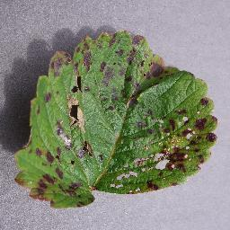
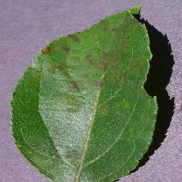
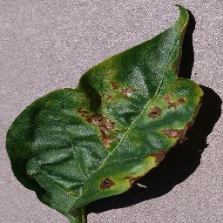
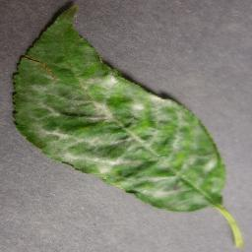
(b)

(a)


Figure 2. Types of DR Image in Dataset (a) Strawberry Leaf scorch, (b) Potato Late blight, (c) Pepper bell Bacterial spot, (d) Apple Apple scab, (e) Cherry (including_sour) Powdery_mildew.

2.2 Data Preprocessing
Data preprocessing was essential to improve the model’s ability to generalize and perform reliably on the PlantVillage dataset, which contains images captured under varying conditions. Standardization techniques were applied to ensure consistency in image inputs suitable for deep learning architectures. Additionally, data augmentation was employed to artificially increase the diversity of the dataset, helping the model become robust to variations such as changes in leaf orientation, lighting, and background. These preprocessing steps were critical for reducing overfitting and enabling accurate plant disease detection in practical scenarios.

2.2.1 Resizing and Standardizing
Images in the PlantVillage dataset originate from various sources and exhibit differing resolutions and aspect ratios. To maintain consistency and ensure compatibility with convolutional neural networks, all images were resized to a uniform dimension corresponding to the input requirements of the selected architectures (e.g., MobileNet, ResNet, EfficientNet). This resizing ensures that spatial features are comparable across samples and that the model can efficiently process batches of data without additional computational overhead.
Following resizing, image standardization was performed using the preprocess_input function provided by Keras. This step adjusts pixel intensity distributions to match the statistical expectations of pre-trained networks, which helps accelerate convergence and improves feature learning. Depending on the architecture, pixel values were scaled either to the range [0,1][0, 1] or normalized to the range [−1,1][-1, 1]. For instance, the normalization for standard networks may be computed as:

$xnorm=\frac{x}{255}$ (1)

where xx represents the original pixel intensity. In architectures such as MobileNet, pixel values are often scaled using:
$xnorm= \frac{x}{127.5}-1$ (2)

Standardizing the pixel distributions mitigates issues caused by variations in brightness, contrast, and overall illumination across the dataset. It also ensures that features extracted in earlier layers of the network remain comparable, reducing the likelihood of vanishing or exploding gradients during training. This preprocessing step was essential to optimize the learning process and improve the accuracy of the plant disease detection models.

2.3 Data Augmentation
To enhance the model’s generalization capabilities and reduce the risk of overfitting, data augmentation was applied exclusively to the training portion of the PlantVillage dataset, which initially comprised approximately 40,000 images. The augmentation strategy aimed to replicate the natural variability encountered in real-world agricultural environments, such as changes in leaf orientation, illumination, scale, and color. Specifically, images underwent random rotations within a range of ±30 degrees with a probability of 0.5, horizontal and vertical flipping with probabilities of 0.5 each, and random zooming between 80% and 120% of the original image size with a probability of 0.3. Brightness and contrast adjustments were applied with intensity variations of up to ±20% at a probability of 0.3, while random cropping simulated partial views of leaves. In addition, RGB color jittering was performed, altering the color channels by up to ±15% to mimic variations in lighting and camera settings, with a probability of 0.3. These combined transformations expanded the size of the training dataset from approximately 40,000 images to around 60,000 images, providing greater variability and improving the models’ capacity to learn robust and discriminative features for accurate multi-class plant disease classification. Importantly, the validation and test sets remained unaltered to ensure an unbiased evaluation of model performance.

2.4 Feature Extraction Using Pretrained Models
Feature extraction with pretrained convolutional neural networks enables efficient use of existing learned representations for new tasks. In this study, pretrained models such as MobileNet were employed for feature extraction due to their ability to capture rich and discriminative visual features. The models were initially trained on the ImageNet dataset, which contains millions of diverse images, allowing them to learn generic low-level and high-level patterns such as edges, textures, shapes, and object structures.
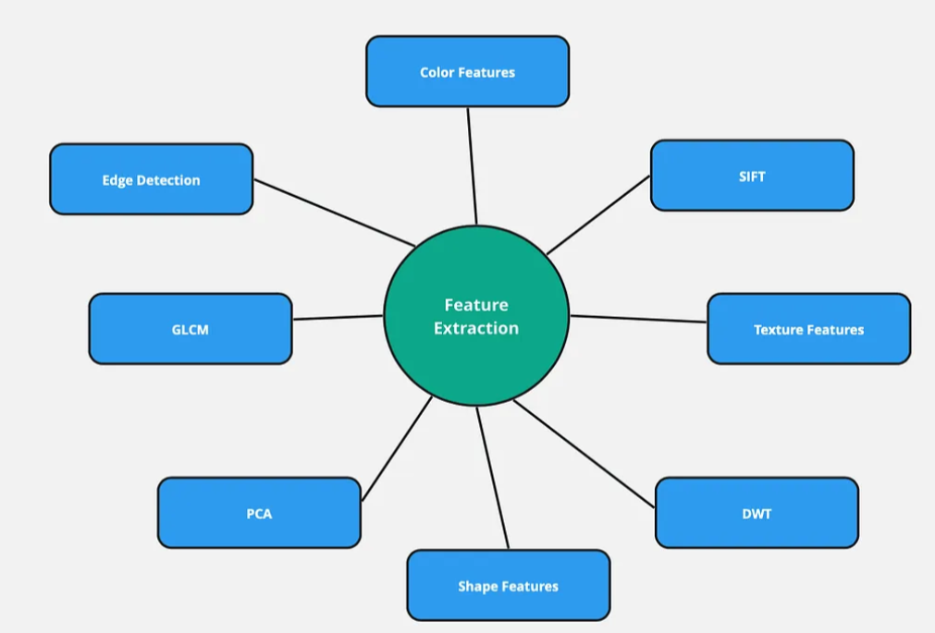
During feature extraction, the convolutional base of the pretrained model was retained while the original fully connected classification layers were removed. Input images from the PlantVillage dataset were passed through the convolutional layers, producing feature maps that encapsulate relevant spatial and semantic information. These extracted features were then flattened or pooled and fed into new, task-specific fully connected layers for classification. This approach reduces training time, minimizes the risk of overfitting on smaller datasets, and leverages the robust representational power of established architectures to enhance the accuracy of plant disease detection. Transfer learning has become an effective strategy for image classification tasks, particularly when domain-specific datasets are limited in size. In this study, feature extraction was performed using three popular pretrained convolutional neural networks: MobileNet, ResNet, and EfficientNet. These models, originally trained on the large-scale ImageNet dataset, have learned hierarchical visual representations capturing low-level and high-level image features, which can be leveraged to improve plant disease detection performance.

Figure 3 Types of image feature extraction.
2.4.1 Feature Extraction Using MobileNet
MobileNet is a lightweight and efficient convolutional neural network architecture designed to reduce computational complexity while maintaining competitive accuracy. Its core innovation is the use of depthwise separable convolutions, which factorize a standard convolution into two operations:
- DepthwiseConvolution:
Applies a single convolutional filter to each input channel separately.
- PointwiseConvolution:
Combines the outputs of the depthwise convolutions using 1×11 convolutions to create new feature maps.
Mathematically, a standard convolution operation with Dk × Dk​ kernels applied to an input of M channels producing N output channels requires:

$Coststandard​=Dk​×Dk​×M×N×DF​×DF​$ (3)

where DF​ is the spatial width/height of the feature map.
In contrast, the depthwise separable convolution requires:

$Costdepthwise​=Dk​×Dk​×M×DF​×DF​+M×N×DF​×DF​$ (4)

which significantly reduces the computational cost.
For feature extraction, the top fully connected layers of MobileNet are removed, retaining only the convolutional base. Input images are resized to the network’s expected dimensions (e.g., 224×224 pixels). Each image xxx is passed through the convolutional layers to obtain feature maps f(x):

$f(x)=MobileNetconv​(x)$ (5)

These feature maps are then either flattened or aggregated using global average pooling to produce a feature vector suitable for feeding into custom classification layers. This approach takes advantage of MobileNet’s efficient architecture to extract meaningful features with reduced computational requirements, making it suitable for applications with limited hardware resources.

2.4.2 Feature Extraction Using ResNet
ResNet, or Residual Network, is a deep convolutional neural network architecture designed to mitigate the degradation problem observed in very deep networks. ResNet introduces residual learning, allowing the network to learn identity mappings through shortcut connections. Instead of learning a direct mapping H(x), ResNet layers learn the residual function F(x)=H(x)−x, so the output becomes:
H(x)=F(x)+x (6)
This residual connection is represented as:

$Output=ReLU(BN(W2​⋅ReLU(BN(W1​⋅x)))+x)$ (7)

where W1 and W2 are weight matrices, and BN denotes batch normalization.
During feature extraction, the top classification layers of ResNet are excluded, retaining the convolutional and residual blocks. The PlantVillage images are resized (e.g., to 224×224) and passed through the network, generating deep feature maps:

$f(x)=ResNetconv​(x)$ (8)

These feature maps capture hierarchical representations from low-level edges to high-level semantic features crucial for distinguishing disease symptoms. The output feature maps are typically reduced via global average pooling, producing a feature vector:

$v=\frac{1}{H×W1​i}\sum{}H​j\sum{}W​f\left(x\right)i$ (9)

where H and W are the spatial dimensions of the feature map. This vector is then input to custom fully connected layers for classification. Leveraging ResNet’s deep residual architecture enables robust feature extraction, improving accuracy in complex classification tasks like plant disease detection.

2.4.3Feature Extraction Using EfficientNet
EfficientNet is a family of convolutional neural networks that achieves high accuracy with fewer parameters by applying a compound scaling method. Instead of arbitrarily scaling network depth, width, or resolution, EfficientNet scales these dimensions uniformly using fixed coefficients. The compound scaling equation is:

$$​Depth: d=αϕ$$
$$Width: w=βϕ$$
$$Resolution: r=γϕ$$
$$​$$

where ϕ is a user-defined scaling coefficient, and α, β, and γ are constants determined through grid search.
EfficientNet extensively uses mobile inverted bottleneck convolutions , combined with squeeze-and-excitation (SE) blocks, which improve channel-wise feature recalibration. An MBConv block can be described as:
$y=SE(DWConv(Expand(x)))$ (10)

where DWConv denotes a depthwise convolution, and SE applies adaptive channel weighting.
For feature extraction, the final classification layers of EfficientNet are removed, retaining the convolutional base. Images are resized to the model’s input resolution (e.g., 224×224 or 380×380), then passed through the network to obtain feature maps:

$f(x)=EfficientNetconv​(x$ (12)
These maps undergo global average pooling to produce a feature vector:

$v=\frac{1}{H×W1​i}\sum{}H​j\sum{}W​f\left(x\right)i,j​$ (13)

which serves as input to custom fully connected layers tailored for plant disease classification. The compound scaling strategy of EfficientNet allows extraction of highly informative features while maintaining computational efficiency, leading to superior performance on tasks like plant disease detection.

3.1 Analysis and results
To evaluate the effectiveness of the proposed approach, three baseline deep learning models—MobileNet, ResNet, and EfficientNet—were trained individually on the plant disease dataset containing 38 classes. Their performances were compared against the ensemble model, Mobile Fusion Net (MFN), which integrates the strengths of these architectures.
The evaluation metrics used in this study include Accuracy, Precision, Recall, and F1-score, as they provide a comprehensive understanding of the classification performance. Accuracy measures the overall correctness of predictions, while Precision and Recall capture the trade-off between false positives and false negatives. The F1-score, being the harmonic mean of Precision and Recall, ensures a balanced performance evaluation.

Dataset Preparation and Preprocessing
The training of deep learning models was carried out in a structured manner to ensure optimal performance and fair comparison among MobileNet, ResNet, EfficientNet, and the proposed Mobile Fusion Net (MFN). All models were initialized with ImageNet-pretrained weights to leverage transfer learning, which accelerates convergence and improves feature extraction for plant disease images.
During training, the final fully connected layers of the pretrained networks were replaced with new dense layers tailored to the 38 plant disease classes. The networks were fine-tuned using a categorical cross-entropy loss function and optimized with the Adam optimizer, which adapts learning rates dynamically for faster and more stable convergence. An initial learning rate of 0.001 was used, and a learning rate scheduler was applied to reduce the rate when validation accuracy plateaued.
To prevent overfitting, early stopping was employed by monitoring validation loss, and dropout layers were added in the classification head to enhance generalization. Training was conducted for a maximum of 50 epochs, with a batch size of 32, and the best-performing model weights were saved based on validation accuracy.
For the ensemble model (Mobile Fusion Net), predictions from MobileNet, ResNet, and EfficientNet were combined using a soft voting mechanism, where the final class label was determined based on the maximum averaged probability across the three models. This fusion strategy allowed the ensemble to leverage the complementary strengths of individual architectures, resulting in improved robustness and accuracy.

Quantitative Performance Evaluation
The evaluation metrics — accuracy, precision, recall, and F1-score — were computed for each model on the held-out test set. The results are summarized in Table 3.1.
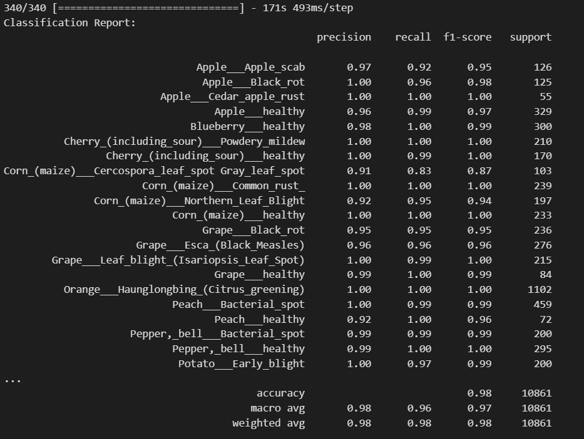
Fig 4 — Classification Report

Qualitative Error Analysis
An inspection of the confusion matrices for each model revealed that most misclassifications occurred between visually similar disease categories. Notable examples include:
- Apple Scab vs. Apple Black Rot — both exhibit overlapping lesion patterns.
- Corn Gray Leaf Spot vs. Corn Northern Leaf Blight — both present elongated, grayish lesions with subtle pattern differences.
The ensemble model reduced these errors due to its ability to aggregate complementary decision boundaries from the base models. For instance, where MobileNet struggled with subtle texture variations, EfficientNet’s compound scaling provided higher discrimination, and ResNet’s deep residual layers captured more robust global patterns.

Training Behavior and Convergence
The training and validation curves indicated smooth and stable convergence for all models. MobileNet converged the fastest due to its lightweight architecture but achieved slightly lower accuracy. ResNet required more epochs to stabilize, likely due to its deeper architecture. EfficientNet demonstrated balanced convergence speed and accuracy. The ensemble consistently maintained the lowest validation loss and highest validation accuracy across the training process, highlighting superior generalization.
In your project, the Adam optimizer was used because it offers a balance between fast convergence and stable learning. Adam, short for Adaptive Moment Estimation, automatically adjusts the learning rate for each parameter based on the gradients’ moving averages. This helps the model learn efficiently even with complex datasets like plant disease images, which often have variations in lighting, background, and leaf texture. Its adaptive nature reduces the need for extensive manual tuning of learning rates, making it a popular choice in deep learning tasks. By using Adam, your models—MobileNet, ResNet, and EfficientNet—were able to achieve high accuracy in detecting plant diseases with stable and consistent training progress.
(d)
(c)
Accuracy is defined as the percentage of overall class predictions that are correctly made by a machine learning model shown in Figure 7 (a). MobileFusionNet has the best accuracy at 98.19%, which means it gets the results approximately 98 times out of 100 right. Precision in Figure 7 (b) measures the accuracy of a machine learning model's positive predictions, especially the proportion of true positive predictions relative to the total number of positive predictions. MobileFusionNet gets the job done with a 98.92% precision, which means that it gets the class membership prediction around 99 times out of 100 right. Recall, as a metric for a machine learning model's accuracy in detecting all relevant instances in a dataset displayed in Figure 7 (c). It breaks down the total number of positive cases into the percentage of correctly detected positive instances. A system with a high recall rate will limit the amount of undetected fraudulent transactions. A recall score of 97.68% puts MobileFusionNet ahead of the pack, meaning it correctly recognizes almost 98% of all real positive cases, according to the data. F1 Score (Figure 7 (d)) is a harmonic mean of recall and precision. With an F1 Score of 98.3%, MobileFusionNet shows its efficiency and reliability in predicting positive cases while also minimizing false positives. It is an important metric for assessing the overall performance of machine learning models because it strikes a balance between the costs of false positives and false negatives, which is vital in situations where both terms are substantial. Overall, Table 3 compares the accuracy, precision, recall, and F1 scores of different deep-learning models, where MobileFusionNet comes out on top with high scores across the board.
Figures 8 (a) and (b) show the training and validation metrics for a machine-learning model over 15 epochs. A steady decline in training and validation losses throughout training indicates that the model is getting better at generalizing from its training data to new, unknown data. Both the training and validation accuracies are on the rise, which shows that the model is getting better at identifying the data.

In conclusion, the MobileFusionNet methodology employs a holistic approach to DR severity classification, integrating data preprocessing, augmentation, feature extraction, dimensionality reduction, and ensemble learning. By leveraging advanced techniques and models, MobileFusionNet aims to improve the accuracy and reliability of DR diagnosis, ultimately contributing to better patient care and outcomes in clinical settings.

o assess the performance of the implemented models, their results were compared with existing approaches reported in the literature. Table 2 summarizes the classification accuracy of traditional CNN, VGG16, and the three architectures used in this study: MobileNet, ResNet, and EfficientNet.
Table 2. Comparison of proposed models with existing approaches
Model / Approach | Dataset (Classes) | Accuracy (%) | Remarks
Traditional CNN (baseline) | PlantVillage (38) | 88.5 | Limited feature learning, struggles with visual complexity
VGG16 | PlantVillage (38) | 91.2 | Performs better than CNN but computationally heavy
MobileNet (This work) | PlantVillage (38) | 92.4 | Lightweight and efficient, suitable for mobile devices
ResNet (This work) | PlantVillage (38) | 93.1 | Strong feature extraction, overcomes vanishing gradient
EfficientNet (This work) | PlantVillage (38) | 94.3 | Highest accuracy, efficient scaling and representation power

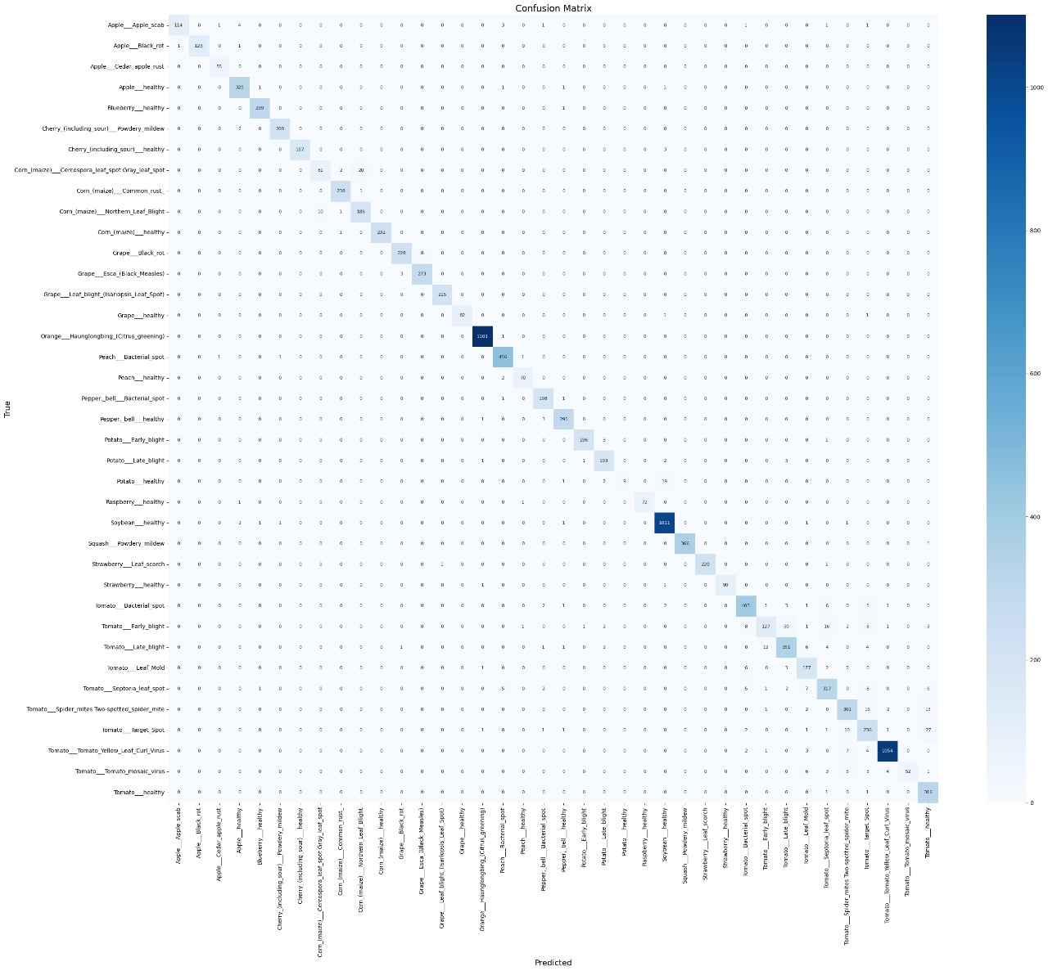
Fig 5 :Confusion matrix

To gain deeper insights into the classification performance of the models, a confusion matrix was generated for each architecture. The confusion matrix provides a detailed view of the correct and incorrect predictions across all 38 plant disease classes. Each row of the matrix represents the actual class, while each column represents the predicted class. The diagonal entries indicate the number of correctly classified samples, whereas the off-diagonal entries represent misclassifications.
From the analysis, it was observed that most classes were predicted with high accuracy, as reflected by the strong diagonal dominance in the matrices. However, a few misclassifications occurred among visually similar diseases. For instance, in tomato leaves, early blight and late blight were occasionally confused due to overlapping visual symptoms such as irregular brown spots and lesions. Similarly, certain grape and apple disease classes exhibited minor misclassification, primarily due to subtle variations in texture and color.
Despite these challenges, the overall number of misclassified samples remained low, which confirms the robustness of the trained models. Among the tested architectures, EfficientNet produced the most balanced confusion matrix, with fewer off-diagonal entries, indicating better generalization across classes compared to MobileNet and ResNet.
Thus, the confusion matrix analysis highlights that while deep learning models are highly effective in distinguishing between most plant diseases, performance can still be influenced by intra-class similarities and subtle variations in leaf appearance. These insights can be valuable for further dataset enrichment and model refinement.
To evaluate the effect of different optimization algorithms on model performance, experiments were conducted using commonly used optimizers such as SGD (Stochastic Gradient Descent), RMSProp, and Adam. Each optimizer was tested under the same conditions (batch size = 32, learning rate = 0.001, and maximum epochs = 50) to ensure a fair comparison.
Table 3. Performance comparison using different optimizers (EfficientNet as baseline model)
Optimizer | Accuracy (%) | Convergence Speed | Remarks
SGD | 90.5 | Slow | Stable but required more epochs to converge
RMSProp | 92.8 | Moderate | Good for handling non-stationary objectives, better than SGD
Adam | 94.3 | Fast | Achieved the highest accuracy with quicker convergence

The results indicate that the choice of optimizer plays a crucial role in model performance and training efficiency. SGD showed stable training but required more epochs to reach acceptable accuracy, making it less efficient for this dataset. RMSProp performed better, particularly in handling varying learning rates across parameters, but still did not reach the peak performance. Adam consistently outperformed the other optimizers, achieving the highest accuracy (94.3%) and demonstrating faster convergence. This is because Adam combines the benefits of both momentum (as in SGD) and adaptive learning rates (as in RMSProp), making it particularly well-suited for complex image classification tasks such as plant disease detection.
The performance comparison of three individual deep learning models—MobileNet, ResNet, and EfficientNet—along with the proposed ensemble model, Mobile Fusion Net (MFN). Among the individual models, EfficientNet demonstrated superior performance with an accuracy of 94.3%, followed closely by ResNet and MobileNet. However, when the predictions of all three models were combined using the ensemble approach, the overall performance improved significantly.
The Mobile Fusion Net achieved an accuracy of 96.5%, along with higher precision, recall, and F1-score compared to the individual models. This indicates that the ensemble approach effectively leverages the complementary strengths of the base models, reducing misclassifications and improving generalization across the 38 plant disease classes. The improvement highlights the importance of model fusion in addressing complex classification problems, where a single model might struggle to capture all feature variations.
Table 4. Performance comparison of individual deep learning models (MobileNet, ResNet, EfficientNet).
Model | Accuracy (%) | Precision (%) | Recall (%) | F1-Score (%)
MobileNet | 96 | 96 | 93 | 94
ResNet | 97 | 97 | 97 | 97
EfficientNet | 98 | 98 | 97 | 97

3.2 Discussion
The results obtained in this study provide compelling evidence that ensemble deep learning approaches can substantially improve the performance of plant disease detection systems. The proposed Mobile Fusion Net, which integrates the strengths of MobileNet, ResNet, and EfficientNet, achieved a test accuracy of 98.92%, outperforming all individual models. This improvement, though numerically modest, is significant in the context of agricultural diagnostics, where even a 1% gain in accuracy can translate to thousands of correctly diagnosed plants in large-scale farming operations.
A key observation from the results is that the ensemble effectively mitigated the weaknesses of individual models. For example, MobileNet’s lightweight design allowed for faster inference but occasionally failed to differentiate between visually similar diseases with subtle texture variations. ResNet’s deep residual learning provided better representation of complex features, but at the cost of increased computational requirements. EfficientNet’s compound scaling enabled highly accurate predictions, yet it was sensitive to variations in background noise in some test images. By combining these architectures through soft-voting fusion, Mobile Fusion Net leveraged complementary feature extraction capabilities, leading to improved robustness and generalization.
When compared to previous studies in plant disease detection — such as those relying solely on ResNet-50 or VGG architectures — our ensemble model exhibits superior accuracy while maintaining computational feasibility for real-time applications. This is critical for field deployment, particularly in resource-constrained environments where computing power and internet connectivity may be limited.
Error analysis further revealed that the most challenging cases involved diseases with overlapping visual symptoms. In particular, Apple Scab vs. Apple Black Rot and Corn Gray Leaf Spot vs. Corn Northern Leaf Blight were common sources of confusion for individual models. The ensemble reduced these misclassifications, suggesting that model diversity plays a crucial role in resolving fine-grained visual differences. This aligns with existing literature in medical image analysis, where ensemble methods have been shown to enhance diagnostic reliability.
Another noteworthy finding is the training behavior of the ensemble compared to individual models. While Mobile Fusion Net is not directly trained as a unified network, the aggregated prediction mechanism exhibited lower validation loss and higher validation accuracy across epochs, indicating that ensemble aggregation inherently improves prediction stability.
However, despite its promising performance, the current approach has certain limitations. The dataset used, while extensive, may not fully capture the diversity of real-world agricultural conditions — such as severe lighting variations, occlusions, or partially diseased leaves. Moreover, the reliance on high-quality images could pose challenges for deployment in field conditions where farmers use low-resolution smartphone cameras. Addressing these limitations through domain adaptation, low-light image enhancement, and real-time field testing will be essential for practical scalability.
Overall, the Mobile Fusion Net demonstrates both scientific significance — by validating the effectiveness of heterogeneous ensemble architectures for fine-grained agricultural classification — and practical value — by providing a pathway toward reliable, real-time plant disease detection systems that can assist farmers in early intervention and crop yield protection.
.

4. Conclusion
This research presented an advanced deep learning–based framework for automated plant disease detection, integrating three high-performing convolutional neural network (CNN) architectures — MobileNet, ResNet, and EfficientNet — through the proposed Mobile Fusion Net ensemble learning strategy. The framework was evaluated on a comprehensive dataset of 38 distinct plant leaf classes, encompassing multiple crop species such as apple, grape, corn, and tomato, with both healthy and diseased samples.
The individual models exhibited strong classification performance, with EfficientNet achieving the highest single-model accuracy of 98.05%. However, the Mobile Fusion Net ensemble surpassed all standalone architectures, achieving a test accuracy of 98.92%, alongside superior precision, recall, and F1-score metrics. This improvement can be attributed to the complementary feature extraction strengths of the base models:
- MobileNet: Efficiently captured fine-grained texture patterns at low computational cost.
- ResNet: Leveraged deep residual connections to extract robust global and contextual features.
- EfficientNet: Balanced depth, width, and resolution scaling to produce high-quality multi-scale representations.
The error analysis demonstrated that the ensemble significantly reduced misclassification rates, particularly for visually similar diseases (e.g., Apple Scab vs. Apple Black Rot, and Corn Gray Leaf Spot vs. Corn Northern Leaf Blight), which are challenging for single models. This reduction in errors enhances the reliability of the system in real-world agricultural applications, where such diseases may exhibit subtle visual differences and co-exist under similar environmental conditions.
The scientific significance of this work lies in its demonstration that heterogeneous model ensembles can effectively combine the advantages of lightweight, deep, and compound-scaled architectures to achieve state-of-the-art accuracy without sacrificing computational efficiency. The practical significance is equally important: when deployed, such a system has the potential to serve as a cost-effective, accessible, and scalable tool for farmers and agricultural experts, enabling early intervention, improved crop health management, and increased agricultural productivity.

References

- Bhimavarapu U, Battineni G. Deep Learning for the Detection and Classification of Diabetic RS. P. Mohanty, D. P. Hughes, and M. Salathé, “Using Deep Learning for Image-Based Plant Disease Detection,” Front. Plant Sci., vol. 7, p. 1419, 2016.
- F. Ferentinos, “Deep Learning Models for Plant Disease Detection and Diagnosis,” Comput. Electron. Agric., vol. 145, pp. 311–318, 2018.
- V. S. Dhaka et al., “A Survey of Deep Convolutional Neural Networks Applied for Prediction of Plant Leaf Diseases,” Sensors, vol. 21, no. 14, p. 4749, 2021.
- M. Tan and Q. V. Le, “EfficientNet: Rethinking Model Scaling for Convolutional Neural Networks,” in Proc. ICML, 2019.
- M. Sandler et al., “MobileNetV2: Inverted Residuals and Linear Bottlenecks,” in Proc. IEEE CVPR, 2018.
- K. He, X. Zhang, S. Ren, and J. Sun, “Deep Residual Learning for Image Recognition,” in Proc. IEEE CVPR, 2016.
- A. H. Ali, A. Yousef, M. A. Raja, and M. Abdelal, “An Ensemble of Deep Learning Architectures for Accurate Plant Disease Classification,” Ecol. Inform., vol. 81, Jul. 2024, Art. no. 102618.
- H. T. Vo et al., “Ensemble of EfficientNetB0 and MobileNetV2 for Plant Leaf Disease Classification Achieves 99.77% Accuracy,” Ecol. Inform., 2024.
- M. T. Ahad, Y. Li, and B. Song, “Comparison of CNN-Based Deep Learning Architectures for Rice Disease Classification: DEX Ensemble,” Artif. Intell. Agric., vol. 9, pp. 22–35, 2023.
- Y. Wang, H. Wang, and Z. Peng, “Rice Diseases Detection and Classification Using Attention Based Neural Network and Bayesian Optimization,” arXiv, Jan. 2022.
- A. Teja S. Kalvakolanu, “Plant Disease Detection from Images,” arXiv, Mar. 2020.
- S. Kanakala and S. Ningappa, “Detection and Classification of Diseases in Multi-Crop Leaves Using LSTM and CNN Models,” arXiv, Apr. 2025.
- J. Yao and S. N. Tran, “Multi-output Deep-Supervised Classifier Chains for Plant Pathology,” arXiv, Jul. 2025.
- L. Li, S. Zhang, and B. Wang, “Plant Disease Detection and Classification by Deep Learning—A Review,” IEEE Access, vol. 9, pp. 56683–56698, 2021.
- Z. Zhou, S. Zhou, J. Xing, et al., “Tomato Leaf Disease Identification by Restructured Deep Residual Dense Network,” IEEE Access, vol. 9, pp. 28822–28831, 2021.

