Q1 // Q1 Write a program to calculate the sum of first 10 natural number.

**package** assignment2;

**public** **class** NaturalNumber {

**public** **static** **void** main(String[] args) {

**int** sum = 0;

**for**(**int** i = 1; i <= 10; i++) {

sum = sum + i;

}

System.***out***.println("The Sum of first 10 Natural Number is :"+sum);

}

}

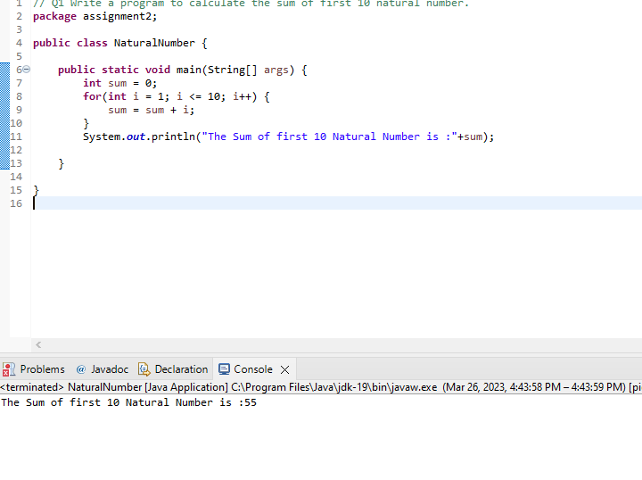

Q2 // Q 2 Write a program that prompts the user to input a positive integer.

// It should then print the multiplication table of that number.

**package** assignment2;

**import** java.util.*;

**public** **class** InputPositiveNumber {

**public** **static** **void** main(String[] args) {

Scanner s = **new** Scanner(System.***in***);

**int** num = 0;

System.***out***.print("Enter a Number :");

num = s.nextInt();

**if**(num>0) {

**for**(**int** i = 1; i<=10;i++) {

System.***out***.println(num*i);

}

}

**else** {

System.***out***.println("Negative Number");

}

s.close();

}

}

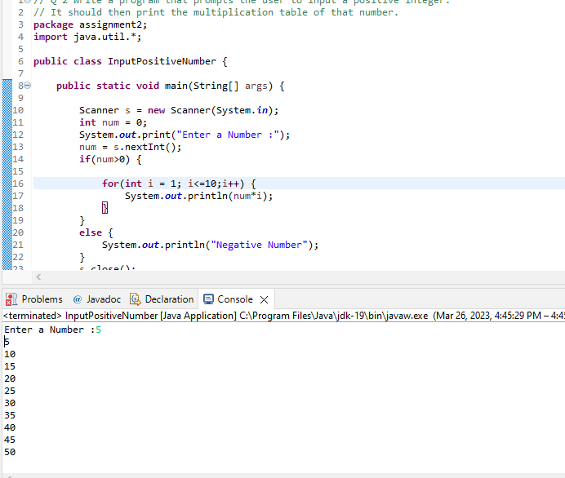

//Q3 Write a program that prompts the user to input an integer and then outputs the number

// with the digits reversed. For example,if the input is 12345, the output should be 54321.

package assignment2;

import java.util.*;

public class ReversedNumber {

public static void main(String[] args) {

Scanner s = new Scanner(System.in);

System.out.println("Enter a Number :");

int num = s.nextInt();

int reverse = 0;;

while(num!=0) {

int rem = num % 10;

reverse = reverse * 10 + rem;

num = num / 10;

}

System.out.println("Reverse of that Number is : "+reverse);

s.close();

}

}

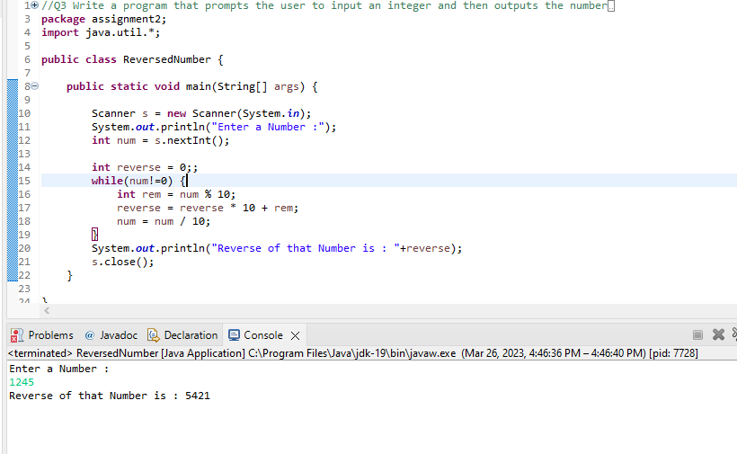

Q4 /*Q4 Write a do-while loop that asks the user to enter two numbers. The numbers should be added and

the sum displayed. The loop should ask the user whether he or she wishes to perform the operation again.

If so, the loop should repeat; otherwise it should terminate.(while loop)*/

**package** assignment2;

**import** java.util.*;

**public** **class** whileLoop {

**public** **static** **void** main(String[] args) {

Scanner s = **new** Scanner(System.***in***);

System.***out***.println("Enter a Number :");

**int** num1 = s.nextInt();

**int** num2 = s.nextInt();

**int** i = 0;

**int** result;

**do** {

result = num1 + num2;

System.***out***.println("The Sum of Num1 & Num2 is "+result);

**break**;

}**while**(result!=i);

}

}

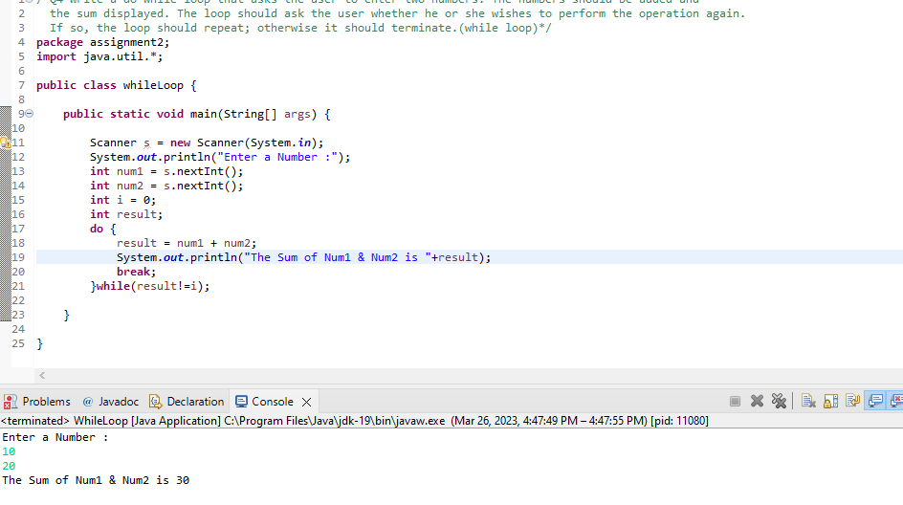

Q5 // Q5 Write a program to print out all Armstrong numbers between 1 and 500. If sum of cubes of each digit of the number is equal to the number

// itself, then the number is called an Armstrong number For example, 153 = ( 1 * 1 * 1 ) + ( 5 * 5 * 5 ) + ( 3 * 3 * 3 )

package assignment2;

public class ArmStrongNumber {

public static void main(String[] args) {

int i=1,a,arm,n;

System.out.println("Armstrong number are");

while(i<500)

{

n=i;

arm = 0;

while(n>0)

{

a = n % 10;

arm = arm + (a*a*a);

n = n / 10;

}

if(arm==i)

System.out.println(i);

i++;

}

}

}

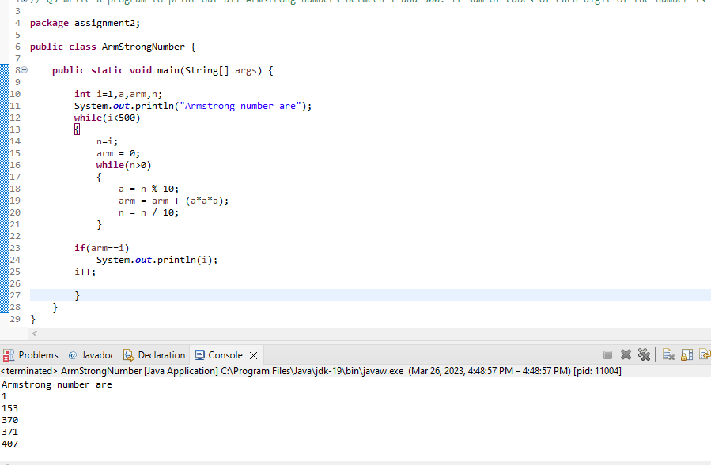

Q6 //Q 6 Write a program to print Fibonacci series of n terms where n is input by user : 0 1 1 2 3 5 8 13 24 ....

**package** assignment2;

**import** java.util.*;

**public** **class** FibonacciSeries {

**public** **static** **void** main(String[] args) {

**int** n, a = 0, b = 0, c = 1;

Scanner s = **new** Scanner(System.***in***);

System.***out***.print("Enter the Value : ");

n = s.nextInt();

**for**(**int** i = 1;i<=n;i++) {

a = b;

b = c;

c = a + b;

System.***out***.print(a+" ");

}

s.close();

}

}

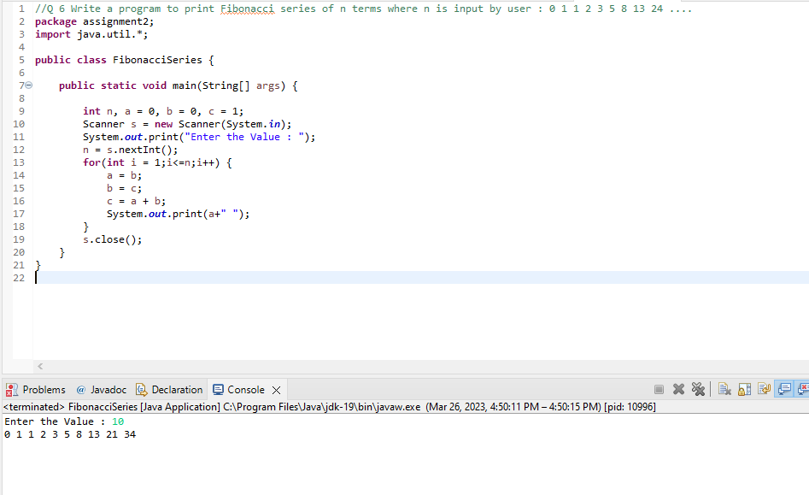

**Q7 package** assignment2;

**public** **class** Pattern1 {

**public** **static** **void** main(String[] args) {

**for**(**int** i = 1;i <=4; i++) {

**for**(**int** j = 1; j <= 10; j++) {

System.***out***.print("*");

}

System.***out***.println();

}

}

}

/*

**********

**********

**********

**********

*/

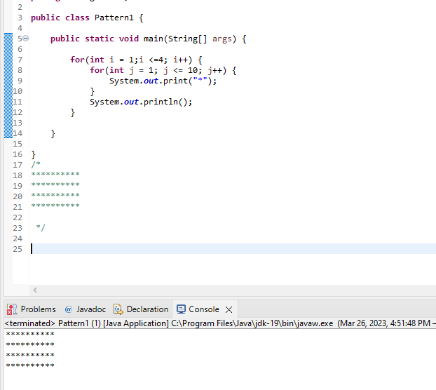

**Q7 package** assignment2;

**public** **class** Pattern2 {

**public** **static** **void** main(String[] args) {

**for**(**int** i = 1;i <= 5; i++) {

**for**(**int** j = 1;j <= i; j++) {

System.***out***.print("*");

}

System.***out***.println();

}

}

}

/*

*

**

***

****

*****

*/

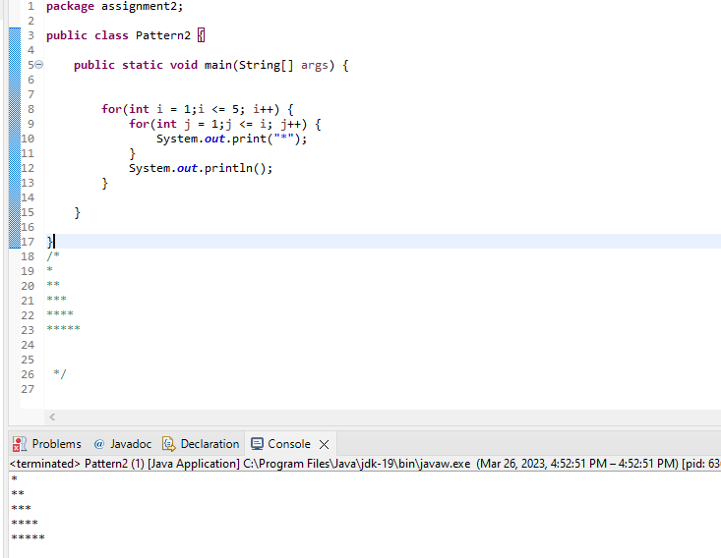

**Q7 package** assignment2;

**public** **class** Pattern4 {

**public** **static** **void** main(String[] args) {

**int** space = 6;

**int** k = 1;

**for**(**int** i = 1;i < space; i++)

{

**for**(**int** l =space-i; l>1; l--)

{

System.***out***.print(" ");

}

**for**(**int** j = 1; j <= i; j++)

{

System.***out***.print("* ");

k++;

}

System.***out***.println();

}

}

}

/*

*

***

*****

*******

*********

*/

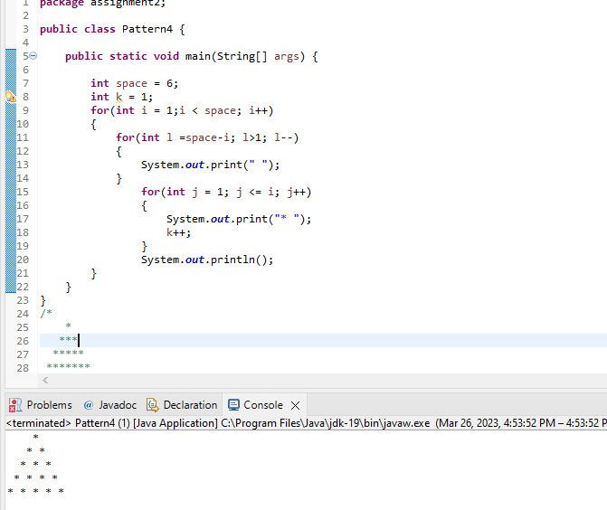

**Q7 package** assignment2;

**public** **class** Pattern5 {

**public** **static** **void** main(String[] args) {

**int** space = 4;

**for**(**int** i = 1; i<=5; i++) {

**for**(**int** j = 1; j <= space; j++)

{

System.***out***.print(" ");

}

**for**(**int** k = 1;k <= i; k++) {

System.***out***.print(" " +i+ " " );

}

System.***out***.println();

space--;

}

}

}

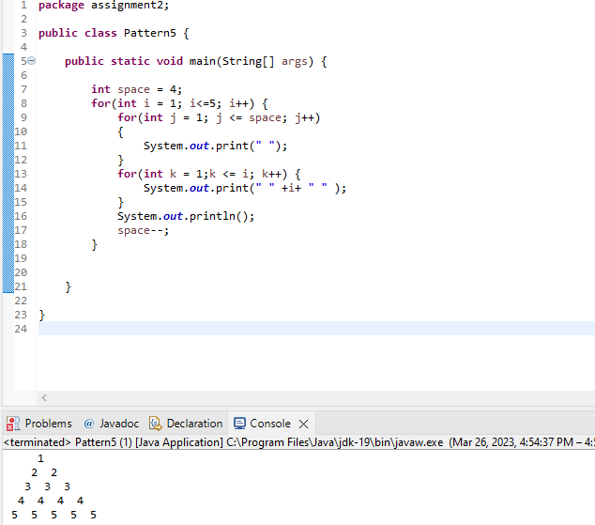

Q8 // Q8 Write a program in java to find the sum of the even and odd digits of the number which is given as input.

**package** assignment2;

**import** java.util.*;

**public** **class** SumOfEvenOddDigit {

**public** **static** **void** main(String[] args) {

Scanner s = **new** Scanner(System.***in***);

System.***out***.print("Enter a Number : ");

**int** num = s.nextInt();

**int** SumEven = 0;

**int** SumOdd = 0;

**do**

{

**int** p = num % 10;

num = num / 10;

**if**(p%2==0) {

SumEven = SumEven + p;

}

**else** {

SumOdd = SumOdd + p;

}

}**while**(num != 0);

System.***out***.println("Sum of all Even Number is : "+SumEven);

System.***out***.println("Sum of all Odd Number is : "+SumOdd);

}

}

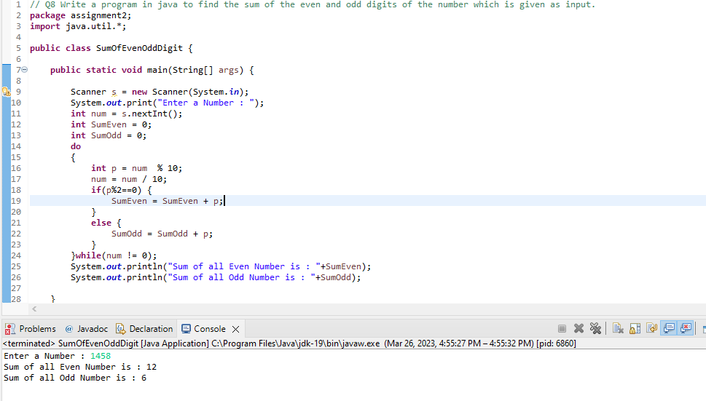

Q9 // Q9 Write a program to check if given number is prime or not

**package** assignment2;

**import** java.util.*;

**public** **class** PrimeOrNot {

**public** **static** **void** main(String[] args) {

Scanner s = **new** Scanner(System.***in***);

**int** num = s.nextInt();

**int** count = 0;

**if**(num <= 1) {

System.***out***.println("Not a Prime Number");

**return**;

}

**for**(**int** i = 1; i <= num/2; i++) {

**if**(num % i == 0) {

count++;

}

}

**if**(count > 1) {

System.***out***.println("Not Prime Number");

}

**else** {

System.***out***.println("Prime Number");

}

}

}

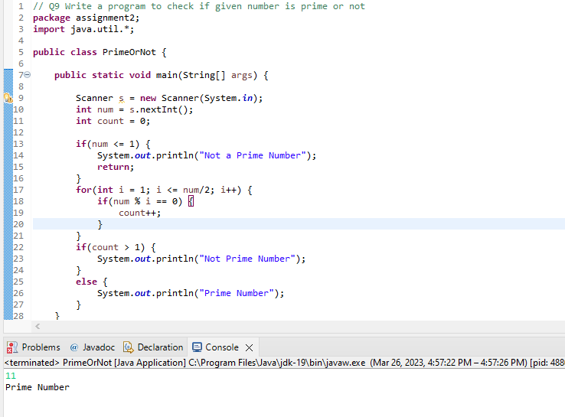

Q10 // Q 10 write a program to print prime numbers between 2 to 20.

**package** assignment2;

**public** **class** PrimeNum {

**public** **static** **void** main(String[] args) {

**int** count;

**int** num = 20;

**for**(**int** i = 1; i <= num; i++) {

count = 0;

**for**(**int** j = 2;j <= i / 2; j++) {

**if**(i % j == 0) {

count++;

**break**;

}

}

**if**(count == 0) {

System.***out***.println(i);

}

}

}

}

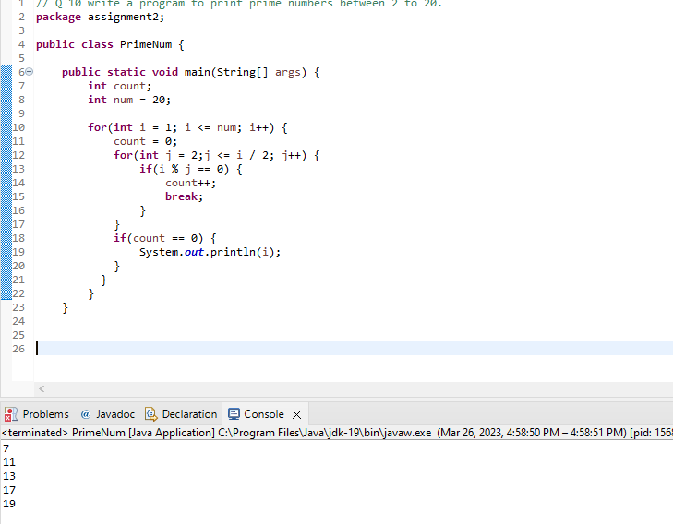

Q11 // Q 11 Write program to find largest among three numbers

**package** assignment2;

**public** **class** largestThreeNumber {

**public** **static** **void** main(String[] args) {

**int** a = 10;

**int** b = 25;

**int** c = 15;

**if**(a >= b) {

**if**(a >= c) {

System.***out***.println("Greatest Number is : "+a);

}

**else** {

System.***out***.println("Greatest Number is : "+c);

}

}

**else** {

**if**(b >= c) {

System.***out***.println("Greatest Number is : "+b);

}

**else** {

System.***out***.println("Greatest Number is : "+c);

}

}

}

}

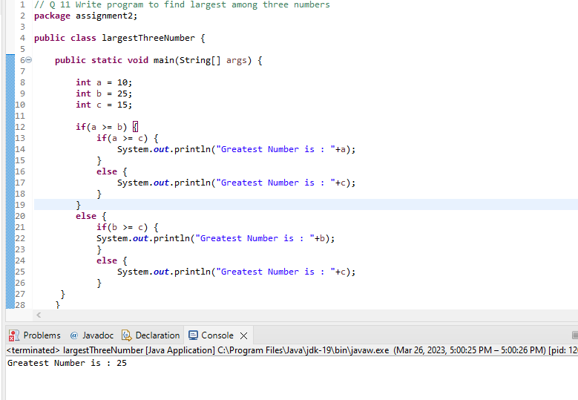

Q12 // Q 20 Write a program to find sum of all integers greater than 100 and less than 200 that are divisible by 7

**package** assignment2;

**public** **class** Divisible7 {

**public** **static** **void** main(String[] args) {

**int** sum = 0;

**int** count = 0;

**for**(**int** i = 100; i < 200; i++)

{

**if**(i % 7 == 0)

{

sum = sum + i;

count++;

}

}

System.***out***.println(sum);

}

}

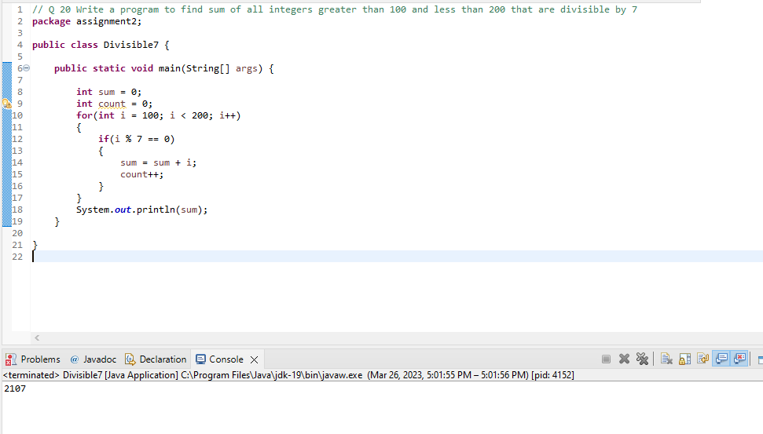

Q13 /*Q 21 8. Write a Java program to print numbers between 1 to 100 which are divisible by 3, 5 and by both.

Hint

System.out.println("\nDivided by 3: ");

for (int i=1; i<100; i++) {

if (i%3==0)

System.out.print(i +", ");

}*/

**package** assignment2;

**public** **class** DivisibleBy3and5 {

**public** **static** **void** main(String[] args) {

**for**(**int** i = 1; i <= 100; i++)

{

**if**(i % 3 == 0 && i % 5 == 0) {

System.***out***.println(i);

}

}

}

}

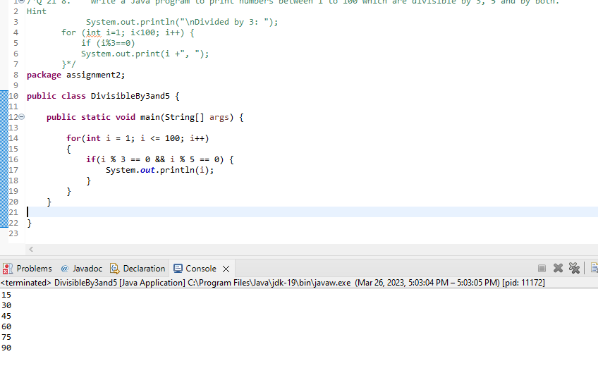

Q14 /*Q 22 create a menu driven application in java that show

"Add" Add two number

"subtract" Subtract two number

"Multiple" Multiple two numbers

"Exit " Exit

Ask two numbers from user and as per user choice perform necessary action using switch command*/

**package** assignment2;

**import** java.util.*;

**public** **class** SwitchCase {

**public** **static** **void** main(String[] args) {

Scanner s = **new** Scanner(System.***in***);

System.***out***.println("Enter two Number :");

**int** a = s.nextInt();

**int** b = s.nextInt();

// String choice = s.next();

**int** result = 0;

System.***out***.println("Enter your choice : Add : Sub : Mul : Exit ");

String choice = s.next();

**switch**(choice) {

**case** "Add":

result = a + b;

System.***out***.println("Sum of A and B is : "+result);

**break**;

**case** "Sub":

result = a - b;

System.***out***.println("Subtraction of A and B is : "+result);

**break**;

**case** "Mul":

result = a * b;

System.***out***.println("Multiplaction of A and B is : "+result);

**break**;

**case** "Exit":

System.***out***.println("Exit");

**break**;

}

}

}

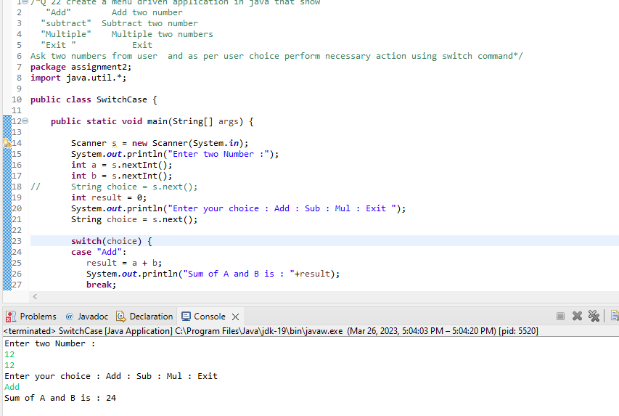

Q15 //Q 23 Write a program to display first 1 to 20 even number on screen . Terminate the program when number 16 is found using break command .

**package** assignment2;

**public** **class** EvenNum1to20 {

**public** **static** **void** main(String[] args) {

**for**(**int** i = 1; i <= 20; i++) {

**if**(i % 2 == 0) {

**if**(i == 16) {

**break**;

}

System.***out***.println(i);

}

}

}

}

