**MEDIPAL**

## A PROJECT REPORT

***Submitted by,***

**Mr. R SHREYAS - 20201CCS0009**

**Ms. VAISHNAVI M - 20201CCS0005**

**Mr. SHIVANAND M - 20201CCS0022**

**Ms. POORVA Y - 20201CCS0120**

**Ms. SUPRIYA KP - 20201CCS0138**

### *Under the guidance of,*

**Ms. KAIPA SANDHYA**

***in partial fulfillment for the award of the degree of***

**BACHELOR OF TECHNOLOGY**

**IN**

**COMPUTER SCIENCE AND ENGINEERING(CYBER SECURITY)**

**At**



**PRESIDENCY UNIVERSITY**

**BENGALURU**

**JANUARY 2024**

**PRESIDENCY UNIVERSITY**

**SCHOOL OF COMPUTER SCIENCE ENGINEERING & INFORMATION SCIENCE**

**CERTIFICATE**

This is to certify that the Project report **“MEDIPAL”** being submitted by “R Shreyas, Vaishnavi M, Shivanand M, Poorva Y, Supriya KP” bearing roll number(s) “20201CCS0009, 20201CCS0005, 20201CCS0022, 20201CCS0120, 20201CCS0138” in partial fulfilment of requirement for the award of degree of Bachelor of Technology in Computer Science and Engineering is a bonafide work carried out under my supervision.



|  |  |
| --- | --- |
| **MS. KAIPA SANDHYA**  Assistant Professor  School of CSE&IS  Presidency University | **Dr. ANANDARAJ SP**  Professor & HoD  School of CSE&IS  Presidency University |



|  |  |  |
| --- | --- | --- |
| **Dr.C. KALAIARASAN**  Associate Dean  School of CSE&IS  Presidency University | **Dr. L. SHAKKEERA**  Associate Dean  School of CSE&IS  Presidency University | **Dr. SAMEERUDDIN KHAN** Dean  School of CSE&IS  Presidency University |

**PRESIDENCY UNIVERSITY**

**SCHOOL OF COMPUTER SCIENCE ENGINEERING & INFORMATION SCIENCE**

**DECLARATION**

We hereby declare that the work, which is being presented in the project report entitled **MEDIPAL** in partial fulfilment for the award of Degree of **Bachelor of Technology** in **Computer Science and Engineering**, is a record of our own investigations carried under the guidance of **Ms. Kaipa Sandhya, Assistant Professor,** **School of Computer Science Engineering & Information Science, Presidency University, Bengaluru.**

We have not submitted the matter presented in this report anywhere for the award of any other Degree.

|  |  |
| --- | --- |
|  | **R Shreyas 20201CCS0009**  **Vaishnavi M 20201CCS0005**  **Shivanand M 20201CCS0022**  **Poorva Y 20201CCS0120**  **Supriya KP 20201CCS0138** |

**ABSTRACT**

This report explores the development and implementation of an innovative Integrated Healthcare App designed to streamline and optimize the process of booking medical appointments. The ever-evolving landscape of healthcare services demands efficient solutions to enhance patient access, improve communication between healthcare providers and patients, and ultimately contribute to better overall health outcomes.

**MEDIPAL** serves as a comprehensive platform, seamlessly integrating various aspects of the healthcare ecosystem. The primary focus is on simplifying the appointment booking process, thereby reducing wait times, enhancing patient satisfaction, and promoting timely healthcare interventions.

The successful implementation of the Integrated **MEDIPAL** presents a transformative approach to healthcare delivery by addressing scheduling inefficiencies and enhancing patient engagement. As the healthcare landscape continues to evolve, such technological solutions play a crucial role in creating a more patient-centric and accessible healthcare system.

**ACKNOWLEDGEMENT**

First of all, we indebted to the **GOD ALMIGHT**Y for giving me an opportunity to excel in our efforts to complete this project on time.

We express our sincere thanks to our respected dean Dr. Md. Sameeruddin Khan, Dean, School of Computer Science Engineering & Information Science, Presidency University for getting us permission to undergo the project.

We record our heartfelt gratitude to our beloved Associate Deans **Dr. Kalaiarasan C** and **Dr. Shakkeera L**, School of Computer Science Engineering & Information Science, Presidency University and **Dr. Anandraj SP**, Head of the Department, School of Computer Science Engineering, Presidency University for rendering timely help for the successful completion of this project.

We are greatly indebted to our guide **Ms. Kaipa Sandhya**, Assistant Professor, School of Computer Science Engineering, Presidency University for his/her inspirational guidance, and valuable suggestions and for providing us a chance to express our technical capabilities in every respect for the completion of the project work.

We would like to convey our gratitude and heartfelt thanks to the University Project-II **Coordinators Dr. Sanjeev P Kaulgud, Dr. Mrutyunjaya MS** and also the department Project Coordinators **“Ms. Manasa CM**”.

We thank our family and friends for the strong support and inspiration they have provided us in bringing out this project.

**R Shreyas**

**Vaishnavi M**

**Shivanand M**

**Poorva Y**

**Supriya KP**

**LIST OF TABLES**

|  |  |  |  |
| --- | --- | --- | --- |
| **Sl. No.** | **Table Name** | **Table Caption** | **Page No.** |
| 1 | Table 1.1 | Literature Survey | 1,2 |

**LIST OF FIGURES**

|  |  |  |  |
| --- | --- | --- | --- |
| **Sl. No.** | **Figure Name** | **Caption** | **Page No.** |
| 1 | Figure 1.1 | Gantt Chart | 10 |
| 2 | Figure 1.2 | Gannt Chart | 10 |
| 3 | Figure 1.3 | Appointment Page | 17 |
| 4 | Figure 1.4 | Database Page | 17 |
| 5 | Figure 1.5 | Database Page | 18 |
| 6 | Figure 1.6 | Home Page | 18 |
| 7 | Figure 1.7 | Home Page | 19 |
| 8 | Figure 1.8 | Home Page | 19 |
| 9 | Figure 1.9 | Home Page | 20 |
| 10 | Figure 1.10 | Home Page | 20 |
| 11 | Figure 1.11 | Login Page | 21 |
| 12 | Figure 1.12 | Logout Page | 21 |
| 13 | Figure 1.13 | Main Page | 22 |
| 14 | Figure 1.14 | Register Page | 22 |
| 15 | Figure 1.15 | Services Page | 23 |
| 16 | Figure 1.16 | Doctors Page | 23 |
| 17 | Figure 1.17 | Doctors Page | 24 |
| 18 | Figure 1.18 | Doctors Page | 24 |
|  |  |  |  |
|  |  |  |  |
|  |  |  |  |
|  |  |  |  |
|  |  |  |  |

**TABLE OF CONTENTS**

|  |  |  |
| --- | --- | --- |
| **CHAPTER NO.** | **TITLE** | **PAGE NO.** |
|  | **ABSTRACT ACKNOWLEDGMENT**  **…** | **I**  **ii**  **…** |
| **1.** | **INTRODUCTION** |  |
| **2.** | **LITERATURE REVIEW** | **1** |
|  |  |  |
| **3.** | **RESEARCH GAPS IN EXISTING METHODS** | **3** |
|  |  |  |
| **4.** | **PROPOSED METHODOLOGY** | **4** |
|  |  |  |
| **5.** | **OBJECTIVES** | **6** |
|  |  |  |
| **6.** | **SYSTEM DESIGN AND IMPLEMENTATION** | **7** |
|  |  |  |
| **7.** | **TIMELINE FOR EXECUTION OF PROJECT** | **10** |
|  |  |  |
| **8.** | **OUTCOMES** | **11** |
|  |  |  |
| **9.** | **CONCLUSION** | **13** |
|  |  |  |
| **10.** | **REFERENCES** | **14** |
|  |  |  |
| **11.** | **APPENDIX A**  **(PSEUDO CODE)** | **15** |
|  |  |  |
| **12.** | **APPENDIX B (SCREENSHOTS)** | **17** |

**CHAPTER-1**

**INTRODUCTION**

Welcome to the future of healthcare – a paradigm shift brought to life through **MEDIPAL**. This groundbreaking application is not merely a technological advancement but a holistic transformation of how we approach and experience healthcare.

Imagine a seamless convergence of medical expertise, data management, and patient engagement, all encapsulated within a single, intuitive platform. **MEDIPAL** is not just a tool; it's a healthcare ecosystem reimagined, offering a spectrum of services that transcend traditional boundaries.

At its core, this app serves as a digital nexus, weaving together the intricate threads of medical records, appointment scheduling, and health monitoring into a tapestry of personalized care. Gone are the days of fragmented health information; instead, users wield the power to access, manage, and share their comprehensive health data at their fingertips.

But the brilliance of **MEDIPAL** extends beyond mere convenience. It's a guardian of privacy and security, employing robust measures to safeguard sensitive health information. This fortress of confidentiality ensures that users can trust the app as a custodian of their well-being.

What truly sets this innovation apart is its commitment to inclusivity. Bridging generational gaps, the app is designed for universal accessibility, catering to both tech-savvy individuals and those less familiar with digital interfaces. It's a healthcare revolution that leaves no one behind.

Interoperability is the heartbeat of this application, fostering seamless communication among disparate healthcare systems. Health records are no longer confined within silos but flow effortlessly, enhancing coordination among healthcare providers and ultimately elevating the quality of care.

MEDIPAL is more than a tool for the present; it's a visionary solution for the future of healthcare. It envisions a world where patient empowerment, data-driven insights, and medical collaboration converge to create a new standard of healthcare excellence. Welcome to a healthier tomorrow, welcome to **MEDIPAL**

**CHAPTER-2**

**LITERATURE SURVEY**

|  |  |  |  |  |
| --- | --- | --- | --- | --- |
| **S.NO** | **ARTICLE NAME** | **YEAR AND AUTHOR** | **ADVANTAGES** | **LIMITATIONS** |
| **1** | Regulation of Digital Healthcare in India: Ethical and Legal Challenges | 2023, Deepika Jain | They are concerns at the level of patient privacy. | The current laws in India that regulate technology do not explicitly address telemedicine |
| **2** | Users’ response toward online doctor consultation platforms: SOR approach | 2021, Sandeep Goyal, Sumedha Chauhan, and Parul Gupta | Convenient, time saving, and even can have Medical health record. | Integrating technology oriented factors with behavioral attributes for determining the behavioral intention of user toward the online doctor consultation platform. |
| **3** | Research on the Impact of mHealth Apps on the Primary Healthcare Professionals in Patient Care | 2021, Majed Kamel Al-Azzam | Health service quality development, clinical error reduction, and resource integration. | The threat to the exposure of personal information by the hacker and sharing with third parties is major part. |

|  |  |  |  |  |
| --- | --- | --- | --- | --- |
| **3** | Research on the Impact of mHealth Apps on the Primary Healthcare Professionals in Patient Care | 2021, Majed Kamel Al-Azzam | Health service quality development, clinical error reduction, and resource integration. | The threat to the exposure of personal information by the hacker and sharing with third parties is major part. |
| **4** | Usability of a mobile apps for health professionals: a user-centered approach | 2023, Griselda Manzano-Monfort, Guillermo Paluzie, & Carolina Chabrera | Convenience, easy communication with customers and online usage. | Difficulty to create, the cost to create them, and make them available to people, need updates and support. |
| **5** | Mobile health apps for disease screening and treatment support in low and middle-income countries | 2021, Ernest Osei , Tivani P. Mashamba-Thompson | Take preventive care and avert possibility of common but dreaded diseases. | Future research efforts and policy dialogue should be directed to explore health system readiness for adopting sustainable solutions to improve |

**CHAPTER-3**

**RESEARCH GAPS OF EXISTING METHODS**

1. **Fragmented Data:**

Many apps struggle with interoperability, leading to fragmented health data. This can hinder a comprehensive view of a patient's medical history.

1. **Security Concerns:**

Privacy and security issues may arise due to the sensitive nature of health data. Inadequate protection could lead to unauthorized access or breaches.

1. **User Adoption:**

Some users, especially older populations, may find it challenging to adapt to digital healthcare solutions, impacting widespread adoption and usability.

1. **Limited Integration:**

Lack of integration with various healthcare systems and devices can limit the app's ability to provide a comprehensive health profile for users.

1. **Reliability and Accuracy:**

Inaccurate health information or unreliable monitoring tools may compromise the effectiveness of healthcare apps, potentially leading to incorrect diagnoses or treatment plans.

1. **Regulatory Compliance:**

Adhering to evolving healthcare regulations and standards poses a challenge, and non-compliance could result in legal issues and a loss of trust.

**CHAPTER-4**

**PROPOSED MOTHODOLOGY**

1. Needs Assessment

* Identify the healthcare needs and problems that your app will address.
* Engage with potential users, healthcare professionals, and stakeholders to gather insights and requirements.

1. Market Research

* Analyze the competitive landscape to understand existing healthcare apps.
* Identify gaps and opportunities for innovation in integrated healthcare.

1. Regulatory Compliance

* Familiarize yourself with healthcare regulations such as HIPAA (in the United States) or GDPR (in the EU).
* Ensure that your app complies with all relevant laws and regulations.

1. Team Formation

* Assemble a team with expertise in healthcare, app development, design, and data security.
* Consider involving healthcare professionals or advisors for domain-specific knowledge.

1. Concept and Design

* Create a detailed concept for the app, including its features, user interface, and user experience (UI/UX) design.
* Develop wireframes and prototypes to visualize the app's functionality.

1. Data Security

* Implement robust security measures to protect sensitive health data.
* Encrypt data at rest and in transit.
* Establish strict access controls and authentication procedures.

1. Data Integration

* Design a data architecture that allows seamless integration with electronic health records (EHR) systems, wearables, and other data sources.

1. Development

* Build the app using appropriate technologies and frameworks.
* Consider a cross-platform development approach for wider accessibility.
* Implement features like appointment scheduling, telemedicine, health monitoring, and more.

1. Testing and Quality Assurance

* Thoroughly test the app for functionality, security, and usability.
* Conduct user testing with real healthcare professionals and patients to gather feedback.

1. Regulatory Clearance

* If required, obtain necessary approvals and clearances from regulatory bodies.

1. User Training and Onboarding

* Create user-friendly onboarding processes.
* Train healthcare providers and patients on how to use the app effectively.

1. Launch

* Publish the app on relevant platforms (iOS, Android, web).
* Promote the app through marketing and outreach campaigns.

1. Data Analytics

* Utilize data analytics to gather insights on app usage and user behavior.
* Improve the app based on data-driven decision-making.

1. User Support

* Offer customer support for users who may have questions or issues with the app.
* Provide a feedback channel for users to report problems and suggest improvements.

1. Security Updates

* Stay up-to-date with evolving security threats and regularly update the app to address vulnerabilities.

**CHAPTER-5**

**OBJECTIVES**

1. **Enhance Communication:**

Facilitate seamless communication between healthcare providers, patients, and stakeholders through secure messaging and notification systems.

1. **Optimize Data Efficiency:**

Implement efficient data management systems to streamline medical records, ensuring accessibility and accuracy for healthcare professionals.

1. **Improve Access to Healthcare:**

Increase accessibility to healthcare services by providing a user-friendly interface for patients to schedule appointments, access medical information, and engage in telemedicine consultations.

1. **Ensure Data Security and Privacy:**

Implement robust security measures to safeguard patient data, ensuring compliance with healthcare privacy regulations such as HIPAA.

1. **Facilitate Appointment Management:**

Enable users to schedule, reschedule, and manage appointments seamlessly, reducing waiting times and improving overall appointment efficiency.

1. **Promote Telemedicine Services:**

Develop and integrate telemedicine features to enable virtual consultations, providing convenient access to healthcare services remotely.

1. **User-Friendly Interface:**

Design an intuitive and user-friendly interface to enhance the overall user experience, catering to both healthcare providers and patients.

**CHAPTER-6**

**SYSTEM DESIGN & IMPLEMENTATION**

**SYSTEM DESIGN:**

Designing an integrated healthcare app involves considering various components such as user roles, data security, interoperability, and user experience.

**Key elements include:**

**User Roles and Access Control:**

Define user roles (patients, doctors, administrators).

Implement strict access controls based on roles to protect sensitive data.

**Interoperability:**

Ensure seamless integration with electronic health records (EHR) systems.

Support industry standards like HL7 for data exchange between systems.

**Data Security:**

Employ robust encryption for data transmission and storage.

Implement secure authentication mechanisms (e.g., two-factor authentication).

**Scalability:**

Design the system to handle varying loads, considering potential growth.

Utilize scalable cloud infrastructure for flexibility.

**User Experience:**

Prioritize a user-friendly interface for both patients and healthcare professionals.

Include features such as appointment scheduling, prescription management, and telemedicine.

**Telemedicine Functionality:**

Integrate video/audio communication for remote consultations.

Ensure compliance with privacy regulations for telehealth services.

**Data Analytics:**

Implement analytics tools for extracting valuable insights from patient data.

Use machine learning algorithms for predictive analysis (e.g., disease prediction).

**Notification and Alerts:**

Provide timely alerts for appointments, medication reminders, and test results.

Support push notifications for real-time updates.

**Compliance with Regulations:**

Ensure adherence to healthcare regulations (e.g., HIPAA).

Regularly update the system to comply with evolving standards.

**Feedback and Reporting:**

Include a feedback mechanism for patients and healthcare providers.

Generate comprehensive reports for administrators and clinicians.

**Offline Functionality:**

Offer basic functionality offline, ensuring data synchronization when connectivity is restored.

Facilitate access to critical information during network outages.

**Mobile Responsiveness:**

Design the app to be responsive on various devices, especially mobile.

Prioritize a mobile-first approach for a broader user reach.

**Emergency Features:**

Implement emergency features like quick access to emergency contacts and medical history.

Enable location sharing for emergency services.

**Continuous Testing and Monitoring:**

Regularly test the app for security vulnerabilities.

Implement monitoring tools to detect and address issues promptly.

**Collaboration Tools:**

Include features that enable collaboration among healthcare professionals.

Support secure messaging for communication within the platform.

Remember, collaboration with healthcare professionals and stakeholders throughout the design process is crucial to ensure the app meets the diverse needs of the healthcare ecosystem

**IMPLEMENTATION:**

To build an integrated healthcare app, consider using a combination of front-end technologies like React Native or Flutter for cross-platform development. For the back end, use a robust framework such as Django or Ruby on Rails, and a database like PostgreSQL or MongoDB. Implement RESTful APIs for seamless communication between the front end and back end. Prioritize security measures, including data encryption and user authentication.

**CHAPTER-7**

**TIMELINE FOR EXECUTION OF PROJECT**

**(GANTT CHART)**

Figure 1.1

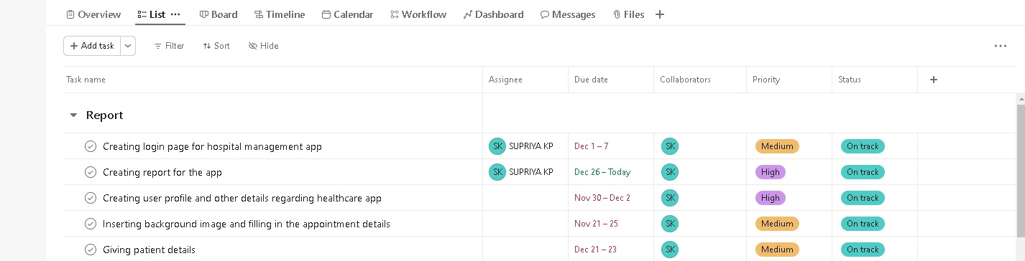

Figure 1.2

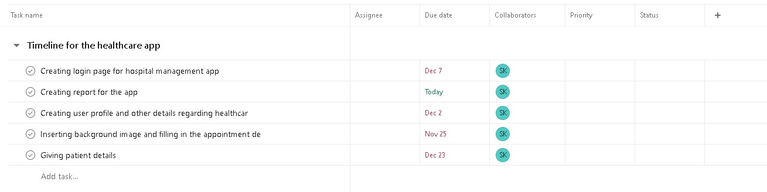

**CHAPTER-8**

**OUTCOMES**

Implementing a healthcare portal can yield various positive outcomes for both healthcare providers and patients. The specific outcomes will depend on the features and functionalities of the portal, as well as the goals and objectives set by the organization.

Here are some common outcomes that healthcare portals aim to achieve:

1. **Enhanced Patient Engagement:**
   * Patients can access their health records, test results, and other relevant information online.
   * Increased patient participation in healthcare decision-making and management of their own health.
2. **Improved Communication:**
   * Secure messaging features facilitate communication between patients and healthcare providers.
   * Efficient sharing of information between different healthcare professionals involved in a patient's care.
3. **Streamlined Appointment Management:**
   * Online appointment scheduling and reminders reduce administrative burdens and enhance patient convenience.
   * Minimized waiting times and improved clinic workflow.
4. **Efficient Prescription Management:**
   * Patients can request prescription refills online.
   * Electronic prescription systems can improve accuracy and reduce the risk of errors.
5. **Health Monitoring and Management:**
   * Patients can input and track health metrics, such as blood pressure, glucose levels, or physical activity.
   * Healthcare providers can monitor and intervene more proactively in the management of chronic conditions.
6. **Enhanced Data Security and Privacy:**
   * Compliance with data protection regulations ensures the security and privacy of patient information.
   * Building trust among patients regarding the confidentiality of their health data.
7. **Operational Efficiency for Healthcare Providers:**
   * Reduced paperwork and administrative tasks.
   * Integration with electronic health records (EHRs) and other healthcare systems improves overall efficiency.
8. **Data Analytics and Insights:**
   * Aggregated and anonymized data can be analyzed to derive insights for population health management.
   * Identifying trends, risk factors, and opportunities for improving healthcare delivery.
9. **Compliance with Regulatory Requirements:**
   * Adherence to healthcare regulations and standards ensures legal and ethical practices.
   * Avoidance of penalties and legal issues related to non-compliance.
10. **Increased Patient Satisfaction:**
    * A user-friendly portal that meets the needs of patients can contribute to higher satisfaction levels.
    * Positive patient experiences may lead to increased loyalty and retention.

It's important for healthcare organizations to continually assess and optimize their portals to ensure they align with evolving patient needs and industry standards. The successful implementation of a healthcare portal often requires ongoing collaboration between healthcare providers, IT professionals, and patients.

**CHAPTER 9**

**CONCLUSION**

In conclusion, the **MEDIPAL** app presented in this report emerges as a transformative tool with immense potential to revolutionize the healthcare landscape. Through its user-friendly interface, robust features, and seamless integration with modern technologies, the app addresses critical challenges in healthcare delivery and patient engagement.

The app's ability to enhance accessibility to healthcare services, streamline communication between healthcare providers and patients, and facilitate remote monitoring signifies a significant step forward in promoting preventive care and early intervention. The incorporation of cutting-edge technologies such as AI-driven diagnostics, telemedicine, and personalized health recommendations further underscores its adaptability to the evolving needs of the healthcare industry.

Moreover, the positive impact of the healthcare app extends beyond individual patient care to contribute to the broader healthcare ecosystem. It has the potential to alleviate the burden on healthcare systems by reducing unnecessary hospital visits, optimizing resource allocation, and fostering a more efficient healthcare delivery model.

As we move forward, it is imperative to recognize the importance of continued innovation, user feedback, and collaboration with healthcare professionals to refine and enhance the app's functionality. Additionally, addressing concerns related to data security and privacy remains crucial to fostering trust among users and stakeholders.

In essence, the healthcare app analyzed in this report emerges as a promising solution that not only facilitates a paradigm shift in healthcare delivery but also holds the promise of improving health outcomes, reducing costs, and ultimately contributing to a healthier society. It stands as a testament to the transformative potential of technology in shaping the future of healthcare.

**REFERENCES**

1. [**https://www.emerald.com/insight/content/doi/10.1108/ITP-11-2021-0835/full/html**](https://www.emerald.com/insight/content/doi/10.1108/ITP-11-2021-0835/full/html)
2. [**https://www.emerald.com/insight/content/doi/10.1108/MD-02-2021-0268/full/html**](https://www.emerald.com/insight/content/doi/10.1108/MD-02-2021-0268/full/html)
3. [**https://www.emerald.com/insight/content/doi/10.1108/LHTN-07-2017-0052/full/html**](https://www.emerald.com/insight/content/doi/10.1108/LHTN-07-2017-0052/full/html)
4. [**https://www.emerald.com/insight/content/doi/10.1108/AJIM-07-2021-0211/full/html**](https://www.emerald.com/insight/content/doi/10.1108/AJIM-07-2021-0211/full/html)

**APPENDIX-A**

**PSEUDOCODE**

1. Initialize variables and data structures:

- user_profile

- medical_history

- appointment_schedule

- health_records

2. User Registration:

2.1 Display welcome message

2.2 Prompt user to create an account or log in

2.3 If new user:

2.3.1 Collect user details (name, email, password)

2.3.2 Create user_profile

2.4 If existing user:

2.4.1 Prompt for login credentials

2.4.2 Validate credentials

2.5 Display main menu

3. Main Menu:

3.1 Display options:

- View medical history

- Schedule an appointment

- Access health records

- Update profile

- Log out

4. View Medical History:

4.1 Retrieve medical_history for the user

4.2 Display medical_history

5. Schedule an Appointment:

5.1 Display available healthcare providers and their schedules

5.2 Prompt user to select a provider and preferred time

5.3 Confirm appointment

5.4 Update appointment_schedule

6. Access Health Records:

6.1 Display options:

- View test results

- View prescriptions

- View diagnoses

6.2 Allow user to select an option

6.3 Retrieve and display relevant health_records

7. Update Profile:

7.1 Display current user_profile information

7.2 Prompt user to update specific details (e.g., contact information)

7.3 Update user_profile

8. Log Out:

8.1 Display logout confirmation message

**APPENDIX-B**

**SCREENSHOTS**

Figure 1.3

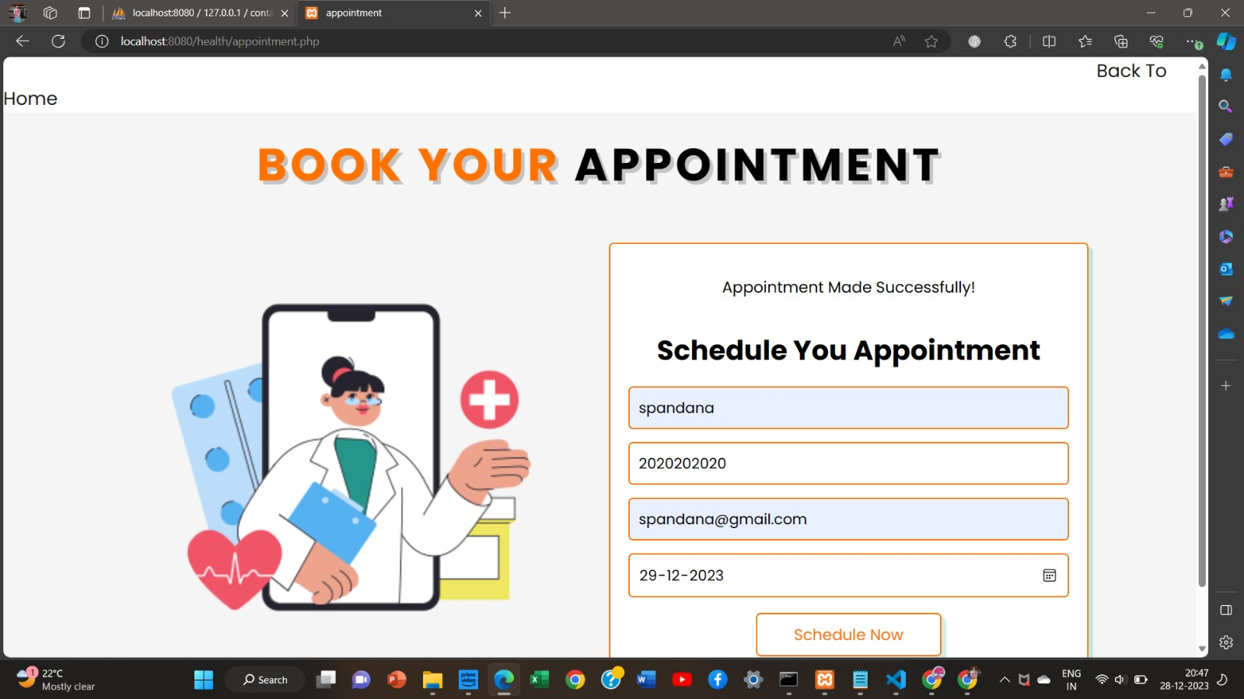

Figure 1.4

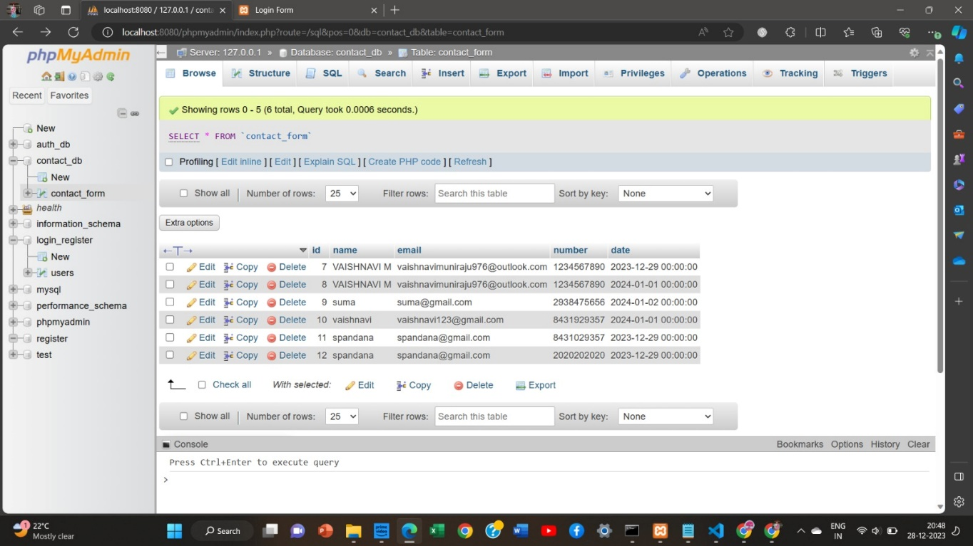

Figure 1.5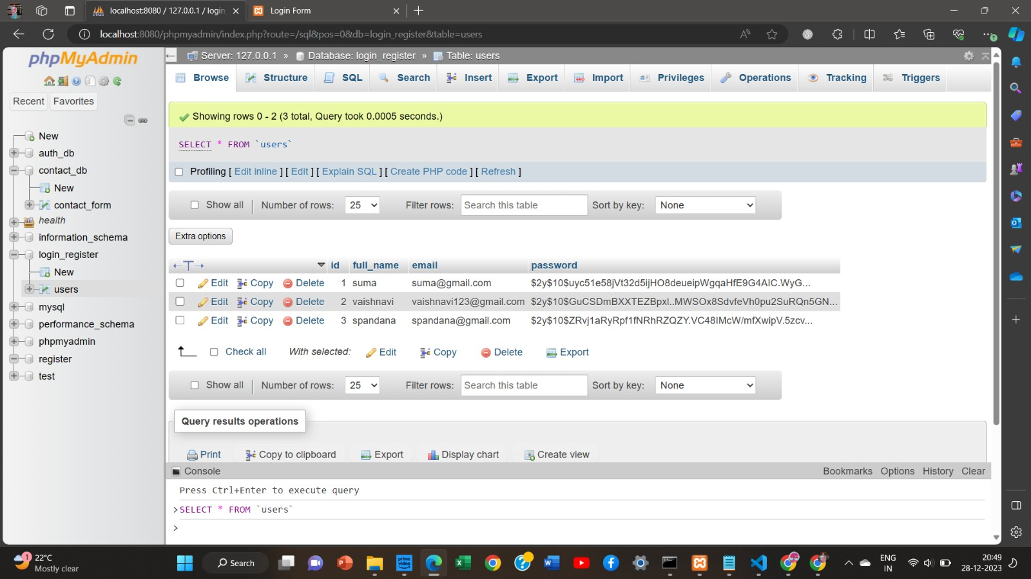

Figure 1.6

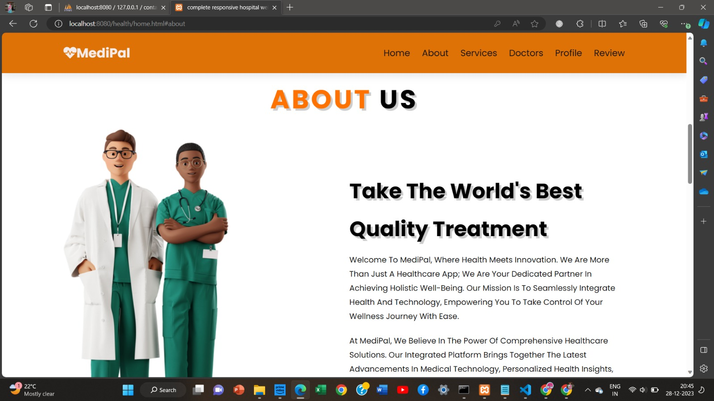

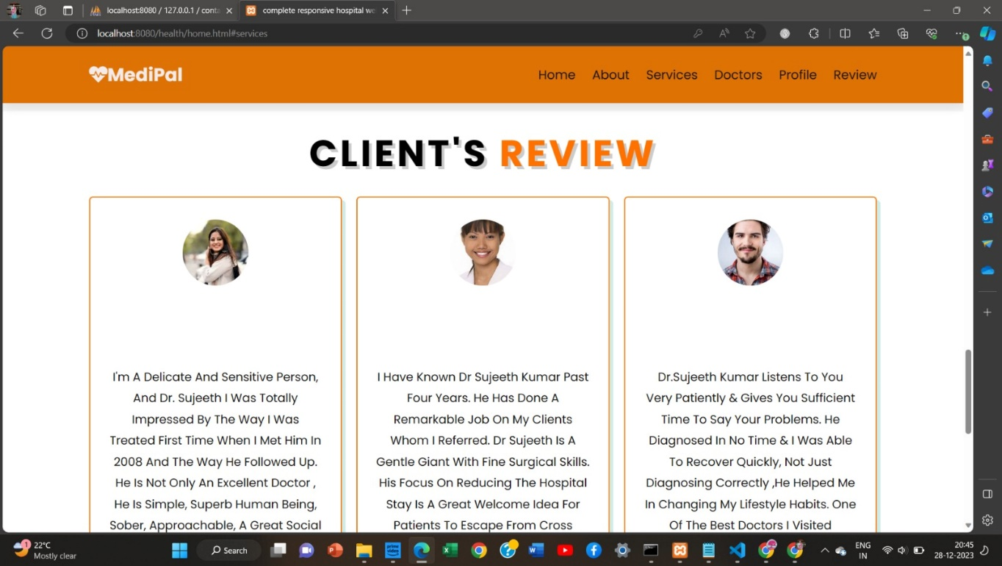

Figure 1.7

Figure 1.8

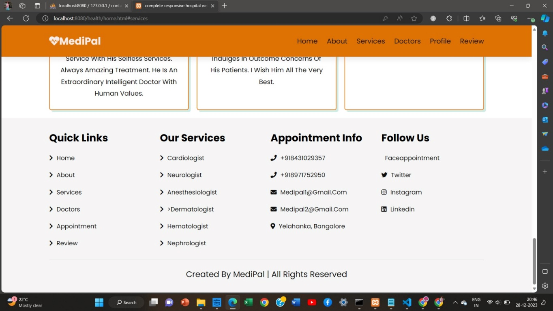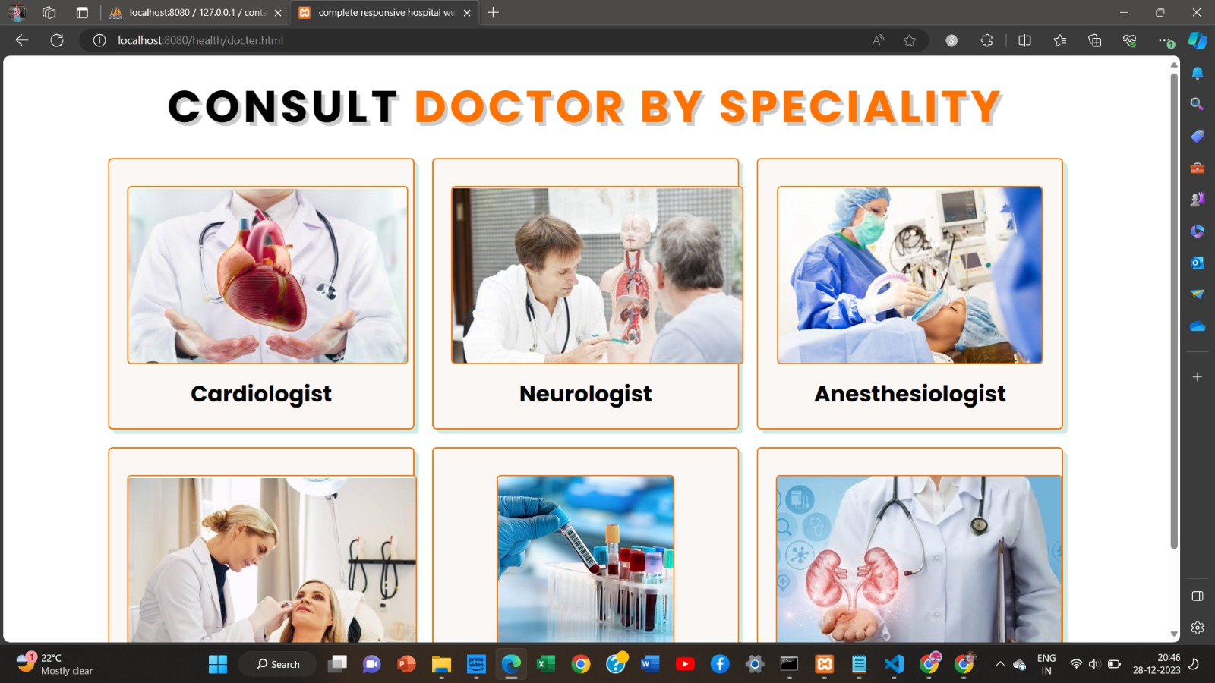

Figure 1.9

Figure 1.10

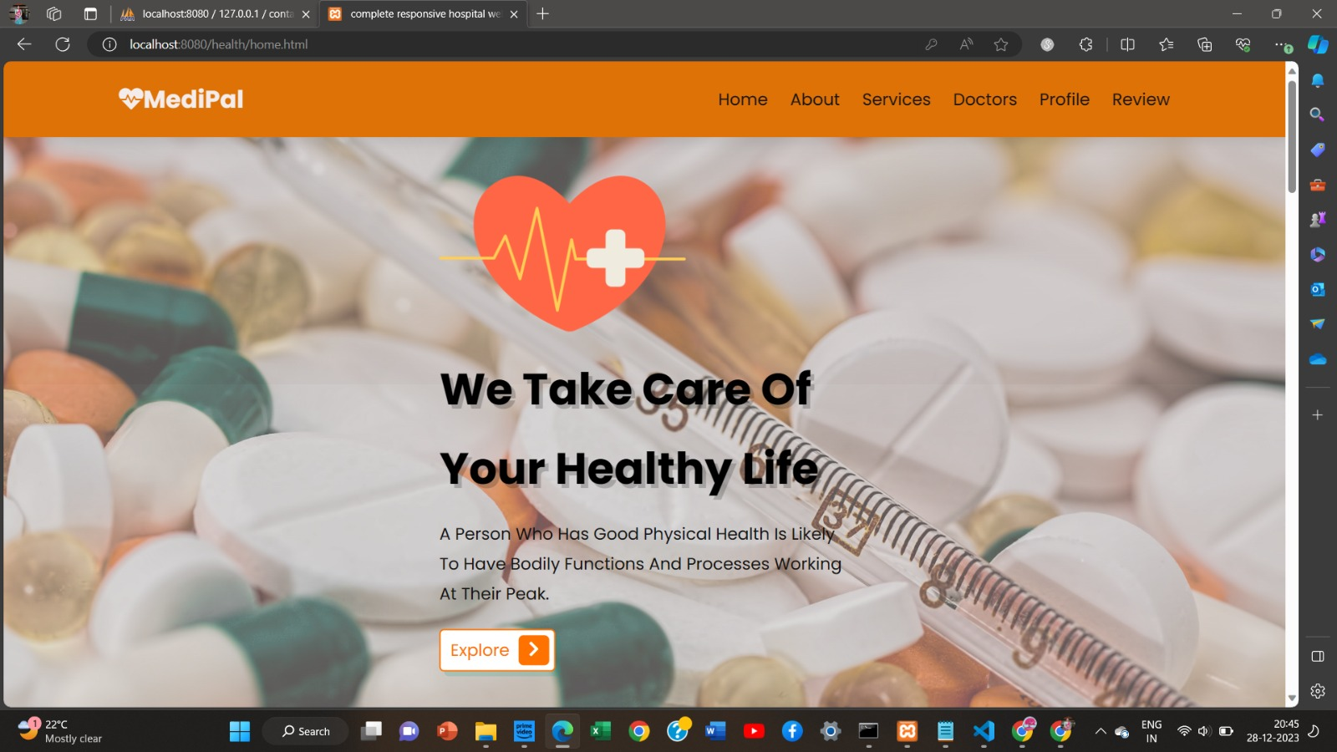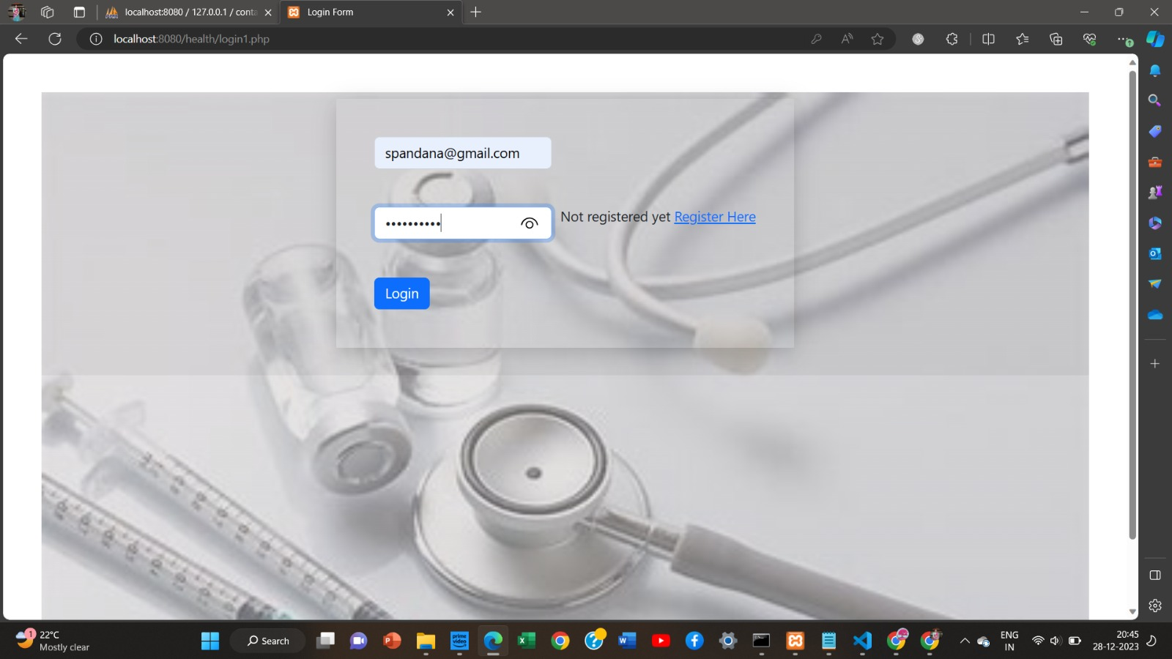

Figure 1.11

Figure 1.12

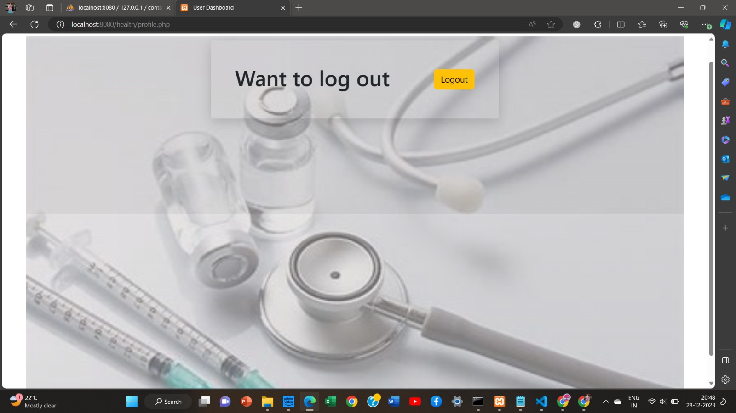

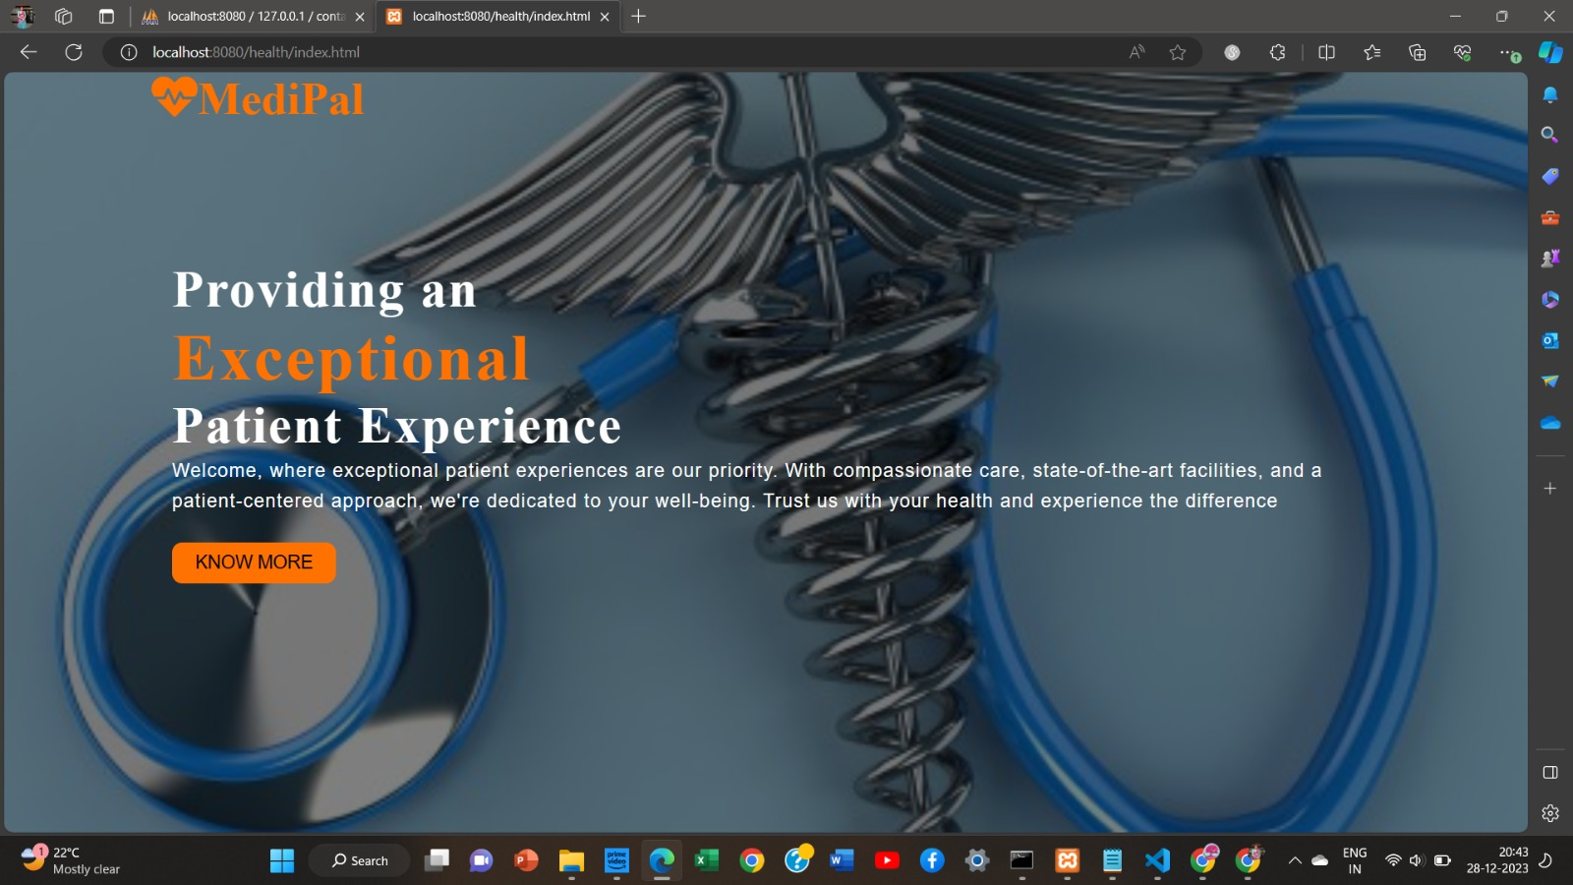

Figure 1.13

Figure 1.14

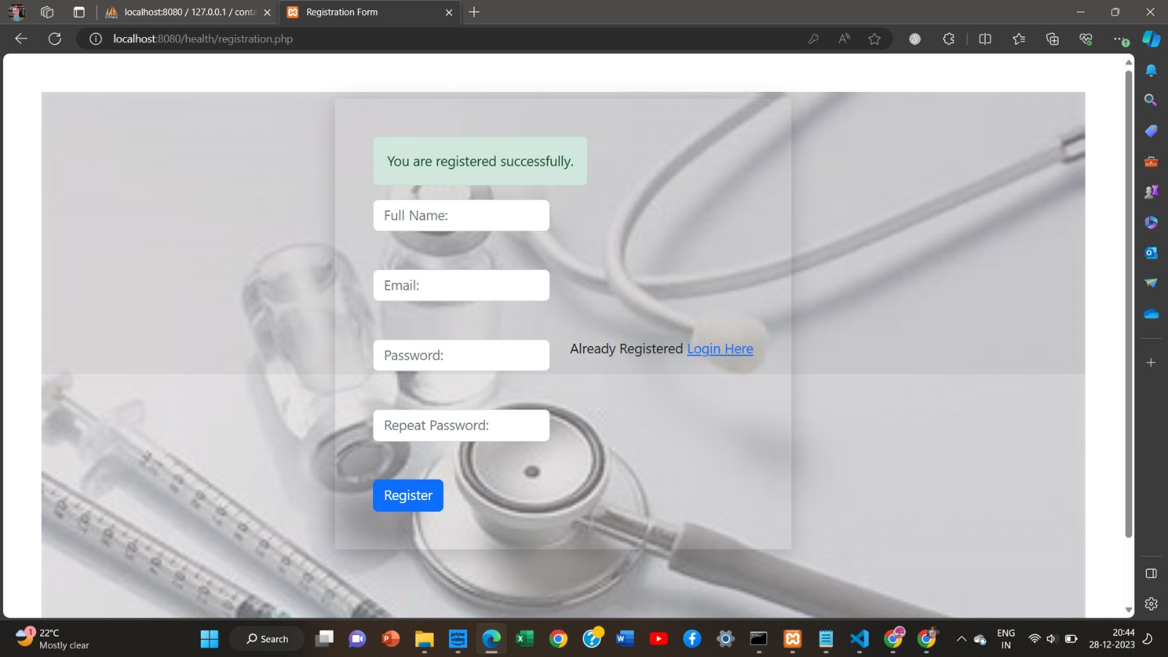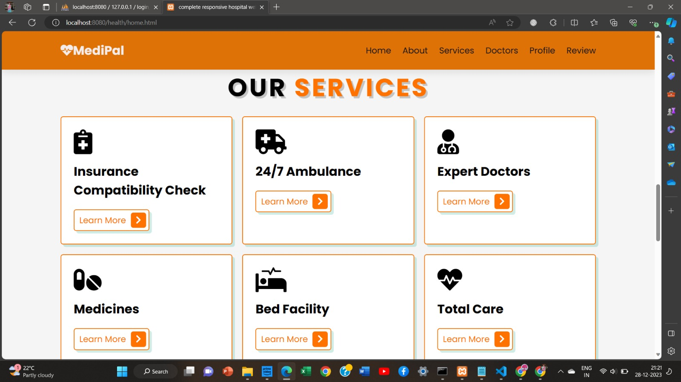

Figure 1.15

Figure 1.16

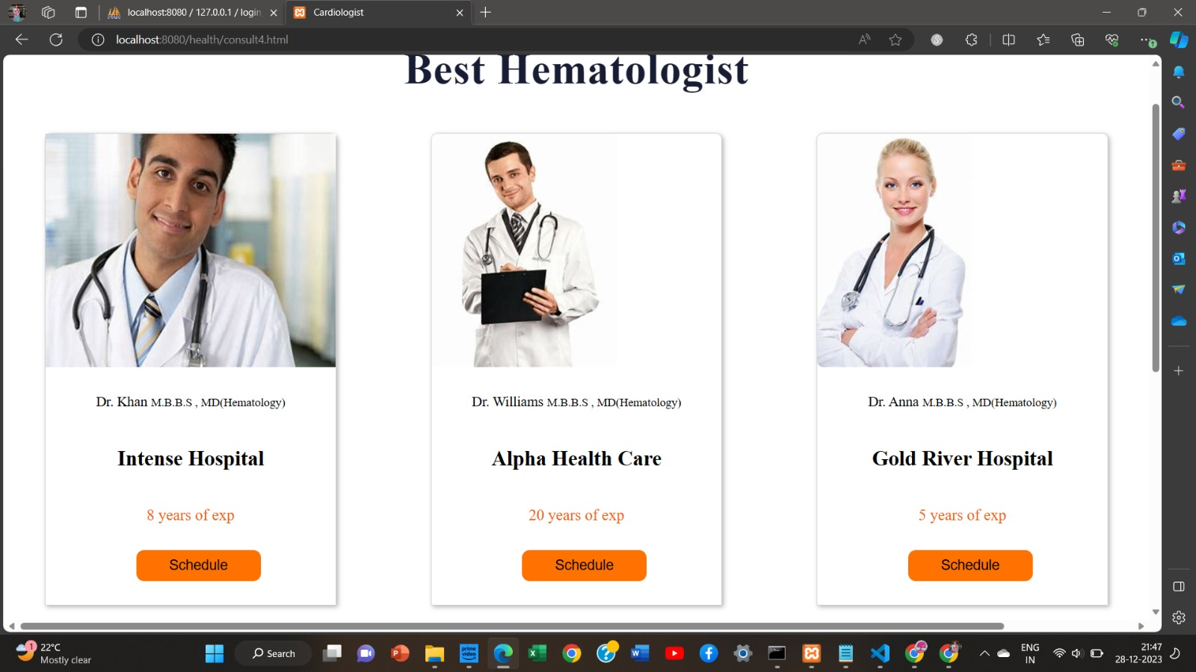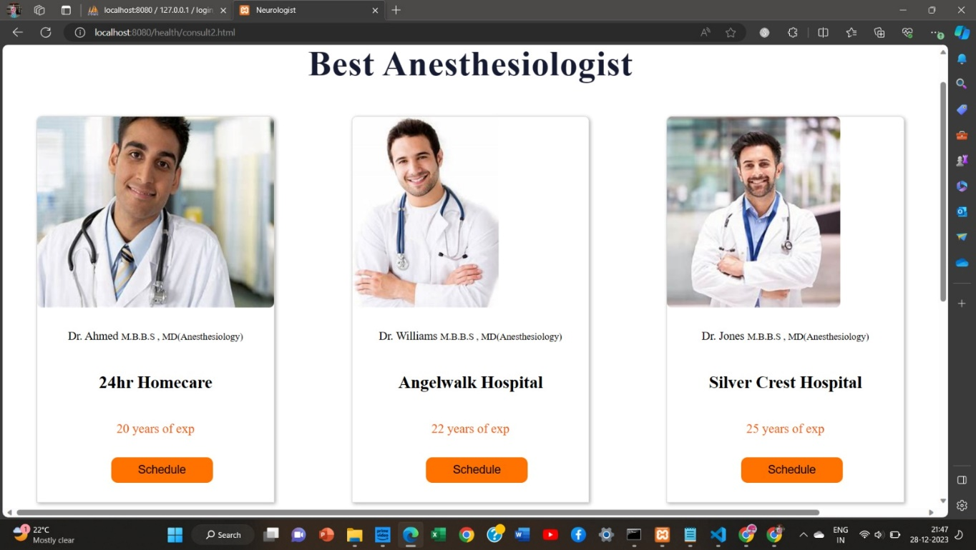

Figure 1.17

Figure 1.18

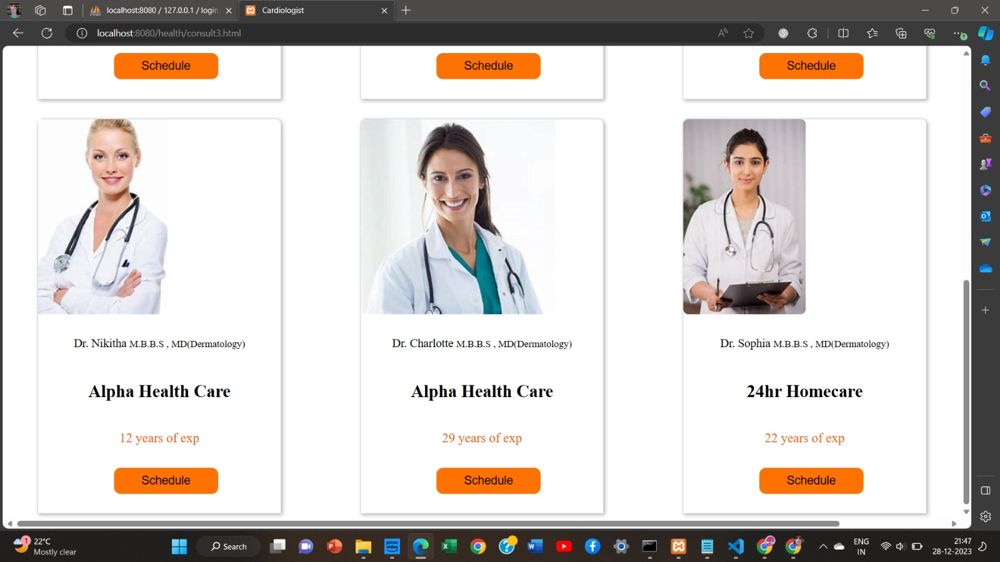

**APPENDIX-C**

**ENCLOSURES**

**1. Conference Paper Presented Certificates of all students.**

**2. Include certificate(s) of any Achievement/Award won in any project related event.**

**3. Similarity Index / Plagiarism Check report clearly showing the Percentage (%). No need of page-wise explanation.**

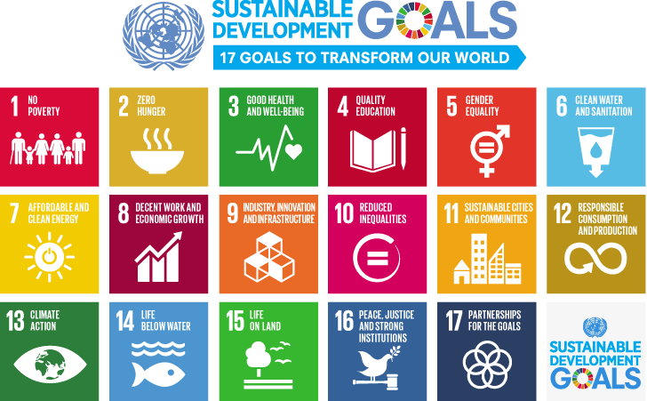

**The project work carried out here is mapped to SDG-3 Good Health and Well Being.**

The project work carried out here contributes to the wellbeing of human society. This can be used for appointment booking and insurance compatibility checks to save people’s time.