FINSIGHT
The Complete Technical Architecture
From First Principles to Production Pipelines
OCR & Extraction · PII Masking · Face Matching · Document Tampering Detection · Fraud Detection System
A ground-truth reference written directly from the deployed code —
every number, threshold and model version verified against the running system.
July 2026

How to Read This Book
This book documents FinSight's five completed AI/ML systems exactly as they exist in the codebase today — not as they were originally planned, and not aspirationally. Every threshold, every weight, every hyperparameter, and every measured number in these pages was read directly from the project's source files and configuration on the date this book was generated. Where the code and an earlier design comment disagreed (this happened at least once — the tamper-detection CNN's parameter count), the book uses the number obtained by actually running the code.
The book is written for a reader who may not have a machine-learning or computer-vision background. Part I is a self-contained primer: it introduces every concept the later parts rely on — what a neural network is, what an embedding is, what ensemble learning means, how to read a confusion matrix — before those concepts are used. If you already know this material, skip to Part II.

Structure
Part I — Foundations: the vocabulary and concepts used throughout the rest of the book.
Part II — OCR & Document Extraction: turning an uploaded photo or PDF into structured, validated data.
Part III — Document PII Masking: automatically redacting sensitive numbers before a human ever sees the raw document.
Part IV — Face Matching: verifying the same person appears across every submitted document.
Part V — Document Tampering Detection: nine independent detectors and the ensemble that fuses them — this is the deepest part of the book, and the one that answers the ensemble-learning question in full: what models exist, how they were trained, on what data, with what hyperparameters, and why each one carries the fusion weight it does.
Part VI — The Fraud Detection System: how the four systems above come together today, and the module designed to unify them next.
Part VII — Appendices: a glossary, the full annotated configuration file, and the complete library inventory with exact versions.

Conventions used in this book
A shaded blue box marked CONCEPT explains a general idea (e.g. "what is a convolution") before it is applied.
A shaded green box marked MEASURED IN THIS PROJECT reports a number that was actually run and recorded — not a textbook default.
A shaded amber box marked WHY IT MATTERS explains the practical consequence of a design decision — what would break, or what fraud pattern would slip through, if it were done differently.
A shaded red box marked HONEST CAVEAT states a real limitation. This book does not round up: where a component is a heuristic rather than a proof, or a pretrained model whose training data this project did not choose, that is said plainly.

Table of Contents
How to Read This Book 2
Structure 2
Conventions used in this book 2
Table of Contents 3
Part I — Foundations 6
1.1 The Problem This System Solves 6
1.2 Images as Numbers 6
1.3 What Is a Neural Network? 6
1.4 Convolutional Neural Networks (CNNs) 7
1.5 Training, Validation, and Overfitting 7
1.6 Precision, Recall, F1, and the Confusion Matrix 8
1.7 Embeddings and Cosine Similarity 8
1.8 OCR and Vision-Language Models 9
1.9 Ensemble Learning and Score Fusion 9
1.10 Calibration and the Sigmoid Function 10
1.11 Checksums, Regular Expressions, and Deterministic Validation 10
1.12 REST APIs and Client–Server Architecture 11
Part II — OCR & Document Extraction 12
2.1 Two Roads: Images vs. PDFs 12
2.2 The Five-Stage Image Cleanup Pipeline 12
Stage 0 — EXIF Orientation Fix 12
Stage 0.5 — Background Removal (optional, off by default) 12
Stage 1 — Resolution Normalisation 13
Stage 1.5 — Auto-Orientation ("which way is up?") 13
Stage 2 — Document Contour Detection & Deskew 13
Stage 3 — Adaptive Image-Quality Correction 13
Stage 4 — The Revert Guard 13
2.3 Why the Encoding Format Was the Single Biggest Speed Fix 14
2.4 The Reading Model: A Local Vision-Language Model 14
2.5 Guardrails: Never Trust the Model Alone 14
The Verhoeff checksum, worked through by hand 15
Format checks and confidence scoring 15
2.6 Performance Summary 15
Part III — Document PII Masking 17
3.1 Why Pattern Detection, Not Trust in the Extraction Step 17
3.2 What Gets Detected 17
3.3 Handling a Sideways or Mixed-Orientation Document 17
3.4 A Deliberate Bug Fixed: Over-Eager Substring Matching 18
3.5 Lazy Loading and Caching 18
Part IV — Face Matching 19
4.1 Two Separate Jobs: Detection, Then Recognition 19
Detection — OpenCV's YuNet 19
Recognition — OpenCV's SFace 19
4.2 Finding a Face at Any Orientation 19
4.3 Rescuing a Washed-Out Photo 20
4.4 Reading the Similarity Score 20
4.5 The Rule That Keeps This System Honest 20
4.6 From Pairs to One Overall Verdict 21
Part V — Document Tampering Detection 22
Chapter 7 — Why Tampering Detection Needs Many Signals, Not One 22
7.1 Two Fraud Families 22
7.2 The Nine Signals, at a Glance 22
Chapter 8 — The Deterministic Signals (Stage 1) 24
8.1 Metadata Forensics 24
8.2 Business Rules 24
8.3 PDF Forensics 24
8.4 Copy-Move Detection — the Deepest Classical Algorithm in the System 25
8.5 The Authenticity Signal — the One Non-Deterministic Signal in the System 26
Two layers, not one 26
The grounding gate — a real hallucination this project caught and fixed 27
How it's fenced into the fusion layer 27
8.6 The Stage-1 Gate: Why Most Clean Documents Never Reach Pixel Forensics 27
Chapter 9 — The Pixel Forensics Signals (Stage 2) 29
9.1 Error Level Analysis (ELA) 29
9.2 Noise Inconsistency Analysis 29
9.3 The Tamper CNN — Full Deep Dive 29
9.3.1 Why a Small Custom CNN, Not a Large Pretrained Model 30
9.3.2 Architecture, Layer by Layer 30
9.3.3 Patch-Based Training: Why Not the Whole Page 31
9.3.4 The Synthetic Dataset Generator 31
9.3.5 Group-Aware Splitting: Avoiding Data Leakage 32
9.3.6 Hyperparameters 33
9.3.7 Class-Weighted Loss 34
9.3.8 Two-Phase Training: Hard-Negative Mining 34
9.3.9 Version History: Ten Training Iterations 34
9.3.10 Reading v009's Real Confusion Matrix 35
9.3.11 From Patches to a Page Score: Sliding-Window Inference and Calibration 36
9.3.12 MC-Dropout: The Model Reporting Its Own Uncertainty 37
9.3.13 The Model Registry: A Deliberate Safety Gate 37
Chapter 10 — Fusion: This Project's Ensemble Learning, in Full 38
10.1 This System's Ensemble Family 38
10.2 Every Signal's Weight, and Why 38
10.3 Single-Signal Confidence: How Much a Lone Voice Is Trusted 39
10.4 The Three Fusion Paths 40
10.5 Worked Example: The Real Fake Payslip 41
10.6 Worked Example: The Genuine Unlocked Bank Statement 41
Part VI — The Fraud Detection System 42
11.1 Four Evidence Producers, Working Together Today 42
11.2 The Officer Decision Workflow 42
11.3 What's Designed but Not Yet Built: The Fusion Module 43
11.4 The RBI Compliance Engine (Built), and Deferred Credit-Risk Scoring 43
Appendix A — Glossary 44
Appendix B — The Annotated Tampering Configuration 46
Pipeline & Fusion 46
Per-Signal Tuning 46
Appendix C — Complete Library Inventory 47

Part I — Foundations
This part builds the vocabulary the rest of the book uses. Nothing here is FinSight-specific yet — these are the general ideas that machine learning, computer vision and document engineering all rest on. Part II onward will constantly refer back to these sections ("as explained in 1.4, this is a group-aware split"), so it is worth reading in order even if some sections feel elementary.

1.1 The Problem This System Solves
FinSight is a lending platform for a Non-Banking Financial Company (NBFC) — a company that lends money (personal loans, vehicle loans, gold loans, business loans, and so on) without being a licensed bank. Every loan application arrives with a bundle of documents: a PAN card, an Aadhaar card, salary slips, bank statements, and product-specific paperwork. Three things must happen to every one of those documents before a human underwriter should trust it:
- The information on it must be read accurately (this is OCR — Optical Character Recognition).
- Sensitive numbers on it must be hidden from casual viewing while still being verifiable (this is PII masking).
- The document itself must be checked for signs that it was edited or fabricated, and the person in the photo ID must be confirmed to be the same person across every document (this is tampering detection and face matching).
All four of those are built and running today. A fifth piece — combining their outputs into one fraud score — is designed but not yet implemented; Part VI covers exactly where that boundary sits.
WHY IT MATTERS
Why this matters for an NBFC specifically
A bank has in-person KYC (Know Your Customer) verification at a branch. Much of NBFC lending happens entirely online: a person photographs their own documents on a phone and uploads them. That removes the human check a bank teller would normally provide, which is exactly the gap this system exists to fill — automatically, before a loan officer ever sees the file.

1.2 Images as Numbers
Every image a computer works with — a photo of a PAN card, a scanned bank statement — is stored as a grid of numbers, not as a picture. Each tiny square in that grid is a pixel, and each pixel is usually described by three numbers: how much red, green and blue light it contains (an "RGB" image). A modest 1000×1300 pixel photo is therefore an array of 1000 × 1300 × 3 ≈ 3.9 million numbers, each between 0 and 255.
This matters because every algorithm in this book — from a simple brightness check to a neural network — is ultimately just arithmetic performed on that grid of numbers. "Brightness" is the average of all the numbers. "Sharpness" is how quickly neighbouring numbers change. "Finding a face" is finding a region of numbers that matches patterns the detector was shown during training. There is no magic beyond this — only which arithmetic is applied, and in what order.

1.3 What Is a Neural Network?
A neural network is a mathematical function built by stacking many simple layers on top of each other. Each layer takes in a set of numbers, multiplies them by a set of adjustable numbers called weights, adds them up, and passes the result through a small non-linear function (so the network can represent curves, not just straight lines). Stack enough of these layers and the network can approximate extremely complicated functions — such as "is there a tampered region in this document image".
"Training" a network means showing it many examples where the right answer is already known, measuring how wrong its current answer is (the loss), and nudging every weight slightly in the direction that would have made that example less wrong. Do this over millions of small nudges (across many examples, repeated for many passes called epochs) and the weights settle into values that generalise — meaning the network gets new, unseen examples right too, not just the ones it memorised.
CONCEPT
Weights vs. hyperparameters — a distinction used constantly in Part V
"Weights" are the millions of numbers INSIDE the network that training adjusts automatically.
"Hyperparameters" are the handful of settings a human chooses BEFORE training starts and that training does NOT adjust — how many examples to show at once (batch size), how big a step to nudge the weights by (learning rate), how many passes to make over the data (epochs). Get the hyperparameters wrong and training can fail outright, however good the weights would eventually have been.

1.4 Convolutional Neural Networks (CNNs)
A plain neural network that looked at every pixel of an image independently would need an enormous number of weights and would have no notion that nearby pixels are related. A Convolutional Neural Network (CNN) fixes this by sliding a small grid of weights (a filter, typically 3×3 pixels) across the whole image, computing the same small calculation at every position. This has two consequences that matter for this book:
- A single filter can detect the same pattern (an edge, a corner, later — a texture inconsistency) anywhere in the image, using far fewer weights than a plain network would need.
- Stacking several convolutional layers lets early layers detect simple things (edges) and later layers combine those into complex things (a region whose compression artefacts don't match its surroundings).
Between convolutional layers, a CNN typically shrinks the image with pooling (keeping only the strongest response in each small area — this is what "MaxPool 2×2" means: look at every 2×2 block and keep the single largest number, halving both width and height). This lets the network build up an increasingly abstract, increasingly compact understanding of the image as it goes deeper. Part V.9.3 walks through FinSight's own CNN, layer by layer, using exactly this vocabulary.

1.5 Training, Validation, and Overfitting
A model's accuracy on the exact examples it was trained on is not a trustworthy number — a large enough network can simply memorise the training examples without learning anything general, the way a student could memorise the answers to last year's exam without understanding the subject. This failure mode is called overfitting.
The standard defence is to hold back a slice of the labelled data — the validation set — that the model never sees during training, and to measure accuracy only on that held-back slice. If training accuracy keeps climbing while validation accuracy stalls or falls, the model has started memorising rather than learning.
WHY IT MATTERS
Data leakage — the subtle way this check can lie to you
If the training set and the validation set are not truly independent, validation accuracy can look good while still being untrustworthy. FinSight's own CNN training hit exactly this trap early on, and Part V.9.3.5 walks through the real fix (splitting by document GROUP, not by individual training crop) with a diagram.

1.6 Precision, Recall, F1, and the Confusion Matrix
For a system that sorts documents into two classes — genuine or tampered — "accuracy" (percent correct overall) can be misleading when one class is much rarer than the other. A model that always says "genuine" could still be 90% accurate if only 10% of documents are actually tampered, while being completely useless. Four sharper measurements are used throughout Part V:
Term | Definition | Why it's the number that matters here
True Positive (TP) | Actually tampered, correctly flagged | —
True Negative (TN) | Actually genuine, correctly cleared | —
False Positive (FP) | Actually genuine, wrongly flagged | Annoys a genuine borrower — costly, but a human review catches it
False Negative (FN) | Actually tampered, wrongly cleared | The expensive mistake — fraud goes through undetected
Precision | TP / (TP + FP) | Of everything flagged, how much was really tampered
Recall | TP / (TP + FN) | Of everything actually tampered, how much was caught — the number this project optimises for first
F1 score | harmonic mean of precision and recall | One number balancing both, used to compare model versions
A confusion matrix is simply a 2×2 table laying out those four counts (TP, TN, FP, FN) for one evaluation run, so a reviewer can see not just the summary percentage but exactly which mistakes were made and how many. Part V.9.3.9 shows the real confusion matrix for FinSight's live tamper-detection model.

1.7 Embeddings and Cosine Similarity
Many modern recognition systems (this project's face-matching system is one) do not try to directly classify an image. Instead they learn to convert it into a list of numbers — an embedding, sometimes called a "fingerprint" or "faceprint" — such that two embeddings from the SAME underlying identity end up close together in that numeric space, and two embeddings from DIFFERENT identities end up far apart. A face-recognition embedding is typically 128 to 512 numbers long; this project's face model produces 128.
"Close together" is measured with cosine similarity: imagine each embedding as an arrow pointing from the origin in a very high-dimensional space. Cosine similarity is the cosine of the angle between two such arrows — it equals 1.0 when the arrows point in exactly the same direction (identical), 0 when they are at right angles (unrelated), and −1.0 when they point in opposite directions. It only cares about direction, not length, which makes it robust to lighting/exposure differences that would change an embedding's magnitude but not the identity it represents.
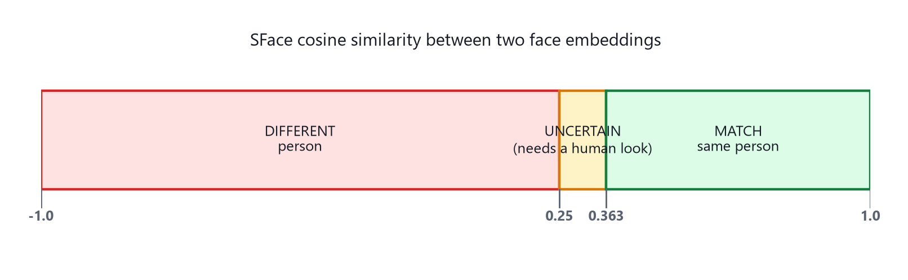
Figure 1.1 — The cosine-similarity scale this project actually uses for face matching, with the real thresholds explained in Part IV.

1.8 OCR and Vision-Language Models
OCR (Optical Character Recognition) is the general task of turning an image of text into machine-readable text. Classic OCR engines (like Tesseract) work by segmenting an image into individual characters and classifying each one. This project instead uses a Vision-Language Model (VLM) — a large neural network trained to jointly understand images and text, so it can be handed a photo of a document and a plain-English instruction ("extract the PAN number, name, and date of birth as JSON") and produce the answer directly, without a separate character-segmentation step. Part II covers exactly which VLM this project runs and why it runs locally rather than through a cloud API.

1.9 Ensemble Learning and Score Fusion
An ensemble is a system that combines the outputs of several individual detectors ("models", "signals", "experts" — this book uses "signal" for FinSight's individual detectors, since most of them are not machine-learning models at all) into one final answer, on the reasoning that different detectors make different mistakes, and a well-designed combination makes fewer mistakes than any single detector alone. There are several well-known families of ensemble, shown in Figure 1.2:
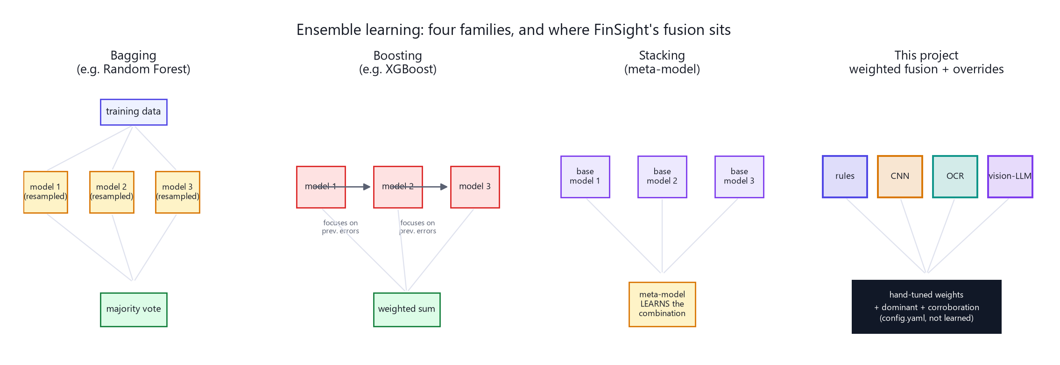
Figure 1.2 — Four ensemble families. FinSight's own fusion layer (rightmost) is closest in spirit to a weighted-voting ensemble, but with two hand-designed override rules layered on top — detailed fully in Part V, Chapter 10.
- Bagging (Bootstrap Aggregating) — train the SAME model architecture on many random resamples of the training data, then let the resulting models vote. Random Forest is the classic example (many decision trees, majority vote).
- Boosting — train a sequence of models where each new model focuses specifically on the examples the previous models got wrong, then combine them with learned weights. XGBoost and AdaBoost are classic examples.
- Stacking — train several different models, then train a further "meta-model" whose job is to learn the best way to combine their outputs.
- Weighted voting / mixture of experts — combine heterogeneous detectors using fixed or learned weights, optionally with override rules for cases where one detector's opinion should count more than a simple average would allow.
HONEST CAVEAT
Where FinSight's tampering system actually sits — read this before Part V
FinSight does NOT do classical bagging or boosting for its tamper-detection CNN: there is exactly one CNN architecture, and it was retrained through ten iterative versions (Part V.9.3.9) as more data accumulated — not ten different models voting.
What FinSight DOES build is a genuine, heterogeneous ensemble at the FUSION layer: nine independent signals of completely different kinds (pixel-forensics CNN, classical computer vision, file-metadata rules, arithmetic-checksum rules, and one vision-language-model judgement) are combined with hand-set weights, PLUS two override mechanisms — a "dominant evidence" rule and a "corroboration bonus" — that a simple weighted average alone would not provide. This is this project's actual ensemble-learning implementation, and Part V, Chapter 10 explains every one of its weights and why each was chosen.

1.10 Calibration and the Sigmoid Function
A raw model score is not automatically a trustworthy probability. A classifier might output 0.97 for its most confident correct predictions but also 0.97 for a good chunk of its mistakes — the raw number is directionally useful (higher = more suspicious) but not honestly calibrated (a raw score of 0.8 does not mean "80% chance of being tampered"). Calibration is the process of fitting a small correction curve — usually a sigmoid (S-shaped) curve — that maps raw scores to genuinely meaningful probabilities, using a held-out set of examples where the true answer is known.
The sigmoid function itself is: sigmoid(x) = 1 / (1 + e^−x). It squashes any real number into the range 0 to 1, which is exactly the shape a probability needs. Part V.9.3.10 shows the real calibration curve FinSight fitted for its live tamper-detection model, together with the exact formula and fitted constants.

1.11 Checksums, Regular Expressions, and Deterministic Validation
Not every check in this system uses machine learning at all — and several of the most reliable ones deliberately don't. A regular expression (regex) is a pattern that describes the valid SHAPE of a string, e.g. "5 uppercase letters, then 4 digits, then 1 uppercase letter" is the shape of a valid Indian PAN number. A checksum is a mathematical formula built into an identifier specifically so that a computer can verify it wasn't mistyped or fabricated — India's Aadhaar number uses a checksum called the Verhoeff algorithm, explained in full with a worked example in Part II.5.
CONCEPT
Why deterministic checks are trusted MORE than the AI checks in this system
A regex or checksum either matches or it doesn't — there is no ambiguity, no training data it could have been biased by, and no possibility of a "confidently wrong" answer the way a neural network can produce. Wherever this book says a signal has fusion confidence 1.00 (Part V, Chapter 10), it is because that signal is one of these deterministic checks.

1.12 REST APIs and Client–Server Architecture
FinSight is built as two separate programs that talk to each other over the network using HTTP, the same protocol web browsers use to load pages: a backend (written in Python, using a framework called FastAPI) that does all the actual processing — OCR, masking, face matching, tampering detection — and a frontend (written in JavaScript/React) that renders the screens a loan officer or borrower actually sees and clicks through.
The frontend and backend communicate through a REST API: the frontend sends an HTTP request (e.g. "POST this file to /extract") and the backend sends back a response, almost always formatted as JSON (a simple, human-readable way of writing structured data — think of it as a universally-understood way to write a Python dictionary or a JavaScript object as plain text). Every diagram in Parts II through VI that shows an arrow labelled "POST /something" is describing exactly this kind of request.

Part II — OCR & Document Extraction
This is the first thing that happens to any document a user uploads. Its job is narrow but critical: turn a photo or PDF into structured, labelled, validated data — a PAN number in a field called pan_number, not just "some text somewhere on the page" — while being fast enough that a real person waits for it on a real screen.

2.1 Two Roads: Images vs. PDFs
The very first decision the backend makes is what kind of file it received, checked by looking at the file's actual byte content (the first five bytes of a real PDF are always the literal text %PDF-), never by trusting the filename extension a browser reports — a renamed file cannot fool this check. Images and PDFs then take completely different paths through the system, because they have opposite problems.
- A photo taken on a phone camera can be blurry, tilted, poorly lit, or rotated with no record of which way is up — problems a scanner-fed PDF essentially never has. So images get a five-stage cleanup pipeline before anything else touches them.
- A PDF is already digital text-and-vector data (or a clean embedded scan); there is nothing to physically straighten or re-light. So PDFs skip the entire cleanup pipeline and go straight to being rendered into images for the reading model.
CONCEPT
The original file is never thrown away
Whichever path a document takes, the SERVER KEEPS THE ORIGINAL, UNTOUCHED BYTES aside before doing any cleanup. This matters because Part V's tampering-forensics signals read exactly the kind of fine detail (JPEG compression history, sensor noise) that cleanup would destroy. OCR gets the cleaned-up copy for the best possible reading accuracy; forensics always gets the original.

2.2 The Five-Stage Image Cleanup Pipeline
Every uploaded photo passes through five stages, each of which is a measured, independently-justified fix — not a single generic "enhance" filter applied blindly.

Stage 0 — EXIF Orientation Fix
A phone's camera sensor doesn't physically rotate when you turn the phone to take a portrait photo — instead, the phone writes a note into the image file's metadata (called EXIF data) saying "this was captured rotated; display it turned by this amount." Most image viewers respect that note automatically, but raw pixel-processing code does not unless it is told to. Stage 0 reads that EXIF orientation tag and physically transposes the pixel grid to match it, so every later stage works on an image that is actually right-side-up in its stored pixels, not just in a metadata flag.

Stage 0.5 — Background Removal (optional, off by default)
An optional stage that can remove a document's background if enabled — kept off by default because it adds meaningful processing time for a benefit that only matters for a minority of upload conditions (a document photographed on a highly cluttered background).

Stage 1 — Resolution Normalisation
Phone cameras now commonly produce images 4000+ pixels wide. That much resolution is unnecessary for either reading text or running the cleanup stages that follow, and it multiplies processing time for every later step. Stage 1 caps the image at a resolution that keeps text legible while keeping the pipeline fast.

Stage 1.5 — Auto-Orientation ("which way is up?")
If EXIF data was missing or wrong (common — messaging apps like WhatsApp routinely strip EXIF metadata when a photo is forwarded), the document could still be sideways or upside down. This stage answers that question empirically rather than guessing: it downsizes the image to a small 450-pixel thumbnail (chosen because detecting which way TEXT DIRECTION runs does not need full reading resolution — measured: RapidOCR's own processing cost scales steeply with input size, while character recall barely drops below roughly 500 pixels), then scores candidate rotations.
The scoring is coarse-to-fine, an optimisation worth understanding precisely: it first tries only the four cardinal rotations (0°, 90°, 180°, 270°) — because real phone photos are essentially always rotated in clean 90° multiples, never at odd angles — using a lightweight OCR pass (RapidOCR) at each angle. Only if those four results are ambiguous (the best score is not at least double the second-best) does it widen the search to the remaining eight angles in 30° steps. The score for each candidate angle is not a simple character count; it is a confidence-weighted character score — the number of characters detected in each text region, multiplied by that region's OCR confidence, summed across the page. This means a rotation that reads fewer characters but with much higher confidence can still beat a rotation that reads more characters garbled. Whichever rotation scores highest is applied, but only if it beats the original by more than 10% — a deliberate margin so a document that was already upright is never needlessly flipped by noise in the scoring.

Stage 2 — Document Contour Detection & Deskew
This stage tries to find the document's four physical corners against its background (using classical edge-detection: Canny edge detection followed by contour analysis) and, if found, applies a perspective warp that "flattens" an angled photo the way a flatbed scanner would have captured it. If no clean four-corner contour is found — common when the document fills the whole frame with no visible background — the stage falls back to measuring the overall tilt angle of the text lines and rotating by that smaller amount, skipping the correction entirely if the measured tilt is below roughly 0.3° (not worth the risk of introducing new artefacts for an angle nobody would notice).

Stage 3 — Adaptive Image-Quality Correction
Rather than always applying the same fixed brightness/contrast/sharpen/denoise filter, this stage first MEASURES the image's actual brightness, contrast, sharpness and noise level as numbers, and only applies the specific correction each measurement calls for — gamma correction only if highlights are genuinely blown out, sharpening only if genuine blur is detected, and so on. An already-good photo passes through this stage almost unchanged.

Stage 4 — The Revert Guard
This is the safety net that makes the whole pipeline provably unable to make things worse. Both the cleaned-up image and the original are independently OCR'd (again as small thumbnails, for speed) and their readable-character counts are compared. If the cleaned-up version reads fewer than roughly 70% of the characters the original read, the entire cleanup is discarded and the original image is used instead. Every earlier stage's fix is therefore always "try it, then prove it helped" rather than a blind, irreversible transformation.
Real server log for one uploaded photo (verified this session):
[Stage 0] EXIF orientation fix — done
[Stage 1] Resolution 2143x3301 OK
[Stage 1.5] Auto-orientation — 0deg weighted=6.0, 90deg weighted=74.0
-> Rotating 90deg (+1130% over next-best)
[Stage 2] No document contour found -> fallback deskew: 0.00deg negligible, skipped
[Stage 3] Adaptive IQA: highlight(g=1.22), sharpen(lap=57.5)
[Stage 4] Chars (450px compare) - original: 26 preprocessed: 105
-> [ok] Preprocessed is better or equal - keeping

2.3 Why the Encoding Format Was the Single Biggest Speed Fix
MEASURED IN THIS PROJECT
Measured in this project: a 25× file-size difference
The cleaned-up image used to be re-encoded as a lossless PNG before being sent to the reading model. On one real 2760×1792 test photo, that PNG was 8.7 MB. Switched to JPEG at quality 92 (visually indistinguishable for the purpose of reading text), the same image became roughly 350 KB — and because a vision model turns every patch of an image into processing tokens, a smaller image is directly, proportionally faster to read. This single change cut total end-to-end time for a real image upload from roughly 75 seconds (cold) down to roughly 11 seconds (warm, steady-state) — a bigger win than any of the five cleanup stages individually.

2.4 The Reading Model: A Local Vision-Language Model
The cleaned image (or, for a PDF, up to four rendered pages) is sent to Ollama — a program that runs large language models entirely on the local machine, with no data leaving the server — hosting qwen2.5vl:7b, a 7-billion-parameter vision-language model quantized to Q4_K_M (a compression format that shrinks the model's memory footprint roughly fourfold by storing its weights at lower numeric precision, in exchange for a small, generally imperceptible accuracy cost — this is what makes running a 7-billion-parameter model practical on a normal server instead of requiring a data-centre GPU cluster).
The model is called with temperature set to 0 — meaning it is instructed to always pick its single most likely next word rather than sampling with any randomness, which is what "temperature" controls in a language model. This is deliberate: OCR must be as literal and repeatable as possible; creative variation is the opposite of what a lending platform reading a PAN number needs. Each document type gets its own tailored prompt (stored in doc_types.py) instructing the model exactly which fields to return and in what JSON shape — for example the PAN-card prompt asks for exactly {"pan_number":..., "full_name":..., "dob":..., "father_name":...} and nothing else.

2.5 Guardrails: Never Trust the Model Alone
A vision-language model can misread — and worse, it can "hallucinate" a plausible-looking but wrong answer with no visible sign of uncertainty. This project treats every extracted field as a claim to be verified, never as a fact to be trusted outright, using purely deterministic checks (Section 1.11's regex and checksum ideas, applied here concretely).

The Verhoeff checksum, worked through by hand
An Aadhaar number's final digit is not arbitrary — it is a checksum digit computed from all the preceding digits using the Verhoeff algorithm, specifically so that a single mistyped or fabricated digit can be caught mathematically, without needing to check the number against any database. The algorithm processes the digits from right to left, maintaining a running value that starts at 0. For each digit, it looks up a value in a "multiplication table" built from the symmetry group of a pentagon (this specific mathematical structure is chosen because it detects a slightly wider class of common errors than simpler checksums like Luhn's algorithm, including every single-digit error and every adjacent-digit transposition). A valid number always ends this process with the running value back at exactly 0.
- If any single digit was mistyped: the running value will not return to 0 — caught.
- If two adjacent digits were swapped (a very common data-entry mistake): also caught.
- A number invented by a forger who didn't know this checksum existed will fail it with near certainty.

Format checks and confidence scoring
Alongside the Aadhaar checksum, the same guardrail layer validates PAN numbers against the fixed pattern 5 letters, 4 digits, 1 letter; IFSC bank codes against 4 letters, a literal 0, 6 alphanumeric characters; and GSTIN business-tax numbers against their own fixed structure. Every field is assigned a flag — ok, warn, or error — and the whole document is given a confidence score equal to the fraction of its fields that came back ok. A document with any error flag, or an overall confidence below 0.7, is automatically routed for human review rather than silently auto-filling the application.

2.6 Performance Summary
Stage of the fix | Before | After | Measured on
Auto-orientation scoring resolution | 700 px | 450 px | real photo, verified 31% preprocessing speedup
Stage-4 compare resolution | 900 px (full-res) | 450 px | same photo — cut Stage 4 from ~35s of a ~42s total to a few seconds
Output encoding | lossless PNG (8.7 MB) | JPEG q92 (≈350 KB) | real 2760×1792 photo — the single largest win
End-to-end, warm server | ~75–78 s | ~11 s | same document, repeat request after model warm-up
HONEST CAVEAT
Cold start is a separate, unavoidable cost
The VERY FIRST request after the Ollama service or the API server restarts is still slow (~75–80s) because Ollama has to load the 7-billion-parameter model into memory for the first time. This is a one-time infrastructure warm-up cost, not a per-image cost — it does not recur on the second, third, or thousandth upload.

Part III — Document PII Masking
Once a document has been read and validated, a loan officer reviewing an application needs to be able to glance at the document to confirm it looks right — but does not need, and under India's KYC (Know Your Customer) data-handling norms should not casually see, the borrower's full Aadhaar number, PAN number, or bank account number in the clear. This system automatically redacts exactly those numbers wherever they appear, while leaving the last four digits visible — the standard compromise that lets a reviewer still cross-check a document without exposing the complete identifier.

3.1 Why Pattern Detection, Not Trust in the Extraction Step
HONEST CAVEAT
The extraction step is deliberately NOT the source of truth for masking
Part II's OCR step is instructed to NEVER invent the digits of a masked Aadhaar number it can already see is partially hidden — so its own extracted field might legitimately read "XXXX-XXXX-1234". But the IMAGE itself may still show the FULL, unmasked number printed on the physical card. If masking simply trusted the extracted field, it would miss exactly the numbers most in need of hiding. So masking re-reads the document from scratch with its own OCR pass and looks for the number's SHAPE directly on the page — a 12-digit run, three 4-digit groups on one line, a 10-character PAN pattern — rather than trusting any upstream field.

3.2 What Gets Detected
- PAN numbers — the same fixed pattern from Part II.5 (5 letters, 4 digits, 1 letter), detected directly in the page's OCR text.
- Aadhaar numbers — either as a single 12-digit run, or (the more common printed layout) as three separate 4-digit groups sitting on the same line; the detector recognises both layouts.
- Long account/card numbers — any 9-to-18-digit run that isn't a 12-digit Aadhaar number and doesn't contain a decimal point (which excludes money amounts like 1,56,400.00 from being mistaken for an account number).
- As a supplementary anchor, the account number OCR already extracted for this document (Part II) is also searched for on the page, in case its printed form is slightly different from a pure digit-run.
Whichever of these patterns matches, a redaction bar is painted over every character except the last four, which is what the earlier claim about "the standard last-4-digit compromise" refers to concretely: for a single matched number, the bar covers a proportional slice of its bounding box (roughly all but the final 4 characters' width); for the three-separate-groups Aadhaar layout, the first two groups are fully covered and the third is left untouched.

3.3 Handling a Sideways or Mixed-Orientation Document
ID cards are frequently photographed at an angle, and — a subtlety that matters here — a single card can legitimately carry text in MORE than one orientation on the same page (a horizontal header alongside a vertically-printed serial number, for example, which is common on Indian ID cards). Masking therefore does not simply try the whole page at one rotation and give up. It first tries the page as uploaded; if nothing sensitive is found, it re-runs OCR at each of the other three 90° rotations and, for anything found there, mathematically maps the detected box back onto the ORIGINAL, upright image using the exact geometric transform for that rotation, so every redaction bar still lands in the right place on the one image that gets shown to the reviewer — even when the sensitive text was only readable sideways.
MEASURED IN THIS PROJECT
Measured in this project: a real sideways Aadhaar card
A genuine test Aadhaar photo had its Aadhaar number printed running vertically along the card's edge — invisible to the upright OCR pass. The rotation-and-remap logic found it at the 90° pass and correctly redacted it in place on the upright preview, with the last four digits ("9012") left legible.

3.4 A Deliberate Bug Fixed: Over-Eager Substring Matching
An early version of the matcher would flag a short field (like a 4-digit employee ID, "1234") as "found" whenever it appeared as a SUBSTRING of a longer cited number — which meant an employee ID that happened to be a substring of a much longer account number could get a stray redaction bar drawn over an unrelated field. The fix requires a match to be either an exact match, or the shorter string must be at least 4 characters AND the LONGER of the two numbers must be reasonably close in length to the shorter (not simply "contains") — verified on the same real document that the employee ID box disappeared while the true account-number redaction remained correct.

3.5 Lazy Loading and Caching
Running an OCR pass and drawing redactions costs a couple of seconds of server time — real, but not something every document should pay for on every page load. The frontend only requests a masked preview the FIRST TIME a reviewer actually hovers over a document's thumbnail to enlarge it, and caches the result after that, so re-hovering the same document is instant and a document nobody ever looks closely at never costs anything beyond its initial OCR.
While the masked image is being generated, the enlarged preview shows a "Securing preview…" placeholder rather than the raw document — the unmasked image is never shown, not even for a single frame, while its safe version is being prepared.

Part IV — Face Matching
A borrower typically submits several documents that carry a photograph — a PAN card, an Aadhaar card, sometimes a passport-style photo. This system's job is to answer one specific question with evidence a human can double-check: does the same person's face appear on every one of these documents? A mismatch is exactly the signature of identity fraud — someone else's ID photo attached to a different person's application.

4.1 Two Separate Jobs: Detection, Then Recognition
"Find where a face is in this image" and "determine whose face it is" are two different problems solved by two different models in sequence, a standard architecture in production face-recognition systems.

Detection — OpenCV's YuNet
YuNet is a small, fast, anchor-free face detector distributed through the OpenCV Zoo (the ONNX model file is roughly 230 KB). "Anchor-free" means it does not rely on a predefined grid of candidate box shapes the way older detectors did — it directly regresses a face's bounding box and five facial landmark points (both eyes, the nose tip, both mouth corners) from the image. This project runs it with a detection-confidence threshold of 0.6, deliberately lower than YuNet's own common default of around 0.9 — ID-card photographs are small and often low-quality, and the higher default threshold was measured to miss faces this system genuinely needs to find.

Recognition — OpenCV's SFace
Once a face box is found, SFace (also distributed through the OpenCV Zoo, roughly 37 MB) converts the aligned face crop into a 128-number embedding — exactly the concept introduced in Section 1.7. Two embeddings are then compared with cosine similarity to decide whether they represent the same person.
HONEST CAVEAT
Neither model was trained by this project
YuNet and SFace are used exactly as published, third-party, pretrained ONNX models — this project loads their published weights and never retrains or fine-tunes them. This is a deliberate, sensible choice: face detection and face recognition are extremely well-studied problems with large, mature public training pipelines behind models like these, and there would be no realistic way for a project this size to collect the millions of face images needed to train a comparable model from scratch. What this project DOES own and calibrate itself is everything AROUND these two models — the rotation sweep, the low-quality fallback, the similarity thresholds, and the safety rule in Section 4.4 below.

4.2 Finding a Face at Any Orientation
An ID card photographed at an angle can leave the printed portrait itself sideways or even upside down in the uploaded image. Rather than assuming the document's overall orientation (already handled once for OCR in Part II) is also correct for face detection, this system runs YuNet at all four 90° rotations (0°, 90°, 180°, 270°) for every document and keeps whichever rotation produces the single strongest detection. The chosen rotation is recorded ("rotation_to_upright") and shown to a reviewer, alongside the fine residual tilt angle computed from the line between the two detected eye points — so a reviewer can see not just THAT a face was found but exactly how it was sitting in the original photograph.
Multiple faces per document are supported and used: an Aadhaar card commonly carries both a large primary photo and a small secondary "ghost" photo (a security feature), and both are detected independently, up to four faces per document.

4.3 Rescuing a Washed-Out Photo
MEASURED IN THIS PROJECT
Measured in this project: a real overexposed PAN card photo
A genuine test PAN card's printed photograph was so overexposed (blown-out highlights) that YuNet could not detect a face in it at all, at any rotation, at any threshold down to 0.3. Applying CLAHE (Contrast-Limited Adaptive Histogram Equalization — a technique that boosts local contrast in an image without over-amplifying noise the way a simple global contrast stretch would) followed by gamma darkening (gamma 2.5, which compresses bright tones more than dark ones) recovered the face at a detection confidence of 0.76 — from completely undetectable to reliably found.
This enhancement pass only runs as a FALLBACK, when the unenhanced image yields no detection at all — it costs extra processing time, so a normal, well-exposed document never pays for it. Crucially, any face recovered only through this rescue path (or detected with an unusually weak raw confidence below 0.7) is tagged quality: "low", which feeds directly into the safety rule in the next section.

4.4 Reading the Similarity Score
Figure 4.1 — SFace's cosine-similarity scale, with the exact bands this system applies.
0.363 is not a number this project invented — it is SFace's own officially published, validated decision threshold: two embeddings with cosine similarity at or above 0.363 are considered the same person by the model's own designers' benchmarking. Below 0.25, this system independently calls the pair different people. Between those two numbers is a deliberate, explicit "uncertain" band — real ID-card photographs vary enough in age, lighting and print quality that forcing every comparison into a hard yes/no at a single threshold would manufacture false confidence in exactly the borderline cases that most need a human's eyes.

4.5 The Rule That Keeps This System Honest
WHY IT MATTERS
A low-quality face may CONFIRM a match, but can never assert a mismatch
If either face in a compared pair was only found via the contrast-rescue fallback, or was detected with unusually low raw confidence, that pair's comparison is never allowed to be reported as "different person" — even if the raw cosine similarity falls below the 0.25 different-person threshold. In that specific situation the verdict is downgraded to "uncertain", with an explicit note that photo quality, not identity, may be the reason the score is low. WHY THIS MATTERS: a lending platform that confidently declared "different person!" on the strength of a bad photo would manufacture fraud alerts against genuine, innocent borrowers — exactly the outcome a system like this must never produce automatically. This rule was written directly in response to testing against a real, badly overexposed borrower photo.

4.6 From Pairs to One Overall Verdict
A loan application can carry more than two documents with faces on them, so every possible PAIR of documents (each with at least one detectable face) is compared, and the strongest-matching face pair between each two documents is kept as that pair's result. The overall verdict shown to a reviewer follows simple, strict logic:
- insufficient — fewer than two documents had a detectable face at all; nothing to compare.
- mismatch — at least one pair was confidently scored as a different person. This is the loudest possible signal and is always surfaced, even if other pairs matched fine.
- match — every compared pair scored as the same person.
- uncertain — everything else: at least one pair fell in the ambiguous band, or was downgraded by the low-quality safety rule above.
All of this runs in a single request from the frontend that sends every uploaded document at once, typically completing in around two seconds of server time for five documents — fast enough to run automatically the moment a reviewer opens the application's Review & Submit page, with no manual "run check" button required.

Part V — Document Tampering Detection
This is the deepest and most technically involved part of the book, because it is where this project's ensemble learning actually lives. A document can be fraudulent in two fundamentally different ways, and — this is the central engineering insight this whole part is built around — no single detector can catch both.

Chapter 7 — Why Tampering Detection Needs Many Signals, Not One

7.1 Two Fraud Families
EDITED documents start out genuine and are then altered — a real bank statement where one digit of a balance was changed, or a real salary slip where a number was whited-out and retyped. These leave physical traces: a pasted region has a different JPEG compression history than the rest of the page; a locally-redrawn area has different sensor noise; a copied-and-pasted row is pixel-for-pixel identical to another region of the same page. Forensic, pixel-level analysis is built specifically to catch this family.
FABRICATED documents are built from scratch — an entirely computer-generated "salary slip" that was never a real document to begin with, often produced by a script or an AI tool. These carry NO forensic edit traces at all, because nothing was ever edited — there is no genuine original to compare against. Pixel forensics is structurally blind to this family, by definition: it looks for evidence of change, and a fabricated document never changed.
WHY IT MATTERS
This is not a hypothetical distinction — it is the exact gap a real incident exposed
Earlier in this project's life, an AI-generated fake salary slip was submitted as a test and was NOT flagged, because every forensic pixel-level signal correctly found nothing (there was nothing to find — the whole document was fabricated, not edited). This directly motivated adding a completely different KIND of signal — the authenticity check in Section 8.5 — that judges whether a document looks like a genuine institutional artefact at all, rather than looking for edit traces.

7.2 The Nine Signals, at a Glance
Signal | Catches | Stage | Runs on
metadata | EXIF editor software tags | 1 | images only
business_rules | Bad checksums, broken arithmetic, placeholders | 1 | OCR'd fields, any format
copy_move | Duplicated regions within one page | 1 | images + PDFs
pdf_forensics | Re-saves, generator/editor producer strings | 1 | PDFs only
authenticity | Fabricated-from-scratch documents | 1 | income/financial doc types
ela | Localised JPEG re-compression inconsistency | 2 (escalated only) | camera photos / scans
noise | Localised sensor-noise inconsistency | 2 (escalated only) | camera photos / scans
cnn | Learned visual tamper patterns | 2 (escalated only) | camera photos / scans
"Stage 1" signals are cheap and always run. "Stage 2" signals are more expensive pixel-forensics and only run if Stage 1 found reason for concern — this two-stage gate is explained fully in Chapter 8's closing section and is the reason a genuinely clean document is typically evaluated in well under a second.

Chapter 8 — The Deterministic Signals (Stage 1)
Every signal in this chapter is either a fixed rule or a classical (non-learned) computer-vision algorithm — no neural network, no training data, no possibility of the kind of confident-but-wrong mistake a learned model can make. This is why, as Chapter 10 will show, these signals are trusted with the HIGHEST fusion confidence in the entire system.

8.1 Metadata Forensics
The cheapest possible evidence: many image files carry an EXIF "Software" tag recording which program last touched them. If that tag names a known photo editor (Photoshop, GIMP, Canva, Lightroom, Snapseed, and roughly a dozen others configured in this project), that alone is strong evidence — genuine camera photos are not touched by editing software before being uploaded to a lending platform. The signal reports the MAXIMUM of its individual observations, not their sum, on the philosophy that three weak hints do not add up to proof, but one clear editor tag is close to it. Missing EXIF data entirely is scored only weakly (0.15) and deliberately so — WhatsApp, Telegram and most messaging-app upload pipelines strip EXIF data from perfectly genuine photos as a matter of routine, so its absence alone is a poor signal of anything.

8.2 Business Rules
Covered in depth already in Part II.5 (the Verhoeff checksum worked example) — this signal is the same engine, but reused here specifically as tampering EVIDENCE rather than as an extraction-confidence gate. It additionally checks whether a document's own internal arithmetic is self-consistent: does gross salary minus deductions equal the stated net salary, within a one-rupee tolerance? Does a bank statement's opening balance plus credits minus debits equal its closing balance? A forger who edits one number rarely remembers to fix every other number that mathematically depends on it — this is a deliberately cheap, deterministic, and (as Chapter 10 will show) extremely trustworthy check.
This signal ALSO does a narrow, deterministic scan for obviously fake placeholder values printed directly in fields that should carry real identifying information — a bank name field literally reading "abc bank", or an account number that is a repeated or perfectly sequential run of digits like "123456789". These patterns are so specific (word-boundary matched, narrow keyword list) that a genuine document essentially cannot trigger them by coincidence.

8.3 PDF Forensics
A born-digital PDF (as opposed to a scanned photo saved as a PDF) has no JPEG compression history for pixel forensics to examine — but the FILE ITSELF still testifies. This signal reads two kinds of evidence directly from the PDF's raw byte structure and metadata, without needing a full PDF parsing library:
- Incremental updates — a PDF that has been saved more than once appends the new save AFTER the original end-of-file marker rather than rewriting the whole file, so counting occurrences of the %%EOF marker (or the startxref keyword) reveals how many times the file was saved. A bank-generated statement is written once; more than one save generation is a re-save event worth noting.
- Producer/Creator strings — every PDF records which software generated it. This project distinguishes THREE different categories of producer, each scored differently: (1) known photo/document EDITING tools (Photoshop, iLovePDF used as an editor, and similar) score the highest, 0.85; (2) developer/scripting PDF-GENERATION LIBRARIES — jsPDF, reportlab, pdfkit, and roughly twenty others — score 0.62, because a genuine employer's payroll system or a bank's statement generator is never built on a hand-run script or browser library, while a FABRICATED salary-slip generator commonly is exactly that; (3) PDF UTILITIES — iLovePDF, Smallpdf and similar tools used for unlocking or compressing, not editing — score a lower 0.60, with honest wording explaining that the SAME tool can be used to merely unlock a password-protected bank statement (routine and legitimate) or to actually edit its contents, and the file's metadata alone cannot tell which happened.
HONEST CAVEAT
A real false-positive this project found and fixed
A genuine, unmodified bank statement that a borrower had simply unlocked from its bank-issued password protection using iLovePDF was originally being scored as clean/silent on this signal — which on reflection was wrong: the file WAS re-processed after the bank issued it, and staying silent about that hid a legitimate thing to note. It now correctly surfaces as a MEDIUM-tier note ("re-processed after issue — could be unlock or edit, verify") rather than either silently passing OR being wrongly treated as equivalent to a confirmed editing tool. This is a case where the fix was not "stop flagging it" but "flag it honestly, at the right severity."

8.4 Copy-Move Detection — the Deepest Classical Algorithm in the System
This signal catches a very specific and otherwise-hard-to-detect fraud technique: content copied from ONE part of a document and pasted onto ANOTHER part of the SAME document — duplicating a transaction row, cloning an official stamp, repeating a digit. Because the pasted pixels came from the same image, they share its exact same compression history, so Error Level Analysis (Section 9.1) sees nothing unusual about them at all. A completely different technique is needed, and this project uses a five-step classical computer-vision pipeline with no machine learning involved.
- 1. ORB keypoint detection — find up to 4,000 small, distinctive, rotation-and-scale-robust visual features across the page (corners, textured spots, letterforms — anything a matching algorithm can reliably re-recognise).
- 2. Self-matching — compare every keypoint's descriptor against every OTHER keypoint's descriptor on the SAME page (not against a second image), looking for near-identical pairs. A duplicated region produces keypoints that match another region on the same page almost perfectly.
- 3. Lowe's ratio test — a classic filter that keeps a candidate match only if it is significantly more distinctive than the second-best alternative match (ratio 0.75), discarding ambiguous matches that could be coincidental similarity rather than true duplication.
- 4. Displacement clustering — a genuine copy-paste produces MANY keypoint pairs that all share the SAME displacement vector (the region moved by one consistent x,y offset); random incidental similarity (repeated document text, a common word appearing on several lines) scatters across many different, inconsistent displacements. Matches are grouped ("binned") by their rounded displacement, and neighbouring bins are merged to absorb small measurement jitter.
- 5. Pixel-level verification (NCC) — the step that finally separates a REAL copy-move from mere repeated text. A dense cluster of matching keypoints only proves "similar features, consistent shift"; a genuine copy-paste is additionally PIXEL-IDENTICAL. The two candidate regions are aligned using only the tightly-agreeing inlier points (a subtlety found through real testing: including stray outlier points from a neighbouring displacement bin can inflate a true 148×49 pixel patch into a spurious 439×98 box, diluting the correlation score from near-1.0 down to around 0.30 even for a perfect duplicate) and compared with Normalized Cross-Correlation. A score at or above 0.92 is treated as verified, pixel-identical duplication.
HONEST CAVEAT
An honestly-acknowledged ambiguity this signal cannot resolve alone
Real testing found a genuine false positive: the short label "CHQ DEP" appearing twice on two different rows of an authentic bank statement is, by coincidence, pixel-identical at a size (187×28 px) that overlaps the size range of real forged regions (measured across 20 real forgeries: 16–253 px wide, 16–60 px tall). Geometry and pixel correlation alone genuinely cannot tell "a forger copied this row" from "this label just repeats" — that requires understanding whether the matched text is a category LABEL (expected to repeat) or a VALUE (which should never repeat), which is business_rules' job, not this pixel-only signal's. This is exactly why a verified copy-move match is deliberately capped at fusion confidence 0.50 (Chapter 10) rather than 1.0 — strong evidence, not proof, and always routed to a human rather than auto-flagged HIGH on its own.
A related, separate refinement handles ID cards specifically: a PAN or Aadhaar card legitimately contains small pixel-identical repeats by construction (a person's surname repeating in "Name" and "Father's Name", or a repeated official emblem/security pattern) that are not forgery. For these document types, a duplicated region must cover at least 1.5% of the page's area to count as evidence — filtering out a shared surname (well under 0.3% of the card) while still catching an actually swapped photograph (roughly 4%+ of the card).

8.5 The Authenticity Signal — the One Non-Deterministic Signal in the System
This is the signal built specifically to close the fabricated-document gap described at the top of Chapter 7, and it is deliberately the ONLY signal in the whole cascade that involves a probabilistic AI judgement rather than a fixed rule or classical algorithm — which is precisely why it carries the heaviest, most carefully engineered set of safeguards of any signal in this book.

Two layers, not one
Layer 1 is fully deterministic and runs first, always: the page is OCR'd and scanned for VERBATIM placeholder text actually printed on it — an institution name matching a pattern like "abc bank" or "xyz company", or a sequential/repeated account number. These are FACTS read off the page, not opinions, and alone are strong enough evidence to flag a document even if the AI layer below is unavailable.
Layer 2 asks the same local vision-language model used for OCR (Part II.4) a narrowly-scoped question: does this specific document look like a genuine institutional artefact, or a fabricated/templated one? The model is explicitly told what it may and may NOT judge — it may flag missing details a real document of this type almost always carries, placeholder/dummy values, boilerplate-sounding wording, or visibly generated-looking branding; it is explicitly FORBIDDEN from judging arithmetic (business_rules already owns that, deterministically) or from opining on whether an amount seems "too high" or "unrealistic" (the model's sense of a plausible salary is not reliable enough to trust).

The grounding gate — a real hallucination this project caught and fixed
HONEST CAVEAT
Measured in this project: the model misread ₹1,00,000 as ₹1,00,00,000
During testing, the vision model looked at a real payslip and asserted the basic salary of ₹1,00,000 (one lakh) was implausibly high, having actually misread the printed figure as ₹1,00,00,000 (one crore) — a hundred-fold misreading, stated with no visible uncertainty. This is exactly the class of confident-but-wrong error that makes an AI judgement risky to trust blindly. The fix: every number the model's reasoning cites is now checked against an independent OCR pass of the actual page — a claim about a figure that is NOT literally printed on the document is discarded before a human ever sees it. The specific hallucinated reason was verified, in a follow-up test, to be correctly dropped, while true reasons citing real printed values survived.
On top of the grounding gate, two entire CLASSES of reasoning are filtered out unconditionally, regardless of whether they cite a real number: arithmetic claims ("gross and deductions don't add up") are always discarded, because business_rules already owns arithmetic with exact, deterministic numbers and zero false-positive risk; and amount-magnitude opinions ("this salary looks unusually high") are always discarded, because — as the hallucination above demonstrates — the model's sense of a plausible figure is not trustworthy enough to act on. A flag with zero surviving, verified reasons is discarded entirely rather than shown to a reviewer on a bare, unjustified verdict.

How it's fenced into the fusion layer
- Config-gated and scope-limited — runs only for the fraud-prone document types (salary slips, bank statements, ITR, Form 16), never across every document type indiscriminately.
- Capped, never a solo verdict — as Chapter 10 will detail precisely, this signal's fusion confidence (0.60) is deliberately set so that a lone "likely fabricated" verdict from this signal alone can raise a document to MEDIUM risk (send it for review) but can NEVER, by itself, raise it all the way to HIGH. Reaching HIGH always requires a second, independent signal to agree.
- Fail-safe by construction — any model error, timeout, or unparseable response causes this signal to report itself as simply unavailable (excluded from fusion entirely, its weight redistributed to the other signals) rather than ever silently defaulting to "suspicious". Detection never depends on the AI model being reachable.

8.6 The Stage-1 Gate: Why Most Clean Documents Never Reach Pixel Forensics
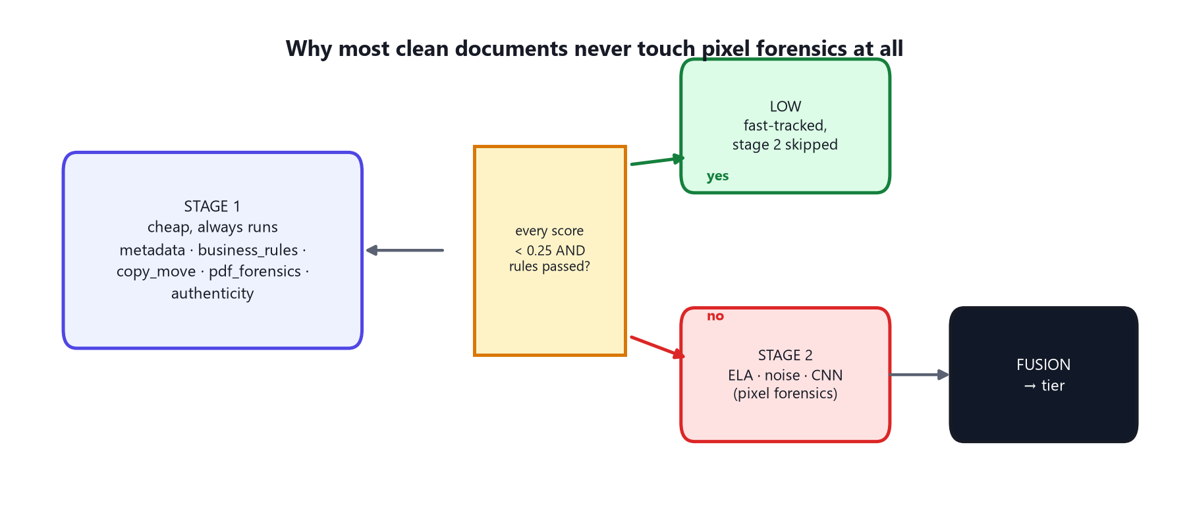
Figure 8.1 — The fast-track gate. A document only pays for expensive pixel forensics if Stage 1 found something worth investigating further.
If every Stage-1 signal that ran scores below 0.25, AND business_rules specifically ran and affirmatively PASSED (not merely "had nothing to say" — an absence of evidence is not treated as evidence of cleanliness), the document is fast-tracked directly to LOW risk and the three expensive Stage-2 pixel-forensics signals (ELA, noise, the CNN) never run at all. This is a genuine performance optimisation with a real fraud-detection justification behind it, not just a speed shortcut: the documents that fast-track this way are the ones where nothing about the file's structure, metadata, or internal arithmetic gave any reason for suspicion in the first place.

Chapter 9 — The Pixel Forensics Signals (Stage 2)
These three signals only run once Stage 1 has flagged a document as worth a closer, more expensive look. All three operate directly on pixel data — this is where genuine EDITS (Chapter 7's first fraud family) leave physical evidence that classical or learned pixel analysis can recover.

9.1 Error Level Analysis (ELA)
The core idea: re-save the image at a known JPEG quality (90) and measure the difference against the original. JPEG compression is lossy in a way that is NOT uniform across an image's history — a region that was pasted in or locally edited AFTER the rest of the page was compressed carries a different compression "error level" than its surroundings, and re-compressing the whole page a second time makes that inconsistency visible as a brighter patch in the difference map.
A subtlety this project's implementation gets right that a naive version would not: on ANY text document, the single brightest pixels in a raw ELA map are almost always just ordinary text edges (any high-frequency content re-compresses differently by nature) — so a global brightness threshold would just detect "this page has text", not tampering. Instead, the page is divided into 64×64 pixel blocks, and each block's MEAN error level is compared statistically (a robust z-score, resistant to being thrown off by a handful of outlier blocks) against the page's own median. What betrays a real edit is not that some pixels are bright — text edges guarantee that everywhere — but that one specific REGION is inconsistent with the rest of the page's typical compression behaviour. A guard also excludes near-lossless source images entirely (where the recompression difference is too small to carry meaningful signal at all, and the resulting map would just be amplified sensor noise, not evidence).

9.2 Noise Inconsistency Analysis
A complementary technique keyed on a different physical property: every camera sensor and every processing pipeline leaves a characteristic background noise floor across an image. Content pasted in from a different source — or locally smoothed/redrawn — carries a DIFFERENT noise level than its surroundings. This signal estimates local noise per 64-pixel block using a high-pass residual (a Laplacian filter, which responds to fine-grained variation and is largely blind to smooth regions), but critically first MASKS OUT any block with significant text/edge content (measured via image gradients) — because text strokes dominate any raw noise statistic, turning what should be a noise detector into an accidental text-density detector. Only the flat, background paper area of each block is used to estimate that block's true noise floor, and blocks whose estimate deviates strongly (in both relative and absolute terms — a safeguard against a very uniform page collapsing its own statistical baseline toward zero and manufacturing false outliers from ordinary rounding) from the page's typical level are flagged.
ELA and noise analysis are deliberately complementary, not redundant: a forgery that successfully evades one (say, by carefully matching compression quality) can still trip the other (because matching noise texture is a separate, harder problem), which is exactly the kind of coverage an ensemble is supposed to provide.

9.3 The Tamper CNN — Full Deep Dive
This is the one learned model anywhere in the tampering-detection system, and the component the rest of this chapter exists to explain completely: its architecture, exactly how and on what data it was trained, every hyperparameter used, and precisely how its output becomes a trustworthy probability.

9.3.1 Why a Small Custom CNN, Not a Large Pretrained Model
A natural instinct might be to reach for a large, ImageNet-pretrained network (something in the EfficientNet or ResNet family). This project deliberately does not, for three specific reasons documented directly in the model's own source code:
- The input is an Error Level Analysis residual map (Section 9.1's output), not a natural photograph — ImageNet pretraining teaches a network to recognise cats, cars and everyday objects, none of which transfers meaningfully to recognising compression-inconsistency patterns.
- A small network (four convolutional blocks, roughly 218,000 parameters — see the exact figure below) trains in minutes on an ordinary CPU and runs in milliseconds at inference time, which matters directly for a real-time lending workflow where a loan officer is waiting on the result.
- Small models overfit less on the modest dataset sizes this project starts from (Section 9.3.4) — a huge pretrained network fine-tuned on a few thousand examples risks memorising them rather than learning a general pattern (Section 1.5's overfitting concept, applied concretely here).

9.3.2 Architecture, Layer by Layer
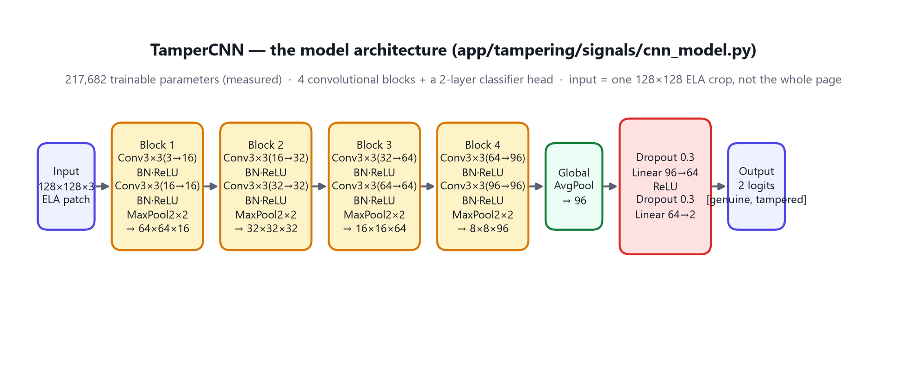
Figure 9.1 — TamperCNN's complete architecture, verified by directly instantiating the model and counting its parameters: 217,682 trainable weights.
The network is named TamperCNN in the codebase. Its input is a single 128×128 pixel, 3-channel (RGB) crop of an ELA map — not a whole page, for reasons Section 9.3.3 explains in detail. It consists of four convolutional "blocks", each following the identical pattern: two 3×3 convolutional layers (each followed by Batch Normalization, which keeps the numeric scale of activations stable through training and is one of the standard techniques that makes deep networks trainable at all, and a ReLU non-linearity, the simple "replace any negative number with zero" function introduced conceptually in Section 1.3), followed by one 2×2 max-pooling layer that halves both width and height. Four such blocks in sequence take the 128×128 input down to an 8×8 feature map with 96 channels.
A Global Average Pooling layer then collapses that 8×8×96 feature map down to a single list of 96 numbers by averaging each channel over its whole spatial area — a standard technique that makes the network robust to exactly where in the crop a pattern appeared. A small classifier head (Dropout, a 96-to-64 fully-connected layer, ReLU, Dropout again, then a final 64-to-2 layer) turns those 96 numbers into two output numbers ("logits"): one representing evidence for "genuine", one for "tampered".
CONCEPT
Dropout does double duty in this design
Dropout (randomly zeroing 30% of the head's internal activations during training) is the standard technique for reducing overfitting by preventing the network from becoming overly reliant on any single internal pathway. This project reuses the SAME mechanism at inference time as MC-Dropout ("Monte Carlo Dropout", Section 9.3.11) to estimate the model's own uncertainty about a specific prediction — one piece of code, two genuinely different jobs.

9.3.3 Patch-Based Training: Why Not the Whole Page
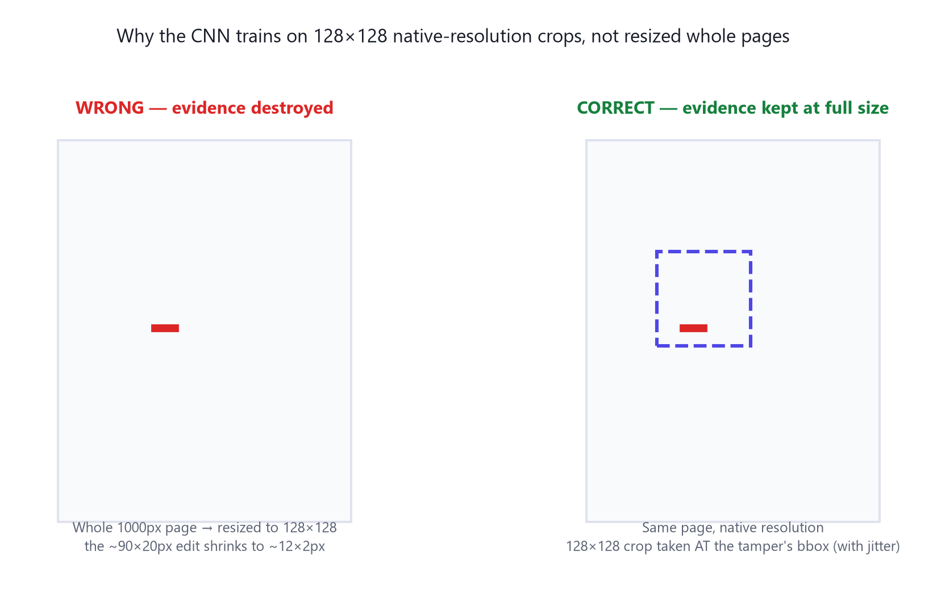
Figure 9.2 — A realistic digit edit is roughly 90×20 pixels on a ~1000-pixel page. Resizing the whole page down to the CNN's 128×128 input shrinks that evidence to roughly 12×2 pixels — effectively invisible.
Early experiments (recorded in this project's own development log) tried training the CNN on whole pages resized down to 128×128, and it failed outright — several early attempts collapsed to guessing the majority class and never learned anything, because at that resolution the tampered evidence itself had been resized into visual noise. The fix was to train on 128×128 crops taken at NATIVE resolution — i.e., zoomed into the actual area of the page where the edit is, not the whole page shrunk down — which keeps the evidence at full, learnable size. This is why inference (Part V.9.3, cnn_classifier.py) works by sliding this same 128-pixel window across the whole page in a grid and scoring every window, rather than looking at one whole-page image at once — described fully in Section 9.3.11.

9.3.4 The Synthetic Dataset Generator
Before any real, human-labelled fraud examples exist, the CNN needs SOMETHING to learn from. This project's training pipeline includes a synthetic data generator that draws plausible-looking documents (bank-statement-style rows of dates, transaction types and amounts, using varied fonts, layouts and JPEG quality) and then applies five distinct, realistic tampering operations to copies of them, each one modelled on an actual forgery technique rather than an arbitrary random corruption:
Operation | What it simulates
splice | Pasting a patch from a DIFFERENT document — the classic ELA-visible forgery, since the pasted content carries a different compression history
copy_move | Duplicating a region within the SAME document — trains the CNN on exactly the pattern Section 8.4's classical algorithm also targets, from a different angle
erase_redraw | Whiting out a region and typing new content over it — value editing, the single most realistic and common real-world forgery
digit_edit | Overwriting just ONE number in place, in a small, background-matched region — added specifically after testing showed the model was missing this subtlest, most realistic edit class when it wasn't represented in training
rescaled_splice | A splice where the pasted patch is resized before pasting — forgers commonly scale a donor patch to fit the slot they're filling
Every synthetic image also carries a recorded group_id (which BASE document it was derived from) and, for every tampered variant, the exact bounding box of the edit — both are essential to the correctly-designed training process described in the next two sections. Realism touches matter too: each generated page is given slight random rotation, sensor-noise-like grain, and a genuine JPEG save/reload round-trip before being used, and — a fix directly motivated by an earlier failure — roughly a quarter of generated documents are randomly rotated 90°/270° and roughly a third are downscaled the way real phone-camera uploads commonly are, specifically because an earlier model version was found to call ANY rotated or resized CLEAN page tampered with near-certainty, having accidentally learned "portrait orientation" or "native resolution" as a proxy for genuineness rather than learning anything about actual tampering.
HONEST CAVEAT
The dataset also grows from real production use, carefully
Beyond synthetic data, genuine documents that pass through the live system and receive an officer's "genuine" verdict are added to the training pool as real, additional clean examples. Documents an officer marks TAMPERED are deliberately NOT yet used for CNN training, because the current feedback pipeline does not record WHERE on the page the tampering was — and, as Section 9.3.3 explained, the patch-based training approach specifically needs that location. The system is honest about this gap in its own code comments rather than pretending to use data it can't yet use correctly.

9.3.5 Group-Aware Splitting: Avoiding Data Leakage
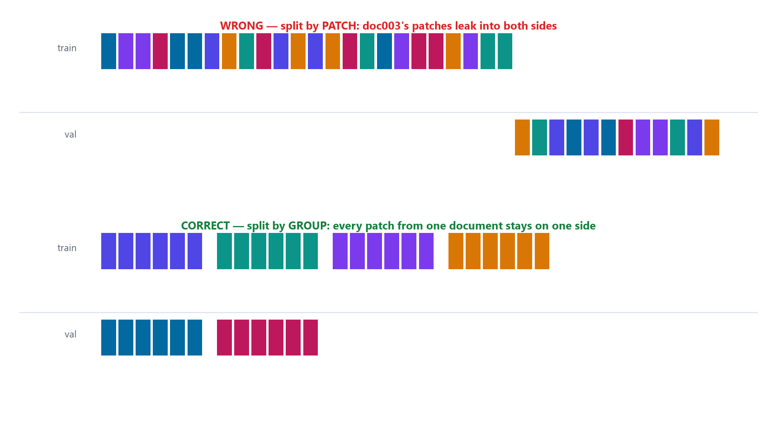
Figure 9.3 — The data-leakage trap, and the fix. Every training/validation split in this project's CNN pipeline is done by GROUP (base document), never by individual patch.
Recall Section 1.5's warning about data leakage. A single base document can produce MANY individual 128×128 training patches (several clean crops, several crops covering its tampered variants at different jittered offsets). If patches were assigned to the training and validation sets independently at random, patches from the SAME underlying document could end up on BOTH sides of the split — meaning the model's validation accuracy would partly just be measuring how well it memorised patterns from documents it had, in effect, already seen. This project's dataset code splits by GROUP first — every patch derived from one base document is guaranteed to land entirely in either the training set or the validation set, never straddling both — specifically so validation accuracy is a trustworthy, honest measurement.

9.3.6 Hyperparameters
Hyperparameter | Value | Why
Optimizer | AdamW | The standard, well-behaved default for training a network of this size; adapts its effective step size per-weight automatically
Learning rate | 0.001 | A conservative, standard starting point for AdamW on a small network
Batch size | 32 | Balances training stability against speed on CPU-only hardware
Epochs (phase 1) | 30 | Enough passes over the data for the loss to stabilise without excessive overfitting risk
Random seed | 42 | Fixed for reproducibility — the same training run produces the same result twice
Dropout rate | 0.3 | Standard moderate regularisation strength for a head this small
Validation group fraction | 0.25 | One quarter of document GROUPS (not patches — see 9.3.5) held out
Rotation-augmentation probability | 0.25 | A training-time augmentation: 25% chance of a random 90° rotation per patch, teaching the model tamper patterns are not orientation-dependent

9.3.7 Class-Weighted Loss
A raw dataset of genuine vs. tampered patches is rarely perfectly balanced, and training on an imbalanced dataset without correction risks the network simply learning to always predict the majority class and stop improving — a real risk with cross-entropy loss (the standard loss function for classification, which measures how far a model's predicted probabilities are from the true answer) on skewed data. This project computes each class's weight as total_examples / (2 × count_of_that_class) before training starts, and prints the resulting class balance and computed weights to the training log every run, so an imbalance is visible and accounted for rather than silently degrading training.

9.3.8 Two-Phase Training: Hard-Negative Mining
Training happens in two distinct phases, and the second phase is a deliberate, targeted fix for a specific measured failure mode. Because inference (Section 9.3.11) slides roughly 80 overlapping windows across every page and takes the SINGLE HOTTEST window's score as the page's evidence, even a small per-window false-positive rate compounds across all 80 attempts into a near-guaranteed false alarm somewhere on the page. Measured directly: before this fix, 90% of genuinely CLEAN pages contained at least one window scored 0.99 or higher purely by chance.
Phase 2 finds exactly these problem cases: after Phase 1 training completes, the model is run (in evaluation mode, no further learning yet) over every CLEAN training patch, and any clean patch the model scores above 0.4 is collected as a "hard negative" — a clean example the model is currently, wrongly, uncertain or confident about. These hard negatives are then oversampled 5× in a second, shorter training phase (roughly half as many epochs, at 30% of the original learning rate — a smaller, more careful adjustment rather than a full retrain) specifically to push the model's confidence DOWN on exactly the clean patterns it was most likely to false-positive on, directly lowering the real-world false-alarm rate the sliding-window scoring would otherwise produce.

9.3.9 Version History: Ten Training Iterations
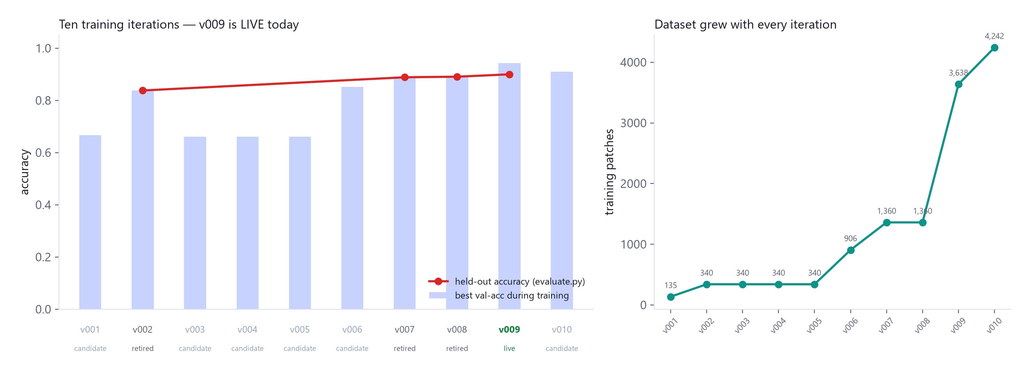
Figure 9.4 — Every one of this project's ten real training runs, with its actual dataset size and measured accuracy. v009 is the model live in production today.
Version | Status | Train patches | Val patches | Held-out accuracy | Note
v001 | candidate | 135 | 45 | — (66.7% during training) | Very small initial dataset
v002 | retired | 340 | 111 | 83.8% | First version with full held-out metrics recorded
v003–v005 | candidate | 340 | 111–112 | — (~66% during training) | Rotation-augmentation experiments; whole-page-resize failure era
v006 | candidate | 906 | 298 | — (85.2% during training) | Dataset scaled up ~2.7×
v007 | retired | 1,360 | 448 | 88.8% | Precision 0.908 / recall 0.737
v008 | retired | 1,360 | 448 | 89.1% | Precision improved to 0.954, recall dipped to 0.703
v009 | LIVE TODAY | 3,638 | 1,190 (1,386 in final eval) | 89.97% | Precision 0.912 / recall 0.714 / F1 0.801 — the model this whole book's fusion numbers reflect
v010 | candidate | 4,242 | 1,386 | 91.05% (training) | Largest dataset yet; not yet promoted live
A version only becomes "live" — the one inference actually loads and uses — through an explicit, separate promotion step (Section 9.3.12); training a new candidate never silently changes what production uses.

9.3.10 Reading v009's Real Confusion Matrix
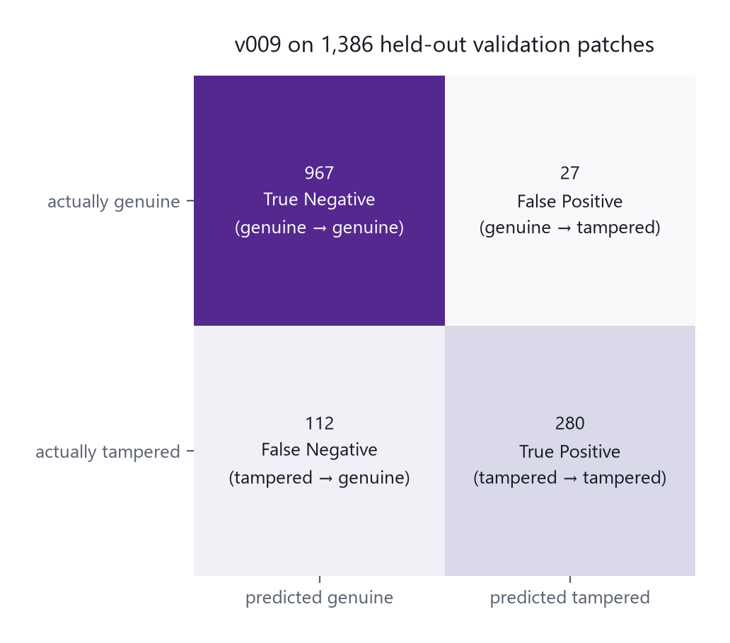
Figure 9.5 — v009 evaluated on 1,386 held-out validation patches it never trained on.
Applying Section 1.6's definitions to these real numbers: precision of 91.2% means that of every patch v009 flagged as tampered, roughly 9 in 10 really were. Recall of 71.4% means it catches roughly 7 in 10 of the truly tampered patches, missing the remaining 3 in 10 (112 false negatives) at the individual-patch level. Two things are worth being precise about here. First, this is PATCH-level accuracy, not page-level — a real forged PAGE is scored using its single hottest of roughly 80 overlapping patches (Section 9.3.11), so a page-level detection can succeed even when several individual patches near the true forgery are missed, provided at least one patch centred closely enough on it scores high. Second, and stated plainly: 71.4% patch-level recall means this signal, alone, is not close to catching every tampered document — which is exactly why it is one of nine signals rather than the whole system, and why Chapter 10 deliberately caps how much a single CNN verdict can move the final risk tier by itself.

9.3.11 From Patches to a Page Score: Sliding-Window Inference and Calibration
At inference time, the model does not see a whole page at once. It slides its 128-pixel window across the full-resolution ELA map of the page being checked, using a stride of 96 pixels (meaning consecutive windows overlap by 32 pixels, so a tampered region near a window boundary is still very likely to be well-centred in at least one neighbouring window), scoring every window in one batched forward pass for speed. The page's raw evidence is the single HIGHEST window score found anywhere on the page — deliberately the max, not an average, since a forger only needs to succeed in one small region.
That raw maximum is not used directly as a probability — it is passed through a per-model CALIBRATION curve (Section 1.10's sigmoid concept, applied here concretely): evidence = sigmoid(w × raw_max + b), with w and b fit by logistic regression on a held-out set of real pages specifically for whichever model version is currently live, and stored alongside that model in the registry. This replaced an earlier design that used one single hardcoded floor (0.96) for every model version — which failed to serve models fairly, since a conservative model's typical forged-page maximum might only reach 0.64 while an over-confident model's might reach 0.92, and one fixed floor cannot honestly calibrate both.
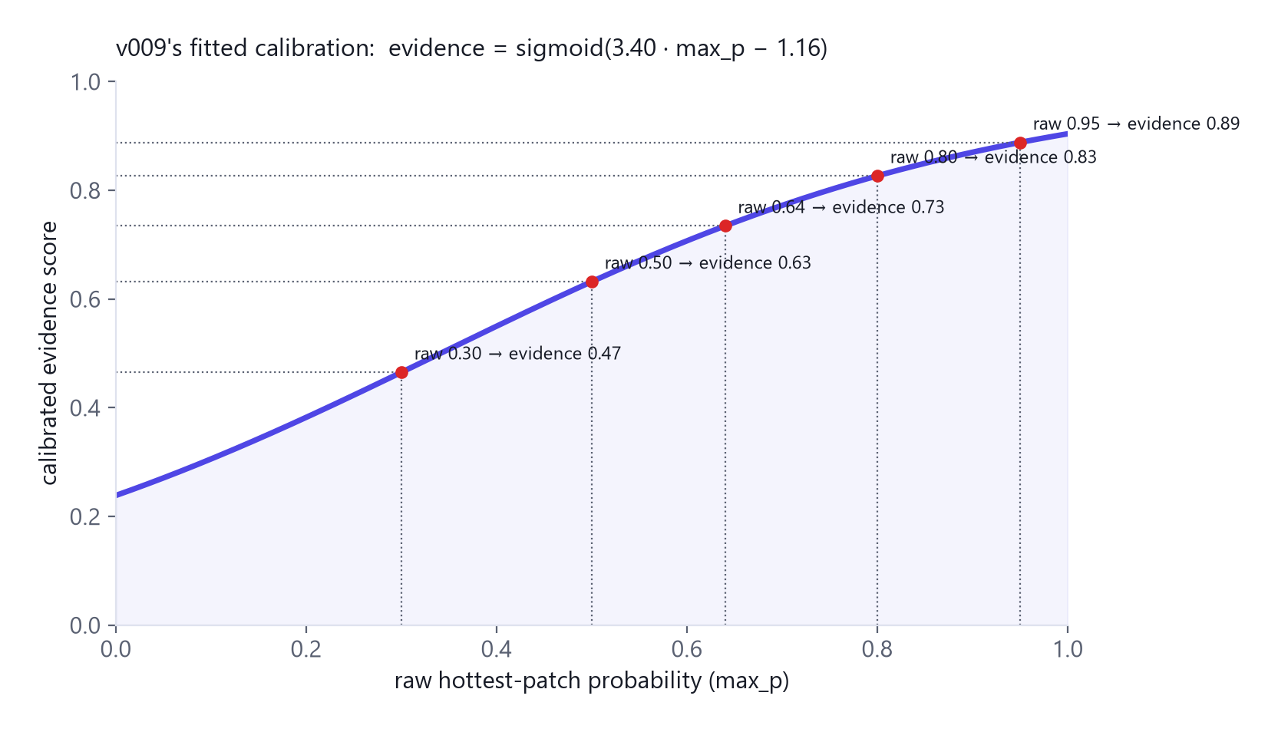
Figure 9.6 — v009's actual fitted calibration curve: evidence = sigmoid(3.40 × raw_max − 1.16). A raw maximum of 0.50 becomes a calibrated evidence score of 0.63; a raw maximum of 0.95 becomes 0.89.

9.3.12 MC-Dropout: The Model Reporting Its Own Uncertainty
Beyond a single evidence score, the system also asks the model how CONFIDENT it is about its own hottest-window verdict, using Monte-Carlo Dropout (Section 9.3.2's earlier note on Dropout's second job): the model is switched back into training mode ONLY for its Dropout layers (Batch Normalization layers are explicitly kept in evaluation mode, since only the dropout randomness — not statistics drift — should vary here) and run 12 times on the exact same hottest patch. Because dropout randomly disables different internal connections on each of those 12 passes, a confidently-tampered patch tends to score consistently high across all 12 runs, while a genuinely ambiguous patch produces meaningfully scattered scores. The standard deviation across those 12 runs is reported alongside the evidence score, and a spread at or above 0.15 is surfaced to the reviewer as an explicit "treat this automated score with caution" note — the model, in effect, flagging its own uncertainty rather than presenting every verdict with equal, unearned confidence.

9.3.13 The Model Registry: A Deliberate Safety Gate
Training a new candidate model NEVER automatically changes what the live system uses. The lifecycle is explicit and separated into three distinct steps, precisely so a bad or under-tested training run can never silently degrade production: TRAIN saves a new version with status "candidate" and nothing more; EVALUATE measures that candidate against the held-out validation set and records its real metrics; PROMOTE is a separate, deliberate action that (a) fits and stores that specific version's calibration curve, then (b) flips it to "live" while automatically demoting whatever was live before to "retired". Inference code only ever loads whichever single version is currently marked live — there is no code path by which a freshly-trained, unevaluated model can reach production.

Chapter 10 — Fusion: This Project's Ensemble Learning, in Full
This chapter directly answers the question this whole book was written to answer in depth: what does ensemble learning mean HERE, specifically, concretely, with every real number and the reasoning behind it.

10.1 This System's Ensemble Family
As Section 1.9 previewed, FinSight's fusion layer is a heterogeneous weighted-voting ensemble with two hand-designed override mechanisms layered on top of a plain weighted average. It is deliberately NOT a learned meta-model (no stacking) and NOT a resampled-and-voted set of identical models (no bagging) — every weight in this chapter is a number a human engineer set directly in a configuration file, based on how much each signal's evidence can be trusted, and can be changed by editing that file and restarting the service, with no retraining required.

10.2 Every Signal's Weight, and Why
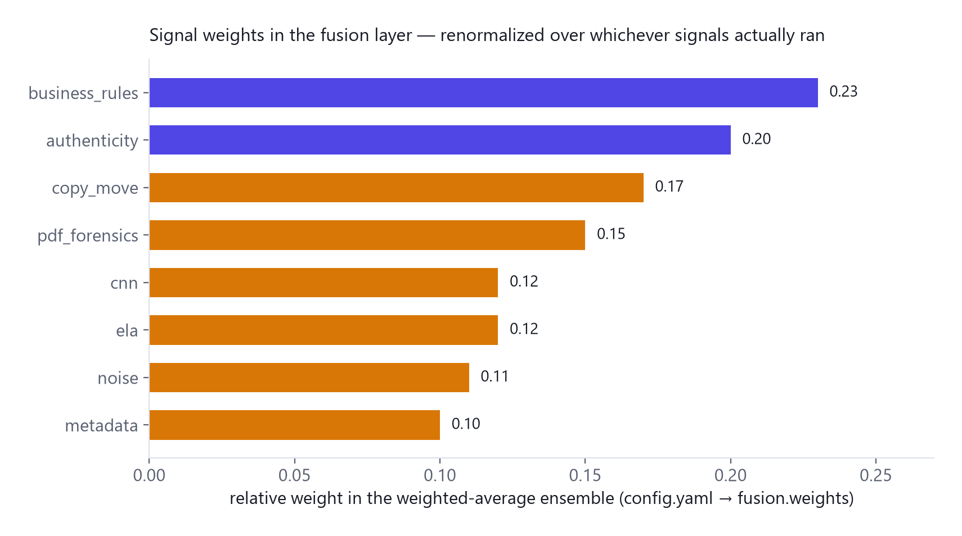
Figure 10.1 — Relative weight of each signal in the weighted-average path. Weights are automatically re-normalised over whichever signals actually ran for a given document, so a signal that doesn't apply to a PDF (like metadata, which is image-only) never silently drags the score toward zero.
Signal | Weight | Why this weight specifically
business_rules | 0.23 | Highest weight of any signal — deterministic arithmetic and checksum failures essentially never false-positive
authenticity | 0.20 | Weighted as a strong heuristic (it corroborates other signals well) despite being the one AI-judgement signal — its INDIVIDUAL power to act alone is separately capped via confidence, not via this weight
copy_move | 0.17 | A verified, pixel-identical duplication is near-proof; weighted accordingly
pdf_forensics | 0.15 | Structural PDF facts (re-saves, producer strings) are objective observations, not inference
cnn / ela | 0.12 each | Real but comparatively weaker signals — cnn's own measured page-level AUC (0.83 on synthetic held-out pages, per this project's own config comments) places it here deliberately, pending further real-verdict retraining to earn more trust
noise | 0.11 | Complementary to ELA but slightly less discriminative in practice
metadata | 0.10 | The cheapest, least specific signal — useful corroboration, rarely conclusive alone

10.3 Single-Signal Confidence: How Much a Lone Voice Is Trusted
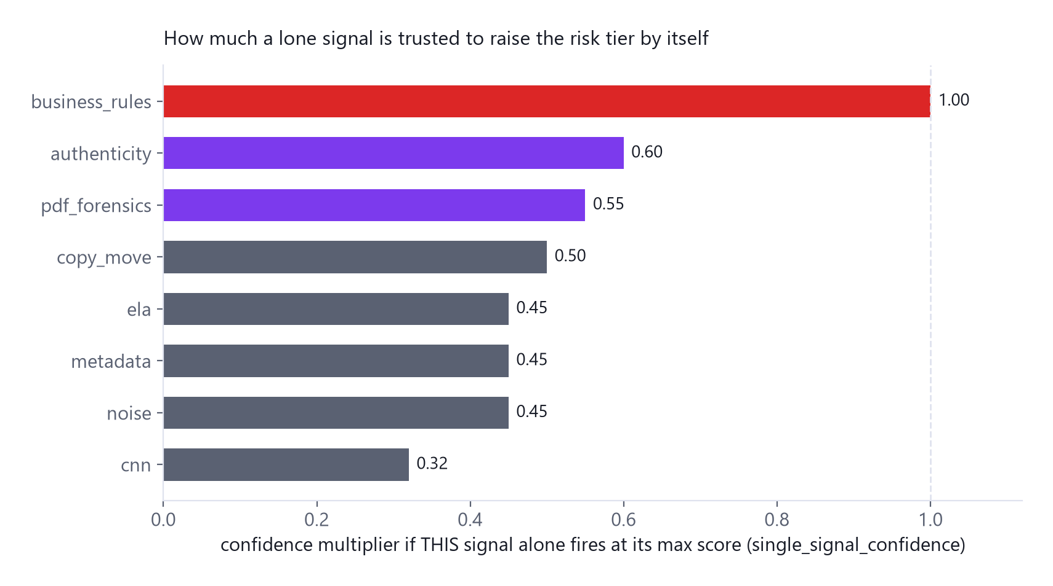
Figure 10.2 — A completely separate number from the fusion weight above: if ONLY this one signal fires, at its maximum, how far can it push the risk tier by itself?
This is the mechanism that lets a single, extremely strong piece of evidence overrule what a plain weighted average would otherwise wash out — and it is the precise, numeric implementation of Section 1.11's principle that deterministic checks are trusted more than probabilistic ones.
Signal | Confidence | Reasoning, verbatim from this project's own configuration
business_rules | 1.00 | "deterministic rule failures don't false-positive" — the only signal trusted at full strength alone
authenticity | 0.60 | Deliberately capped: a lone "likely_fabricated" verdict (evidence 0.85) × 0.60 = 0.51, which reaches MEDIUM (the review threshold, 0.30) but falls short of HIGH (0.60) — this AI-driven signal can never condemn a document to the highest tier alone
pdf_forensics | 0.55 | "re-save/editor-producer are factual observations" — high, but not as absolute as a checksum
copy_move | 0.50 | "≥0.92 NCC-verified duplication is near-proof" — but Section 8.4's CHQ-DEP ambiguity means "near", not full, proof
metadata / ela / noise | 0.45 each | Real evidence, but each individually explainable by a non-fraud cause often enough to warrant a lower solo weight
cnn | 0.32 | The lowest confidence in the system — "a weak signal; only a saturated hit moves the tier" — direct acknowledgment that this is the least mature signal, honestly reflected in how much it's trusted alone

10.4 The Three Fusion Paths
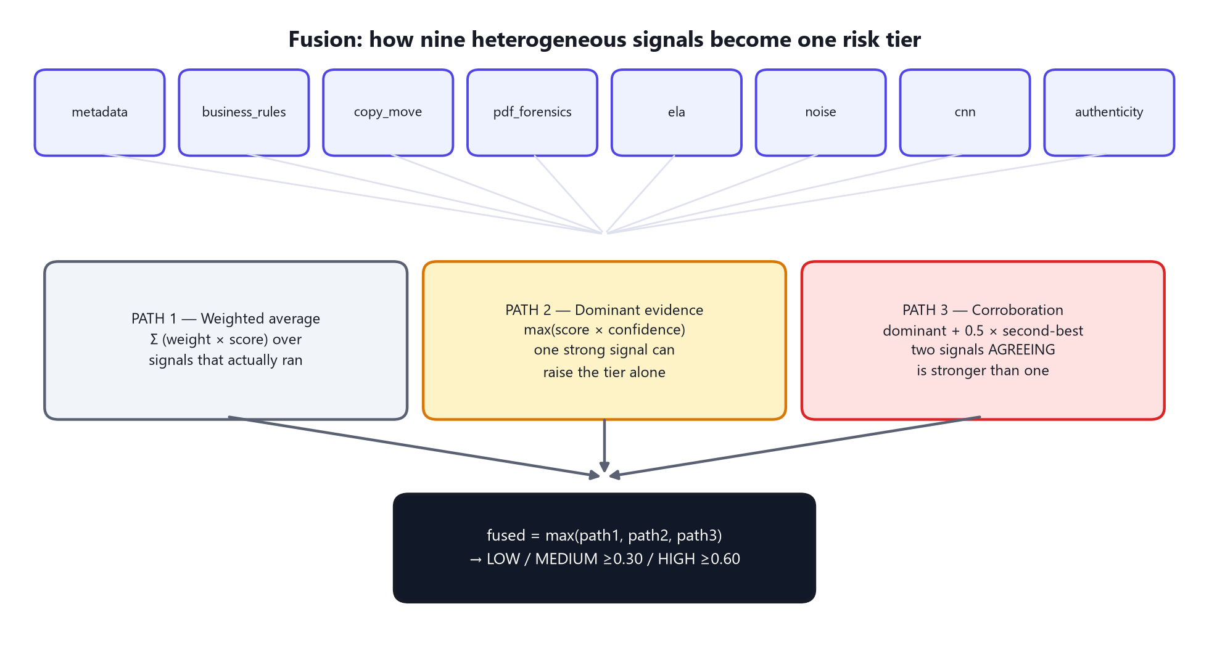
Figure 10.3 — The final fused score is the MAXIMUM of three independently-computed paths, never a single blended average alone.
PATH 1 — Weighted average: the standard ensemble computation from Section 1.9, Σ(weight × score) across every signal that actually ran, with weights renormalised to sum to 1 over just that available set. This path measures overall CORROBORATION — how much the signals agree, in aggregate.
PATH 2 — Dominant evidence: for every signal, compute score × single_signal_confidence (Section 10.3), and take the single highest result across all signals. This path exists because averaging can wash out one genuinely damning piece of evidence against five quiet, unremarkable signals — a real forgery usually trips only the ONE detector that happens to be matched to its specific type, and requiring corroboration from unrelated signals before acting on it would be a mistake.
PATH 3 — Corroboration bonus: dominant_score + 0.5 × second_highest_dominant_score, capped at 1.0. This path captures a real, specific idea: two INDEPENDENT signals agreeing is meaningfully stronger evidence than either alone, even when neither alone would have been quite enough to reach the highest tier. This is the exact mechanism by which the real fake-payslip case (Section 10.6) escalated from MEDIUM to HIGH.
The final fused score is simply the MAXIMUM of all three paths — whichever path currently makes the strongest, best-justified case for risk wins, and the tier boundaries (from this project's own configuration) are: below 0.30 is LOW, 0.30 up to 0.60 is MEDIUM (send for human review), and 0.60 and above is HIGH.

10.5 Worked Example: The Real Fake Payslip
A genuinely AI-generated, fabricated "salary slip" test document, run through the live system, produced these real per-signal results:
Signal | Score | What it found
pdf_forensics | 0.62 | Producer string 'jsPDF 2.5.1' — a scripting library, not a payroll system
authenticity | 0.85 | "Likely fabricated" — placeholder account number, placeholder bank name, both grounded/verified as literally printed on the page
business_rules | 0.00 | Arithmetic was internally self-consistent — this signal correctly found nothing wrong
noise / ela / cnn | 0.00 / n/a / n/a | Nothing to find — there were no forensic edit traces, because nothing was ever edited (Chapter 7's core distinction, demonstrated directly)
Dominant path: authenticity's 0.85 × 0.60 confidence = 0.51. Second-highest dominant: pdf_forensics' 0.62 × 0.55 = 0.34. Corroboration path: 0.51 + 0.5 × 0.34 = 0.68 — two independent, unrelated signals (an AI judgement about the document's content, and an objective fact about the PDF's producer software) agreeing pushed the fused score from what would have been a MEDIUM-only 0.51 up to 0.68, crossing the 0.60 HIGH threshold. This is Section 10.4's corroboration path working exactly as designed, on a real case.

10.6 Worked Example: The Genuine Unlocked Bank Statement
The same real document from Section 8.3's false-positive story: a genuine bank statement, unlocked from bank-issued password protection via iLovePDF. pdf_forensics correctly notes the re-processing (score 0.60, a MEDIUM-tier note with honest wording) but no OTHER signal finds anything — authenticity correctly reads the document as genuine (score 0.00), business_rules' arithmetic checks pass. With no second signal to corroborate, the fused score settles at pdf_forensics' own dominant contribution (0.60 × 0.55 confidence = 0.33) — comfortably inside MEDIUM, nowhere near HIGH. The system correctly tells a reviewer "this is worth a quick glance" without ever wrongly escalating a genuine, unmodified document to a false HIGH-risk alarm.

Part VI — The Fraud Detection System
Parts II through V each described a complete, independently useful system. This part explains how they come together into one coherent review experience today, and precisely where the boundary sits between what is built and what is designed but not yet implemented — a distinction this book maintains carefully throughout, and states most explicitly here.

11.1 Four Evidence Producers, Working Together Today
Figure 11.1 — Reused from Part V: fusion is a genuinely working ensemble WITHIN the tampering system. What this chapter describes is the layer ABOVE that — combining tampering with three further, currently-separate evidence producers.
- Field validation (Part II.5) — is each extracted value structurally real: correct format, correct checksum, sensible range?
- Cross-document consistency checks — do the documents agree with each other: the same name (tolerant of initials, honorifics, and the common Indian convention of surname-first ordering), the same date of birth, the same PAN number, across every document submitted for one application?
- Document tampering detection (Part V) — the full nine-signal cascade and its fused risk tier, for every individual document.
- Face matching (Part IV) — whether the same person's photograph appears across every document.
All four of these run automatically and are shown together the moment a reviewer opens an application's Review & Submit page — a Submission Readiness checklist surfaces at-a-glance status for each, a Document Integrity card shows tampering findings with the exact page location marked, and an Identity Verification card shows face-match results with similarity scores. Nothing here requires a reviewer to manually trigger a check; it is all computed and waiting by the time the page loads.

11.2 The Officer Decision Workflow
Every application decision is recorded with an explicit stage (officer recommendation, or head-manager final decision) and an explicit outcome (approve, reject, send back for more information, or request additional documents), always accompanied by a note. A specific, hard rule governs when an officer's recommendation alone is sufficient versus when it must escalate: applications requesting more than ₹5,00,000 require the head manager's final sign-off — an officer cannot approve above that limit acting alone, regardless of how clean every automated check comes back.

11.3 What's Designed but Not Yet Built: The Fusion Module
HONEST CAVEAT
Being precise about the boundary — this is deliberately NOT overstated
The four systems above each produce their OWN independent verdict today (a tampering tier, a face-match verdict, a set of field flags, a set of cross-check results) — a reviewer sees all four, side by side, and forms their own judgement. There is currently NO single combined "fraud score" that mathematically fuses all four into one number the way Part V, Chapter 10 fuses the nine tampering signals into one tampering tier. That combining layer is designed (the database schema for it — a table that would be called fraud_assessments, holding a per-component score for face, tampering, cross-checks and validation, a single fused score, and the exact weights-version used to produce it, specifically so a fraud score computed today stays reproducible even after the weights are later retuned) but has not been implemented as running code.
The design for that future module also includes duplicate/identity-ring detection — the same uploaded FILE (matched by its exact cryptographic hash), the same PAN or Aadhaar identity, or the same FACE (via the embedding technology Part IV already runs) appearing across multiple, DIFFERENT loan applications is a classic fraud-ring signal that today's per-application view cannot see, because each application is currently evaluated in isolation.

11.4 The RBI Compliance Engine (Built), and Deferred Credit-Risk Scoring
Of the two modules this book originally scoped as future work, one is now built: the automated RBI (Reserve Bank of India) regulatory-compliance checker is live — a regulatory knowledge base with BM25 retrieval, a deterministic rules engine that checks each application against every active rule, a RAG-backed policy Q&A, and a maker-checker workflow for rules drafted from regulatory documents. The other remains deliberately deferred: a general credit-risk probability-of-default model, sequenced to follow the fraud-fusion layer — a deliberate ordering decision, not an oversight.

Appendix A — Glossary
AUC — Area Under the (ROC) Curve — a single number summarising a classifier's ability to separate two classes across every possible threshold at once, from 0.5 (no better than a coin flip) to 1.0 (perfect separation).
Calibration — Fitting a correction curve (usually a sigmoid) so a model's raw score becomes an honestly meaningful probability. See Section 1.10 and 9.3.11.
Checksum — A digit or code mathematically derived from the rest of an identifier, specifically so a computer can catch a mistyped or fabricated value without a database lookup. See the Verhoeff worked example, Section 2.5.
Cosine similarity — A measure of how similar two embeddings' DIRECTIONS are, ignoring their magnitude. Ranges from −1 to 1. See Section 1.7.
CNN (Convolutional Neural Network) — A neural network built from layers that slide small filters across an image, detecting the same pattern anywhere it appears. See Section 1.4.
Embedding — A learned, fixed-length list of numbers representing an image (or a face) such that similar things end up numerically close together. See Section 1.7.
Ensemble — A system combining several detectors' outputs into one final answer. See Section 1.9 and Part V, Chapter 10.
EXIF — Metadata embedded in an image file by the capturing device or editing software — orientation, timestamp, and sometimes which program last touched the file.
F1 score — The harmonic mean of precision and recall — one balanced number for comparing classifiers. See Section 1.6.
Fusion — This project's specific term for the weighted combination of its nine tampering signals into one risk tier. See Part V, Chapter 10.
Group-aware split — Splitting training/validation data by the underlying source document, not by individual training example, to prevent data leakage. See Section 9.3.5.
Hyperparameter — A setting chosen by a human before training starts (learning rate, batch size, epochs) that training itself does not adjust. See Section 1.3.
MC-Dropout — Monte-Carlo Dropout — running a model multiple times with its dropout layers active to estimate how uncertain it is about a specific prediction. See Section 9.3.12.
OCR — Optical Character Recognition — extracting machine-readable text from an image. See Section 1.8.
ONNX — Open Neural Network Exchange — a standard file format for trained models that lets them run without the original training framework. Used for this project's face-detection and face-recognition models.
Overfitting — When a model memorises its training data rather than learning a generalisable pattern, revealed by validation accuracy stalling while training accuracy keeps climbing. See Section 1.5.
Quantization — Compressing a model by storing its weights at lower numeric precision, trading a small accuracy cost for a large reduction in memory and compute needs. See Section 2.4.
Recall — Of everything that was actually positive (tampered), the fraction correctly caught. The single most important metric for this project's tamper detector. See Section 1.6.
Regex (regular expression) — A pattern describing the valid textual SHAPE of a string, e.g. a PAN number's 5-letters-4-digits-1-letter structure. See Section 1.11.
Sigmoid function — 1 / (1 + e^−x) — squashes any real number into the 0–1 range, the standard shape for a calibrated probability. See Section 1.10.
VLM (Vision-Language Model) — A neural network trained to jointly understand images and natural-language text. This project's OCR reading engine is one. See Section 1.8.

Appendix B — The Annotated Tampering Configuration
Every tunable number in the document-tampering cascade lives in one file, config.yaml, and nowhere else in the code — this is a deliberate design principle ("code never hardcodes a threshold or weight") that makes every number in Part V directly traceable to a single source of truth. The complete, real file is reproduced below.

Pipeline & Fusion
pipeline:
gate_threshold: 0.25 # Stage-1 fast-track gate (Section 8.6)
max_pdf_pages: 4
fusion:
weights: # Section 10.2
metadata: 0.10 business_rules: 0.23 copy_move: 0.17
pdf_forensics: 0.15 ela: 0.12 noise: 0.11
cnn: 0.12 authenticity: 0.20
tier_medium: 0.30 # fused score >= this -> MEDIUM
tier_high: 0.60 # fused score >= this -> HIGH
single_signal_confidence: # Section 10.3
business_rules: 1.00 copy_move: 0.50 pdf_forensics: 0.55
metadata: 0.45 ela: 0.45 noise: 0.45
cnn: 0.32 authenticity: 0.60
corroboration_factor: 0.5 # Section 10.4, Path 3

Per-Signal Tuning
signals:
metadata:
score_missing_exif: 0.15 score_editor_found: 0.90 score_date_mismatch: 0.40
business_rules:
amount_tolerance: 1.0 # rupees, for arithmetic checks
copy_move:
orb_features: 4000 match_ratio: 0.75 min_displacement_px: 24
min_cluster_matches: 8 saturation_matches: 40
pdf_forensics:
score_incremental_update: 0.65 score_editor_producer: 0.85
score_utility_resave: 0.60 score_date_mismatch: 0.30
score_generation_library: 0.62
ela:
jpeg_quality: 90 top_percentile: 99.0
noise:
block_size: 64 outlier_sigma: 2.5
cnn:
input_size: 128 cam_alpha: 0.45
training: # Section 9.3.6
epochs: 30 batch_size: 32 lr: 0.001
val_group_fraction: 0.25 seed: 42

Appendix C — Complete Library Inventory
Every runtime dependency this project actually imports, with the exact installed version, verified directly against the running environment's package manager output on the date this book was generated. This table is also maintained as a standalone spreadsheet, FinSight-Library-Inventory.xlsx, alongside this book.
Library | Version | What it does in this project
fastapi | 0.115.6 | Backend web framework — every REST endpoint (/extract, /document/mask, /face/verify, /tampering/…)
uvicorn | 0.34.0 | ASGI server that actually runs the FastAPI application
httpx | 0.28.1 | HTTP client used to call the local Ollama vision-language model
pydantic | 2.10.4 | Request/response schema validation for every API endpoint
pydantic-settings | 2.7.1 | Typed environment-variable configuration loading
python-multipart | 0.0.20 | Parses multipart file uploads (every document upload endpoint)
pillow (PIL) | 11.1.0 | Core image loading, resizing, format conversion, and drawing (redaction bars, annotation boxes)
opencv-python-headless | 4.10.0.84 | Classical computer vision — copy-move (ORB/NCC), ELA/noise block analysis, YuNet & SFace inference, contour/deskew
numpy | 2.5.0 | Numeric array operations underlying almost every image-processing routine
scipy | 1.18.0 | Statistical routines (used in calibration fitting)
scikit-image | 0.26.0 | Supplementary image-processing utilities
shapely | 2.1.2 | Geometric operations for region/bounding-box logic
easyocr | 1.7.2 | Lightweight OCR used internally for preprocessing decisions (orientation scoring, before/after comparison) — not the main document-reading engine
torch | 2.12.1 | Deep-learning framework — trains and runs the TamperCNN (Part V, Chapter 9)
torchvision | 0.27.1 | Companion image-model utilities for PyTorch
ninja | 1.13.0 | Build-acceleration tool used by PyTorch's native-extension compilation
pypdfium2 | 4.30.1 | PDF rendering — turns PDF pages into images for OCR and forensics
PyYAML | 6.0.3 | Loads config.yaml (Appendix B) into the running application
Ollama (qwen2.5vl:7b, Q4_K_M) | model pulled via Ollama | The local vision-language model performing OCR reading (Part II.4) and the authenticity signal's visual judgement (Part V.8.5)
YuNet (ONNX) | face_detection_yunet_2023mar | Pretrained face detector, OpenCV Zoo — Part IV.4.1 (≈230 KB model file)
SFace (ONNX) | face_recognition_sface_2021dec | Pretrained face-embedding model, OpenCV Zoo — Part IV.4.1 (≈37 MB model file)
react | 18.2.0 | Frontend UI framework — every screen a loan officer or borrower sees
react-dom | 18.2.0 | React's browser-rendering layer
lucide-react | 1.21.0 | Icon set used throughout the frontend
vite | 5.0.0 | Frontend build tool and local development server
@vitejs/plugin-react | 4.0.0 | React support for the Vite build pipeline

