Pimpri Chinchwad Education Trust's
PIMPRI CHINCHWAD COLLEGE OF ENGINEERING
Department of Computer Science & Engineering (AI & ML)
PROJECT SYNOPSIS
(Submitted for Research Methodology Review I)
LegalAI: A Fully Agentic Legal Intelligence Platform for End-to-End Litigation Support Using Multi-Agent LLM Orchestration, Legal Knowledge Graphs and Multimodal RAG for the Indian Judicial System
Submitted by
Ayush Deshmukh — 123B1C002
Gargee Wagh — 123B1C005
Janhvi Dhamak — 123B1C010
Shreyas Bile — 123B1C065
B.Tech, Semester I, Final Year
Under the Guidance of
Prof. Pradhnya Narkhede
Department of Computer Science & Engineering (AI & ML)
Pimpri Chinchwad College of Engineering, Pune
Academic Year 2026 – 2027

Abstract
India's judiciary is currently burdened with over 5.39 crore pending cases across the Supreme Court, High Courts and district courts as of December 2025, against a judge-to-population ratio of roughly 21 per million — less than half the 50-per-million benchmark recommended by the Law Commission of India. A significant share of this delay is attributable not to adjudication itself but to the labour-intensive, manual nature of litigation support work: statute and precedent search, evidence review, drafting of pleadings, and argument preparation. This project proposes LegalAI, a fully agentic legal intelligence platform designed to assist Indian lawyers across the complete litigation lifecycle — from client consultation and case understanding through legal research, precedent discovery, evidence analysis, petition drafting, argument preparation, courtroom preparation and post-judgment analysis. The system is built on a multi-agent Large Language Model (LLM) orchestration layer (LangGraph and CrewAI), grounded by an Indian-legal Retrieval-Augmented Generation (RAG) pipeline over statutes, case law and evidentiary documents, and structured through a Neo4j-based legal knowledge graph that models statute–precedent–fact relationships. Multimodal document understanding handles scanned judgments, FIRs, contracts and exhibits; domain fine-tuning and context engineering adapt general-purpose LLMs to Indian legal language and citation conventions; and an explainability layer traces every generated output back to its source clause, section or precedent. Throughout, the lawyer remains the final decision-maker — the system drafts, cites and recommends, but never files, submits or advises autonomously. The expected outcome is a working prototype, evaluated on retrieval accuracy, citation faithfulness and drafting quality, that demonstrably reduces the research-and-drafting time consumed in a case while keeping every legal judgment under human control.

1. Introduction
Legal practice in India involves a chain of cognitively demanding, document-heavy tasks: understanding a client's factual narrative, mapping it to applicable statutes, searching case law for binding and persuasive precedent, examining evidence for admissibility and relevance, drafting petitions and applications in the prescribed format, and preparing arguments and rebuttals for hearings. Each of these stages is currently performed largely manually or with the help of fragmented, single-purpose tools — keyword-based case-law search engines, generic document editors, and standalone plagiarism or citation checkers — none of which communicate with one another or preserve context across the life of a case.
The consequence is twofold. First, junior lawyers, paralegals and even senior advocates spend a disproportionate share of billable time on retrieval and drafting rather than legal reasoning and courtroom strategy. Second, this manual bottleneck compounds the systemic pendency problem: with only about 21 judges per million population against a recommended 50, every hour saved in case preparation has a direct, cumulative effect on how quickly matters can be brought to hearing-readiness.
Generative AI and, more specifically, agentic multi-agent LLM systems offer a credible path to closing this gap — provided they are grounded in verifiable sources and kept firmly under human supervision. Global "legal co-pilot" products (e.g., CoCounsel, Harvey, Lexis+ AI) and India's own judiciary-side initiatives such as SUPACE and SUVAS demonstrate both the appetite for and the feasibility of AI-assisted legal workflows, but none of them offer a single, end-to-end, agentic pipeline purpose-built for the Indian advocate's workflow, in Indian statutory language, across Indian courts' procedural formats. This project, LegalAI, is motivated by that specific gap.
LegalAI is conceived as a multi-agent system in which specialised LLM-based agents — a client-intake agent, a research agent, an evidence-analysis agent, a drafting agent, an argumentation agent and a review/explainability agent — collaborate under an orchestrator to move a matter from client consultation to courtroom-ready material. Each agent's output is grounded in retrieved statutory text, precedent, or case-file evidence via a RAG pipeline layered over a legal knowledge graph, and every claim the system makes is traceable to its source. The lawyer reviews, edits and approves every agent output before it is used — the system is explicitly designed as a decision-support and productivity tool, not an autonomous legal decision-maker.

2. Literature Review
The literature and current practice relevant to this project fall into four broad strands: (a) Indian legal NLP research and datasets, (b) judiciary-led and commercial AI legal tools, (c) multi-agent LLM orchestration frameworks, and (d) retrieval-augmented generation and knowledge-graph techniques for grounded generation. Each is summarised below.

2.1 Indian Legal NLP Research
Foundational work in Indian legal NLP has produced both benchmark corpora and domain-adapted language models. The Indian Legal Documents Corpus (ILDC) introduced by Malik et al. established the first large-scale annotated corpus of Supreme Court judgments for court-judgment prediction and explanation, and remains a standard benchmark. Building on this, InLegalBERT — a BERT model further pre-trained on roughly 5.4 million Indian court documents spanning Supreme Court and High Court judgments from 1950 to 2019 — was shown to outperform generic Legal-BERT variants on statute retrieval, rhetorical-role labelling and judgment-prediction tasks, and has since been downloaded over 1.8 million times on Hugging Face. More recent efforts extend this line of work: NyayaAnumana (developed at IIT Kharagpur) is presented as the largest Indian legal judgment-prediction dataset; INLegalLlama applies continual pre-training to a LLaMA-family model on Indian legal text, reporting close to 90% F1 on judgment-prediction tasks; and benchmark suites such as IL-TUR (ACL 2024) evaluate models across monolingual and multilingual Indian legal-reasoning tasks, showing that even strong general-purpose models such as GPT-3.5/GPT-4 struggle to solve the full range of tasks without domain grounding.

2.2 Judiciary-Led and Commercial Legal AI Tools
On the institutional side, the Supreme Court of India has deployed two assistive AI tools since 2019–2021. SUVAS (Supreme Court Vidhik Anuvaad Software) is a machine-translation tool that has translated over 36,000 Supreme Court judgments from English into Hindi and other scheduled languages, explicitly scoped to translation rather than legal reasoning. SUPACE (Supreme Court Portal for Assistance in Courts Efficiency) assists judges and research staff by extracting facts, provisions and precedents from case records, but by institutional design does not draft judgments, make outcome predictions, or replace human decision-making — a boundary the Supreme Court's AI Committee has reaffirmed. Commercially, global platforms such as CoCounsel, Harvey and Lexis+ AI, and Indian legal-research platforms such as Manupatra, SCC Online and Casemine, provide keyword- or embedding-based case-law search and, in some cases, single-turn drafting assistance, but operate as isolated retrieval or drafting utilities rather than a coordinated, multi-stage litigation pipeline.

2.3 Multi-Agent LLM Orchestration
Frameworks such as LangGraph, CrewAI and AutoGen-style architectures have matured to support graph- and role-based orchestration of multiple cooperating LLM agents, each with a distinct system prompt, toolset and memory scope, coordinated by a supervisor/orchestrator node. This pattern has been applied successfully to software engineering, customer support and research-assistant use cases, where decomposing a complex task into specialised agents (e.g., a search agent, a summarisation agent, a critique agent) improves both output quality and auditability compared with a single monolithic prompt. Its application to the specific, high-stakes, multi-stage structure of Indian litigation — intake, research, evidence review, drafting, argumentation, courtroom prep, post-judgment analysis — remains largely unexplored in published work.

2.4 Retrieval-Augmented Generation and Legal Knowledge Graphs
RAG techniques ground LLM outputs in retrieved documents to reduce hallucination, and are widely used in legal-tech contexts because of the domain's low tolerance for fabricated citations. Recent Indian-legal-AI research (for example, graph-constrained generation approaches for Indian judicial reasoning) explicitly argues that plain vector-similarity RAG is insufficient for verified legal reasoning, and proposes combining RAG with structured knowledge graphs — encoding statute sections, precedent citation networks and fact patterns as nodes and edges — so that generated reasoning chains can be checked against an explicit, queryable structure rather than free-text similarity alone. This motivates LegalAI's combination of a Neo4j legal knowledge graph with vector-based multimodal RAG, rather than relying on either technique in isolation.
System / Work | Type | Core Capability | Key Limitation
InLegalBERT / InCaseLawBERT (IIT Kharagpur) | Research model | Domain-adapted embeddings for statute retrieval, rhetorical-role labelling, judgment prediction | Classification/embedding model only — no generative drafting or agentic workflow
SUPACE (Supreme Court of India) | Judiciary tool | Extracts facts, provisions and precedents to assist judges | Judge-facing only; not designed for advocate workflows; explicitly non-generative by policy
SUVAS (Supreme Court of India) | Judiciary tool | AI-assisted translation of judgments into Indian languages | Translation only; no research, drafting or evidence analysis capability
Manupatra / SCC Online / Casemine | Commercial platform | Keyword and citation-based case-law and statute search | Search-only; no drafting, evidence analysis, or multi-agent reasoning
CoCounsel / Harvey / Lexis+ AI | Commercial platform | LLM-assisted research and drafting for common-law practice | Built for US/UK legal systems and citation formats; not adapted to Indian statutes, courts or procedure
LegalAI (Proposed) | Proposed system | End-to-end, multi-agent, evidence-grounded litigation support for Indian advocates | Prototype scope; requires legal-expert validation before real-world deployment
Table 1: Comparative summary of existing Indian and global legal-AI systems against the proposed platform.

3. Identification of Research Gaps
The literature review surfaces seven specific, actionable gaps that this project is designed to address. Each gap is framed against the current state of the art rather than in general terms, so that the corresponding objective in Section 5 can be evaluated directly against it.
- Absence of agentic reasoning in existing legal-AI systems: SUPACE, SUVAS, and commercial search platforms such as Manupatra and SCC Online are single-pass, non-agentic tools — they retrieve or translate on request but do not plan, self-critique, or iteratively refine their own output. No reviewed Indian system employs an agentic loop (plan → act → observe → reflect) capable of decomposing an open-ended legal task, invoking tools autonomously, and revising its own intermediate reasoning before presenting a result.
- No end-to-end, context-persistent pipeline for the litigation lifecycle: Existing tools address isolated stages — translation (SUVAS), fact extraction (SUPACE), or keyword search (Manupatra/SCC Online) — but no reviewed system carries a matter continuously from client intake through post-judgment analysis while preserving a shared, evolving case-context across stages, agents, and sessions.
- Shallow multi-agent orchestration in the legal domain: Multi-agent LLM frameworks (LangGraph, CrewAI, MCP-based tool ecosystems) are maturing rapidly in software-engineering and general-research contexts, but their application to the specific hierarchical role-decomposition litigation demands — supervisor-coordinated research, evidence, drafting, argumentation and adversarial-critique agents operating over a shared state graph — is essentially unexplored in published Indian-legal-AI work.
- Weak verifiability of generative legal drafting: Indian legal NLP research to date has concentrated on discriminative tasks — classification, embedding and retrieval (InLegalBERT, ILDC, IL-TUR) — not generation. Very little work grounds generative drafting and argument construction against a formally verifiable structure such as a knowledge graph with graph-constrained decoding, leaving open the risk of fabricated or misattributed citations, a well-documented failure mode of LLMs in legal contexts.
- No self-verifying / adversarial-review loop: Even RAG-grounded generation can drift from its sources during multi-step reasoning. No reviewed Indian system pairs a drafting agent with an independent, tool-using critic agent that re-verifies every citation and clause against the knowledge graph before output is surfaced to the lawyer — a gap this project addresses through a dedicated review-and-explainability agent.
- Global legal-AI platforms are not adapted to Indian law: Commercial platforms such as CoCounsel, Harvey and Lexis+ AI are optimised for common-law citation formats, US/UK statutes and procedural conventions, and do not natively reason over Indian statutes (e.g., BNS, BNSS, BSA), vernacular case documents, or Indian court filing formats.
- Insufficient multimodal and multilingual grounding: Real Indian case files include scanned FIRs, handwritten annexures, vernacular-language pleadings and photographed evidence. Few existing systems combine agentic multimodal document understanding, OCR and multilingual retrieval within a single grounded, tool-orchestrated pipeline.

4. Problem Statement
Design and develop a fully agentic legal intelligence platform for Indian lawyers that unifies client consultation, legal research, precedent discovery, evidence analysis, petition drafting, argument preparation, courtroom preparation and post-judgment analysis into a single, evidence-grounded, multi-agent LLM system — using Indian-legal RAG, a legal knowledge graph, multimodal document understanding and domain fine-tuning — while ensuring every agent-generated output is explainable, source-traceable, and subject to mandatory lawyer review before use, so that litigation-support time is measurably reduced without displacing the lawyer's professional judgment.
Sub-problems that follow from this objective include: (i) how to decompose the litigation workflow into coordinated agent roles with well-defined handoffs; (ii) how to ground each agent's output in verifiable statutory and precedent sources rather than parametric LLM knowledge alone; (iii) how to represent Indian statute–precedent–fact relationships in a queryable knowledge graph; (iv) how to process multimodal and multilingual case documents reliably; and (v) how to make every generated recommendation explainable and auditable for professional accountability.

5. Objectives
- To design a hierarchical, agentic multi-agent orchestration architecture (LangGraph state machines coordinated with CrewAI role-based crews) in which a supervisor agent plans, delegates and sequences specialised sub-agents — intake, research, evidence, drafting, argumentation and review — through an explicit plan–act–observe–reflect loop, rather than a single-pass prompt-response pattern.
- To build an advanced, agentic Indian-legal RAG pipeline in which a research agent autonomously reformulates queries, performs iterative multi-hop retrieval across statutes, case law and procedural rules in a vector database, and self-evaluates retrieval sufficiency before handing results to downstream agents — rather than relying on single-shot retrieval.
- To construct a legal knowledge graph in Neo4j modelling relationships between statutes, sections, precedents and fact patterns, and to implement graph-constrained generation so that agent reasoning chains can be formally checked against explicit graph structure rather than embedding similarity alone.
- To implement agentic multimodal document understanding — an evidence agent that autonomously selects the right tool (OCR, layout parser, table extractor, translator) for each uploaded exhibit, FIR, contract or scanned judgment, and flags relevance/admissibility without a fixed, hand-coded pipeline.
- To apply context engineering and instruction/context-tuning of open-weight LLMs (served via Ollama) to Indian legal language, drafting conventions and citation style, and to benchmark this against untuned general-purpose LLM baselines — deliberately avoiding reliance on traditional feature-engineered or purely discriminative models as the core reasoning component.
- To build a dedicated review-and-critique agent that independently re-verifies every drafted clause, citation and recommendation from other agents against the knowledge graph, and triggers a self-correction loop before output reaches the lawyer, functioning as an explainable-AI and hallucination-mitigation layer.
- To evaluate the end-to-end agentic system on retrieval sufficiency, multi-agent task-completion rate, citation faithfulness, drafting quality and time-saved-per-task against both non-agentic RAG baselines and manual workflows, keeping the lawyer as the final approver of every output.

6. Proposed Methodology and System Architecture
LegalAI is deliberately architected as an agentic system rather than a static ML/DL pipeline: no stage of the core reasoning process relies on a traditional single-shot classifier or a fixed-function model. Instead, every stage is handled by an autonomous, tool-using LLM agent that plans its own sub-steps, invokes external tools (retrievers, the knowledge graph, OCR/document parsers, calculators) on demand, observes the results, and revises its own output through a reflection step before handing off to the next agent. The architecture has five layers: an interface layer, a hierarchical agent-orchestration layer, an agentic grounding layer (agentic RAG + knowledge graph), a data layer, and an explainability/control layer that keeps the lawyer in the loop at every checkpoint.

6.1 Agent Roles and Agentic Behaviour
- Intake Agent: Conducts a guided, multi-turn conversation to structure the client's narrative into facts, parties, relief sought and case category, asking clarifying follow-up questions autonomously when information is incomplete.
- Research Agent: Performs agentic, multi-hop retrieval — reformulating its own queries, deciding when to query the vector store versus traverse the knowledge graph, and iterating until it self-assesses that retrieved statutes and precedents are sufficient.
- Evidence Agent: Performs multimodal, tool-augmented analysis of uploaded exhibits — dynamically selecting OCR, layout parsing, translation or table-extraction tools per document type — and flags relevance and admissibility.
- Drafting Agent: Generates petitions, applications and synopsis drafts in standard Indian court formats, citing only agent-retrieved sources, and revises its own draft when the review agent returns a correction.
- Argumentation Agent: Prepares structured arguments, anticipates and drafts counter-arguments, and stress-tests its own position against retrieved opposing precedent before finalising output.
- Review & Critique Agent: Acts as an independent verifier — cross-checks every citation and clause generated by other agents against the knowledge graph, triggers a self-correction loop on mismatch, and presents a source-linked, human-reviewable summary before any output is finalised. This closes the loop that purely generative pipelines leave open.
- Supervisor / Orchestrator Agent: Owns the shared case-state graph, decides agent sequencing and re-invocation, and is the single point where the human lawyer intervenes, overrides, or approves progression to the next stage.
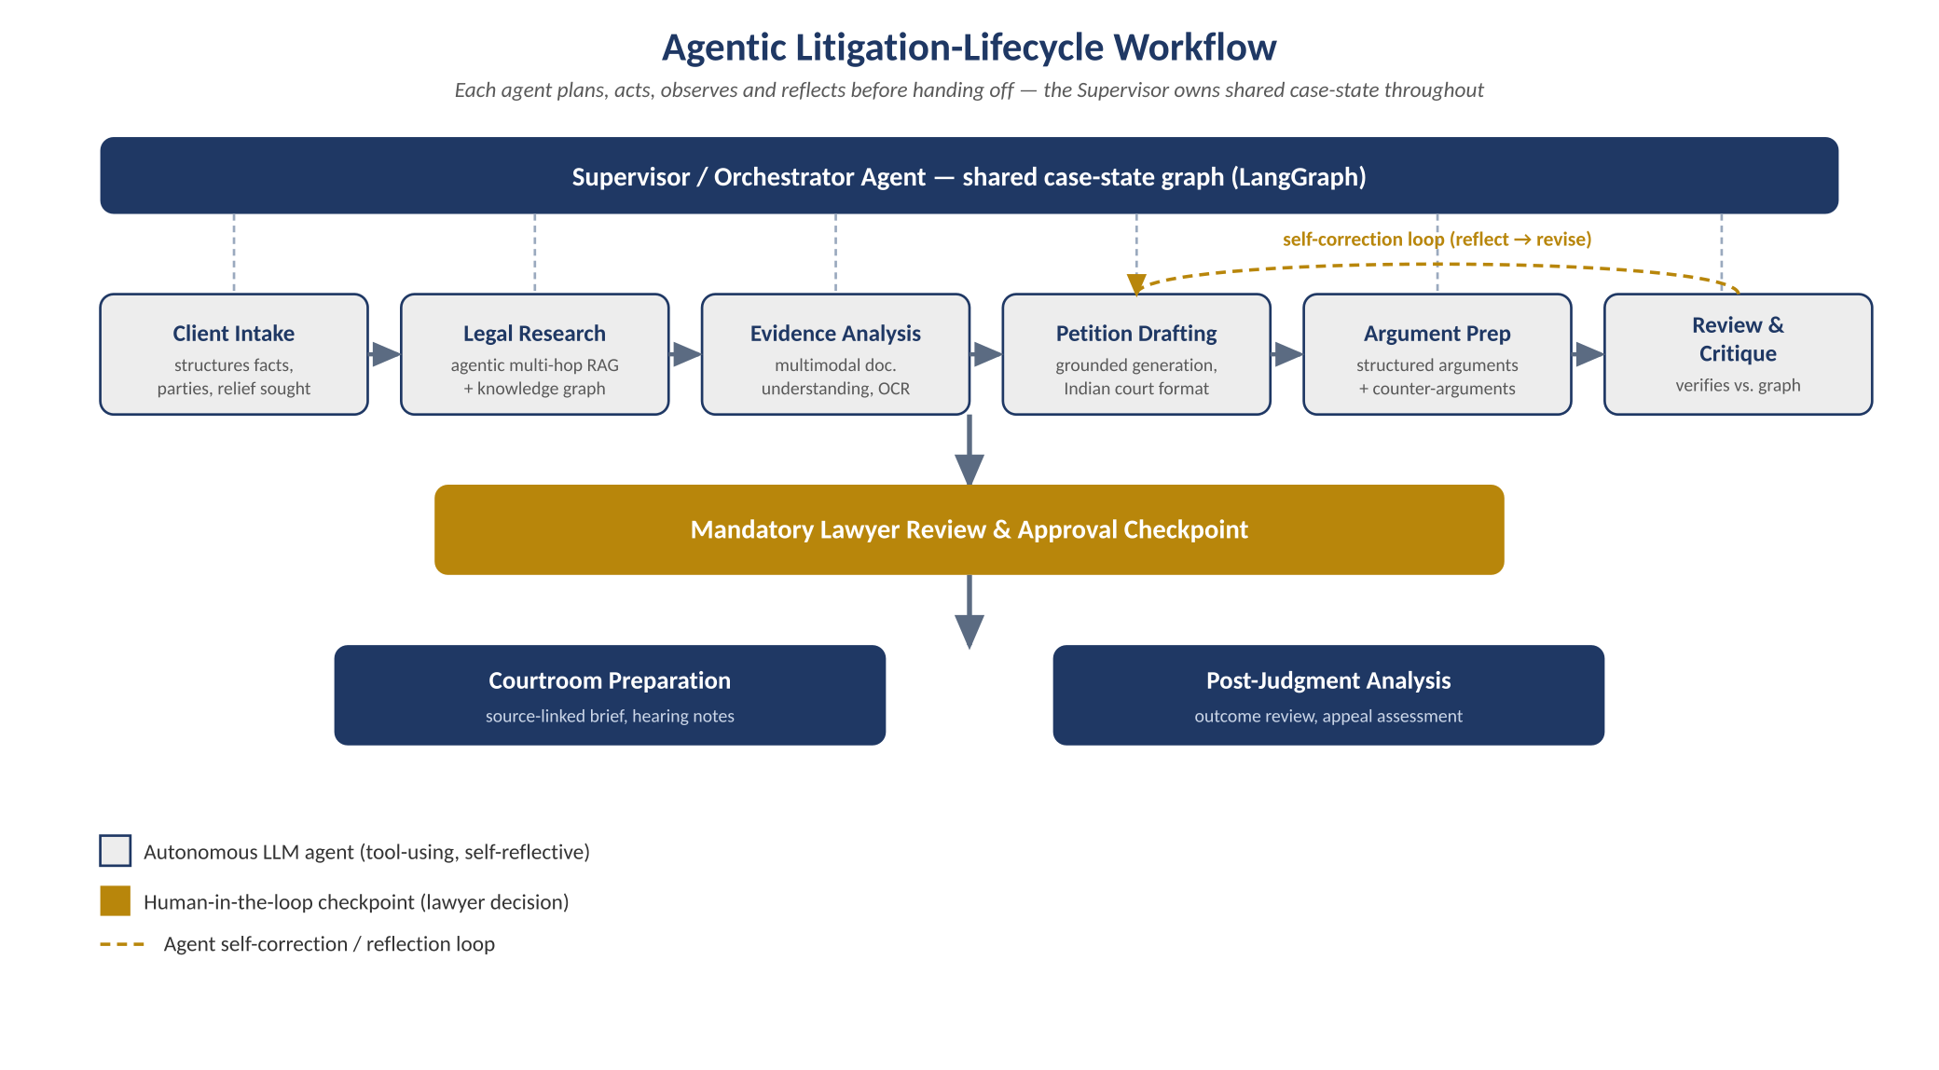
Figure 1: Agentic litigation-lifecycle workflow — specialised agents hand off under a supervisor, with a self-correction loop and a mandatory lawyer checkpoint before courtroom preparation or post-judgment analysis.

6.2 Agentic Grounding: RAG + Knowledge Graph
Grounding is itself agentic rather than a single retrieval call: the research and review agents combine dense vector search (over embedded statutes, precedents and case documents) with structured graph traversal in Neo4j (over statute–section–precedent–fact relationships), and use graph-constrained generation to verify that reasoning chains are supported by explicit graph edges rather than embedding similarity alone. This iterative, self-checking retrieval loop directly targets the hallucination and verifiability gaps identified in Section 3.
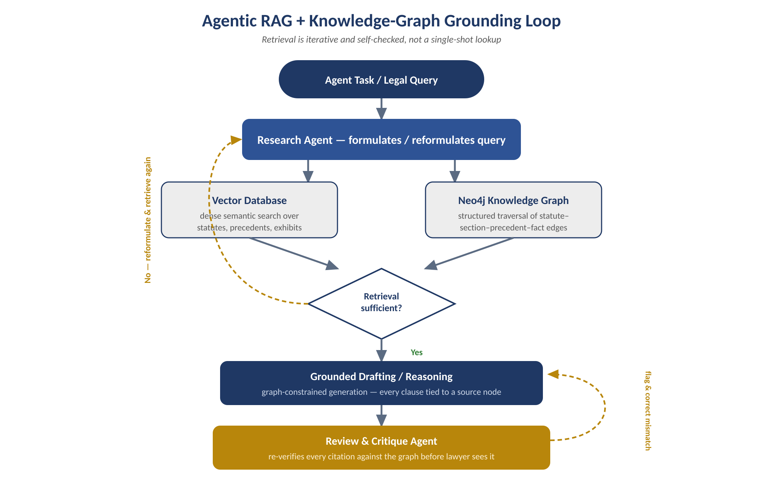
Figure 2: Agentic RAG + knowledge-graph grounding loop — the research agent iterates until retrieval is self-assessed as sufficient, and the review agent independently re-verifies every citation before output reaches the lawyer.

6.3 Data and Processing Pipeline
- Ingestion: Statutes, reported judgments, and case documents (PDF/scanned/vernacular) are collected and normalised.
- Agentic multimodal parsing: The evidence agent autonomously selects OCR and layout-aware extraction tools to convert scanned/handwritten material into structured text and metadata.
- Embedding & graph construction: Text chunks are embedded into a vector database; entities and relationships are extracted into the Neo4j knowledge graph via an LLM-based extraction agent, not a fixed rule-based pipeline.
- Hierarchical agent orchestration: A LangGraph state machine, coordinated with CrewAI role-based crews and exposed through the Model Context Protocol (MCP) for external tool access, manages planning, delegation, and shared case-context across the full lifecycle.
- Human-in-the-loop review: Every drafted or recommended output is presented with source citations, agent-reasoning traces and confidence indicators for lawyer approval, edit or rejection before use.

6.4 System Architecture Overview
Client / Lawyer Interface (React front-end) → API Gateway (FastAPI) → Supervisor / Orchestrator Agent (LangGraph state machine + CrewAI crews, MCP tool access) → Specialised Autonomous Agents (Intake, Research, Evidence, Drafting, Argumentation, Review & Critique) → Agentic Grounding Layer (Vector DB + Neo4j Knowledge Graph + Context-engineered LLM via Ollama) → Data Layer (MongoDB for case/document data, SQL for structured records) → Explainability & Audit Layer (source-linked outputs, agent-reasoning traces, human approval checkpoints).
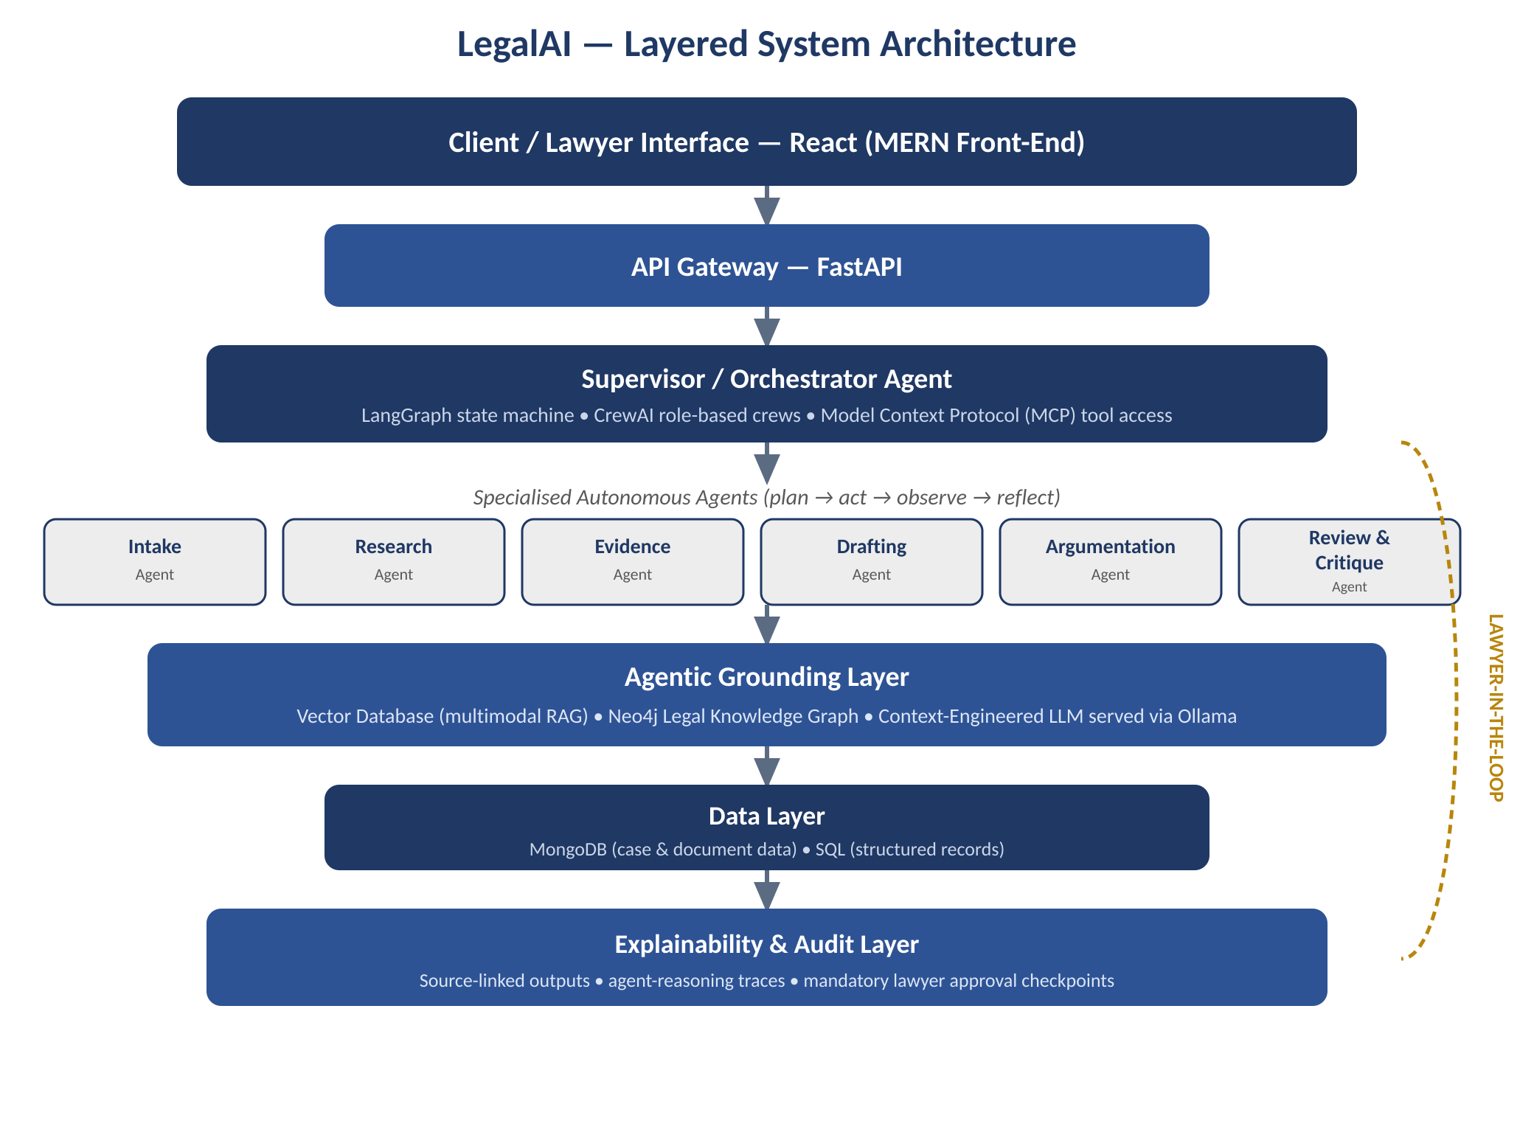
Figure 3: LegalAI layered system architecture, from the client-facing interface down to the explainability and audit layer, with the lawyer-in-the-loop spanning every stage.

7. Technology Stack
The core reasoning of LegalAI is deliberately agentic — orchestration, retrieval and drafting are performed by autonomous, tool-using LLM agents rather than static classifiers. Traditional ML/DL and data-science libraries listed below (Scikit-learn, TensorFlow, Pandas, NumPy, Matplotlib) are used only in supporting roles — data preprocessing, embedding utilities, evaluation metrics and result visualisation — and not as the primary decision-making mechanism of the platform.
Layer | Technologies
AI / ML Core | Machine Learning, Deep Learning, Large Language Models, NLP, Generative AI, Explainable AI, LLM Fine-tuning
Agent Orchestration | LangChain, LangGraph, CrewAI, LlamaIndex, Multi-Agent Systems, Model Context Protocol (MCP), Ollama
Retrieval & Context | RAG (multimodal and advanced), Context Engineering, Prompt Engineering, Vector Databases
Modelling & Data Tooling | Transformers, Hugging Face, TensorFlow, Pandas, NumPy, Scikit-learn, Matplotlib
Automation & Integration | n8n (workflow automation), GitHub (version control), Google Colab (experimentation), VS Code (development)
Backend & APIs | FastAPI, Node.js, Express.js
Data Storage | MongoDB (NoSQL), SQL databases, Vector Databases, Neo4j (knowledge graph)
Frontend | React.js (MERN stack)
Table 2: Technology stack mapped to system layers.

8. Expected Outcomes
- A working multi-agent prototype covering intake, research, evidence analysis, drafting and argumentation for representative Indian case types (e.g., civil suit, criminal bail application).
- An Indian-legal RAG corpus and knowledge graph covering a defined subset of statutes and reported precedents, queryable for grounded retrieval.
- Measurable reduction in time spent on legal research and first-draft preparation compared with manual baseline, evaluated on a sample task set.
- Citation-faithfulness and hallucination-rate metrics demonstrating that generated content is traceable to real, retrieved sources.
- A documented, reproducible system architecture and evaluation methodology suitable for extension in subsequent project phases.

9. Ethics, Data Privacy and Plagiarism Compliance
This project involves processing sensitive client and case data and generating legal drafts, and is therefore designed around the following commitments:
- Human-in-the-loop control: The system never files, submits, or independently advises; every draft, citation and recommendation requires explicit lawyer review and approval, consistent with the Supreme Court AI Committee's stated position that AI must remain assistive, not decisional.
- Source traceability: All generated legal content is required to cite a retrieved statute, precedent or document passage; unsupported claims are flagged rather than presented as fact.
- Data privacy: Client and case data used for testing will be anonymised or drawn from publicly available judgments; access to any real client data (if used with consent in later phases) will follow informed consent and confidentiality safeguards consistent with the Digital Personal Data Protection framework.
- Academic integrity: All literature, datasets and open-source frameworks used are appropriately cited; the final synopsis and report will be checked through the institute's plagiarism-detection tool, and original content will be maintained above the permissible similarity threshold.
- Bias and fairness review: Retrieval and generation outputs will be periodically audited for consistent treatment across case types to avoid embedding or amplifying bias present in historical judgment data.

10. References
[1] Malik, V. et al., "ILDC for CJPE: Indian Legal Documents Corpus for Court Judgment Prediction and Explanation," ACL-IJCNLP 2021.
[2] Paul, S., Mandal, A., Goyal, P., Ghosh, S., "Pre-trained Language Models for the Legal Domain: A Case Study on Indian Law" (InLegalBERT), ICAIL 2023.
[3] Joshi, A. et al., "IL-TUR: Benchmark for Indian Legal Text Understanding and Reasoning," ACL 2024.
[4] Ministry of Law and Justice / National Judicial Data Grid (NJDG), case-pendency statistics, December 2025.
[5] Supreme Court of India, SUPACE and SUVAS documentation and press releases, 2019–2026.
[6] Various authors, "Falkor-IRAC: Graph-Constrained Generation for Verified Legal Reasoning in Indian Judicial AI," arXiv preprint, 2026.
[7] LangChain / LangGraph documentation, https://python.langchain.com and https://langchain-ai.github.io/langgraph/
[8] CrewAI documentation, https://docs.crewai.com
[9] Neo4j Graph Database documentation, https://neo4j.com/docs/
[10] Hugging Face Model Hub — law-ai/InLegalBERT, https://huggingface.co/law-ai/InLegalBERT

