**SEGMENTING LIVER FROM REAL TIME DATSET**

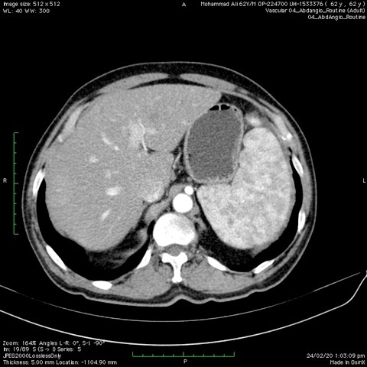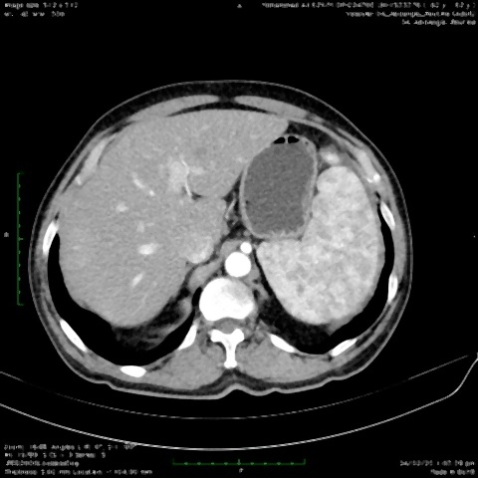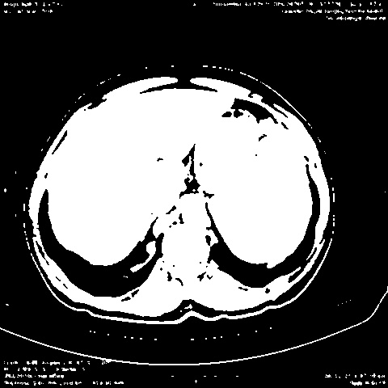

**1. ABDOMINAL CT IMAGE 2. BLURRED IMAGE 3. THRESHOLD IMAGE**

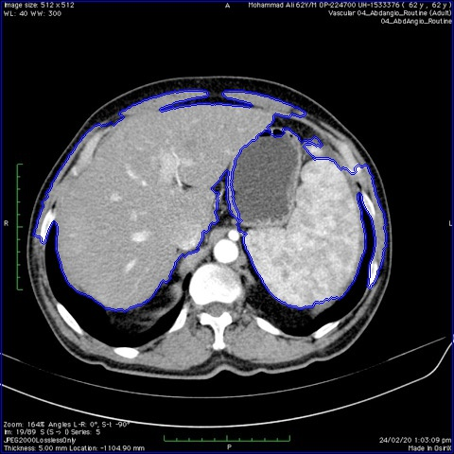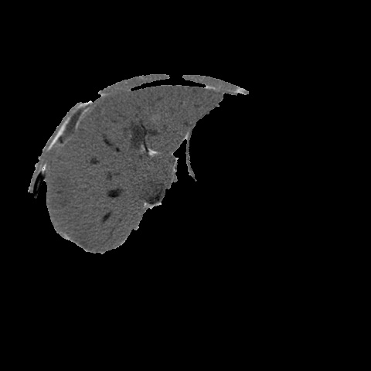

**4. NOISE REMOVED IMAGE 5. LIVER DETECTED IMAGE 6. SEGMENTED LIVER**