System Benchmarks:

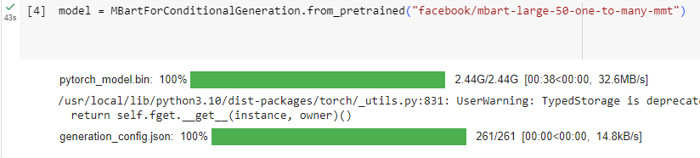

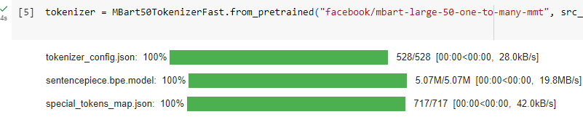





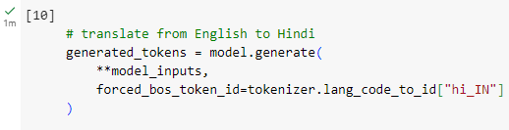





Total time: 111s

Intel Xeon VM

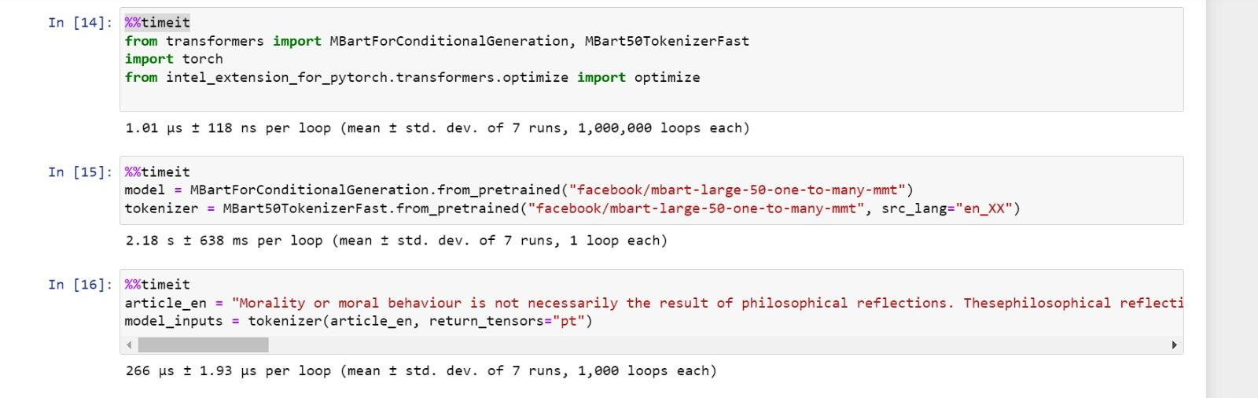  
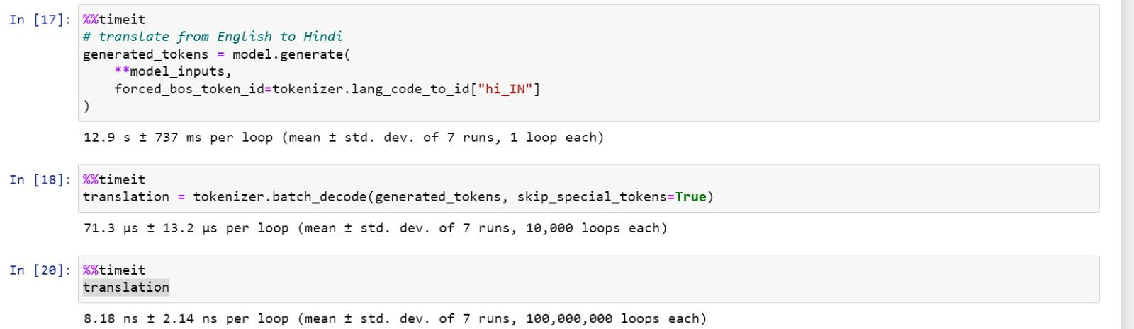

Time : 15s

Time Difference : 111 - 15 = 96s