# Introduction

An autoencoder is a neural network that attempts to reconstruct its input. The internal representation of an autoencoder compresses the input features into a feature vector in the hidden layers and learn the weights for these hidden layers. Hence, an autoencoder is a form of feature extraction algorithm that learns the important features of the data. This representation can be then feed into other algorithms, such as softmax algorithm for classification problem.

# Methodologies

## Model Architectures

### 1 Autoencoder

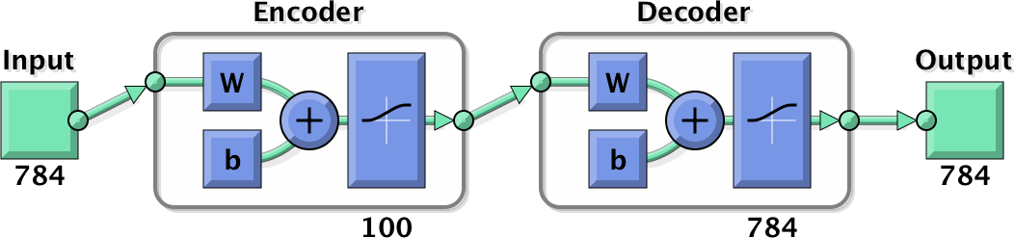

### 2 Autoencoders



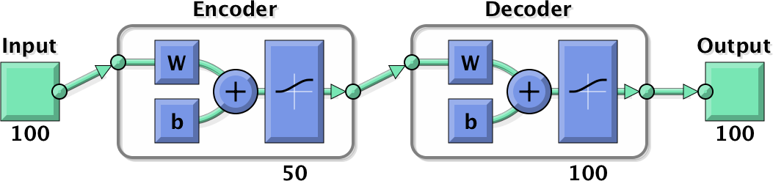

### 2 Autoencoders and 1 Softmax layer

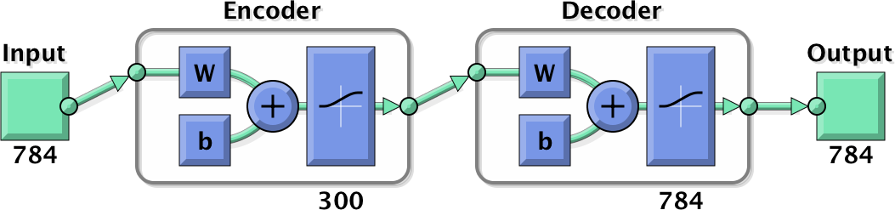

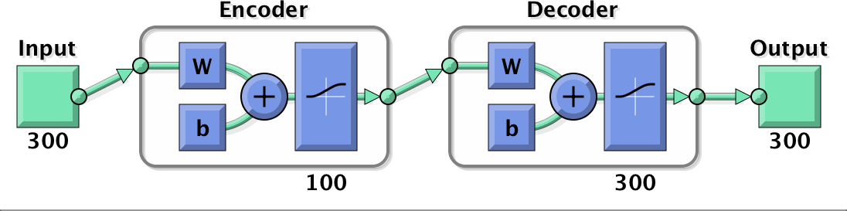

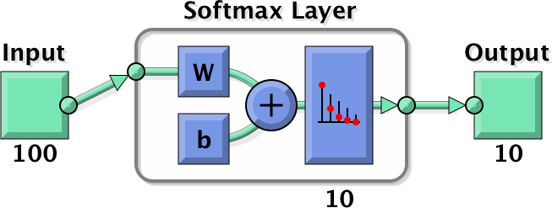

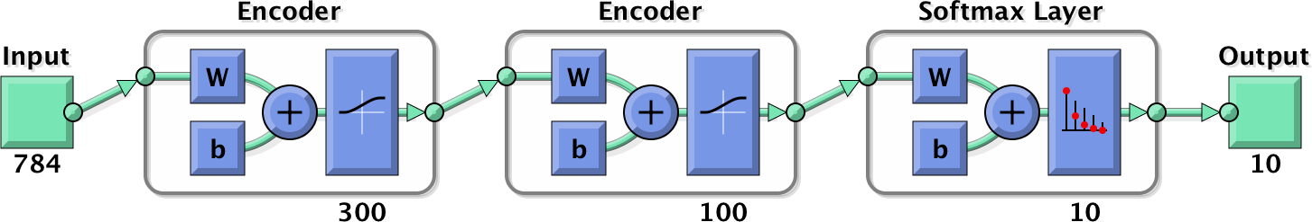

## Learning Algorithms

# Implementation

# Results and Analysis

## Model with 1 Autoencoder layers

### Number of Epochs

#### Reconstruction

// Compare best and worst MSE

#### MSE

### Sparsity Proportions and Sparsity Regularization Coefficients

#### Reconstruction

#### MSE

### Transfer Functions

#### Reconstruction

#### MSE

## Model with 2 Autoencoder layers

### Sample features

## Model with 2 Autoencoder layers and 1 Softmax Layer

# Discussions and Challenges