Assumptions:
1)Each robot has a fixed alogorithm of moving with a set target of the ball, the goal, or some other location.
2)Any robot can either move with the ball or can kick it to a given target.
3)The kick can be given to any desired location on the field.
4)If two robots(of opposite sides) get hold of the ball together, then the game is reset.
5)Let Team A be team for which we are developing the algorithm for and Team B be the opposite side.
6)At any moment let that robot calculate the fd,fc for itself and all its team members.

Lexicon:
'Possible':
It means that the ball can be directed to a certain location without any direct blocking of the robots from the opposite team.
Fd:
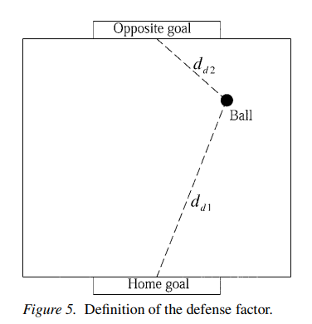
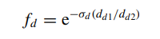

the defense factor is defined as follows:

where dd1 is the distance between the ball and the home goal, dd2 is the distance between the ball and the opposite goal, and σd is a large positive constant. From the above definition, the value of fd varies between 0 and 1. fd = 1 and fd = 0 denote that the ball is very close to the home goal and the opposite goal, respectively. If fd = 1, then the robot should play the role of a defender. On the other hand, if fd = 0, then the role of the robot is of a striker.

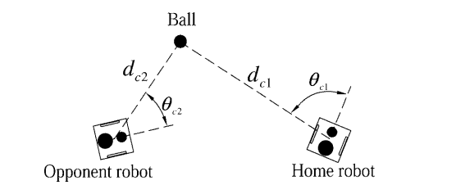
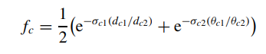

, the competition factor is defined as
where dc1 is the distance between the ball and the home robot, dc2 is the distance between the ball and the opponent robot, θc1 is the angle between the ball and the home robot, θc2 is the angle between the ball and the opponent robot, and σc1 and σc2 are two large positive constants. The definition in Equation (9) shows that the value of fc varies between 0 and 1. fc = 1 indicates that the ball is very close to the home robot and the angle between the ball and the home robot is quite small, such that the home robot has a much better chance to control the ball than the opponent robot. On the other hand, if fc = 0, then the opponent robot will have an obvious advantage over the home robot.

Algorithm:
If Team A gets the ball:
If it is possible to kick to the goal, then do so:
If not, then navigate the ball to goal:
If not possible, kick to a player with least fd:
If not possible, kick to a point where Team A's players get the most fc:
If not possible, kick to a point, where the player itself has a better fd:
If not possible, kick to a point where both teams have an equal chance of getting the ball.(Here the possibilities of kicking the ball exhaust)
Now, the player can also navigate the ball:
Here, the players collaborate(passing as well as navigating the ball) at each moment in time such that the global best fd is non-increasing, and if passing is not possible, then the ball is passed to points such that fc of any one (at least) of the team A's players is more than that of all of team B' players.

If Team B gets the ball:
At this juncture, the value of fd and fc become a non-controllable factor.
So the no. of players in the home side of the half, i.e., the half in which the home goal is located must be proportional to the value of fd, with the value of fd = 1 representing that all players gather at the home goal, and fd = 0 indicating that all players gather at the opposite goal.
The function that describes this relation b/w the distance and no. of players from the home goal can be determined or rather learnt through past experiences by techniques of RL or simplistic neural networks.

The above algorithm will be used after a certain position has been reached. To reach a certain position the method give below will be used. When the ball is with us.

I propose that we divide the play area into subparts and plan the strategy that how will the bots move from a particular configuration to other.

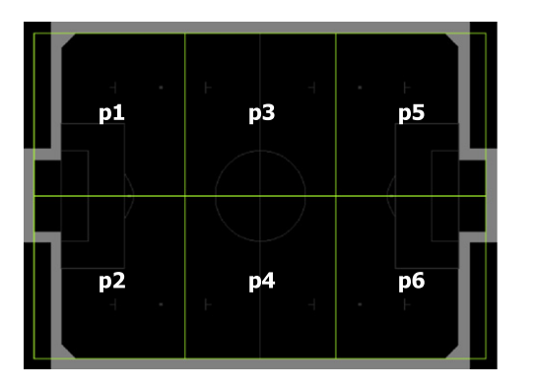
the strategy grid , has a much lower resolution than the abstract grid. This simplification is sufficient because it is unnecessary to know the robots precise position in the logical part. It is enough to know the robot’s approximate position for strategy realization

The position information, representing the situation of both sides, is much more important than the others in the logic part. Abstract grid, velocity, acceleration and posture of robots are associated with motion planning and robot control . Apparently, motion planning and robot control are the implementation of strategies, while the strategies should be made through game situation. Therefore we express the game situation by position information.

In a strategy rule the subpart in which a bots are present is given and its next destination is given
Eg this is a decision table which consists of many strategy rules where 0 indicates a bot is not there (of our team) and 1 indicates present.
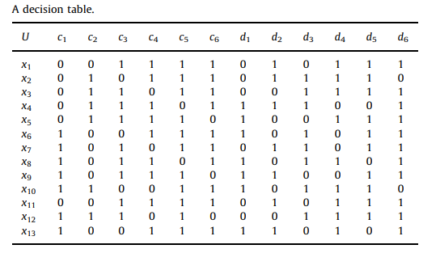

After the strategies are made we can rank them.
While in strategy ranking, the strategy that has more links to other strategies is more important because that strategy has more influence on the process of game, the game situation is mostly depends on the follow-up execution of that strategy. In other words, the strategy becomes a power where strategy influence other strategies by linking to them. In addition, this kind of strategy is a hub because many other strategies have to be achieved through it. The links to other strategies are called forwardlinks for the hub strategy. If we can destroy opponent’s hub strategy, then we eliminate most of the follow-up rules of opponent, and vice versa. Suppose the strategy set of interest contains n strategies, each strategy indexed by an integer k, 1rkrn. An example is illustrated in Fig. 8, in which there are four strategies, an arrow from strategy A to strategy B indicates a link from strategy A to strategy B. Such a strategy set is an example of a directed graph. We use xk to denote the importance score of strategy k in the set.
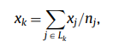
important fact that a link from strategy k to an important strategy should boost strategy k’s importance score more than a link to an unimportant strategy. For example, in the strategy set of Fig. 8, strategies 2 and 4 both have two forwardlinks: each links to the other, but strategy 4’s second forwardlink is to the seemingly important strategy 1, while strategy 2’s second forwardlink is to the relatively unimportant strategy 4. As such, perhaps we should rate strategy 4’s importance higher than that of strategy 2. The most fundamental problem of the simple approach mentioned above is that a single individual could gain influence merely by sending out multiple arrows. Therefore, we seek a scheme in which a strategy does not gain extra influence simply by linking to lots of other strategies. If strategy j contains nj backlinks, one of which links from strategy k, then we will boost strategy k’s score by xj=nj, rather than by 1. To quantify a set of n strategies, let Lk f1,2, ... ,ng denote the set of strategies with a backlink from strategy k, that is, Lk is the set of strategy k’s forwardlinks. For each k we require

where nj is the number of forwardlinks to strategy j (which must be positive since if jALk, then strategy j links from at least strategy k). We will assume that a link from a strategy to itself will not be counted, and we should delete this kind of self-loop strategy from strategy set because it is harmful to the robot’s action, which would make robots be in a trap of executing repeated actions. Now we go back to the example in Fig. 8 again. For strategy 1, we have x1 ¼ x2=1þx3=3þx4=2, since strategies 2, 3 and 4 are forwardlinks for strategy 1 and strategy 2 contains only one link, strategy 3 assembles three links, while strategy 4 receives two links. Similarly, x2 ¼ x3=3þx4=2, x3 ¼ x1=2, x4 ¼ x1=2þx3=3. These linear equations can be written as
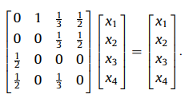

In this case we obtain x1¼0.3750, x2¼0.1875, x3¼0.1875, x4¼0.2500. Thus strategy 1 gets the highest importance score.

Using this we can know which strategy to use.

We can also use probabilistic approach to analyse oppoenent’s strategies and make prediction which can be found in[2].

we can also implement the below mechanism:
Robot soccer simulator is a good test bed for strategy set. In the simulator, two teams, such as red and blue team, will share the same strategy selection algorithm, prediction of movement, tactics, and so on, which would eliminate the impact of the simulator, and distinctly display differences between the two
strategy sets. According to the game simulation result, it is easy to know which strategy set is better, because the better strategy set could achieve better competition result. In the game log file, we can find
the process of goal, which is useful to improve the generation of strategy set. For example, we can find the last action before goal score in the log file of game, and then transform it to be an offensive strategy.
What this indicates is that any strategy that was used earlier by a team that resulted in a goal being scored can be used by Team A to score a goal successfully.
Similarly which strategies led to saving of goals can also be evaluated and added in our strategies.
The reference for this can be found in [2] where it is proven in a tabulated form.

References:
[1]A Fuzzy Mechanism for Action Selection of
Soccer Robots
CHIA-JU WU and TSONG-LI LEE
[2]Analysis of strategy in robot soccer game
Jie Wu; Vaclav Snasel; Eliˇska Ochodkova´; Jan Martinovicˇ; Va´clav Svato; Ajith Abraham
[3])A* Algorithm For Path Planning of Robotic Soccer
Player
Tingsheng Liao ;Polat Utku Kayrak

