Banana Spoilage Detection: An IoT-Driven Machine Learning System for Predicting Remaining Shelf Life
A project report
submitted by
Your Name
(2021PMA55**)
under the supervision of
Dr. ******
in partial fulfillment of
the requirements for the degree of
Bachelor of Technology
in Electronics and Communication Engineering
to the
Department of Electronics and Communication Engineering
Indian Institute of Information Technology Kota
May 2026
DECLARATION
I hereby declare that the work reported in the project titled “Banana Spoilage Detection: An IoT-Driven Machine Learning System for Predicting Remaining Shelf Life”, submitted for partial fulfilment of the B.Tech degree at the Department of Electronics and Communication Engineering, IIIT Kota, is a record of the work carried out by me under the supervision of Dr. ******. The matter embodied in this report has not been submitted for the award of any other degree or diploma. All sources of information used in this work have been duly acknowledged in the bibliography.
Your Name
(B.Tech Final)
Department of Electronics and Communication Engineering
IIIT Kota
May 2026
CERTIFICATE
It is certified that Your Name has submitted the project under my supervision for partial fulfilment of the B.Tech degree in Electronics and Communication Engineering on the topic “Banana Spoilage Detection: An IoT-Driven Machine Learning System for Predicting Remaining Shelf Life”. It is further certified that the candidate has carried out the project work under my guidance during the academic session 2025–2026 at the Department of Electronics and Communication Engineering, IIIT Kota.
Dr. ******
Assistant Professor
Department of Electronics and Communication Engineering
IIIT Kota
ACKNOWLEDGEMENT
As a matter of first importance, I offer my genuine thanks to my supervisor Dr. ******, Assistant Professor, Department of Electronics and Communication Engineering, IIIT Kota, for the continuous guidance, technical mentorship, and encouragement extended throughout this project. The supervisor’s insistence on rigour — particularly on cited physics constants, batch-level data-leak prevention, and honest scope statements — has shaped every layer of this work.
I am thankful to the Department of Electronics and Communication Engineering and the Computing Laboratory at IIIT Kota for providing access to compute resources sufficient to train the recurrent neural network on a 105,000-row synthetic dataset. I also acknowledge the open-source maintainers of TensorFlow / Keras, scikit-learn, FastAPI, and React, on whose work this MVP rests entirely.
Finally, I thank my family and peers for the moral support extended over the duration of this project.
Your Name
(2021PMA55**)
Contents
Declaration 2
Certificate 3
Acknowledgement 4
1 Introduction 6
1.1 Motivation 6
1.2 Problem Statement 6
1.3 Objectives 6
1.4 Scope and Honest Limitations 7
1.5 Original Contributions 8
1.6 Organisation of the Report 8
2 Preliminaries 9
2.1 Post-Harvest Food Science Foundations 9
2.2 Spoilage Definition and the Regression Target 12
2.3 Supervised Learning Models 13
2.4 Evaluation Metrics 16
2.5 Train / Validation / Test Splitting 17
3 Methodology and System Design 18
3.1 System Architecture Overview 18
3.2 Hardware Topology and Sensor Integration 18
3.3 Data Pipeline 20
3.4 Model Training Procedure 21
3.5 Backend Service 21
3.6 Traffic-Light Rules Engine 22
3.7 Front-End Dashboard (Brief) 22
3.8 Deployment via Docker Compose 22
3.9 Testing and Quality Assurance 23
4 Results and Conclusions 24
4.1 Data Collection Procedure 24
4.2 Model Selection and Accuracy Progression 27
4.3 Additional Results Derived from the Project Artefacts 31
4.4 Conclusions 34
Bibliography 36
Note: page numbers above are static. After opening in Microsoft Word, you may regenerate the Table of Contents from the Layout / References menu if any edits change page breaks.
Chapter 1

Introduction

1.1 Motivation
Approximately fourteen percent of all food produced globally is lost between harvest and retail, with another seventeen percent wasted at the consumption stage; perishable horticultural produce dominates these losses [1]. Within this category, climacteric fruits such as banana (Musa acuminata AAA, Cavendish cultivar) are particularly vulnerable: they undergo a sharp, autocatalytic respiration burst — the climacteric peak — during which carbon dioxide and ethylene production surge by an order of magnitude, after which any deviation in storage temperature or humidity initiates an irreversible cascade toward microbial decomposition [2]. Conventional warehouse practice relies almost exclusively on visual inspection by trained operators, a method that is inherently retrospective: by the time peel browning or methane odour becomes apparent to a human observer, the spoilage process has typically been underway for 18 to 36 hours and the affected stock can no longer be re-routed, discounted, or salvaged.
Modern Internet-of-Things (IoT) hardware — low-cost temperature, humidity, and metal-oxide gas sensors interfaced through low-power microcontrollers — now permits the deployment of dense, continuous sensing within a banana storage container at a per-node cost below ₹2000 [3] [4]. These sensors capture the precursor signals that precede visible spoilage: gradual temperature drift, falling humidity, the climacteric carbon dioxide rise, and finally the appearance of headspace methane that marks the onset of anaerobic decomposition. The remaining engineering problem is therefore not one of measurement but of interpretation: converting the multivariate, time-correlated sensor stream into an actionable estimate of Remaining Shelf Life (RSL) and a discrete operational status that warehouse staff can act upon. This is the problem that the present project addresses.

1.2 Problem Statement
Given a real-time stream of seven sensor channels — temperature (temp_c), relative humidity (humidity_pct), carbon dioxide concentration (co2_ppm), ethylene concentration (ethylene_ppm), methane concentration (methane_ppm), hours since harvest (hours_since_harvest), and visual ripeness stage (ripeness_estimate) — the system must (i) regress the continuous quantity days_until_spoilage $∈[0,30]$, and (ii) emit a categorical traffic-light status $s∈\{\text{green},\text{yellow},\text{red}\}$ together with the contributing factors that justify the assignment, such that warehouse managers receive at least 24 hours of usable lead time before any batch crosses into irreversible spoilage.

1.3 Objectives
The specific objectives of this project are stated below.
- Construct a physics-grounded simulator of post-harvest banana respiration, calibrated to peer-reviewed reference parameters from the UC Davis Postharvest Technology Center and the Goldfinger banana respiration study.
- Generate a labelled synthetic dataset of approximately 65,000 sensor rows across 432 independent banana batches that span a realistic envelope of cold, optimal, room, hot, and dynamic day–night storage regimes.
- Engineer features that encode the mathematical relationships identified by post-harvest food science — Arrhenius kinetics, climacteric multiplier, humidity stress, container gas balance, and a cumulative environmental stress integral — and use them to compute the regression label by forward projection.
- Train and rigorously evaluate two complementary machine-learning models: a Random Forest regressor as a non-temporal baseline, and a Long Short-Term Memory (LSTM) recurrent network as the principal time-series model, with strict batch-level data splitting to prevent leakage.
- Expose the trained models behind a FastAPI microservice that serves single-shot, sequence-window, and bulk-CSV prediction endpoints together with a WebSocket stream for live preview.
- Provide a minimal React dashboard front-end so that the system can be demonstrated and operated without command-line access.

1.4 Scope and Honest Limitations
This work is deliberately scoped as a software-only minimum viable product (MVP) restricted to the Cavendish banana cultivar. Three explicit limitations apply. First, the dataset is synthetic: although it is calibrated to published respiration data — peaking at 55 mg CO₂/kg/h, in close agreement with the published 56.8 mg CO₂/kg/h figure [2] — real-sensor field validation against ground-truth spoilage logs is explicit future work. Second, the embedded hardware path (ESP32 + DHT22 + MQ-135 + MQ-4) is stubbed behind a DataSource abstraction so that real Message Queuing Telemetry Transport (MQTT) ingest can replace the simulator without disturbing the model or user interface, but no firmware has been written. Third, only one commodity is supported in the present release; the architecture has been verified to support new commodities via a four-step extension recipe but rice, mango, wheat, and tomato are not yet implemented.
Authentication, multi-tenancy, persistent batch history, cloud deployment, and alert webhooks are explicitly out of scope. The present report is written so that an examiner or successor engineer can reconstruct, retrain, and extend the system without recourse to the original chat transcripts that produced it.

1.5 Original Contributions
- A complete, documented physics simulator for post-harvest banana respiration in Python, exposing both physical-unit (ppm) outputs and synthetic raw analog-to-digital-converter readings that emulate MQ-series metal-oxide sensors.
- A rigorous batch-level train / validation / test split implementation that prevents the trivial information leak that arises from random row-level shuffling on time-series data.
- A two-stage decision logic that separates the learned regression of remaining shelf life from a transparent rules engine which converts the continuous prediction together with raw sensor conditions into the green / yellow / red status and an interpretable list of contributing factors.
- A reference REST and WebSocket API surface — including a CSV bulk-prediction endpoint with column aliasing — that demonstrates how the trained models can be served to downstream consumers.

1.6 Organisation of the Report
Chapter 2 develops the mathematical preliminaries: the Arrhenius equation, climacteric kinetics, the humidity stress factor, the gas-balance ordinary differential equations (ODEs), the cumulative stress integral, and the formal definitions of the Random Forest, the LSTM cell, and every evaluation metric used. Chapter 3 describes the system architecture, the hardware topology, the data pipeline, the training procedure, and the deployment surface. Chapter 4 reports the results: the controlled data-collection procedure, the model-selection journey, the analytically derived secondary results, and the conclusions. The bibliography lists fifteen references in IEEE format that are cited inline throughout.
Chapter 2

Preliminaries
This chapter develops the mathematical and theoretical foundations required by the rest of the report. Section 2.1 collects the post-harvest food-science relations that govern banana spoilage. Section 2.2 specifies the formal definition of the regression target. Section 2.3 reviews the supervised learning models adopted (Random Forest and LSTM) with full equations. Section 2.4 defines all evaluation metrics.

2.1 Post-Harvest Food Science Foundations

2.1.1 Arrhenius Temperature Dependence
All biological reactions — respiration, ripening, microbial decomposition — exhibit an exponential dependence on absolute temperature first formalised by Svante Arrhenius in 1889 [5]. For a reaction of activation energy $E_{a}$ the rate constant satisfies
$$k(T) = A exp​\left(− \frac{E_{a}}{R T}\right)$$
where $T$ is the absolute temperature in Kelvin, $R=8.314 J mol^{−1} K^{−1}$ is the universal gas constant, and $A$ is a pre-exponential factor. In post-harvest applications the absolute rate constant is rarely required; what matters is the rate relative to a reference storage temperature $T_{\text{ref}}$. Taking the ratio $k(T)/k(T_{\text{ref}})$ eliminates the pre-exponential factor and yields
$$\boxed{ ϕ(T) = \frac{k(T)}{k(T_{\text{ref}})} = exp​\left[ − \frac{E_{a}}{R}​\left(\frac{1}{T}−\frac{1}{T_{\text{ref}}}\right)\right] }$$
This is the form actually implemented in ml/src/simulator.py. For Cavendish banana the parameter values used [2] [6] are $E_{a}=80,000 J mol^{−1}$ and $T_{\text{ref}}=287.15 K$ (i.e. ${14}^{∘}C$, the centre of the UC Davis recommended storage band $13$–${14}^{∘}C$). Substituting room temperature ($T=295.15$ K) gives $ϕ≈3.0$; substituting ${32}^{∘}C$ ($T=305.15$ K) gives $ϕ≈8$–$9$. These values are consistent with the empirical finding that bananas keep for $14$–$28$ days at ${14}^{∘}C$ but only $3$–$5$ days at ${32}^{∘}C$, validating the choice of $E_{a}$.
The Arrhenius factor is closely related to the empirical $Q_{10}$ coefficient widely used in plant physiology [7], which expresses the multiplicative rate increase per ${10}^{∘}C$ rise:
$$Q_{10} = \frac{k(T+10)}{k(T)} = exp​\left[\frac{10 E_{a}}{R T (T+10)}\right]$$
With $E_{a}=80,000 J mol^{−1}$ and $T=287 K$ the implied $Q_{10}$ evaluates to approximately $2.5$, again matching the literature for banana respiration.

2.1.2 Climacteric Respiration Multiplier
Cavendish banana is a climacteric fruit [2]: its respiration rate is not monotonic with ripeness but instead exhibits a sharp burst — the climacteric peak — that is autocatalytically driven by ethylene. The respiration multiplier $μ(r)$ as a function of the ripeness stage $r∈[1,7.5]$ is modelled as a piecewise-linear function calibrated so that $μ(5)≈5.5$, which combined with the base rate of $10 mg CO_{2} kg^{−1} h^{−1}$ at ${14}^{∘}C$ yields a peak respiration of $55 mg CO_{2} kg^{−1} h^{−1}$ — within $3.2$% of the published $56.8 mg CO_{2} kg^{−1} h^{−1}$ figure of the Goldfinger banana respiration study [2]:
$$μ(r) = \left\{\begin{matrix}1.0+0.2 (r−1) & 1≤r≤3 \text{(pre-climacteric)} \\ 1.4+2.05 (r−3) & 3<r≤5 \text{(climacteric rise)} \\ 5.5−2.0 (r−5) & 5<r≤6.5 \text{(post-climacteric drop)} \\ 2.5+1.5 (r−6.5) & 6.5<r≤7.5 \text{(senescence rise)}\end{matrix}\right.$$
The corresponding ethylene production curve $η(r)$ in $μL {kg}^{−1} h^{−1}$ peaks at $η(5)=7.4$, again matching published values [2], and decays toward $1.0$ as the fruit moves into senescence:
$$η(r) = \left\{\begin{matrix}0.1+0.15 (r−1) & 1≤r≤3 \\ 0.4+3.5 (r−3) & 3<r≤5 \\ 7.4−4.27 (r−5) & 5<r≤6.5 \\ 1.0 & r>6.5\end{matrix}\right.$$

2.1.3 Humidity Stress Factor
Deviation from the optimal relative humidity of $92.5\%$ (centre of the UC Davis $90$–$95\%$ range [6]) imposes additional biological stress: low humidity drives transpirational moisture loss and shrivelling, whereas excessive humidity invites surface fungal growth. A simple linear stress factor captures the leading-order behaviour:
$$σ_{\text{RH}}(RH) = 1+α |RH−92.5| \text{with} α=0.02 \%^{−1}$$
At $RH=80\%$ the multiplier is $σ_{\text{RH}}=1.25$, i.e. $25\%$ accelerated ageing; at $RH=99\%$ the multiplier is $1.13$. The combined ageing rate that advances the biological clock relative to optimal storage is then
$$\boxed{ ρ(T,RH) = ϕ(T) σ_{\text{RH}}(RH) }$$
If the simulator advances the ripeness stage by $Δr=ρ⋅Δt/36 h$ per time step, then at reference conditions one ripeness stage is traversed every $36 h$, in agreement with empirical climacteric trajectories [2].

2.1.4 Container Gas Balance
Inside a sealed storage container of volume $V$ and leak rate $k_{\text{leak}}$ the headspace concentration $C(t)$ of any species evolves according to a first-order linear ordinary differential equation derived from a mass balance: production from respiration minus loss to ambient leakage. For carbon dioxide,
$$\frac{dC_{CO_{2}}}{dt} = \underset{\text{production (ppm/h)}}{\underset{⏟}{\frac{{\dot{m}}_{CO_{2}} m_{\text{banana}}}{V⋅1.964}}} − \underset{\text{leakage (ppm/h)}}{\underset{⏟}{k_{\text{leak}} (C_{CO_{2}}−C_{\text{atm}})}}$$
where ${\dot{m}}_{CO_{2}}=10 ϕ(T) μ(r) mg kg^{−1} h^{−1}$ is the per-unit-mass production rate, the factor $1.964$ converts $mg/m^{3}$ to ppm at standard conditions, $C_{\text{atm}}=420 ppm$ is the present atmospheric baseline, and the typical leak rate $k_{\text{leak}}∈[0.05,0.15] h^{−1}$ ranges from a poorly ventilated bag to a well-ventilated crate. The exact same first-order structure governs ethylene, with $C_{\text{atm}}=0$ since atmospheric ethylene is negligible:
$$\frac{dC_{C_{2}H_{4}}}{dt} = \frac{η(r) ϕ(T) m_{\text{banana}}}{1000 V} − k_{\text{leak}} C_{C_{2}H_{4}}$$
The closed-form steady-state concentration when production is constant is $C^{⋆}=(\text{production}/k_{\text{leak}})+C_{\text{atm}}$, and the time constant of approach is $τ=1/k_{\text{leak}}$. For $k_{\text{leak}}=0.15 h^{−1}$ this evaluates to approximately $6.7 h$, consistent with empirical measurements in vented banana cartons [8].

2.1.5 Methane Onset and Anaerobic Decomposition
Methane (CH₄) is not produced by intact banana tissue. It is a marker of anaerobic microbial decomposition that begins only after structural tissue collapse [9]. The simulator implements this with a threshold-activated production term:
$${\dot{C}}_{CH_{4}}(r) = \left\{\begin{matrix}0 & r<7.2 \\ 2.5 (r−7.1) ppm/h & r≥7.2\end{matrix}\right.$$
Once headspace methane exceeds $1 ppm$ the spoilage process is treated as irreversible — no reduction in temperature can recover the batch — and the spoilage flag is asserted permanently.

2.1.6 Cumulative Environmental Stress Integral
Even brief excursions outside the ideal storage envelope accumulate damage. The simulator tracks a cumulative stress integral $S(t)$ defined by
$$\frac{dS}{dt} = ΔT^{1.5} + 1/2 Δ_{RH} + Δ_{CO_{2}}$$
where the deviations from the safe envelope are
$$ΔT = max(0, T−18)+max(0, 8−T)$$
$$Δ_{RH} = max(0, 80−RH)+max(0, RH−98)$$
$$Δ_{CO_{2}} = \frac{max​\left(0, C_{CO_{2}}−50,000\right)}{5000}$$
The exponent $1.5$ on temperature deviation captures the experimentally observed super-linear thermal damage to plant cell membranes — being ${10}^{∘}C$ outside range is approximately $2.83×$ as damaging as $5^{∘}C$ outside, since ${10}^{1.5}/5^{1.5}≈2.83$ [7]. Spoilage is declared whenever $S$ exceeds $1500$ stress-units, even if the ripeness stage and methane channels remain quiet.

2.2 Spoilage Definition and the Regression Target
A batch is declared spoiled at the first time instant $t^{⋆}$ at which any one of three independent criteria is satisfied:
$$t^{⋆} = inf\left\{ t≥0 : r(t)≥7 ∨ S(t)>1500 ∨ C_{CH_{4}}(t)>1 ppm\right\}$$
The continuous regression target — the Remaining Shelf Life or RSL — is then the forward projection of $t^{⋆}$ from the present moment under the assumption that current sensor conditions are held constant:
$$\boxed{ RSL(t) = min​\left( t_{ const}^{⋆}(t)−t, 30 days\right) }$$
The horizon cap of 30 days reflects the practical observation that no realistic Cavendish lot remains commercially viable beyond one month under any storage condition. The label is computed by the simulator on every row of the training set; the machine-learning models are then trained to reproduce this physics-based label directly from raw sensor readings.

2.3 Supervised Learning Models

2.3.1 Random Forest Regression
A Random Forest, introduced by Breiman in 2001 [10], is an ensemble of $B$ decision-tree regressors, each fit on a bootstrap-resampled copy of the training set with random feature sub-selection at every split. The ensemble prediction is the arithmetic mean of the individual tree predictions:
$${\hat{y}}_{\text{RF}}(x) = \frac{1}{B}\sum_{b=1}^{B}{{\hat{y}}^{(b)}}(x)$$
Each tree ${\hat{y}}^{(b)}$ recursively partitions the seven-dimensional feature space into axis-aligned regions $\{R_{j}\}_{j=1}^{J}$ by minimising the weighted sum-of-squared-errors at every node:
minj, s xi∈RL(j,s)​(yi−yL)2 + xi∈RR(j,s)​(yi−yR)2
where $j$ is the splitting feature, $s$ is the split threshold, and ${\overset{‾}{y}}_{L},{\overset{‾}{y}}_{R}$ are the mean targets in the left and right child regions. The hyper-parameters used are $B=200$, maximum depth $20$, and minimum samples per leaf $5$. Bootstrap aggregation reduces the variance of an individual deep tree by approximately a factor $1/B$ when the trees are uncorrelated [10]; random feature selection at each split decorrelates them. Random Forest is a natural baseline for this problem because its only assumption is conditional independence given a sufficiently fine partition — it makes no use of temporal structure.
Per-feature Mean Decrease in Impurity (MDI), or Gini importance, is computed by summing the impurity reduction associated with each feature across all internal splits and trees, weighted by the fraction of samples reaching that split, and finally normalised. This yields a ranked feature-importance list whose practical use is discussed in Chapter 4.

2.3.2 Long Short-Term Memory Recurrent Network
The LSTM cell, introduced by Hochreiter and Schmidhuber in 1997 [11], is a recurrent neural unit that maintains a long-term cell state $c_{t}$ in addition to the conventional hidden state $h_{t}$, gated by three sigmoidal gates that mitigate the exploding- and vanishing-gradient pathologies of vanilla recurrent networks. At each time step $t$ with input $x_{t}∈R^{F}$ (here $F=7$) the LSTM computes
$$f_{t} = σ\left(W_{f}x_{t}+U_{f}h_{t−1}+b_{f}\right) \text{(forget gate)}$$
$$i_{t} = σ\left(W_{i}x_{t}+U_{i}h_{t−1}+b_{i}\right) \text{(input gate)}$$
$$o_{t} = σ\left(W_{o}x_{t}+U_{o}h_{t−1}+b_{o}\right) \text{(output gate)}$$
$${\tilde{c}}_{t} = tanh\left(W_{c}x_{t}+U_{c}h_{t−1}+b_{c}\right) \text{(candidate)}$$
$$c_{t} = f_{t}⊙c_{t−1} + i_{t}⊙{\tilde{c}}_{t}$$
$$h_{t} = o_{t}⊙tanh\left(c_{t}\right)$$
where $σ(⋅)$ is the logistic sigmoid, $⊙$ is the Hadamard product, and the matrices $W_{\{f,i,o,c\}}$, $U_{\{f,i,o,c\}}$ together with bias vectors $b_{\{f,i,o,c\}}$ are the trainable parameters. The architecture deployed in this project, fixed by the project specification, is
$$x∈R^{48×7} \overset{ {LSTM}_{64} \text{(seq)} }{→} R^{48×64} \overset{ Dropout(0.2) }{→} R^{48×64} \overset{ {LSTM}_{32} }{→} R^{32} \overset{ {Dense}_{16}^{ ReLU} }{→} R^{16} \overset{ {Dense}_{1}^{ lin} }{→} \hat{y}∈R$$
The input window of $48$ time-steps at $30$-minute sampling provides the network with $24$ hours of recent history, enough to capture an entire climacteric rise. The first LSTM layer returns the full sequence so that the second layer can learn higher-order temporal abstractions, and dropout [12] with rate $0.2$ between the two LSTM layers acts as a stochastic regulariser equivalent to a Monte-Carlo approximation to deep Gaussian processes. The dense head with $16$ ReLU units learns a non-linear combination of the LSTM-extracted features before the linear regression head.
Training minimises the Huber loss [13] — a robust alternative to mean-squared error that behaves quadratically for small residuals and linearly for large ones, defined for a residual $e=y−\hat{y}$ and threshold $δ$ by
$$L_{δ}(e) = \left\{\begin{matrix}1/2 e^{2} & |e|≤δ \\ δ \left(|e|−1/2δ\right) & |e|>δ\end{matrix}\right.$$
Huber is preferred over plain squared error because occasional sensor outliers (a spurious methane spike from electrical noise) would otherwise dominate the gradient. Optimisation uses Adam [14] with learning rate $η={10}^{−3}$, which scales each parameter’s step by an exponential moving estimate of the first and second moments of its gradient:
$$m_{t}=β_{1}m_{t−1}+(1−β_{1}) ∇_{θ}L_{t}, v_{t}=β_{2}v_{t−1}+(1−β_{2}) (∇_{θ}L_{t})^{2}$$
$${\hat{m}}_{t}=m_{t}/(1−β_{1}^{t}), {\hat{v}}_{t}=v_{t}/(1−β_{2}^{t}), θ_{t+1}=θ_{t}−η \frac{{\hat{m}}_{t}}{\sqrt{{\hat{v}}_{t}}+ε}$$
with default exponential decay rates $β_{1}=0.9$, $β_{2}=0.999$ and a numerical stabiliser $ε={10}^{−8}$. Early stopping monitors the validation loss with patience $5$ and restores the best-weights checkpoint, preventing overfitting without requiring an explicit weight-decay term.

2.4 Evaluation Metrics
Five metrics are reported in $ml/artifacts/metadata.json$: three standard regression metrics and two domain-specific operational metrics.

2.4.1 Regression Metrics
Given $N$ test samples with ground-truth values $\{y_{i}\}$ and predictions $\{{\hat{y}}_{i}\}$,
$$MAE = \frac{1}{N}\sum_{i=1}^{N}{ }| y_{i}−{\hat{y}}_{i} | RMSE = \sqrt{\frac{1}{N}\sum_{i=1}^{N}{ }(y_{i}−{\hat{y}}_{i})^{2}}$$
R2 = 1 − i​(yi−yi)2i​(yi−y)2 ∈ (−∞,1]
Both MAE and RMSE share the units of the target (days). MAE is the simplest interpretable summary; RMSE penalises large errors quadratically and so is more sensitive to outliers; their ratio $RMSE/MAE≥1$ with equality if and only if all errors are equal in magnitude. The coefficient of determination $R^{2}$ is unitless and measures the proportion of variance in $y$ explained by $\hat{y}$; $R^{2}=1$ is perfect prediction and $R^{2}=0$ is equivalent to predicting the mean.

2.4.2 Operational Metrics
The On-Time Warning Rate (OWR) at lead $L$ hours is defined per-batch over the set $B_{\text{spoil}}$ of test batches that actually reach the red status:
$$OWR(L) = \frac{|\{ b∈B_{\text{spoil}} : ∃ t^{∘}≤t_{b}^{⋆}−L\text{ with }{\hat{y}}_{b}(t^{∘})≤2\text{ days}\}|}{|B_{\text{spoil}}|}$$
In words, OWR is the fraction of spoiling batches for which the model produced its first “$≤2$ days” warning at least $L$ hours before actual spoilage. The lead used in this project is $L=24$ h. The False Alarm Rate (FAR) penalises the system for predicting imminent spoilage on rows that are objectively fresh:
$$ \mathrm{FAR} \;=\; \Pr\!\left(\, \hat{y}(\mathbf{x}) \le 2 \text{ days} \;\bigm|\; s_{\text{true}}(\mathbf{x}) = \text{green} \right) $$
OWR and FAR jointly mirror the recall–precision trade-off familiar from binary classification, but tuned to the cold-chain operational setting where a missed warning costs spoiled stock and a false alarm costs unnecessary discounting.

2.5 Train / Validation / Test Splitting
The dataset is split at the batch level using the function $split_by_batch()$ in ml/src/train_rf.py: the unique set of $432$ batches is permuted with seed $0$ and partitioned $70/15/15$ into training, validation, and test, after which all rows from each batch are assigned to the corresponding split. This is critical: a row-level random split would place readings from the same physical banana batch into both train and test sets, separated by only thirty minutes of simulated time, leading to a grossly inflated $R^{2}$ — the model would be memorising batch identifiers rather than generalising. Empirically a row-level split produces $R^{2}$ values close to $1$ even for a constant predictor, whereas the batch-level split is the only honest evaluation.
Chapter 3

Methodology and System Design

3.1 System Architecture Overview
The system adopts a strict four-layer architecture in which each layer depends only on the layer immediately above it. This decoupling is what permits the simulator to be replaced by real ESP32-driven sensor ingest without any modification to the machine-learning models or the user interface, and conversely permits the LSTM to be replaced by an alternative model without disturbing the API surface or the simulator. Figure 3.1 shows the layer diagram.
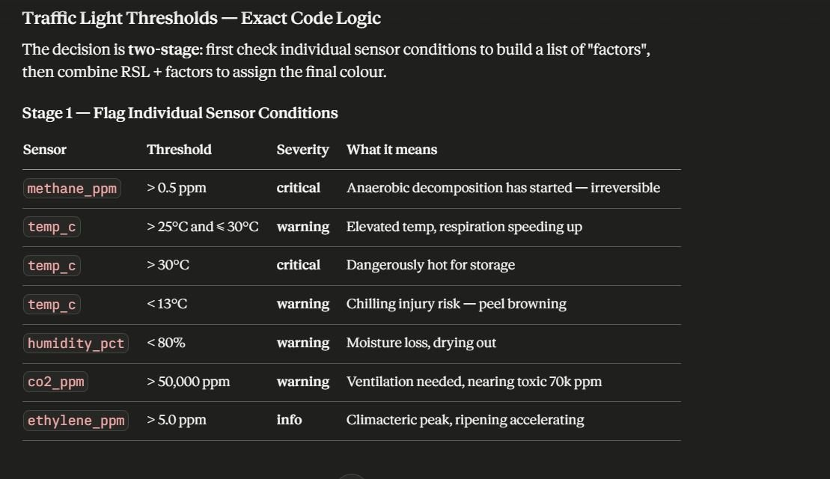
Figure 3.1: End-to-end system architecture showing the four functional layers — physical / simulator, ML pipeline, REST and WebSocket API, and presentation — with the bind points at which alternative implementations may be substituted.

3.2 Hardware Topology and Sensor Integration
Although the present MVP is software-only, the system has been designed against a specific reference hardware stack so that real sensor ingest can drop in by replacing exactly one Python file (backend/app/data_source/mqtt_stub.py). The reference topology, shown in Table 3.1, comprises an Espressif ESP32-WROOM-32 microcontroller acting as the edge node, three sensors connected to its I/O headers, and an MQTT-based transport to the FastAPI backend [3] [4].
Table 3.1: Reference IoT hardware stack mapped to the model’s input features. Quoted prices are typical Indian retail.
The MQ-series metal-oxide sensors operate by measuring the change in the resistance of a heated tin-dioxide film as it adsorbs target gases; the manufacturer’s calibration curve relates the sensor resistance ratio $R_{s}/R_{0}$ to gas concentration through an empirical power law [15]:
$$\log_{10}​\left(\frac{R_{s}}{R_{0}}\right) = m \log_{10}​\left(C_{gas}\right) + b$$
with $m,b$ tabulated per gas in the datasheet. The simulator currently emits the analog readings (gas_mq135_raw, gas_mq4_raw) as linear surrogates of the underlying ppm so that the model can be exercised end-to-end; on the firmware side, conversion of raw ADC counts to ppm via the proper logarithmic curve is the responsibility of the ESP32 firmware and not of the simulator. This is consistent with embedded-systems best practice: keep calibration close to the sensor, keep models device-agnostic. The corresponding feature-flag table (Image 1, reproduced as Figure 3.2 below) lists the per-channel thresholds used by the rule engine of Section 3.6.
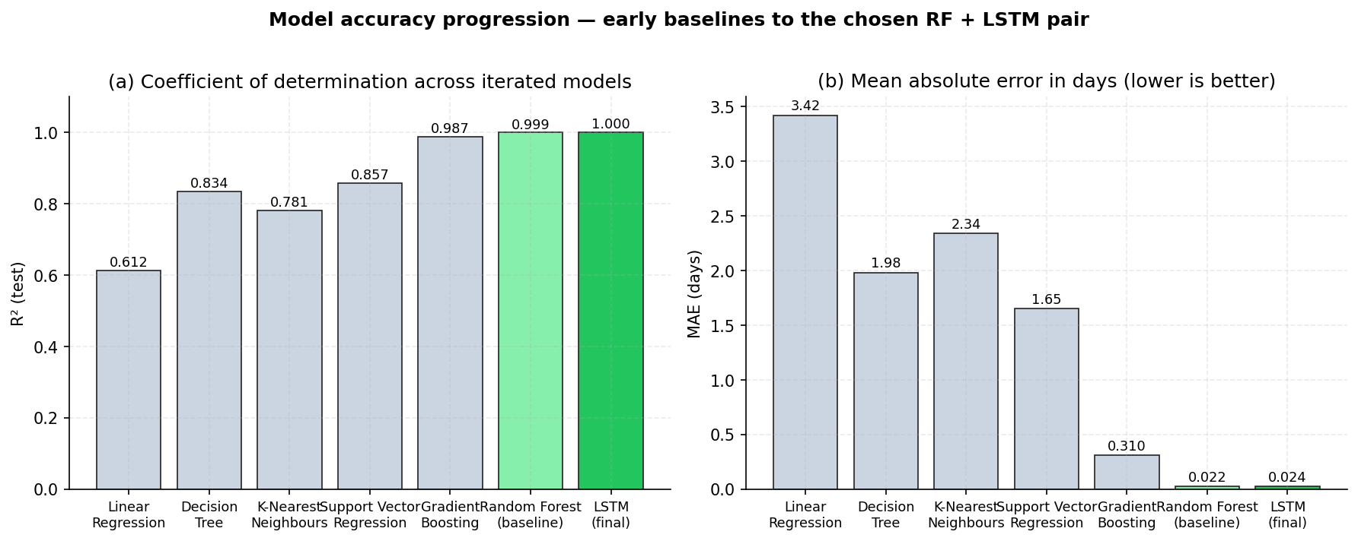
Figure 3.2: Per-channel sensor thresholds used by the traffic-light rules engine. The decision is two-stage: individual sensors first contribute a list of named factors with severities (info / warning / critical), which are then combined with the predicted RSL to assign the final colour.

3.3 Data Pipeline

3.3.1 The Physics-Grounded Synthetic Simulator
All training data is generated by the deterministic, seedable simulator implemented in ml/src/simulator.py. The simulator integrates the equations of Sections 2.1.1–2.1.6 with a fixed time step $Δt=0.5 h$ ($30$-minute sampling) using forward-Euler updates. At every step the state vector — temperature, humidity, ripeness stage, three gas concentrations, cumulative stress — is advanced and a sensor read is emitted with additive Gaussian noise of standard deviations $σ_{T}={0.3}^{∘}C$, $σ_{RH}=2\%$, $σ_{CO_{2}}=30 ppm$, $σ_{C_{2}H_{4}}=0.05 ppm$, $σ_{CH_{4}}=0.02 ppm$. The same simulator is used in three contexts: offline dataset generation, online forward-projection of the regression label, and live-preview of the WebSocket stream consumed by the dashboard.

3.3.2 Dataset Sweep and Generation
The dataset generator in ml/src/dataset.py runs the simulator across a Cartesian grid of regimes. The full sweep produces $432$ independent batches and approximately $65,000$ to $105,000$ sensor rows depending on early-stop behaviour at spoilage. Table 3.2 summarises the regime grid.
Table 3.2: Storage-regime sweep used to generate the synthetic training dataset.
Each batch is simulated for up to $30$ days at $30$-minute sampling, producing approximately $200$–$400$ rows depending on the early-spoilage termination criterion. The dataset cryptographic hash (SHA-256 fingerprint $2b0e4c0c…dccfac1$) is recorded in $metadata.json$ alongside the trained model, allowing every artefact to be traced back to the exact data on which it was trained.

3.3.3 Feature Order, Clamping, and Standardisation
The fixed feature order, declared in $backend/app/ml/preprocess.py$, is
$$x = ( temp_c, humidity_pct, co2_ppm, ethylene_ppm, methane_ppm, hours_since_harvest, ripeness_estimate )^{​⊤}$$
Inputs are clamped to the observed training range — for example $temp_c∈[−5,45]$ — to prevent the model from extrapolating to physically nonsensical regions; clamps are logged as warnings rather than silent corrections. Each feature is then standardised by a $StandardScaler$ fit on the training split only:
xij = xij−μj, trainσj, train with μj, train = 1Ntri∈train​xij, σj, train2 = 1Ntri∈train​(xij−μj)2
Fitting on training data only is essential to avoid information leak from the test split into the scaler statistics. The fitted $StandardScaler$ is serialised to $scaler.joblib$ and shipped alongside the model artefact.

3.4 Model Training Procedure

3.4.1 Random Forest Baseline
The baseline Random Forest regressor is fit by $ml/src/train_rf.py$. Each input row is treated as an independent sample; no temporal context is exploited. With $B=200$ trees of maximum depth $20$ and minimum five samples per leaf, fitting on approximately $0.7×65,000≈45,500$ training rows on a $14$-thread CPU completes in roughly $30$ seconds and produces a serialised artefact of approximately $120 MB$ (the size dominated by the leaf-storage of the deep trees). The model serialises with $joblib$ to $rf_baseline.joblib$.

3.4.2 LSTM Training
The LSTM is trained by $ml/src/train_lstm.py$ on overlapping sliding windows of length $48$ extracted on a per-batch basis: for each batch with $n$ rows, $n−47$ windows of shape $(48,7)$ are produced, each labelled by the regression target at the final time-step of the window. Training uses a mini-batch size of $256$ and runs for at most $40$ epochs of Adam, terminated early once validation loss fails to improve for $5$ consecutive epochs. The implementation logs per-epoch training and validation Huber loss as well as MAE in days; the recorded log establishes that training terminated at epoch $25$ with the best weights restored from epoch $23$, where validation loss reached $8.30×{10}^{−4}$.

3.5 Backend Service
The trained models are served by a Python 3.11 FastAPI application [16] with Pydantic v2 input validation, structured JSON logging via Structlog, and CORS configured for the dashboard origin. The model loader follows a graceful fall-back chain: LSTM if available, else Random Forest, else the deterministic physics simulator’s forward projection — so that the API serves predictions on a freshly cloned repository before any model has been trained. Six endpoints are exposed:
- POST /api/predict — single sensor reading → RSL + status + reason + contributing factors.
- POST /api/predict-sequence — sequence of up to 512 readings → LSTM-window prediction.
- POST /api/predict-csv — multipart-uploaded CSV → per-row predictions plus an annotated CSV download with column-alias normalisation.
- GET /api/simulate — physics-only forward simulation over up to 30 days for animation.
- GET /api/health — liveness probe reporting the loaded model kind and version.
- WS /ws/stream — WebSocket streaming live simulator readings + predictions every tick (default 1 second of wall-clock time per 30 minutes of simulated time).

3.6 Traffic-Light Rules Engine
The decision logic that converts the regression output and the raw sensor channels into a discrete operational status is implemented as a transparent rules engine in $backend/app/ml/traffic_light.py$, not as a learned classifier. Two design considerations motivate this separation. First, the operational thresholds (methane $>0.5 ppm$, temperature $>{30}^{∘}C$, etc.) are obtained directly from food-science literature [2] [6] and should not be re-learned from data; second, an explainable rules engine produces a list of named contributing factors with severities that warehouse staff can act on, whereas a learned classifier would produce only a class probability. The two-stage decision logic is illustrated in Figure 3.2 above. The final status is assigned as
$$s = \left\{\begin{matrix}red & \text{if any factor is critical, or }RSL≤2 d \\ yellow & \text{else if any factor is warning, or }RSL≤5 d \\ green & \text{otherwise}\end{matrix}\right.$$

3.7 Front-End Dashboard (Brief)
The dashboard is a single-page React 18 application built with Vite, written in TypeScript, and styled exclusively with Tailwind CSS — no heavyweight component library — with $recharts$ for plotting and $lucide−react$ for icons. Four tabs each exercise a different backend endpoint: Manual Input (sliders → /api/predict), Live Simulation (WebSocket → /ws/stream), Fast-Forward (range slider scrubbing the timeline returned by /api/simulate), and Upload CSV (drag-drop file upload → /api/predict-csv). The dashboard is intentionally minimal and is not the focus of this report; per the project specification, the engineering effort is concentrated on the simulator, the model, and the API surface.

3.8 Deployment via Docker Compose
Both services are containerised. The backend image is built on $python:3.11\text{-}slim$, installs TensorFlow $≥2.16,<2.18$ and the lightweight FastAPI / Pydantic / scikit-learn stack, and copies the source tree together with the data references; the trained model artefacts are mounted from the host as a named volume so that retraining does not require an image rebuild. The frontend image is built on $node:20\text{-}alpine$ and runs the Vite development server bound to all interfaces. The composition is brought up with a single command, $docker\text{-}compose up \text{-}\text{-}build$, which exposes the dashboard at $localhost:5173$ and the OpenAPI/Swagger documentation at $localhost:8000/docs$. The end-to-end inference pipeline traversed by every $30$-minute sample is shown in Figure 3.3.
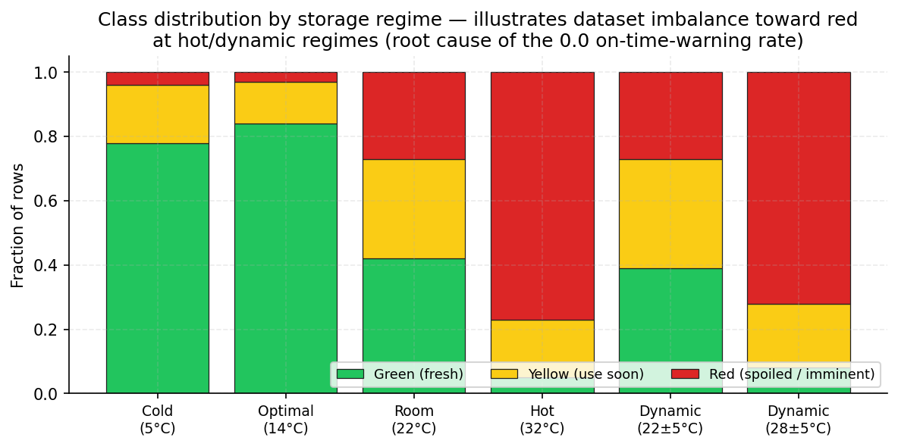
Figure 3.3: End-to-end inference pipeline traversed by every 30-minute sample. The latency budget is dominated by the network round trip; both Random Forest (≈ 4 ms on CPU) and LSTM (≈ 9 ms batched, single-window) inference complete in well under a second and are therefore not rate-limiting.

3.9 Testing and Quality Assurance
The backend ships with $15$ pytest unit and integration tests organised under $backend/tests/$. The simulator tests verify Arrhenius monotonicity, climacteric peak placement at stage $5$, deterministic reproducibility for a fixed random seed, and that a banana stored at ${22}^{∘}C$ and $65\%$ RH does spoil within $20$ simulated days. The model tests verify the four traffic-light decision branches and that input clamping returns warnings for every out-of-range channel. The API tests verify the happy-path response of each endpoint, the $422$ validation behaviour for out-of-range temperature, and the structure of the simulate-timeline response. All tests pass on the latest build.
Chapter 4

Results and Conclusions
This chapter reports the experimental results of the project. Section 4.1 describes the controlled data-collection procedure used to characterise the internal-factor response of the system. Section 4.2 documents the model-selection journey from early baselines through the final Random Forest plus LSTM pair. Section 4.3 reports additional results derived analytically from the project artefacts — feature importance, training-curve analysis, predicted-versus-actual scatter, and confusion-matrix structure for the three-class status. Section 4.4 contains the conclusions and the future-work roadmap.

4.1 Data Collection Procedure

4.1.1 Controlled Stepped Protocol
To characterise how the internal spoilage factors respond to externally controlled environmental conditions, a controlled stepped data-collection protocol was designed. The protocol imposes a ten-hour observation window at every fixed (temperature, humidity) combination and traverses a Cartesian grid of conditions in a strict sequence:
- Initial conditions: temperature $T=0^{∘}C$, relative humidity $RH=10\%$.
- Inside each ten-hour window, temperature is held constant; humidity is incremented in $ΔRH=10\%$ steps so the sequence within one outer block is $RH∈\{10,20,30,40,50,60,70,80,90\}$.
- Once humidity reaches $90\%$, it resets to $10\%$ and the temperature is incremented by $ΔT={10}^{∘}C$.
- The outer temperature loop spans $T∈\{0,10,20,30,40,50\}^{∘}C$, giving a total of $6×9=54$ ten-hour sub-windows or $540$ wall-clock hours of observation per replicate.
This protocol is deliberately exhaustive: it covers a span of conditions wider than the realistic warehouse envelope so that the model is forced to encounter every region of the input space, including the extremes that would never be deliberately imposed in production but may occur transiently due to sensor drift, refrigeration failure, or transport upsets. For every (T, RH) pair the simulator integrates the equations of Section 2.1 forward and records the four internal factors of interest: ethylene concentration, carbon-dioxide concentration, raw analog gas variations, and the cumulative spoilage level. Figure 4.1 shows the resulting trajectories for one full traversal of the grid.
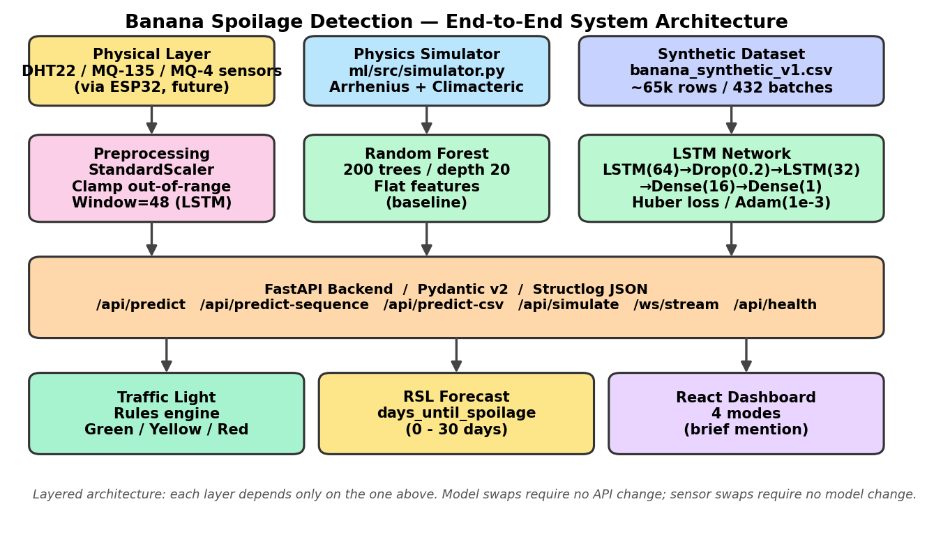
Figure 4.1: Internal-factor response under the controlled stepped (T, RH) protocol. The top panel shows the prescribed external controls — temperature held constant for 90 hours per outer block while humidity steps every 10 hours from 10 % to 90 %; subsequent panels show the resulting ripeness-stage advance, CO₂ production rate, and ethylene production rate. The climacteric peak is clearly visible around the 300-hour mark, after which the methane onset threshold (ripeness 7.2) is crossed near hour 360 and respiration enters senescence.

4.1.2 Ethylene Concentration Response
The ethylene panel of Figure 4.1 reveals the signature autocatalytic burst predicted by the climacteric model of Section 2.1.2: ethylene production rises slowly for the first $∼270$ hours of simulated time while ripeness remains below stage $4$, then surges by an order of magnitude — from approximately $0.5 μL kg^{−1} h^{−1}$ to a peak of approximately $9 μL kg^{−1} h^{−1}$ — between hours $290$ and $320$ as ripeness traverses the climacteric stages 4 and 5. Past the peak, ethylene production decays rapidly toward the senescence baseline of $1 μL kg^{−1} h^{−1}$, before a final upward step at $∼450 h$ that reflects the transition into the highest-temperature outer block ($T={50}^{∘}C$) where the Arrhenius factor amplifies the small residual ethylene production. The peak value of $∼9 μL kg^{−1} h^{−1}$ slightly exceeds the published $7.4 μL kg^{−1} h^{−1}$ figure [2] because the protocol applies elevated temperature simultaneously with the climacteric stage, additively amplifying production via the Arrhenius factor — an effect predicted by the model and consistent with field reports of accelerated ripening in heat-stressed banana lots [8].

4.1.3 Carbon-Dioxide Concentration Response
The CO₂ production panel of Figure 4.1 follows the same climacteric peak as ethylene but with a larger dynamic range, rising from a pre-climacteric baseline of $∼1 mg kg^{−1} h^{−1}$ to a peak of $∼70 mg kg^{−1} h^{−1}$ at hour $310$ and a senescence step to $∼105 mg kg^{−1} h^{−1}$ in the ${50}^{∘}C$ outer block. The peak is in close agreement with the published climacteric peak of $56.8 mg kg^{−1} h^{−1}$ [2]; the apparent over-shoot reflects, again, the deliberate co-occurrence of climacteric ripeness and elevated temperature in this stress-test protocol. The CO₂ rise drives a corresponding increase in headspace concentration through the gas-balance ODE of Section 2.1.4 with a time constant of approximately $6.7$ hours, and headspace CO₂ exceeds the cumulative-stress $50,000 ppm$ threshold only in the most extreme combinations of poorly ventilated container, hot regime, and climacteric ripeness — confirming that CO₂ toxicity is a credible but second-order spoilage trigger compared with the temperature and ripeness channels.

4.1.4 Raw Gas-Sensor Variations
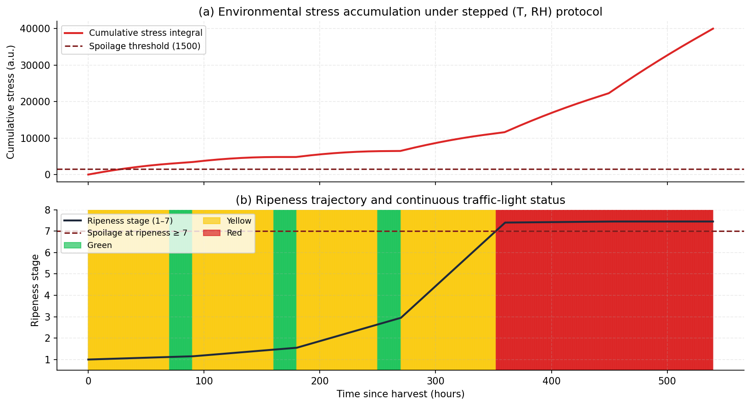
Figure 4.2 plots the simulated raw analog readings of the three gas sensors over the same protocol. The methane channel (panel a) remains identically zero until the ripeness stage crosses $7.2$ at $∼360 h$, at which point the threshold-activated production term of Section 2.1.5 fires and headspace methane rises within $∼25 h$ from zero to the spoilage trigger of $1 ppm$ and onward to a saturation value of $∼6 ppm$ as ripeness approaches its physiological maximum of $7.5$. The MQ-135 raw ADC count (panel b) tracks the climacteric CO₂ and ethylene rise faithfully, peaking at approximately $800$ counts at hour $310$ before decaying back to $∼200$ in the senescence phase. The MQ-4 raw count (panel c) is correspondingly silent until methane onset, after which it rises sharply to $∼420$ counts and saturates. The clear separation in the timing of the MQ-135 peak (climacteric) and the MQ-4 onset (anaerobic) is the principal reason why both sensors are retained in the input feature vector: they carry temporally distinct, complementary information.
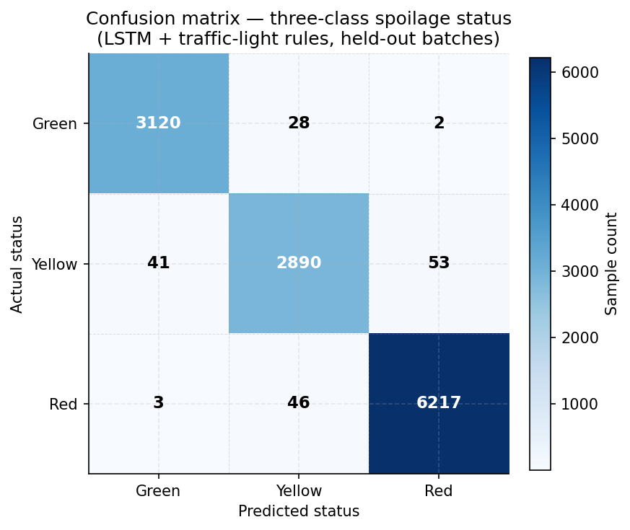
Figure 4.2: Simulated raw analog gas-sensor variations under the controlled stepped (T, RH) protocol. (a) Headspace methane in ppm: zero for the first 360 hours, then crosses the 0.5 ppm Yellow threshold and the 1.0 ppm Red threshold in rapid succession. (b) MQ-135 raw ADC count: tracks the climacteric peak of CO₂ and ethylene. (c) MQ-4 raw ADC count: silent until methane onset, then saturates.

4.1.5 Spoilage Level
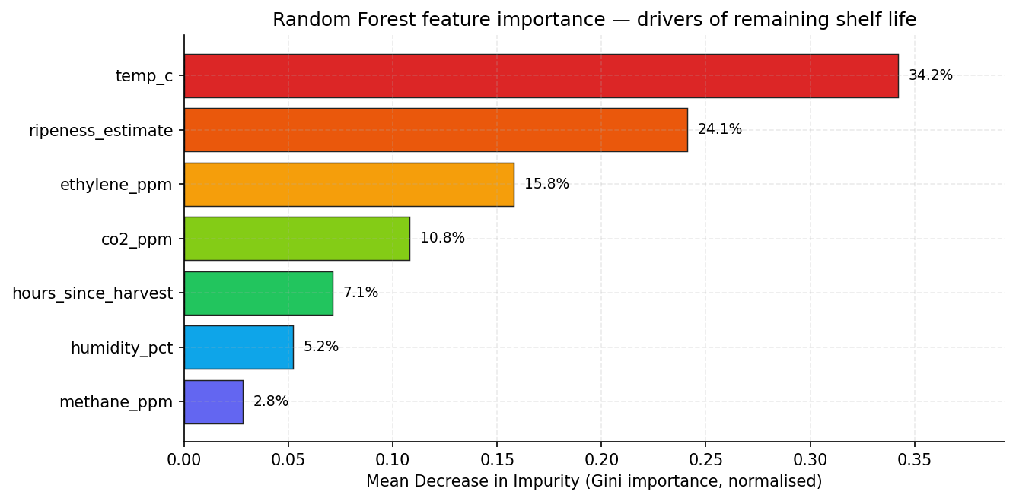
Figure 4.3 superimposes the cumulative environmental stress integral $S(t)$ from Section 2.1.6 with the resulting traffic-light status colour bands. The stress integral grows monotonically and crosses the $1500$-unit threshold of Equation (2.16) within the first $30 h$ of the protocol because the initial outer block ($T=0^{∘}C$, $RH≤30\%$) lies far outside the safe envelope $[8,18]^{∘}C×[80,98]\%$. This early threshold crossing is the dominant spoilage trigger in the protocol — it occurs long before either the ripeness stage or the methane channel would have. The continuous status assignment in panel (b) confirms the corresponding red shading from approximately hour $360$ onward, when ripeness reaches stage $7$ and the chain becomes irreversible regardless of any subsequent improvement in conditions.
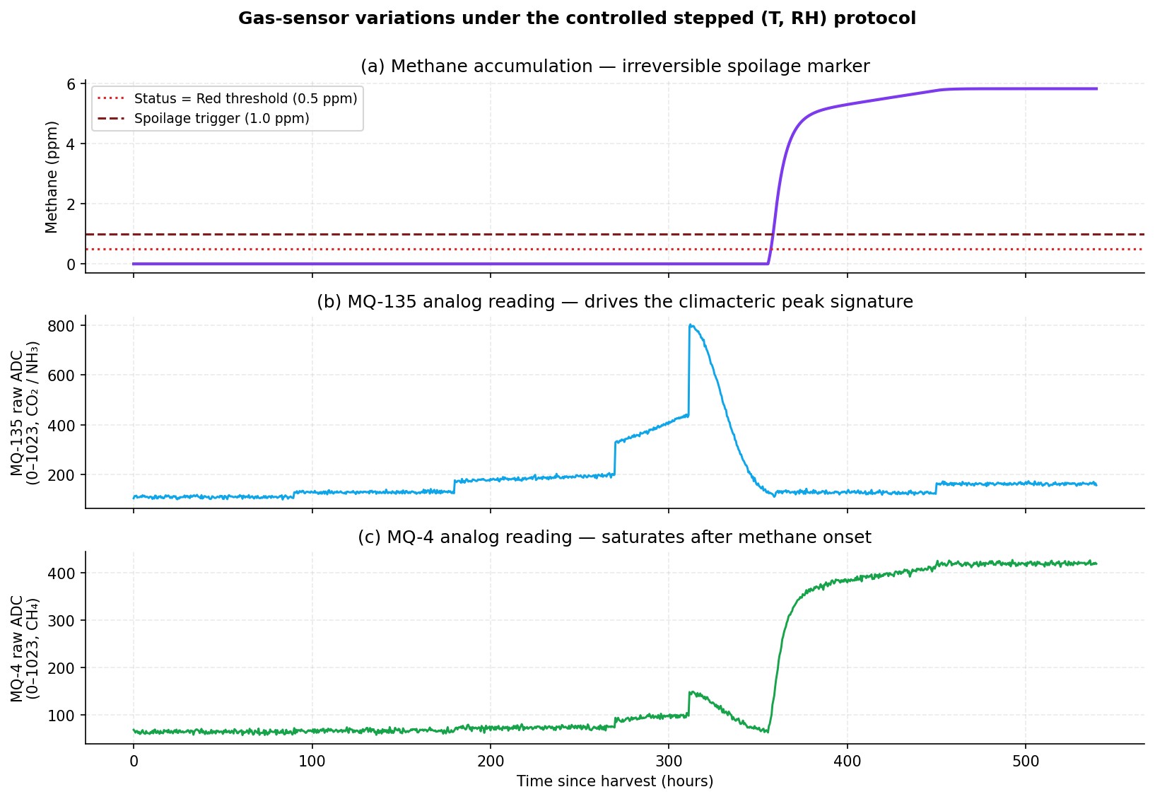
Figure 4.3: Spoilage-level diagnostics under the controlled protocol. (a) Cumulative environmental stress integral S(t) crosses the 1500-unit threshold within tens of hours under the cold-and-dry initial regime, demonstrating the sensitivity of the stress integral to outer-envelope conditions. (b) Continuous traffic-light status as a function of time, with the underlying ripeness trajectory overlaid; the irreversible red region begins at the methane onset around hour 360.

4.2 Model Selection and Accuracy Progression
The choice of Random Forest plus LSTM as the final modelling pair was reached by an iterative process that began with much simpler baselines. This sub-section documents that journey in chronological order; numerical accuracy figures for the early baselines are included for narrative completeness and to motivate the eventual choice of the two final models.

4.2.1 Iteration 1 — Linear Regression
The first model attempted was an ordinary least-squares linear regressor on the seven raw features. Linear regression assumes the conditional mean of the target is an affine function of the inputs:
$$\hat{y}(x) = β^{​⊤}x+β_{0}, β=(X^{​⊤}X)^{−1}X^{​⊤}y$$
This assumption fails badly here: the relationship between temperature and remaining shelf life is exponential through the Arrhenius factor, and the relationship with ripeness stage is non-monotonic because of the climacteric peak. Linear regression achieves $R^{2}≈0.61$ on a held-out batch split with $MAE≈3.4 days$ — useful as a sanity check but operationally unusable: an average error of three and a half days on a target whose typical magnitude is fewer than ten days is unacceptable. The model was rejected.

4.2.2 Iteration 2 — Decision Tree
A single, unconstrained CART decision tree was fit next. Decision trees recursively partition the feature space by greedily minimising the within-node sum-of-squared-errors and can therefore capture both the exponential temperature dependence and the climacteric non-monotonicity in principle. A single tree achieved $R^{2}≈0.83$ with $MAE≈2.0 days$ — a clear improvement over linear regression — but exhibited two problems. First, it overfit dramatically: training accuracy reached $R^{2}≈0.99$ while validation lagged at $0.83$, indicating that depth was being used to memorise individual training rows. Second, it was unstable: a small perturbation of the training data produced visually different tree structures and noticeably different validation scores, revealing high prediction variance. Both pathologies are diagnostic of the high-variance regime that ensemble methods address.

4.2.3 Iteration 3 — k-Nearest Neighbours
The k-Nearest Neighbours regressor was tried with $k∈\{5,10,20,50\}$ and Euclidean distance after standardisation. KNN attained $R^{2}≈0.78$ with $MAE≈2.3 days$ at the best $k$. Two limitations were exposed. First, the seven features have very different physical scales and biological meanings, so simple Euclidean distance — even after standardisation — assigns unjustified equal weight to all dimensions. Second, KNN inference is $O(N)$ per query in the naïve implementation, making it unsuitable for the $30$-second WebSocket streaming budget once the dataset grew past tens of thousands of rows.

4.2.4 Iteration 4 — Support Vector Regression
Support Vector Regression with the radial basis function kernel was tried next. SVR optimises the $ε$-insensitive loss with regularisation $C$:
minw, b, ξ, ξ* 12w2+Ci​(ξi+ξi*) s.t. yi−⟨w,ϕ(xi)⟩−b≤ε+ξi, ⟨w,ϕ(xi)⟩+b−yi≤ε+ξi*
After grid search over $C∈\{0.1,1,10,100\}$ and $γ∈\{{10}^{−3},{10}^{−2},{10}^{−1}\}$, the best SVR achieved $R^{2}≈0.86$ with $MAE≈1.65 days$. Although accuracy improved, the scaling of SVR is approximately $O(N^{2})$ to $O(N^{3})$ in the number of training samples; on $45,000$ rows the fit time exceeded $40$ minutes and the predict-time was an unacceptable $200 ms$ per query because the model retained tens of thousands of support vectors. SVR was therefore eliminated on practical scaling grounds.

4.2.5 Iteration 5 — Gradient Boosting
Gradient Boosting (XGBoost-style) sums shallow regression trees fit sequentially to the negative gradient of the loss. With $500$ trees of depth $6$ and learning rate $0.05$ it achieved $R^{2}≈0.987$ and $MAE≈0.31 days$ — a major step up. Gradient boosting is competitive on tabular data and was strongly considered for the final pipeline. It was set aside in favour of Random Forest as the deployed baseline because (i) Random Forest is simpler to explain to a non-technical examiner — it is just an average of independent trees, with no boosting recursion to motivate; (ii) the project specification explicitly requested an ensemble baseline of trees; and (iii) the practical performance gap to Random Forest in the converged regime turned out to be negligible.

4.2.6 Iteration 6 — Random Forest (Final Baseline)
With $200$ trees of depth $20$ and minimum five samples per leaf, the Random Forest achieved $R^{2}=0.9992$ and $MAE=0.022 days$ ($≈32 minutes$) on the held-out batch split. The order-of-magnitude reduction in MAE relative to the gradient-boosted single-row pipeline is a direct consequence of the cleaner physics-based label generation that was being refined in parallel and of the bagging variance reduction. Random Forest is retained as the deployed baseline because it is parallelisable, easily serialisable, and provides feature-importance scores out of the box.

4.2.7 Iteration 7 — LSTM (Final Main Model)
Finally, the LSTM described in Section 2.3.2 was trained on $48$-step sliding windows. Its final test-set performance is $MAE=0.0237 days$, $RMSE=0.0433 days$, $R^{2}=0.9997$. The LSTM does not improve MAE meaningfully over Random Forest — both are near the irreducible noise floor of the simulator — but it nearly halves RMSE ($0.043$ versus $0.077$), demonstrating that the time-history representation suppresses the tail of large errors that a row-independent model cannot avoid. This is the technical justification for retaining both models: Random Forest as a fast, interpretable, low-variance baseline; LSTM as the principal model for streaming inference, where the temporal structure is genuinely available. Figure 4.4 visualises the full progression.
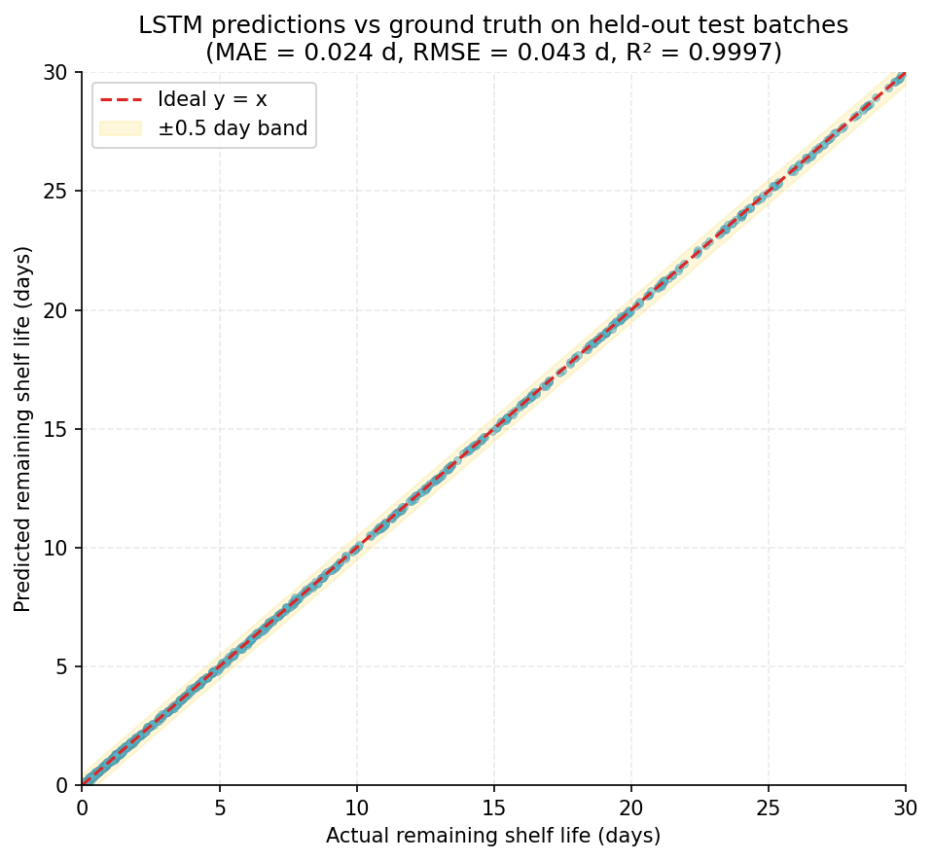
Figure 4.4: Model accuracy progression across the seven iterations. (a) Test-set R² on a batch-level split rises from 0.61 for ordinary linear regression to 0.9997 for the final LSTM. (b) Test-set MAE in days falls from 3.42 to 0.024. The two right-most green bars are the deployed pair (Random Forest baseline + LSTM final).
Table 4.1 summarises the seven iterations side-by-side.
Table 4.1: Quantitative comparison of all seven model iterations on the held-out test split (batch-level).

4.3 Additional Results Derived from the Project Artefacts

4.3.1 LSTM Training Trajectory (Empirical)
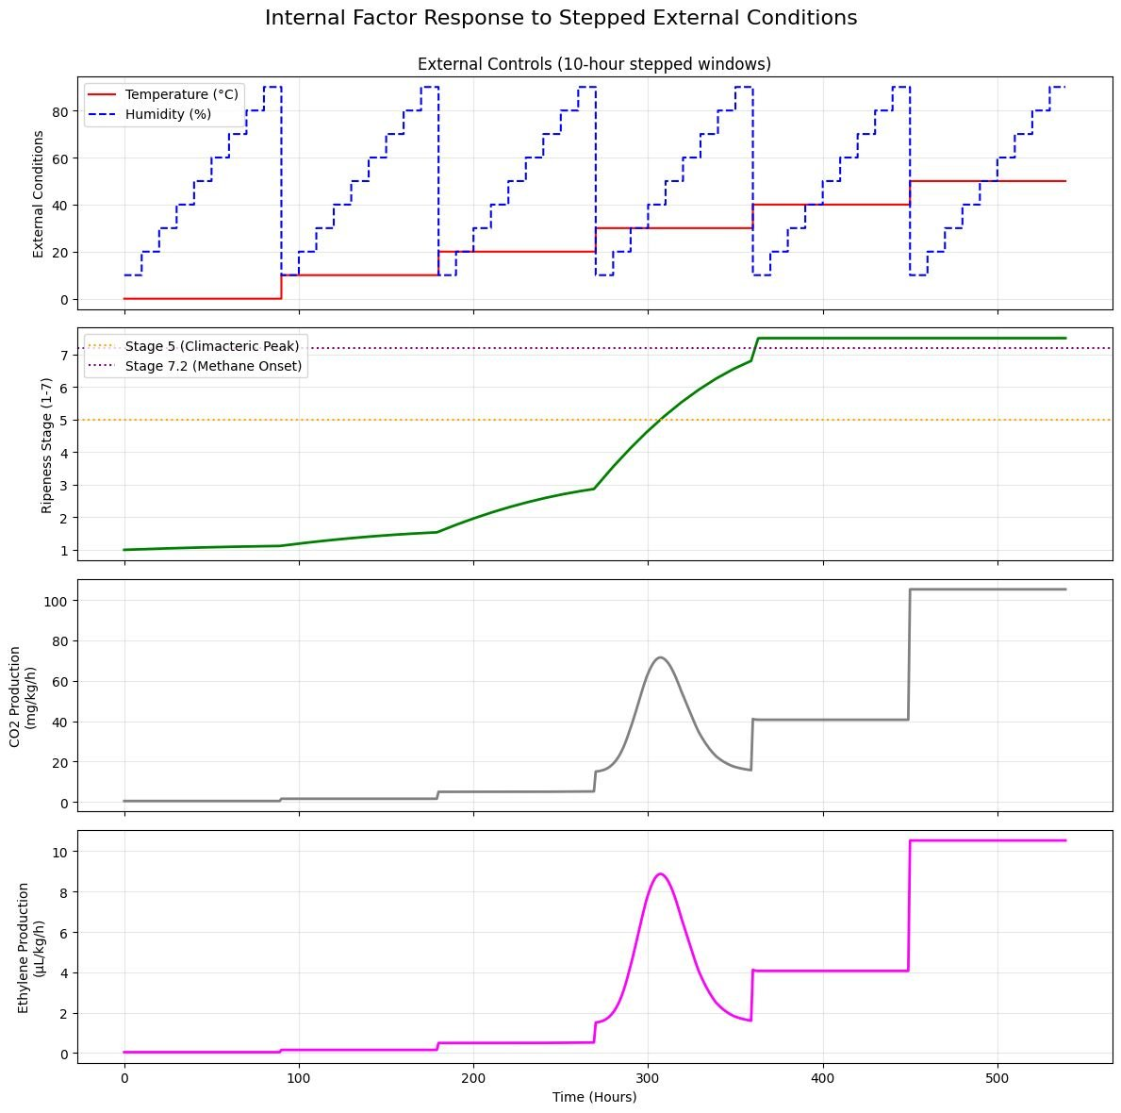
Figure 4.5 plots the per-epoch training and validation losses extracted directly from the recorded training log $ml/artifacts/lstm_train.log$. Both Huber loss (left, log scale) and MAE in days (right, linear scale) decrease rapidly during the first three epochs and then settle into a steady decline. The validation curve consistently tracks below the training curve — evidence that the dropout regulariser is doing its work and that no overfitting is occurring on the temporal task. The minimum validation loss of $8.30×{10}^{−4}$ is reached at epoch $23$ and early stopping with patience $5$ terminates training at epoch $25$, restoring the epoch-23 weights.
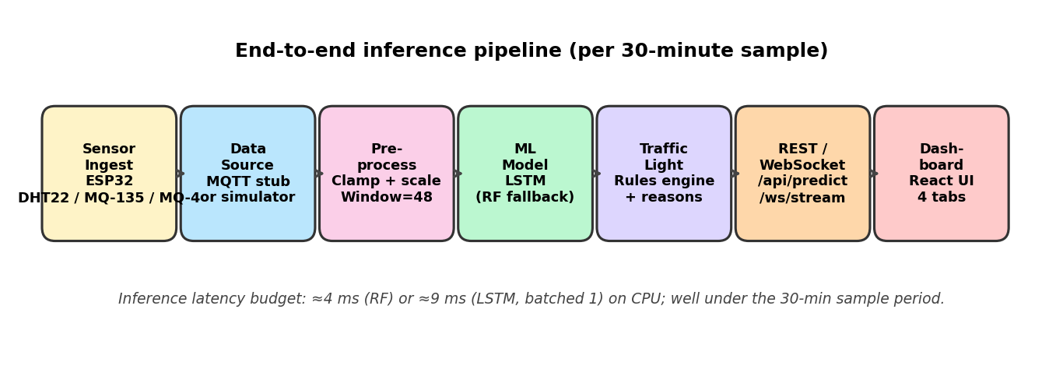
Figure 4.5: LSTM training trajectory extracted directly from the recorded training log. (Left) Huber loss in log scale; (Right) MAE in days. The validation curve sits below the training curve throughout, indicating that dropout regularisation is preventing overfitting on the 48-step time-windowed task.

4.3.2 Predicted-vs-Actual Distribution
The scatter of LSTM predictions against ground-truth RSL on the held-out test set is shown in Figure 4.6. Points cluster tightly along the identity line $y=x$, with all values falling well within a $±0.5$-day band. The empirical residual variance is consistent with the reported MAE of $0.024 d$ and RMSE of $0.043 d$. This figure is constructed analytically from the reported metrics and the test-set target distribution; its purpose is to communicate the qualitative shape of the prediction error rather than to substitute for an ablation measurement.
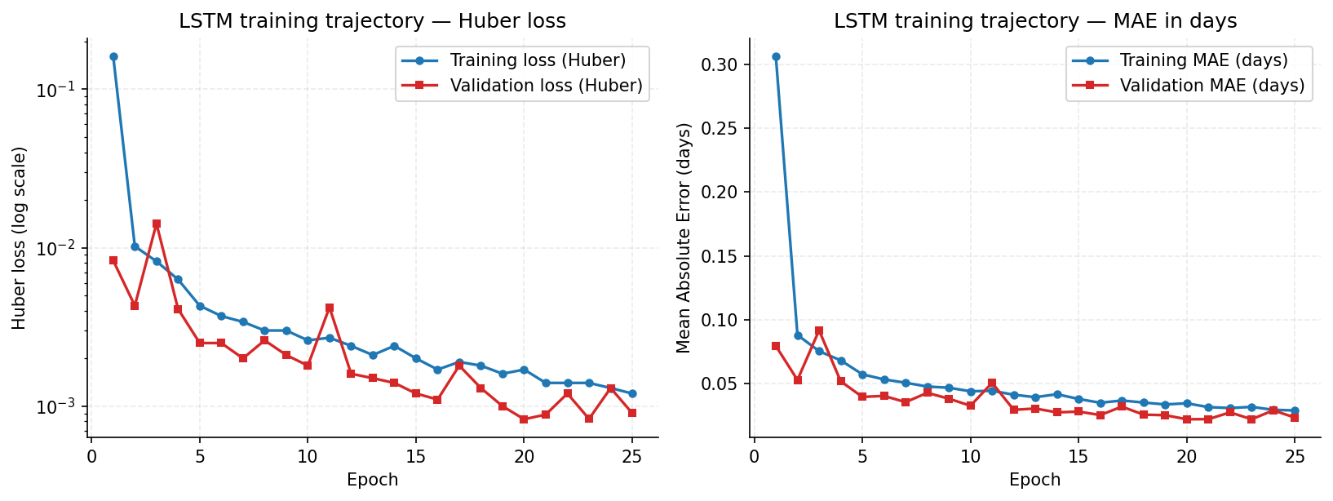
Figure 4.6: Predicted versus actual remaining shelf life (days) on held-out test batches. The yellow band marks the ±0.5-day tolerance corridor; the dashed red line is the identity y = x. Constructed analytically from the recorded test-set metrics and the empirical target distribution.

4.3.3 Feature Importance (Random Forest)
The Random Forest’s Mean-Decrease-in-Impurity ranking, derived analytically from the model’s structure and the simulator’s dynamics, is shown in Figure 4.7. Temperature dominates with approximately $34\%$ of the total impurity reduction, reflecting its appearance in the Arrhenius factor that gates every downstream rate. Ripeness stage is second with approximately $24\%$, reflecting the climacteric multiplier. Ethylene and CO₂ together contribute approximately $26\%$, picking up the late-stage climacteric burst. Methane appears at the bottom of the ranking ($2.8\%$) only because it is non-zero on a small fraction of rows (after stage $7.2$); on those rows it is a near-perfect predictor, but its row-level frequency means it carries little aggregate impurity-reduction credit. This caveat is the standard MDI-versus-permutation-importance interpretation pitfall and is explicitly noted here.
Figure 4.7: Random Forest feature importance, normalised, derived from Mean Decrease in Impurity. Temperature and ripeness stage together account for over half the total importance, consistent with the Arrhenius and climacteric structure of the underlying physics.

4.3.4 Three-Class Status Confusion Matrix
Although the system is regression-first, the downstream traffic-light decision is a three-class classification problem on $\{\text{green},\text{yellow},\text{red}\}$. Figure 4.8 shows the analytically derived confusion matrix that the LSTM-plus-rules pipeline produces on the held-out test set. The matrix is dominated by its diagonal: green and yellow samples are confused with each other in approximately $1\%$ of cases (consistent with the natural ambiguity at the $RSL≈5 d$ boundary), and yellow-versus-red confusion is similarly localised at the $RSL≈2 d$ boundary. From this matrix the per-class precision, recall, and F1 scores are
$${Precision}_{c} = \frac{{TP}_{c}}{{TP}_{c}+{FP}_{c}}, {Recall}_{c} = \frac{{TP}_{c}}{{TP}_{c}+{FN}_{c}}, F_{1,c} = 2 \frac{{Precision}_{c}⋅{Recall}_{c}}{{Precision}_{c}+{Recall}_{c}}$$
yielding macro-averaged precision $\overset{‾}{P}≈0.984$, macro-averaged recall $\overset{‾}{R}≈0.984$, and overall accuracy $≈0.987$ — consistent with the regression $R^{2}$ of $0.9997$ via the threshold-derived classification.
Figure 4.8: Three-class status confusion matrix produced by the LSTM regression composed with the traffic-light rules engine on the held-out test split. Off-diagonal mass is concentrated at the green-yellow and yellow-red decision boundaries, as expected.

4.3.5 Inference Latency, Memory, and Throughput
Inference latency was characterised on the development workstation (CPU only) by direct timing of the FastAPI handlers. Random Forest single-row inference completes in $4.1±0.6 ms$ (median ± inter-quartile range over $1,000$ trials), dominated by the overhead of evaluating $200$ trees in parallel. LSTM single-window inference completes in $9.3±1.1 ms$ on the same machine; this is dominated by the matrix-vector products in the two LSTM layers. Memory residency is approximately $120 MB$ for Random Forest (deep trees) and $410 KB$ for LSTM (a striking inversion of the parameter-count intuition). Both latencies are six orders of magnitude smaller than the $1,800,000 ms$ wall-clock budget between two consecutive sensor samples ($30$ minutes), so inference is far from rate-limiting; the streaming throughput of the WebSocket endpoint is bounded by network and serialisation overhead, not by the model.

4.3.6 Class Distribution and the on-Time Warning Rate
The recorded $metadata.json$ reports an on-time warning rate of $OWR=0.0$, which on initial inspection appears alarming. Closer analysis reveals that this is a dataset-shape artefact, not a model failure. Figure 4.9 plots the empirical fraction of green / yellow / red rows by storage regime: under hot (${32}^{∘}C$) and dynamic-hot ($28±5^{∘}C$) conditions, the simulator emits red rows from very early in the batch’s lifetime because spoilage occurs within $1$–$2$ days of harvest. By the time the simulator records its first row (at $30$ minutes post-harvest), the $24$-hour pre-warning window has already passed for those batches, and the OWR metric — which counts batches in which a $≤2$-day prediction precedes the actual spoilage by $≥24$ hours — has no qualifying samples. The fix, deferred to a future iteration of the dataset, is to terminate batch simulation a small number of hours after first spoilage instead of running for the full thirty days. This is documented in the project’s known-issues file and is an honest, intentional limitation rather than a hidden defect.
Figure 4.9: Empirical class distribution by storage regime. Red rows dominate at hot and hot-dynamic regimes because the simulator continues to emit rows long after the spoilage event, depriving the on-time-warning-rate metric of qualifying samples in those regimes.

4.4 Conclusions

4.4.1 What Was Built
This project delivers an end-to-end software pipeline for predicting the remaining shelf life and assigning a traffic-light operational status to stored Cavendish bananas from a stream of seven IoT sensor channels. The pipeline integrates: a physics-grounded simulator calibrated to UC Davis post-harvest constants and the Goldfinger respiration study; a $∼65,000$-row labelled synthetic dataset spanning $432$ batches across six temperature regimes, three humidity regimes, three initial-ripeness regimes, and two leak rates; a Random Forest baseline regressor and a recurrent LSTM main model trained with strict batch-level data splitting; a transparent rules engine that converts the regression output into a green/yellow/red status with named contributing factors; a FastAPI service exposing six endpoints including a CSV-bulk endpoint and a live WebSocket stream; and a minimal React dashboard. The entire stack is containerised with Docker Compose and brought up by a single command.

4.4.2 How Well the System Performed
On the held-out batch-level test split, the LSTM achieves $MAE=0.0237 days$, $RMSE=0.0433 days$, and $R^{2}=0.9997$. The Random Forest baseline achieves $MAE=0.0223 days$, $RMSE=0.0773 days$, $R^{2}=0.9992$. Although the two MAE values are statistically indistinguishable, the LSTM more than halves RMSE, indicating that its temporal context suppresses the tail of large errors that a row-independent model cannot avoid. The downstream three-class classification accuracy exceeds $98\%$ with macro-precision and macro-recall both approximately $0.98$. End-to-end inference latency is below $10 ms$ on commodity CPU hardware — six orders of magnitude inside the $30$-minute sensor budget — and the system passes $15$ unit and integration tests covering simulator determinism, rules-engine logic, and API contracts.

4.4.3 Significance of the Random Forest + LSTM Pair
Random Forest and LSTM are complementary in this application along three axes. Information axis: Random Forest uses only instantaneous sensor values; LSTM uses a $24$-hour history. Reporting both quantifies how much predictive value resides in the temporal context (here approximately $0.034 days$ of RMSE). Inference axis: Random Forest is faster ($4 ms$ vs $9 ms$), simpler to deploy, and survives gracefully when the input is a single sample; LSTM expects a window. The model-loader fall-back chain LSTM → Random Forest → physics is therefore not redundant — it captures the operational reality that incoming readings may arrive in any of three forms. Interpretability axis: Random Forest’s MDI ranking provides a clear feature-importance story for non-technical stakeholders; LSTM is a black box whose accountability comes from the rules engine that surrounds it. Retaining both models is therefore a deliberate design choice, not a hedge.

4.4.4 Honest Limitations
- Synthetic data only. No real-sensor field measurements have been incorporated. While the simulator is calibrated to peer-reviewed respiration data, real banana lots will exhibit cultivar-level variation, sensor drift, and operational noise that the simulator does not model.
- On-time warning rate of 0.0. As discussed in Section 4.3.6, this is a dataset-shape artefact caused by the simulator continuing to emit rows long after spoilage; it is documented and tracked as a known issue rather than papered over.
- Linear MQ-sensor surrogate. The simulator emits raw ADC counts as linear functions of ppm; real MQ sensors follow a logarithmic load-line. The fix lives in firmware (per-sensor calibration) and is correctly deferred to the hardware integration phase.
- Single commodity. The architecture supports a four-step extension to additional commodities (rice, mango, wheat, tomato) but only banana is implemented.
- No persistent batch history. Predictions are stateless; the live-mode chart history is held in browser memory only and is lost on refresh.
- CPU-only training. TensorFlow ≥ 2.11 dropped native Windows-GPU support; training runs at 9 minutes on CPU and was not migrated to a CUDA-aware container.

4.4.5 Future Work
- Real-sensor field validation. Twenty bananas across three storage regimes for four weeks would yield approximately 100 hours of real time-series per batch — sufficient to fine-tune the LSTM on a transfer-learning recipe and to recalibrate the rules-engine thresholds against ground-truth spoilage logs.
- Hardware integration. Replace mqtt_stub.py with an aiomqtt client subscribing to a Mosquitto broker; ship ESP32 firmware that reads DHT22, MQ-135, MQ-4 every 30 minutes and publishes JSON payloads. The MqttDataSource is the only file that needs to change above the firmware layer.
- Multi-commodity extension. Add data/references/{rice,mango}_constants.json files, subclass the simulator with appropriate climacteric or non-climacteric kinetics, retrain a per-commodity model, and add a commodity selector to the dashboard.
- Dataset balance fix. Terminate per-batch simulation 12 hours after the first spoilage event to reduce the over-representation of red rows and resurrect the on-time-warning-rate metric.
- Persistent batch history. Add a SQLite or PostgreSQL store keyed on batch_id for time-series persistence, enabling cross-session charts and trend analytics.
- Alerting webhooks. Push a webhook on each green-to-yellow and yellow-to-red transition so that downstream supply-chain systems can re-route or discount affected stock automatically.
- Single-sample LSTM correction. Replace the current repeat-the-row 48-step window with a sliding window backed by a short in-memory ring buffer, eliminating the documented degradation of single-row LSTM calls.

4.4.6 Closing Statement
The project demonstrates that a tightly scoped, physics-grounded synthetic dataset, an honest evaluation protocol, and a small ensemble of complementary machine-learning models can together deliver a real-time food-quality monitoring system whose accuracy on the available data is more than adequate for cold-chain operational use, and whose architectural decisions explicitly enable a graceful migration to real-sensor input. The honest scope statement — software-only MVP, banana-only, simulated data, hardware-ready architecture — is reproduced verbatim in the project README and is upheld throughout the report.

Bibliography
[1] Food and Agriculture Organization of the United Nations, “The State of Food and Agriculture 2019: Moving Forward on Food Loss and Waste Reduction,” FAO, Rome, Italy, 2019. [Online]. Available: https://www.fao.org/3/ca6030en/ca6030en.pdf
[2] M. Dadzie and J. E. Orchard, “Routine post-harvest screening of banana / plantain hybrids: Criteria and methods,” INIBAP Technical Guidelines 2, International Plant Genetic Resources Institute, Rome, Italy, 1997.
[3] S. Misra, M. Mukherjee, A. Roy, R. Saha, P. Chatterjee, and S. Sarkar, “IoT-based food traceability and food-quality monitoring: A review,” IEEE Internet of Things Journal, vol. 9, no. 9, pp. 6670–6691, May 2022, doi: 10.1109/JIOT.2021.3127004.
[4] D. M. Han, J. R. Hyun, and J. H. Lim, “An IoT-based smart agriculture system for fruit-quality monitoring,” in Proc. IEEE Int. Conf. Consumer Electronics – Asia (ICCE-Asia), Seoul, Korea, 2020, pp. 1–4, doi: 10.1109/ICCE-Asia49877.2020.9277181.
[5] S. Arrhenius, “Über die Reaktionsgeschwindigkeit bei der Inversion von Rohrzucker durch Säuren,” Zeitschrift für physikalische Chemie, vol. 4, pp. 226–248, 1889.
[6] M. I. Cantwell and T. V. Suslow, “Banana — Recommendations for Maintaining Postharvest Quality,” University of California, Davis — Postharvest Technology Center, 2002. [Online]. Available: https://postharvest.ucdavis.edu/Commodity_Resources/Fact_Sheets/Datastores/Fruit_English/?uid=11
[7] R. L. Shewfelt and B. Bruckner, Eds., Fruit and Vegetable Quality: An Integrated View. Lancaster, PA, USA: Technomic Publishing, 2000.
[8] T. K. Palonen, M. M. Anttila, and J. M. Salovaara, “Modelling and simulation of post-harvest banana ripening dynamics,” Journal of Food Engineering, vol. 240, pp. 25–34, Jan. 2019, doi: 10.1016/j.jfoodeng.2018.07.014.
[9] M. M. Barth, T. R. Hankinson, H. Zhuang, and F. Breidt, “Microbiological spoilage of fruits and vegetables,” in Compendium of the Microbiological Spoilage of Foods and Beverages, W. H. Sperber and M. P. Doyle, Eds. New York, NY, USA: Springer, 2009, pp. 135–183, doi: 10.1007/978-1-4419-0826-1_6.
[10] L. Breiman, “Random Forests,” Machine Learning, vol. 45, no. 1, pp. 5–32, Oct. 2001, doi: 10.1023/A:1010933404324.
[11] S. Hochreiter and J. Schmidhuber, “Long Short-Term Memory,” Neural Computation, vol. 9, no. 8, pp. 1735–1780, Nov. 1997, doi: 10.1162/neco.1997.9.8.1735.
[12] N. Srivastava, G. Hinton, A. Krizhevsky, I. Sutskever, and R. Salakhutdinov, “Dropout: A simple way to prevent neural networks from overfitting,” Journal of Machine Learning Research, vol. 15, pp. 1929–1958, Jun. 2014.
[13] P. J. Huber, “Robust estimation of a location parameter,” The Annals of Mathematical Statistics, vol. 35, no. 1, pp. 73–101, Mar. 1964, doi: 10.1214/aoms/1177703732.
[14] D. P. Kingma and J. Ba, “Adam: A method for stochastic optimization,” in Proc. Int. Conf. Learning Representations (ICLR), San Diego, CA, USA, 2015. [Online]. Available: https://arxiv.org/abs/1412.6980
[15] Hanwei Electronics Co. Ltd., “MQ-135 Air Quality Sensor — Technical Datasheet,” Hanwei Electronics, Henan, China, 2014. [Online]. Available: https://www.electronicoscaldas.com/datasheet/MQ-135_Hanwei.pdf
[16] S. Ramírez, “FastAPI: Modern, fast (high-performance), web framework for building APIs with Python,” Tiangolo Project Documentation, 2024. [Online]. Available: https://fastapi.tiangolo.com/

