EXPERIMENT 2: Wireshark - OSI Layers

NAME : SHREYAS PATIL

REG NO : 24BCE1882
Experiment No: 2

Objectives of the Experiment:
- To understand the OSI (Open Systems Interconnection) model and its 7 layers
- To use Wireshark as a network protocol analyzer
- To capture live network traffic on a MacBook Air M2
- To identify and analyze different OSI layers in captured packets
- To examine protocols like ARP, ICMP, DNS, TCP, and HTTP
- To document observations with screenshots showing each OSI layer

Introduction to OSI Model:
The OSI (Open Systems Interconnection) model is a conceptual framework that standardizes the functions of a telecommunication or computing system into seven distinct layers:
Layer | Name | Function | Protocols Observed
Layer 7 | Application | End-user applications, data generation | DNS, HTTP
Layer 6 | Presentation | Data formatting, encryption, compression | (Embedded in protocols)
Layer 5 | Session | Session management, authentication | (Embedded in TCP)
Layer 4 | Transport | End-to-end communication, port numbers | TCP, UDP
Layer 3 | Network | Routing, IP addressing | IPv4, ICMP
Layer 2 | Data Link | MAC addressing, frame delivery | Ethernet, ARP
Layer 1 | Physical | Raw bit transmission | Frame (Wireshark)

Procedure:

Step 1: Install and Launch Wireshark
- Wireshark was already installed on the MacBook Air M2
- Version: 4.6.3
- Launched Wireshark from Applications folder

Step 2: Select Network Interface
- Selected Wi-Fi interface (en0) for packet capture
- This interface captures all network traffic going through the wireless adapter

Step 3: Start Packet Capture
- Clicked the blue shark fin icon to start capturing packets
- Wireshark began capturing live packets from the network

Step 4: Generate Network Traffic
The following commands and actions were performed while Wireshark was capturing:
In Terminal:
bash
# Generate ARP and ICMP traffic
ping -c 5 google.com
ping -c 3 yahoo.com
ping -c 4 8.8.8.8

# Generate DNS traffic
nslookup google.com
In Web Browser:
- Opened http://neverssl.com (forces HTTP, not HTTPS)
- Opened http://example.com

Step 5: Stop Capture
- Clicked the red square button to stop packet capture

Step 6: Apply Filters
Used the following filters to isolate specific protocols:
Filter | Purpose
arp | View ARP packets (Layer 2/3)
icmp | View ping packets (Layer 3)
dns | View DNS queries/responses (Layer 7)
tcp | View TCP packets (Layer 4)
http | View HTTP web traffic (Layer 7)

Step 7: Analyze Packets
- Selected individual packets from the top pane
- Expanded sections in the middle pane to view OSI layers
- Captured screenshots for documentation

Step 8: Save Capture
- Saved the capture file as osi_layers_capture.pcapng

Observations and Screenshots:

Screenshot 1: ARP Packet - Data Link Layer (Layer 2)
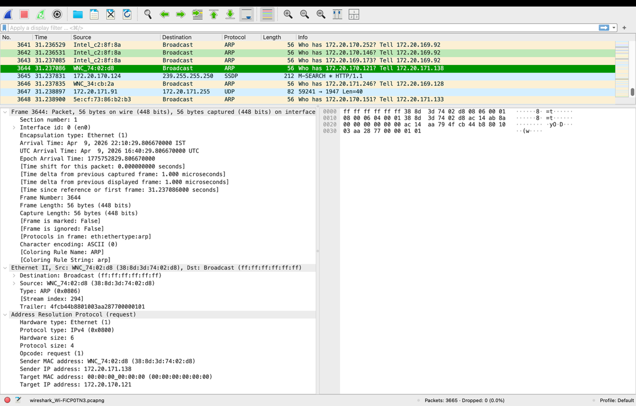
Description:
The above screenshot shows an ARP (Address Resolution Protocol) packet captured in Wireshark. The middle pane is expanded to show the Frame, Ethernet II, and ARP sections. The Ethernet II section reveals the Data Link Layer (Layer 2) information including the source MAC address (WNC_74:02:d8) and destination MAC address (Broadcast: ff:ff:ff:ff:ff:ff). The ARP request asks "Who has 172.20.170.121? Tell 172.20.171.138", demonstrating how devices discover each other's MAC addresses. This packet clearly illustrates how Layer 2 uses MAC addresses for communication within the same network segment.

Screenshot 2: ICMP Packet - Network Layer (Layer 3)
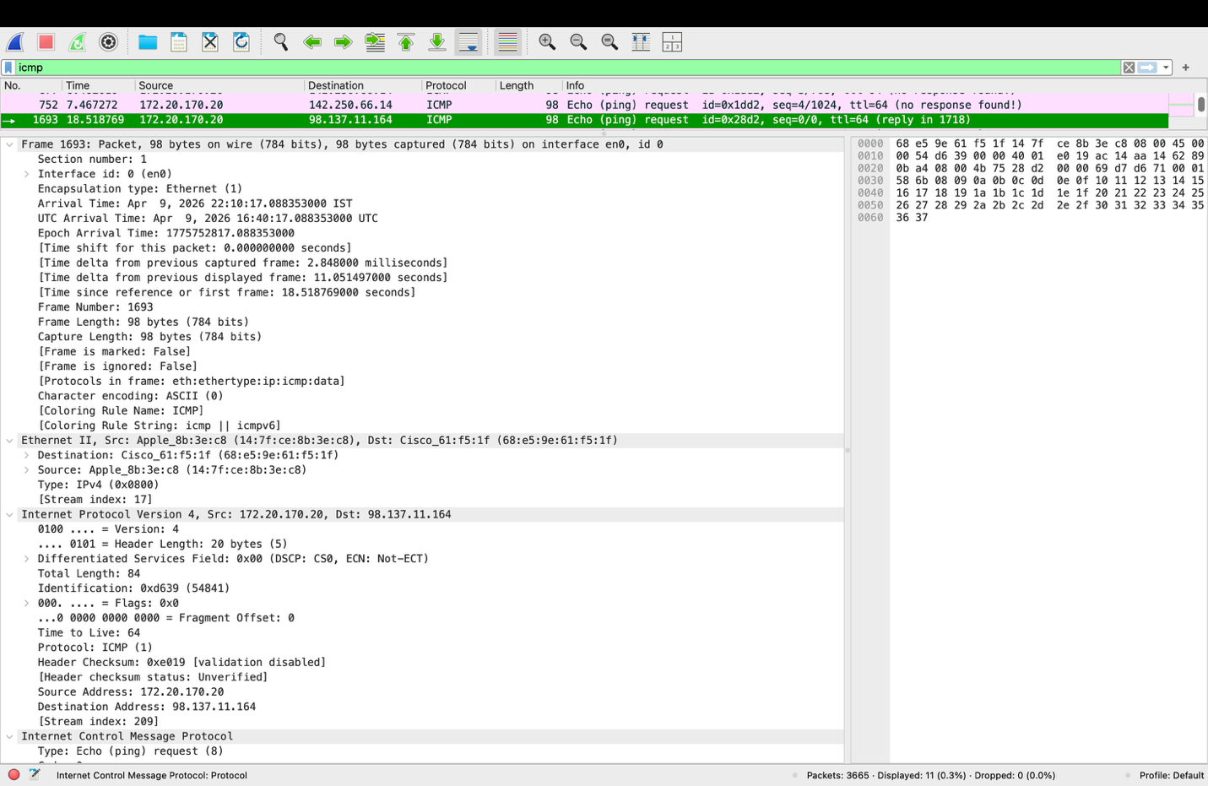Description:
This screenshot displays an ICMP Echo (ping) request packet, which operates at the Network Layer (Layer 3) of the OSI model. The Internet Protocol Version 4 section is expanded, revealing key Layer 3 information including the source IP address (172.20.170.20) and destination IP address (98.137.11.164). The ICMP protocol section shows this is an "Echo (ping) request" with sequence numbers and TTL (Time to Live) value of 64. The ping request was sent to yahoo.com and received a successful reply, demonstrating how Layer 3 handles routing and addressing across internetworks.

Screenshot 3: DNS Packet - Application Layer (Layer 7)
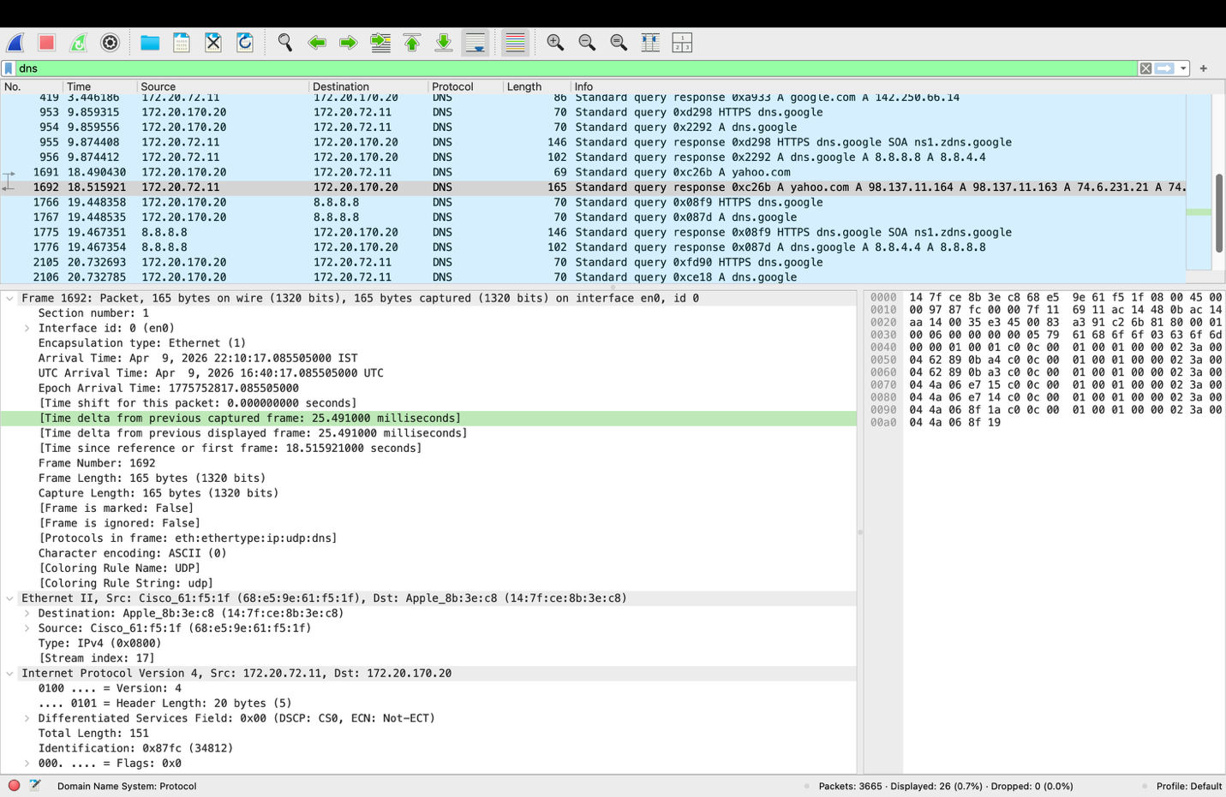Description:
The screenshot presents a DNS (Domain Name System) packet, which functions at the Application Layer (Layer 7) of the OSI model. The expanded sections show the complete protocol stack: Frame (Layer 1), Ethernet II (Layer 2), Internet Protocol (Layer 3), UDP (Layer 4), and finally DNS (Layer 7). The DNS section reveals a "Standard query response" containing the A record for google.com with the resolved IP address 142.250.66.14. This demonstrates how application layer protocols like DNS translate human-readable domain names into machine-readable IP addresses, enabling users to access websites by name rather than numeric addresses.

Screenshot 4: TCP Packet - Transport Layer (Layer 4)
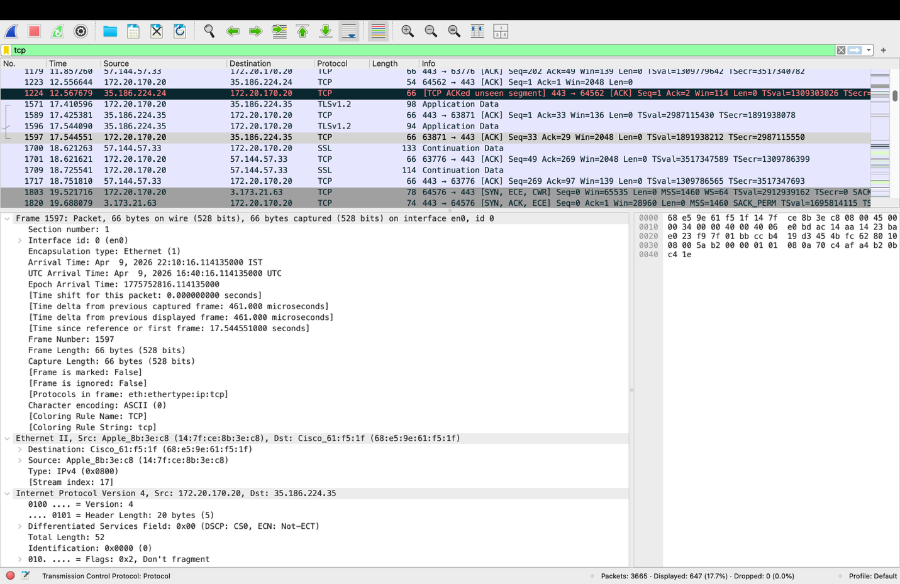Description:
This screenshot illustrates a TCP (Transmission Control Protocol) packet operating at the Transport Layer (Layer 4). The TCP section is expanded to show crucial transport layer information including the source port (63871), destination port (443 - HTTPS), sequence number, acknowledgment number, and TCP flags. The packet shows an ACK (acknowledgment) response between the local machine and a remote server. The transport layer is responsible for end-to-end communication, port number assignment, and reliable data delivery. The presence of port 443 indicates this is secure web traffic, while the ACK flag confirms successful receipt of previous data.

Screenshot 5: HTTP Packet - Application Layer (Layer 7)
[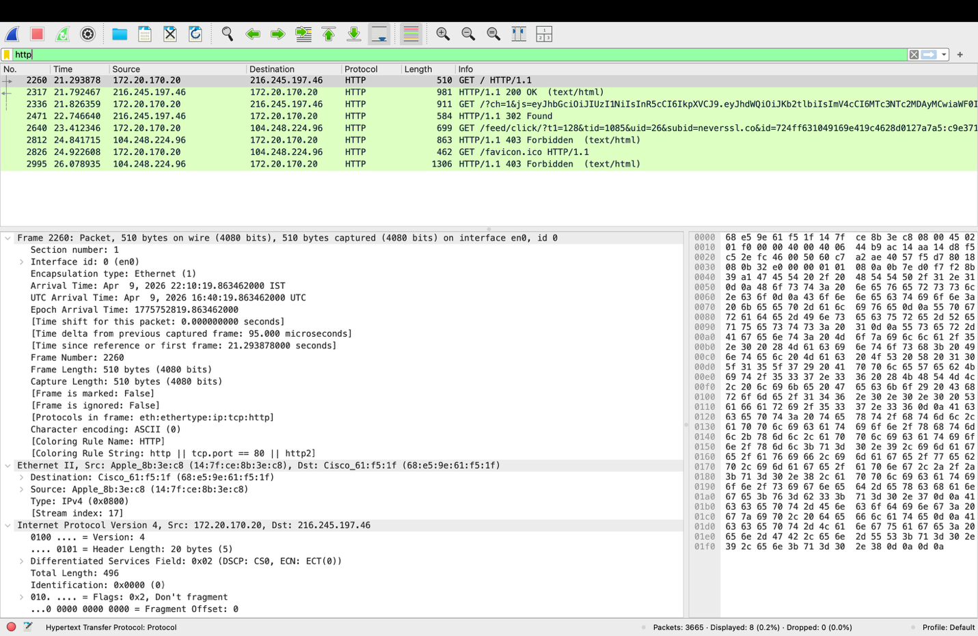Description:
The final screenshot displays an HTTP (Hypertext Transfer Protocol) packet, another Application Layer (Layer 7) protocol. The expanded HTTP section reveals a GET request to "/" (root directory) using HTTP/1.1 protocol. The packet shows the request line "GET / HTTP/1.1" followed by headers including "Host: neverssl.com" and "User-Agent" information. The response packet (HTTP/1.1 200 OK) confirms the web server successfully delivered the requested webpage. HTTP is a classic example of Layer 7 protocols, as it handles the actual data and requests that users interact with when browsing the web. Unlike HTTPS, HTTP traffic is unencrypted and can be fully analyzed in Wireshark.

OSI Layer to Protocol Mapping Table:
OSI Layer | Layer Name | Protocol Observed | Key Information Found
Layer 1 | Physical | Frame | Packet length, timestamp, interface
Layer 2 | Data Link | Ethernet II | Source MAC, Destination MAC
Layer 3 | Network | IPv4, ICMP | Source IP, Destination IP, TTL
Layer 4 | Transport | TCP, UDP | Source Port, Destination Port, Sequence numbers
Layer 5 | Session | (Embedded in TCP) | Session management flags
Layer 6 | Presentation | (Embedded in protocols) | Data format (ASCII, hex)
Layer 7 | Application | DNS, HTTP | Domain names, HTTP methods, status codes

Analysis and Discussion:

How Wireshark Displays OSI Layers:
Wireshark organizes packet information in a hierarchical manner that directly corresponds to the OSI model. The top pane shows a list of captured packets. The middle pane (Packet Details) displays the decoded protocol information in expandable sections, each representing one or more OSI layers:
- Frame Section: Represents the Physical Layer (Layer 1) - contains timing and length information
- Ethernet II Section: Represents the Data Link Layer (Layer 2) - contains MAC addresses
- Internet Protocol Section: Represents the Network Layer (Layer 3) - contains IP addresses
- TCP/UDP Section: Represents the Transport Layer (Layer 4) - contains port numbers
- Application Protocol Section (HTTP/DNS): Represents the Application Layer (Layer 7)

Key Observations:
- ARP packets provide insight into how devices discover each other's MAC addresses without involving higher layers
- ICMP packets demonstrate network layer connectivity testing through ping requests and replies
- DNS packets show the complete protocol stack from physical to application layer
- TCP packets reveal reliable transport mechanisms including port numbers and acknowledgment flags
- HTTP packets illustrate unencrypted application layer communication

Importance of OSI Model in Networking:
The OSI model provides a standardized framework for understanding how data travels from an application on one device to an application on another device. By analyzing packets in Wireshark, we can observe each layer's contribution to reliable network communication, from physical transmission (Layer 1) to application data exchange (Layer 7).

Conclusion:
In this experiment, the OSI model was successfully studied using Wireshark packet analysis on a MacBook Air M2. Live network traffic was captured and various protocols were analyzed to identify their corresponding OSI layers.

Key Learnings:
- Layer Identification: Learned to identify OSI layers by examining the Packet Details pane in Wireshark, where each expandable section corresponds to one or more OSI layers.
- Protocol Analysis: Analyzed multiple protocols including ARP (Layer 2), ICMP (Layer 3), TCP (Layer 4), DNS (Layer 7), and HTTP (Layer 7), understanding how each protocol contributes to network communication.
- Packet Structure: Understood that each protocol adds its own header information (encapsulation) as data moves down the OSI stack, and Wireshark beautifully decodes these nested headers.
- Practical Application: Realized how network administrators use Wireshark to troubleshoot network issues by examining packets at different OSI layers.

Summary of Protocols Analyzed:
Protocol | OSI Layer | Purpose
ARP | Layer 2/3 | Resolves IP addresses to MAC addresses
ICMP | Layer 3 | Network diagnostics (ping)
TCP | Layer 4 | Reliable, connection-oriented transport
UDP | Layer 4 | Fast, connectionless transport (DNS uses UDP)
DNS | Layer 7 | Domain name to IP address resolution
HTTP | Layer 7 | Web page transfer (unencrypted)

References:
- Wireshark Official Documentation - http://www.wireshark.org/docs/
- OSI Model - ISO/IEC 7498-1 Standard
- Computer Networks: A Top-Down Approach - Kurose & Ross
- Wireshark Network Analysis - Laura Chappell
- https://www.wireshark.org/download.html - Wireshark Download

GitHub Repository:
Repository Link: https://github.com/ShreyasPatil3105/Computer-Networks-Lab

