EXPERIMENT 6: Wireshark - Checksum Calculations
Experiment No: 6
NAME: SHREYAS PATIL
REG NO:24BCE1882

Objectives of the Experiment:
- To understand the concept of checksums in network protocols
- To validate checksums using Wireshark's built-in feature
- To manually calculate checksums using packet header fields
- To automate checksum calculation using Scapy (Python)
- To analyze checksums for UDP and TCP protocols

Introduction to Checksum:
A checksum is an error-detection mechanism used in network protocols to ensure data integrity. It is a calculated value that is sent along with the data. The receiver recalculates the checksum and compares it with the received value to detect any corruption during transmission.

Protocols Using Checksums:
Protocol | Checksum Size | Covers
IP (Internet Protocol) | 16 bits | IP header only
TCP (Transmission Control Protocol) | 16 bits | Pseudo header + TCP header + Data
UDP (User Datagram Protocol) | 16 bits | Pseudo header + UDP header + Data
ICMP (Internet Control Message Protocol) | 16 bits | ICMP header + Data

Procedure:

Step 1: Capture Network Traffic
A packet capture was taken using Wireshark on the Wi-Fi interface (en0). The capture file contains various protocols including UDP, TCP, ICMP, and IP packets.

Step 2: Method 1 - Wireshark Validate Checksum
Wireshark has a built-in feature to validate checksums for various protocols.
Steps Performed:
- Opened Wireshark → Preferences → Protocols → UDP
- Enabled "Validate the UDP checksum if possible"
- Applied filter: udp.checksum_bad == 1
Observation: No packets with bad UDP checksums were found, indicating all UDP checksums in the capture are valid.

Output Screenshot - Method 1 (UDP Checksum Enabled):
[Insert ss1_method01_udp_checksum_enabled.png here]
Description:
The above screenshot shows the Wireshark Preferences window with UDP protocol selected. The option "Validate the UDP checksum if possible" is enabled. This setting instructs Wireshark to verify the checksum of each UDP packet and flag any packet with an invalid checksum.

Output Screenshot - Method 1 (Filter Result):
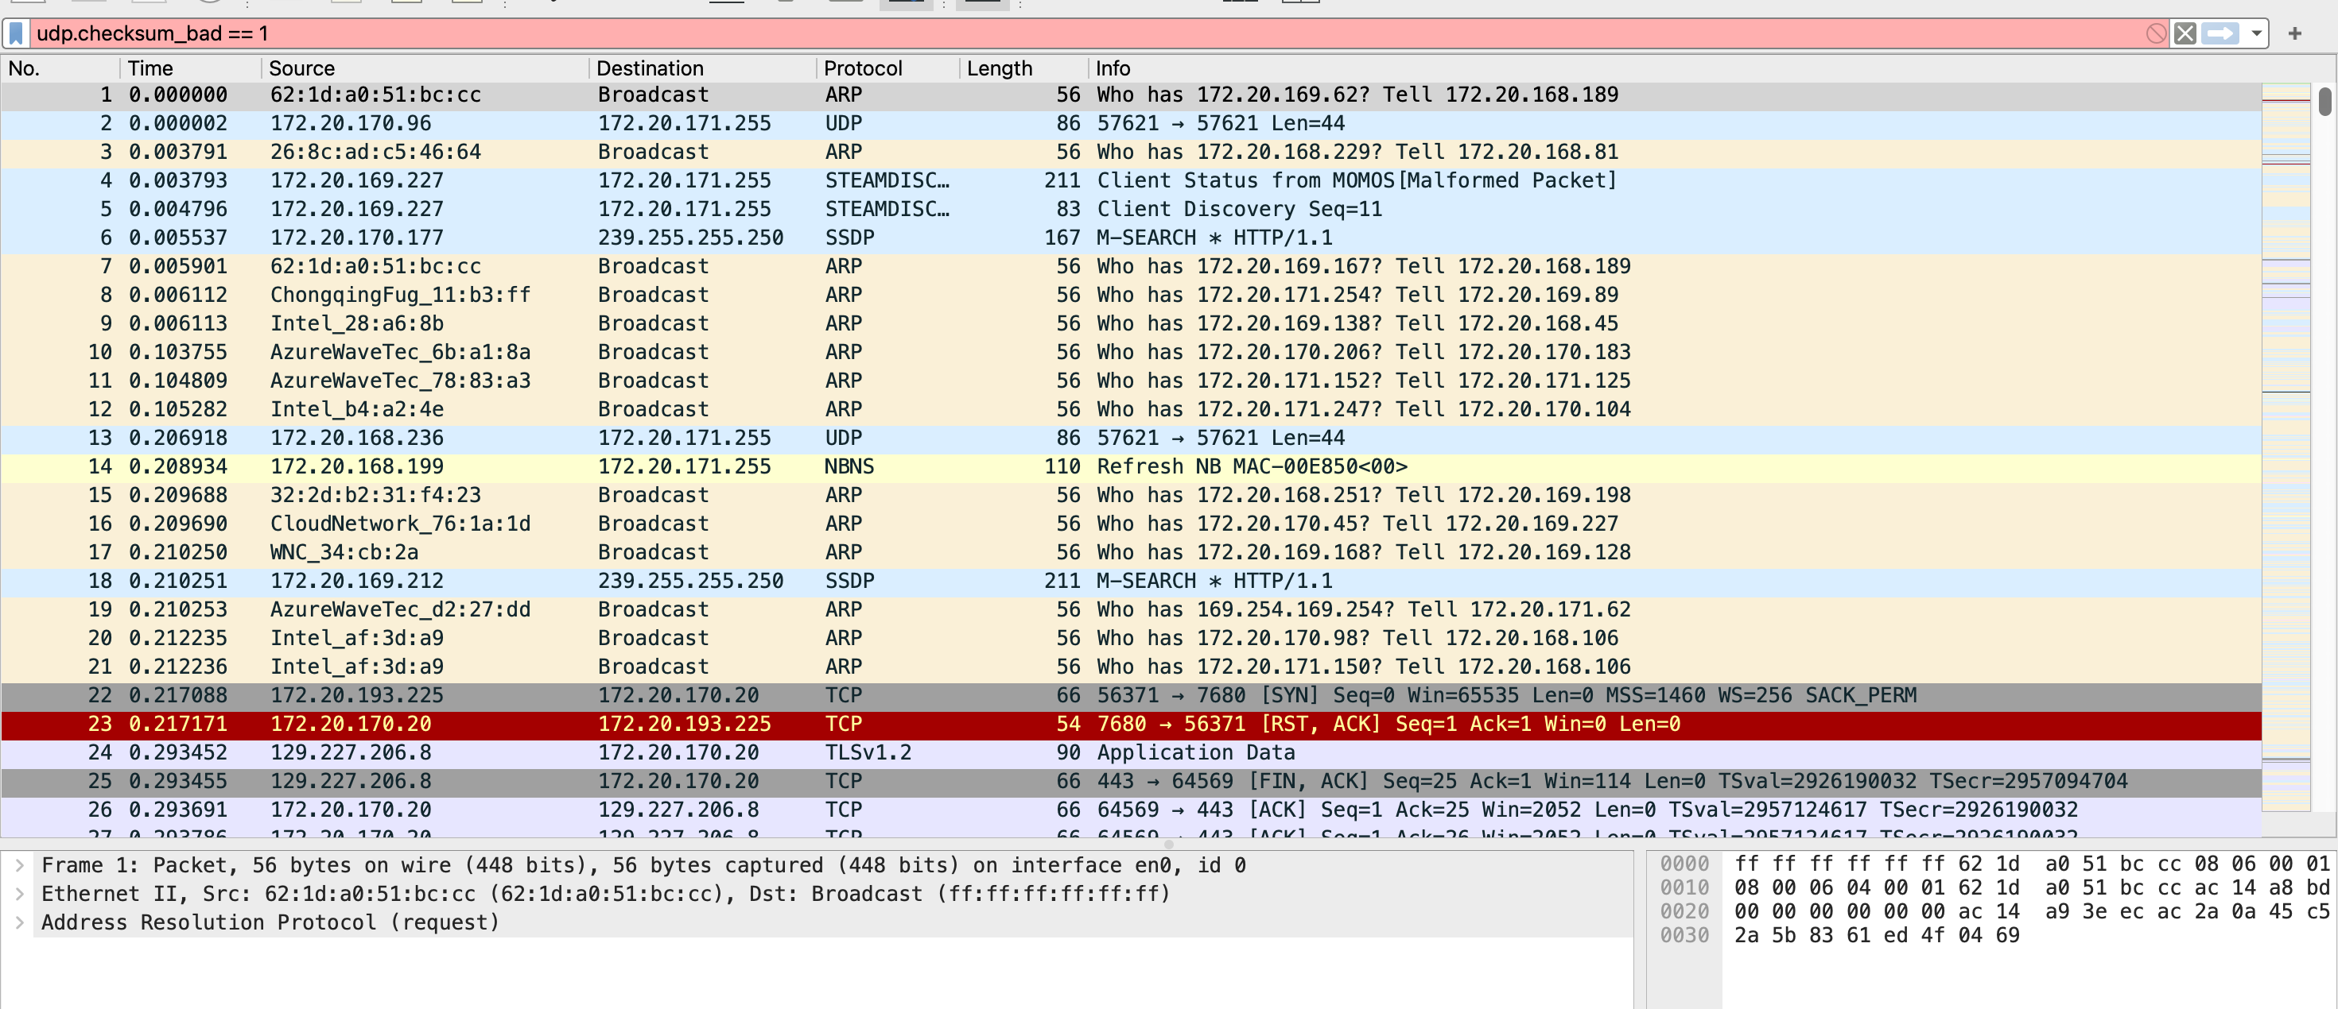
Description:
This screenshot shows the filter udp.checksum_bad == 1 applied in Wireshark. No packets are displayed, confirming that all UDP checksums in the captured traffic are valid and no data corruption occurred during transmission.

Step 3: Method 2 - Manual Checksum Calculation
For manual checksum calculation, a UDP packet was selected from the capture. The UDP header fields are:
Field | Value | Description
Source Port | 57621 | Source port number
Destination Port | 57621 | Destination port number
Length | 86 bytes | UDP header + data length
Checksum | 16-bit value | Extracted from packet header
UDP Checksum Calculation Formula:
text
UDP Checksum = Pseudo Header + UDP Header + Data

Pseudo Header contains:
- Source IP Address (32 bits)
- Destination IP Address (32 bits)
- Protocol (8 bits, 0x11 for UDP)
- UDP Length (16 bits)

Output Screenshot - Method 2:
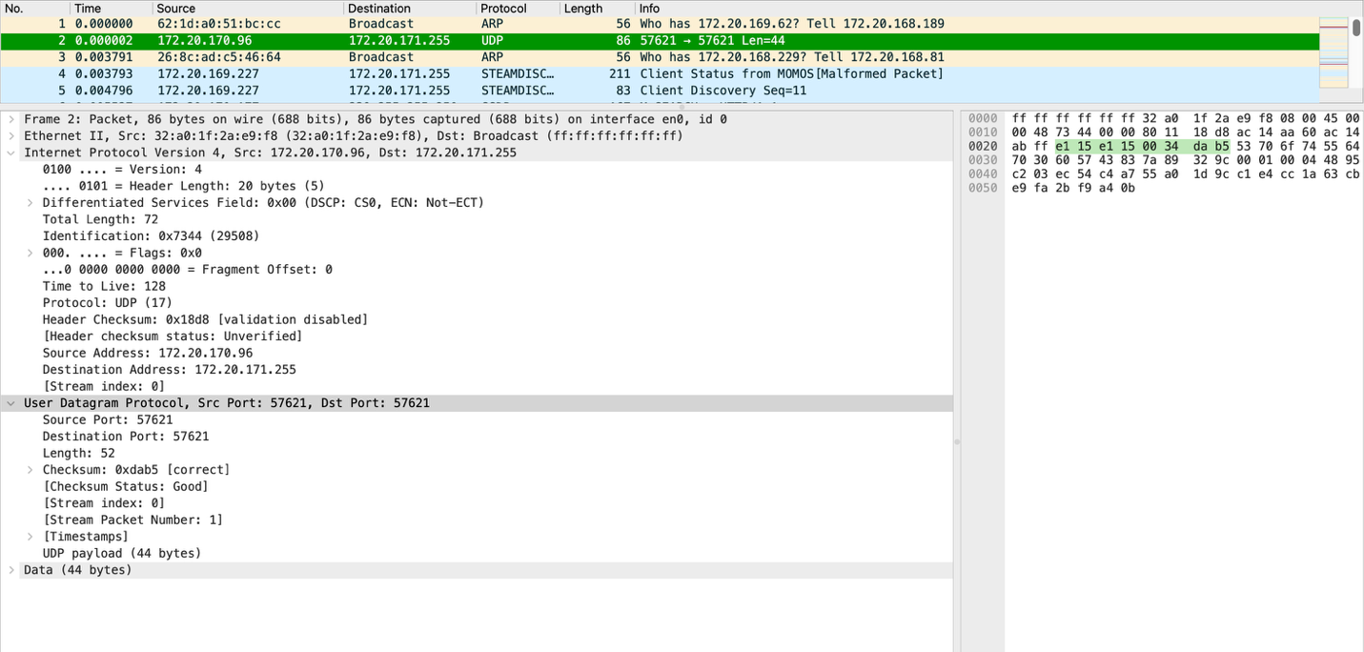
Description:
The above screenshot shows a UDP packet selected in Wireshark with both IP and UDP headers expanded. The UDP header clearly displays the checksum field. The source and destination ports (57621), length (86 bytes), and the 16-bit checksum value are visible. This packet can be used for manual checksum verification using the pseudo header calculation method.

Step 4: Method 3 - Scapy Python Script
Scapy is a Python library for packet manipulation and analysis. A Python script was created to automatically calculate and display checksums for all packets in the capture file.
Python Script: checksum_calculator.py
python
#!/usr/bin/env python3
"""
Checksum Calculator for Network Packets
Experiment 6: Wireshark - Checksum Calculations
"""

from scapy.all import *

def analyze_pcap(pcap_file):
print("=" * 60)
print("CHECKSUM CALCULATOR USING SCAPY")
print("=" * 60)
print(f"\nAnalyzing: {pcap_file}\n")

packets = rdpcap(pcap_file)
print(f"Total packets: {len(packets)}\n")

# Statistics
ip_count = 0
udp_count = 0
tcp_count = 0
icmp_count = 0

for packet in packets:
if IP in packet:
ip_count += 1
if UDP in packet:
udp_count += 1
if TCP in packet:
tcp_count += 1
if ICMP in packet:
icmp_count += 1

print("=" * 60)
print("PACKET STATISTICS")
print("=" * 60)
print(f"Packets with IP Layer: {ip_count}")
print(f"Packets with UDP Layer: {udp_count}")
print(f"Packets with TCP Layer: {tcp_count}")
print(f"Packets with ICMP Layer: {icmp_count}")

# Show UDP packets with checksums
print("\n" + "=" * 60)
print("UDP PACKETS WITH CHECKSUMS")
print("=" * 60)

udp_shown = 0
for i, packet in enumerate(packets):
if udp_shown >= 5:
break
if UDP in packet:
print(f"\nPacket #{i}:")
print(f" Source IP: {packet[IP].src}")
print(f" Destination IP: {packet[IP].dst}")
print(f" UDP Source Port: {packet[UDP].sport}")
print(f" UDP Destination Port: {packet[UDP].dport}")
print(f" UDP Length: {packet[UDP].len}")
print(f" UDP Checksum: 0x{packet[UDP].chksum:04x}")
udp_shown += 1

# Show TCP packets with checksums
print("\n" + "=" * 60)
print("TCP PACKETS WITH CHECKSUMS")
print("=" * 60)

tcp_shown = 0
for i, packet in enumerate(packets):
if tcp_shown >= 5:
break
if TCP in packet:
print(f"\nPacket #{i}:")
print(f" Source IP: {packet[IP].src}")
print(f" Destination IP: {packet[IP].dst}")
print(f" TCP Source Port: {packet[TCP].sport}")
print(f" TCP Destination Port: {packet[TCP].dport}")
print(f" TCP Checksum: 0x{packet[TCP].chksum:04x}")
tcp_shown += 1

print("\n" + "=" * 60)
print("CHECKSUM CALCULATION COMPLETE")
print("=" * 60)

if __name__ == "__main__":
pcap_file = "osi_layers_capture.pcapng"
analyze_pcap(pcap_file)

Output Screenshot - Method 3 (UDP):
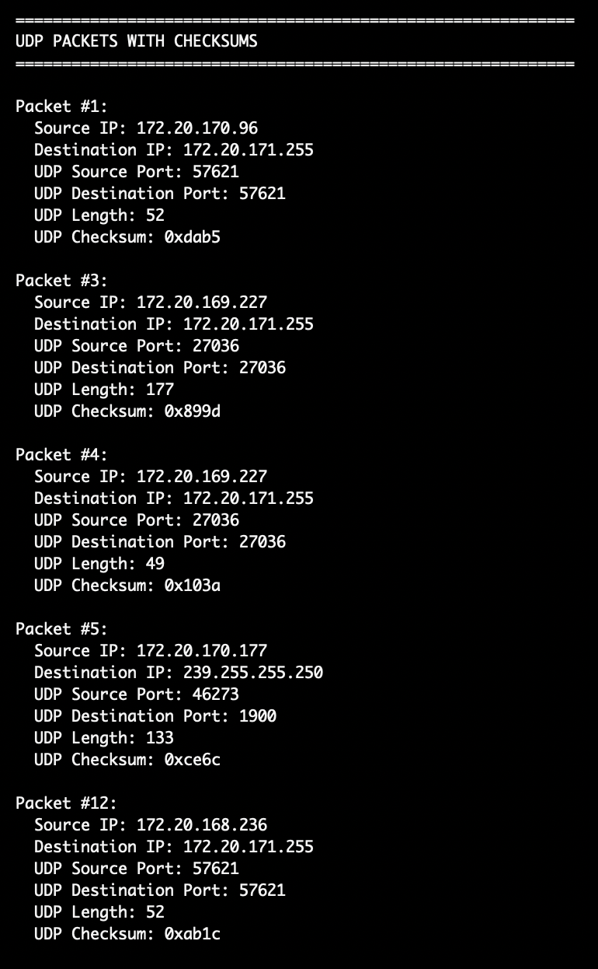
Description:
This screenshot shows the Scapy script output for UDP packets. For each UDP packet, the script displays the source IP, destination IP, source port, destination port, UDP length, and the 16-bit checksum value in hexadecimal format. The output confirms that Scapy successfully reads the PCAP file and extracts checksum information from UDP packets.

Output Screenshot - Method 3 (TCP):
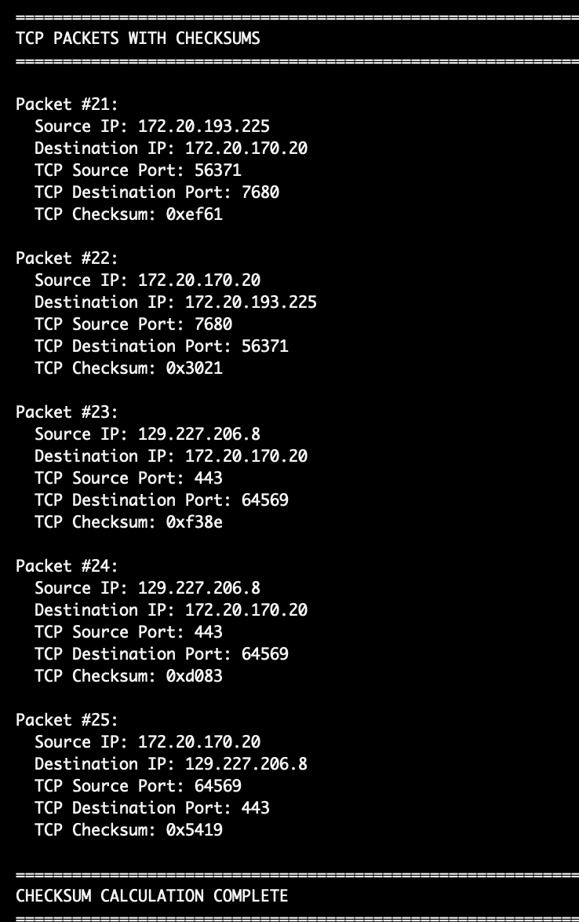
Description:
This screenshot shows the Scapy script output for TCP packets. The script displays TCP checksums along with source and destination IP addresses and port numbers. TCP checksums are more complex as they cover the TCP pseudo header, TCP header, and payload data. The script successfully extracts and displays these checksum values.

Summary of Results:

Method 1 - Wireshark Validation:
Protocol | Result
UDP Checksums | All valid (no bad checksums found)

Method 2 - Manual Calculation:
Field | Value
Selected Packet | UDP Packet
Source Port | 57621
Destination Port | 57621
Length | 86 bytes

Method 3 - Scapy Automation:
Parameter | Value
Script Language | Python with Scapy
Function | Extracts UDP and TCP checksums
Output Format | Hexadecimal (0xXXXX)

Comparison of Three Methods:
Method | Tool | Speed | Accuracy | Best For
Method 1 | Wireshark | Fast | High | Quick validation
Method 2 | Manual | Slow | High | Learning/Teaching
Method 3 | Scapy | Fast | High | Large-scale analysis

Conclusion:
In this experiment, checksum validation was successfully performed using three different methods:
- Method 1 (Wireshark): Demonstrated how Wireshark's built-in checksum validation can quickly identify packets with corrupted checksums. All UDP checksums in the capture were found to be valid.
- Method 2 (Manual): Selected a UDP packet and identified all header fields required for manual checksum calculation, including source/destination ports, length, and the checksum field itself.
- Method 3 (Scapy): Created a Python script using the Scapy library to automatically parse a PCAP file and extract checksum information for both UDP and TCP packets. This method is highly efficient for analyzing large capture files.

Key Learnings:
- Checksums are essential for detecting data corruption in network transmission
- Different protocols (UDP, TCP, IP, ICMP) have different checksum calculation methods
- Wireshark provides an easy way to validate checksums
- Manual calculation helps understand the underlying algorithm
- Scapy enables automated checksum analysis for large-scale packet captures

References:
- https://www.securitynik.com/2015/08/calculating-ip-checksum-with-taste-of.html
- https://www.securitynik.com/2015/08/calculating-udp-checksum-with-taste-of_3.html
- Wireshark Documentation - https://www.wireshark.org/docs/
- Scapy Documentation - https://scapy.readthedocs.io/

GitHub Repository:
Repository Link: https://github.com/ShreyasPatil3105/Computer-Networks-Lab

