**PYTHON PROJECT**

***Email Slicer***

Under the guidance of my favourite teacher 😊

**Mr. Naresh Saharan**

**Shreyas Sawaiker**

**12220132**

**KOC35**

**Technology Used**

**Python-** Python is a high-level, general-purpose programming language. Its design philosophy emphasizes code readability with the use of significant indentation.

Python was conceived in the late 1980s by Guido van Rossum at Centrum Wiskunde and Informatica in the Netherlands as a successor to the ABC programming language which was inspired by SETL, capable of exception handling and interfacing with the Amoeba operating system. Its implementation began in December 1989.

Python is dynamically-typed and garbage-collected. It supports multiple programming paradigms, including structured (particularly procedural), object-oriented and functional programming. It is often described as a “batteries included” language due to its comprehensive standard library.

**ABOUT PROJECT**

**Email Slicer:** Email Slicer is just a simple tool that will take multiple email address as an input and slice it to produce the username and the domain associated with it. The email must be divided into two strings by using ‘@’ as the separator.

**Conditions:**

1. user provides n number of email addresses, and you have to design a logic to slice the username and the domain out of those email addresses. The domain part must print in capitals.

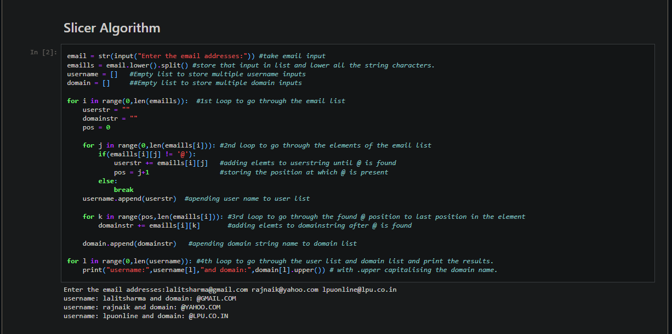

***CODE OF THE PROJECT-***

