Summary:

Objective of this activity is to get the image database of Vehicles from a high quality video footage of Highway during different daytimes, to learn about tuning parameters of the algorithm which will be used for the automation purpose and to label the image Database according to the type of vehicles (ex. Car, Bikes, High load vehicles etc.) for building a ML model for Vehicle Classification.

The tuning parameters of the algorithm and the labelling process of the image dataset to different vehicle classes which will be used for machine learning model

Now the steps/process by which it has been done:

The video file, if not grey scale, should be turned into grey scale image in order to get the 2 dimensional matrix instead of 3. Because image operations are meant to be done on 2d image matrix.

Then we will take the Gaussian blur of the image to smooth out the image so that object can be seen easily.

Now we will take the difference frame of two frames in the video to identify and track the movement of the objects.

We have two options for differencing the frame.

First we compare it with very first frame or second we check the adjacent frame of the video.

The first case is useful when there is no movement of the camera. Then only the objects moved will be detected and still objects remain unnoticed.

But if the camera moved a bit, the receding frames would have a difference of still objects in every frame.

Then the second case is useful in this scenario. When we compare with previous frame, if the camera moves, difference frames would only have a temporary fluctuation of still objects.

Next, the image thresholding is done to get the frame in only two colours black and white to get clear contours.

Above the threshold the pixel value is set to 255 which is white and others to 0 which is black.

Now, Image dilation is done to dilate the contours in image to get better picture area of the moving object.

Then we will find the white contours in the frame and create a bounding box around it and we will save the images by cropping from the original frame.

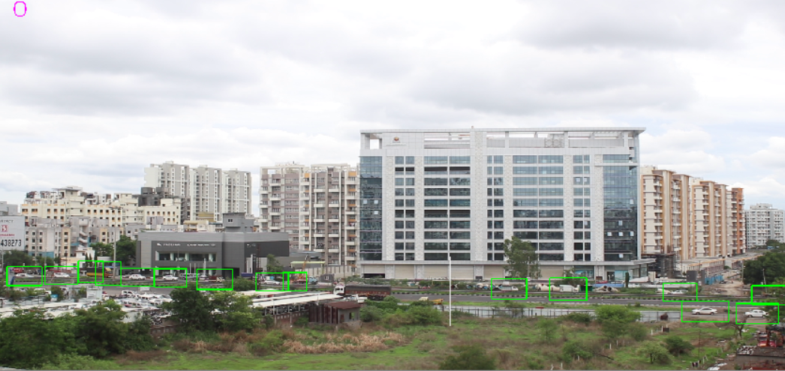

Flow chart of the code:

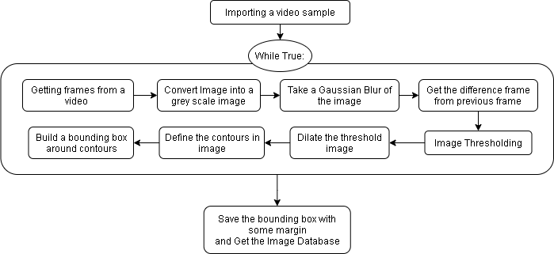

Now, we will talk about the tuning parameters so that a new user can implement this object detection algorithm.

The most important parameter is the image threshold parameter. It should be set manually according to the FPS and the exposure of the video frames.

Because the both the factors affect the difference frame.

Higher iterations would have more dilated image increasing the contour area.

Dilate function iterations should also be chosen according to the video.

Also the coordinates of crossing points of the vehicle should be set manually by the user depending upon the direction of the vehicle movement.

The lower limit on the contour area is also set to reduce the errors. But the default value of parameter also works fine.