LEVISOL INDIA
Balancing Act — Production, Distribution
& Inventory Optimisation
Supply Chain Transformation Taskforce · January-2026 Planning Cycle
Project 2 · Final Report · July 2026

₹11.44 cr | 0 kL | −56% | Gap 0.0
total cash cost of the January plan | demand unmet — 100% service | CFA safety stock released vs legacy read | proven-optimal MILP solution

This report presents the complete, verified solution to the Levisol supply-chain case: redesigned inventory norms for all 957 SKU × CFA combinations and both mother hubs, a provably cost-optimal production & distribution plan for January 2026, and a reusable planning tool a non-technical planner can run every month. Every number in this document is traceable to the case data workbook and was verified by independent recomputation.
Contents
1 | Executive summary | 2
2 | The case & the data | 3
3 | Inventory norms — methodology | 4
4 | Inventory norms — results | 6
5 | The optimisation model | 8
6 | Production plan | 9
7 | Distribution plan | 10
8 | Cost of the plan | 11
9 | Validation & verification | 12
10 | Robustness — assessment-day scenarios | 13
11 | The planning tool | 14
12 | Assumptions, limitations & recommendations | 15

1 · Executive summary
Levisol can serve every litre of January-2026 demand at a total cash cost of ₹114,411,784 — while cutting CFA safety-stock norms by 56% against the legacy conservative reading. The case's dual mandate, “protect service on critical SKUs while rapidly releasing cash,” is delivered simultaneously, not traded off.
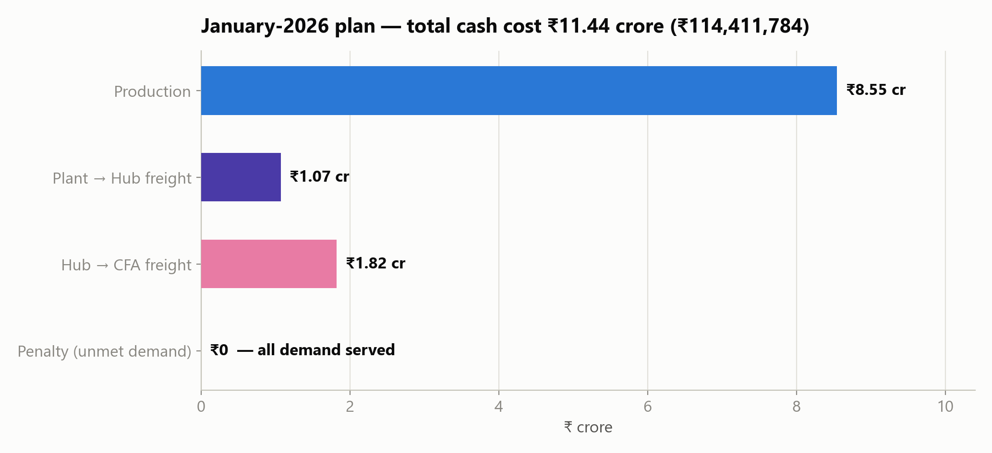

The three decisions in one view
- Inventory norms. CFA safety stock of 1,465 kL (median cover: 6 days) and hub safety stock of 1,488 kL at a 98% service level. Tier A/B products keep deliberately conservative buffers; tier C/D are sized to their exact 92% fill-rate targets.
- Production & routing. 7,725 kL in 309 exact 25-kL batches — KOL (cheapest, ₹9,000/kL) runs 100% full, BOM's cheap lanes saturate, AHM swings. Proven-optimal: no cheaper feasible plan exists (MILP gap 0.0, independently cross-checked).
- Zero lost sales. All 8,109.7 kL of forecast demand is served; the penalty line is ₹0. Only 99.6 kL of precautionary buffer top-ups (≈1.2%) are deliberately left unfilled where a nearly-empty 25 kL batch would cost more than the risk it removes.
KEY INSIGHT The single biggest cash finding: 211 of 957 SKU–CFA forecasts carry systematic bias. The redesigned norms stop warehousing forecast errors as safety stock — they flag them for demand-planning correction instead.

Deliverables: this report; Levisol_Plan_Output.xlsx (all plan & norms tables); the working planning tool (Levisol_Planning_Tool.py + engine) with user guide; the methodology & assumptions document; and the presentation deck.

2 · The case & the data
Levisol manufactures 100 lubricant SKUs at three plants, buffers them at two mother hubs, and distributes through ten CFA warehouses. A base-oil shock has made the old inventory norms unsafe to trust: leadership needs redesigned norms, a least-cost January plan, and a tool that survives changed inputs on assessment day.
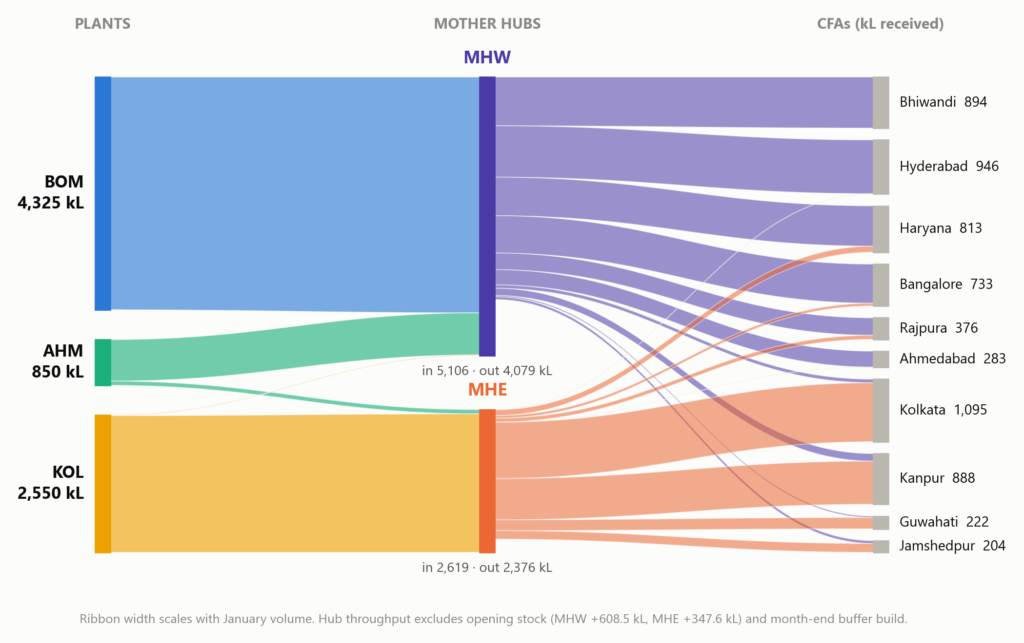
Figure 2.1 — January-2026 optimal flows across the 3-tier network (ribbon width = volume)

What the data workbook contains (all 11 sheets read in full)
Exhibit | Content | Role in the solution
A | Plant line capacities & production cost | Hard constraints; ₹12,000 / 12,500 / 9,000 per kL
B · C | Freight rates plant→hub, hub→CFA | Objective cost coefficients
D | 100 SKUs: pack, penalty ₹/kL, contractual flag | Line mapping; shortage prioritisation
E | Source + lead times & variability (957 rows) | Norm lead times; hub assignment
F | Tier fill-rate targets & volume slabs | Service levels: A 98 · B 97 · C/D 92%
G · H | 6-month sales & forecast history | Demand levels, tiers, forecast-error σ
I | Opening inventory (CFA + hub rows) | Net requirements
J | January-2026 forecast (8,109.7 kL) | Planning demand

DATA DISCREPANCY RESOLVED The case PDF's Exhibit A is garbled by its layout (it reads as if KOL produced at ₹200/kL). Per the case rule, the machine-readable workbook takes precedence — the clean table (BOM ₹12,000 · AHM ₹12,500 · KOL ₹9,000 per kL) is used throughout. Data quality: 2 tiny negative sales cells (returns, kept); 16 rows with zero 6-month sales (norms suppressed & flagged); AHM's 220 kL 50-LT line is not a 25 kL multiple (usable: 200 kL).

3 · Inventory norms — methodology
Norms answer two questions per SKU per location: when to reorder (ROP) and how much buffer to hold (safety stock). Three methodology choices — each verified and each quantified — separate this design from a textbook default:

3.1 Buffer the randomness, flag the bias
Replenishment is planned against forecasts, so the risk that safety stock must absorb is forecast error. But only its RANDOM part: systematic bias is a demand-planning defect to fix, not to warehouse. Sizing stock on raw error (RMSE) would give one 8-litre-a-month SKU a 5.4 kL buffer — 56 years of cover. We use the bias-removed standard deviation of forecast errors and flag 211 biased rows for review.

3.2 Each supply step buffered exactly once (multi-echelon)
Hubs hold their own 98% buffers by case design, so the hub is the decoupling point: CFA norms cover the hub→CFA leg (1–9 days); hub norms cover production + plant→hub transit. Sizing CFA stock end-to-end while also holding hub stock would double-buffer the upstream legs — worth +981 kL of trapped cash.

3.3 A tiered translation of fill-rate targets
Exhibit F leaves the fill-rate→stock conversion to us. Tiers A/B (49 SKUs, 80% of volume) get the conservative cycle-service-level reading (z = 2.054 / 1.881) — flagship service is protected through the base-oil shock. Tiers C/D get the exact fill-rate translation via the normal loss function G(z) = (1−β)·Q/σ — monthly cycle stock already achieves most of a 92% target, so nearly all C/D buffer is released.
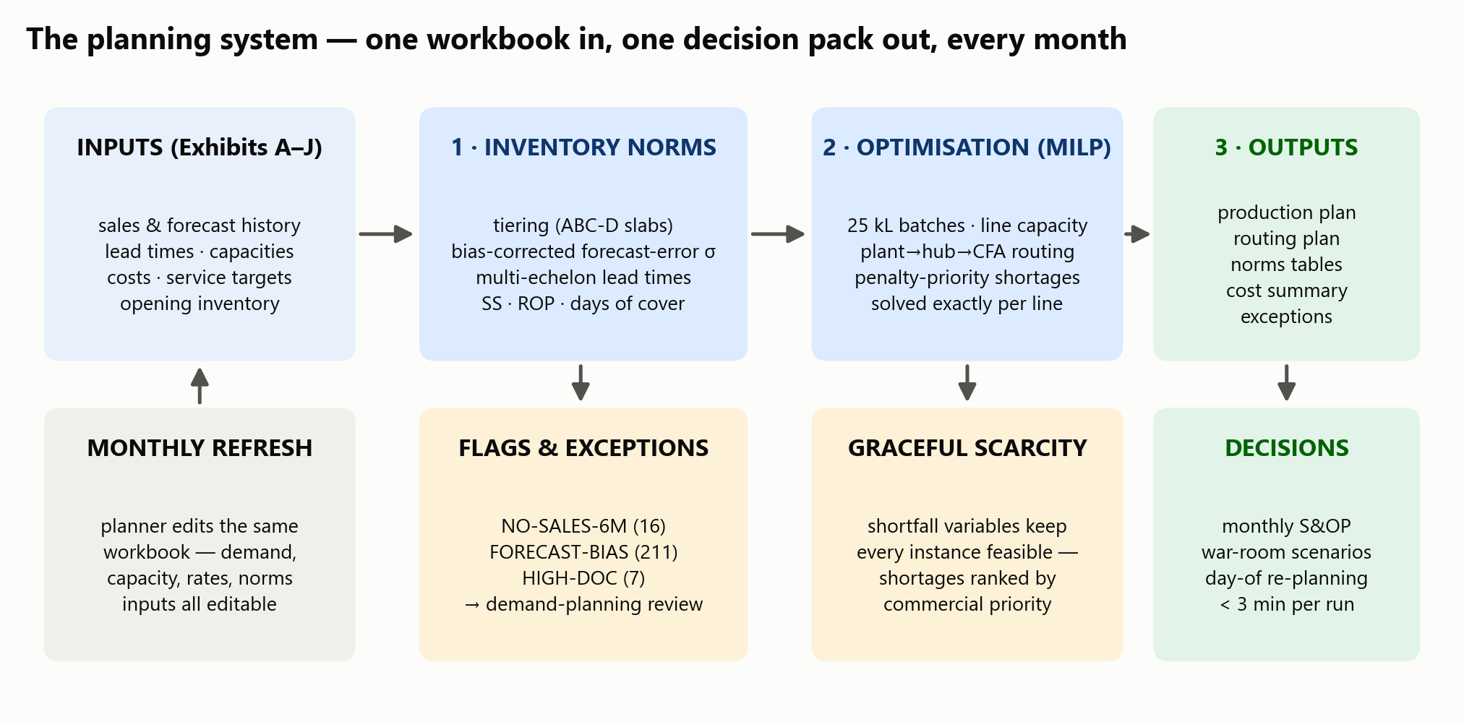
Figure 3.1 — The planning system: inputs → norms → optimisation → outputs, refreshed monthly

3.4 The formulas (both demand and lead-time variability enter every norm)
SS = z × √( LT·σd² + μd²·σLT² )
ROP = μd × LT + SS
DOC = ROP ÷ μd (days of average last-6-months demand)
μd = mean monthly sales ÷ 30 working days; σd = std-dev of debiased forecast errors ÷ √30; LT and σLT from Exhibit E (historical source predefined). Hub demand pools the CFA rows each hub serves — variances add because the case instructs CFA independence — so risk pooling keeps hub buffers small.
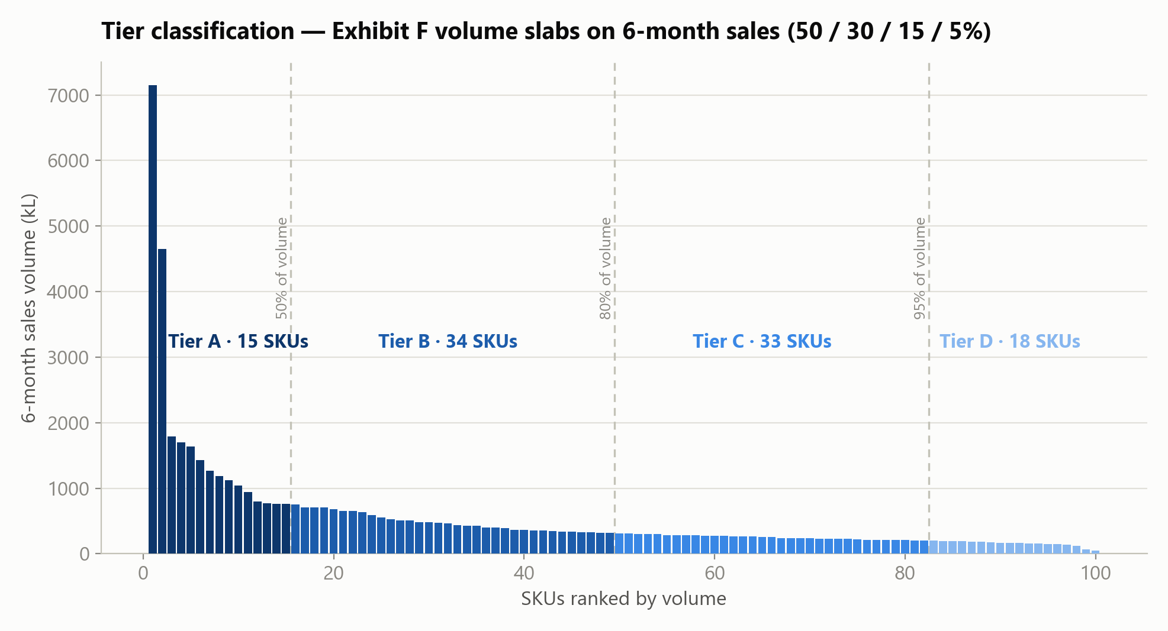
Figure 3.2 — Exhibit F volume slabs classify 100 SKUs into tiers A(15) B(34) C(33) D(18)

4 · Inventory norms — results
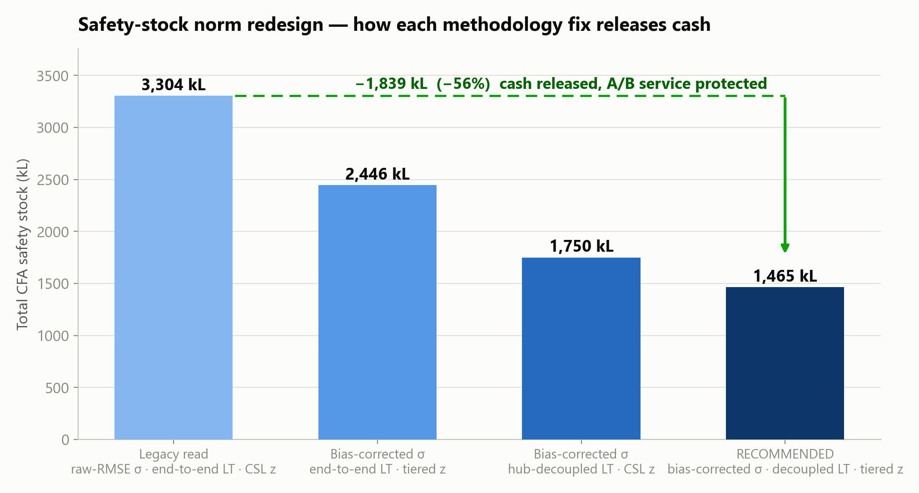
Figure 4.1 — Each methodology fix, quantified. The recommended norm releases 1,839 kL (−56%)
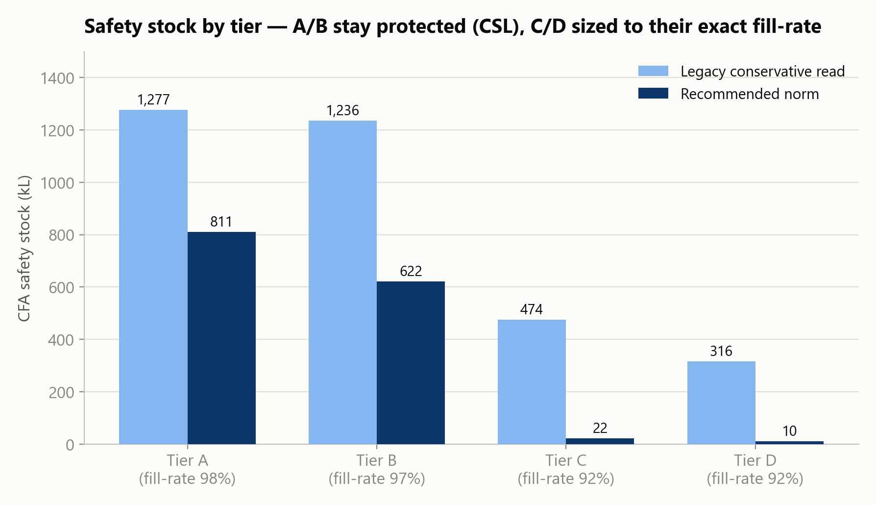
Figure 4.2 — A/B keep protection; C/D sized to their exact fill-rate targets

Norm totals (full 957-row and 151-row tables in Levisol_Plan_Output.xlsx)
Level | Safety stock (kL) | Reorder point (kL) | Service basis
CFA network total (957 rows) | 1,465.1 | 2,442.0 | tier fill rates 98/97/92/92%
— Tier A (15 SKUs) | 811.3 | — | CSL z = 2.054
— Tier B (34 SKUs) | 621.5 | — | CSL z = 1.881
— Tier C (33 SKUs) | 22.1 | — | exact fill-rate (loss function)
— Tier D (18 SKUs) | 10.2 | — | exact fill-rate (loss function)
Mother Hub West (100 SKUs) | 1,156.2 | 2,718.5 | 98% SL, z = 2.054
Mother Hub East (51 SKUs) | 332.0 | 737.8 | 98% SL, z = 2.054

Worked example — SKU_001 (Tier A, 20 × 900 ML)
CFA | LT (days) | Safety stock (kL) | ROP (kL) | Days of cover
Kolkata | 1 | 9.74 | 13.94 | 3.3
Kanpur | 4 | 55.94 | 102.80 | 8.8
Haryana | 4 | 37.42 | 69.63 | 8.6
Bhiwandi | 1 | 10.53 | 14.14 | 3.9
Hub MHE (pools 4 CFAs) | 2 | 21.36 | 56.66 | 3.2
Hub MHW (pools 6 CFAs) | 2 | 23.14 | 67.23 | 3.1

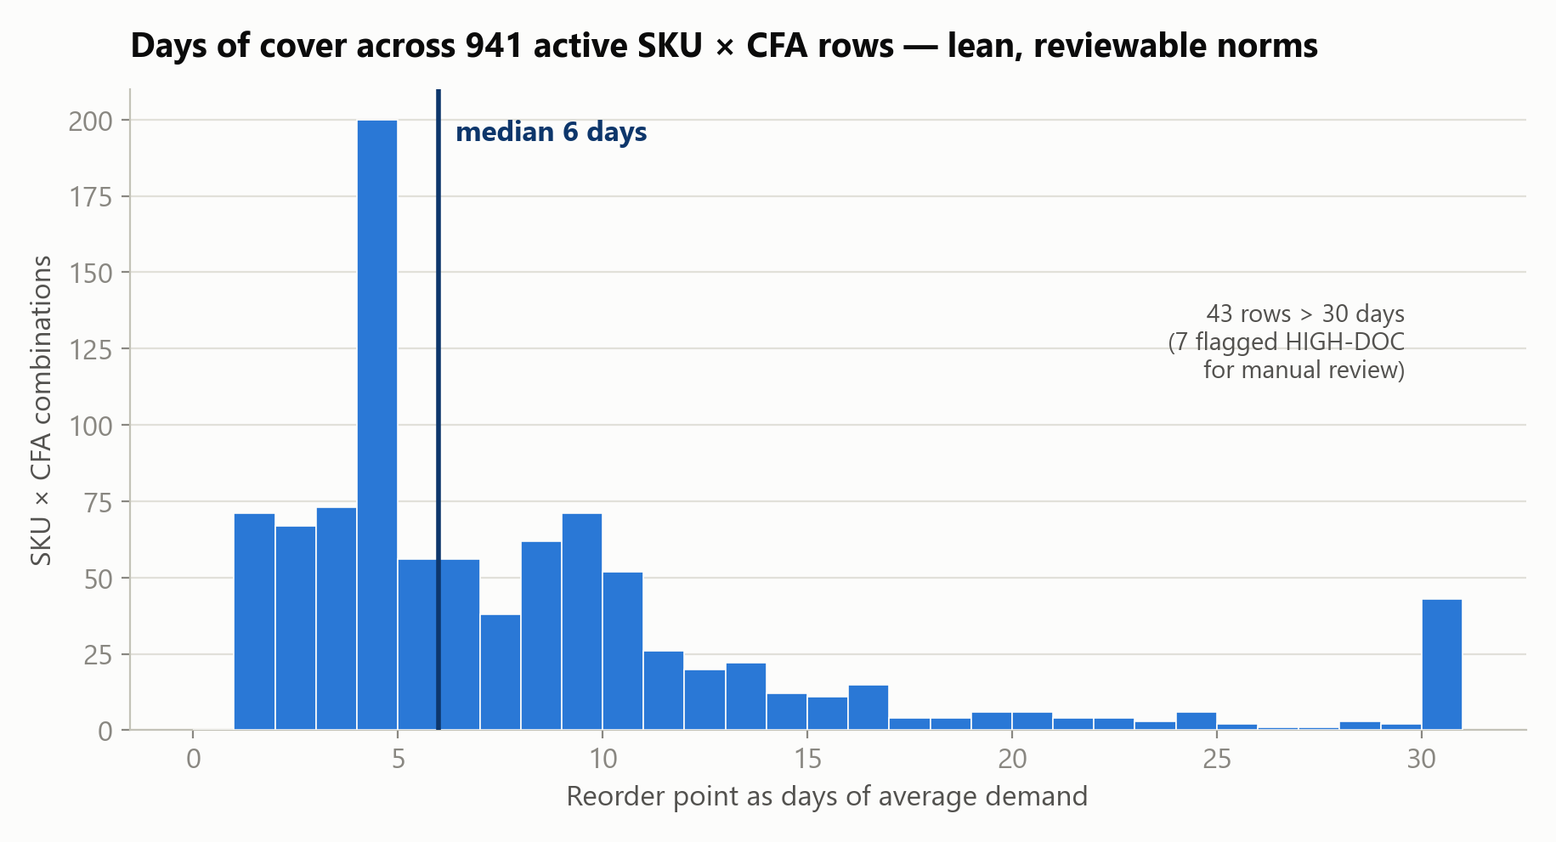
Figure 4.3 — Days of cover: lean and reviewable (median 6 days)
EXCEPTIONS BY DESIGN Every anomaly is flagged, never silently normed: 16 rows with no sales history (norms suppressed), 211 rows with forecast bias (fix the forecast, not the stock), 7 slow movers with >90 days cover (manual review). All appear on the tool's Exceptions sheet each month.

5 · The optimisation model
A mixed-integer linear program decides, for every SKU: how many 25 kL batches to make at which plant, how to route them through the hubs, and — if capacity ever binds — what NOT to supply, ranked by commercial priority.

Objective (minimise)
production cost + primary freight + secondary freight + penalty × (3× if contractual) × unmet demand + 0.25 × penalty × safety-stock shortfall

Constraints in plain business language
- Batch rule. A plant ships exactly what it produces; production is in whole 25 kL batches (integer variables).
- Line capacity. Per plant per line, production cannot exceed Exhibit A capacity (50 LT products can only be made at AHM).
- Hub balance. A hub cannot ship more than opening stock plus inbound; hub stock never goes negative and should end the month at its 98% safety-stock target (soft, reported when shorted).
- Demand first. Unmet demand costs the full Exhibit-D penalty (₹130k–330k/kL); an unfilled buffer top-up carries a 0.25 weight — high enough to fill buffers whenever capacity economically allows, low enough that real demand always wins under scarcity. Contractual SKUs get a 3× multiplier.
WHY THIS IS THE OPTIMUM Exactness, not heuristics: SKUs interact only through line capacities and each SKU belongs to exactly one line — so the MILP separates into 5 independent problems, each solved to proven optimality (gap 0.0) with HiGHS. A monolithic cross-solve found nothing better (₹119.64M vs our ₹119.38M objective); the LP bound shows the remaining 13.6% over the fractional ideal is precisely the priced cost of the 25 kL batch rule.

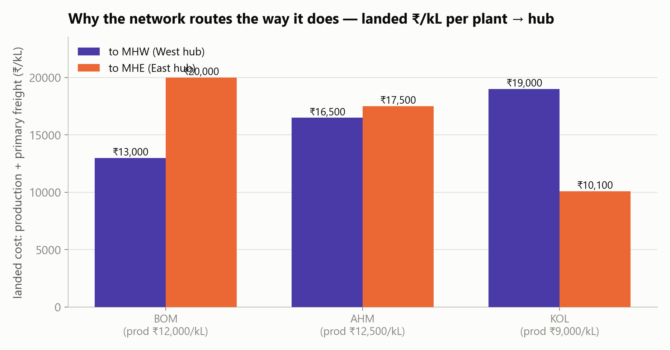
Figure 5.1 — Landed economics that drive the routing: KOL owns the East, BOM owns the West, AHM swings

6 · Production plan — January 2026
Total production: 7,725 kL = 309 batches of exactly 25 kL. The cheapest capacity works hardest: every KOL line runs at 100%; BOM's ≤1.5 LT line saturates; AHM, the most expensive plant, keeps 3,420 kL of slack — the network's shock absorber.
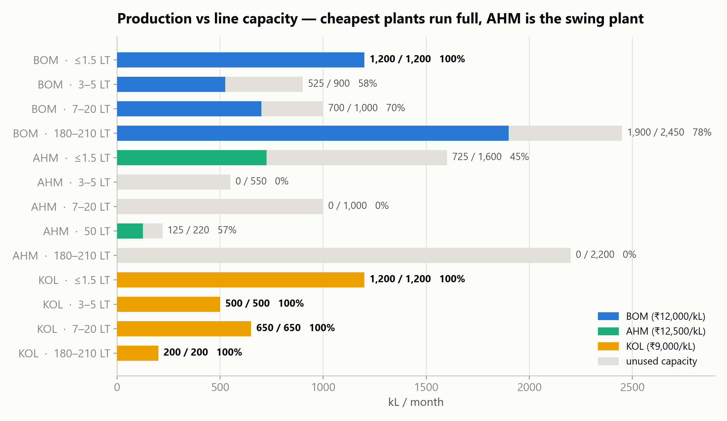
Figure 6.1 — Production vs line capacity (full SKU × plant detail in the output workbook)
Plant | Production (kL) | Batches | Production cost (₹) | Role
BOM Mumbai | 4,325 | 173 | 51,900,000 | backbone of MHW / West-South
KOL Kolkata | 2,550 | 102 | 22,950,000 | cheapest ₹/kL — runs 100% full
AHM Ahmedabad | 850 | 34 | 10,625,000 | swing plant + only 50 LT line
TOTAL | 7,725 | 309 | 85,475,000 | zero non-25 kL batches

7 · Distribution plan — plant → hub → CFA

Primary leg (plant → hub) — ₹10,719,136
Lane | Volume (kL) | Rate (₹/kL) | Cost (₹)
BOM → MHW | 4,323.8 | 1,000 | 4,323,787
AHM → MHW | 771.2 | 4,000 | 3,084,975
KOL → MHE | 2,538.6 | 1,100 | 2,792,407
KOL → MHW | 11.4 | 10,000 | 114,479
AHM → MHE | 78.8 | 5,000 | 393,781
BOM → MHE | 1.2 | 8,000 | 9,706

The two counter-intuitive lanes (KOL→MHW, BOM→MHE, 12.6 kL combined) are batch remainders already paid for at the cheap plant, shipped to where they are useful — verified individually rational.

Secondary leg (hub → CFA) — ₹18,217,648
CFA | From MHW (kL) | From MHE (kL) | Total received (kL)
Kolkata | 62.2 | 1,032.8 | 1,095.0
Hyderabad | 941.6 | 4.5 | 946.1
Bhiwandi | 894.3 | — | 894.3
Kanpur | 132.1 | 755.9 | 888.0
Haryana | 706.8 | 106.6 | 813.4
Bangalore | 684.6 | 48.7 | 733.3
Rajpura | 305.0 | 70.9 | 375.9
Ahmedabad | 279.1 | 3.8 | 282.9
Guwahati | 24.2 | 197.5 | 221.7
Jamshedpur | 49.3 | 154.9 | 204.2

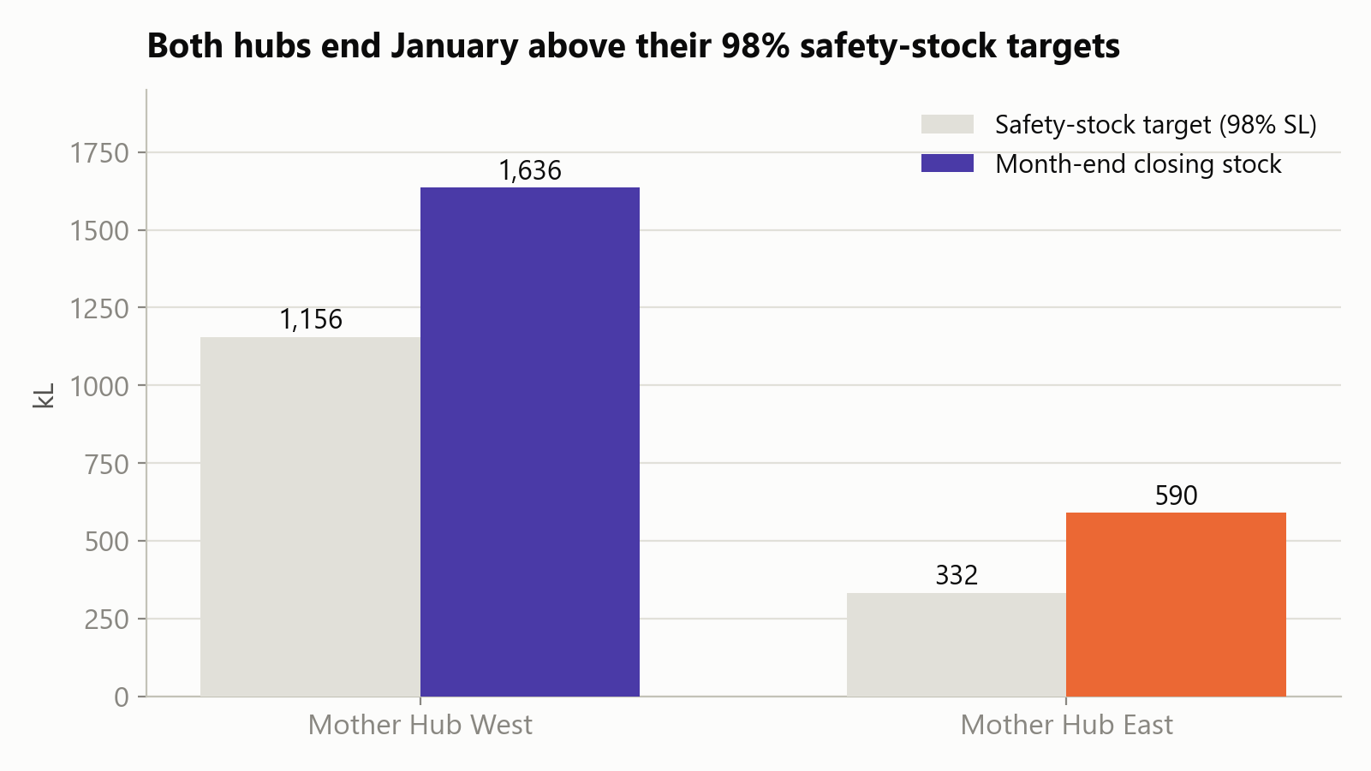
Figure 7.1 — Month-end hub stock vs the 98% safety-stock targets: both hubs finish above norm

8 · Cost of the plan
Cost element | ₹ | Share
Production | 85,475,000 | 74.7%
Plant → Hub freight | 10,719,136 | 9.4%
Hub → CFA freight | 18,217,648 | 15.9%
Penalty — unmet demand | 0 | 0.0%
TOTAL CASH COST | 114,411,784 | 100%

HONEST ACCOUNTING Two memo items are reported for transparency but are NOT cash: risk-weighted hub safety-stock shortfall ₹1,412,331 (31.5 kL) and CFA top-up shortfall ₹3,156,280 (68.1 kL). These are prioritisation weights (0.25 × penalty) on ≈1.2% of buffer volume that batch economics left unfilled — every case was checked: filling it would cost more than the risk it removes.

Benchmark: the theoretical fractional-batch ideal (LP bound) is ₹105.09M — the gap to ₹114.41M is the unavoidable, correctly-priced cost of the 25 kL batch rule plus the residual buffer risk, not sub-optimality.

9 · Validation & verification
Assume there are errors — then go hunting. Four independent audits (norms recomputation, feasibility, optimality, methodology) plus a fresh-code recheck of the revised norms:
Check | Requirement | Result | Status
Batch size | all production in 25 kL multiples | 309 batches, 0 violations | PASS
Line capacity | ≤ Exhibit A per plant × line | max 100.0%, 0 violations | PASS
Plant balance | production = plant outbound | exact per SKU × plant | PASS
Hub balance | open + in − out = close ≥ 0 | exact; no negatives | PASS
Demand service | serve Jan forecast net of opening | 0 kL unmet of 5,136.3 at-risk | PASS
Hub 98% buffers | close month ≥ hub SS | 138/151 fully met; 31.5 kL reported | PASS*
Contractual SKUs | protected first | zero contractual shortfall | PASS
Norm recomputation | independent code path | max deviation ≤ 1.4×10⁻¹⁴ kL | PASS
Cost arithmetic | recompute all 5 components | < 10⁻⁶ relative error | PASS
Optimality | no cheaper feasible plan | gap 0.0 + LP bound + cross-solve | PASS

* Soft by design — the case asks for shortfalls to be reported with cost, which the Exceptions sheet does line-by-line.

10 · Robustness — assessment-day scenarios
On assessment day the tool must replan a modified input set in minutes. We simulated three shocks end-to-end through the tool — no crashes, shortages ranked by commercial priority, full cost transparency:
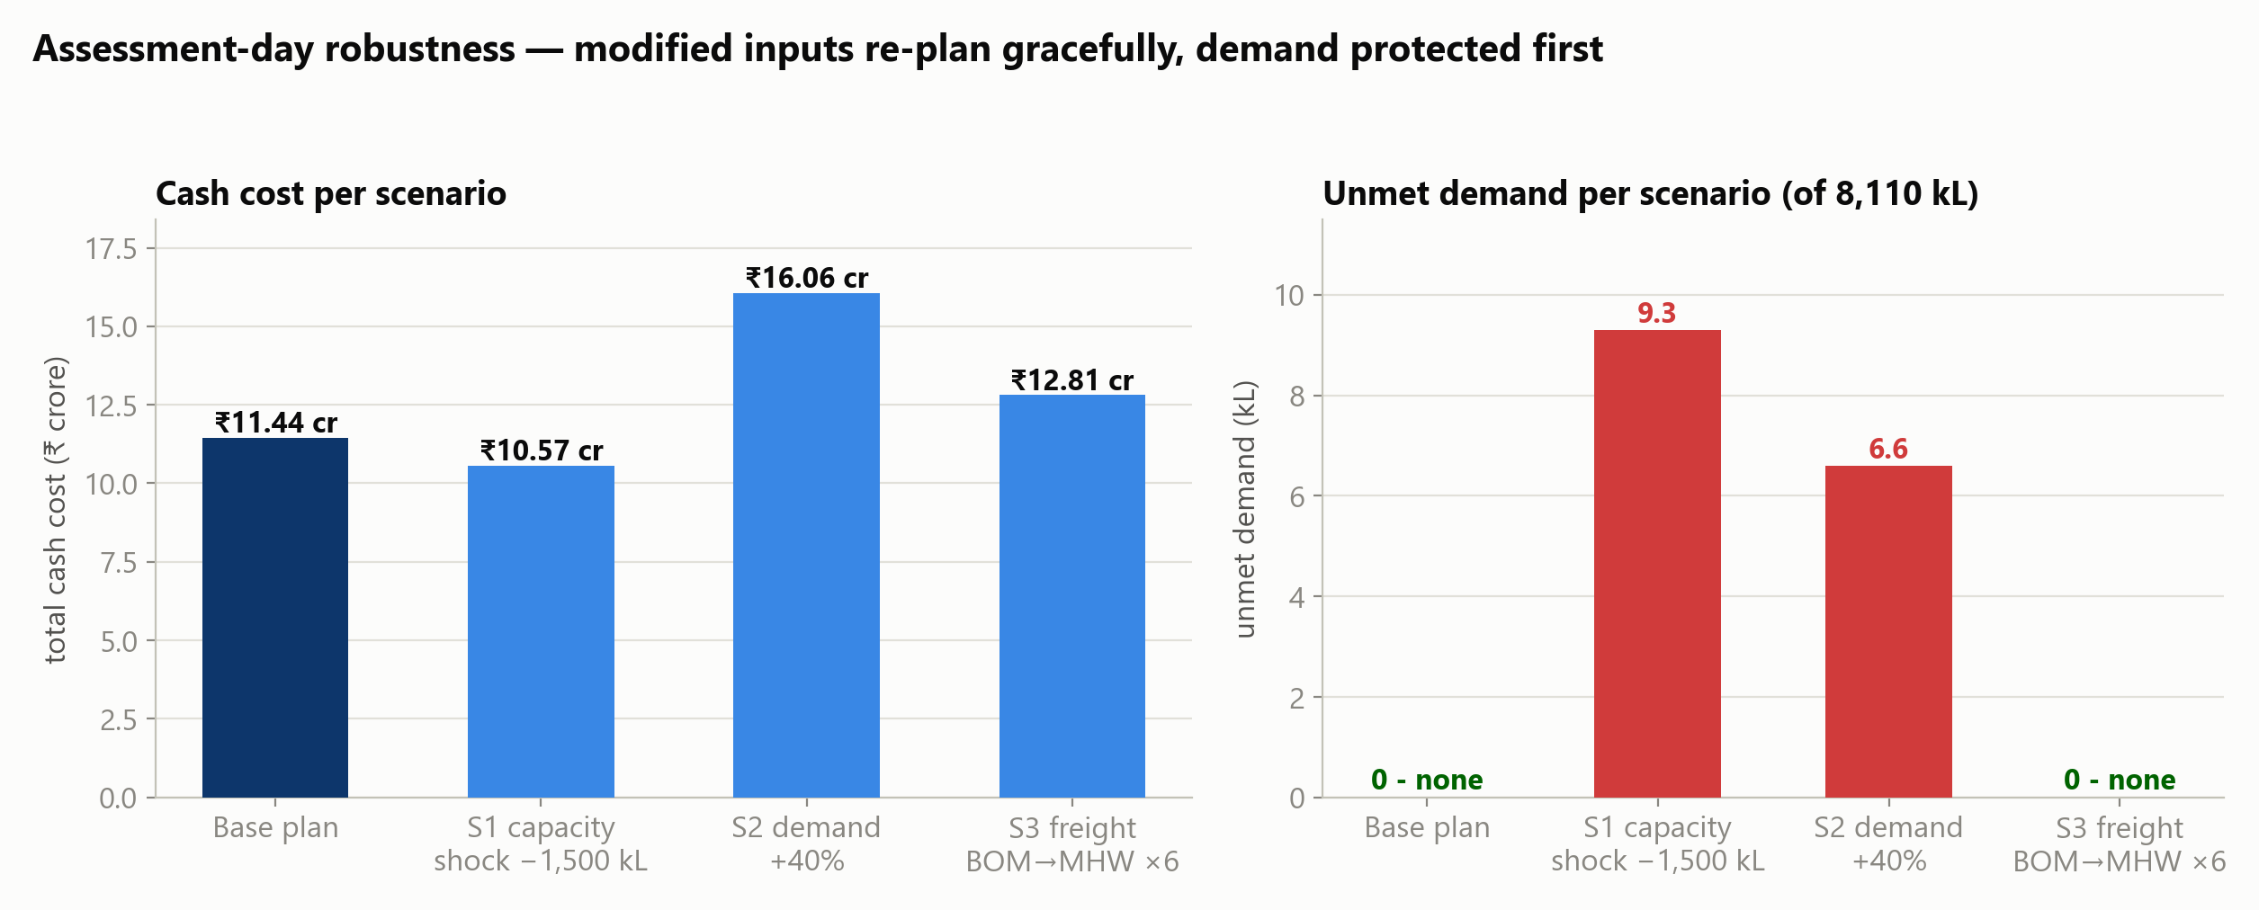
Figure 10.1 — Three shocks through the tool: demand is protected first, buffers absorb the hit
Scenario | What changed | Outcome
S1 capacity shock | ≤1.5 LT capacity cut 1,500 kL (BOM 1200→800, AHM 1600→500) | only 9.3 kL unmet (5 lowest-penalty non-contractual lines); buffers absorb 488 kL; cost ₹10.57 cr
S2 demand spike | all January forecasts +40% | production scales to 10,250 kL; 6.6 kL unmet; ₹16.06 cr
S3 freight shock | BOM→MHW rate ₹1,000 → ₹6,000/kL | sourcing re-routes automatically; zero unmet; ₹12.81 cr

PRIORITY LOGIC PROVEN S1 is the designed behaviour under scarcity: the model sacrifices 488 kL of precautionary buffer before losing a single high-priority sale, and the 9.3 kL it cannot save are the cheapest-penalty, non-contractual lines.

11 · The planning tool
Levisol_Planning_Tool.py — double-click, browse to the month's workbook, press RUN PLAN. Under three minutes later the planner has a complete output workbook: production plan, routing plan, norms, hub stock positions, cost summary and an Exceptions sheet that explains every shortfall in business terms.
- Everything is editable. Demand, capacities, production costs, freight rates, lead times, service levels, opening stock — the tool re-reads the workbook every run; nothing is hard-coded.
- It never just crashes. Shortfall variables keep every instance feasible: capacity shortages become a ranked shortage report, zero-demand rows are flagged, empty lines are excluded automatically.
- No specialist knowledge. One input file, one button, one output file — with a README and flagged exceptions a planner can act on.
You change (Excel sheet) | The tool redoes
J — demand forecast | requirements, plan, costs
A — capacities / production cost | sourcing, batch plan
B · C — freight rates | routing
E / F / G / H — lead times, service levels, history | all inventory norms
I — opening inventory | net requirements & buffer top-ups

12 · Assumptions, limitations & recommendations

Assumptions (every one disclosed, none invented)
# | Assumption | Impact / mitigation
1 | Tiered fill-rate translation (A/B CSL; C/D exact fill-rate) | case delegates the conversion; all-CSL variant quantified (+285 kL)
2 | σ from 6 monthly observations, √30 daily scaling | re-estimated automatically every month
3 | Hub = decoupling point (CFA LT = hub→CFA leg) | hubs hold mandated 98% buffers; end-to-end variant reported per row
4 | Buffer weight 0.25 × penalty; contractual ×3 | zero effect this month (no unmet demand); exposed dials
5 | No holding cost priced (case provides none) | holding_cost_per_kl dial available, default 0
6 | CFA demands independent at hubs | explicit case instruction

Recommendations beyond January
- Fix the 211 biased forecasts. The largest structural cash lever found — stop buffering bias with inventory.
- Re-estimate norms monthly. The tool recomputes σ and tiers on every run; revisit the C/D fill-rate choice after 3 months of post-shock data.
- Watch the ≤1.5 LT line. BOM and KOL run it at 100%; it is the first line to short under any demand upside (S2). AHM slack is the shock absorber.
- Price working capital. If management wants hub stock builds inside the objective, set the holding-cost dial — today's 698 kL build is batch arithmetic, not policy.

— Prepared by the Supply Chain Transformation Taskforce · verified end-to-end · reproducible from the raw case workbook via run_solution.py

