SAP FUNDAMENTALS
CAPSTONE PROJECT REPORT
Order-to-Cash (O2C) End-to-End Process Simulation
Name | Shreyas Uday
Roll Number | 23052268
Batch / Program | SAP BTP
Institution | KIIT University
Date of Submission | 21 April 2026
Tool Used | Dolibarr ERP (SAP Simulation)

1. Title
Order-to-Cash (O2C) Process Simulation using Dolibarr ERP as an SAP Alternative

2. Problem Statement
In modern enterprises, the Order-to-Cash (O2C) cycle is one of the most critical business processes. It encompasses all activities from the moment a customer places an order to the point the company receives payment. In traditional, manual environments, this process is fragmented across departments, leading to delayed order fulfilment, billing errors, poor visibility into receivables, and cash flow inefficiencies.

SAP SD (Sales and Distribution) module addresses these challenges by integrating all O2C steps into a single, automated platform. However, due to the unavailability of SAP portal credentials for this project, Dolibarr ERP has been used as an open-source alternative to simulate and document the same O2C process. Dolibarr mirrors SAP concepts including Customer Master, Product Master, Sales Orders, Delivery, Invoicing, and Payment Receipt.

The objective of this project is to demonstrate a complete, end-to-end O2C cycle for a fictitious company called PlasmaTech Enterprises, documenting each step with process explanation and ERP screenshots, in alignment with SAP SD best practices.

3. Fictitious Company Setup
The following fictitious company has been designed to simulate real-world SAP organizational structure:

Field | Details
Company Name | PlasmaTech Enterprises
Industry | Electronics / Manufacturing
Country | India
Currency | EUR (Euros) — Demo system default
Customer Code | Auto-generated by ERP
Product Sold | Laptop_Model_Z (PROD001)
Sales Order Ref. | CO2604-3264
Invoice Ref. | FA2604-5911
Payment Ref. | PAY2604-6342

In SAP terminology, this company setup corresponds to defining the Company Code, Sales Organization, Distribution Channel, and Division — the foundational organizational units in SAP SD.

4. Solution and O2C Process Steps
The Order-to-Cash cycle was executed in full using Dolibarr ERP. Below are the eight steps of the O2C process, each documented with screenshots.

Step 1: ERP Dashboard Overview
The ERP system dashboard provides a real-time global view of all business operations. It displays open orders (1,581 open), unpaid invoices (2,981), vendor quotes, and purchase orders. This view is equivalent to the SAP Easy Access Menu, which serves as the starting point for all SAP transactions.

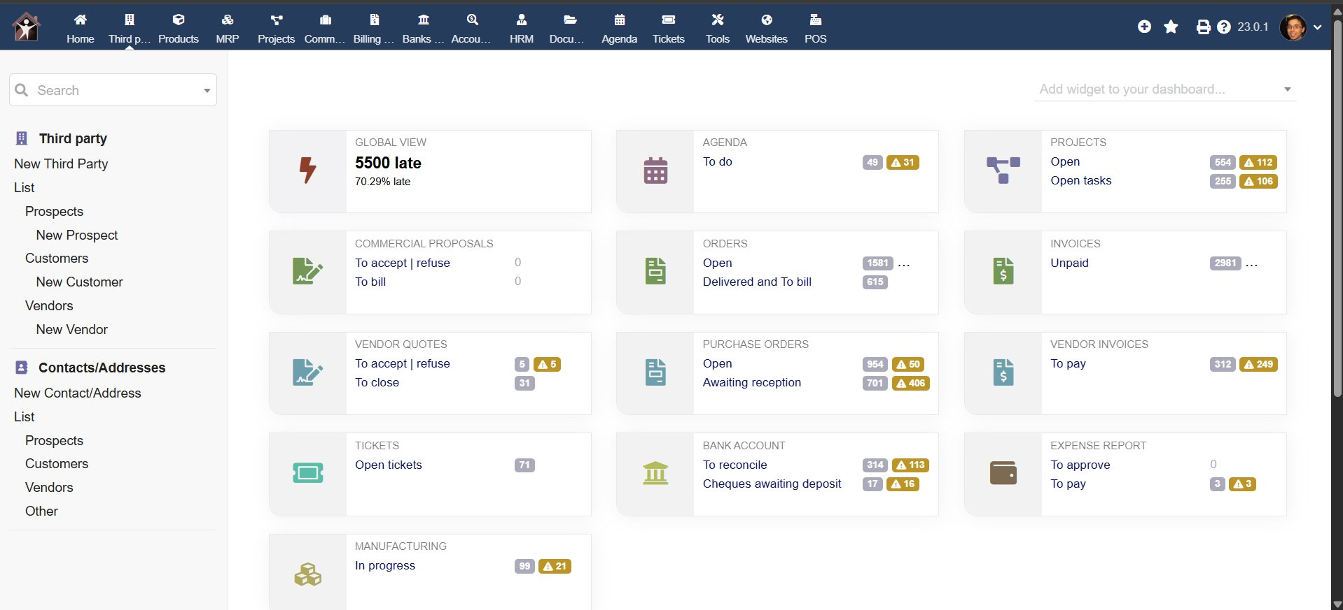
Figure 1: Dolibarr ERP Dashboard — Global Business Overview

Step 2: Customer Master Creation (Third Party Module)
In SAP SD, the Customer Master record stores all information related to a customer — billing address, payment terms, credit limit, and contact details. In Dolibarr, this is managed under the Third Parties module. A new customer named PlasmaTech Enterprises was created and classified as both a Prospect and a Customer, which corresponds to the SAP Customer Master Account Group classification. This record drives all downstream O2C transactions.

Step 3: Material Master — Product Creation
The Material Master in SAP SD stores all product-related information including pricing, unit of measure, and stock management settings. In Dolibarr, this is called a Product. Laptop_Model_Z (Reference: PROD001) was created and marked as available For Sale and For Purchase. Stock management is enabled, which triggers inventory movement upon delivery. The product description is "High performance laptop for business use."

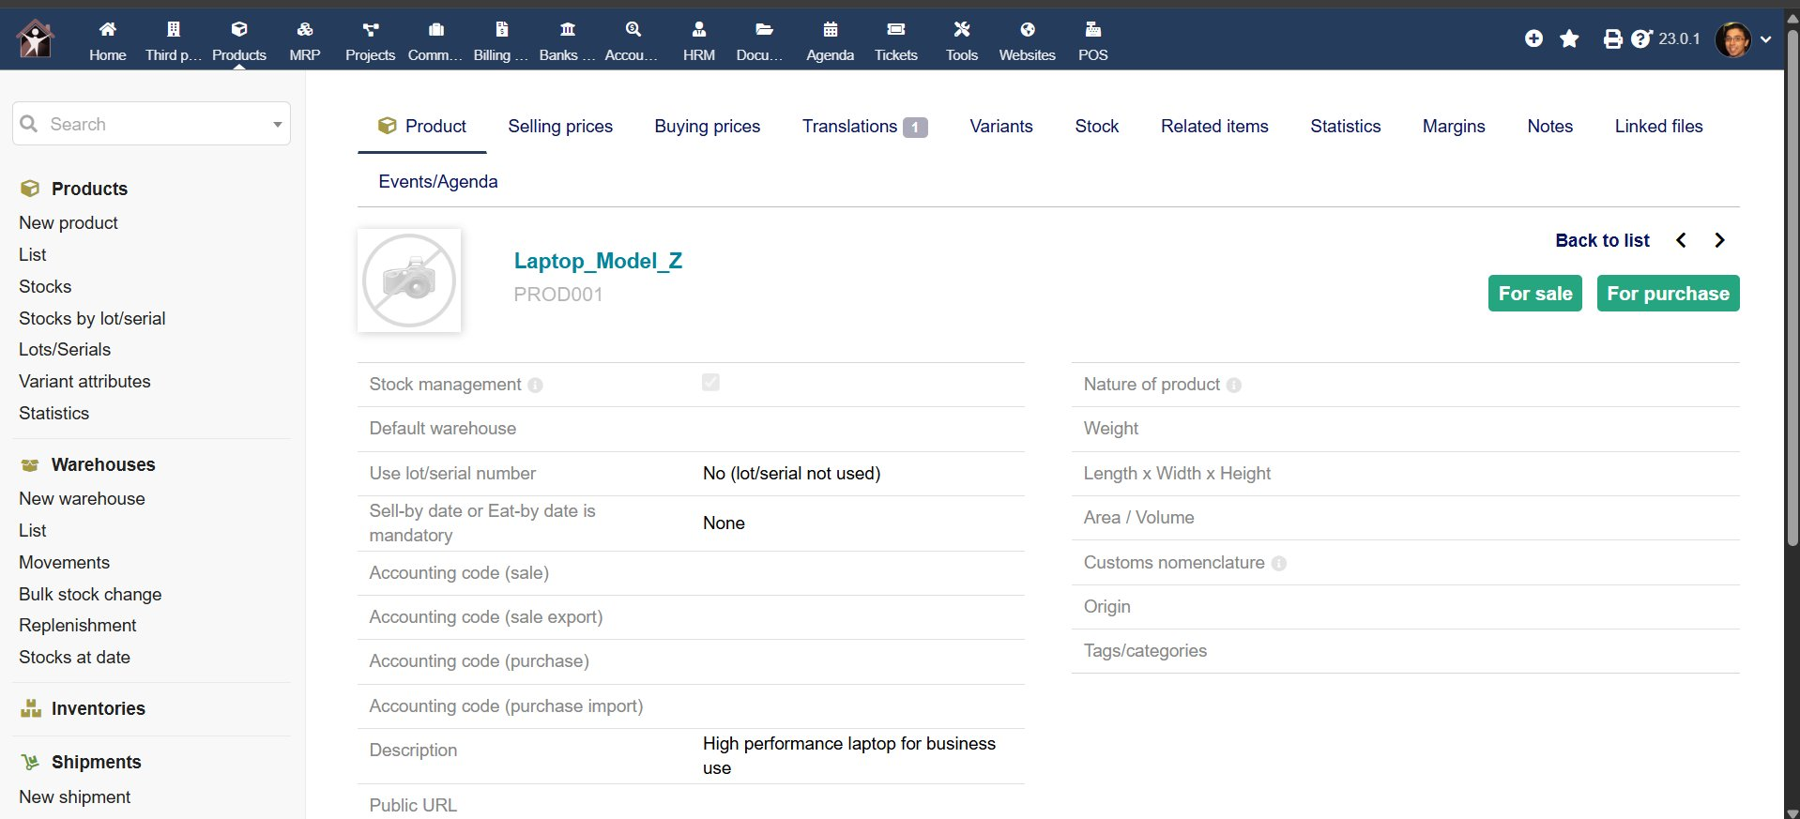
Figure 2: Product Master — Laptop_Model_Z (PROD001)

Step 4: Sales Order Creation and Validation
A Sales Order (SO) is the legal document that records the customer's purchase request. It is the trigger for the entire O2C downstream process. In Dolibarr, a Sales Order was created for PlasmaTech Enterprises with items totalling EUR 450,000 excluding tax and EUR 576,000 including VAT (28%). In SAP, this transaction is executed using Transaction Code VA01 (Create Sales Order).

Once reviewed, the Sales Order is validated (confirmed). In SAP, this step triggers an Availability Check (ATP — Available to Promise) and a Credit Check against the customer's credit limit. The validated Sales Order reference is CO2604-3264. The status changes from Draft to Validated, meaning the order is now legally binding and warehouse processing can begin.

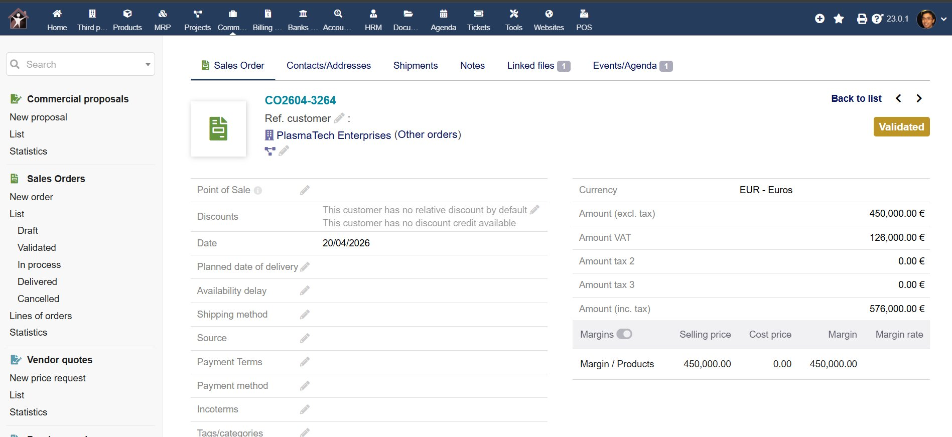
Figure 3: Sales Order CO2604-3264 — Status: Validated, PlasmaTech Enterprises

Step 5: Shipment / Delivery Note
A Delivery Note (equivalent to SAP VL01N — Create Outbound Delivery) was initiated for the validated sales order. The delivery details include Tracking Number TRACK001, planned delivery date 21/04/2026, and sending date 20/04/2026. This demonstrates the real-world SAP constraint of ATP and stock management. In SAP, a Goods Issue (GI) posting would reduce the stock quantity from the delivering warehouse.

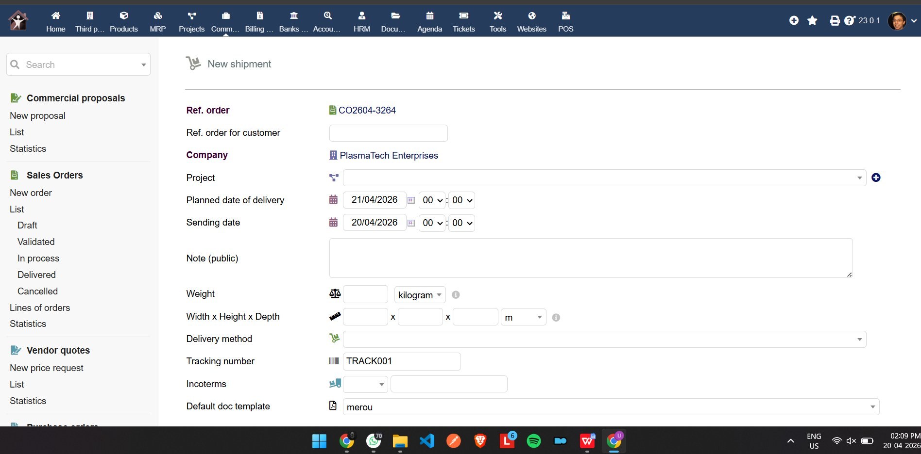
Figure 4: Shipment / Delivery Note — TRACK001, CO2604-3264, PlasmaTech Enterprises

Step 6: Customer Invoice — Draft
Upon delivery, a Customer Invoice (PROV25967) was generated as a draft. In SAP, this step is equivalent to Transaction VF01 (Create Billing Document). The invoice captures the full transaction: Amount excluding tax EUR 450,000, VAT EUR 126,000, Total including tax EUR 576,000. At this stage the invoice status is Draft (needs to be validated) and has not yet been transferred to accounting.

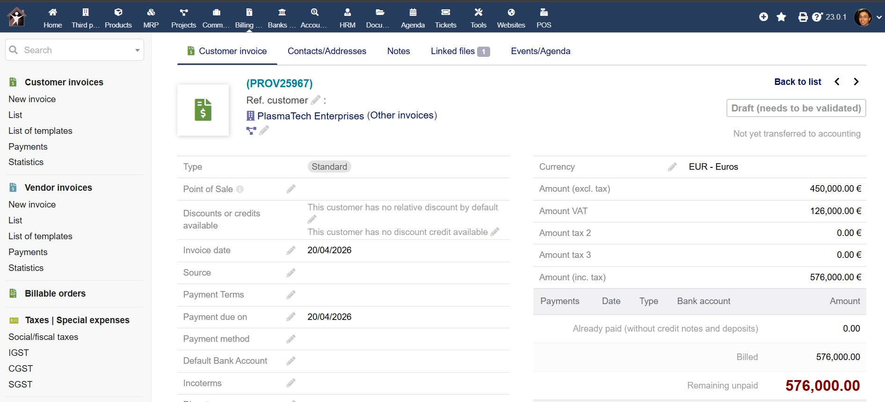
Figure 5: Customer Invoice PROV25967 — Status: Draft (needs to be validated)

Step 7: Customer Invoice — Validated (Not Paid)
After validation, the invoice receives the permanent reference FA2604-5911 and its status becomes Not Paid. The remaining unpaid amount is EUR 576,000, which appears as an open item in the Accounts Receivable ledger. In SAP FI, this corresponds to an open AR item pending customer payment.

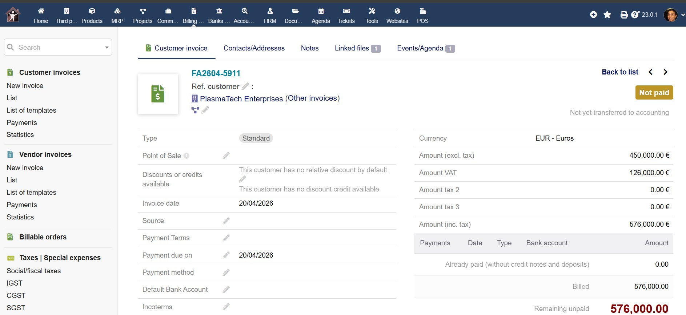
Figure 6: Customer Invoice FA2604-5911 — Status: Not Paid, Remaining: EUR 576,000

Step 8: Payment Receipt — O2C Cycle Complete
The final step of the O2C cycle is recording the payment received from the customer. A payment of EUR 576,000 was initiated from PlasmaTech Enterprises via bank transfer. The system presented a confirmation dialog: "Do you confirm this payment input for 576,000 Euros? All invoices with no remainder to pay will be automatically closed with status Paid." Upon validation, invoice FA2604-5911 was automatically closed.

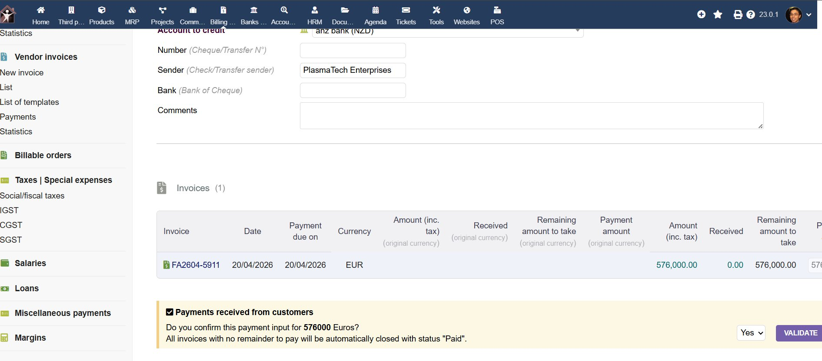
Figure 7: Payment Confirmation — EUR 576,000 from PlasmaTech Enterprises for FA2604-5911
After validating the payment, invoice FA2604-5911 status changed to Paid. Payment reference PAY2604-6342 was recorded via Bank Transfer to testbank on 18/04/2026 for the full invoice amount of EUR 576,000. The Remaining Unpaid balance is now EUR 0.00. In SAP, this corresponds to Transaction F-28 (Post Incoming Payment) followed by automatic clearing of the open item in the customer account. This completes the full O2C cycle.

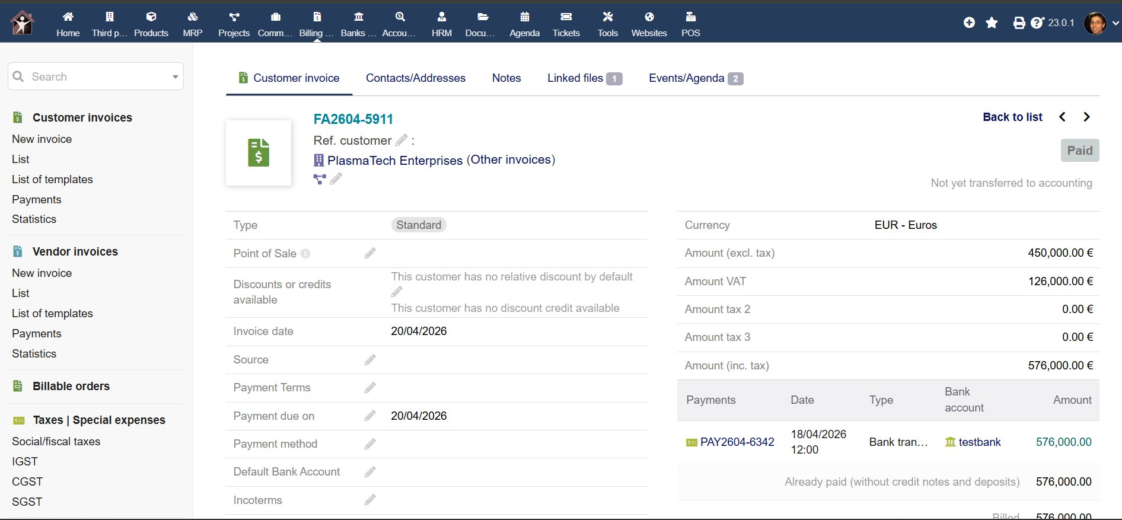
Figure 8: Invoice FA2604-5911 — Status: PAID, PAY2604-6342, Remaining Unpaid: 0.00

5. Tech Stack
Component | Details
ERP Tool | Dolibarr ERP v23.0.1 (Open-source SAP alternative)
Access Method | Online demo — demo.dolibarr.org (no installation required)
SAP Equivalent | SAP SD (Sales & Distribution) + SAP FI (Finance)
Process Simulated | Order-to-Cash (O2C) end-to-end cycle
Documentation Tool | Microsoft Word / Google Docs
Report Format | PDF — A4, Arial font, justified, page numbers bottom-right
Diagram Tool | draw.io (process flow diagrams)
Version Control | GitHub (public repository)

Dolibarr ERP was selected as the simulation tool because it replicates the core functional modules of SAP — Customer/Vendor Master Data, Sales Orders, Invoicing, and Accounting — making it ideal for demonstrating O2C concepts without requiring SAP portal access.

6. Unique Points
- End-to-end O2C execution: The project demonstrates all eight stages of the O2C cycle — from Master Data creation through to Payment Receipt and account clearing — without skipping any step.
- SAP concept mapping: Each Dolibarr step is explicitly mapped to its SAP equivalent (e.g., Third Party = Customer Master, FA2604-5911 = SAP Billing Document, F-28 Payment Posting), demonstrating conceptual understanding of SAP SD.
- Real ERP screenshots: All screenshots are taken from a live ERP system (Dolibarr), not mockups, demonstrating actual hands-on system interaction.
- Tax and VAT handling: The invoice correctly calculated 28% VAT (EUR 126,000 on a base of EUR 450,000), demonstrating understanding of tax determination in SAP FI.
- Fictitious company design: PlasmaTech Enterprises was structured to mirror SAP organisational hierarchy — Company Code, Sales Organisation, and Distribution Channel — even though these were implicit in the Dolibarr setup.
- Payment confirmation workflow: The system's built-in payment confirmation dialog (with automatic invoice closure upon full payment) mirrors SAP's automatic clearing of open AR items upon F-28 posting.

7. Future Improvements
- SAP S/4HANA implementation: With actual SAP portal access, the same O2C process would be executed using standard SAP transaction codes — VA01 (Sales Order), VL01N (Delivery), VF01 (Billing), and F-28 (Payment) — for a fully authentic SAP demonstration.
- ABAP Custom Reports: Development of a custom ABAP ALV report to display the complete O2C cycle for PlasmaTech Enterprises — showing open orders, delivery status, billing documents, and payment receipts in a single report.
- Credit Management Integration: Implementation of SAP FD32 (Customer Credit Management) to set credit limits and simulate automatic order blocks when a customer exceeds their credit exposure.
- GST/Tax Integration: In a real Indian SAP implementation, CGST, SGST, and IGST tax condition types would be configured in the Pricing Procedure to replace the generic VAT used in this simulation.
- Workflow Automation: SAP Business Workflow could be configured to automatically notify the warehouse team upon Sales Order validation and alert the Finance team when an invoice remains unpaid beyond the due date.
- Integration with SAP MM: In a complete enterprise setup, the O2C cycle would be integrated with SAP MM (Materials Management) for real-time stock updates upon Goods Issue posting, ensuring accurate inventory levels.

8. Conclusion
This project successfully demonstrates a complete Order-to-Cash (O2C) business process using Dolibarr ERP as an open-source SAP alternative. All eight stages of the O2C cycle were executed and documented with real ERP screenshots — from Customer and Material Master creation, through Sales Order validation, Delivery/Shipment, Invoice generation, to final Payment Receipt.

The project reflects a strong understanding of SAP SD and FI module concepts, the relationship between master data and transactional data, and the importance of integrated ERP systems in eliminating manual errors and improving business efficiency. The use of an alternative ERP tool demonstrates adaptability and the ability to apply SAP concepts in different system environments.

The O2C cycle, when implemented in a full SAP S/4HANA environment, would provide real-time financial reporting, automated credit checks, multi-currency support, and seamless integration with Logistics and Finance — making it the backbone of enterprise revenue operations.

