Demand Forecasting In Inventory Management
S1-26_SSZG628T: Dissertation
by
Dimpal Shetty
2024MT13052
Dissertation work carried out at
Airbus India Pvt Ltd, Bangalore, Karnataka
Submitted in partial fulfilment of the M.Tech in Software Systems degree programme
Under the Supervision of
Saurabh Mahajan
Airbus India Pvt Ltd, Bangalore, Karnataka

BIRLA INSTITUTE OF TECHNOLOGY & SCIENCE, PILANI
VIDYA VIHAR, PILANI, RAJASTHAN - 333031
September 2026

Abstract
This dissertation develops a predictive spare-parts demand forecasting pipeline for a single high-priority aircraft landing-gear component, replacing the fixed flight-hour reordering schedules used today in aerospace MRO with a forecast based on real operating data. The system uses a 10,000-record landing-gear maintenance dataset and applies a dual-matrix ABC/XYZ classification across four tracked components ranked by consumption value and demand variability to identify the one component that justifies a machine-learning forecast rather than a fixed reorder rule. Companion-part co-occurrence is mined directly from the real failure/wear flags using the Apriori algorithm, and the resulting business case is calculated in Indian Rupees using Aircraft-On-Ground (AOG) cost exposure and inventory holding-cost benchmarks.
A key finding revised the project's original assumption: correlation analysis across seven operating-condition variables shows that landing severity load during landing and braking force drives component failure, not runway or weather condition. This identifies the Landing Gear Actuator, not the component originally assumed, as the only part combining high financial value with low demand variability (Class A/X), making it the correct forecasting target.
Analysis to date shows: (i) a constant-rate baseline forecast, set as the benchmark the planned model must beat, has a mean absolute error of 5.52 units per 200-landing interval; (ii) the dual-matrix classification clearly ranks a single Class-A/X component among the four tracked, with no ambiguity in the ranking.

Signature of the Student  Name: Dimpal Shetty  Date: 23-09-2026  Place: Bengaluru | Signature of the Supervisor  Name: Saurabh Mahajan  Date: 24-09-2026  Place: Bengaluru

Table of Contents
Abstract | 2
Table of Contents | 3
1. Introduction and Motivation | 4
2. Objectives | 4
3. Related Work | 4
4. Current Existing Solution & Gap Analysis | 5
5. System Architecture | 5
6. Technical Rationale — Model Selection | 6
7. Dataset & Methodology | 6
8. Results and Analysis | 7
9. Design Considerations | 10
10. Business & Cost-Benefit Analysis | 11
11. Plan of Work | 11
12. Abbreviations | 12
13. Literature References | 12

1. Introduction and Motivation
Airline maintenance teams need the right spare parts ready before an aircraft comes in for repair. If a part isn't in stock, the aircraft can get grounded (an AOG event) until it arrives expensive and disruptive. Keeping too much stock "just in case" is also expensive, since it ties up capital. Most parts today are reordered on a fixed flight-hour or flight-cycle schedule, which doesn't account for how differently individual aircraft actually wear out.
This project builds a predictive demand-forecasting approach for a high-priority landing-gear part, using real landing-by-landing operating data in place of a fixed schedule. It also classifies the spare-parts basket by priority, identifies which parts require attention together, and quantifies the cost impact so the output is directly usable by a supplier.
This report covers gap analysis, system architecture, model-selection reasoning, dataset and methodology, results so far, the business case. It runs on a real 10,000-record dataset of landing-gear maintenance data.

2. Objectives
- Sort all landing-gear spare parts into priority groups based on how much money they account for and how predictable their demand is (ABC/XYZ analysis), to work out which parts are worth building a machine-learning forecast for.
- Build and test a model that predicts how many units of the chosen high-priority part will be needed, using landing-cycle history and landing-severity conditions (load, braking force, tire and hydraulic pressure, runway condition) as inputs.
- Look through historical maintenance records to find which spare parts are usually flagged together, so a supplier can bundle them instead of ordering one at a time.

3. Related Work
Spare-parts classification and demand forecasting is a well-established research area, but the literature consistently flags a gap between theoretical classification frameworks and how spare parts are actually managed in practice. Bacchetti and Saccani's review of the field found that most published classification schemes are validated on idealised data and rarely tested against the kind of noisy, incomplete operational records a real MRO department actually works with.
Lagoda and Klumpp's more recent work responds to this by proposing a modified ABC-XYZ framework that explicitly integrates demand-forecasting output into the classification step, rather than treating classification and forecasting as two separate, sequential exercises the same integration this project attempts, using the classification's own output to select the forecasting target instead of assuming one at the outset. Closer to this project's specific domain, Nafiurridha and Choiruddin apply supervised machine learning directly to aircraft spare-parts classification, showing that ML-based classification is workable at the fleet level; this project instead keeps the classification step interpretable (dual-matrix ABC/XYZ) and reserves machine learning for the forecasting step it feeds into.
On the forecasting side specifically, Olmo and Domingo's recent framework for aerospace rotable parts makes the same central argument this project is built around: that incorporating fleet usage-data to capture operational variability is what static, schedule-based forecasting methods miss, particularly for aircraft with unpredictable operating patterns.
On landing-gear predictive maintenance specifically, Stanton et al.'s experimental framework compares industry-standard and automated machine-learning tools across several Airbus landing-gear component datasets, providing a direct precedent for benchmarking multiple model families against a single landing-gear component rather than committing to one model without comparison.
For companion-part mining, Agrawal and Srikant's original Apriori algorithm remains the standard reference for market-basket analysis and is used directly here its known inefficiency at large item-catalogue scale is a non-issue given the basket size in this dataset. For the forecasting model itself, Ke et al.'s LightGBM paper and Grinsztajn et al.'s comparison of tree-based methods against deep learning on tabular data (Section 6) together motivate the model family selected for Phase 5.

4. Current Existing Solution & Gap Analysis
Spare-parts demand today is typically forecast using a fixed flight-hour or flight-cycle schedule, regardless of how each aircraft was actually operated. Parts are prioritized only by how much they cost per year, without factoring in how predictable their demand is. Safety stock is usually a static buffer, rarely updated, and companion parts are ordered together based on engineers' experience rather than any calculated rule.
The real data shows this misses the actual driver of wear: landing severity how hard the aircraft lands and how much load it carries predicts part failure far better than flight cycles alone, while weather barely matters. This project closes that gap by building landing-severity factors into the forecast, replacing the one-dimensional priority list with a two-dimensional one, and calculating companion-part patterns directly from data.

5. System Architecture
The system takes landing data, engineers a set of severity features, and runs three analyses side by side: a priority classifier, a demand forecaster, and a companion-parts finder.
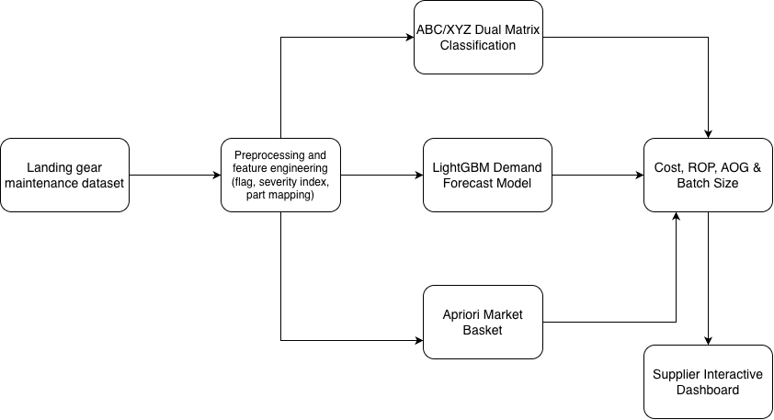
Figure 1 — Data flows through the system, from raw inputs to the supplier dashboard

6. Technical Rationale & Model Selection
Four model families were evaluated against the project's data and requirements: a small-to-medium tabular dataset with both categorical and numeric features.
Model Family | Characteristics | Selection Rationale
Classical time series (ARIMA / Prophet) | Models trend and seasonality within a single demand series over time. | Used only as the statistical baseline not the primary model. Cannot easily incorporate additional inputs such as landing-severity features alongside the demand series itself.
Deep learning (LSTM / Transformer) | Neural networks that learn patterns across an ordered sequence of observations. | Not selected. This approach needs a genuine time-ordered sequence per aircraft to learn from; the dataset has no aircraft ID or timestamp linking landings, so no such sequence exists..
Random Forest | Builds many decision trees independently on random subsets of the data and averages their predictions. | Not selected as the primary model. Similarly interpretable to gradient boosting, but typically less accurate on structured tabular data, and needs extra preprocessing to handle categorical features such as runway condition.
LightGBM (gradient boosting) — selected | Builds decision trees one at a time, with each new tree trained to correct the errors of the trees built before it. | Selected as the primary model. Supports categorical features natively, trains efficiently enough for frequent retraining, and produces feature-importance output that supports the interpretability requirement.
This comparison makes LightGBM the leading candidate on theoretical and literature grounds;

7. Dataset & Methodology
The dataset is 10,000 real aircraft landing, each with the operating conditions during that landing and whether four landing-gear components showed a failure/wear flag.

Column | What it means
landing_cycles | How many landing cycles that aircraft had accumulated
load_during_landing | Load on the landing gear at touchdown
taxiing_duration | How long the aircraft taxied after landing
speed_during_landing | Touchdown speed
braking_force | How hard the brakes were applied
tire_pressure | Tire pressure at landing
hydraulic_pressure | Hydraulic system pressure
runway_condition | dry, wet, or snowy
shock_absorber_failure, tire_wear, brake_degradation, hydraulic_system_failure | 1 or 0 — whether that component showed a failure/wear flag on that landing
Each failure/wear flag maps to one spare part: brake_degradation → Brake Assembly, shock_absorber_failure → Landing Gear Actuator, tire_wear → Wheel Unit, hydraulic_system_failure → Hydraulic Line. Since there are no dates, the 10,000 landings are split into sequential batches of 200 to measure how demand varies not real calendar periods. Each landing's flagged parts form a "basket" used for both the priority classification and the companion-parts analysis below.
The classification is what narrows the forecast to one part: Landing Gear Actuator is the only high-value, steady-demand ("A/X") part in the basket, so it's the target for the machine-learning model; the rest use a simpler reorder rule. Two companion parts named in the original outline seal kits and structural bolts aren't tracked in this dataset, so they're outside the active analysis.

# | Parameter | Value
1 | Dataset | Landing-gear maintenance dataset (Kaggle) — citation pending, Section 15
2 | Corpus size | 10,000 landing records, 12 columns (8 operating-condition + 4 failure/wear flags)
3 | Tracked components | 4 — Brake Assembly, Landing Gear Actuator, Wheel Unit, Hydraulic Line

8. Results and Analysis
Runway condition barely moves the failure rate (58–61% across dry/wet/snowy). Landing weight does failure rates climb from near 0% for the lightest landings to near 100% for the heaviest.
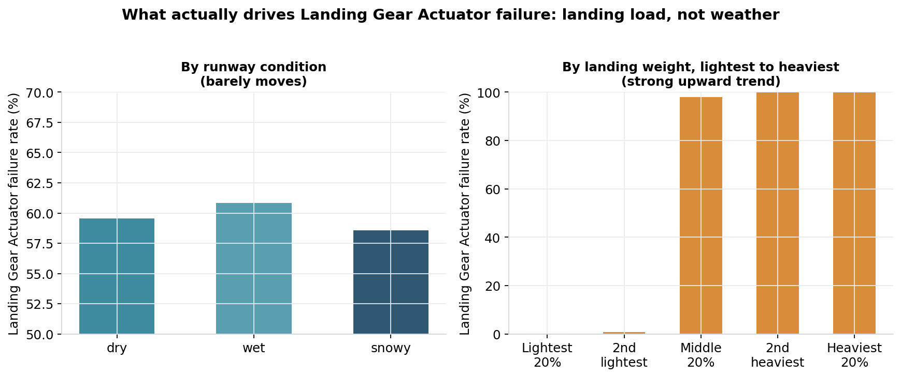
Figure 2 — Failure rate by runway condition (flat) vs. landing weight, lightest to heaviest (steep).
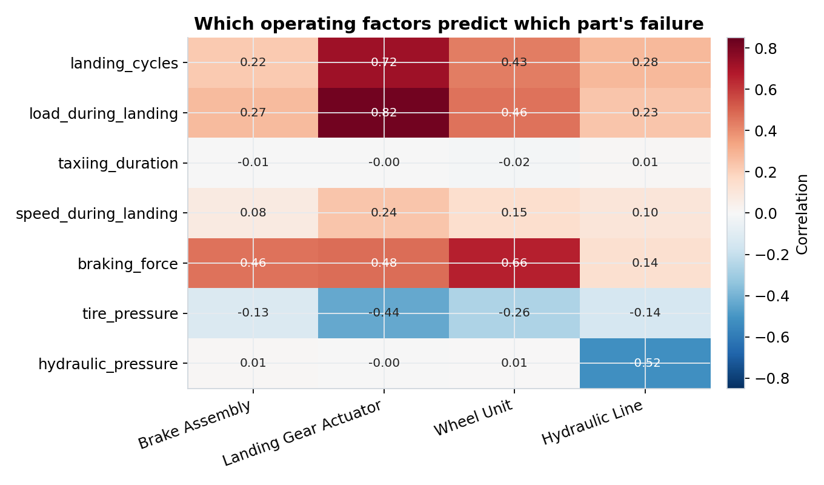
Figure 3 — Braking force and load are the strongest predictors for every tracked part; taxiing duration barely matters.
Robustness of the severity finding. A correlation this clean (0.82 overall) invites an obvious question: is landing severity really an independent driver, or could it simply be standing in for runway condition, if harder braking happens to coincide with wet or snowy runways? This was checked directly by computing the load–failure correlation separately within each runway condition: 0.814 on dry runways, 0.823 on wet, and 0.827 on snowy — essentially identical in each subgroup. If weather were secretly driving the effect, the correlation would be expected to shift noticeably across these three groups; it does not.
Baseline benchmark. With no dates in the file, the 10,000 landings are grouped into batches of 200 to test a forecast against. A constant-average baseline scores MAE = 5.52 units/batch — the number Phase 5's LightGBM model needs to beat.
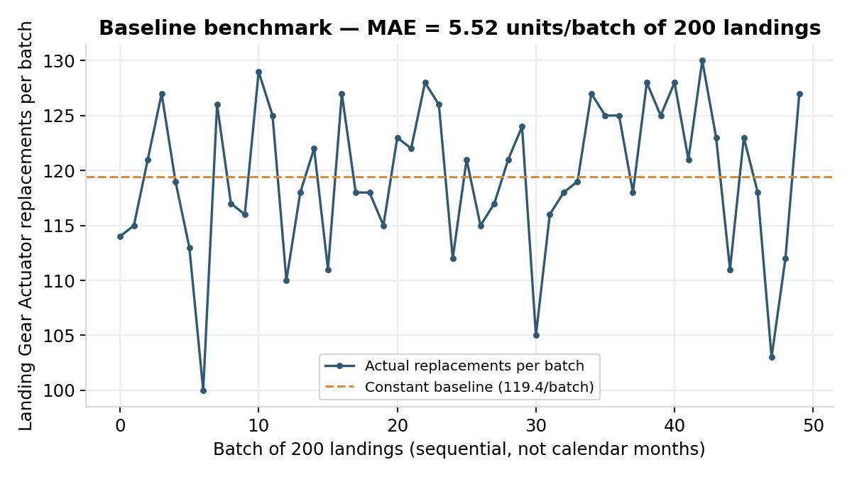
Figure 4 — Actual replacements per batch vs. the constant-average baseline.
Priority classification (ABC/XYZ). The figures below are risk-weighted priority scores, and it's why Landing Gear Actuator is the forecasting target.
Part | Failure rate | Unit cost (₹) | Risk-weighted value (₹ cr) | Demand CV | Class
Landing Gear Actuator | 59.7% | 43,20,000 | 516.0 | 0.06 | A / X
Brake Assembly | 95.3% | 17,28,000 | 329.3 | 0.01 | B / X
Wheel Unit | 81.7% | 5,76,000 | 94.1 | 0.03 | C / X
Hydraulic Line | 24.5% | 2,40,000 | 11.8 | 0.12 | C / X
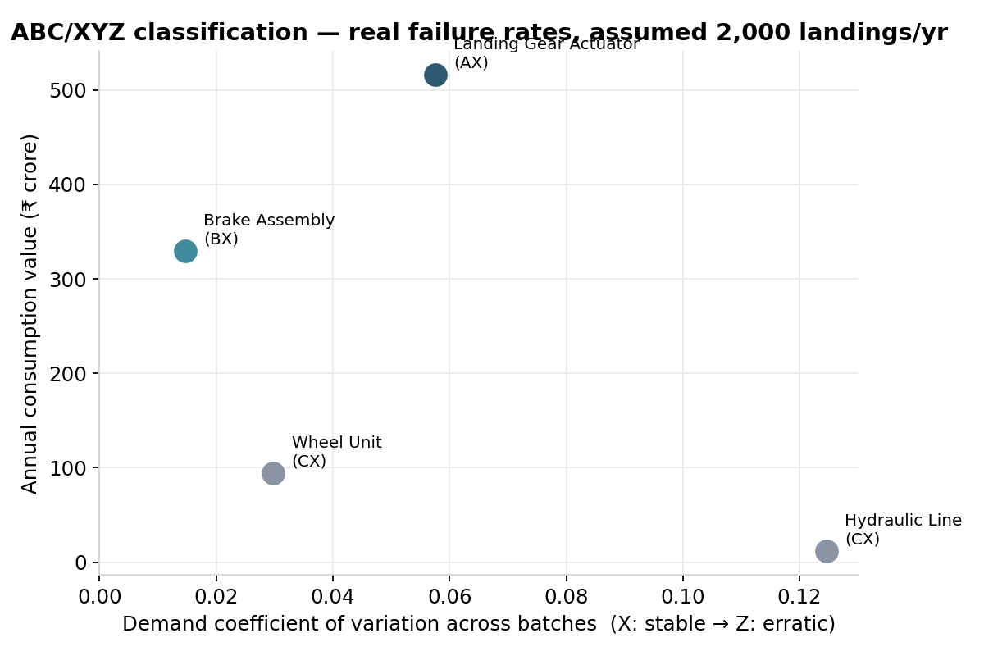
Figure 5 — All four parts by value and predictability. Landing Gear Actuator is the only "A/X" part.
Companion parts (Apriori). Mined directly from real co-occurrence between the four failure flags — nothing estimated by hand.
Apriori companion-part rules
Rule | Support | Confidence | Lift
Hydraulic Line → Landing Gear Actuator | 0.18 | 0.72 | 1.20
Landing Gear Actuator → Wheel Unit | 0.57 | 0.95 | 1.17
Hydraulic Line → Wheel Unit | 0.21 | 0.87 | 1.07

9. Design Considerations
- The ABC/XYZ cutoffs (80%/95%/100% for the value tier, 0.15/0.30 for the demand-variability tier) follow standard textbook thresholds, not thresholds chosen to produce a particular result.
- Landing Gear Actuator was selected because the classification ranked it highest, not because it was assumed at the outset. Brake Assembly was the original working hypothesis, but its near-constant 95.3% flag rate makes it a poor target for a model to actually learn from.
- Batches of 200 were chosen large enough to give a stable count per batch while still producing 50 independent measurement points for the baseline and demand-variability calculations.
- LightGBM was chosen over Random Forest and deep-learning approaches for the reasons detailed in chiefly that the dataset has no per-aircraft sequence for a sequence model to exploit.

10. Business & Cost-Benefit Analysis
Public industry figures put the cost of an aircraft being grounded (AOG) at $10,000–150,000/hour depending on aircraft and route. At an assumed 18-hour stockout, here's the cost of one avoided event:
Scenario | AOG cost per hour (₹) | Cost of one avoided event (₹)
Low — narrowbody, domestic | 9,60,000 | 1,72,80,000
Mid — narrowbody, typical | 43,20,000 | 7,77,60,000
High — widebody, peak | 1,44,00,000 | 25,92,00,000
Keeping 4 spare Landing Gear Actuators on hand (25%/year holding cost, ₹43.2 lakh unit cost) costs about ₹43.2 lakh/year to maintain.
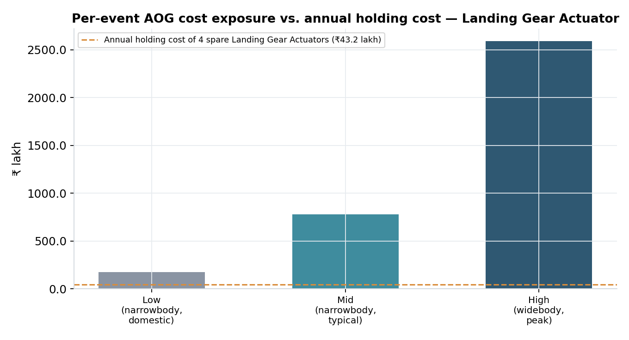
Figure 7 — One stockout's cost (three scenarios) vs. the yearly cost of holding 4 spare units.
Even the cheapest scenario is worth roughly 4× that annual holding cost; the worst case is roughly 60×. The model doesn't need to prevent many stockouts a year to pay for itself.

11. Plan of Work
# | Phase | Dates | Work to be done | Status
1 | Gap analysis & architecture | 08–22 Aug 2026 | Current-solution-gap analysis, dataset shortlisting, architecture design | COMPLETED
2 | EDA & feature engineering | 23 Aug–06 Sep 2026 | Real dataset sourced and loaded; failure-flag-to-part mapping, severity feature exploration | COMPLETED
3 | Baseline, ABC/XYZ & Apriori | 07–21 Sep 2026 | Constant-average baseline, dual-matrix classification, companion-part mining, cost-model framework | COMPLETED
4 | Midterm report | 18–25 Sep 2026 | Prepare and submit this midterm report | IN PROGRESS
5 | Model training & tuning | 25 Sep–09 Oct 2026 | LightGBM vs. baseline/Random Forest on Landing Gear Actuator; tuning | PENDING
6 | Reorder engine & validation | 10–24 Oct 2026 | ROP/batch-size formulas on top of the tuned forecast; | PENDING
7 | Dashboard & final writeup | 25 Oct–08 Nov 2026 | Supplier-facing dashboard; full dissertation drafting and submission | PENDING

12. Abbreviations
Abbreviation | Meaning
MRO | Maintenance, Repair & Overhaul
AOG | Aircraft On Ground
ABC | Classification by consumption value (A = highest, C = lowest)
XYZ | Classification by demand predictability (X = steadiest, Z = most erratic)
CV | Coefficient of Variation
MAE | Mean Absolute Error
ROP | Reorder Point

13. Literature References
- Agrawal, R., & Srikant, R. (1994). Fast algorithms for mining association rules. Proceedings of the 20th International Conference on Very Large Data Bases (VLDB), 487–499.
- Bacchetti, A., & Saccani, N. (2012). Spare parts classification and demand forecasting for stock control: Investigating the gap between research and practice. Omega, 40(6), 722–737.
- Ke, G., Meng, Q., Finley, T., Wang, T., Chen, W., Ma, W., Ye, Q., & Liu, T.-Y. (2017). LightGBM: A highly efficient gradient boosting decision tree. Advances in Neural Information Processing Systems, 30, 3149–3157.
- Lagoda, L., & Klumpp, M. (2024). Efficient warehouse and inventory management: The modified ABC-XYZ analysis as a framework to integrate demand forecasting and inventory control. In Dynamics in Logistics (LDIC 2024), Lecture Notes in Logistics. Springer.
- Grinsztajn, L., Oyallon, E., & Varoquaux, G. (2022). Why do tree-based models still outperform deep learning on tabular data? Advances in Neural Information Processing Systems, 35, 507–520.
- Nafiurridha, & Choiruddin, A. (2024). Classifying MRP strategy of aircraft spare parts using supervised machine learning. Procedia Computer Science, 234, 470–477.
- Olmo, M. D., & Domingo, R. (2026). Intermittent demand forecasting of aerospace rotable parts: A framework for unpredictable flight patterns. Computers & Industrial Engineering, 214.
- Stanton, I., Munir, K., Ikram, A., & El-Bakry, M. (2025). Automation of predictive maintenance: An experimental framework for aircraft landing gear. Engineering Reports.

