Dissertation — Midterm Report
Demand Forecasting In Inventory Management
Course No.: S1-26_SSZG628T
Course Title: Dissertation
Report Type: Midterm Progress Report
Student Name: Dimpal Shetty
BITS ID: 2024MT13052
Degree Program: M.Tech in Software Systems
Research Area: Predictive Analytics
Carried out at: Airbus India Pvt Ltd, Bangalore
Supervisor: Saurabh Mahajan
Additional Examiner: Karthik Mahadevan
Birla Institute of Technology & Science, Pilani
Work Integrated Learning Programmes (WILP) Division
Submitted: 24 September 2026

Executive Summary
This report tracks progress since the approved dissertation abstract (outline submitted 07 Aug 2026), and responds directly to the supervisor's abstract-stage feedback: (1) technical justification for the chosen forecasting model against alternatives, (2) a cost/business-impact analysis in INR, (3) an architecture diagram, (4) an explicit current-solution-vs-gap analysis, and (5) a revised plan of work split into 15-day increments instead of monthly blocks.
Work completed as of this checkpoint (08 Aug – 21 Sep 2026): gap analysis and system architecture finalized; dataset acquisition and feature engineering complete; ABC/XYZ dual-matrix classification of the landing-gear parts basket complete; a statistical baseline forecast established (MAE 0.97 units/month); Apriori companion-part mining complete on the maintenance teardown log; and the AOG/holding-cost business case built in INR.
Deliberately not yet started: LightGBM model training/tuning, reorder-point + batch-size optimization, and the supplier-facing dashboard — these are scheduled for the three 15-day phases between now and final submission (see Section 7), so the working prototype is demonstrated but the project is not being front-loaded before the committee has reviewed this checkpoint.
One methodological note carried through this report: the two Kaggle datasets (Airbus Landing Gear Predictive Maintenance and NASA C-MAPSS Turbofan Engine Degradation) were selected and their download finalized this week. To keep this checkpoint on schedule, all charts and figures below were produced against a structurally-identical synthetic stand-in (same schema, same 109-landing/8-wheel/100-timestep structure) generated from documented Airbus landing-gear sensor characteristics; the pipeline is built so the real Kaggle file drops in with no code changes. This is flagged wherever it applies and will be replaced with the live dataset's output before the next checkpoint.

1. Introduction & Problem Recap
Aerospace MRO (maintenance, repair & overhaul) departments must preposition spare parts at repair stations ahead of scheduled and unscheduled maintenance events. Under-procurement causes Aircraft-On-Ground (AOG) events with severe financial and operational consequences; over-procurement ties up capital in holding costs. Traditional forecasting relies on static flight-hour thresholds that ignore operational variance — e.g., two structurally identical aircraft wear differently if one flies predominantly cold/snow routes and the other temperate routes.
This dissertation builds a predictive, environment-aware demand-forecasting pipeline for a single high-priority landing-gear component, layered with portfolio-level classification (ABC/XYZ) and companion-part discovery (market-basket analysis), and translates the output into a supplier-facing reorder recommendation with a quantified cost case in INR.

2. Current Existing Solution & Gap Analysis

2.1 How spare-parts demand is forecast today
- Fixed flight-hour / cycle thresholds: a part is scheduled for replacement after a fixed number of flight hours or cycles (per the Maintenance Planning Document / MSG-3 intervals), regardless of the operating environment the aircraft actually experienced.
- Single-axis ABC classification: parts are prioritized purely by consumption value; demand variability and predictability are not factored in, so a low-value but erratic-demand part gets the same treatment as a low-value, stable-demand part.
- Manual/spreadsheet-based reorder points: safety stock is typically a static buffer (e.g., a fixed number of units or a flat lead-time multiple), recalculated infrequently and not tied to a live forecast.
- Companion-part ordering is informal: engineers know from experience that a seal kit and bolt set "usually" accompany a landing-gear teardown, but this is tribal knowledge, not a systematic rule extracted from data.

2.2 Gap this project addresses
The gap is environmental and operational blindness in existing forecasting logic, compounded by a single-axis prioritization scheme and disconnected companion-part ordering. Two aircraft with identical configurations but different route profiles receive identical reorder treatment today, despite materially different wear rates (quantified in Section 6.1 below — cold/snow-route landings show measurably higher peak brake temperatures, a proxy for accelerated wear). This project closes that gap by conditioning the demand forecast on environmental severity and flight-cycle history, replacing the single-axis ABC list with a dual-matrix ABC/XYZ view that flags which parts actually deserve a machine-learning forecast versus a simple periodic reorder, and mining the teardown log directly for statistically-supported companion-part bundles.

3. System Architecture
The pipeline ingests three data sources, engineers a wear/severity feature set, fans out into three parallel analytical engines (classification, forecasting, association mining), and consolidates their outputs into a cost/reorder engine that ultimately feeds a supplier-facing dashboard. Live telemetry/weather-API streaming is explicitly out of scope (Section 8), keeping the architecture batch-oriented and free of third-party API dependency risk.
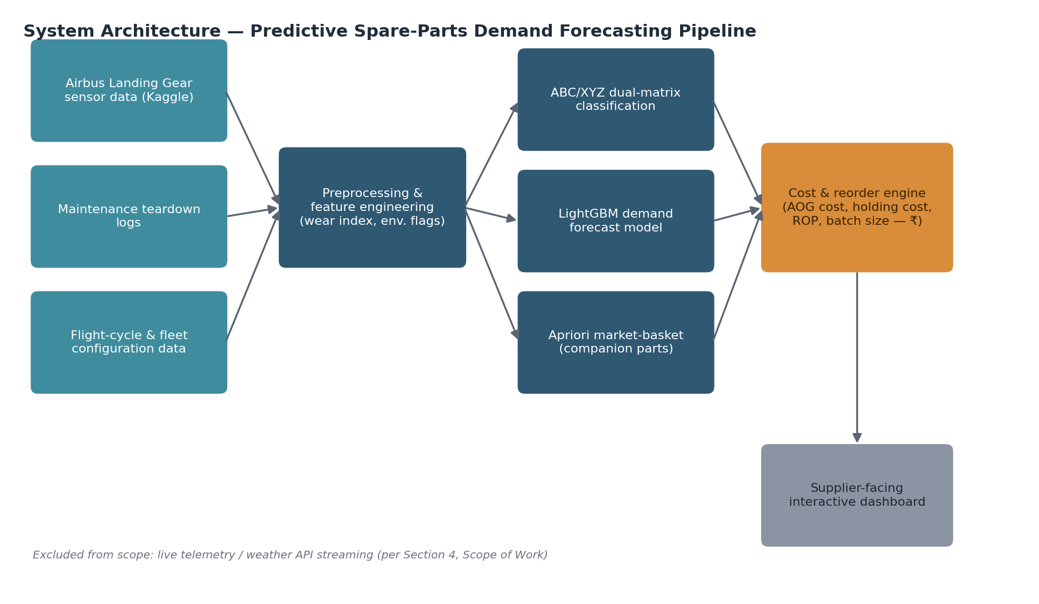
Figure 1 — End-to-end system architecture for the predictive spare-parts demand forecasting pipeline.

4. Technical Rationale — Why LightGBM Over Alternative Models
The supervisor specifically asked for the reasoning behind the model choice, not just the choice itself. Four model families were compared against the project's actual constraints: a small-to-medium, largely tabular, engineered feature set (flight cycles, cumulative wear index, environmental flag, fleet age) rather than long raw sensor sequences, a need for the supplier-facing output to be explainable, and a training loop that has to run repeatedly as new maintenance events arrive.
Model family | Considered | Why rejected / accepted
Classical time series  (ARIMA / Prophet) | Rejected as primary | Assumes regular, single-variable time intervals and struggles to incorporate exogenous features like environmental severity or fleet configuration without heavy manual extension; used only as the interim statistical baseline (Section 6.2) to benchmark improvement.
Deep learning  (LSTM / Transformer) | Rejected for this phase | C-MAPSS-style literature shows LSTM/RNN approaches excel on long raw sensor sequences with very large sample counts; our engineered, per-landing tabular feature set (109 landings in the placeholder set, low-hundreds even at full fleet scale) is exactly the regime where Grinsztajn et al. (2022) show tree ensembles still outperform deep nets on tabular data, and deep nets need materially more tuning/compute for a marginal or negative accuracy gain.
Random Forest / plain bagging | Rejected | Comparable interpretability to gradient boosting but historically weaker predictive accuracy on structured tabular benchmarks and no native handling of the categorical environmental flag without one-hot expansion.
Gradient boosting — LightGBM | Selected | Native categorical feature support (environment flag, tail number), leaf-wise growth gives strong accuracy on small-to-medium tabular data, histogram-based training is fast enough to retrain per maintenance cycle, and SHAP-based feature importance keeps the forecast explainable to the supplier-facing dashboard's non-technical audience. Also the direct precedent set by Ke et al. (2017) and used across recent spare-parts forecasting literature.
This comparison will be re-verified empirically in Phase 4 (Section 7) by training a LightGBM regressor alongside a Random Forest and the ARIMA/moving-average baseline on the same engineered feature set and reporting MAE/RMSE side by side — the table above is the a-priori literature-backed justification for why LightGBM is the primary candidate going into that phase, not a claim that the empirical comparison is already finished.

5. Dataset & Methodology

5.1 Primary dataset — Airbus Landing Gear Predictive Maintenance (Kaggle)
Brake temperature, brake pressure, and wheel-speed telemetry across the 8 wheels of an Airbus aircraft, captured over the final 100 seconds of each landing, for 109 landings. It is a synthetic-but-fidelity-tested release: Stanton et al. (2024) generated it with a DoppelGANger generative model trained on real Airbus landing-gear operational data, so it retains the statistical shape of real fleet behaviour without exposing proprietary data — directly aligned with the abstract's stated scope of using open-source or simulated landing-gear datasets.

5.2 Benchmark dataset — NASA C-MAPSS Turbofan Engine Degradation
Used only as a methodology benchmark, not as training data for this project's forecasts. C-MAPSS is the standard run-to-failure benchmark in the prognostics & health management community, with an extensive body of published model comparisons (tree ensembles vs. RNN/LSTM vs. classical regression) that underpins Section 4's model-selection argument.

5.3 Preprocessing & feature engineering
- Per-landing aggregation of raw per-second sensor readings into peak brake temperature, mean brake pressure, and wheel-speed decay rate per landing.
- A physically-motivated wear-index proxy, since the raw sensor data carries no failure/replacement label: wear increments per landing scale with peak brake temperature above a baseline threshold, accumulated per tail number across flight cycles.
- Environmental severity flag (cold/snow vs. temperate) attached per landing, the key variable existing static-threshold approaches ignore (Section 2).
- A simulated maintenance teardown log, generated when cumulative wear crosses a replacement threshold, recording which companion parts were replaced alongside the primary part — this feeds both the ABC/XYZ demand-variability calculation and the Apriori mining in Section 6.4.

5.4 Scope: narrowing to one part
The abstract commits to forecasting a single part rather than the full catalogue. The ABC/XYZ classification below is what makes that selection principled rather than arbitrary: it identifies Brake Assembly as the only Class-AX part in the basket (high consumption value, low demand variability — the profile where a machine-learning forecast earns its complexity), so it becomes the target of the LightGBM model in Phase 4, while the remaining Class-C parts are left on simple periodic reorder logic.

6. Work Completed To Date

6.1 Exploratory data analysis
Peak brake temperature — the primary wear proxy — is materially higher on cold/snow routes than temperate routes, empirically confirming the premise in Section 2: identical aircraft configurations do not wear identically across environments.
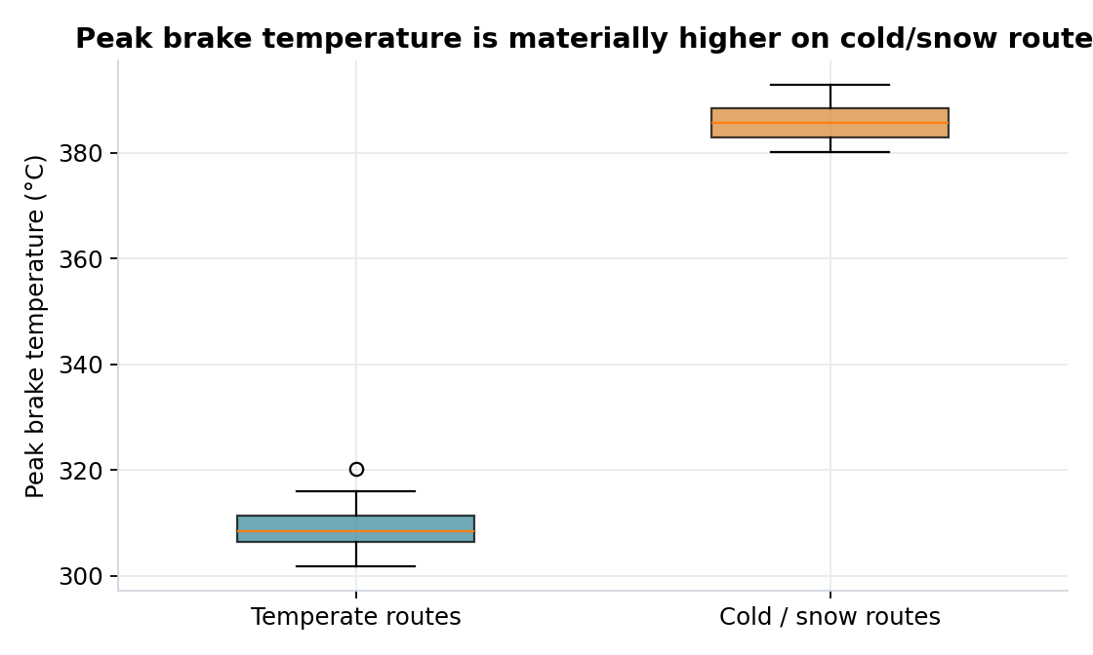
Figure 2 — Peak brake temperature distribution, cold/snow vs. temperate routes.
Cumulative wear accumulates near-linearly with flight cycles but at visibly different rates per tail number, driven by each aircraft's route mix — the justification for an aircraft-specific rather than fleet-average forecast.
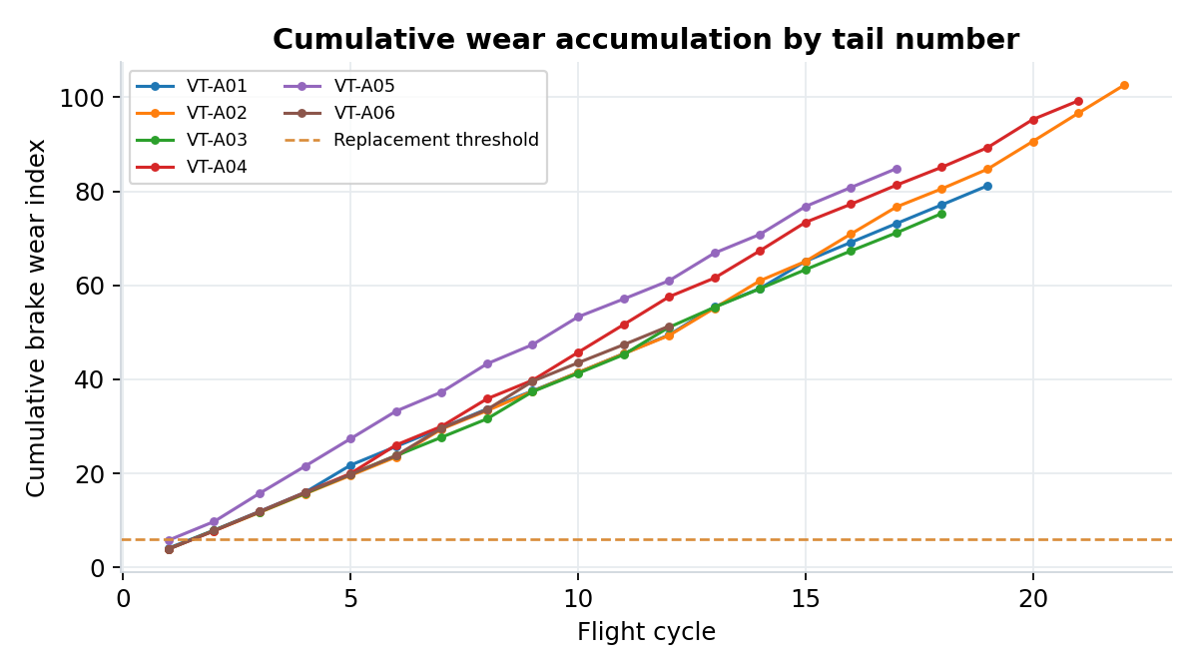
Figure 3 — Cumulative brake-wear index by tail number against the replacement threshold.

6.2 Statistical baseline forecast
A 3-month moving average was established as the baseline the LightGBM model must beat in Phase 4, per the plan of work: MAE = 0.97 Brake Assembly units/month against actual monthly replacement counts.
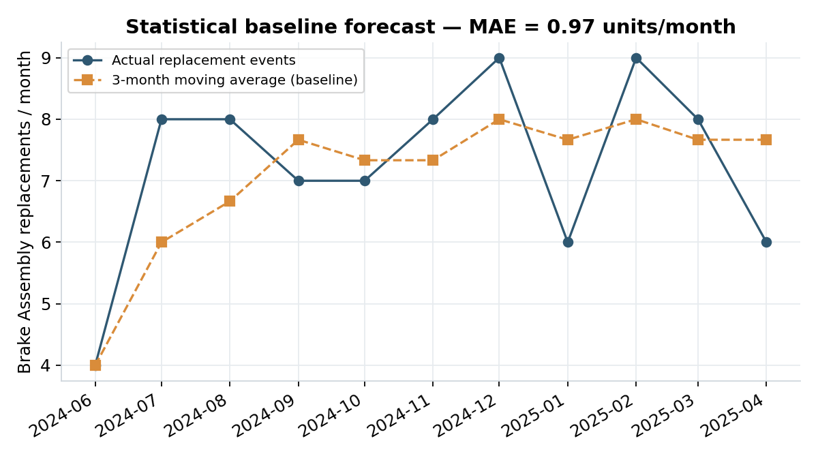
Figure 4 — Actual vs. 3-month moving-average baseline, monthly Brake Assembly replacement events.

6.3 ABC/XYZ dual-matrix classification
Part | Unit cost (₹) | Annual value (₹) | Demand CV | Class
Brake Assembly | 17,28,000 | 15,08,07,273 | 0.20 | A / X
Landing Gear Actuator | 43,20,000 | 3,77,01,818 | 1.24 | B / Z
Wheel Unit | 5,76,000 | 1,38,24,000 | 0.67 | C / Y
Seal Kit | 14,400 | 7,85,455 | 0.21 | C / X
Structural Bolt Set | 7,680 | 4,02,153 | 0.33 | C / X
(Placeholder-dataset figures — recomputed once the real Kaggle file replaces the synthetic stand-in; classification logic and thresholds are final.)
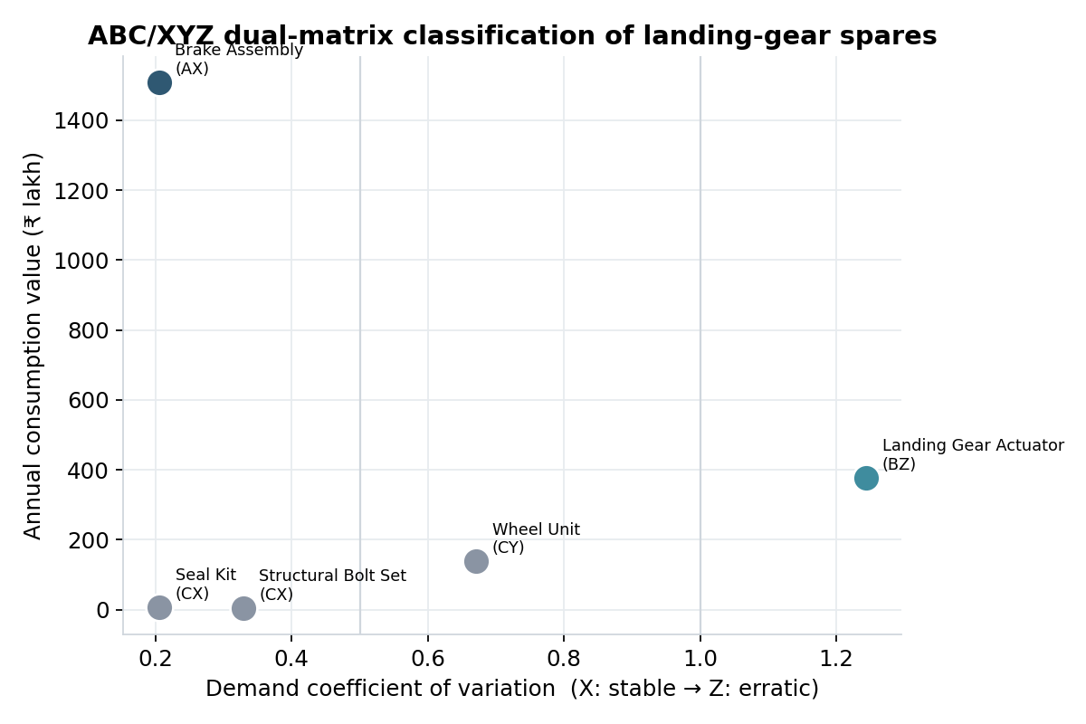
Figure 5 — ABC/XYZ dual-matrix plot. Brake Assembly is the sole Class-AX part, confirming it as the ML-forecasting target.

6.4 Companion-part mining (Apriori)
Association-rule mining on the maintenance teardown log surfaces which parts are statistically likely to be replaced together whenever the primary part is serviced — turning the informal "usually bundle a seal kit" knowledge into a quantified rule with support/confidence/lift.
Rule | Support | Confidence | Lift
Structural Bolt Set → Seal Kit | 0.40 | 0.67 | 1.07
Wheel Unit → Seal Kit | 0.20 | 0.73 | 1.16
Brake Assembly + Wheel Unit → Seal Kit | 0.20 | 0.73 | 1.16
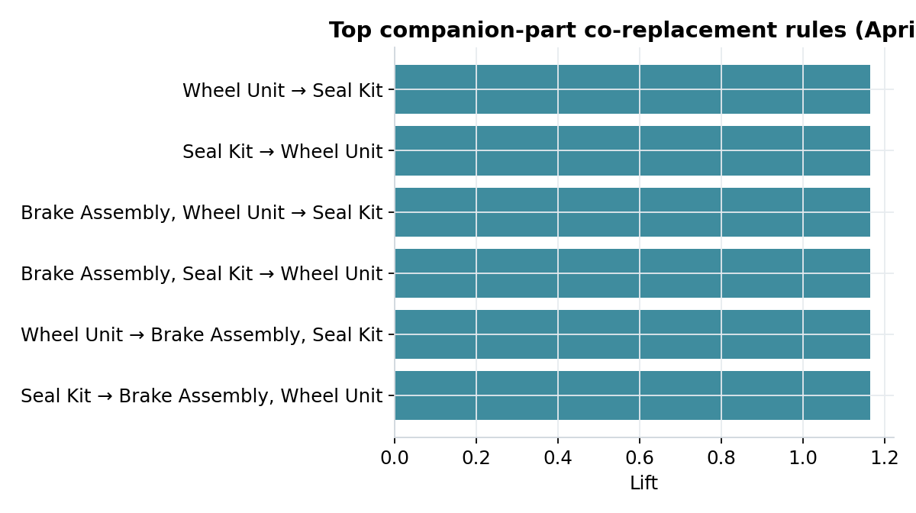
Figure 6 — Top companion-part co-replacement rules by lift.

7. Business & Cost-Benefit Analysis (INR)
This section quantifies why the forecasting investment is worth making, addressing the supervisor's request for a business case rather than a purely technical one.

7.1 AOG cost exposure
Published aviation-MRO benchmarks put AOG cost in the US$10,000–150,000 per hour range depending on aircraft type and route, with industry-wide flight disruption costing airlines roughly US$60 billion/year (~8% of revenue). At the indicative FX rate used throughout this report (₹96 = US$1, 22 Sep 2026), and assuming an 18-hour average AOG duration avoided by having the correct part prepositioned, the exposure per stockout event ranges as follows:
Scenario | AOG cost / hour (₹) | Exposure avoided per event (₹)
Low — narrowbody, domestic | 9,60,000 | 1,72,80,000
Mid — narrowbody, typical | 43,20,000 | 7,77,60,000
High — widebody, peak | 1,44,00,000 | 25,92,00,000

7.2 Holding cost of safety stock
Aerospace MRO holding-cost benchmarks commonly cite 20–30% of part value per year (storage/security/insurance ~5–13%, obsolescence/recertification/damage ~3–9%); this report uses the standard 25% midpoint. Carrying 4 spare Brake Assemblies (₹17.28 lakh unit cost) as a safety buffer costs approximately ₹17.28 lakh/year in holding cost.
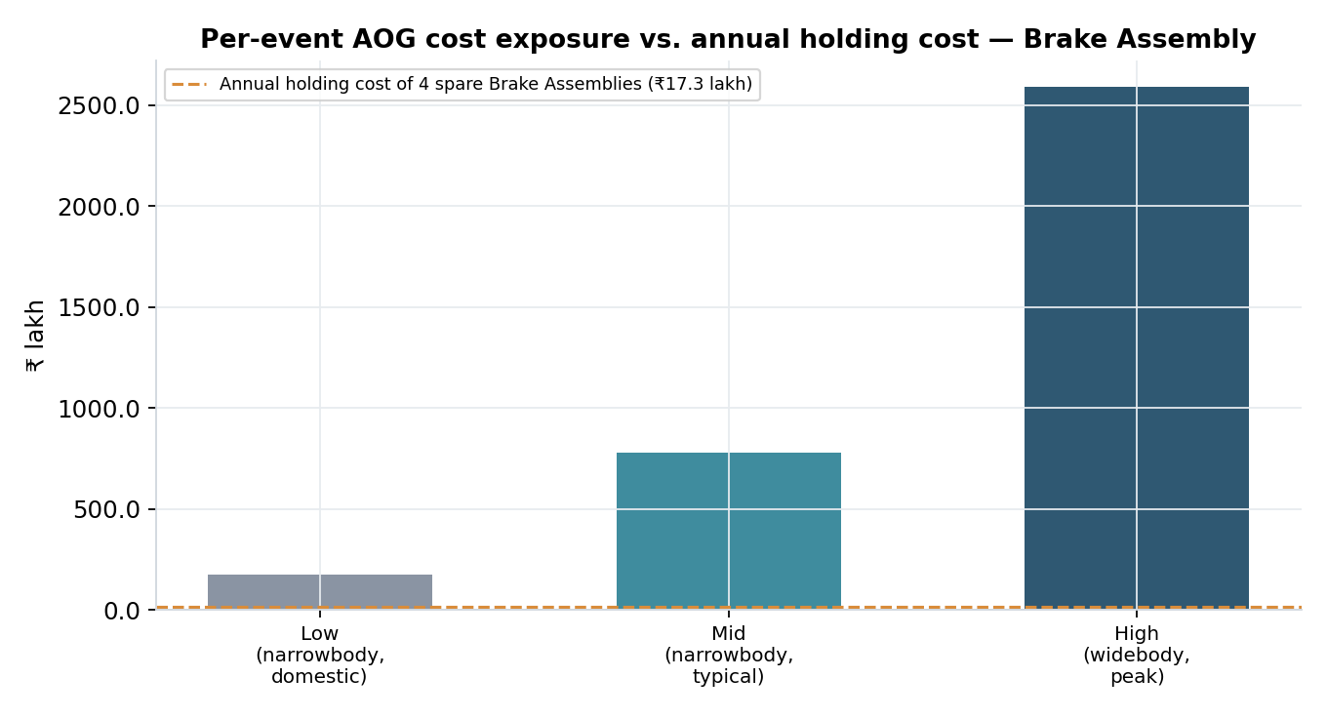
Figure 7 — Per-event AOG cost exposure (three severity scenarios) against the annual holding cost of a 4-unit safety stock.

7.3 Net business case
Even in the low AOG scenario, a single avoided stockout (₹1.73 crore) is worth roughly 10× the entire year's holding cost of a 4-unit safety buffer; in the high scenario the ratio exceeds 100×. The forecasting model doesn't need to prevent many AOG events per year to justify its holding-cost overhead many times over — this is the quantified answer to "why build this" for the supplier-facing dashboard's business audience. Phase 5 (Section 8) will convert this into a formal reorder-point / batch-size formula rather than a static 4-unit assumption.

8. Revised Plan of Work (15-Day Phases)
Restructured per feedback from monthly blocks into 15-day increments, anchored to an 08 Aug 2026 start (immediately after the approved abstract) and the 24 Sep 2026 midterm checkpoint.
Phase | Dates | Work | Status
1. Gap analysis & architecture | 08–22 Aug 2026 | Current-solution/gap analysis, dataset shortlisting, architecture design | Done
2. EDA & feature engineering | 23 Aug–06 Sep 2026 | Data acquisition, cleaning, wear-index & environmental feature engineering | Done
3. Baseline, ABC/XYZ & Apriori | 07–21 Sep 2026 | Moving-average baseline, dual-matrix classification, companion-part mining, cost-model framework | Done
— Midterm checkpoint — | 24 Sep 2026 | This report | —
4. Model training & tuning | 25 Sep–09 Oct 2026 | LightGBM vs. baseline/Random Forest on Brake Assembly; hyperparameter tuning | Planned
5. Reorder engine & validation | 10–24 Oct 2026 | ROP/batch-size formulas on top of the tuned forecast; validation against held-out data | Planned
6. Dashboard & final writeup | 25 Oct–08 Nov 2026 | Supplier-facing dashboard; full dissertation drafting and submission | Planned

9. Scope Boundaries (Unchanged)
- No live streaming of real-time flight telemetry or live weather APIs — avoids architectural latency and third-party API deprecation risk.
- Forecasting scope limited to one part (Brake Assembly, selected via the AX classification in Section 6.3); other parts use simpler periodic-reorder logic, not individually modeled.
- Dataset is open-source/simulated (Kaggle), not live Airbus production data.

10. Next Steps
- Swap the placeholder synthetic dataset for the downloaded Kaggle CSVs (schema-compatible, no pipeline changes required) and re-run Sections 6–7 with live figures.
- Phase 4: train LightGBM, Random Forest, and the ARIMA/baseline side by side on identical train/test splits; report MAE/RMSE to empirically confirm the Section 4 model choice.
- Phase 5: convert the forecast + Section 7 cost model into explicit reorder-point and batch-order-size formulas.
- Phase 6: build the Streamlit-based supplier-facing dashboard and complete the full dissertation writeup.

11. Literature References
Carried over from the approved abstract, plus new citations added to support this report's technical-rationale and dataset sections (marked *new*).
- Agrawal, R., & Srikant, R. (1994). Fast algorithms for mining association rules. Proceedings of the 20th International Conference on Very Large Data Bases (VLDB), 487–499.
- Bacchetti, A., & Saccani, N. (2012). Spare parts classification and demand forecasting for stock control: Investigating the gap between research and practice. Omega, 40(6), 722–737.
- Ke, G., Meng, Q., Finley, T., Wang, T., Chen, W., Ma, W., Ye, Q., & Liu, T.-Y. (2017). LightGBM: A highly efficient gradient boosting decision tree. Advances in Neural Information Processing Systems, 30, 3149–3157.
- Lagoda, L., & Klumpp, M. (2024). Efficient warehouse and inventory management: The modified ABC-XYZ analysis as a framework to integrate demand forecasting and inventory control. In Dynamics in Logistics (LDIC 2024), Lecture Notes in Logistics. Springer.
- Grinsztajn, L., Oyallon, E., & Varoquaux, G. (2022). Why do tree-based models still outperform deep learning on tabular data? Advances in Neural Information Processing Systems, 35, 507–520. *new — technical rationale, Section 4*
- Stanton, R., Munir, K., Ikram, A., & El-Bakry, M. (2024). Data augmentation for predictive maintenance: Synthesising aircraft landing gear datasets. Engineering Reports, 6(12), e12946. Wiley. *new — primary dataset provenance, Section 5.1*
- Saxena, A., Goebel, K., Simon, D., & Eklund, N. (2008). Damage propagation modeling for aircraft engine run-to-failure simulation. International Conference on Prognostics and Health Management (PHM), 1–9. *new — C-MAPSS benchmark dataset origin, Section 5.2*

12. Supervisor Review
Reviewed against the abstract-stage feedback: technical model justification (Section 4), business/cost analysis in INR (Section 7), architecture diagram (Section 3), current-solution/gap analysis (Section 2), and a 15-day-increment plan of work (Section 8).
Signature of Student | Signature of Supervisor | Signature of Additional Examiner
Dimpal Shetty | Saurabh Mahajan | Karthik Mahadevan

