CLASSES STUDENT MANAGEMENT SYSTEM

Designing Pages
Application starts from LoginPage.java page.
- LoginPage.java
A simple JFrame with a title bar(undecorated ) named as Login Page, and generated centre . Another Label class object JLabel (named lbllogin) is use to display a string “LOGIN”. A JTextField (named txtuname) to take username and another JPasswordField (named txtpwd) to take password from user. JPasswordField hides the password entered using *. A JButton (named btnforgot) for forgot password and another JButton (named btnsub) for submitting the login details like username and password for verification.
If the password and username doesn’t match it may be possible that either username or password or both are wrong so then login is unsuccessful. Then a message dialog box having a message type as Error message is displayed. If login is successful then will call next page’s main function (because inside main function new frame’s object creation is written). And the current page will be disposed.
If clicked on the option of forgot password, then a option dialog box is opened which asks for your favorite color, this is the color given by the user as a safeguard question to ask before changing the password. So the system will already have a answer which is previously set by us for the question of favourite color. Then the answer given by user is checked with the stored answer if a match is found then an input dialog box opens up to ask for new password. Else another message dialog pops up having a message type as error message telling that answer doesn’t match.
The value returned by input dialog box is stored in string variable which is a local data member of the function (actionPerformed of action listener) for the submit button. And that local member is checked. In the input dialog box if we give a blank as a password then again a message dialog pops up having a message type as error message displaying message that a password can’t be blank. If we give input as the previous password a message dialog pops up having a message type as error message displaying a message that new password can’t be same as old password. After displaying error message both of blank or of same password login page is displayed.
If at any point be it
- Option dialog box is cancel using close button
- If input dialog box is cancel using close button or cancel button
a message dialog box with error message type pops up displaying message that password the process of updating a password is unsuccessful.
If a valid password is given which is not blank or the previously set password then a message box displaying message of successful update is displayed. And then we can login using new password. The password field is a static data or class member so that once we change the password, the changed password will remain the login password till the application is running. Once it (application) is closed the password is set to the previous value. If the password field is not static then once we login and move on to next page and if we return back and then try t login using changed password we can’t. Login failed is displayed.
This happens because, when we keep the password holding field as non static , a new variable is created everytime a new instance is created, which happens when we return back to that login page, and whenever this happens password field is initialized with previous password. But if we make the password field as static then only 1 variable is created and once it’s changed, even if new instances are created, which means no matter how many times we revert back to that login page, that field is not initialized with previous password. Hence making it possible to login using changed password as long as the application is running.

2) Enquiry_Admission.java
It has JLabel (named lblhead) which displays message asking if for what purpose the student is here. It has a JPanel (named pnlen_ad) which acts as a container to hold all the components. 3 JButtons:
- JButton (named btnenq) is a button for Student enquiry when clicked sets isenquiry (a static class member) true and calls New_Old.java file’s main function. In the main function an object of New_Old class is created. And disposes the current frame.
- JButton (named btnadm) is a button for Student admission when clicked sets isenquiry (a static class member) false and calls New_Old.java file’s main function. In the main function an object of New_Old class is created. And disposes the current frame.
- JButton (named btnback) when clicked we return to LoginPage by calling it’s main function. And disposes the current frame.
Reasons behind isenquiry class member, it being static, it being set to false inside btnadm when it’s already initialized to false.
isenquiry is used so that we understand in next pages that this page is used for enquiry. Like a common New_Old class is used for both student admission because the contents or components are all similar so why to make another file with window. Also when new radio button is clicked which page to open as data fetching and also data retrieving changes according to the if it’s enquiry or admission. Also when adding data in which table enquiry or admission should the data go this is done using isenquiry.
It is static because it will be initialized to false for each new instances, which means it will be false everytime we return to Enquiry_Admission page. But that’s not a major problem as we returned back to page so that we could select for student enquiry or admission so it will be set accordingly. The major problem is that we need to access that class member in other classes in the same package, that’s why that field is having an access specifier as default, and not private. And to access a non static member in another classes we need a object of that class, but if we need object we will have to create it everytime and the variable will hold false everytime. So the purpose behind it’s creation is lost. So we need to access only 1 variable not it’s various instances, for that purpose we use static, because static members are accessed using class name and only 1 instances or copy is created.
The reason behind making isenquiry as false in the actionPerformed of action listener for the btnadm is, that if we return back to the Enquiry_Admission page after returning from selecting btnenq, then isenquiry will be set to true and then an erroneous output will be generated. To avoid it isenquiry is set to false in btnadm actionPerformed.

- New_Old.java
It has a JPanel (named pnlnewold) to hold components. It has JLabel (named lblhead) which asks if the student is new or old. It has two radio buttons JRadioButton, (named chknew and chkold) for new student or old student information from user. Only one of the radio button could be selected so for that purpose ButtonGroup component is used (named cbgnewold). In chknew and chkold, buttonGroup field is selected as cbgnewold.
4 JLabel’s
- Named lblfetch used to display a message asking user how they want to fetch the data using phone number or the student id.
- Named lblor to diplay the “or ” text.
- Named lblmsg1 to display the text “If a student has made a prior enquiry,” only when the New_Old is called for admission button else this label is blank. This label is set with text inside constructor as lblmsg1 is a non static class member. And non static member can’t be accessed from static context
- Named lblmsg2 to display the text “they should be considered an old student.” only when the New_Old is called for admission button else this label is blank. This label is set with text inside constructor as lblmsg2 is a non static class member. And non static member can’t be accessed from static context
3 JButton
- Named btnphn when clicked directs to a page where phone number is asked and data is fetched using it from database. And disposes the current frame.
- Named btnstudid when clicked directs to a page where student id is asked and data is fetched using it from database. And disposes the current frame.
- Named btnback when clicked we return to Enquiry_Admission by calling it’s main function. And disposes the current frame.
When chknew radio button is selected we call the main function of FetchDataEnquiry or FetchDataAdmission depending on the contents of isenquiry field. The calling is done itemStateChanged for chknew.
When old radio button is selected then user need to choose whether to fetch data using phone number or student id.
If either btnphn or btnstudid is clicked when old is not selected, then a message box with message type error message is displayed. Informing user to select old first. Done by using cbgnewold button group. It has getSelection function which returns null if nothing is selected and since when new is selected immediately another window opens up. If a null value is not returned then new window is opened by calling main function. Else if a null value is returned then message box pops up.
While calling main function it is passed a string array which holds only 1 value which is either “Phone Number” or “Student Id”. This passed string is used to set text of the label to avoid creation of many files or classes. The reason behind passing string array instead of string only is because main function of any class accepts only string array as a parameter.
- FetchData.java
It has a JPanel (named pnldata) to contain components.
JLabels
- Named lblfetch to display a message to with passed string to main function from previous page. This label is set with text inside constructor as lblfetch is a non static class member. And non static member can’t be accessed from static context. A class member (named msglbl) which is private static is used to fetch the string from string array passed to the main function of the class.
JTextField
- Named txtphn_id it is used to take either a phone number or id. Here validations are set such that only numbers are entered if by mistake or intentionally any one enters anything other than numbers that key is not displayed. Done in keyTyped function of key Adapter. Also validation for length is done. Here msqlbl is checked if it contains “Phone” in it then the length of the accepted string in textfield limited to 10. Else if msglbl contains “Id” in it then the length of the accepted string in textfield limited to 5. If at any point the number of entering string exceeds the given value excess keys are consumed and hence not displayed nor saved. This string is used to fetch data from the database.
JButton
- Named btnback when clicked we return to New_Old by calling it’s main function. And disposes the current frame.

Queries
To create database
mysql> create database ClassesDB;
Query OK, 1 row affected (0.01 sec)
mysql> use ClassesDB;
Database changed
mysql> mysql> create table Subjects(subName varchar(20) primary key, subFees int, subDuration int);
Query OK, 0 rows affected (0.03 sec)
Questions:
- Why is subName primary key? Why isn’t there another column with subject id?
- There’s no problem with creating an extra column with subject id and making it primary key, but in my projects I didn’t actively used or needed a subject id in other tables. So only purpose behind creating another column would be to use it as primary key, to uniquely identify each subject. But this purpose was already satisfied by subName column. As the subject name for a class are usually unique. So I thought to avoid redundancy it will help to make subName as the primary key which is unique and required field in my application. Also for updating fees or duration for a particular subject in the table, its a functionality I have given in my application, user will give subject name. So I didn’t see any sense in taking setting subject id when the operation of updating could be done using subject name instead. Also the user won’t know the subject id if it’s only used internally then how come they use it to update fees and duration for a subject. Using an subject id would be preferred when the application is for a university or something larger where subject names are slightly conflicting or confusing like subjects named English Literature is one subject and another subject is English Literature and Literacy something.
- Why is subDuration int?
- I want to give the duration in minutes so that it’s easier to perform arithmetics on the time if needed in the future. Also for time datatype supported by sql takes data in the form of hh:mm:ss but I don’t need seconds field. Another purpose of storing minutes instead of hours is that I can easily convert minutes to hours before displaying the value. But suppose a course has a duration of 20 hours and 30 minutes this I can’t store in int datatype. So that’s why using int.

mysql> desc Subjects;
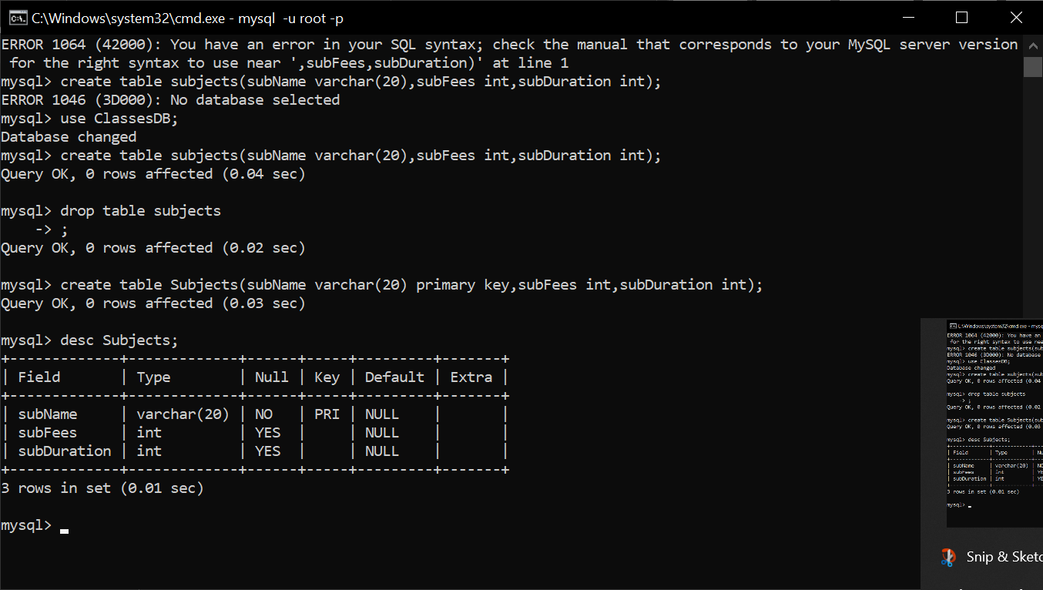
mysql> insert into Subjects values("Java",5000,6000);
Query OK, 1 row affected (0.01 sec)

mysql> insert into Subjects values("C++",4500,5000);
Query OK, 1 row affected (0.01 sec)

mysql> insert into Subjects values("C",4000,3750);
Query OK, 1 row affected (0.01 sec)

mysql> insert into Subjects values("Python",5500,5750);
Query OK, 1 row affected (0.01 sec)

mysql> insert into Subjects values("DS",6000,6500);
Query OK, 1 row affected (0.01 sec)

mysql> insert into Subjects values("ADS",6500,5500);
Query OK, 1 row affected (0.01 sec)

mysql> select* from Subjects;
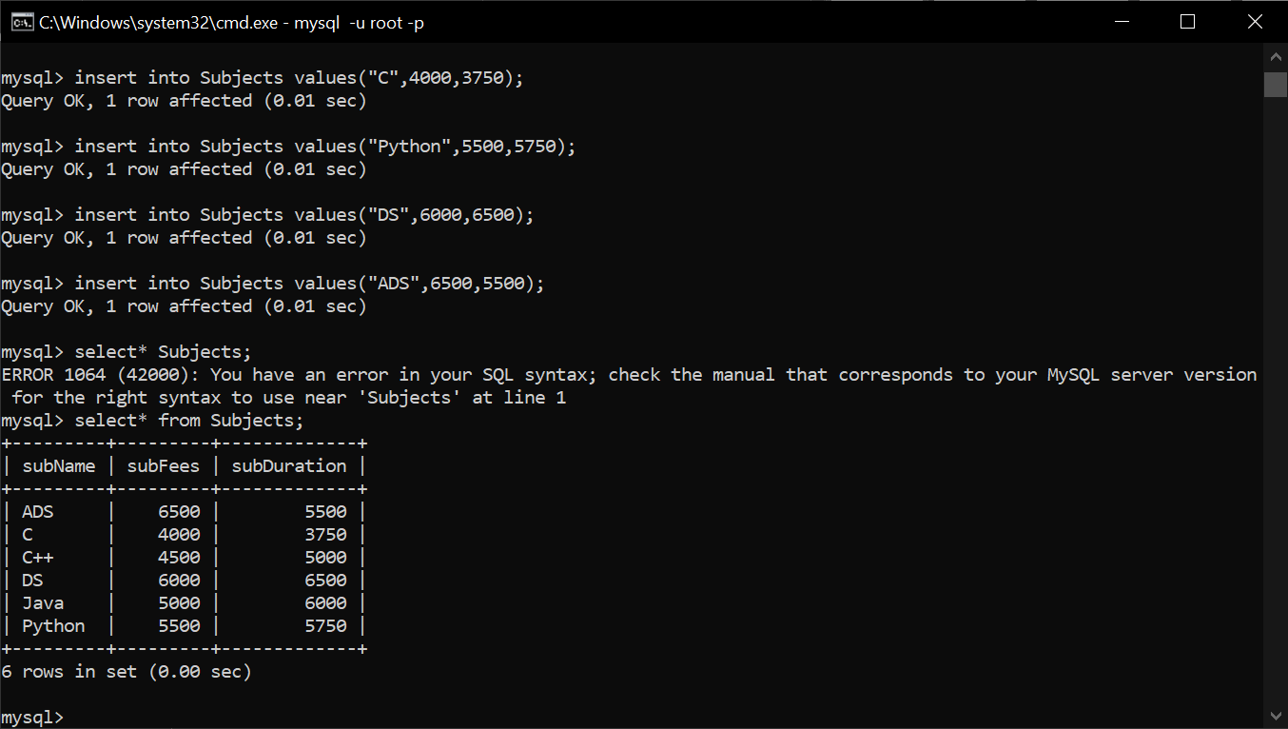

mysql> create table home_town(hometownid int primary key auto_increment, hometown varchar(30));
Query OK, 0 rows affected (0.03 sec)

mysql> desc home_town;
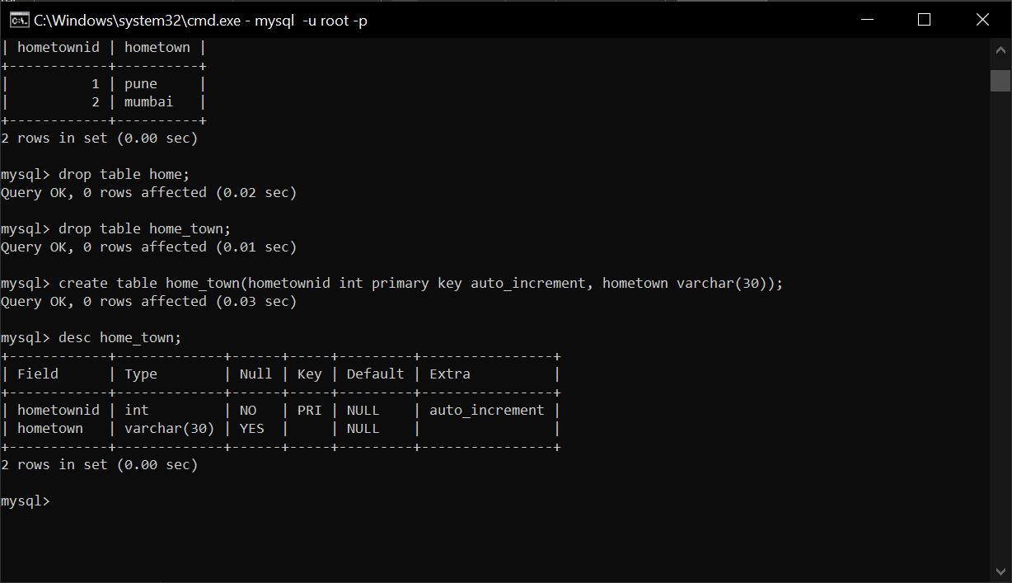
mysql> insert into home_town(hometown) values("Pune");
Query OK, 1 row affected (0.01 sec)

mysql> insert into home_town(hometown) values("Mumbai");
Query OK, 1 row affected (0.01 sec)

mysql> insert into home_town(hometown) values("Shivapur");
Query OK, 1 row affected (0.01 sec)

mysql> insert into home_town(hometown) values("Jejuri");
Query OK, 1 row affected (0.01 sec)

mysql> insert into home_town(hometown) values("Wai");
Query OK, 1 row affected (0.00 sec)

mysql> insert into home_town(hometown) values("Jalgaon");
Query OK, 1 row affected (0.01 sec)

mysql> insert into home_town(hometown) values("Kolhapur");
Query OK, 1 row affected (0.01 sec)

mysql> insert into home_town(hometown) values("Hadapsar");
Query OK, 1 row affected (0.01 sec)

mysql> insert into home_town(hometown) values("Satara");
Query OK, 1 row affected (0.01 sec)

mysql> insert into home_town(hometown) values("Sangli");
Query OK, 1 row affected (0.01 sec)

mysql> select * from home_town;
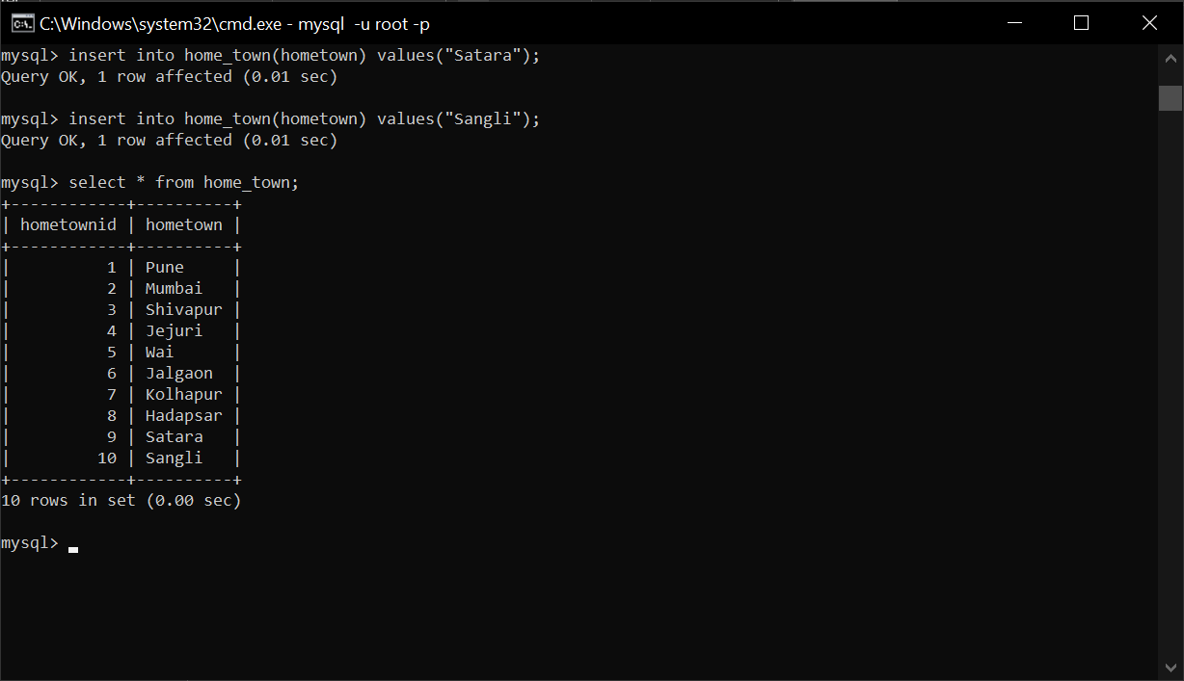

mysql> create table college(collegeid int primary key auto_increment, clgName varchar(100));
Query OK, 0 rows affected (0.02 sec)

mysql> desc college;
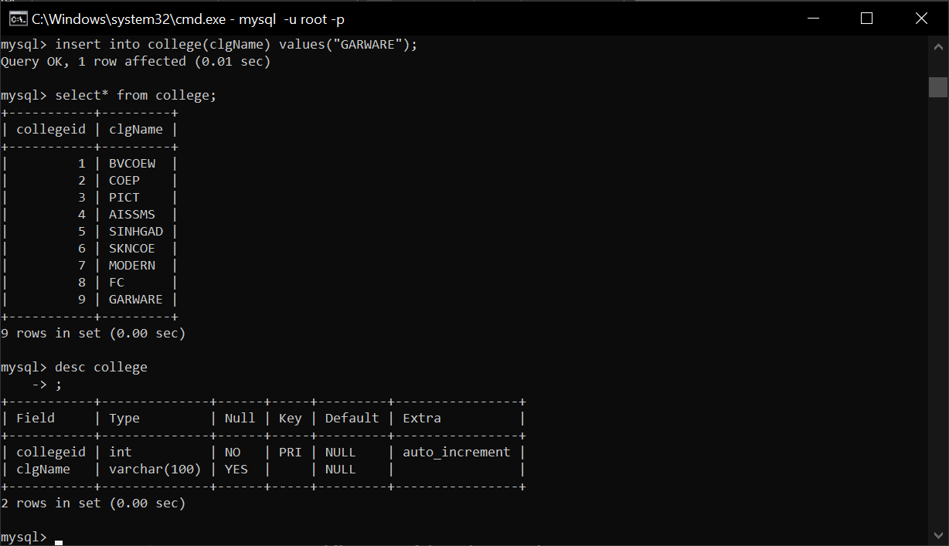

mysql> create table college(collegeid int primary key auto_increment, clgName varchar(100));
Query OK, 0 rows affected (0.02 sec)

mysql> insert into college(clgName) values("BVCOEW");
Query OK, 1 row affected (0.01 sec)

mysql> insert into college(clgName) values("COEP");
Query OK, 1 row affected (0.01 sec)

mysql> insert into college(clgName) values("PICT");
Query OK, 1 row affected (0.00 sec)

mysql> insert into college(clgName) values("AISSMS");
Query OK, 1 row affected (0.01 sec)

mysql> insert into college(clgName) values("SINHGAD");
Query OK, 1 row affected (0.01 sec)

mysql> insert into college(clgName) values("SKNCOE");
Query OK, 1 row affected (0.01 sec)

mysql> insert into college(clgName) values("MODERN");
Query OK, 1 row affected (0.01 sec)

mysql> insert into college(clgName) values("FC");
Query OK, 1 row affected (0.01 sec)

mysql> insert into college(clgName) values("GARWARE");
Query OK, 1 row affected (0.01 sec)

mysql> select* from college;

Important points:
Can’t add auto_increment after table creation and after adding values by this query: alter table table_name auto_increment=100;
Prefer to give auto_increment while table creation.
If we insert a record in table and then delete it immediately, even then the auto_increment is in effect. For eg, say we inserted 6th record and delete it. Then the next record inserted will have primary key as 7 and not 6 even if the 6th record is deleted.
If we want to reset the auto_increment we need to use this: alter table table_name auto_increment=6; 6 as in to this value we need to reset the auto_increment.s

mysql> create table students(studid int primary key auto_increment, fname varchar(20) not null,mname varchar(20), lname varchar(20), photo longblob, phn_no varchar(12) not null unique, email varchar(150) not null unique, birth_date date, local_add text, permanent_add text, hometown_id int, gender varchar(10), college_id int, foreign key(hometown_id) references home_town(hometownid), foreign key(college_id) references college(collegeid));
Query OK, 0 rows affected (0.10 sec)

mysql> desc students;
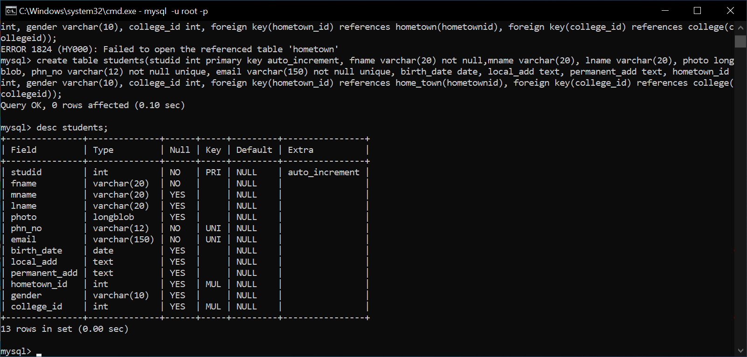
mysql> create table enquiries(enquiryid int primary key auto_increment,stud_id int,sub_Name varchar(20), enquiryDate date, foreign key(stud_id) references students(studid), foreign key(sub_Name) references subjects(subName));
Query OK, 0 rows affected (0.07 sec)

mysql> desc enquiries;
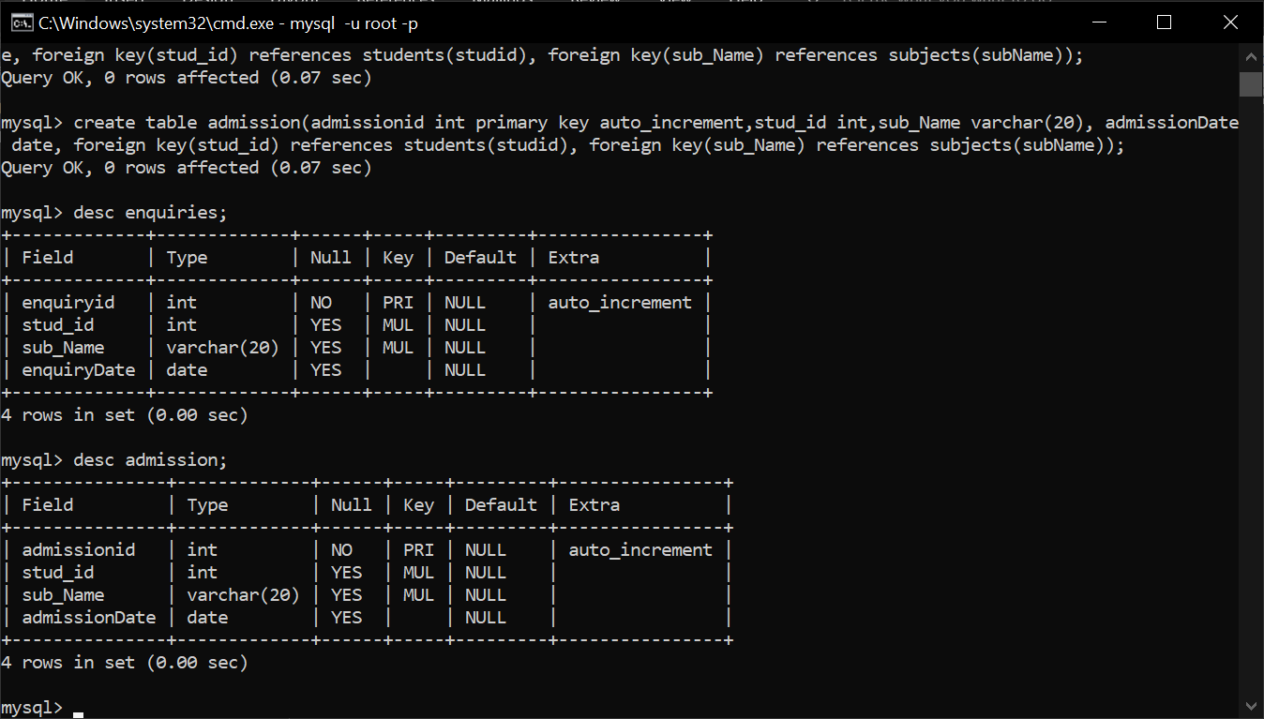
mysql> create table admission(admissionid int primary key auto_increment,stud_id int,sub_Name varchar(20), admissionDate date, foreign key(stud_id) references students(studid), foreign key(sub_Name) references subjects(subName));
Query OK, 0 rows affected (0.07 sec)
mysql> desc admission;


Challenges faced
- Forgot password if blank password given? (displaying dialog box)
- Forgot password if old password is given as new password? (displaying dialog box)
- If option dialog box is closed without giving answer or canceling new password input dialog box then an exception was occurring so to overcome it. (Creates another dialog box to tell password update failed)
- Using common next frame named New_Old after enquiry or admission selection so how to differentiate if them. (isenquiry)
- Since a common New_Old page, if a student has enquired earlier some amount of his data is already present so that student must be considered as old. So need to tell this to the admin as well. For that labels could be used. But these labels are not needed in enquiry page.
- When a student is old then data must be fetched using student id or phone number, so then the label must change accordingly for the next page. And again due to having same next page setting label can be tricky. So sent the string of label as an argument to main function of next page. That sent string was also used for length validation of both phone number and student id. As phone number required a length of 10 while id needed 5.
- Whenever an insertion of subject was done, the added subject should be displayed in the comboBox but this didn’t happen because the subject where added initially during window creation. So whenever an insertion is done it is added in the subjects table but wasn’t displayed in comboBox. To overcome this I simply added the subject added in the comboBox after insertion.
- When fees or duration or both where updated for a particular subject, then if that subject is already selected in the comboBox, then the changes in fees or duration or both aren’t displayed. One would need to select another value from the box and then return back to the modified one then changes where displayed. To overcome this, I created a function containing the logic of state change of comboBox. And this function was called everytime an update is made. And also in state change.
- While inserting using add button the given value must not be blank. For hometown, clgname or subject.
- Error with uploading an image in the database
i want to insert a jpg image in the table. i have done following queries: mysql> create table s(id int,photo longblob);
Query OK, 0 rows affected (0.10 sec)

mysql> desc s;
+-------+----------+------+-----+---------+-------+
| Field | Type | Null | Key | Default | Extra |
+-------+----------+------+-----+---------+-------+
| id | int | YES | | NULL | |
| photo | longblob | YES | | NULL | |
+-------+----------+------+-----+---------+-------+
2 rows in set (0.02 sec)

mysql> insert into s values(1,load_file("E:\\Projects\\PBL Sem IV\\bus1"));
Query OK, 1 row affected (0.02 sec)

mysql> select* from s;
+------+--------------+
| id | photo |
+------+--------------+
| 1 | NULL |
+------+--------------+
1 row in set (0.00 sec)

mysql> insert into s values(2,load_file("E:\\Projects\\PBL Sem IV\\bus1.jpg"));
Query OK, 1 row affected (0.01 sec)

mysql> select* from s;
+------+--------------+
| id | photo |
+------+--------------+
| 1 | NULL |
| 2 | NULL |
+------+--------------+
2 rows in set (0.00 sec)

mysql> insert into s values(2,LOAD_FILE("E:\\Projects\\PBL Sem IV\\bus1.jpg"));
Query OK, 1 row affected (0.01 sec)

mysql> select* from s;
+------+--------------+
| id | photo |
+------+--------------+
| 1 | NULL |
| 2 | NULL |
| 2 | NULL |
+------+--------------+
3 rows in set (0.00 sec)

mysql> insert into s values(2,load_file('/E:/Projects/PBL Sem IV/bus1.jpg'));
Query OK, 1 row affected (0.01 sec)

mysql> select* from s;
+------+--------------+
| id | photo |
+------+--------------+
| 1 | NULL |
| 2 | NULL |
| 2 | NULL |
| 2 | NULL |
+------+--------------+
4 rows in set (0.00 sec) no matter what i try image is not inserted in the table. i cant understand whats wrong. whats wrong and how to solve it?
The issue arises because MySQL's LOAD_FILE() function has specific requirements and restrictions that need to be satisfied for it to successfully load a file into the database. When LOAD_FILE() returns NULL, it typically means one or more of the following conditions are not met:

Common Reasons for LOAD_FILE() Returning NULL
- File Path Issue:
  - The file path provided to LOAD_FILE() must be an absolute path that points to the file on the MySQL server's local file system. If you're running MySQL on a server and the file exists on your local machine, it won't work.
- File Accessibility:
  - The file must be accessible by the MySQL server process.
  - Ensure that the file permissions allow the MySQL server to read the file.
- Secure File Privilege:
  - MySQL has a configuration variable called secure_file_priv. If this variable is set, it restricts file operations (like LOAD_FILE()) to a specific directory.
  - You can check the value of secure_file_priv using:
  - SHOW VARIABLES LIKE 'secure_file_priv';
  - If secure_file_priv is set, you must place the file in the specified directory for LOAD_FILE() to work.
- File Size:
  - Ensure that the file size does not exceed the max_allowed_packet size. If the file is too large, it will not load.
  - You can check and update this setting in the my.cnf or my.ini configuration file:
  - [mysqld]
  - max_allowed_packet = 16M
  - Restart the MySQL server after updating this setting.
- Wrong Path Syntax:
  - Backslashes (\) are escape characters in many programming and SQL contexts. Use forward slashes (/) or double the backslashes (\\) in file paths.

Steps to Resolve the Issue
- Verify secure_file_priv:
  - Check its value:
  - SHOW VARIABLES LIKE 'secure_file_priv';
  - If it's not set (NULL), LOAD_FILE() can read files from any accessible location.
  - If it's set to a specific directory, ensure the file is placed in that directory.
- Place the File in the Correct Directory:
  - Copy the image file to the directory specified by secure_file_priv or to a location accessible by the MySQL server.
- Update the Query with the Correct File Path:
  - Ensure the file path is correct and matches the server's directory structure:
  - INSERT INTO s VALUES (1, LOAD_FILE('/path/to/image.jpg'));
- Check File Permissions:
  - Ensure that the MySQL server process has read permissions for the file.
- Debugging NULL Output:
  - Try reading the file with LOAD_FILE() alone:
  - SELECT LOAD_FILE('/path/to/image.jpg');
  - If it still returns NULL, there is an issue with one of the points above.
- Alternative Method:
  - If LOAD_FILE() continues to fail, consider loading the image using a programming language (e.g., Java or Python) to read the file as binary data and insert it using a prepared statement.

Example of Checking secure_file_priv
Run:
SHOW VARIABLES LIKE 'secure_file_priv';
Example Output:
Variable Name | Value
secure_file_priv | /var/lib/mysql-files/
If the value is /var/lib/mysql-files/, copy the image file to that directory and use:
INSERT INTO s VALUES (1, LOAD_FILE('/var/lib/mysql-files/image.jpg'));

Testing After Changes
After resolving the issues, verify by selecting:
SELECT * FROM s;
If photo still shows as NULL, revisit the above steps, focusing on file path and permissions.
what is the SHOW VARIABLES LIKE 'secure_file_priv'; this statement? can we change the value to this variable. when executing SHOW VARIABLES LIKE 'secure_file_priv'; output is this
+------------------+------------------------------------------------+
| Variable_name | Value |
+------------------+------------------------------------------------+
| secure_file_priv | C:\ProgramData\MySQL\MySQL Server 8.0\Uploads\ |
+------------------+------------------------------------------------+
1 row in set (0.01 sec) so does this means i have to put images in uploads folder only? is there anyway by which i can upload a file specifically jpg image from E:\BVCOEW\Java\FinalProject\src\finalproject this path? i am currently working on a project with java being used for guis, and i am going to use a webcam to capture an image. so how should i proceed to make this work?
Explanation of SHOW VARIABLES LIKE 'secure_file_priv';
- The secure_file_priv variable in MySQL specifies a directory path. It restricts file-related operations like LOAD_FILE() or SELECT INTO OUTFILE to this directory for security reasons.
- In your case, the value is:
- C:\ProgramData\MySQL\MySQL Server 8.0\Uploads\
This means that any file-related operations like LOAD_FILE() can only work on files located in the Uploads directory under this path.

Can You Change the Value of secure_file_priv?
Yes, you can change the value of secure_file_priv, but it requires modifying the MySQL server's configuration file and restarting the server:
- Locate the Configuration File:
  - The configuration file is usually my.cnf (Linux) or my.ini (Windows).
  - For Windows, it might be located in:
  - C:\ProgramData\MySQL\MySQL Server 8.0\my.ini
- Modify the File:
  - Open the file and search for secure_file_priv.
  - Update its value to the directory where your images are stored:
  - secure_file_priv="E:\BVCOEW\Java\FinalProject\src\finalproject"
- Restart MySQL Server:
  - Restart the MySQL service for the changes to take effect.
- Verify:
  - After restarting, verify the new value using:
  - SHOW VARIABLES LIKE 'secure_file_priv';

Alternative Approach Without Changing secure_file_priv
If changing secure_file_priv is not feasible (e.g., lack of admin rights), you can copy the file from your desired directory to the Uploads folder (C:\ProgramData\MySQL\MySQL Server 8.0\Uploads\) before executing LOAD_FILE().

Java Integration with Webcam and MySQL
For capturing an image from a webcam and uploading it to MySQL:
- Capture Image with Webcam:
  - Use a Java library like OpenCV to capture images from the webcam.
- Save the Captured Image:
  - Save the captured image to a temporary location, such as:
  - E:\BVCOEW\Java\FinalProject\src\finalproject
- Read Image as Binary Data in Java:
  - Use Java's FileInputStream to read the image as binary data.
- Insert Image into MySQL Using JDBC:
  - Use a prepared statement to insert the binary data into the longblob column:
  - Connection con = DriverManager.getConnection("jdbc:mysql://localhost:3306/classesdb", "root", "password");
  - String query = "INSERT INTO s (id, photo) VALUES (?, ?)";
  - PreparedStatement pst = con.prepareStatement(query);
  - pst.setInt(1, 1); // Example ID
  - FileInputStream fis = new FileInputStream("E:\\BVCOEW\\Java\\FinalProject\\src\\finalproject\\image.jpg");
  - pst.setBinaryStream(2, fis, fis.available());
  - pst.executeUpdate();
- Test Retrieval:
  - Verify that the image was inserted using:
  - SELECT * FROM s;
  - Extract the image in Java by reading the binary data from the ResultSet.

Steps to Proceed
- Configure MySQL's secure_file_priv or place images in the allowed directory.
- Capture the image using Java and save it locally.
- Use Java's JDBC to read the image file and upload it to the database.
- Test your implementation to ensure both capture and upload work seamlessly.
Let me know if you need specific code snippets or additional assistance!
- To extract image from database:
To extract an image from a MySQL database in Java, follow these steps:
Example Code for Extracting an Image
Below is an example of how to retrieve an image from the database and save it as a file:
import java.io.File;
import java.io.FileOutputStream;
import java.io.InputStream;
import java.sql.Connection;
import java.sql.DriverManager;
import java.sql.PreparedStatement;
import java.sql.ResultSet;

public class ImageExtractor {
public static void main(String[] args) {
Connection con = null;
PreparedStatement pst = null;
ResultSet rs = null;

try {
// Step 1: Connect to the database
con = DriverManager.getConnection("jdbc:mysql://localhost:3306/classesdb", "root", "password");

// Step 2: Write a query to fetch the image
String query = "SELECT photo FROM s WHERE id = ?";
pst = con.prepareStatement(query);
pst.setInt(1, 1); // Replace 1 with the desired ID of the image record

// Step 3: Execute the query and get the ResultSet
rs = pst.executeQuery();

if (rs.next()) {
// Step 4: Get the binary stream of the image
InputStream input = rs.getBinaryStream("photo");

// Step 5: Save the binary stream as a file
File outputFile = new File("extracted_image.jpg");
FileOutputStream fos = new FileOutputStream(outputFile);

byte[] buffer = new byte[1024];
int bytesRead;
while ((bytesRead = input.read(buffer)) != -1) {
fos.write(buffer, bytesRead, bytesRead);
}

fos.close();
input.close();

System.out.println("Image extracted and saved as " + outputFile.getAbsolutePath());
} else {
System.out.println("No record found with the given ID.");
}
} catch (Exception e) {
e.printStackTrace();
} finally {
try {
if (rs != null) rs.close();
if (pst != null) pst.close();
if (con != null) con.close();
} catch (Exception e) {
e.printStackTrace();
}
}
}
}

How It Works
- Connect to the Database: Use DriverManager.getConnection() to establish a connection.
- Retrieve the Image:
  - Use a PreparedStatement to fetch the photo column from the database based on a unique ID.
  - The ResultSet.getBinaryStream() method retrieves the image as a binary stream.
- Save the Image:
  - Use FileOutputStream to write the binary stream to a file on the local file system.

Notes:
- Replace "photo" with the actual column name for the image in your table if different.
- Ensure you have sufficient permissions to write the file to the specified directory.
- The extracted file format (.jpg, .png, etc.) should match the original file format used during the upload.

This code will save the extracted image in the same format as it was uploaded. Let me know if you encounter any issues!
The error indicates an issue with how bytes are being written to the file in the loop. Specifically, the incorrect second parameter in the fos.write(buffer, bytesRead, bytesRead) method is causing this problem.
Issue:
The FileOutputStream.write(byte[] b, int off, int len) method takes the following parameters:
- b: The byte array to write.
- off: The starting offset in the byte array.
- len: The number of bytes to write.
In the line:
fos.write(buffer, bytesRead, bytesRead);
The bytesRead value is incorrectly being used as both the offset and length, which is why the IndexOutOfBoundsException is being thrown.

Correct Code:
Modify the loop as follows:
while ((bytesRead = input.read(buffer)) != -1) {
fos.write(buffer, 0, bytesRead); // Use 0 as the offset
}
Explanation:
- buffer: The byte array that holds the data read from the InputStream.
- 0: Start writing from the beginning of the buffer.
- bytesRead: Write only the number of bytes read in the current iteration.

Full Corrected Code:
Here’s the updated code:
import java.io.File;
import java.io.FileOutputStream;
import java.io.InputStream;
import java.sql.Connection;
import java.sql.DriverManager;
import java.sql.PreparedStatement;
import java.sql.ResultSet;

public class ImageExtractor {
public static void main(String[] args) {
Connection con = null;
PreparedStatement pst = null;
ResultSet rs = null;

try {
// Step 1: Connect to the database
con = DriverManager.getConnection("jdbc:mysql://localhost:3306/classesdb", "root", "password");

// Step 2: Write a query to fetch the image
String query = "SELECT photo FROM s WHERE id = ?";
pst = con.prepareStatement(query);
pst.setInt(1, 1); // Replace 1 with the desired ID of the image record

// Step 3: Execute the query and get the ResultSet
rs = pst.executeQuery();

if (rs.next()) {
// Step 4: Get the binary stream of the image
InputStream input = rs.getBinaryStream("photo");

// Step 5: Save the binary stream as a file
File outputFile = new File("extracted_image.jpg");
FileOutputStream fos = new FileOutputStream(outputFile);

byte[] buffer = new byte[1024];
int bytesRead;
while ((bytesRead = input.read(buffer)) != -1) {
fos.write(buffer, 0, bytesRead); // Fixed this line
}

fos.close();
input.close();

System.out.println("Image extracted and saved as " + outputFile.getAbsolutePath());
} else {
System.out.println("No record found with the given ID.");
}
} catch (Exception e) {
e.printStackTrace();
} finally {
try {
if (rs != null) rs.close();
if (pst != null) pst.close();
if (con != null) con.close();
} catch (Exception e) {
e.printStackTrace();
}
}
}
}
Output:
This corrected code should successfully extract the image from the database and save it as a .jpg file in the current working directory. Let me know if you encounter further issues!
- How to validate an email properly
- Jdatechooser can also take alphabets, number in any sequence or format but to insert in database we need specific format yyyy-MM-dd. So used regex
Here's a regular expression for validating a date in the yyyy-mm-dd format:
^\d{4}-(0[1-9]|1[0-2])-(0[1-9]|[12]\d|3[01])$
Explanation:
- ^: Ensures the match starts at the beginning of the string.
- \d{4}: Matches a four-digit year.
- -: Matches the hyphen separating year and month.
- (0[1-9]|1[0-2]): Matches valid months:
  - 0[1-9] matches months 01 to 09.
  - 1[0-2] matches months 10, 11, and 12.
- -: Matches the hyphen separating month and day.
- (0[1-9]|[12]\d|3[01]): Matches valid days:
  - 0[1-9] matches days 01 to 09.
  - [12]\d matches days 10 to 29.
  - 3[01] matches days
- For each failed insertion the auto increments itself too. So need to use alter after it //if an insertion fails then also studid, or enquiry id, admission id, in short all the autoincrement value increment so need to alter after a failed insertion
- No need: why am i getting this error. i have given code below can you resolve this?error: Exception in thread "AWT-EventQueue-0" java.lang.IllegalArgumentException
at java.base/java.util.Date.parse(Date.java:616)
at java.base/java.util.Date.<init>(Date.java:272)
at finalproject.FetchData.btnfetchActionPerformed(FetchData.java:409)
at finalproject.FetchData$3.actionPerformed(FetchData.java:103)
at java.desktop/javax.swing.AbstractButton.fireActionPerformed(AbstractButton.java:1972)
at java.desktop/javax.swing.AbstractButton$Handler.actionPerformed(AbstractButton.java:2314)
at java.desktop/javax.swing.DefaultButtonModel.fireActionPerformed(DefaultButtonModel.java:407)
at java.desktop/javax.swing.DefaultButtonModel.setPressed(DefaultButtonModel.java:262)
at java.desktop/javax.swing.plaf.basic.BasicButtonListener.mouseReleased(BasicButtonListener.java:279)
at java.desktop/java.awt.Component.processMouseEvent(Component.java:6621)
at java.desktop/javax.swing.JComponent.processMouseEvent(JComponent.java:3404)
at java.desktop/java.awt.Component.processEvent(Component.java:6386)
at java.desktop/java.awt.Container.processEvent(Container.java:2266)
at java.desktop/java.awt.Component.dispatchEventImpl(Component.java:4996)
at java.desktop/java.awt.Container.dispatchEventImpl(Container.java:2324)
at java.desktop/java.awt.Component.dispatchEvent(Component.java:4828)
at java.desktop/java.awt.LightweightDispatcher.retargetMouseEvent(Container.java:4948)
at java.desktop/java.awt.LightweightDispatcher.processMouseEvent(Container.java:4575)
at java.desktop/java.awt.LightweightDispatcher.dispatchEvent(Container.java:4516)
at java.desktop/java.awt.Container.dispatchEventImpl(Container.java:2310)
at java.desktop/java.awt.Window.dispatchEventImpl(Window.java:2780)
at java.desktop/java.awt.Component.dispatchEvent(Component.java:4828)
at java.desktop/java.awt.EventQueue.dispatchEventImpl(EventQueue.java:775)
at java.desktop/java.awt.EventQueue$4.run(EventQueue.java:720)
at java.desktop/java.awt.EventQueue$4.run(EventQueue.java:714)
at java.base/java.security.AccessController.doPrivileged(AccessController.java:400)
at java.base/java.security.ProtectionDomain$JavaSecurityAccessImpl.doIntersectionPrivilege(ProtectionDomain.java:87)
at java.base/java.security.ProtectionDomain$JavaSecurityAccessImpl.doIntersectionPrivilege(ProtectionDomain.java:98)
at java.desktop/java.awt.EventQueue$5.run(EventQueue.java:747)
at java.desktop/java.awt.EventQueue$5.run(EventQueue.java:745)
at java.base/java.security.AccessController.doPrivileged(AccessController.java:400)
at java.base/java.security.ProtectionDomain$JavaSecurityAccessImpl.doIntersectionPrivilege(ProtectionDomain.java:87)
at java.desktop/java.awt.EventQueue.dispatchEvent(EventQueue.java:744)
at java.desktop/java.awt.EventDispatchThread.pumpOneEventForFilters(EventDispatchThread.java:203)
at java.desktop/java.awt.EventDispatchThread.pumpEventsForFilter(EventDispatchThread.java:124)
at java.desktop/java.awt.EventDispatchThread.pumpEventsForHierarchy(EventDispatchThread.java:113)
at java.desktop/java.awt.EventDispatchThread.pumpEvents(EventDispatchThread.java:109)
at java.desktop/java.awt.EventDispatchThread.pumpEvents(EventDispatchThread.java:101)
at java.desktop/java.awt.EventDispatchThread.run(EventDispatchThread.java:90)
BUILD STOPPED (total time: 21 seconds)
code: private void btnfetchActionPerformed(java.awt.event.ActionEvent evt) {
// TODO add your handling code here:
/*will get studid or phn no use it and check in admission table if entry in admission table
display photo wala pg */
/*Connection con;
PreparedStatement pst;
ResultSet rs;
String query;
try
{
con=CommonFunctions.getCon();
if(msglbl.contains("Id"))
{
query="select studid,fname,mnane,lname,phn_no,email,birth_date,hometown_id,gender,college_id from students where studid=?";
pst=con.prepareStatement(query);
pst.setInt(1, Integer.parseInt(txtphn_id.getText()));
}
else
{
query="select studid,fname,mnane,lname,phn_no,email,birth_date,hometown_id,gender,college_id from students where phn_no=?";
pst=con.prepareStatement(query);
pst.setString(1, txtphn_id.getText());
}
rs=pst.executeQuery();
if(rs.next())
{
txtstudid.setText(String.valueOf(rs.getInt("studid")));
txtfname.setText(rs.getString("fname"));
if(rs.getString("mnane")==null && rs.getString("lname")==null)
{
txtmname.setText("");
txtlname.setText("");
}
else if(rs.getString("mnane")==null)
{
txtmname.setText("");
}
else if(rs.getString("lname")==null)
{
txtlname.setText("");
}
else
{
txtmname.setText(rs.getString("mname"));
txtlname.setText(rs.getString("lname"));
}
txtphn.setText(rs.getString("phn_no"));
txtmail.setText(rs.getString("email"));
Date date=new Date(rs.getString("birth_date"));
datechooser.setDate(date);

}

}
catch(SQLException e)
{

}*/

Date date=new Date("2024-11-12");
datechooser.setDate(date);
}
The error occurs because you are using the java.util.Date constructor with a string (new Date(String)), which is deprecated and does not support parsing dates in the yyyy-MM-dd format correctly. Instead, you should use SimpleDateFormat or LocalDate (from Java 8 and onwards) to parse the date string into a Date object.
Updated Code
Here’s how you can fix the issue:
import java.text.ParseException;
import java.text.SimpleDateFormat;
import java.util.Date;

private void btnfetchActionPerformed(java.awt.event.ActionEvent evt) {
try {
// Example of a date string in the yyyy-MM-dd format
String dateString = "2024-11-12";

// Use SimpleDateFormat to parse the date string
SimpleDateFormat sdf = new SimpleDateFormat("yyyy-MM-dd");
Date date = sdf.parse(dateString); // Convert string to Date

// Set the parsed date in the date chooser
datechooser.setDate(date);
} catch (ParseException e) {
e.printStackTrace(); // Log the error if parsing fails
}
}
Key Changes:
- Replaced new Date(String):
  - Use SimpleDateFormat for parsing the date string into a Date object.
- Handling ParseException:
  - Added a try-catch block to handle the checked exception thrown by sdf.parse().
- Set the Date in datechooser:
  - Now the parsed date will correctly set in the date chooser.
This ensures proper parsing of the date string in the desired format without runtime errors.
- Here instead of putting an image into database after saving it on the local machine, is it possible to directly save in in database? the image is present on the label as an icon. Below is the code:private void tbtnclickActionPerformed(java.awt.event.ActionEvent evt) {
// TODO add your handling code here:
int cnt=1;
if(tbtnclick.isSelected())
{
tbtnclick.setText("Try Again");
flag=false;
Image image=webcam.getImage();
lblphoto.setIcon(new ImageIcon(image));
}
else
{
tbtnclick.setText("Click");
flag=true;
t=new Thread(this);
t.start();
}
}

private void btnsaveActionPerformed(java.awt.event.ActionEvent evt) {
// TODO add your handling code here:
JOptionPane.showMessageDialog(this, "Image Saved!");
}

private void jButton1ActionPerformed(java.awt.event.ActionEvent evt) {
// TODO add your handling code here:
txtpermanent.setText(txtlocal.getText());
}

private void btnnextActionPerformed(java.awt.event.ActionEvent evt) {
// TODO add your handling code here:

try
{
ImageIO.write(webcam.getImage(),"JPG", new File("E:\\BVCOEW\\Java\\FinalProject\\src\\finalproject\\mypic.jpg"));
Connection con = CommonFunctions.getCon();
String query = "update students set photo=?,local_add=?,permanent_add=? where studid=?";
PreparedStatement pst = con.prepareStatement(query);
FileInputStream fis = new FileInputStream("E:\\BVCOEW\\Java\\FinalProject\\src\\finalproject\\bus1.jpg");
pst.setBinaryStream(1, fis, fis.available());
pst.setString(2, txtlocal.getText());
pst.setString(3, txtpermanent.getText());
pst.setInt(4, studid);
pst.executeUpdate();
}
catch(SQLException e)
{

}
catch(IOException ex)
{
JOptionPane.showMessageDialog(this, "Error : "+ex);
}

String data[]={String.valueOf(studid)};
SubjectChoice.main(data);
dispose();
}

Yes, it is possible to directly save the image in the database without first saving it on the local machine. You can achieve this by converting the Image (retrieved from webcam.getImage()) into a ByteArrayInputStream and storing it as a binary stream in the database.
Modified Code
Below is the updated btnnextActionPerformed code that directly stores the image in the database:
private void btnnextActionPerformed(java.awt.event.ActionEvent evt) {
// TODO add your handling code here:
try {
// Capture the image from the label icon
ImageIcon icon = (ImageIcon) lblphoto.getIcon();
if (icon != null) {
Image image = icon.getImage();

// Convert the Image to a BufferedImage
BufferedImage bufferedImage = new BufferedImage(image.getWidth(null), image.getHeight(null), BufferedImage.TYPE_INT_RGB);
Graphics2D g2d = bufferedImage.createGraphics();
g2d.drawImage(image, 0, 0, null);
g2d.dispose();

// Convert the BufferedImage to byte array
ByteArrayOutputStream baos = new ByteArrayOutputStream();
ImageIO.write(bufferedImage, "jpg", baos);
byte[] imageBytes = baos.toByteArray();

// Establish database connection and update query
Connection con = CommonFunctions.getCon();
String query = "UPDATE students SET photo = ?, local_add = ?, permanent_add = ? WHERE studid = ?";
PreparedStatement pst = con.prepareStatement(query);

// Set the image as a binary stream
pst.setBinaryStream(1, new ByteArrayInputStream(imageBytes), imageBytes.length);
pst.setString(2, txtlocal.getText());
pst.setString(3, txtpermanent.getText());
pst.setInt(4, studid);

// Execute the update
int updatedRows = pst.executeUpdate();
if (updatedRows > 0) {
JOptionPane.showMessageDialog(this, "Image and details saved successfully!");
} else {
JOptionPane.showMessageDialog(this, "No records updated!");
}

pst.close();
con.close();
} else {
JOptionPane.showMessageDialog(this, "No image available to save!");
}
} catch (SQLException e) {
JOptionPane.showMessageDialog(this, "Database Error: " + e.getMessage());
} catch (IOException ex) {
JOptionPane.showMessageDialog(this, "Image Processing Error: " + ex.getMessage());
}

String data[] = {String.valueOf(studid)};
SubjectChoice.main(data);
dispose();
}

Key Updates in the Code:
- Retrieve Image from lblphoto:
  - The image is obtained from the label (ImageIcon).
- Convert Image to BufferedImage:
  - Necessary for manipulation and further conversion.
- Convert BufferedImage to Byte Array:
  - Use ByteArrayOutputStream to convert the image to a byte array, which is compatible with database storage.
- Store Byte Array in the Database:
  - Use PreparedStatement.setBinaryStream to save the image directly as a binary stream.
- Check if Image Exists:
  - Added a check to ensure an image is available in lblphoto before attempting to save it.

Notes:
- Ensure the photo column in your students table is of a binary type, such as BLOB.
- Adjust the size limit of the BLOB column in your database to accommodate the size of the images.
- Properly handle the connection and resource closing to avoid memory leaks.
- is it possible to directly set an image extracted from database as icon on label named lblphoto? instead of saving the image on local machine? code: private void setValues()
{
Connection con = null;
PreparedStatement pst = null;
ResultSet rs = null;

try
{
con = CommonFunctions.getCon(); // Step 1: Connect to the database
String query = "select photo,local_add, permanent_add from students where studid=?"; // Step 2: Write a query to fetch the image
pst = con.prepareStatement(query);
pst.setInt(1, studid); // Replace 1 with the desired ID of the image record

rs = pst.executeQuery(); // Step 3: Execute the query and get the ResultSet

if (rs.next())
{
InputStream input = rs.getBinaryStream("photo"); // Step 4: Get the binary stream of the image
File outputFile = new File("extracted_image.jpg"); // Step 5: Save the binary stream as a file
FileOutputStream fos = new FileOutputStream(outputFile);
byte[] buffer = new byte[1024];
int bytesRead;
while ((bytesRead = input.read(buffer)) != -1)
{
fos.write(buffer, 0, bytesRead); // Fixed this line
}
fos.close();
input.close();
System.out.println("Image extracted and saved as " + outputFile.getAbsolutePath());
}
else
{
System.out.println("No record found with the given ID.");
}
rs.close();
pst.close();
con.close();
}
catch (Exception e)
{
e.printStackTrace();
}
}

Yes, it is absolutely possible to set an image extracted from the database directly as an icon on a JLabel without saving it on the local machine. Instead of saving the image to a file, you can convert the binary stream (InputStream) to a BufferedImage and then use it to create an ImageIcon for the label.
Here's how you can modify your setValues() method:

Modified Code
private void setValues() {
Connection con = null;
PreparedStatement pst = null;
ResultSet rs = null;

try {
con = CommonFunctions.getCon(); // Step 1: Connect to the database
String query = "SELECT photo, local_add, permanent_add FROM students WHERE studid=?"; // Step 2: Query to fetch the image
pst = con.prepareStatement(query);
pst.setInt(1, studid); // Replace with the appropriate student ID

rs = pst.executeQuery(); // Step 3: Execute the query and get the ResultSet

if (rs.next()) {
InputStream input = rs.getBinaryStream("photo"); // Step 4: Get the binary stream of the image

// Convert the InputStream to a BufferedImage
BufferedImage bufferedImage = ImageIO.read(input);

if (bufferedImage != null) {
// Convert the BufferedImage to an ImageIcon and set it to the JLabel
lblphoto.setIcon(new ImageIcon(bufferedImage));
} else {
System.out.println("Failed to load image from database.");
}

// Close the InputStream
input.close();
} else {
System.out.println("No record found with the given ID.");
}

rs.close();
pst.close();
con.close();
} catch (Exception e) {
e.printStackTrace();
}
}

Explanation of Changes:
- Avoid Saving the Image Locally:
  - Instead of saving the binary stream as a file, the InputStream is directly converted into a BufferedImage.
- Convert to BufferedImage:
  - Used ImageIO.read() to read the binary stream into a BufferedImage.
- Set BufferedImage as Icon:
  - Used ImageIcon to set the BufferedImage directly on the JLabel (lblphoto).
- Handle Null Images:
  - Added a check to ensure the image is successfully loaded before setting it on the label.
- Resource Cleanup:
  - Properly closed InputStream, ResultSet, and database resources.

Notes:
- Ensure the photo column in your students table contains a valid image stored as a BLOB.
- ImageIO.read() supports common image formats like PNG, JPG, etc.
- If the database image format is unsupported, additional processing might be required.
With these changes, the image is directly displayed on lblphoto without creating a temporary file on the local machine.
Where to place old enquiry student?

Reference
To know whether a radio button is selected or not
https://stackoverflow.com/questions/8231663/how-to-get-the-text-value-of-jradiobutton
Netbeans mysql connector
https://mvnrepository.com/artifact/mysql/mysql-connector-java/8.0.30
https://mvnrepository.com/artifact/mysql/mysql-connector-java
https://www.google.com/search?q=mysql+connector+maven&rlz=1C1OZZY_enIN1132IN1132&oq=mysql+connector+maven&gs_lcrp=EgZjaHJvbWUyCQgAEEUYORiABDIHCAEQABiABDIHCAIQABiABDIHCAMQABiABDINCAQQABiGAxiABBiKBTINCAUQABiGAxiABBiKBTIKCAYQABiABBiiBDIKCAcQABiABBiiBDIKCAgQABiABBiiBDIKCAkQABiABBiiBNIBCTE1MzMxajBqN6gCALACAA&sourceid=chrome&ie=UTF-8
Primary key addition constrain
https://stackoverflow.com/questions/5132923/how-to-add-a-primary-key-to-a-mysql-table
https://www.w3schools.com/sql/sql_primarykey.ASP
Hours only data type
https://stackoverflow.com/questions/31787630/what-is-the-correct-datatype-to-store-worked-hours
https://www.w3schools.com/sql/sql_datatypes.asp
https://learn.microsoft.com/en-us/sql/t-sql/data-types/time-transact-sql?view=sql-server-ver16
Auto_Increment
https://www.w3schools.com/sql/sql_autoincrement.asp
https://stackoverflow.com/questions/8923114/how-to-reset-auto-increment-in-mysql
Longblob
https://www.w3schools.com/sql/sql_datatypes.asp
https://www.tutorialspoint.com/mysql/mysql-blob.htm
Unique
https://www.w3schools.com/sql/sql_unique.asp
Text datatype
https://www.w3schools.com/sql/sql_datatypes.asp
Foreign key
https://www.w3schools.com/sql/sql_foreignkey.asp
Email Format checking
https://www.javatpoint.com/java-email-validation
https://www.baeldung.com/java-email-validation-regex#:~:text=We%20can%20use%20the%20EmailValidator,expressions%20to%20validate%20an%20email.
Webcam
https://www.baeldung.com/java-capture-image-from-webcam
https://www.youtube.com/watch?v=2BHyL_XK8YQ
https://stackoverflow.com/questions/11487251/best-way-to-access-web-camera-in-java
https://www.geeksforgeeks.org/java-program-to-take-a-snapshot-from-system-camera/
Library: https://github.com/sarxos/webcam-capture

