AI-BASED E-COMMERCE CUSTOMER CHURN PREDICTION
AND RETENTION RECOMMENDATION SYSTEM
Artificial Intelligence & Data Science II
Mini Project Report
A.Y. 2026–2027
Self-contained prototype with synthetic demonstration data.

Abstract
Customer churn is a major business problem in e-commerce. This project develops an AI-based decision-support system that predicts the probability that a customer will churn from behavioral information such as recency, purchase frequency, spending, returns, discount usage and support interactions. The predicted probability is converted into a practical risk category and a retention recommendation. Random Forest is used as the primary demonstration model, while Gradient Boosting is included for comparison. A Streamlit dashboard provides interactive customer-level predictions. The bundled prototype uses a synthetic dataset so that it can be executed immediately and its results reproduced.

Keywords
Customer Churn, E-Commerce Analytics, Random Forest, Gradient Boosting, Customer Segmentation, Retention Recommendation, Machine Learning, Streamlit

1. Introduction
E-commerce platforms generate detailed behavioral information through customer orders, purchase intervals, spending, returns, support requests and promotional usage. These signals can be transformed into predictive features for identifying customers who may stop purchasing. A churn prediction system can support targeted retention activities by prioritizing customers according to risk.

2. Problem Statement
Develop an AI-based system that analyzes customer behavior, predicts churn probability, classifies customers into low, medium and high-risk groups, and produces a practical retention recommendation through an interactive web interface.

3. Objectives
- Clean and organize customer-level e-commerce behavioral data.
- Engineer interpretable behavioral features related to engagement and purchasing.
- Train a machine-learning classifier for customer churn prediction.
- Compare two tree-based machine-learning approaches using standard classification metrics.
- Convert model probability into risk categories for decision support.
- Generate a retention recommendation based on predicted risk.
- Provide a Streamlit interface for interactive inference.

4. Methodology
The system follows the pipeline: customer data → preprocessing → behavioral feature representation → train/test split → model training → probability prediction → risk categorization → retention recommendation → Streamlit visualization.

4.1 Dataset and Features
The bundled demonstration file contains 1,500 synthetic customer profiles. The fields represent common e-commerce behavior: tenure, number of orders, average order value, total spend, days since last order, returns, discount usage, support tickets, product categories and device type.

4.2 Preprocessing
Numeric features are standardized within a scikit-learn pipeline. The target variable is binary: 0 indicates retained and 1 indicates churned. A stratified 75/25 train-test split is used with a fixed random seed.

4.3 Models
Random Forest and Gradient Boosting are evaluated. Random Forest is selected for the bundled application because it provides nonlinear classification behavior and straightforward feature-importance analysis. The trained model is stored with joblib.

4.4 Risk and Recommendation Logic
Predicted churn probability below 0.33 is labeled Low risk, 0.33–0.65 is Medium risk, and 0.66 or above is High risk. High-risk customers receive a recommendation for a personalized incentive and follow-up; medium-risk customers receive a loyalty reminder and product recommendations; low-risk customers receive regular engagement.

5. Technology Stack
Component | Technology
Language | Python
Data Processing | Pandas, NumPy
Machine Learning | scikit-learn
Models | Random Forest, Gradient Boosting
Visualization | Matplotlib
Web Interface | Streamlit
Model Persistence | joblib
Development | VS Code

6. Results
The actual bundled run selected Random Forest using F1-score and ROC-AUC as selection criteria.
Model | Accuracy | Precision | Recall | F1 | ROC-AUC
Random Forest | 0.773 | 0.522 | 0.539 | 0.530 | 0.787
Gradient Boosting | 0.787 | 0.569 | 0.416 | 0.481 | 0.775
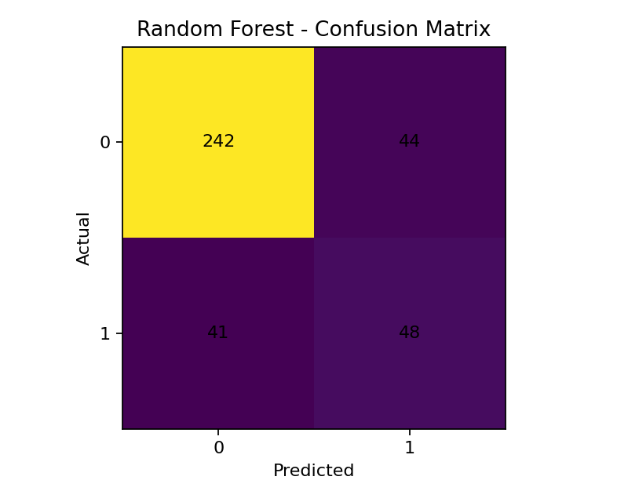
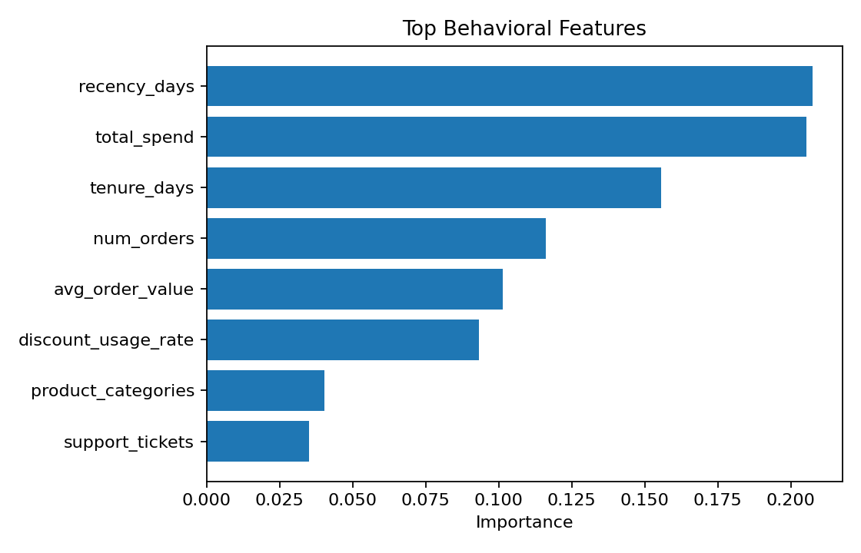
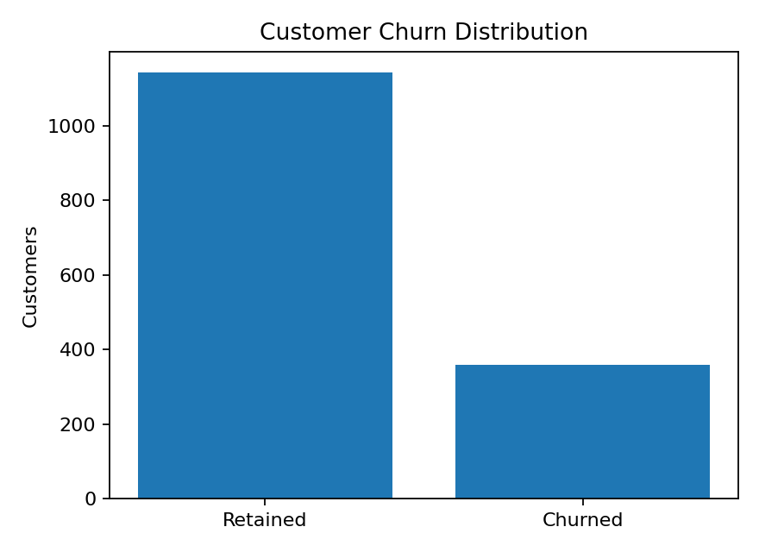

7. Streamlit Application
The application provides a sidebar for customer attributes and displays churn probability, risk level, behavioral inputs and a retention recommendation. Run it with: streamlit run app.py

8. Discussion
The model demonstrates how behavioral signals can be combined into a churn-risk prediction. Because the bundled data is synthetic, the reported metrics are prototype results only and should not be interpreted as production performance.

9. Limitations and Future Scope
- The bundled dataset is synthetic.
- Real deployment requires an approved historical transaction dataset and a documented churn definition.
- Future work can add SHAP explanations and temporal validation.
- A CRM integration can be developed for real retention campaigns.
- Recommendation policies can be optimized using uplift modeling.

10. Conclusion
This project presents a compact AI-based e-commerce churn decision-support system that combines behavioral feature engineering, supervised machine learning, risk categorization and retention recommendations in one interactive Streamlit application. It is intentionally distinct from a churn-plus-LTV-survival workflow.

11. References
- Breiman, L. Random Forests. Machine Learning, 45, 5–32, 2001.
- Friedman, J. H. Greedy Function Approximation: A Gradient Boosting Machine. Annals of Statistics, 2001.
- Scikit-learn documentation.
- Streamlit documentation.

Appendix – Project Structure
ecommerce_churn_ai_submission/
├── app.py
├── train_model.py
├── requirements.txt
├── README.md
├── data/customers.csv
├── models/churn_model.joblib
├── outputs/metrics.json
├── outputs/feature_importance.csv
├── outputs/confusion_matrix.png
├── outputs/feature_importance.png
└── outputs/churn_distribution.png

Submission Note
This is a self-contained prototype. If your department requires a public real-world dataset, replace data/customers.csv with an approved dataset, update the feature mapping if necessary, rerun train_model.py, and regenerate the results before making real-data performance claims.

