Feature: - Road anomalies

Sub Features: -

1. Pothole detection,
2. Hump / speed breaker detection,
3. Road quality,
4. Traffic monitoring

HIGH LEVEL DIAGRAM

Pothole detection and Hump / speed breaker detection

Requirements: -

1. Hardware requirement to gather acceleration data (OBD II or mobile sensor) and to capture image for image processing.
2. System should be able to detect pothole or speed breaker in real time and mark the spot on map/GPS. Also able to tell about road quality by looking at acceleration data and no of potholes are there on road.
3. System should be able to upload to the image and position of detected pothole and corresponding acceleration values.
4. Pothole detection algorithm or setup should be able to run for different cars.

Literature review: -

SWOT analysis

|  |  |
| --- | --- |
| STRENGTH   1. Real time pothole detection. 2. Acceleration data and image processing, two steps are occurring simultaneously will give better efficiency. | WEAKNESS   1. In image processing presence of shadow or in night time, it may not give high accuracy. 2. In normal driving condition, if the pothole is covered by car in front. |
| OPPURTUINITY   1. We alerting about pothole location to respective authority so they can take action and other user can also see how many potholes are there on route to select the route. | THREATH   1. False true can be generated that can mislead other users about route. |

Approach: -

We are going to use acceleration data and images of road to detect road anomalies.

For acceleration we can use smartphone sensor to record acceleration values or acceleration data generated by OBD II module. Here, we are proceeding with OBD module data for acceleration values and smartphone camera to capture images while driving.

For pothole and hump / speed breaker detection one way we are using is analysis of acceleration value. Now, passing through pothole or speed breaker, acceleration value in vertical direction is gets impacted, so our major focus will be on that axis.

Acceleration data from OBD II will be filtered to remove vehicle vibration and noises. Afterwards, dataset is ready to proceed with. Now, out of algorithms from Z-Thresh, Z-Diff, STDEV (Z) based on accuracy we will select one algorithm. Which will help in finding pothole on road.

Another way to find pothole is by image processing. While driving video is getting captured by the smartphone camera. Images will undergo image processing using open CV library in python. Where supervised model will be detecting the potholes or speed breakers. This will work on comparing the grey score of image, if it more than the threshold value that we set, then it will detect the pothole.

Frequency of data collection and image capturing should be same so that data validation can be done, we can see when pothole is detected by acceleration value if it is detected by image processing. Also, drawbacks of each other will be overcome by using them together and synchronized.

Initially, we will take the test on road where we know how many potholes are there and compare them the result to find the accuracy of the system.

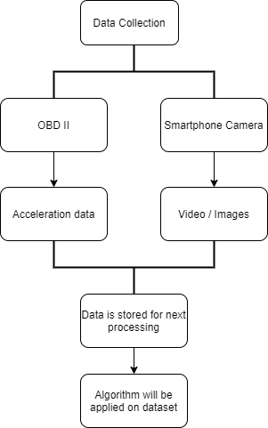

Figure 1 high level dia

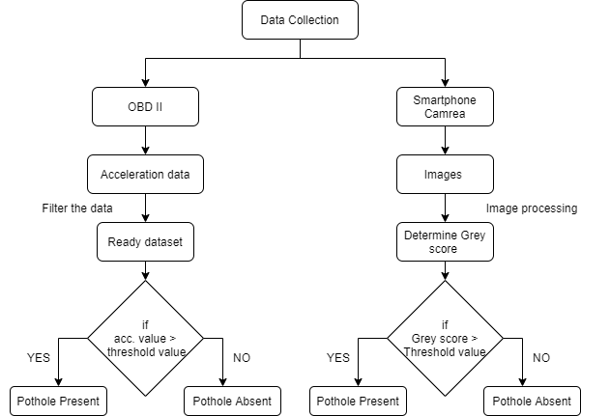

Figure 2 Pothole and Speed breaker detection flowchart

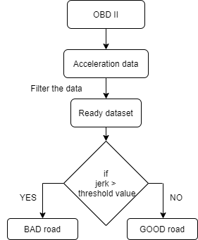

Figure 3 checking the road quality

Execution plan: -

1. Work on available dataset. Learn to filter the data and try to apply Z-thresh, Z-diff algorithms on acceleration values.
2. Understand Image processing techniques, grey scale etc. apply it on available video first instead of trying it in actual vehicle. See the accuracy of code and response time of processing.
3. Now once the pothole detection part is ready look for the reporting part. Reporting the presence of the pothole to user and respective authority.