Tesla Market Research & Strategy

Executive Summary
Tesla's U.S. EV market share is eroding as legacy automakers and new entrants increase spend on digital and traditional advertising. To protect market share and drive growth, a $500k media plan focuses on high‑impact digital channels, a robust content cadence, and measurable KPIs, while leveraging Tesla's brand equity and innovation leadership.

Competitors
Name | Website | Summary
Ford | https://ford.com | Legacy automaker with Mustang Mach-E and F-150 Lightning
BYD | https://byd.com | World's largest EV manufacturer focusing on affordability

Recommendations
- Allocate $200k to Google Ads for high‑intent search and display to capture demand‑ready shoppers.
- Deploy $150k to Meta for social engagement, retargeting, and lead generation across Meta and Twitter/X.
- Invest $100k in YouTube video ads to reinforce brand storytelling and product demos on YouTube and Instagram.
- Use $50k on LinkedIn to target B2B and corporate fleet decision‑makers.
- Implement a weekly content cadence: 2 videos (YouTube/Instagram), 1 blog (website), 5 social posts (Meta, Twitter/X).
- Track brand awareness lift, website traffic, cost per lead, and ROAS; adjust spend monthly based on performance.
- Leverage Tesla's innovation narrative in creative assets to differentiate from price‑driven competitors.
- Integrate government incentive messaging to boost conversion among price‑sensitive segments.

Budget Allocation
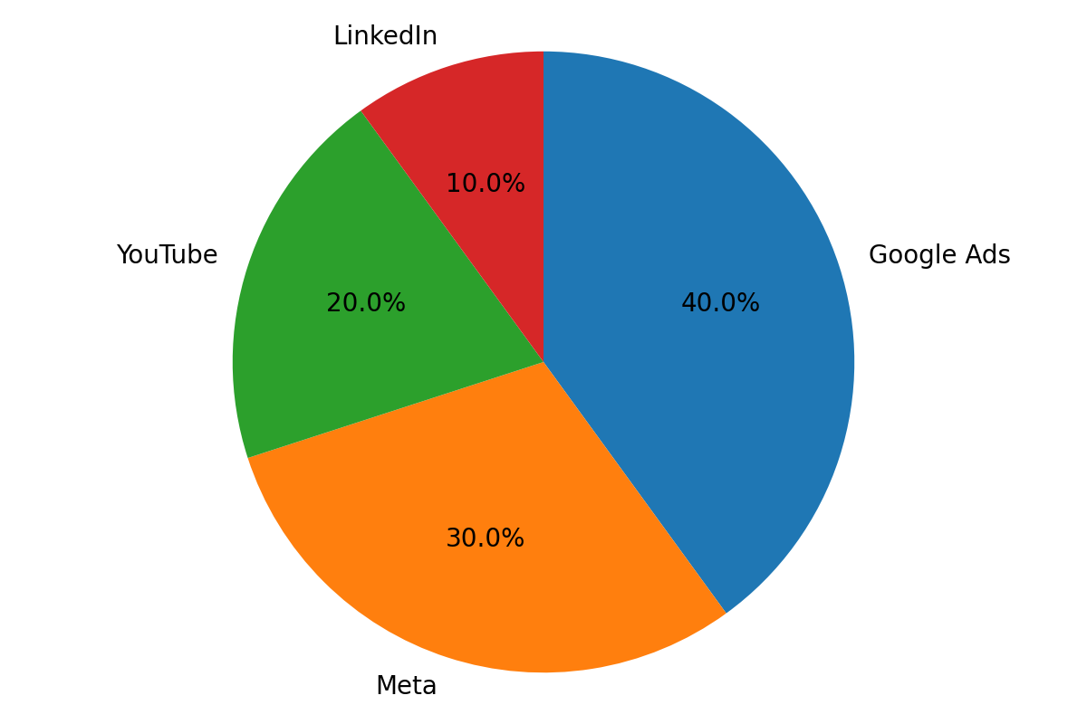

SWOT

Strengths
- Strong brand equity
- Innovation leadership

Weaknesses
- High price perception
- Limited advertising

Opportunities
- Growing EV market
- Government incentives

Threats
- Intense competition
- Supply chain challenges

Timeline
Sep 1‑30, 2025: Setup & Creative – develop video, blog, and social assets; configure tracking and attribution.
Oct 1‑Nov 30, 2025: Execution – launch media spend per weekly calendar, monitor KPIs, and optimize.
Week 1: $50,000 Google Ads – focus on high‑intent keywords and brand search.
Week 2: $37,500 Meta – launch awareness video and carousel ads.
Ongoing: Weekly performance review and budget reallocation based on ROAS and lead quality.

